**USER GUIDE**

**IAM APPLICATION**

Prepared by

Deepak VIJAYAKUMAR

**Table of Contents**

**1.0 Introduction………………………………………………………………………………………**

1.1 Scope and Purpose……………………………………………………………

1.2 Prerequisites……………………………………………… …………………….

1.3 Configuration……………………………………………………………………

**2.0 Detailed Process**

Overview………………………………………………………………………………

2.1 Login………………………………………………………….

2.2 Identity Creation…………………………………………………………………………

2.3 Identity update……………………………………………

2.4 Identity delete………………………………………………………………………………

2.5 List Identities……………………………………………

2.6 Exit……………………………………………

**3.0 Appendices…………………………………………………………………………………….**

## 1.Introduction

### **1.1Scope and Purpose**

The Identity Access Management System is designed to manage Identities and its attributes. The main features of the application are to Create, View, Update and Delete an Identity.

### **1.2 Prerequisites:**

* JRE(<http://www.oracle.com/technetwork/indexes/downloads/> )
* Derby Database server already setup or you could download Derby here.

(<https://db.apache.org/derby/derby_downloads.html> )

### 1.3Configuration

1. Download and install a configurable database server (preferably Derby). This application designed for Derby and configure the database server. Start the derby server by running startNetworkServer.bat from derby installation path %DERBY_HOME%/bin.

## 2.Detailed Process Overview

The application involves the following processes which should be carefully understood for proper usage.

Processes:

* Login
* Identity Creation
* Identity Update
* Identity Delete
* Listing identities
* Exit

**2.1 Login**

* Admins can enter their username and password and access the system. Only admins are authenticated to use this system
* Usernames and passwords of all admins are stored in a database table ADMINS. This portion is not part of the project
* Currently ADMIN table has only 1 row
* We can access the system using username “admin” and password “admin”

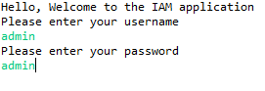

After authentication following menu will be displayed

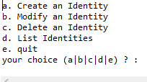

### 

### 2.2 Identity Creation

* Choose option a
* Entering Display Name , Email and phone number to create the identity

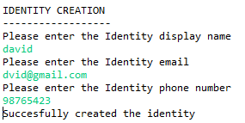

### 2.3 Identity Update

Choose option b

Enter the display name of the identity to be updated. Then enter the new details to update it

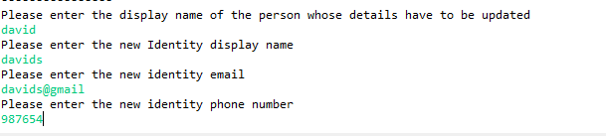

### 2.4 Identity Delete

Choose option c

Enter the display name of the identity to be deleted

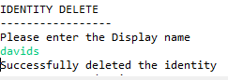

### 2.5 List all Identities

Choose option d to list all the identities

list.PNG

### 2.6 Exit

Choose option e to exit the application

## 3.Appendices

The above application is platform independent however it requires Java run time environment and apache derby to be installed on the target machine/operating system to run