runfile('C:/Users/Wadhwani/AppData/Roaming/SPB_Data/.spyder-py3/temp.py', wdir='C:/Users/Wadhwani/AppData/Roaming/SPB_Data/.spyder-py3')

C:\Users\Wadhwani\Anaconda3\lib\site-packages\sklearn\preprocessing\data.py:625: DataConversionWarning: Data with input dtype uint8, int64, float64 were all converted to float64 by StandardScaler.

return self.partial_fit(X, y)

C:\Users\Wadhwani\Anaconda3\lib\site-packages\sklearn\base.py:462: DataConversionWarning: Data with input dtype uint8, int64, float64 were all converted to float64 by StandardScaler.

return self.fit(X, **fit_params).transform(X)

C:/Users/Wadhwani/AppData/Roaming/SPB_Data/.spyder-py3/temp.py:55: DataConversionWarning: Data with input dtype uint8, int64, float64 were all converted to float64 by StandardScaler.

X_test2 = pd.DataFrame(sc_X.transform(X_test))

C:\Users\Wadhwani\Anaconda3\lib\site-packages\sklearn\linear_model\logistic.py:433: FutureWarning: Default solver will be changed to 'lbfgs' in 0.22. Specify a solver to silence this warning.

FutureWarning)

Test Data Accuracy: 0.6443

C:\Users\Wadhwani\Anaconda3\lib\site-packages\sklearn\linear_model\logistic.py:433: FutureWarning: Default solver will be changed to 'lbfgs' in 0.22. Specify a solver to silence this warning.

FutureWarning)

C:\Users\Wadhwani\Anaconda3\lib\site-packages\sklearn\linear_model\logistic.py:433: FutureWarning: Default solver will be changed to 'lbfgs' in 0.22. Specify a solver to silence this warning.

FutureWarning)

C:\Users\Wadhwani\Anaconda3\lib\site-packages\sklearn\linear_model\logistic.py:433: FutureWarning: Default solver will be changed to 'lbfgs' in 0.22. Specify a solver to silence this warning.

FutureWarning)

C:\Users\Wadhwani\Anaconda3\lib\site-packages\sklearn\linear_model\logistic.py:433: FutureWarning: Default solver will be changed to 'lbfgs' in 0.22. Specify a solver to silence this warning.

FutureWarning)

C:\Users\Wadhwani\Anaconda3\lib\site-packages\sklearn\linear_model\logistic.py:433: FutureWarning: Default solver will be changed to 'lbfgs' in 0.22. Specify a solver to silence this warning.

FutureWarning)

C:\Users\Wadhwani\Anaconda3\lib\site-packages\sklearn\linear_model\logistic.py:433: FutureWarning: Default solver will be changed to 'lbfgs' in 0.22. Specify a solver to silence this warning.

FutureWarning)

C:\Users\Wadhwani\Anaconda3\lib\site-packages\sklearn\linear_model\logistic.py:433: FutureWarning: Default solver will be changed to 'lbfgs' in 0.22. Specify a solver to silence this warning.

FutureWarning)

C:\Users\Wadhwani\Anaconda3\lib\site-packages\sklearn\linear_model\logistic.py:433: FutureWarning: Default solver will be changed to 'lbfgs' in 0.22. Specify a solver to silence this warning.

FutureWarning)

C:\Users\Wadhwani\Anaconda3\lib\site-packages\sklearn\linear_model\logistic.py:433: FutureWarning: Default solver will be changed to 'lbfgs' in 0.22. Specify a solver to silence this warning.

FutureWarning)

C:\Users\Wadhwani\Anaconda3\lib\site-packages\sklearn\linear_model\logistic.py:433: FutureWarning: Default solver will be changed to 'lbfgs' in 0.22. Specify a solver to silence this warning.

FutureWarning)

SVM Accuracy: 0.660 (+/- 0.033)

C:\Users\Wadhwani\Anaconda3\lib\site-packages\sklearn\linear_model\logistic.py:433: FutureWarning: Default solver will be changed to 'lbfgs' in 0.22. Specify a solver to silence this warning.

FutureWarning)

C:\Users\Wadhwani\Anaconda3\lib\site-packages\sklearn\linear_model\logistic.py:433: FutureWarning: Default solver will be changed to 'lbfgs' in 0.22. Specify a solver to silence this warning.

FutureWarning)

C:\Users\Wadhwani\Anaconda3\lib\site-packages\sklearn\linear_model\logistic.py:433: FutureWarning: Default solver will be changed to 'lbfgs' in 0.22. Specify a solver to silence this warning.

FutureWarning)

C:\Users\Wadhwani\Anaconda3\lib\site-packages\sklearn\linear_model\logistic.py:433: FutureWarning: Default solver will be changed to 'lbfgs' in 0.22. Specify a solver to silence this warning.

FutureWarning)

C:\Users\Wadhwani\Anaconda3\lib\site-packages\sklearn\linear_model\logistic.py:433: FutureWarning: Default solver will be changed to 'lbfgs' in 0.22. Specify a solver to silence this warning.

FutureWarning)

C:\Users\Wadhwani\Anaconda3\lib\site-packages\sklearn\linear_model\logistic.py:433: FutureWarning: Default solver will be changed to 'lbfgs' in 0.22. Specify a solver to silence this warning.

FutureWarning)

C:\Users\Wadhwani\Anaconda3\lib\site-packages\sklearn\linear_model\logistic.py:433: FutureWarning: Default solver will be changed to 'lbfgs' in 0.22. Specify a solver to silence this warning.

FutureWarning)

C:\Users\Wadhwani\Anaconda3\lib\site-packages\sklearn\linear_model\logistic.py:433: FutureWarning: Default solver will be changed to 'lbfgs' in 0.22. Specify a solver to silence this warning.

FutureWarning)

C:\Users\Wadhwani\Anaconda3\lib\site-packages\sklearn\linear_model\logistic.py:433: FutureWarning: Default solver will be changed to 'lbfgs' in 0.22. Specify a solver to silence this warning.

FutureWarning)

C:\Users\Wadhwani\Anaconda3\lib\site-packages\sklearn\linear_model\logistic.py:433: FutureWarning: Default solver will be changed to 'lbfgs' in 0.22. Specify a solver to silence this warning.

FutureWarning)

C:\Users\Wadhwani\Anaconda3\lib\site-packages\sklearn\linear_model\logistic.py:433: FutureWarning: Default solver will be changed to 'lbfgs' in 0.22. Specify a solver to silence this warning.

FutureWarning)

C:\Users\Wadhwani\Anaconda3\lib\site-packages\sklearn\linear_model\logistic.py:433: FutureWarning: Default solver will be changed to 'lbfgs' in 0.22. Specify a solver to silence this warning.

FutureWarning)

C:\Users\Wadhwani\Anaconda3\lib\site-packages\sklearn\linear_model\logistic.py:433: FutureWarning: Default solver will be changed to 'lbfgs' in 0.22. Specify a solver to silence this warning.

FutureWarning)

C:\Users\Wadhwani\Anaconda3\lib\site-packages\sklearn\linear_model\logistic.py:433: FutureWarning: Default solver will be changed to 'lbfgs' in 0.22. Specify a solver to silence this warning.

FutureWarning)

C:\Users\Wadhwani\Anaconda3\lib\site-packages\sklearn\linear_model\logistic.py:433: FutureWarning: Default solver will be changed to 'lbfgs' in 0.22. Specify a solver to silence this warning.

FutureWarning)

C:\Users\Wadhwani\Anaconda3\lib\site-packages\sklearn\linear_model\logistic.py:433: FutureWarning: Default solver will be changed to 'lbfgs' in 0.22. Specify a solver to silence this warning.

FutureWarning)

C:\Users\Wadhwani\Anaconda3\lib\site-packages\sklearn\linear_model\logistic.py:433: FutureWarning: Default solver will be changed to 'lbfgs' in 0.22. Specify a solver to silence this warning.

FutureWarning)

C:\Users\Wadhwani\Anaconda3\lib\site-packages\sklearn\linear_model\logistic.py:433: FutureWarning: Default solver will be changed to 'lbfgs' in 0.22. Specify a solver to silence this warning.

FutureWarning)

C:\Users\Wadhwani\Anaconda3\lib\site-packages\sklearn\linear_model\logistic.py:433: FutureWarning: Default solver will be changed to 'lbfgs' in 0.22. Specify a solver to silence this warning.

FutureWarning)

C:\Users\Wadhwani\Anaconda3\lib\site-packages\sklearn\linear_model\logistic.py:433: FutureWarning: Default solver will be changed to 'lbfgs' in 0.22. Specify a solver to silence this warning.

FutureWarning)

C:\Users\Wadhwani\Anaconda3\lib\site-packages\sklearn\linear_model\logistic.py:433: FutureWarning: Default solver will be changed to 'lbfgs' in 0.22. Specify a solver to silence this warning.

FutureWarning)

C:\Users\Wadhwani\Anaconda3\lib\site-packages\sklearn\linear_model\logistic.py:433: FutureWarning: Default solver will be changed to 'lbfgs' in 0.22. Specify a solver to silence this warning.

FutureWarning)

C:\Users\Wadhwani\Anaconda3\lib\site-packages\sklearn\linear_model\logistic.py:433: FutureWarning: Default solver will be changed to 'lbfgs' in 0.22. Specify a solver to silence this warning.

FutureWarning)

[ True True False True True True False False False False True True

True True True True True False True True False True True False

False True True False False True False False False True False False

False False False False False False]

[ 1 1 7 1 1 1 11 6 12 22 1 1 1 1 1 1 1 3 1 1 14 1 1 13

8 1 1 9 2 1 10 19 5 1 21 23 16 4 17 20 15 18]

C:\Users\Wadhwani\Anaconda3\lib\site-packages\sklearn\linear_model\logistic.py:433: FutureWarning: Default solver will be changed to 'lbfgs' in 0.22. Specify a solver to silence this warning.

FutureWarning)

Test Data Accuracy: 0.6459

C:\Users\Wadhwani\Anaconda3\lib\site-packages\sklearn\linear_model\logistic.py:433: FutureWarning: Default solver will be changed to 'lbfgs' in 0.22. Specify a solver to silence this warning.

FutureWarning)

C:\Users\Wadhwani\Anaconda3\lib\site-packages\sklearn\linear_model\logistic.py:433: FutureWarning: Default solver will be changed to 'lbfgs' in 0.22. Specify a solver to silence this warning.

FutureWarning)

C:\Users\Wadhwani\Anaconda3\lib\site-packages\sklearn\linear_model\logistic.py:433: FutureWarning: Default solver will be changed to 'lbfgs' in 0.22. Specify a solver to silence this warning.

FutureWarning)

C:\Users\Wadhwani\Anaconda3\lib\site-packages\sklearn\linear_model\logistic.py:433: FutureWarning: Default solver will be changed to 'lbfgs' in 0.22. Specify a solver to silence this warning.

FutureWarning)

C:\Users\Wadhwani\Anaconda3\lib\site-packages\sklearn\linear_model\logistic.py:433: FutureWarning: Default solver will be changed to 'lbfgs' in 0.22. Specify a solver to silence this warning.

FutureWarning)

C:\Users\Wadhwani\Anaconda3\lib\site-packages\sklearn\linear_model\logistic.py:433: FutureWarning: Default solver will be changed to 'lbfgs' in 0.22. Specify a solver to silence this warning.

FutureWarning)

C:\Users\Wadhwani\Anaconda3\lib\site-packages\sklearn\linear_model\logistic.py:433: FutureWarning: Default solver will be changed to 'lbfgs' in 0.22. Specify a solver to silence this warning.

FutureWarning)

C:\Users\Wadhwani\Anaconda3\lib\site-packages\sklearn\linear_model\logistic.py:433: FutureWarning: Default solver will be changed to 'lbfgs' in 0.22. Specify a solver to silence this warning.

FutureWarning)

C:\Users\Wadhwani\Anaconda3\lib\site-packages\sklearn\linear_model\logistic.py:433: FutureWarning: Default solver will be changed to 'lbfgs' in 0.22. Specify a solver to silence this warning.

FutureWarning)

C:\Users\Wadhwani\Anaconda3\lib\site-packages\sklearn\linear_model\logistic.py:433: FutureWarning: Default solver will be changed to 'lbfgs' in 0.22. Specify a solver to silence this warning.

FutureWarning)

SVM Accuracy: 0.659 (+/- 0.034)

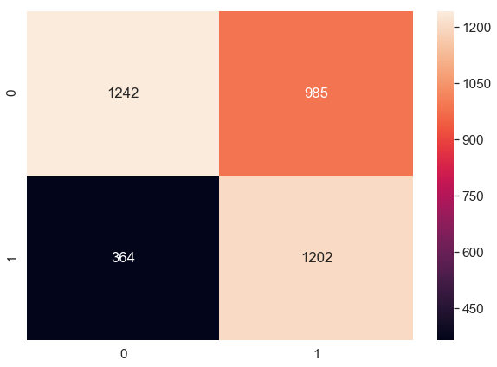

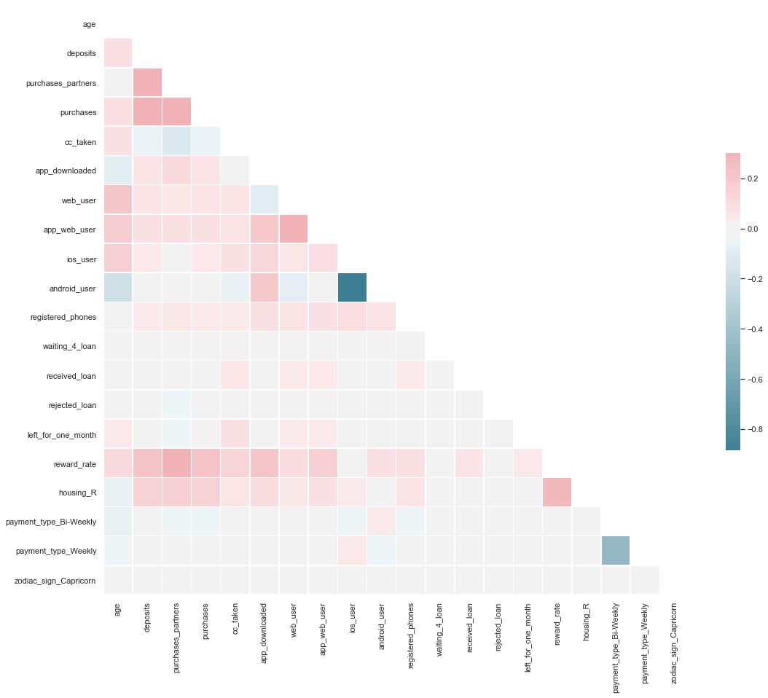

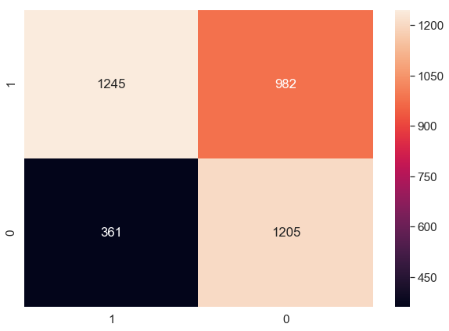

features coef

0 age -0.178667

1 deposits 0.054417

2 purchases_partners -0.699765

3 purchases -0.156581

4 cc_taken 0.079322

5 app_downloaded -0.111570

6 web_user 0.058603

7 app_web_user 0.062376

8 ios_user 0.149200

9 android_user 0.058088

10 registered_phones 0.068700

11 waiting_4_loan -0.044937

12 received_loan 0.114034

13 rejected_loan 0.101964

14 left_for_one_month 0.060921

15 reward_rate -0.241775

16 housing_R 0.073283

17 payment_type_Bi-Weekly -0.043918

18 payment_type_Weekly 0.096454

19 zodiac_sign_Capricorn 0.046591

user churn predicted_churn

0 20839 0.0 1

1 15359 1.0 0

2 34210 1.0 0

3 57608 1.0 1

4 11790 0.0 0

5 1826 1.0 1

6 8508 0.0 1

7 50946 1.0 1

8 50130 1.0 0

9 55422 0.0 1

10 259 1.0 1

11 17451 0.0 0

12 41909 0.0 0

13 38825 0.0 1

14 19314 1.0 1

15 26916 0.0 0

16 30614 0.0 1

17 30329 1.0 1

18 38853 0.0 1

19 15592 1.0 1

20 40888 0.0 1

21 17918 1.0 0

22 52613 0.0 0

23 725 0.0 1

24 51797 0.0 0

25 2601 0.0 0

26 33990 0.0 1

27 10006 0.0 0

28 19296 1.0 0

29 12135 1.0 0

... ... ...

3763 64494 1.0 0

3764 1185 0.0 1

3765 17908 0.0 1

3766 52426 0.0 1

3767 41552 0.0 1

3768 52762 1.0 0

3769 35892 1.0 1

3770 28025 1.0 0

3771 55416 0.0 0

3772 14997 0.0 1

3773 25667 0.0 1

3774 44166 0.0 0

3775 50893 1.0 0

3776 10975 1.0 1

3777 38184 0.0 0

3778 31601 0.0 0

3779 31167 0.0 0

3780 51126 0.0 1

3781 58440 0.0 0

3782 65088 0.0 1

3783 26821 0.0 0

3784 25599 0.0 1

3785 3369 0.0 1

3786 33587 1.0 0

3787 22318 0.0 1

3788 67681 0.0 1

3789 49145 1.0 0

3790 47206 0.0 0

3791 22377 0.0 0

3792 47663 1.0 0

[3793 rows x 3 columns]