Deepak Kumar Behera HW #2

1. The Energy vs Distance for two atoms using LJ potentials is as obtained. For the given problem minimization code is used instead just finding the initial energy between two atoms. The code and files obtained are given in folder ’Problem 1’.

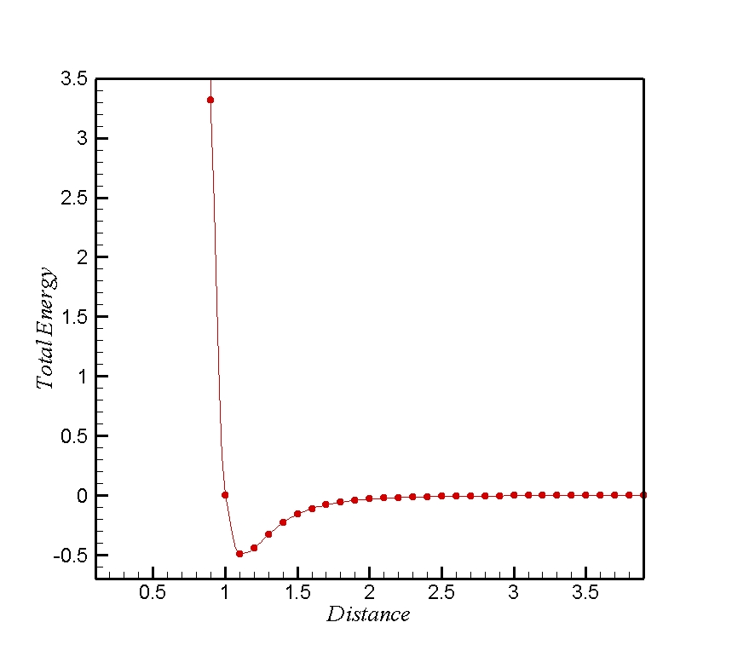

Figure 1: Energy vs Distance between two atoms using LJ Potentials

2. The energy and lattice constant calculated for Al, using EAM for FCC, BCC, SC

|  |  |  |  |
| --- | --- | --- | --- |
| Structure | Total Atoms | Energy (ev) | Lattice Constant (Ao) |
| FCC | 4 | -13.27 | 4.05 |
| BCC | 2 | -6.60 | 3.32 |
| SC | 1 | -3.062 | 2.687 |

From the above results, we can see that the total energy depends on the effective number of atoms in the structure. For SC with 1 effective atom has the least energy and the lattice constant is also minimum as it the simple structure with atoms located at the corners at of the cube. With the introduction of an atom at the center of cube, the effective number of atoms is 2. Thus, the total energy increases by 2 times which depends on the effective number of atoms. The lattice constant also increases as the atomic distance increases to attain the min. potential energy of the system for equilibrium. Similarly, for FCC, has the highest energy which is 4 times of SC due to presence of 4 effective atoms in the cube. The atomic distance also increases as the new atoms are introduced on the faces for FCC. Thus the results confine with the theory.

Problem 3.

Energy vs volume is plotted for Al FCC structure. And is shown below.



The Bulk modulus can be calculated as $B=V_{0}\frac{d^{2}E}{dV^{2}}$

The Bulk Modulus obtained from the equation is 0.24535 (ev/A^3) = 40.6 GPa