Deepak Kumar Behera HW#3



Solution.

Doing NPT for Al, 10x10x 10 structure at 250 K, 300 K and 350 K

We get from the slope of Enthalpy vs Temperature curve.

Also from the same analysis we can obtain thermal coefficient from slope of Volume vs Temperature Curve. And dividing the Slope by Volume.

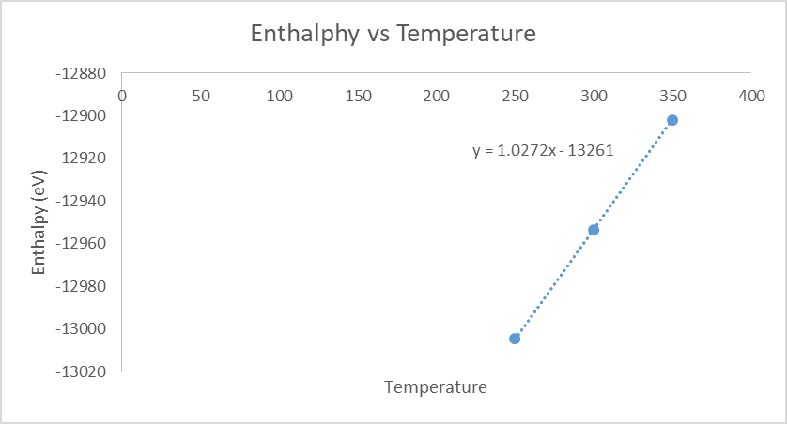

Figure 1: Enthapy vs Temperature for Aluminium at Constant Pressure

From the Slope of the Curve in Figure 1, the value is 

From Figure 2, Slope we get the coefficient of thermal expansion as 

Thus the 



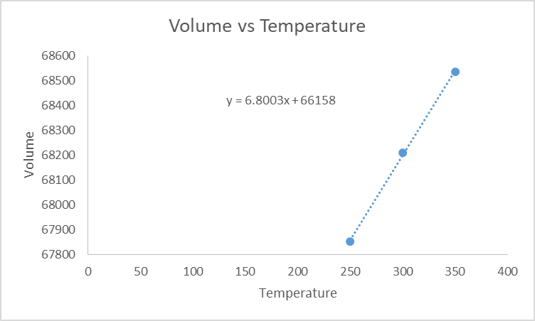

Figure 2: Volume vs Temperature for Aluminium at Constant Pressure

Thus, 

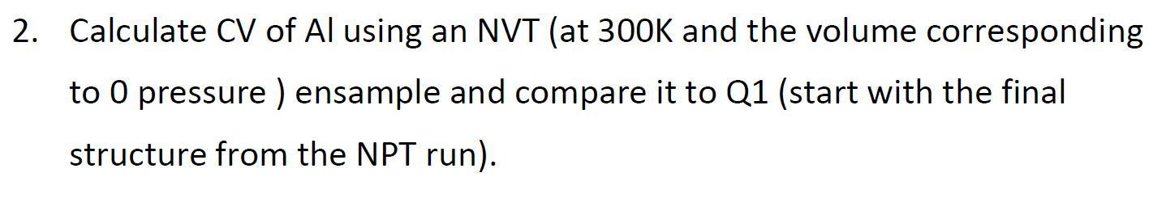

Solution: The can be obtained from the slope of enthalpy vs Temperature at constant volume.

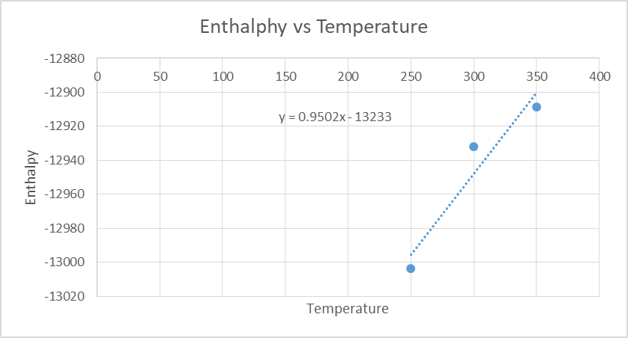

Figure 3: Enthapy vs Temperature for Aluminium at Constant Volume

From the Slope the . The Error in value obtained in question 1 is around 



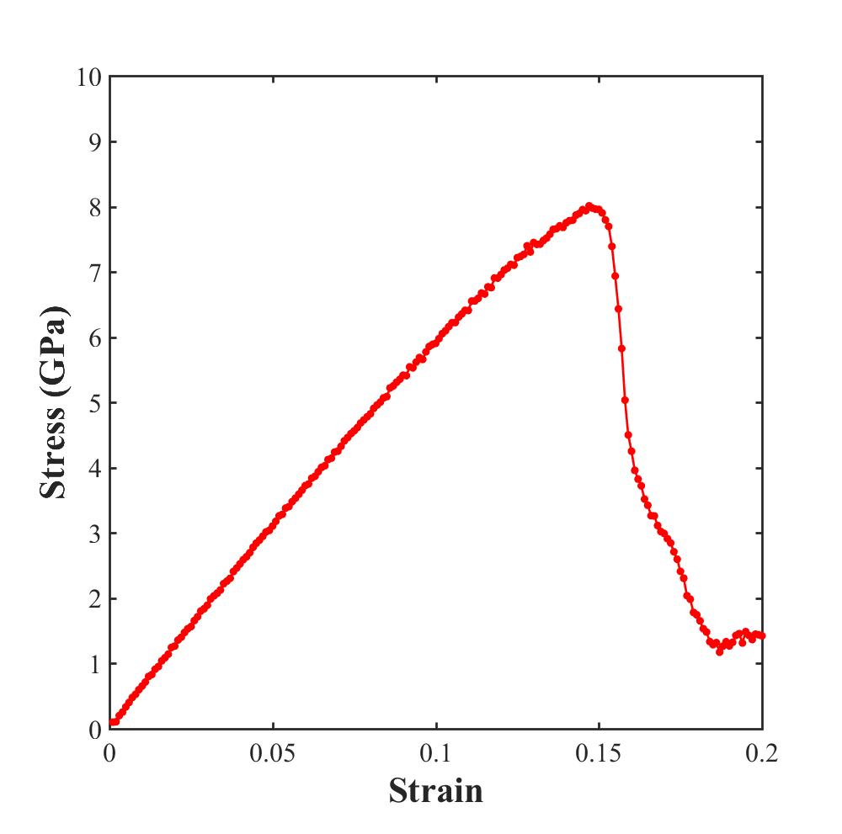

The Elastic Modulus obtained from stress strain curve is 60 Gpa

