

Functional Safety Concept Lane Assistance

**Document Version: [Version]**

**Template Version 1.0, Released on 2017-06-21**



# Document history

|  |  |  |  |
| --- | --- | --- | --- |
| Date | Version | Editor | Description |
| 7/21/2017 | 1.0 | Deepak Zambre | Initial draft |
|  |  |  |  |
|  |  |  |  |
|  |  |  |  |
|  |  |  |  |

# Table of Contents

Document history

Table of Contents

Purpose of the Functional Safety Concept

Inputs to the Functional Safety Analysis

Safety goals from the Hazard Analysis and Risk Assessment

Preliminary Architecture

Description of architecture elements

Functional Safety Concept

Functional Safety Analysis

Functional Safety Requirements

Refinement of the System Architecture

Allocation of Functional Safety Requirements to Architecture Elements

Warning and Degradation Concept

# Purpose of the Functional Safety Concept

To associate functional safety requirements with subsystems and elements of a system

# Inputs to the Functional Safety Concept

## Safety goals from the Hazard Analysis and Risk Assessment

|  |  |
| --- | --- |
| **ID** | **Safety Goal** |
| Safety_Goal_01 | Oscillating torque from LDW function shall be limited |
| Safety_Goal_02 | Lane Keeping Assistance function shall be time limited and additional steering torque shall end after a given time interval, so the driver cannot misuse the system for autonomous driving. |

## Preliminary Architecture

**A close up of a sign

Description generated with high confidence**

### Description of architecture elements

|  |  |
| --- | --- |
| **Element** | **Description** |
| Camera Sensor | Capture​ ​road​ ​images​ ​and​ ​provide​ ​them​ ​to​ ​the Camera​ ​Sensor​ ​ECU |
| Camera Sensor ECU | Analyze​ ​provided​ ​images​ ​to​ ​calculate​ ​the​ ​car position​ ​on​ ​the​ ​road​ ​respect​ ​to​ ​the​ ​road​ ​lanes |
| Car Display | Provide​ ​feedback​ ​to​ ​the​ ​driver​ ​displaying​ ​warnings and​ ​the​ ​Lane​ ​Departure​ ​Assistance​ ​status |
| Car Display ECU | Manage​​ ​Car​ ​Display​ ​component​ ​to​ ​show​ ​the Lane​ ​Keeping​ ​Assistance​ ​warning​ ​and​ ​Lane Departure​ ​Assistance​ ​status |
| Driver Steering Torque Sensor | Measure​ ​the​ ​torque​ ​applied​ ​to​ ​the​ ​steering​ ​wheel by​ ​the​ ​driver |
| Electronic Power Steering ECU | Use​ ​the​ ​information​ ​received​ ​from​ ​the​ ​Driver Steering​ ​Torque​ ​Sensor​ ​and​ ​the​ ​torque​ ​requested by​ ​the​ ​Lane​ ​Keeping​ ​Assistance​ ​and​ ​Lane Warning​ ​and​ ​request​ ​the​ ​necessary​ ​torque​ ​to​ ​be applied​ ​by​ ​the​ ​Motor​ ​actuator |
| Motor | Applies​ ​the​ ​torque​ ​indicated​ ​by​ ​the​ ​Electronic Power​ ​Steering​ ​ECU​ ​to​ ​the​ ​steering​ ​wheel |

# Functional Safety Concept

The functional safety concept consists of:

* Functional safety analysis
* Functional safety requirements
* Functional safety architecture
* Warning and degradation concept

## Functional Safety Analysis

|  |  |  |  |
| --- | --- | --- | --- |
| **Malfunction ID** | **Main Function of the Item Related to Safety Goal Violations** | **Guidewords (NO, WRONG, EARLY, LATE, MORE, LESS)** | **Resulting Malfunction** |
| Malfunction_01 | Lane Departure Warning (LDW) function shall apply an oscillating steering torque to provide the driver a haptic feedback | MORE | The lane departure warning function applies an oscillating torque with very high torque amplitude (above limit) |
| Malfunction_02 | Lane Departure Warning (LDW) function shall apply an oscillating steering torque to provide the driver a haptic feedback | MORE | The lane departure warning function applies an oscillating torque with very high torque frequency (above limit) |
| Malfunction_03 | Lane Keeping Assistance (LKA) function shall apply the steering torque when active in order to stay in ego lane | NO | The lane keeping assistance function is not limited in time duration which leads to misuse as an autonomous driving function |

## Functional Safety Requirements

Lane Departure Warning (LDW) Requirements:

|  |  |  |  |  |
| --- | --- | --- | --- | --- |
| **ID** | **Functional Safety Requirement** | **ASIL** | **Fault Tolerant Time Interval** | **Safe State** |
| Functional  Safety  Requirement  01-01 | The lane keeping item shall ensure that the land departure oscillating torque amplitude is below MAX_TORQUE_AMPLITUDE | C | 50ms | Oscillation torque amplitude less than MAX_TORQUE_AMPLITUDE |
| Functional  Safety  Requirement  01-02 | The lane keeping item shall ensure that the lane departure oscillating torque frequency is below MAX_TORQUE_FREQUENCY | C | 50ms | Oscillation torque frequency less than MAX_TORQUE_FREQUENCY |

Lane Departure Warning (LDW) Verification and Validation Acceptance Criteria:

|  |  |  |
| --- | --- | --- |
| **ID** | **Validation Acceptance**  **Criteria and Method** | **Verification Acceptance**  **Criteria and Method** |
| Functional  Safety  Requirement  01-01 | Validate that MAX_TORQUE_AMPLITUDE is  - high enough that driver is warned and  - low enough that driver does not loose driving control | Verify: when the torque amplitude crosses the limit, the lane assistance output is set to zero within the 50 ms fault tolerant time interval |
| Functional  Safety  Requirement  01-02 | Validate that MAX_TORQUE_FREQUENCY is  - high enough that driver is warned and  - low enough that driver does not loose driving control | Verify: when the torque frequency crosses the limit, the lane assistance output is set to zero within the 50 ms fault tolerant time interval |

Lane Keeping Assistance (LKA) Requirements:

|  |  |  |  |  |
| --- | --- | --- | --- | --- |
| **ID** | **Functional Safety Requirement** | **ASIL** | **Fault Tolerant Time Interval** | **Safe State** |
| Functional  Safety  Requirement  02-01 | The electronic power steering ECU shall ensure that the lane keeping assistance torque is applied for only MAX_DURATION | B | 500ms | LKA torque is zero after MAX_DURATION |

Lane Keeping Assistance (LKA) Verification and Validation Acceptance Criteria:

|  |  |  |
| --- | --- | --- |
| **ID** | **Validation Acceptance**  **Criteria and Method** | **Verification Acceptance**  **Criteria and Method** |
| Functional  Safety  Requirement  02-01 | Validate that chosen MAX_DURATION really did dissuade drivers from taking their hands off the wheel | Verify: the lane assistance system really does turn off if the lane keeping assistance every exceeded MAX_DURATION |

## Refinement of the System Architecture

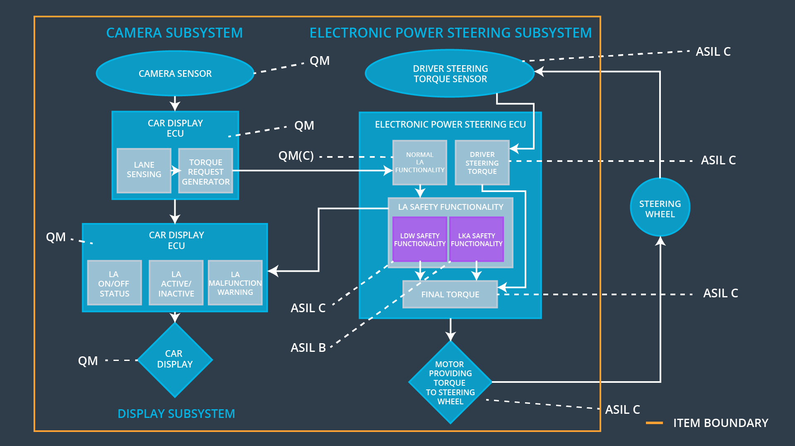

## Allocation of Functional Safety Requirements to Architecture Elements

|  |  |  |  |  |
| --- | --- | --- | --- | --- |
| **ID** | **Functional Safety Requirement** | **Electronic Power Steering ECU** | **Camera ECU** | **Car Display ECU** |
| Functional  Safety  Requirement  01-01 | The lane keeping item shall ensure that the land departure oscillating torque amplitude is below MAX_TORQUE_AMPLITUDE | **X** |  |  |
| Functional  Safety  Requirement  01-02 | The lane keeping item shall ensure that the lane departure oscillating torque frequency is below MAX_TORQUE_FREQUENCY | **X** |  |  |
| Functional  Safety  Requirement  02-01 | The electronic power steering ECU shall ensure that the lane keeping assistance torque is applied for only MAX_DURATION | **X** |  |  |

## Warning and Degradation Concept

|  |  |  |  |  |
| --- | --- | --- | --- | --- |
| **ID** | **Degradation Mode** | **Trigger for Degradation Mode** | **Safe State invoked?** | **Driver Warning** |
| WDC-01 | turn off the functionality | Malfunction_01 Malfunction_02 | Yes | Warning indicator in dashboard |
| WDC-02 | turn off the functionality | Malfunction_03 | Yes | Warning indicator in dashboard |