Industrial Internship Report on
”Banking Infromation System”
Prepared by
Deepali Shukla

Executive Summary
This report is based on my internship project "Banking Information System".
The project is developed using Java programming language.
It helps in performing basic banking operations like account creation, deposit, withdrawal and balance checking.
This internship helped me to gain practical knowledge and improve my programming skills.This internship gave me a very good opportunity to get exposure to Industrial problems and design/implement solution for that. It was an overall great experience to have this internship.

TABLE OF CONTENTS
1 Preface 3
2 Introduction 4
2.1 About UniConverge Technologies Pvt Ltd 4
2.2 About upskill Campus 8
2.3 Objective 9
2.4 Reference 9
2.5 Glossary 10
3 Problem Statement 11
4 Existing and Proposed solution 12
5 Proposed Design/ Model 13
5.1 High Level Diagram (if applicable) 13
5.2 Low Level Diagram (if applicable) 13
5.3 Interfaces (if applicable) 13
6 Performance Test 14
6.1 Test Plan/ Test Cases 14
6.2 Test Procedure 14
6.3 Performance Outcome 14
7 My learnings 15
8 Future work scope 16

Preface
This internship provided me an opportunity to work on a real-world project.
During this period, I learned how to develop a banking system using Java.
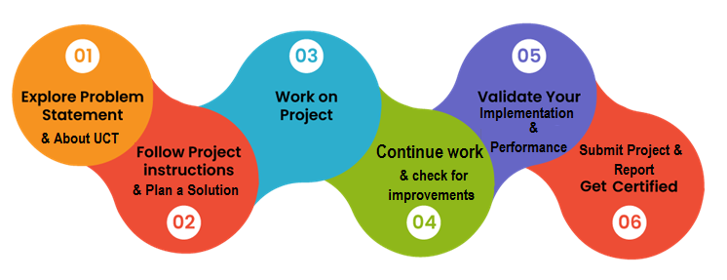
I gained knowledge about programming, problem solving and project development.
I am thankful to my mentors and teachers for their support.

Introduction

About UniConverge Technologies Pvt Ltd
A company established in 2013 and working in Digital Transformation domain and providing Industrial solutions with prime focus on sustainability and RoI.
For developing its products and solutions it is leveraging various Cutting Edge Technologies e.g. Internet of Things (IoT), Cyber Security, Cloud computing (AWS, Azure), Machine Learning, Communication Technologies (4G/5G/LoRaWAN), Java Full Stack, Python, Front end etc.
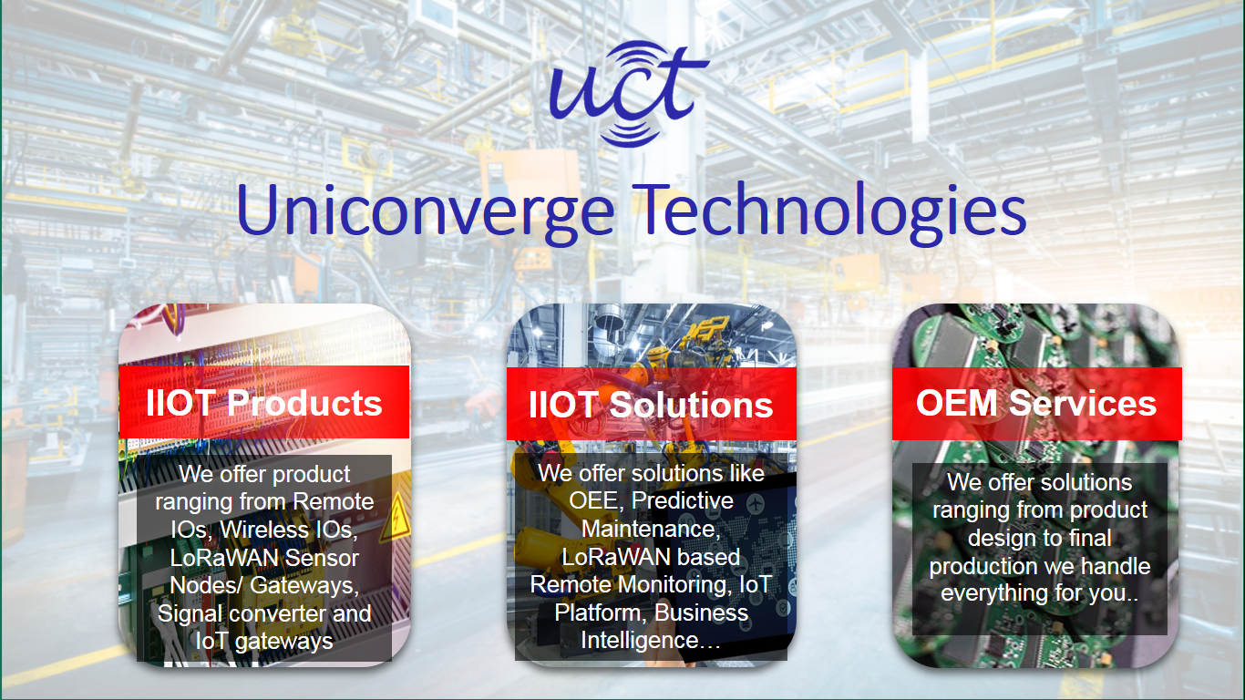
- UCT IoT Platform()
UCT Insight is an IOT platform designed for quick deployment of IOT applications on the same time providing valuable “insight” for your process/business. It has been built in Java for backend and ReactJS for Front end. It has support for MySQL and various NoSql Databases.
- It enables device connectivity via industry standard IoT protocols - MQTT, CoAP, HTTP, Modbus TCP, OPC UA
- It supports both cloud and on-premises deployments.
It has features to
• Build Your own dashboard
• Analytics and Reporting
• Alert and Notification
• Integration with third party application(Power BI, SAP, ERP)
• Rule Engine

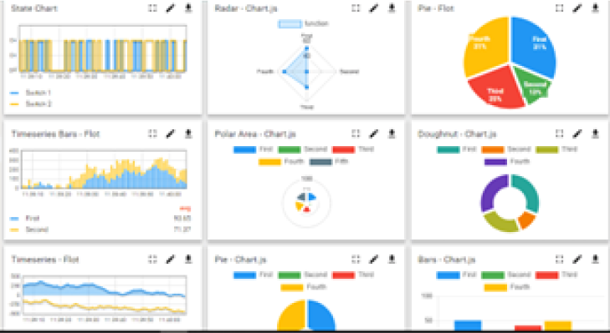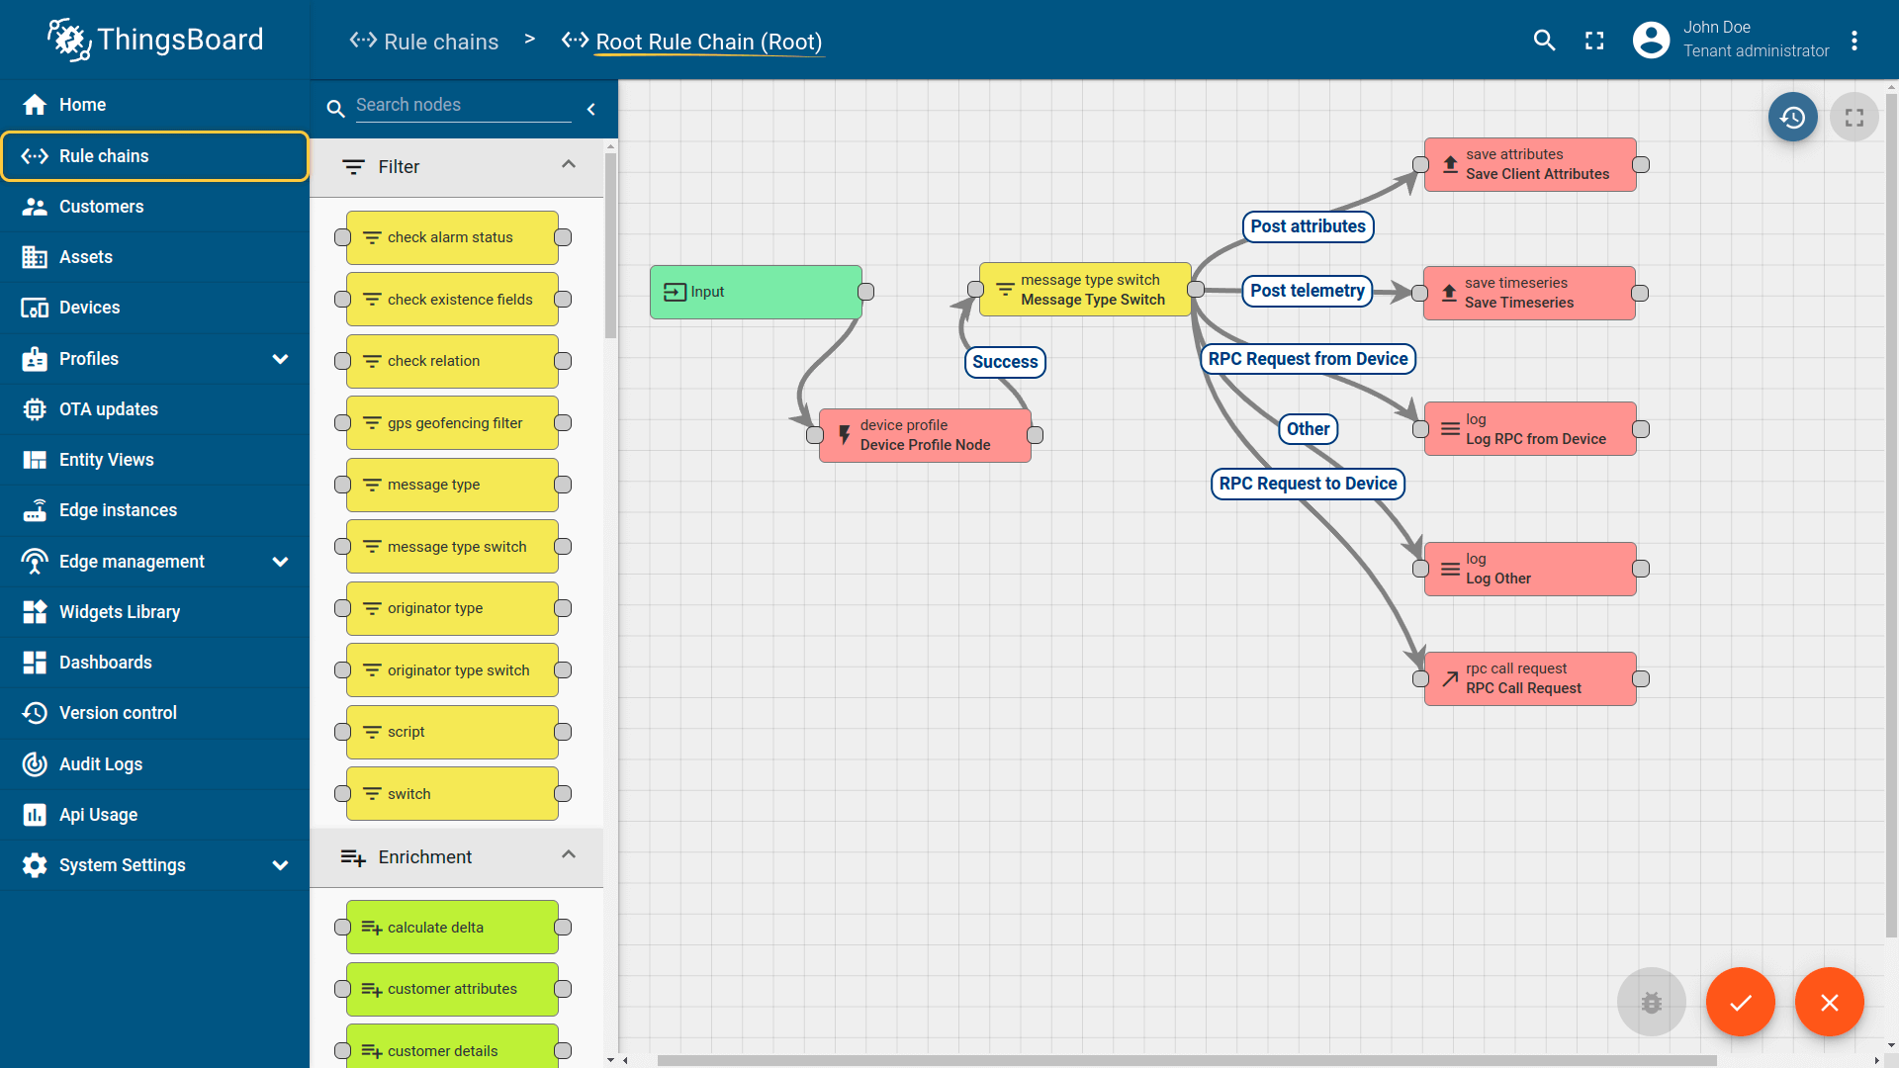

- Smart Factory Platform ()
Factory watch is a platform for smart factory needs.
It provides Users/ Factory
- with a scalable solution for their Production and asset monitoring
- OEE and predictive maintenance solution scaling up to digital twin for your assets.
- to unleased the true potential of the data that their machines are generating and helps to identify the KPIs and also improve them.
- A modular architecture that allows users to choose the service that they what to start and then can scale to more complex solutions as per their demands.
Its unique SaaS model helps users to save time, cost and money.
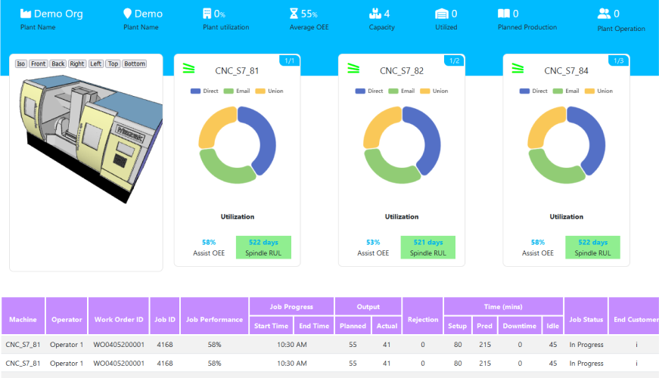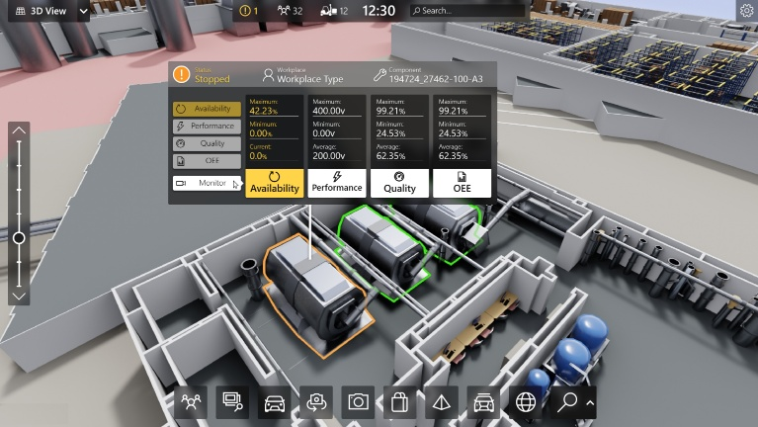

- 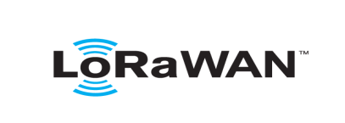based Solution
UCT is one of the early adopters of LoRAWAN teschnology and providing solution in Agritech, Smart cities, Industrial Monitoring, Smart Street Light, Smart Water/ Gas/ Electricity metering solutions etc.
- Predictive Maintenance
UCT isproviding Industrial Machine health monitoring and Predictive maintenance solution leveraging Embedded system, Industrial IoT and Machine Learning Technologies by finding Remaining useful life time of various Machines used in production process.
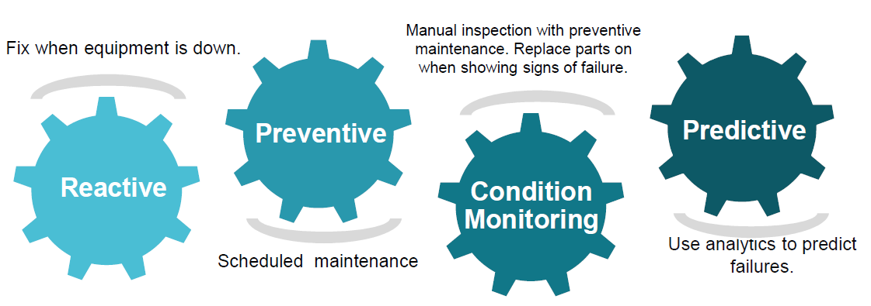

About upskill Campus (USC)
upskill Campus along with The IoT Academy and in association with Uniconverge technologies has facilitated the smooth execution of the complete internship process.
USC is a career development platform that delivers personalized executive coaching in a more affordable, scalable and measurable way.




Seeing need of upskilling in self paced manner along-with additional support services e.g. Internship, projects, interaction with Industry experts, Career growth Services
https://www.upskillcampus.com/
upSkill Campus aiming to upskill 1 million learners in next 5 year

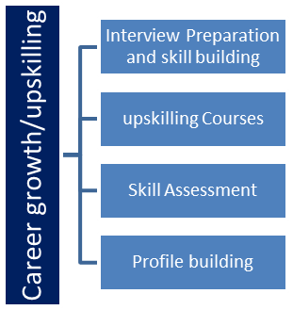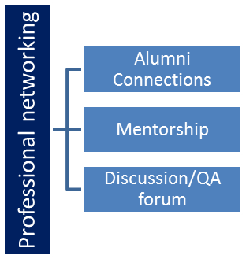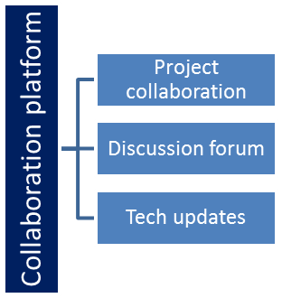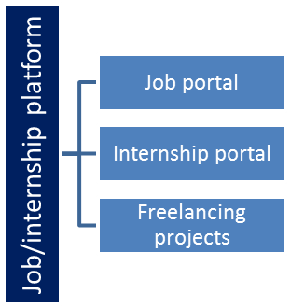

The IoT Academy
The IoT academy is EdTech Division of UCT that is running long executive certification programs in collaboration with EICT Academy, IITK, IITR and IITG in multiple domains.

Objectives of this Internship program
The objective for this internship program was to
☛ get practical experience of working in the industry.
☛ to solve real world problems.
☛ to have improved job prospects.
☛to have Improved understanding of our field and its applications.
☛to have Personal growth like better communication and problem solving.

Reference
[1] https://www.upskillcampus.com
[2] Java Programming Documentation
[3] Online tutorials and study material

Glossary
Terms | Acronym
Java | – Programming language
DB | – Database
GUI | – Graphical User Interface
System | – Software application

Problem Statement
Managing bank records manually is time-consuming and error-prone.
There is a need for a system that can handle banking operations efficiently.
This project aims to solve this problem by providing a simple banking system using Java.

Existing and Proposed solution

Traditional banking systems require manual work and are slow.
This project provides a computerized system to perform banking operations quickly and accurately.

Code submission
upskillcampus/BankingInformationSystem.java at main · deepali200599/upskillcampus

Report submission

upskillcampus/Sample_InternshipReport_Deepali_USC_UCT.docx at main · deepali200599/upskillcampus

Proposed Design/ Model

The system is designed using Java programming language.
It uses a menu-driven approach where the user can select different operations like deposit, withdrawal, etc.
The data is stored temporarily during program execution.

High Level Diagram

The system takes input from the user and performs operations like deposit, withdrawal and balance checking, then displays output.

Low Level Diagram

The system is divided into different functions such as:
- createAccount()
- deposit()
- withdraw()
- display()

Each function performs a specific banking operation.
The program uses conditional statements and loops to control the flow.

Interfaces
The system provides a menu-driven interface where the user selects options by entering numbers.
The interface is simple and easy to use.

Performance Test

The system was tested with different inputs.
All operations like deposit, withdrawal and balance checking worked correctly.
The program runs efficiently without errors.

Test Plan/ Test Cases
The system was tested using different inputs to check its functionality.
Test cases were created for operations like account creation, deposit, withdrawal and balance checking.

Test Procedure

First, the program was executed.
Then different options were selected from the menu.
Data was entered by the user and results were checked for correctness.

Performance Outcome

The system performed all operations successfully.
Deposit and withdrawal functions worked correctly.
The program executed without errors and provided accurate results.

My learnings

During this internship, I learned Java programming concepts,
how to develop a project, and how to solve real-world problems.
I also improved my logical thinking and coding skills.

Future work scope

In future, this project can be improved by adding database support,
user authentication and graphical user interface (GUI).

