Capstone Project Report_v1

Deepali Bhatt

October 25, 2016

# Capstone Project Overview

When people want to move from overseas back to India, they do not do proper research into the job scene in regards with the role they are seeking a career in. People do not do enough research into, which companies are hiring for a data scientist position; what locations have the highest density of data scientists; what companies are hiring; what cities will likely hire in the future etc. When the above questions are not researched properly, immigrants are usually stuck at locations that does not hire for the respective roles, or does not need data scientists.  
The aim of this project is to be able to make informed decisions about taking up data scientist roles and preparing for it in advance when moving to India. To aid in this decision-making, I will be exploring data through descriptive statistics and visualisations making use of various statistical tools including but not limited to histograms, bar plots etc. For data visualisations, I will be using ggplot 2 to help understand the significance of data by placing it in visual context. **The goal of this project is to apply the principles of data science and develop insights from the analysis of structured or unstructured data to aid in better decision-making.**  
The data set was extracted using an open API for the website [Indeed] (www.indeed.com).

# Overview of the Data Files

There is one master csv that was used, which is as following: finalindeed1_trynote.csv The data set is acquired by getting an open API from indeed (job search website), searching for data scientist jobs from all over India. The data set has 10 variables and has over 1200 search results. Lets take a look at the variables in the dataset.

# Methodology

**First Step:Data Import**  
The first step was to import data from the open API which was in XML format and is read properly in the R Studio. For that I first created the file in R. After the data is read in the R studio. It is important to convert it in the data frame for analysis. Due to the HTML tagging, separate nodes were extracted using "getnodes". Then the XMl file is parsed and a csv file is created.The structure of the indeedfile csv is below:

indeedfile <- read.csv("C:/Users/deepa/OneDrive/Documents/capstone csv/indeed1.csv")  
  
str(indeedfile)

## 'data.frame': 1016 obs. of 11 variables:  
## $ X : int 1 2 3 4 5 6 7 8 9 10 ...  
## $ jobtitle : Factor w/ 476 levels "3rd Party Data Matching Expert / Data Scientist / Product Management",..: 328 102 429 73 202 73 374 323 430 88 ...  
## $ company : Factor w/ 466 levels "24 7 Customer Private Ltd",..: 443 443 334 446 431 217 75 144 159 75 ...  
## $ city : Factor w/ 21 levels "Adoni","Ahmedabad",..: NA NA 4 NA 10 4 NA 4 4 4 ...  
## $ state : Factor w/ 13 levels "AP","AS","CH",..: NA NA 8 NA 1 8 NA 8 8 8 ...  
## $ country : Factor w/ 1 level "IN": 1 1 1 1 1 1 1 1 1 1 ...  
## $ formattedLocationFull: Factor w/ 24 levels "Adoni, Andhra Pradesh",..: 11 11 4 11 10 4 11 4 4 4 ...  
## $ source : Factor w/ 117 levels "Accenture","Adobe",..: 111 111 84 112 108 47 13 27 31 13 ...  
## $ date : Factor w/ 549 levels "Fri, 02 Sep 2016 02:40:34 GMT",..: 459 458 457 79 321 400 396 473 131 134 ...  
## $ snippet : Factor w/ 602 levels "?The core objective of this role is to work closely with the solution partners identified and with Business teams as Data Scien"| __truncated__,..: 318 553 508 242 585 317 349 360 587 31 ...  
## $ expired : logi FALSE FALSE FALSE FALSE FALSE FALSE ...

**Second Step:Data Preparation**  
*Adding the logic*- Now once the XML file is converted into dataframe and then to the csv, it is important to look for companies that have the three top skills "Python", "machine learning", "SQL". This was achieved by putting the logic of TRUE if the respective skills were found otherwise put FALSE and create separate columns with respective logical answer. Then these three columns were merged with the existing data file indeed1.csv and new csv file was named finalindeed1_trynote.csv.The finalindeed1_trynote had the following structure:

trynoteindeedfile <- read.csv("C:/Users/deepa/OneDrive/Documents/capstone csv/finalindeed1_trynote.csv")  
  
str(trynoteindeedfile)

## 'data.frame': 1104 obs. of 14 variables:  
## $ X : int 1 2 3 4 5 6 7 8 9 10 ...  
## $ jobtitle : Factor w/ 488 levels "3rd Party Data Matching Expert / Data Scientist / Product Management",..: 87 80 131 165 80 207 80 80 82 80 ...  
## $ company : Factor w/ 475 levels "24 7 Customer Private Ltd",..: 445 122 236 260 455 440 8 196 291 197 ...  
## $ city : Factor w/ 22 levels "Adoni","Ahmedabad",..: 10 NA 8 8 NA 10 4 4 20 4 ...  
## $ state : Factor w/ 13 levels "AP","AS","CH",..: 1 NA 6 6 NA 1 8 8 10 8 ...  
## $ country : Factor w/ 1 level "IN": 1 1 1 1 1 1 1 1 1 1 ...  
## $ formattedLocationFull: Factor w/ 23 levels "600034","Adoni, Andhra Pradesh",..: 11 12 9 9 12 11 5 5 21 5 ...  
## $ source : Factor w/ 114 levels "Accenture","Aconex",..: 111 22 51 60 109 106 2 36 68 37 ...  
## $ date : Factor w/ 555 levels "Fri, 02 Sep 2016 02:40:34 GMT",..: 8 29 337 538 73 353 530 460 356 123 ...  
## $ snippet : Factor w/ 614 levels "? Design and maintain data ingest, cleaning, storage, and query systems. Hinge is growing our data science and analytics team i"| __truncated__,..: 218 483 570 41 241 598 137 47 579 227 ...  
## $ expired : logi FALSE FALSE FALSE FALSE FALSE FALSE ...  
## $ python : logi FALSE FALSE FALSE FALSE FALSE FALSE ...  
## $ machine : logi FALSE FALSE FALSE FALSE FALSE TRUE ...  
## $ sql : logi FALSE FALSE FALSE FALSE FALSE FALSE ...

For consistency purposes and to simplify analysis, I created another file that would lower the cases of every item in the table. The file structure all in lowercase is below:

dflowerfinal1 <- read.csv("C:/Users/deepa/OneDrive/Documents/capstone csv/finaldflower.csv")  
str(dflowerfinal1)

## 'data.frame': 1104 obs. of 14 variables:  
## $ X : int 1 2 3 4 5 6 7 8 9 10 ...  
## $ jobtitle : Factor w/ 477 levels "3rd party data matching expert / data scientist / product management",..: 84 79 128 159 79 201 79 79 79 79 ...  
## $ company : Factor w/ 473 levels "24 7 customer private ltd",..: 443 121 235 259 453 438 8 195 290 196 ...  
## $ city : Factor w/ 22 levels "adoni","ahmedabad",..: 10 NA 8 8 NA 10 4 4 20 4 ...  
## $ state : Factor w/ 13 levels "ap","as","ch",..: 1 NA 6 6 NA 1 8 8 10 8 ...  
## $ country : Factor w/ 1 level "in": 1 1 1 1 1 1 1 1 1 1 ...  
## $ formattedLocationFull: Factor w/ 23 levels "600034","adoni, andhra pradesh",..: 11 12 9 9 12 11 5 5 21 5 ...  
## $ source : Factor w/ 114 levels "accenture","aconex",..: 111 22 51 60 109 106 2 36 68 37 ...  
## $ date : Factor w/ 555 levels "fri, 02 sep 2016 02:40:34 gmt",..: 8 29 337 538 73 353 530 460 356 123 ...  
## $ snippet : Factor w/ 614 levels "?the core objective of this role is to work closely with the solution partners identified and with business teams as data scien"| __truncated__,..: 219 483 570 42 242 598 138 48 579 228 ...  
## $ expired : logi FALSE FALSE FALSE FALSE FALSE FALSE ...  
## $ python : logi FALSE FALSE FALSE FALSE FALSE FALSE ...  
## $ machine : logi FALSE FALSE FALSE FALSE FALSE TRUE ...  
## $ sql : logi FALSE FALSE FALSE FALSE FALSE FALSE ...

head(dflowerfinal1)

## X jobtitle  
## 1 1 data scientist- valuelabs  
## 2 2 data scientist  
## 3 3 data scientist - intern  
## 4 4 data scientist - orgsolutions, mckinsey solutions  
## 5 5 data scientist  
## 6 6 data scientist (intern)  
## company city state country  
## 1 valuelabs llp hyderabad ap in  
## 2 educational initiatives <NA> <NA> in  
## 3 kvantum gurgaon hr in  
## 4 mckinsey & company gurgaon hr in  
## 5 vserv digital services pvt. ltd <NA> <NA> in  
## 6 unwired hyderabad ap in  
## formattedLocationFull source  
## 1 hyderabad, andhra pradesh wisdomjobs.com  
## 2 india educational initiatives  
## 3 gurgaon, haryana kvantum  
## 4 gurgaon, haryana mckinsey & company  
## 5 india vserv digital services pvt. ltd  
## 6 hyderabad, andhra pradesh unwired  
## date  
## 1 fri, 02 sep 2016 02:49:57 gmt  
## 2 fri, 02 sep 2016 06:20:38 gmt  
## 3 sun, 11 sep 2016 11:47:42 gmt  
## 4 wed, 17 aug 2016 16:39:57 gmt  
## 5 fri, 22 jul 2016 09:47:15 gmt  
## 6 thu, 04 aug 2016 15:33:10 gmt  
## snippet  
## 1 hope you are doing well we have openings for data science analyst for our company job location hyderabad experience 3- 10years notice period imm-15 days ctc...  
## 2 strong knowledge in reporting tools, data manipulation, statistical models and visual presentation. synthesize diverse, complex information to develop a...  
## 3 we are looking for candidates who can be an intern for 6 months and then join us as full-time data scientist after successful completion of internship....  
## 4 are you a data scientist? data scientists are creative problem solvers who love all things data. the data scientist we are looking for is not just someone who...  
## 5 jd - data scientist. data scientist will be responsible to design and implement efficient, adaptable, &amp; reusable code and algorithms....  
## 6 work on a small data science team in charge of data mining, predictive modeling and analytics design. strong technical skills regarding data analysis, machine...  
## expired python machine sql  
## 1 FALSE FALSE FALSE FALSE  
## 2 FALSE FALSE FALSE FALSE  
## 3 FALSE FALSE FALSE FALSE  
## 4 FALSE FALSE FALSE FALSE  
## 5 FALSE FALSE FALSE FALSE  
## 6 FALSE FALSE TRUE FALSE

**Third Step: Data Wrangling**  
Now that the data sheet is cleaned, it is time to start slicing the data and develop insights from it. To conduct analysis, we would now answer various questions that would give an indepth analysis of the data scientist job situation in India.Below are the questions:

***Which states are hiring for data scientist roles?***  
To answer the above question, I looked at the data in the states column and looked for unique values. Once the unique values were identified, I found the frequency of each unique value and find out it's frequency.The file structure for state frequency is below:

statesarranged <- read.csv("C:/Users/deepa/OneDrive/Documents/capstone csv/finalarrangedfrequencystate1.csv")  
str(statesarranged)

## 'data.frame': 13 obs. of 3 variables:  
## $ X : int 1 2 3 4 5 6 7 8 9 10 ...  
## $ states : Factor w/ 13 levels "ap","as","ch",..: 8 10 4 1 11 12 6 3 13 5 ...  
## $ Frequencystates: int 548 228 89 71 65 33 27 15 7 6 ...

head(statesarranged)

## X states Frequencystates  
## 1 1 ka 548  
## 2 2 mh 228  
## 3 3 dl 89  
## 4 4 ap 71  
## 5 5 tn 65  
## 6 6 up 33

library(ggplot2)

Following is the barplot displaying the number of data scientist jobs in various states in India.

statebarplot<- ggplot(data=statesarranged, aes(x=states, y=Frequencystates)) +  
 geom_bar(stat = "identity",fill= "yellow", colour= "blue")+  
 geom_text(aes(label=Frequencystates), vjust=-0.3, size=3.5)  
 statebarplot

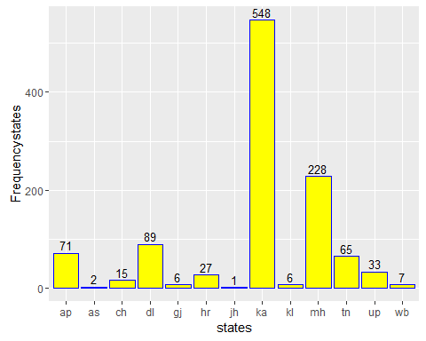

As you can see in the above that the states of ka(Karnataka), mh(Maharashtra), dl(Delhi) have the highest data scientist jobs in India.

***Which cities are hiring for data scientist roles?***  
To answer the above question, I looked at the data in the cities column and looked for unique values. Once the unique values were identified, I found the frequency of each unique value.The file structure for state frequency is below:

citiesarranged <- read.csv("C:/Users/deepa/OneDrive/Documents/finalfreqcity.csv")  
str(citiesarranged)

## 'data.frame': 22 obs. of 3 variables:  
## $ X : int 1 2 3 4 5 6 7 8 9 10 ...  
## $ cities : Factor w/ 22 levels "adoni","ahmedabad",..: 4 16 7 20 10 6 19 8 5 17 ...  
## $ Frequencycities: int 548 134 88 82 68 64 32 27 15 9 ...

head(citiesarranged)

## X cities Frequencycities  
## 1 1 bangalore 548  
## 2 2 mumbai 134  
## 3 3 delhi 88  
## 4 4 pune 82  
## 5 5 hyderabad 68  
## 6 6 chennai 64

Following is the barplot displaying the number of data scientist jobs in various states in India.

citybarplot<- ggplot(data=citiesarranged, aes(x=cities, y=Frequencycities)) +  
 geom_bar(stat = "identity",fill= "green", colour= "blue")+  
 geom_text(aes(label=Frequencycities),vjust=-0.3, size=3.5) +  
 theme(axis.text.x = element_text(angle = 90, hjust = 1))  
   
 citybarplot

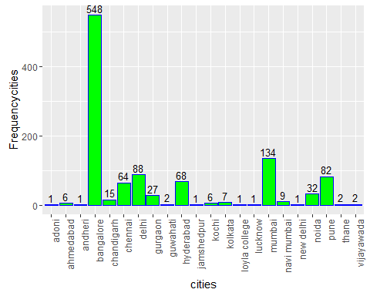

As you can see in the above that the cities of Bangalore, Delhi, Mumbai have the highest data scientist jobs in India. The findings of this data is consistent with the states data which recognised the respective states corresponsing to these cities as highest concentrated areas for data scientist jobs.

***Which companies are hiring for data scientist roles?***  
To answer the above question, I looked at the data in the companies column and looked for unique values. Once the unique values were identified, I found the frequency of each unique value.

companiesarranged <- read.csv("C:/Users/deepa/OneDrive/Documents/capstone csv/finalarrangedfrequencycompany.csv")  
head(companiesarranged)

## X Company Frequencycompany  
## 1 1 rinalytics advisors 248  
## 2 2 mount talent consulting 48  
## 3 3 greenhandle.in 30  
## 4 4 cms computers limited 23  
## 5 5 analyttica 15  
## 6 6 btgt soft app pvt ltd 15

Following is the barplot displaying the number of data scientist jobs according to jobs posted in India on the Indeed website.

companybarplot<- ggplot(data=companiesarranged, aes(x=Company, y=Frequencycompany)) +  
 geom_bar(stat = "identity",fill= "blue", colour= "yellow")+  
 geom_text(aes(label=Frequencycompany),vjust=-0.3, size=3.5)+  
 theme(axis.text.x = element_text(angle = 90, hjust = 1))  
 companybarplot

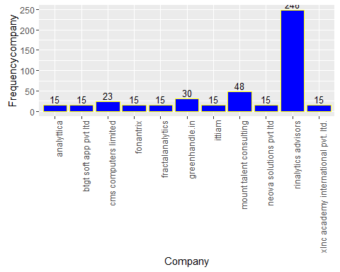 ***What non-technical skills does one need for a Data Scientist role in India?***  
To answer the above question, I resorted to mine the text available in the "snippet" column, which was originally the "job description" column. After pre-processing the data by removing numbers, punctuations and redundant words, I was able to generate a wordcloud. The wordcloud was coded (the code of which is available in the attached code).As you would notice that the words are truncated, I checked for this in the master file and the words are in the same format as in the original file. The wordcloud was saved as a png and is as follows:

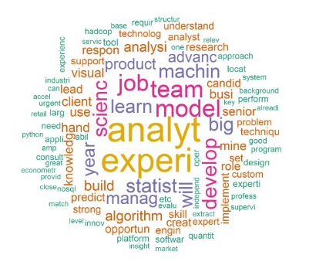

We can see from the above that some of the skills that are densely mentioned are “build”, “predict”, “analysis”, “develop”, “implement”, “machine”, “learn”, “team” etc.

***What technical skills does one need for a Data Scientist role in India?*** To answer the above questions, we created the code using "if else" , "logical condition" and dplyr "regex". We identified python, sql and machine learning as the three main technical skills. Using the 'if else' conditional statement and dplyr regular expression, we created the condition that if in the snippet column we see "python", "sql", "machine" make a respective column name python, sql and machine and print the logic "true" or "false". Then to identify the the companies who require all the technical skills, used the pipe function to filter the columns that have "true" in all the columns python, sql and machine.The following is the structure of the technical skills file.

alltechnicalskills <-read.csv("C:/Users/deepa/OneDrive/Documents/technicalskills1.csv")  
str(alltechnicalskills)

## 'data.frame': 2 obs. of 15 variables:  
## $ X.1 : int 1 2  
## $ X : int 1 2  
## $ jobtitle : Factor w/ 1 level "data scientist - machine learning nlp java": 1 1  
## $ company : Factor w/ 2 levels "premium-jobs",..: 2 1  
## $ city : Factor w/ 1 level "delhi": 1 1  
## $ state : Factor w/ 1 level "dl": 1 1  
## $ country : Factor w/ 1 level "in": 1 1  
## $ formattedLocationFull: Factor w/ 1 level "delhi, delhi": 1 1  
## $ source : Factor w/ 1 level "wisdomjobs.com": 1 1  
## $ date : Factor w/ 2 levels "fri, 02 sep 2016 02:50:16 gmt",..: 1 2  
## $ snippet : Factor w/ 2 levels "ky skills machine learning sas hadoop octave big data weka nlp nosql mahout mathematica mongodb spss matlab python nlp programm"| __truncated__,..: 1 2  
## $ expired : logi FALSE FALSE  
## $ python : logi TRUE TRUE  
## $ machine : logi TRUE TRUE  
## $ sql : logi TRUE TRUE

head(alltechnicalskills)

## X.1 X jobtitle company city  
## 1 1 1 data scientist - machine learning nlp java staffio delhi  
## 2 2 2 data scientist - machine learning nlp java premium-jobs delhi  
## state country formattedLocationFull source  
## 1 dl in delhi, delhi wisdomjobs.com  
## 2 dl in delhi, delhi wisdomjobs.com  
## date  
## 1 fri, 02 sep 2016 02:50:16 gmt  
## 2 fri, 26 aug 2016 03:13:45 gmt  
## snippet  
## 1 ky skills machine learning sas hadoop octave big data weka nlp nosql mahout mathematica mongodb spss matlab python nlp programming languages- minimum 2 yrs...  
## 2 ky skills machine learning sas hadoop octave big data weka nlp nosql mahout mathematica mongodb spss matlab python nlp programming languages - minimum 2 yrs...  
## expired python machine sql  
## 1 FALSE TRUE TRUE TRUE  
## 2 FALSE TRUE TRUE TRUE

Following is the table of the companies looking for three important technical skills python, sql, machine learning.

|  |  |  |  |  |  |  |  |
| --- | --- | --- | --- | --- | --- | --- | --- |
| Title | Company | City | State | Expired | Python | Machine | Sequel |
| data scientist - machine learning nlp java | staffio | Delhi | Delhi | False | True | True | True |
| data scientist - machine learning nlp java | premium-jobs | Delhi | Delhi | False | True | True | True |