**E-Commerce Fraud Classification**

**High-level problem statement**

E-commerce websites often transact huge amounts of money. Whenever a huge amount of money is moved, there is a high risk of users performing fraudulent activities, e.g. using stolen credit cards, laundering money, etc.

**Objective**

The goal of this challenge is to build a machine learning model that predicts the probability that the first transaction of a new user is fraudulent.

**Details**

Electronica is an e-commerce site that sells wholesale electronics. You have been contracted to build a model that predicts whether a given transaction is fraudulent or not. You only have information about each user’s first transaction on Electronica’s website. If you fail to identify a fraudulent transaction, Electronica loses money equivalent to the price of the fraudulently purchased product. If you incorrectly flag a real transaction as fraudulent, it inconveniences the Electronica customers whose valid transactions are flagged—a cost your client values at $8.

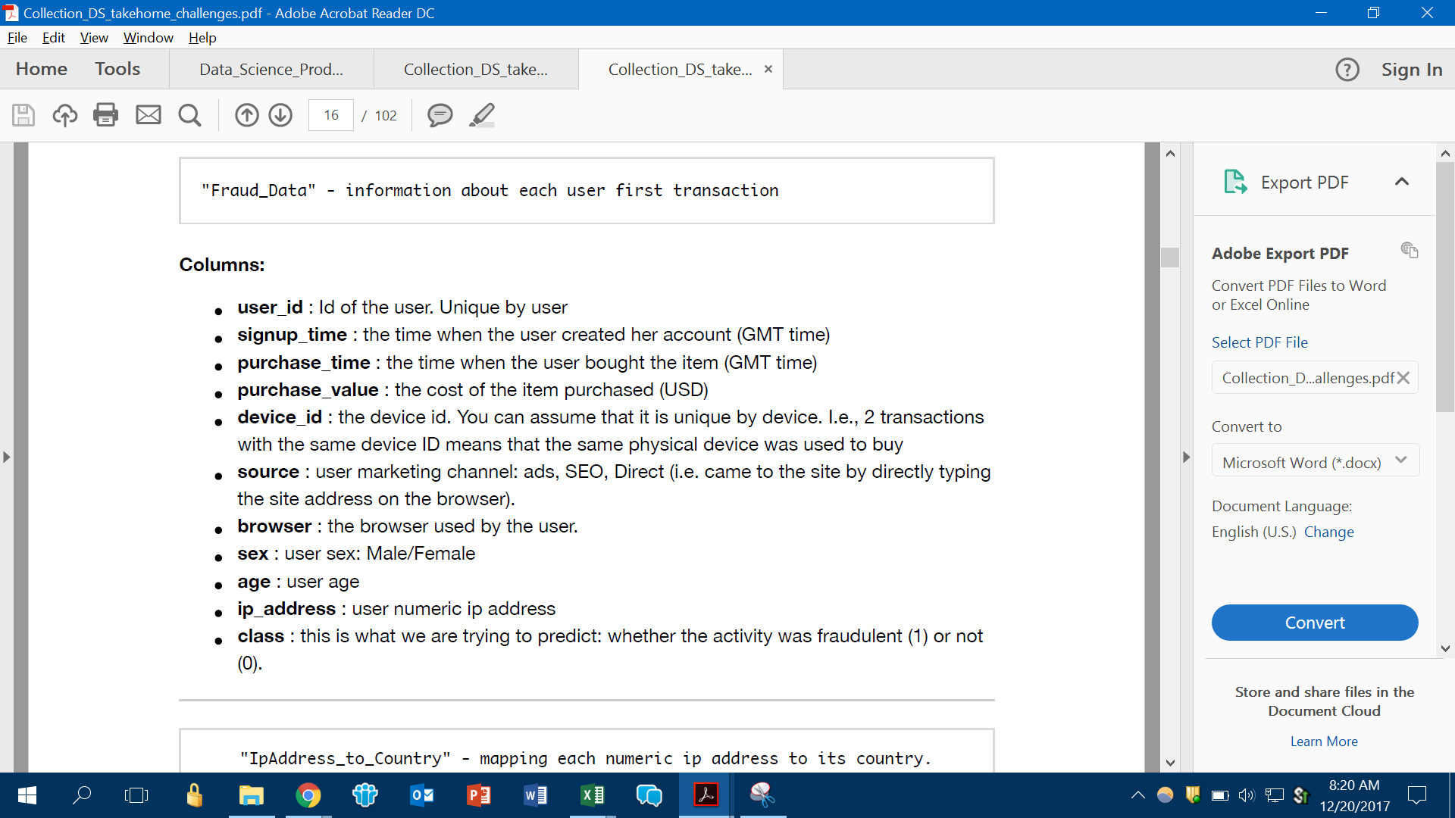

**IP address to country mapping**

