**1.WRITE A PROGRAM TO PRINT THE RESULT OF THE FOLLOWING**

**A.-5+8*6**

**B.(55+9)%9**

**C.20+-3*5/8**

**D.5+15/3*2-8%3**

**public** **class** Ques1 {

**public** **static** **void** main(String[] args) {

System.***out***.println(-5+8*6);

System.***out***.println((55+9)%9);

System.***out***.println(20+-3*5/8);

System.***out***.println(5+15/3*2-8%3);

}

**OUTPUT:**

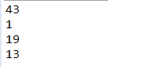

**2.WRITE A JAVA PROGRAM TO SWAP TWO VARIABLES.**

**import** java.util.Scanner;

**public** **class** Ques2 {

**public** **static** **void** main(String[] args) {

Scanner s=**new** Scanner(System.***in***);

System.***out***.println("Enter the Values to be swapped");

**int** var1=s.nextInt();

**int** var2=s.nextInt();

System.***out***.println("Values Before Swap :");

System.***out***.print("variable1=");

System.***out***.println(var1);

System.***out***.printf("variable2=");

System.***out***.println(var2);

**int** temp=var1;

var1=var2;

var2=temp;

System.***out***.println("Values After Swap :");

System.***out***.print("variable1=");

System.***out***.println(var1);

System.***out***.printf("variable2=");

System.***out***.println(var2);

}

}

**OUTPUT:**

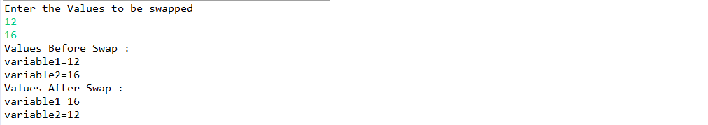

**3.WRITE A JAVA PROGRAM TO PRINT A FACE**

**public** **class** Ques3 {

**public** **static** **void** main(String[] args) {

System.***out***.println(" +\"\"\"\"\"+ ");

System.***out***.println("[| o o |]");

System.***out***.println(" | ^ | ");

System.***out***.println(" | '-' | ");

System.***out***.println(" +-----+ ");

}

}

**OUTPUT:**



**4.WRIE A JAVA PROGRAM TO CREATE A CALCULTOR USING SWITCH CASE WHERE TWO NUMBERS AND ONE OPERATOR MUST BE ENTERED AT RUNTIME.**

**import** java.util.Scanner;

**public** **class** Ques4 {

**public** **static** **void** main(String[] args) {

Scanner reader = **new** Scanner(System.***in***);

System.***out***.print("Enter two numbers: ");

// nextDouble() reads the double from the keyboard

**double** first = reader.nextDouble();

**double** second = reader.nextDouble();

System.***out***.print("Enter an operator (+, -, *, /,%): ");

**char** operator = reader.next().charAt(0);

**double** result;

**switch**(operator)

{

**case** '+':

result = first + second;

**break**;

**case** '-':

result = first - second;

**break**;

**case** '*':

result = first * second;

**break**;

**case** '/':

result = first / second;

**break**;

**case** '%':

result=first%second;

**break**;

// operator doesn't match any case constant (+, -, *, /) **default**:

System.***out***.printf("Error! operator is not correct");

**return**;

}

System.***out***.printf(first + operator + second + result);

}

}

**OUTPUT:**

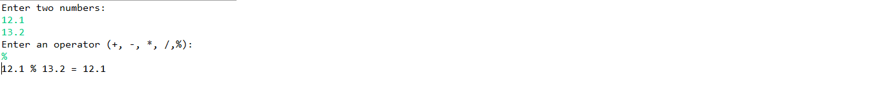

**5.WRITE A JAVA PROGRAM THAT TAKES THREE NUMBERS AS INPUTS AND DISPLAYS THE BIGGEST ONE.**

**import** java.util.Scanner;

**public** **class** Ques5 {

**public** **static** **void** main(String[] args) {

Scanner s=**new** Scanner(System.***in***);

System.***out***.println("Enter The Three Numbers:");

**double** var1=s.nextDouble();

**double** var2=s.nextDouble();

**double** var3=s.nextDouble();

**double** max=var1;

**if**(var2>max)

max=var2;

**if**(var3>max)

max=var3;

System.***out***.println("The Biggest one is: " + max);

}

}

**OUTPUT:**

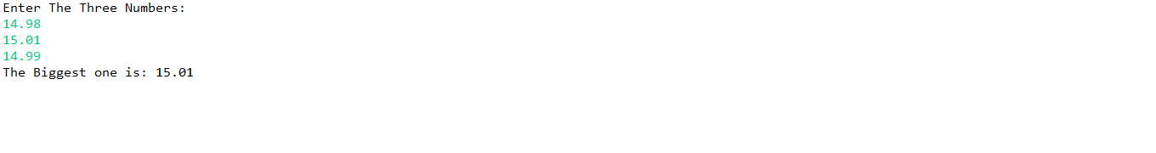

**6.WRITE THE COMMAND TO CHECK THE JAVA VERSION ON YOUR COMPUTER**

**OPEN COMMAND PROMPT AND TYPE**

**Java –version**

**7. WRITE A JAVA PROGRAM TO CHECK WHETHER THE ENTERED NUMBER IS ARMSTRONG OR NOT.**

**import** java.util.Scanner;

**public** **class** Ques7 {

**public** **static** **void** main(String[] args) {

Scanner s=**new** Scanner(System.***in***);

System.***out***.println("Enter The Number To Be Checked :");

**int** number=s.nextInt();

**int** originalNumber, remainder, result = 0;

originalNumber = number;

**while** (originalNumber != 0)

{

remainder = originalNumber % 10;

result += Math.*pow*(remainder, 3);

originalNumber /= 10;

}

**if**(result == number)

System.***out***.println(number + " is an Armstrong number.");

**else**

System.***out***.println(number + " is not an Armstrong number.");

}

}

**OUTPUT:**



**8.WRITE A PROGRAM TO CONVERT TEMPERATURE FROM CELSIUS TO FAHRENHEIT.**

**import** java.util.Scanner;

**public** **class** Ques8

{

**public** **static** **void** main(String[] args)

{

**double** cel, far;

Scanner s=**new** Scanner(System.***in***);

System.***out***.println("Enter temp. in Celsius :");

cel=s.nextDouble();

s.close();

far = (cel * 9/5) + 32;

System.***out***.println("Temp. in Fahrenheit: "+far);

}

}

**OUTPUT:**

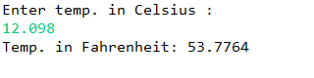

**9. WRITE A JAVA PROGRAM TO CALCULATE THE FACTORIAL OF AN INTEGER.**

**import** java.util.Scanner;

**public** **class** Ques9 {

**public** **static** **void** main(String[] args) {

System.***out***.println("Enter The Number Whose Factorial Is To Be Calculated : ");

Scanner s=**new** Scanner(System.***in***);

**int** number = s.nextInt();

**int** i;

**double** fact=1;

**for**(i=1;i<=number;i++){

fact=fact*i;

}

System.***out***.println("Factorial of "+number+" is: "+fact);

}

}

**OUTPUT:**

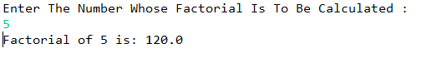

**10.WRITE A JAVA PROGRAM TO COMPUTE THE SUM OF DIGITS OF AN INTEGER.**

**import** java.util.Scanner;

**public** **class** Ques10 {

// Java program to compute sum of digits in number.

/* Function to get sum of digits */

**static** **int** getSum(**int** n)

{

**int** sum = 0;

**while** (n != 0)

{

sum = sum + n % 10;

n = n/10;

}

**return** sum;

}

// Driver program

**public** **static** **void** main(String[] args)

{

Scanner s=**new** Scanner(System.***in***);

System.***out***.println("Enter The Number :");

**int** number = s.nextInt();

System.***out***.println(*getSum*(number));

}

}

**OUTPUT:**

