DESIGN AND IMPLEMENTATION OF APPROXIMATE ADDER FOR ERROR TOLERANT APPLICATIONS

Abstract
In modern VLSI design, achieving high speed and low power consumption is a major challenge, especially in arithmetic circuits such as adders. Conventional adders like Ripple Carry Adder (RCA) and Carry Look Ahead Adder (CLA) provide accurate results but suffer from significant limitations in terms of delay and power consumption. This work presents the design and analysis of an approximate adder optimized for error-tolerant applications. The performance of the proposed approximate adder is compared with RCA and CLA using key parameters such as MOS count, power consumption, delay, and power-delay product (PDP). From the results, the approximate adder exhibits a drastic reduction in delay (0.1 ns) compared to RCA (25 ns) and CLA (9 ns), along with significantly lower power consumption (480 nW). Although the MOS count of the approximate adder is slightly higher than RCA, it remains lower than CLA while delivering superior performance. The PDP of the proposed design (48 aJ) is considerably lower than RCA and CLA, indicating enhanced energy efficiency. These results demonstrate that the approximate adder provides a better trade-off between performance and accuracy, making it highly suitable for error-tolerant applications such as image processing, multimedia systems, and machine learning.
Keywords:
Approximate Adder, Error-Tolerant Applications, Low Power Design, High-Speed Arithmetic, Ripple Carry Adder (RCA), Carry Look Ahead Adder (CLA), Power-Delay Product (PDP), Area Optimization, Digital VLSI Design, Energy Efficiency

CHAPETR-1
INTRODUCTION
The rapid evolution of digital systems and VLSI technology has led to an increasing demand for high-performance, low-power, and area-efficient arithmetic circuits. Adders are fundamental building blocks in almost all digital systems, including processors, digital signal processors (DSPs), and application-specific integrated circuits (ASICs). They are extensively used in arithmetic operations such as addition, subtraction, multiplication, and address generation. Traditionally, exact adders such as the Ripple Carry Adder (RCA) and Carry Look Ahead Adder (CLA) have been widely used due to their ability to produce precise and error-free results. However, with the growing complexity of modern applications and stringent design constraints, these conventional adders face significant limitations in terms of speed, power consumption, and hardware complexity.
The Ripple Carry Adder (RCA) is one of the simplest and most area-efficient adder architectures. It operates by propagating the carry from one stage to the next, which results in a linear increase in delay with the number of bits. Although RCA consumes less hardware, its slow speed makes it unsuitable for high-performance applications. On the other hand, the Carry Look Ahead Adder (CLA) improves speed by computing carry signals in advance using generate and propagate logic. While CLA reduces delay significantly compared to RCA, it introduces increased circuit complexity, higher power consumption, and larger silicon area. As a result, both RCA and CLA present trade-offs that limit their effectiveness in modern low-power and high-speed systems.
In recent years, the concept of approximate computing has emerged as a promising approach to overcome these challenges. Approximate computing is based on the observation that many real-world applications, such as image processing, video streaming, machine learning, and data analytics, do not always require perfectly accurate results. These applications are inherently error-tolerant, meaning that small computational inaccuracies do not significantly affect the overall output quality. By exploiting this tolerance, designers can intentionally introduce controlled errors into arithmetic circuits to achieve substantial improvements in performance metrics such as speed, power, and area.
Approximate adders are a key component of approximate computing systems. Unlike exact adders, approximate adders relax the requirement of precise computation in certain parts of the circuit, typically in the least significant bits (LSBs), where errors have minimal impact on the final result. This simplification reduces the number of transistors, shortens the critical path, and lowers switching activity, leading to reduced power consumption and faster operation. Various design techniques have been proposed for approximate adders, including truncation, carry skipping, speculative computation, and logic simplification.
One of the primary advantages of approximate adders is their ability to provide a better trade-off between accuracy and efficiency compared to traditional RCA and CLA architectures. By selectively compromising accuracy, approximate adders can significantly reduce propagation delay, making them faster than RCA and even comparable or superior to CLA in certain cases. Additionally, the reduced logic complexity results in lower dynamic and static power consumption, which is a critical requirement for battery-operated and portable devices. Furthermore, the compact design of approximate adders leads to reduced silicon area, enabling higher integration density in VLSI systems.
Error metrics play a crucial role in evaluating the performance of approximate adders. Parameters such as Error Rate (ER), Mean Relative Error Distance (MRED), and Mean Normalized Error Distance (MNED) are commonly used to quantify the accuracy of approximate designs. A well-designed approximate adder maintains these error metrics within acceptable limits while achieving significant improvements in power, delay, and area. Therefore, the design of approximate adders involves a careful balance between computational accuracy and hardware efficiency.
The increasing demand for energy-efficient computing in emerging technologies further highlights the importance of approximate adders. In applications such as artificial intelligence (AI), neural networks, and multimedia processing, massive amounts of data are processed continuously, leading to high energy consumption. Approximate adders can reduce this energy requirement by minimizing switching activity and simplifying circuit design. Moreover, in deep learning applications, slight inaccuracies in intermediate computations do not significantly affect the final prediction accuracy, making approximate adders highly suitable for such domains.
Despite their advantages, approximate adders also present certain challenges. The primary concern is maintaining acceptable output quality while introducing approximation. Excessive approximation can lead to significant errors, which may degrade system performance. Therefore, it is essential to design approximate adders that provide controlled and predictable error behavior. Additionally, selecting the appropriate approximation technique and determining the optimal number of approximated bits are critical design considerations.
This work focuses on the design and implementation of an approximate adder optimized for error-tolerant applications. The proposed design aims to outperform conventional RCA and CLA adders in terms of speed, power consumption, and area efficiency while maintaining acceptable error levels. Through simulation and analysis, the performance of the approximate adder is evaluated using various parameters, including delay, power, and error metrics. The results demonstrate that the approximate adder provides a superior trade-off compared to traditional exact adders, making it a viable solution for modern low-power and high-performance digital systems.
In conclusion, approximate adders represent a paradigm shift in digital circuit design by prioritizing efficiency over exact accuracy in error-resilient applications. As technology continues to advance and the demand for energy-efficient computing grows, approximate adders are expected to play a vital role in the development of next-generation VLSI systems.

CHAPTER-2
LITERATURE REVIEW
Joshi Viraj Vilas and Pravin Mane (2024) presented a comprehensive study on approximate arithmetic circuits with a focus on performance optimization for error-tolerant applications. Their work analyzed multiple approximate adder architectures and compared them with traditional adders in terms of delay, power consumption, and error metrics. The authors demonstrated that approximate adders significantly reduce power consumption and propagation delay due to simplified logic structures. Their findings highlight that in applications such as image and video processing, the slight loss in accuracy does not degrade output quality, making approximate adders more efficient than RCA and CLA designs [1].
Akram Mohammadi et al. (2022) proposed a novel approximate full adder using Carbon Nanotube Field Effect Transistor (CNFET) technology. The design incorporates transmission gate logic and pass transistor techniques to minimize switching activity and reduce energy consumption. Their results showed a substantial improvement in power-delay product (PDP) compared to conventional CMOS-based adders. The study also emphasized that approximate adders can achieve higher speed due to reduced critical path delay, outperforming both RCA and CLA in energy-constrained environments [2].
Bhaskar Gaur, Himanshu Thapliyal, and Travis S. Humble (2024) extended the concept of approximate adders into quantum computing systems. They introduced noise-resilient approximate quantum adders that reduce circuit depth and improve fault tolerance. The proposed approach demonstrated that approximation not only reduces computational complexity but also enhances robustness against quantum noise. This work indicates that approximate adders are not limited to classical systems but can also play a vital role in emerging quantum technologies [3].
Melanie Qiu et al. (2024) developed IMPLY logic-based approximate full adders for in-memory computing architectures. Their design reduces the number of computational steps required for addition, thereby improving speed and reducing energy consumption. The authors showed that the proposed approximate adder performs efficiently in machine learning workloads, where minor computational errors are acceptable. Compared to RCA, the design achieves lower delay, and compared to CLA, it offers reduced complexity and power consumption [4].
Omkar Kokane et al. (2024) introduced a Hybrid Overestimating Approximate Adder (HOAA) that provides configurability between accurate and approximate modes. This flexibility allows the system to adapt based on application requirements. Their results indicate significant reductions in area and power while maintaining acceptable error levels. The study concludes that HOAA is particularly suitable for edge AI applications where energy efficiency is critical, and it outperforms traditional RCA and CLA adders in most performance metrics [5].
Nivedita and Anuradha Savadi (2022) proposed an approximate adder based on error-reduced carry prediction combined with truncation techniques. Their approach minimizes error distance while simplifying circuit design. The authors demonstrated that the proposed adder achieves a balanced trade-off between accuracy and hardware efficiency. Compared to RCA and CLA, the design reduces logic complexity and power consumption while maintaining acceptable accuracy levels, making it suitable for digital signal processing applications [6].

CHAPTER-3
EXISTING METHOD
Ripple Carry Adder (RCA)
The Ripple Carry Adder is the simplest and most straightforward implementation of a binary adder. It consists of a cascade of full adders, where each full adder is responsible for adding corresponding bits of two input operands along with a carry input. The carry output generated from one stage is passed as the carry input to the next higher stage. This sequential propagation of carry from the least significant bit (LSB) to the most significant bit (MSB) gives the RCA its name.
In an n-bit RCA, n full adders are connected in series. The first full adder takes the initial carry input (usually zero), and each subsequent adder waits for the carry from the previous stage before producing its output. This results in a simple and compact design with minimal hardware requirements. Due to its regular structure, RCA is easy to design and implement, making it suitable for small-scale applications where speed is not a critical concern.
However, the major drawback of RCA lies in its propagation delay. Since each stage must wait for the carry from the previous stage, the total delay increases linearly with the number of bits. This delay is commonly referred to as carry propagation delay and becomes significant for large bit-width adders such as 16-bit, 32-bit, or 64-bit systems. As a result, RCA is not suitable for high-speed applications where fast computation is essential.
Another limitation of RCA is its inefficiency in terms of performance scalability. As the bit size increases, the delay grows proportionally, making it increasingly unsuitable for modern processors that require rapid arithmetic operations. Additionally, although RCA consumes relatively low area, the long propagation path leads to increased dynamic power consumption due to prolonged switching activity.
Carry Look Ahead Adder (CLA)
To overcome the delay limitations of RCA, the Carry Look Ahead Adder (CLA) was introduced. CLA improves the speed of addition by eliminating the sequential carry propagation mechanism. Instead of waiting for the carry to ripple through each stage, CLA computes carry signals in advance using generate (G) and propagate (P) functions.
For each bit position, the generate and propagate signals are defined as follows:
- Generate (G) = A · B
- Propagate (P) = A ⊕ B
Using these signals, the carry output for each stage can be calculated using combinational logic expressions. This allows the carry signals to be determined simultaneously, significantly reducing the overall delay. As a result, CLA achieves much faster operation compared to RCA, especially for larger bit-width adders.
CLA is widely used in high-speed arithmetic circuits due to its ability to compute carries in parallel. It is particularly effective in medium-sized adders such as 4-bit or 8-bit designs, where the complexity remains manageable. For larger adders, CLA is often implemented in hierarchical structures to balance speed and complexity.
Despite its advantages, CLA introduces several challenges. The main issue is the increased hardware complexity due to the implementation of generate and propagate logic. As the number of bits increases, the carry equations become more complex, requiring a large number of logic gates. This results in increased silicon area and higher power consumption.

CHAPTER-4
DISADVANTAGES
Drawbacks of Ripple Carry Adder
- High Propagation Delay: The primary disadvantage of RCA is the linear increase in delay with respect to the number of bits. This limits its use in high-speed systems.
- Poor Performance for Large Bit Widths: RCA becomes inefficient as the operand size increases, making it unsuitable for advanced processors.
- Sequential Carry Dependency: Each stage depends on the previous carry, preventing parallel computation.
- Increased Power Consumption at Higher Frequencies: Longer delay paths lead to higher switching activity, increasing power usage in high-speed operations.
Drawbacks of Carry Look Ahead Adder
- High Hardware Complexity: CLA requires additional logic circuits to compute generate and propagate signals, increasing design complexity.
- Increased Area: The number of gates required grows rapidly with the number of bits, leading to larger chip area.
- Higher Power Consumption: More logic gates result in increased switching activity, contributing to higher dynamic power consumption.
- Design Difficulty for Large Adders: Implementing CLA for large bit-widths becomes challenging due to complex carry equations.
- Scalability Issues: Although faster than RCA, CLA becomes inefficient for very large designs without hierarchical optimization.

CHAPETR-5
PROPOSED METHOD
With the continuous advancement of VLSI technology and the increasing demand for energy-efficient and high-speed digital systems, conventional exact adders such as Ripple Carry Adder (RCA) and Carry Look Ahead Adder (CLA) are becoming less suitable for modern applications. These traditional adders are designed to provide precise outputs for every computation, which often results in increased power consumption, larger area, and higher delay. However, many emerging applications, such as multimedia processing, machine learning, and data analytics, do not require perfect accuracy in every operation. This observation has led to the development of approximate adders, which form the basis of the proposed method.
Proposed Approximate Adder Design
The proposed approximate adder is designed by intentionally relaxing the requirement of exact computation in certain portions of the circuit. Typically, approximation is applied to the least significant bits (LSBs), where errors have minimal impact on the final output, while the most significant bits (MSBs) are computed accurately to maintain overall result quality. This selective approximation ensures a balance between accuracy and performance.
In the proposed design, the adder is divided into two main parts:
- Accurate Part (MSB Section):
The higher-order bits are implemented using exact full adders to preserve computational correctness where it matters the most. This ensures that the magnitude of the result remains close to the actual value.
- Approximate Part (LSB Section):
The lower-order bits are implemented using simplified logic circuits. In this section, carry propagation is either eliminated or approximated using simplified Boolean expressions. This reduces the number of logic gates and shortens the critical path delay.
The key idea behind this approach is to remove or simplify carry chains in the approximate section. Since carry propagation is the main source of delay and power consumption in adders, eliminating it significantly improves speed and energy efficiency. Various techniques such as truncation, carry skipping, and logic simplification are used to implement the approximate section.
Working Principle
The approximate adder operates by computing partial sums in parallel without waiting for carry propagation in the approximate region. For example, instead of calculating the exact sum using full adder equations, simplified expressions like XOR or OR operations may be used. This reduces computational complexity and allows faster output generation.
The accurate section handles carry propagation normally, ensuring that the most critical bits are computed correctly. The combination of accurate and approximate sections results in a hybrid architecture that delivers high performance with acceptable error levels.
Error Management
A crucial aspect of the proposed approximate adder is error control. Since approximation introduces inaccuracies, it is important to ensure that these errors remain within acceptable limits. Error metrics such as Error Rate (ER), Mean Relative Error Distance (MRED), and Mean Normalized Error Distance (MNED) are used to evaluate performance.
By carefully selecting the number of bits to approximate, the design ensures that the overall error remains low while achieving significant improvements in speed and power consumption. Typically, approximating 25% to 50% of the LSBs provides a good trade-off between accuracy and efficiency.

CHAPTER-6
ADVATAGES
• Reduced Power Consumption:
By simplifying logic and reducing switching activity, approximate adders consume significantly less power. This is particularly beneficial for portable and battery-operated devices.
• High-Speed Operation:
Eliminating or reducing carry propagation in the approximate section shortens the critical path delay, resulting in faster computation compared to RCA and even CLA in some cases.
• Lower Hardware Complexity:
Approximate adders require fewer logic gates, leading to reduced circuit complexity and easier implementation.
• Area Efficiency:
The reduced number of transistors results in smaller silicon area, enabling higher integration density in VLSI systems.
• Improved Power-Delay Product (PDP):
Approximate adders achieve a better balance between power and speed, resulting in lower PDP compared to traditional adders.
• Scalability:
The design can be easily scaled by adjusting the number of approximated bits, allowing designers to control the trade-off between accuracy and performance.
• Suitability for Error-Tolerant Applications:
Since many modern applications can tolerate minor inaccuracies, approximate adders provide an optimal solution without compromising system performance.
• Reduced Heat Dissipation:
Lower power consumption leads to reduced heat generation, improving system reliability and longevity.
CHAPTER-7
APPLICATIONS
• Image Processing:
In image processing tasks such as filtering, compression, and enhancement, minor errors in pixel values are not noticeable to the human eye. Approximate adders help reduce power consumption and improve processing speed in such systems.

• Video Processing and Multimedia Systems:
Applications like video streaming, encoding, and decoding can tolerate small computational errors. Approximate adders enable faster processing with lower energy consumption.

• Machine Learning and Artificial Intelligence:
Neural networks and deep learning models inherently tolerate approximation due to their probabilistic nature. Approximate adders are used in hardware accelerators to improve energy efficiency without significantly affecting accuracy.

• Digital Signal Processing (DSP):
DSP applications such as audio processing and filtering do not require exact precision at every stage. Approximate adders reduce computational complexity and enhance performance.

• Internet of Things (IoT) Devices:
IoT devices are often battery-powered and require low-energy operation. Approximate adders help extend battery life by minimizing power consumption.

• Edge Computing:
In edge devices where resources are limited, approximate adders provide efficient computation with reduced hardware requirements.
CHAPTER-8
TOOL CONTENT
Basic Design Flow

- Overall design flow

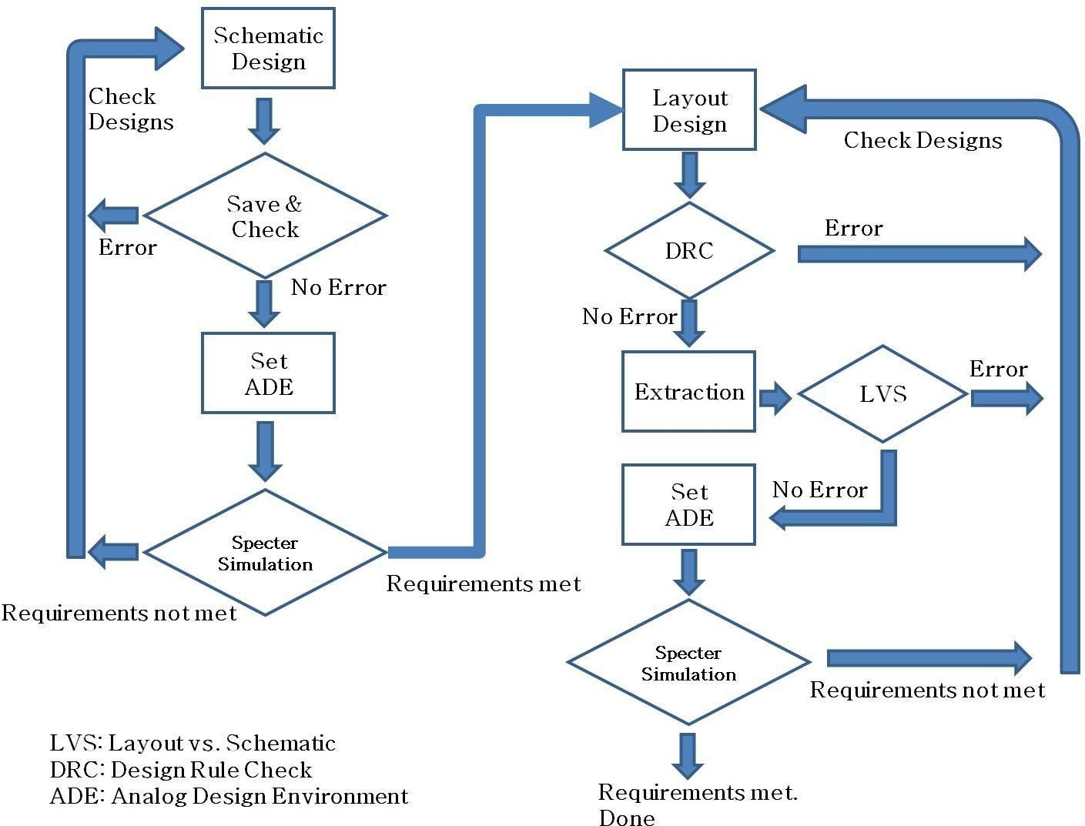
Following flow chart shows overall design flow.

Create Library

For prompt to access for higher tiered license, click “always”.



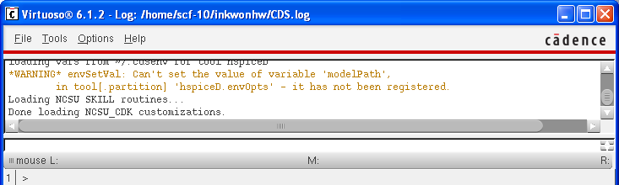
  - Tools à Library Manager

  - File à New à Library
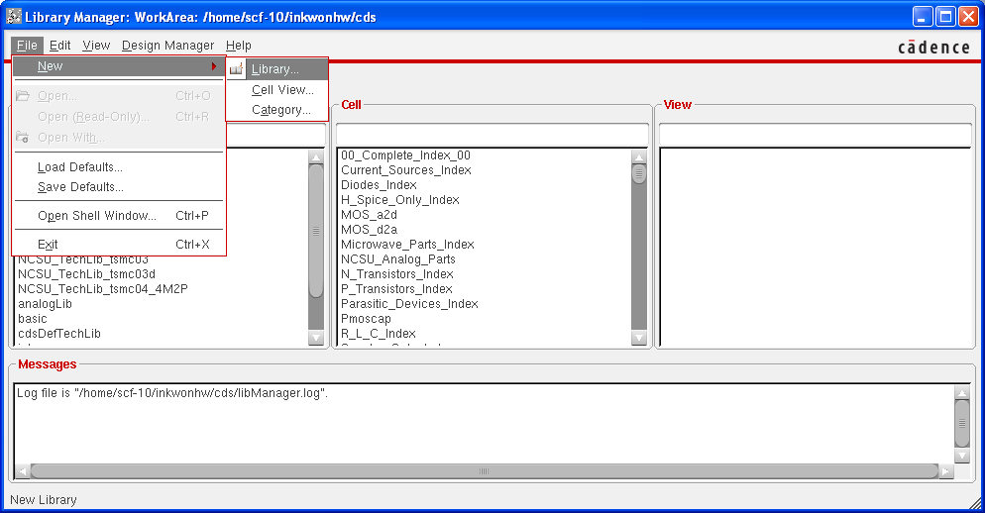

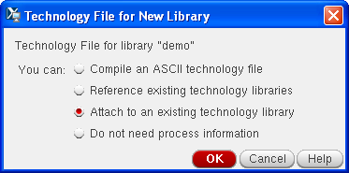
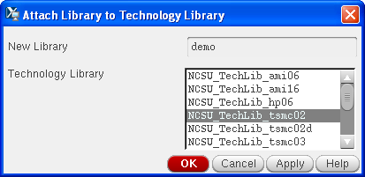
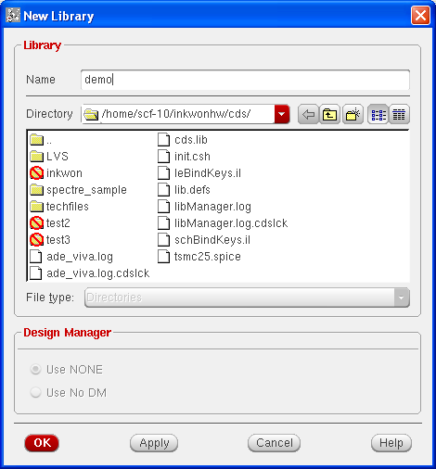
  - Give a name and attach it to a technology library

- Schematic

  - Create a cell view

select the library just created, File->new

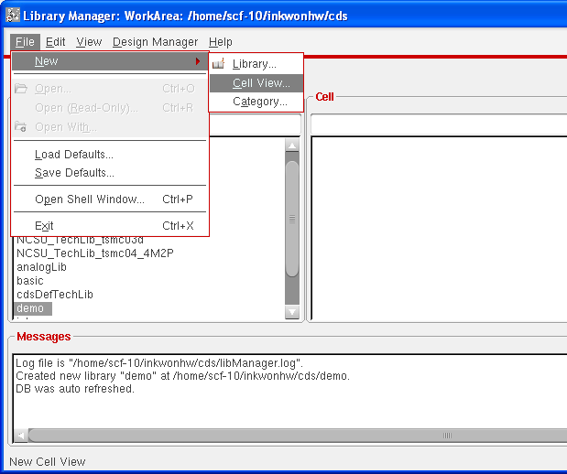
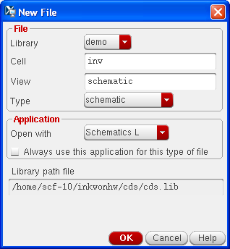

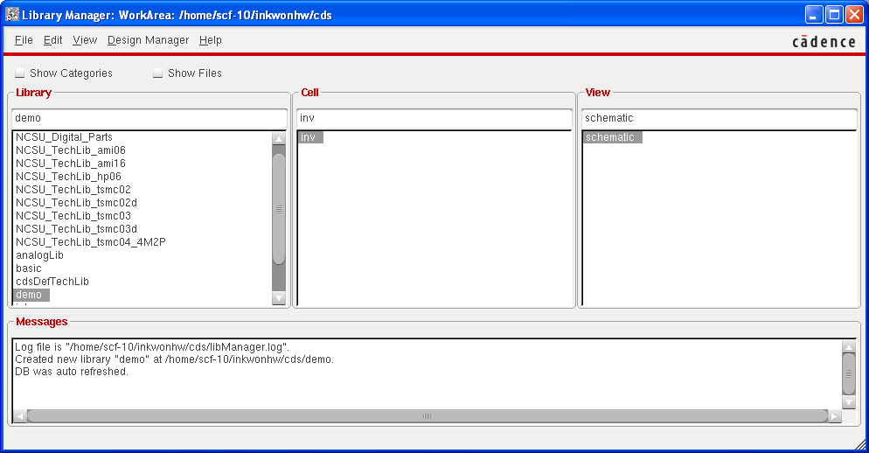

- Draw a schematic
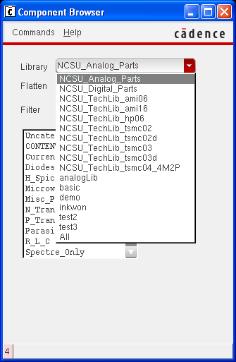
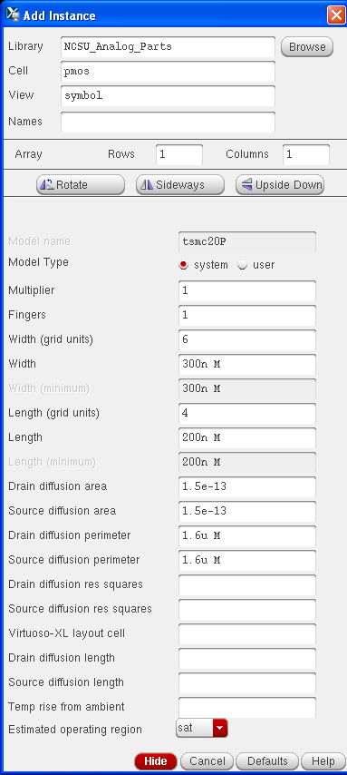
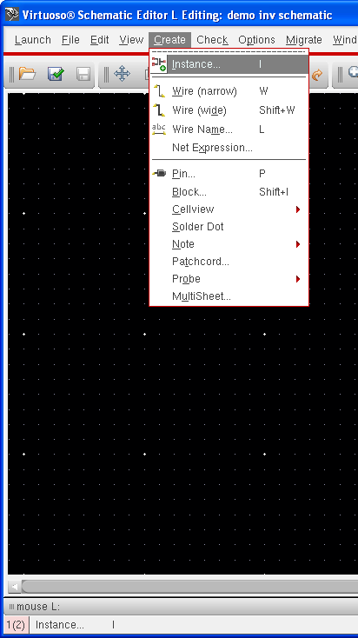
    - Add instances – pmos you can modify Width of transistors. Don’t modify length unless you have a special purpose. You should select an NCSU_Analog_Parts library

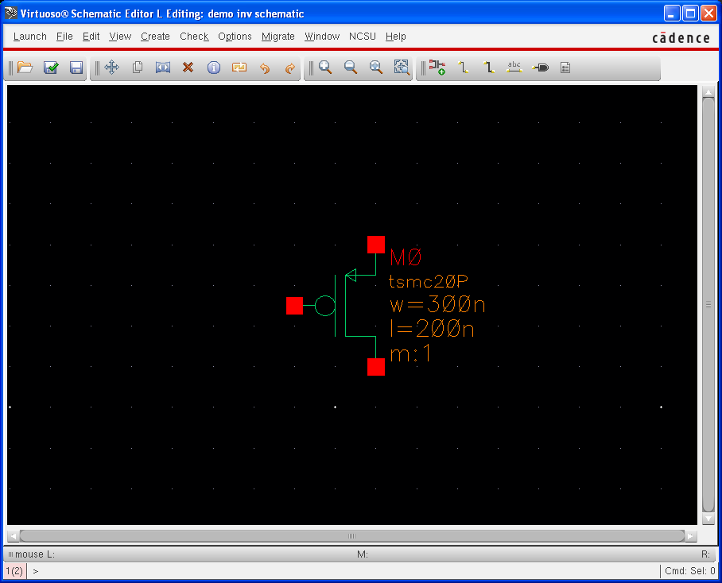

    - Add instances – nmos, vdd, and gnd
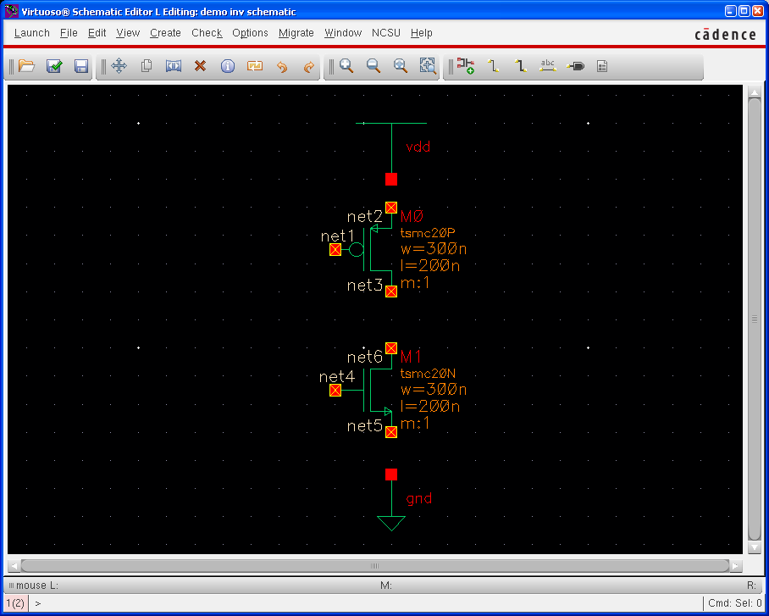
    - Add wires: Create à Wire

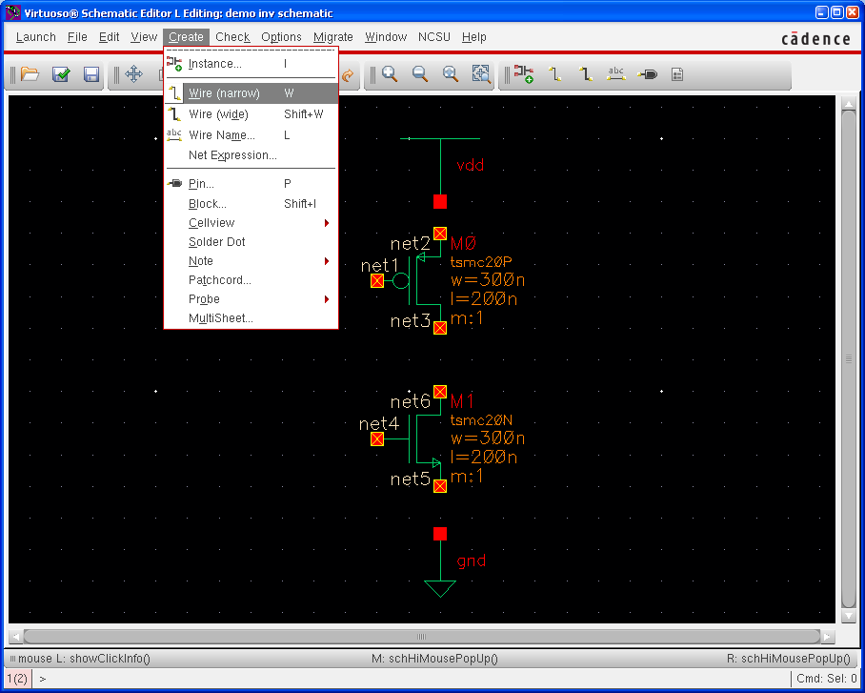
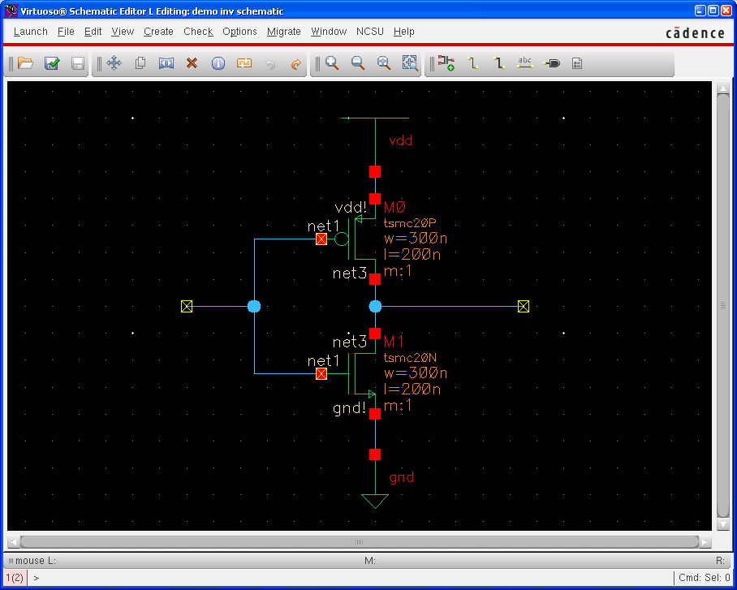

    - Add pins: Create à Pin
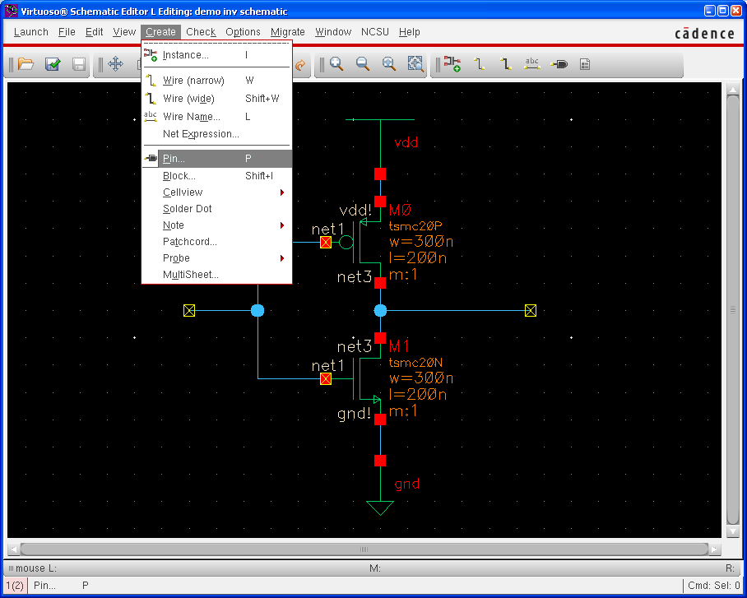
We have for different types of direction. For schematics, we only use two types, input and output. InputOutput type is for supply changes, and it is necessary only for layout. We will discuss about this later.
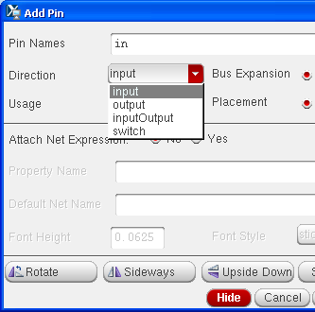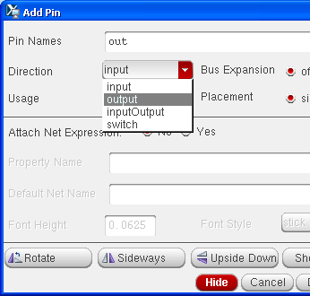

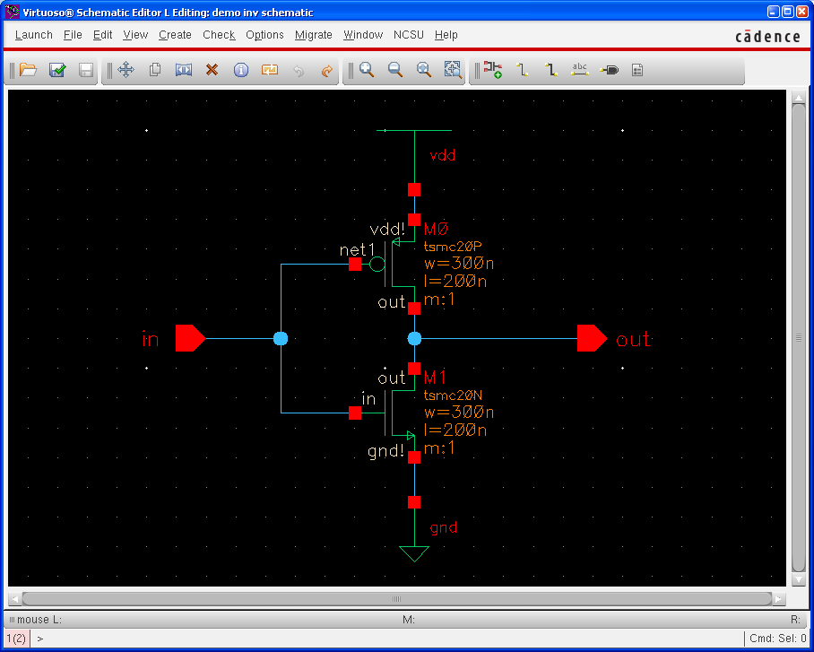

Check and save à to make sure there are no errors. Now, we completed a schematic design.

- Create a symbol (Optional)
For hierarchical design, we may need to make symbols of designed circuits.
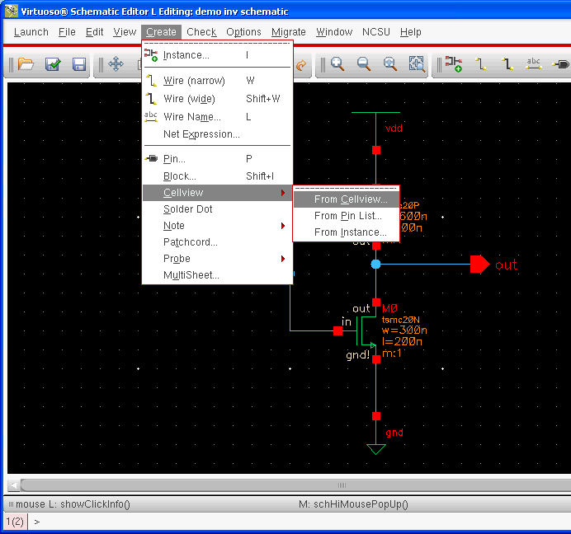

Create à CellView à From Cellview

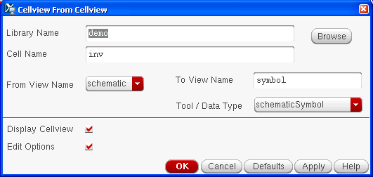
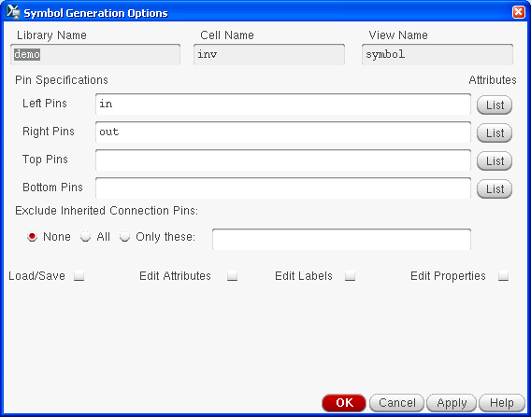
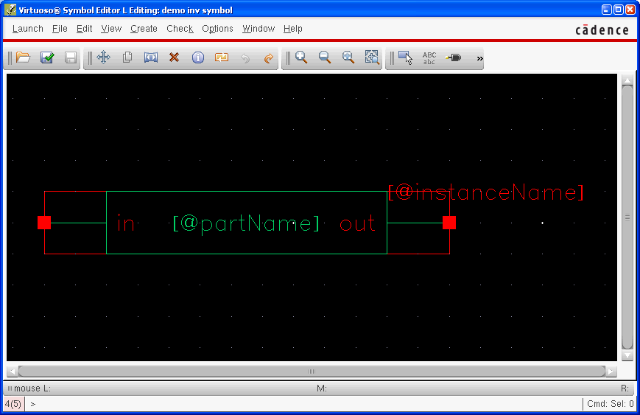

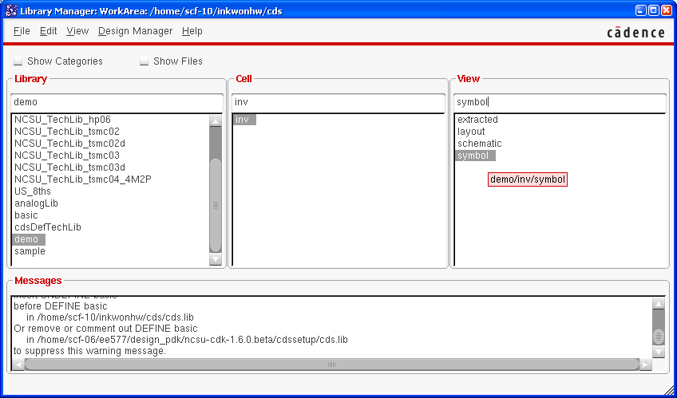

Remember that when you use more than one symbol in schematic, they all will have common Vdd and Gnd even if there are one Gnd and Vdd for each symbol (in the original design). To design with symbols in layout, you should make sure that all of the Vdd and Gnds are connected.

- Run Spectre simulation (Transient analysis)

We will run spectre simulation. This section is for both schematics and layouts. I will show an example for a schematic. You can do the same thing for a layout.

  - Launch ADE (Analog Design Environment) L

Launch à ADE L

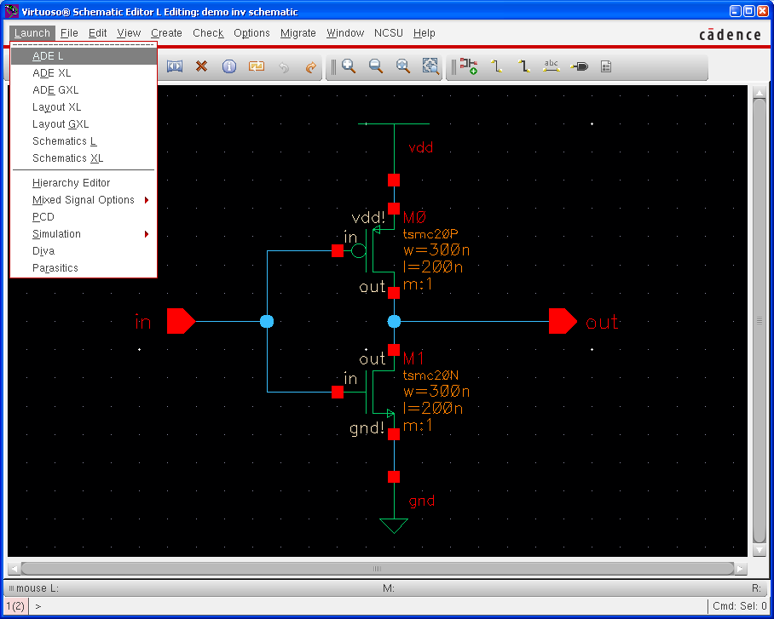
- Basic setup
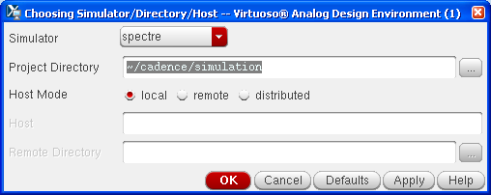
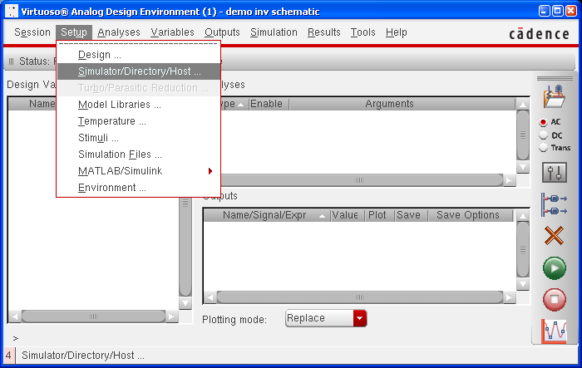
Check if your simulator is spectre. You can modify project directory.

- Model Libraries
You can download a library file at the DEN blackboard.
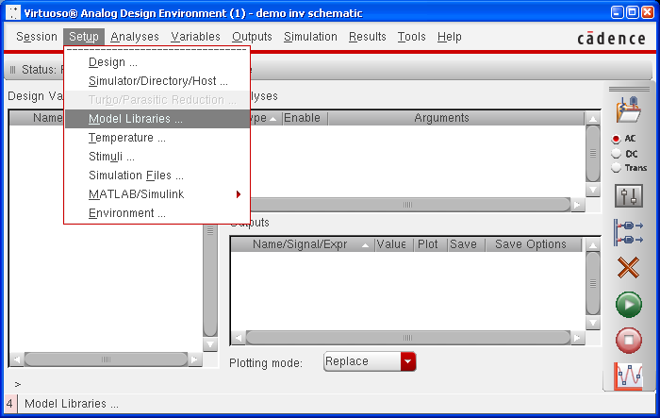
Put the tech file under /home/scf-10/your-user-name/cds/techfiles/

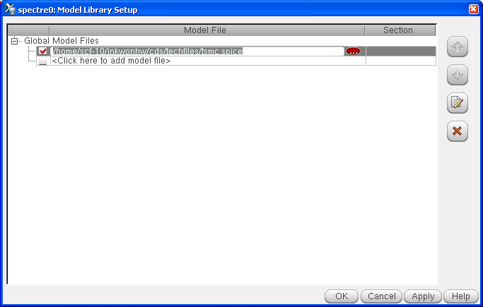

Please only use the provided tsmc file because some tsmc files does not work correctly.

- Stimuli
Define input signals include supply nets (for layout, vdd! and gnd! are under inputs and both should be enabled.)

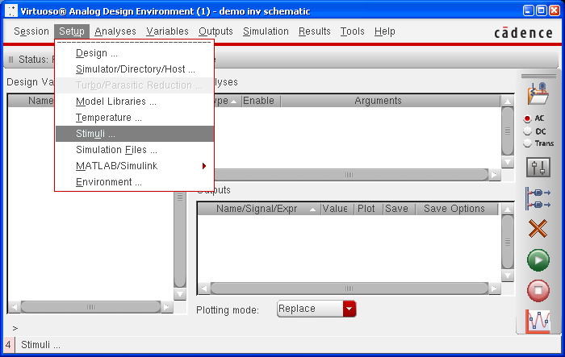

Global sources Input (change)
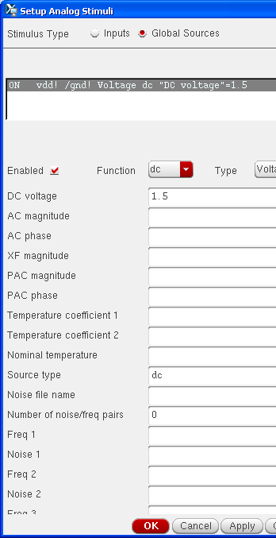
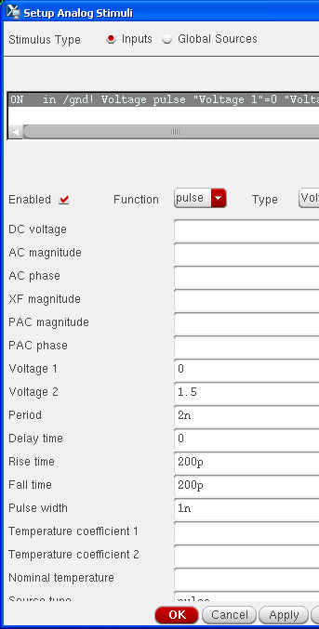

Remember to check Enabled button and then press OK or APPLY otherwise you will lose the configured numbers.

- Choose a type of analysis - transient

You can choose „dc‟ if you want to do dc analysis

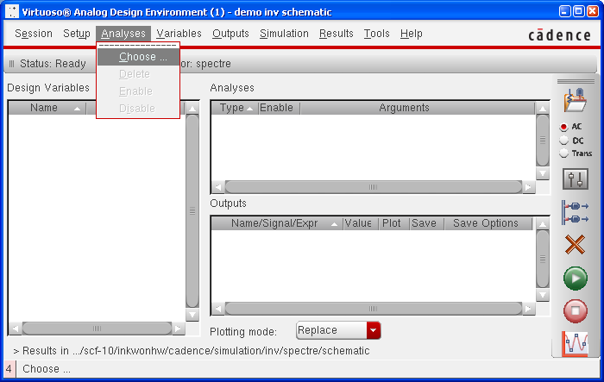

- Choose tran
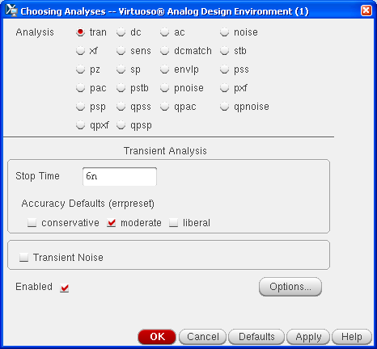
- Give Stop time which means how long you want to simulate
- Select moderate as accuracy defaults
- Do not check Transient Noise
- Check Enabled

- Select signals to plot
Outputs à To Be Plotted à Select On Schematic
Click a signal (Pin) on a schematic/extracted. In Extracted try to use pins for signal that you need in the simulation because it is hard to select a net in the extracted view.
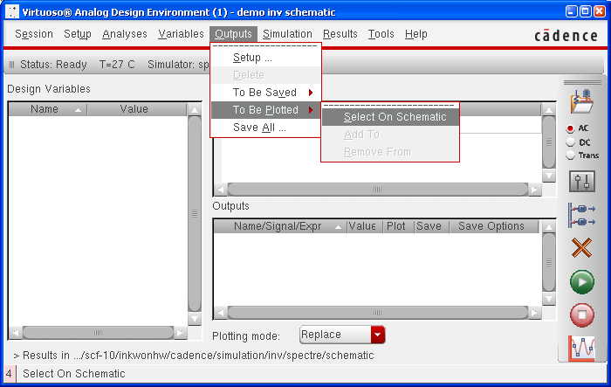

- Run simulation
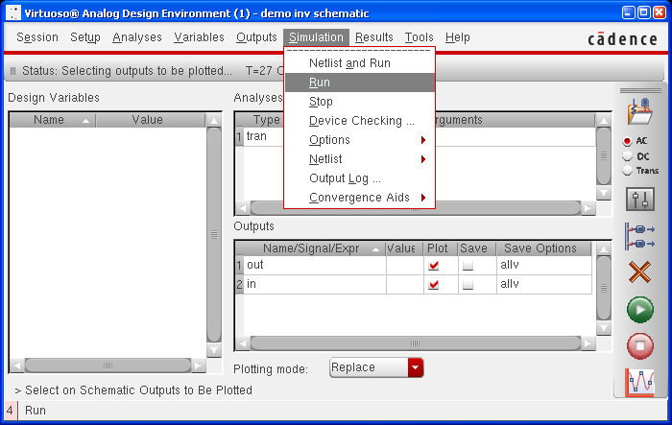
Simulation à Run

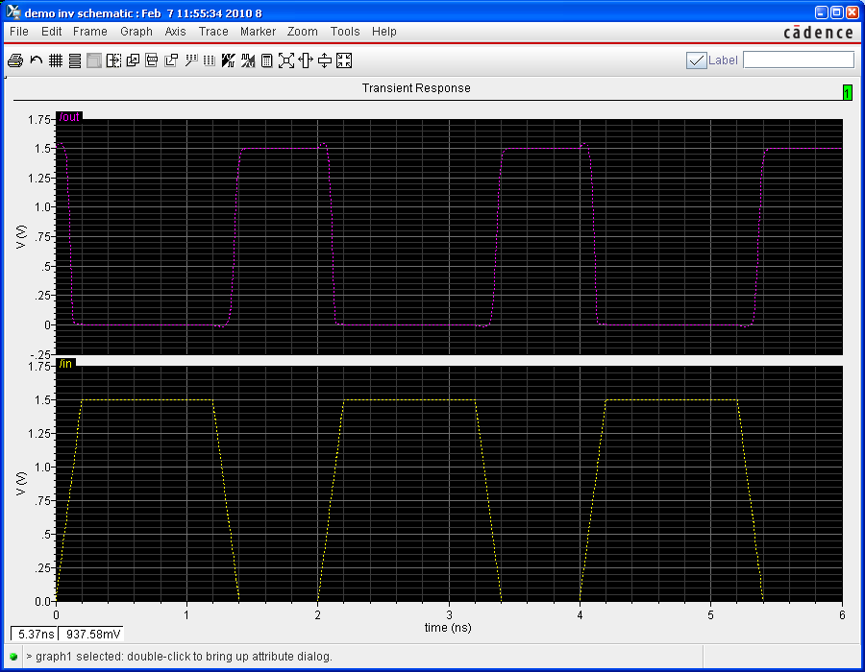

If you see a waveform like above picture, you followed every step properly. Good job!.

- Measurement
The following steps describe the measurement of rise time. Using similar steps other parameters of delay, fall time can be estimated.
Invoke the calculator or tools-> calculator , select the Wave radio button:
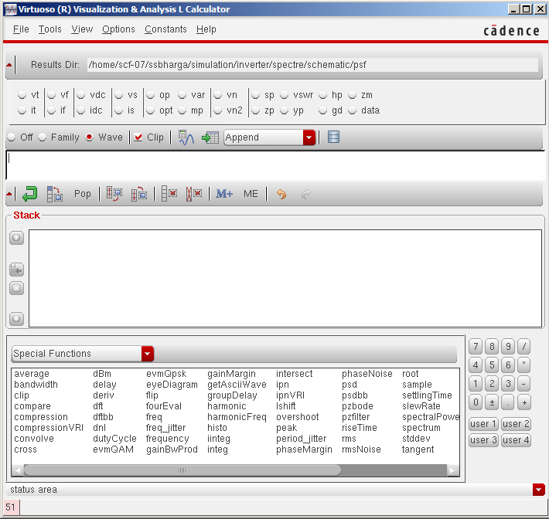

In the functions window – choose “all”
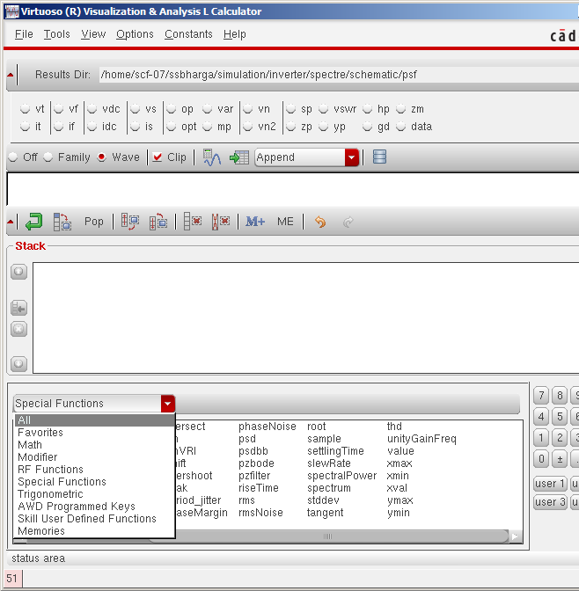

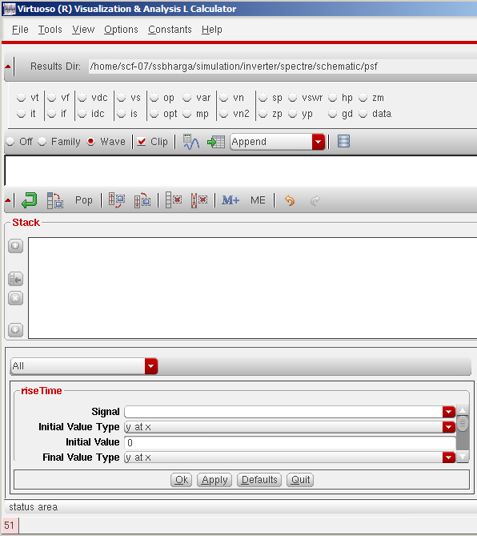
Select the rise time option

Select the signal from the waveform window whose rise time needs to be determined and click “OK”:

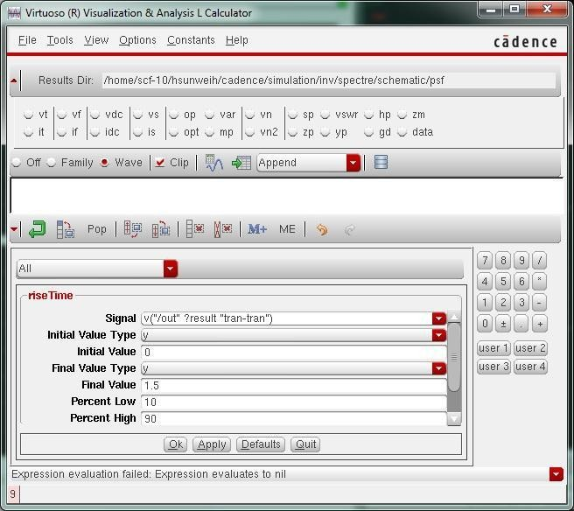

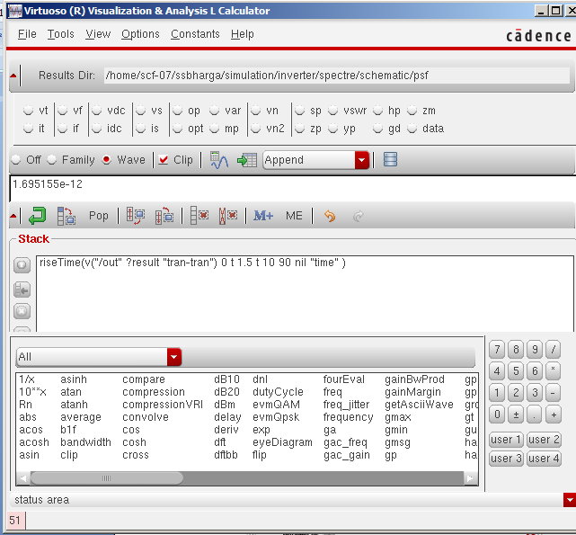
Click the evaluate buffer à
to display results as follows

You can also select a signal from calculator for example cos(Vin) as one of the plotted signals and you can see the results whenever you run the simulation.
Remember to save the simulation setup to use it later. You can do so by clicking on Session à Save State in the ADE (Analog Design Environment) window. Next time you want to simulate the same cell, you can reload your configuration by clicking on Session à Load State.
- Run Spectre simulation (DC analysis)

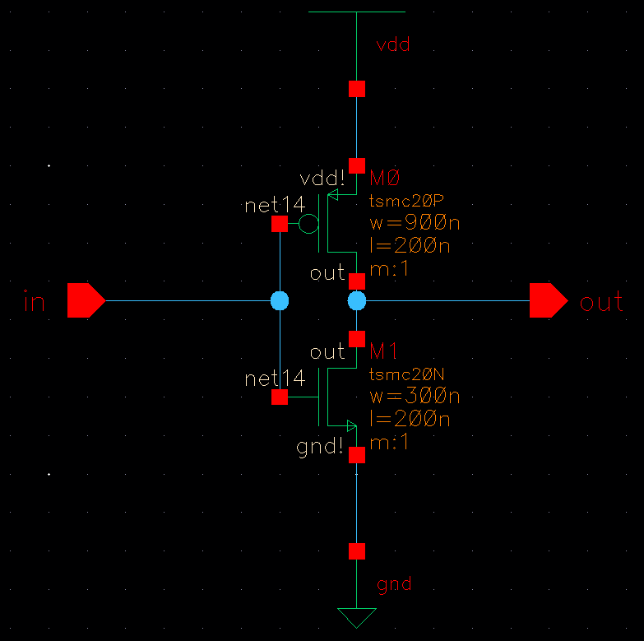
The following inverter schematic is already created

  - Voltage Source
For DC analysis , the input pin “in” must be altered. The following are the steps to alter the pin “in” : CreateàinstanceàNCSU analog partsàVoltage_sources select Vdc
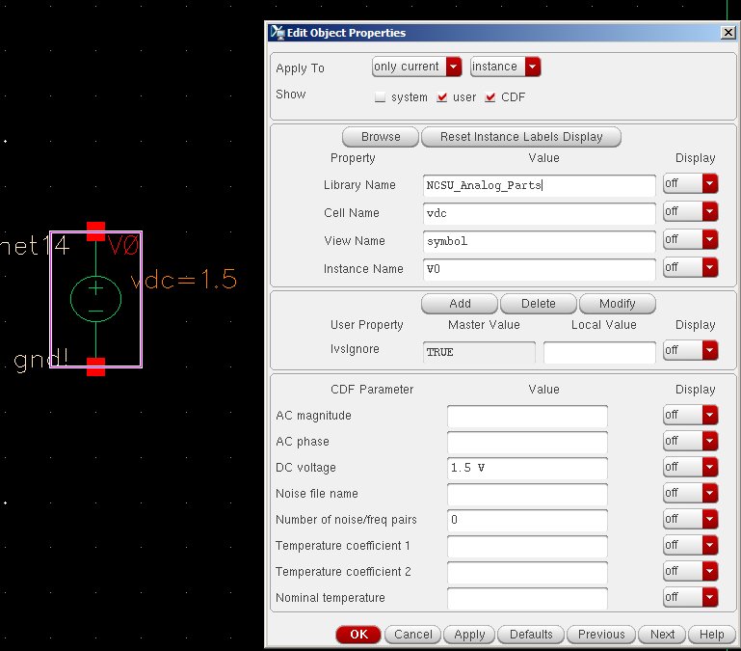
The DC voltage must be set to 1.5V as shown.

  - Replace Input Pin
The Input pin “in” must be replaced with the above voltage source as shown below

Check and Save (make sure you get no errors)
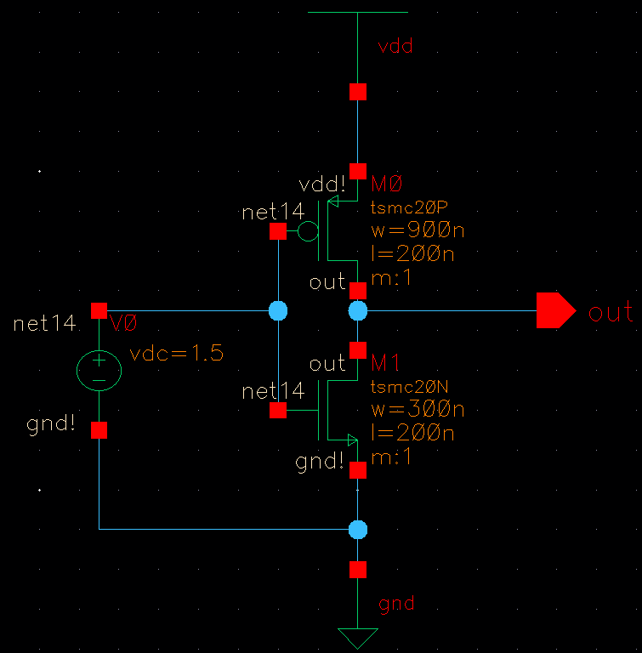

  - Choosing Analyses
Launch ADE L, repeat steps A to D in section 3 of „Basic Design Flow‟ except that there is no “in” input signal this time.
Go to Analyses à Choose dc Choose „Component Parameter‟,
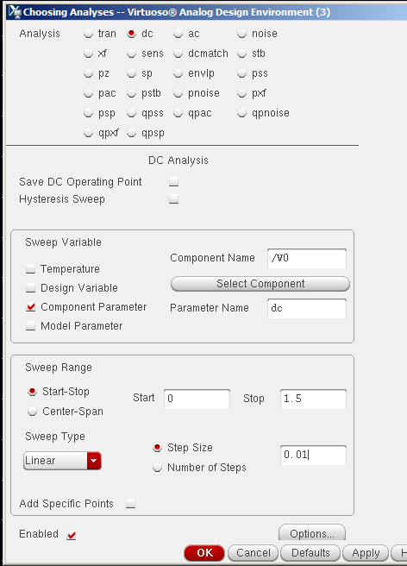
Select Component, then the voltage source in the schematic, then choose 0 as Start, 1.5 as Stop and
0.01 as step .

Make sure that there are no other analyses selected apart from DC
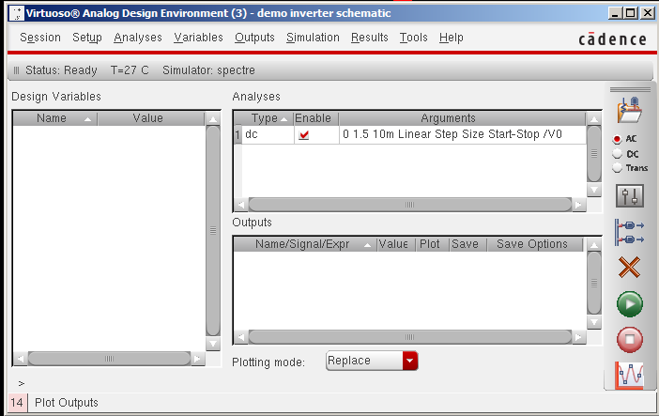

  - Run Simulation
Do simulationsànetlist and run. On successful completion we get the following

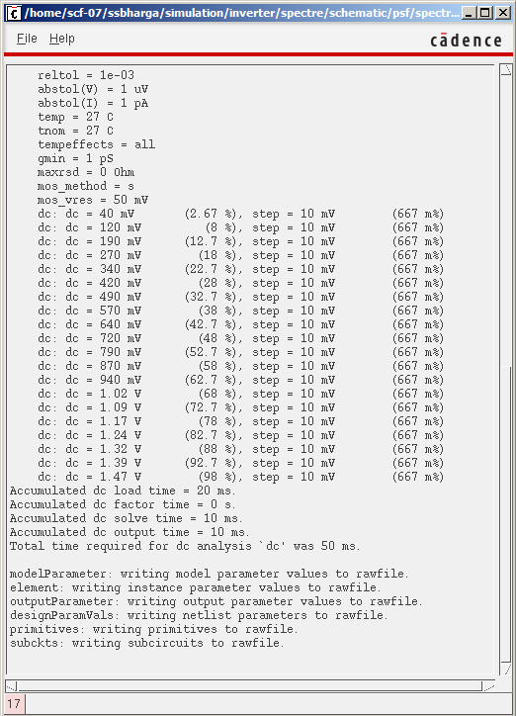

Now, go to the resultsàDirect plotàDC. Click on the output pin “out” on the schematic and ESC key to get the following VTC

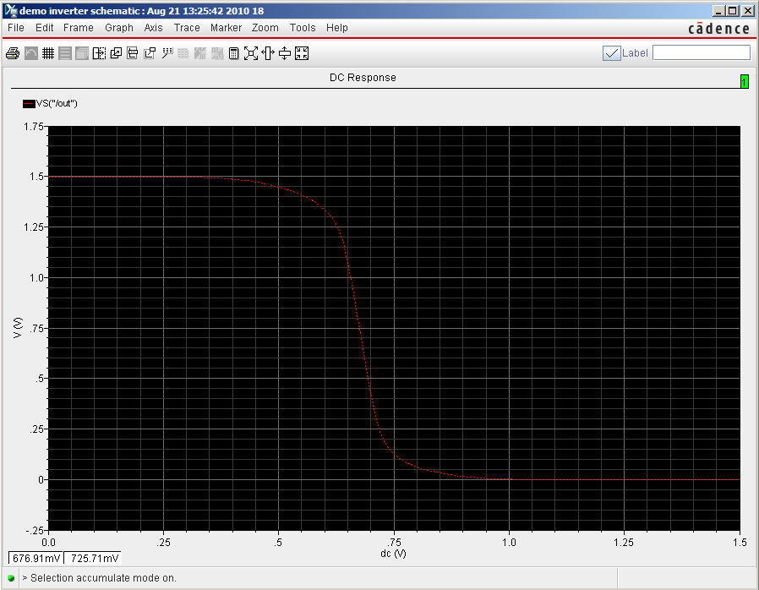

- Layout

It‟s time to draw layout. Schematics are for verifying your design very roughly. They don‟t consider physical features like parasitic capacitances. After determining your design variables by schematics, you need to draw layouts.
Design flow of layouts is very similar to one of schematics, but it has additional step which is LVS check. It is for check if your layout is identical to the schematic or not. Hence, this step is very important. If your logic doesn‟t pass this step, you may lose significant points for that.

  - Create a layout
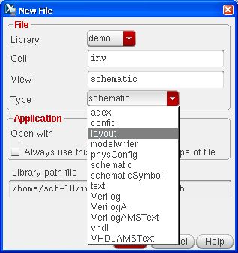
- Add an instance - nmos

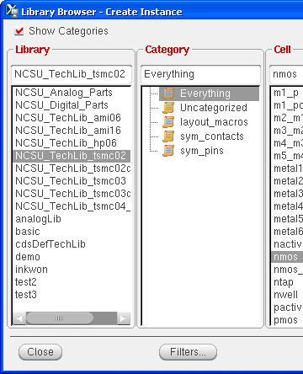
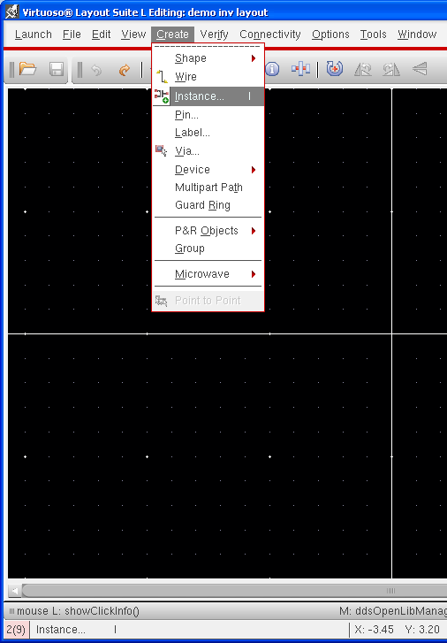
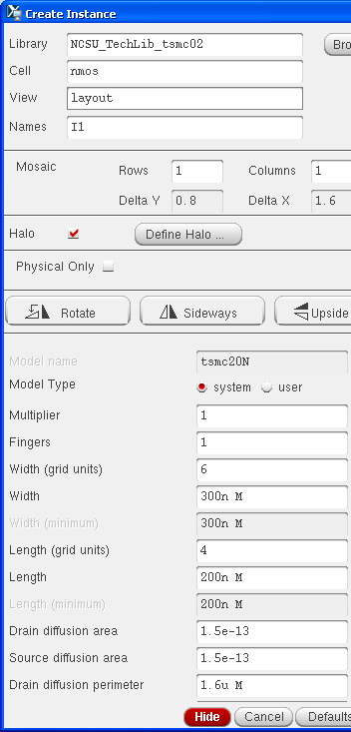
You can modify width of transistors.

Add more instances – pmos, ptap, ntap, and m1_ploy
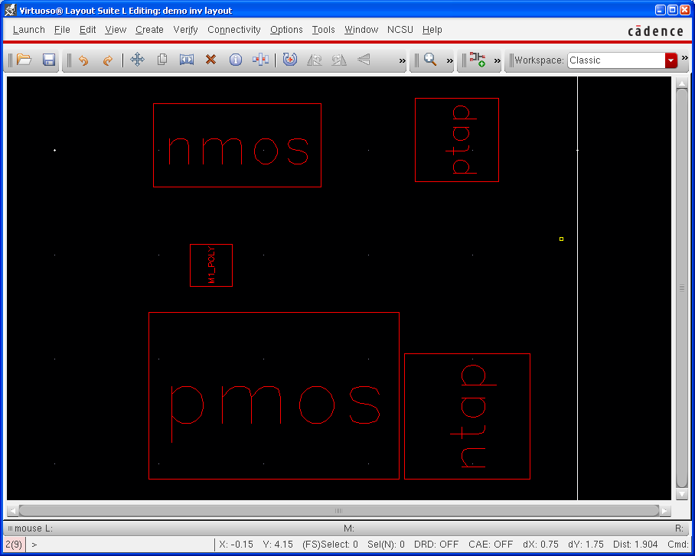

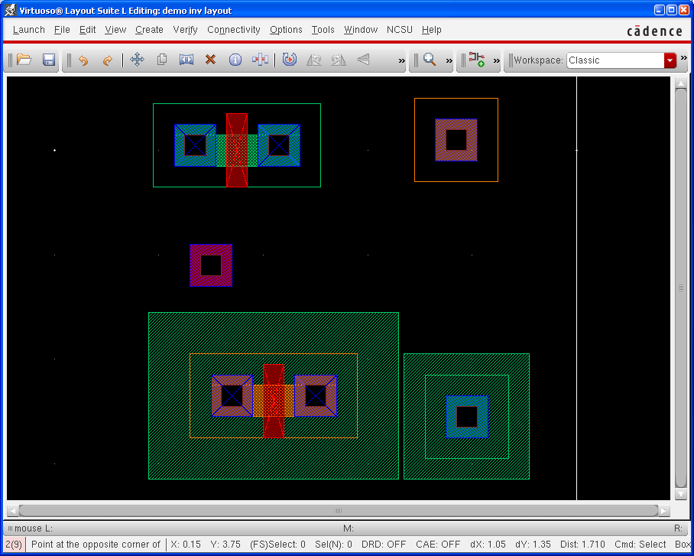
You can select alternate view of a layout. Try „Shift + f‟ and „Ctrl + f‟.

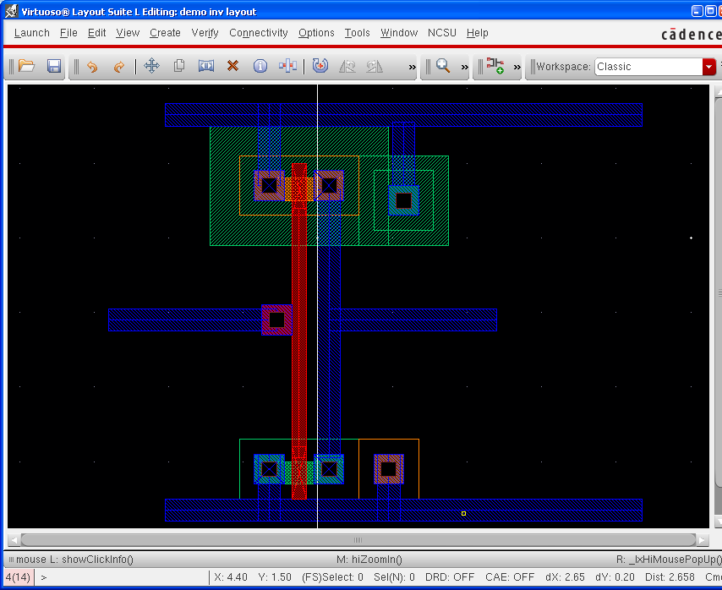
- Draw metal1

There are few ways for drawing metal, but I recommend you use „path‟. It‟s quite convenience than others.

Create à Shape à Path

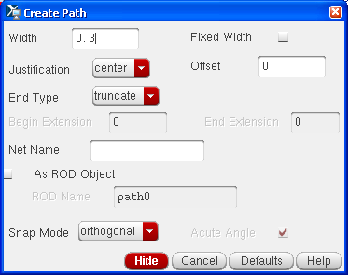
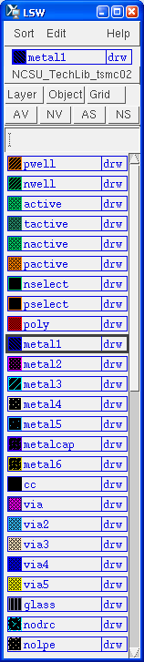
First of all, you should select metal1 on LSW window. Default width for metal1 is 0.3, which means 300nm (3 λ). You can draw metal layer simply by clicking

- Run DRC
This step checks if your layout follows design rules. Verify à DRC
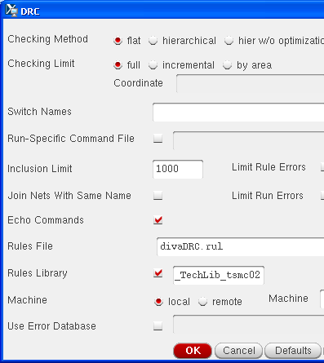
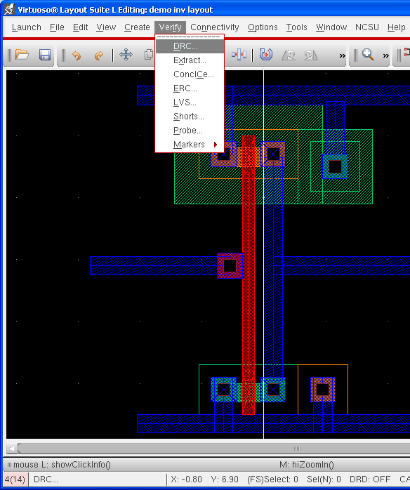

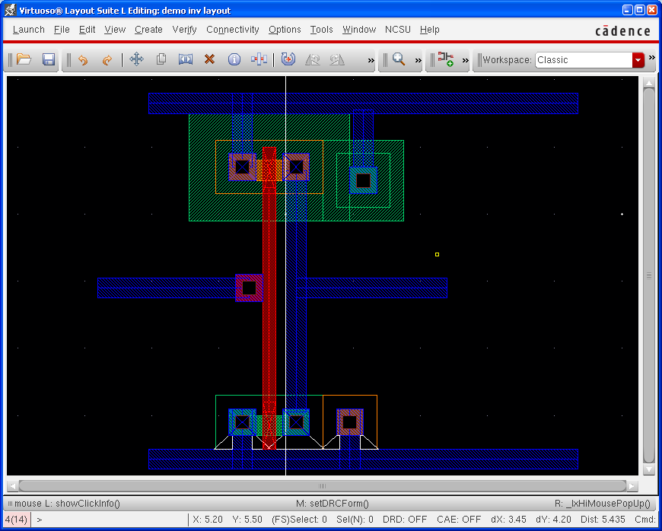
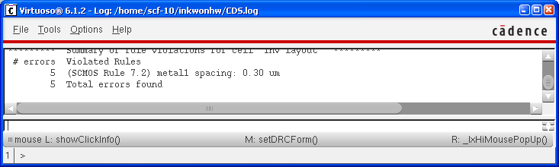

We have five errors. It is because a gnd metal layer is too close to an nmos transistor. After modifying layout, run DRC again.
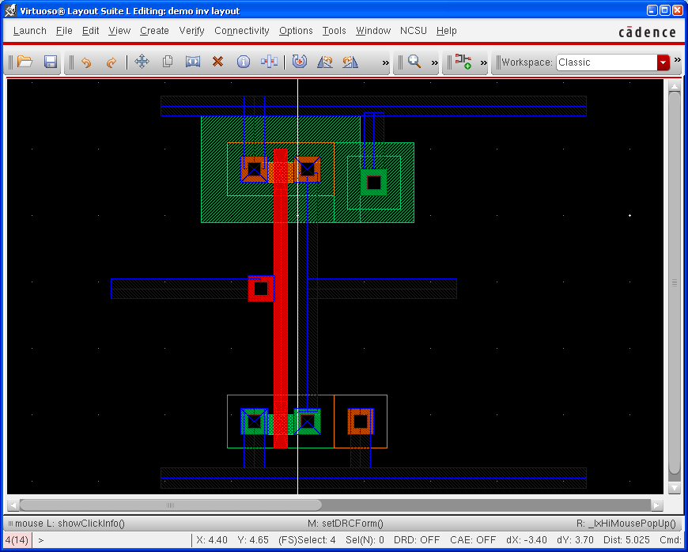
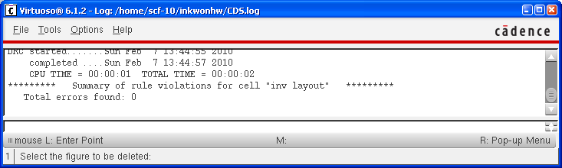

There is no error!!

- Add pins

We had two pins on a schematic, which are „in‟ and „out‟. Pins are for assigning signals to physical device, so we assign voltage level of gnd and vdd by using pins. Hence, we have 4 pins for the layout, which are „in‟, „out‟, „gnd!‟, and „vdd!‟.
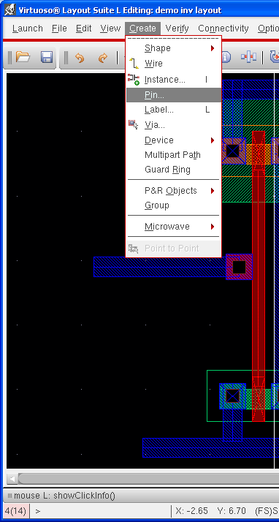
Create à Pin

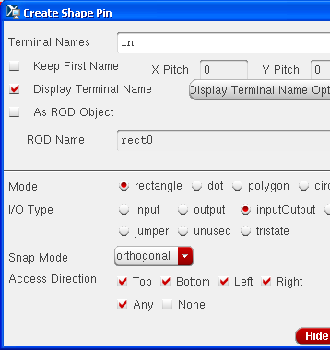
Check „Display Terminal Name‟ if you want to see pin name on the layout.
Click „Display Terminal Option
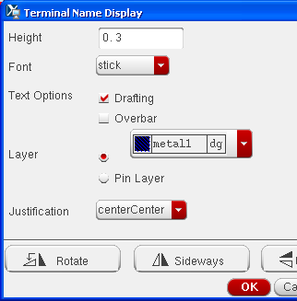

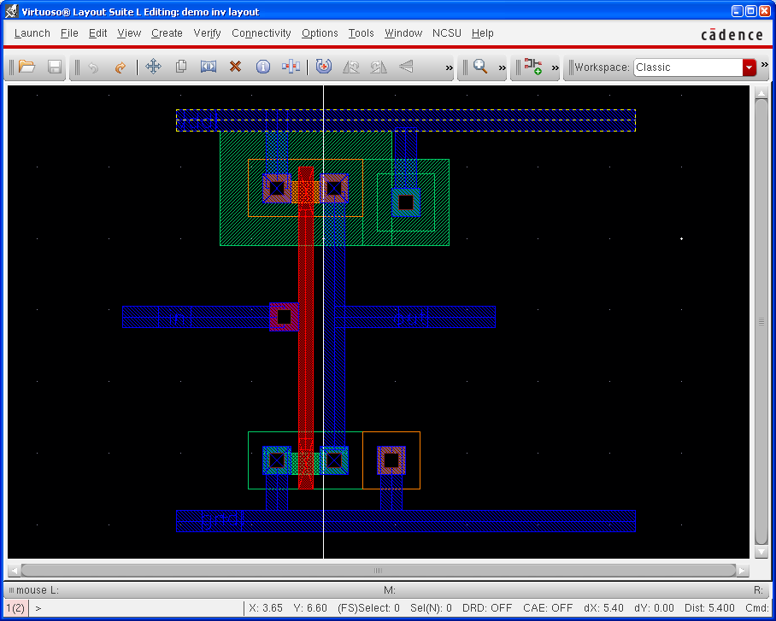
- Extract
A layout is just a picture. If you need to run simulation using the layout, you should convert it to the other format. It is done by extracting. It‟s something like compiling a code.
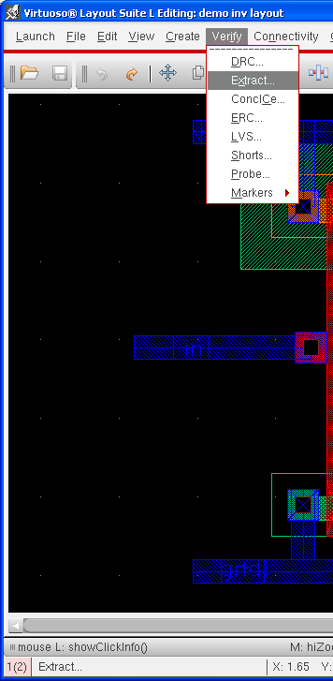
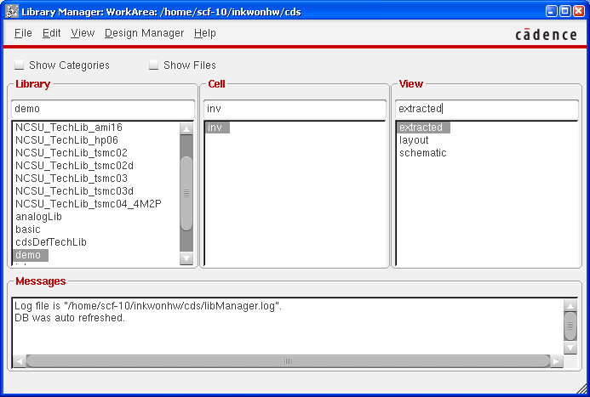
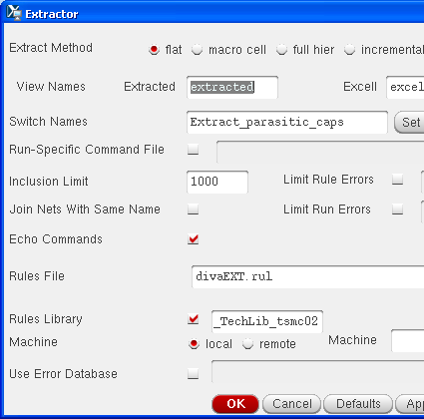

Select „Extract_parastic_cap‟ as a switch name, otherwise your extracted design won’t have parasitic capacitances.

- Run LVS
As I mentioned before, this step is very important for your grading. More complicated design, more time will be required for debugging LVS.

Verify à LVS

Keep in mind. You SHOULD compare your schematic with EXTRACTED.

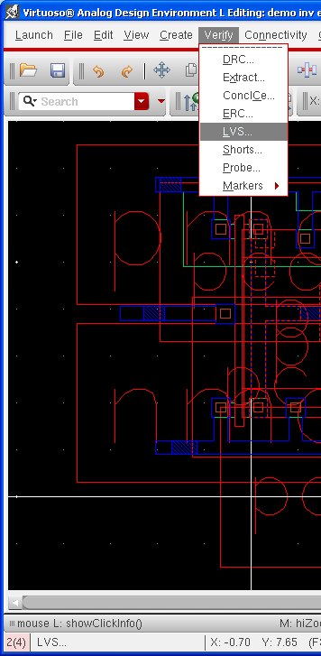
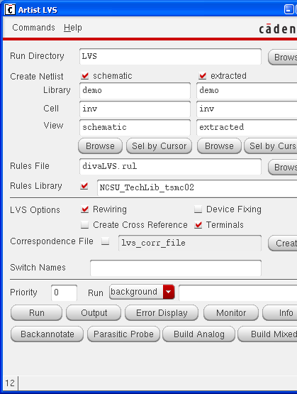


I hope all of you will see the following window.

If there are errors, you can check the results by clicking „Output‟ button. „Error Display‟ also
- Run Spectre simulation

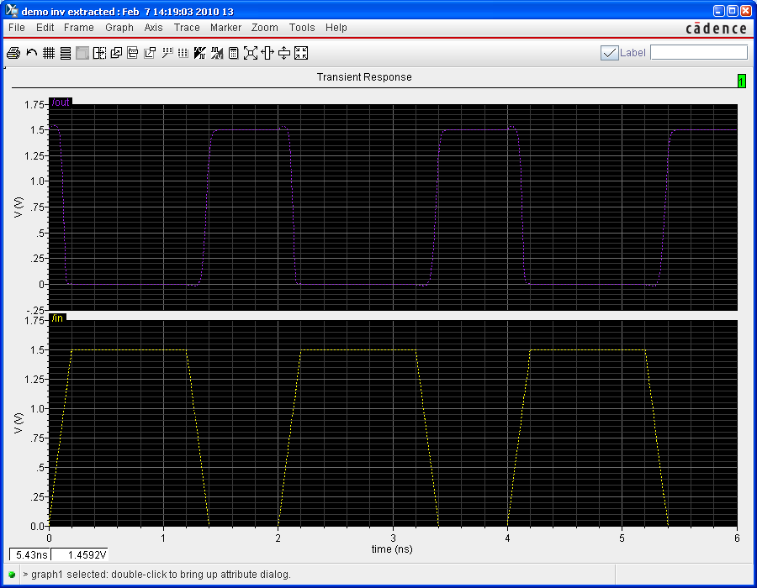
It is same as schematics. Please follow the instructions for the schematics.

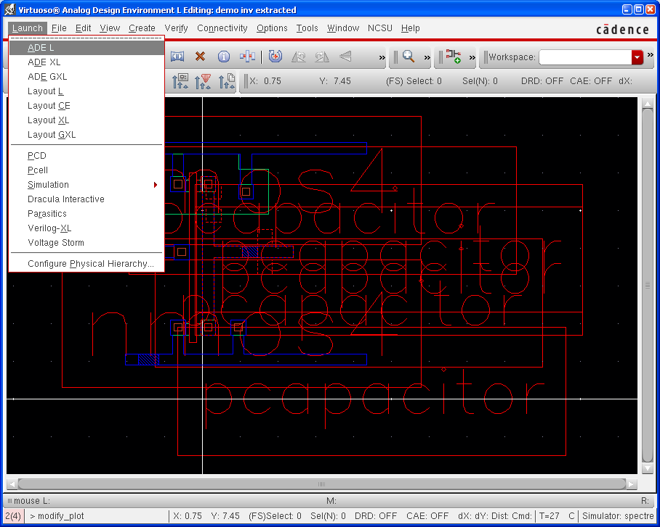
Congratulations!!
You followed all steps I prepared. Let‟s do the same thing for more complicated designs.

CHAPTER-9
RESULTS
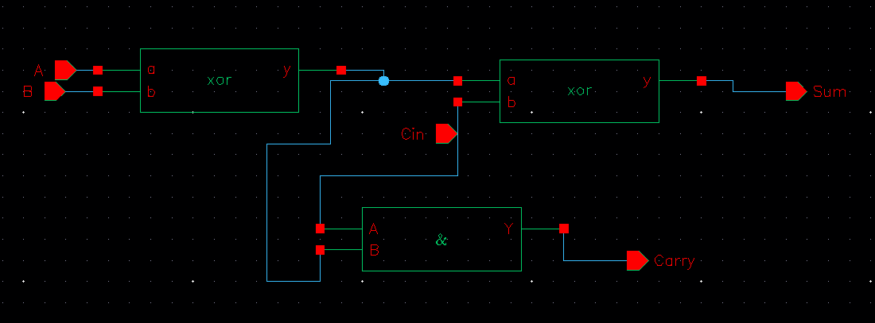
Approximate full adder
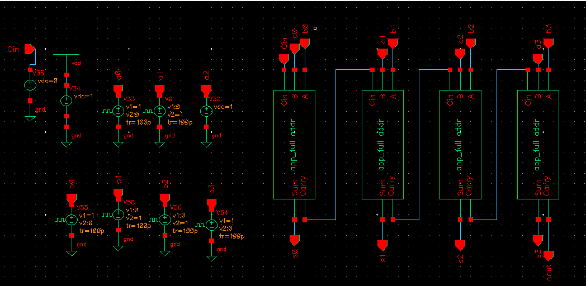
Approximate 4 bit adder
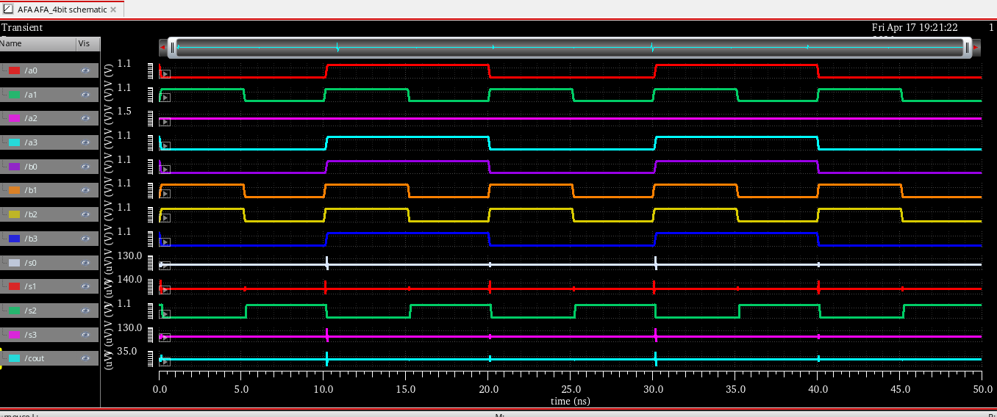
Waveform of Approximate full adder 4 bit
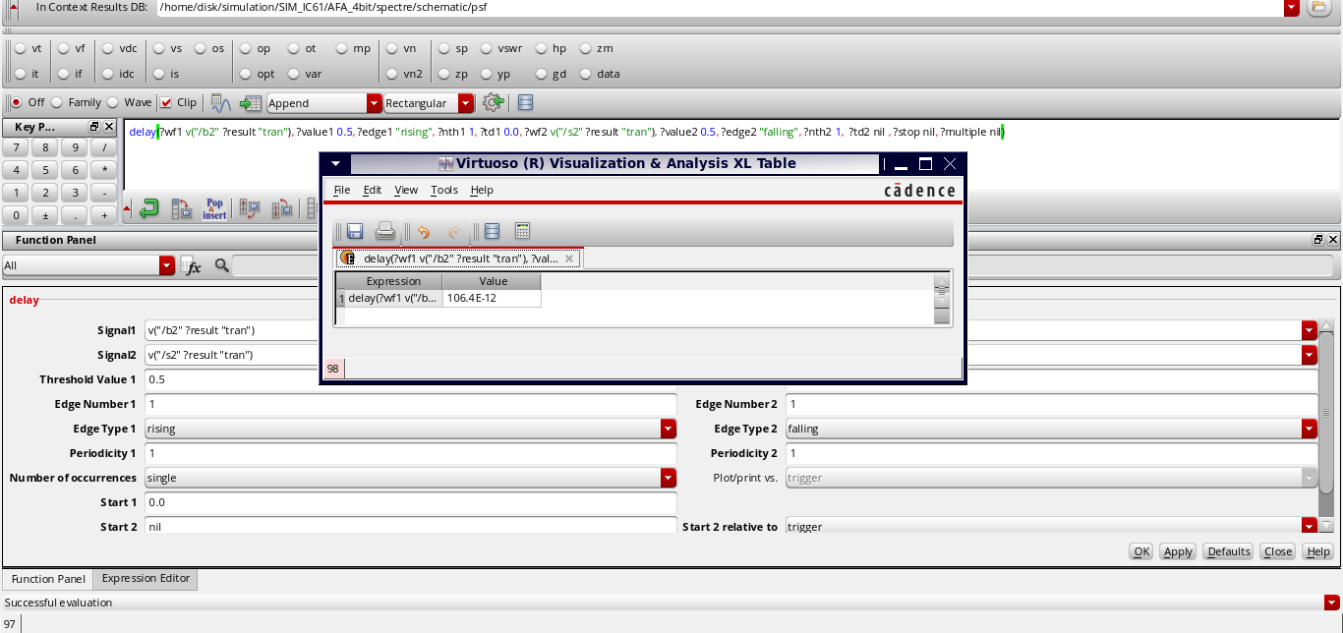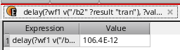
DELAY VALUE OF AFA 4 BIT
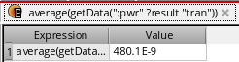
Power consumption of AFA 4 bit
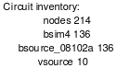
Mos count of AFA 4 bit

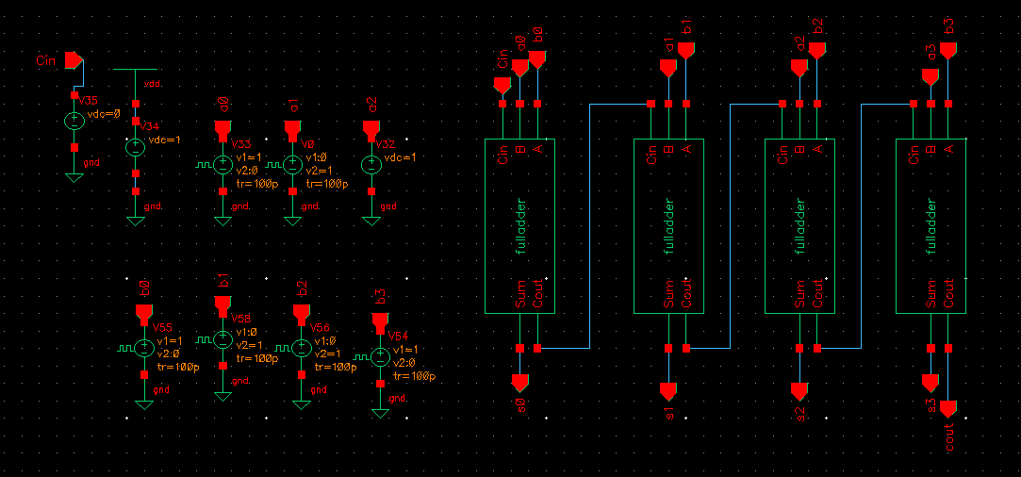
4 bit rca
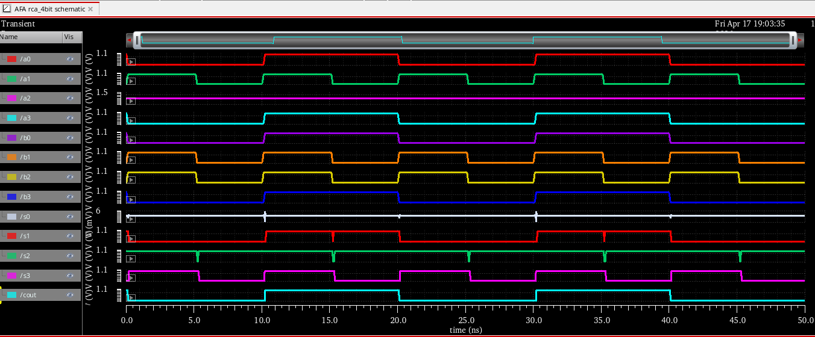
Waveform of 4bit rca
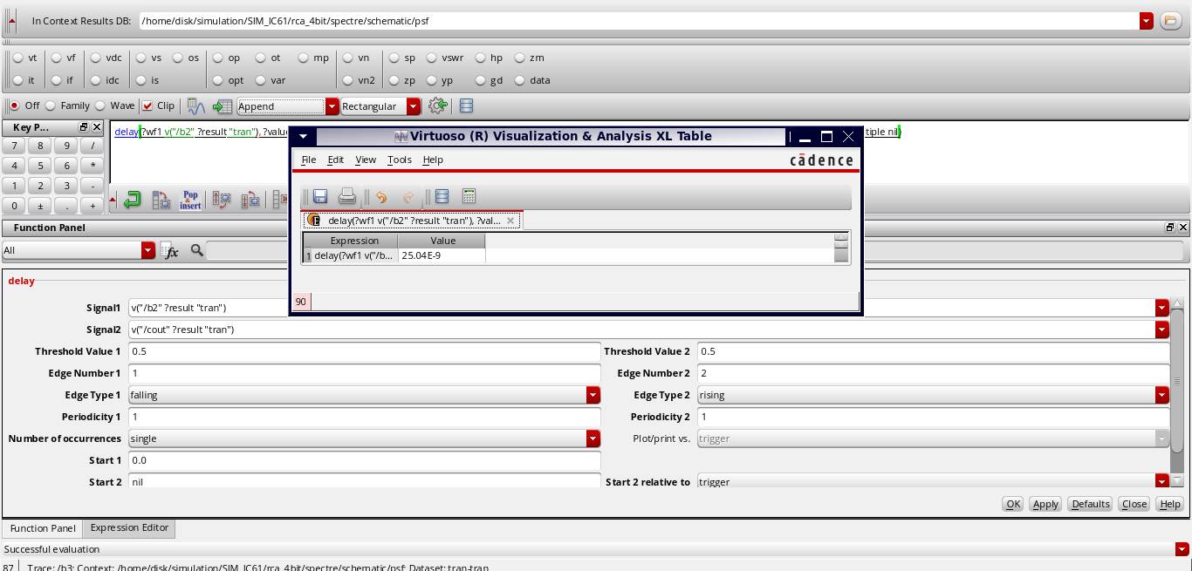
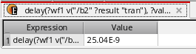
Delay value of 4bit RCA
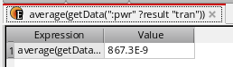
Power consumption of 4bit RCA
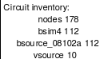
MOS COUNT OF 4 BIT RCA

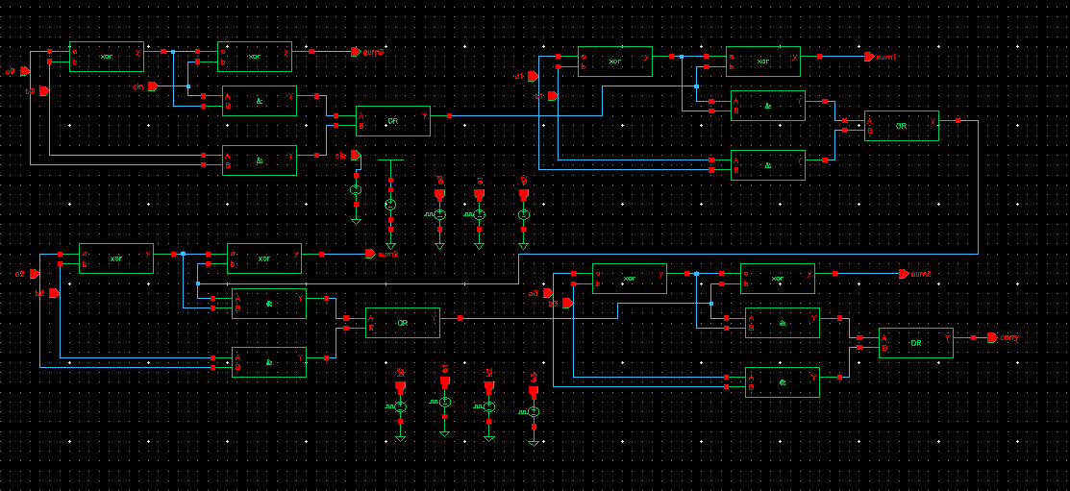
4 bit cla
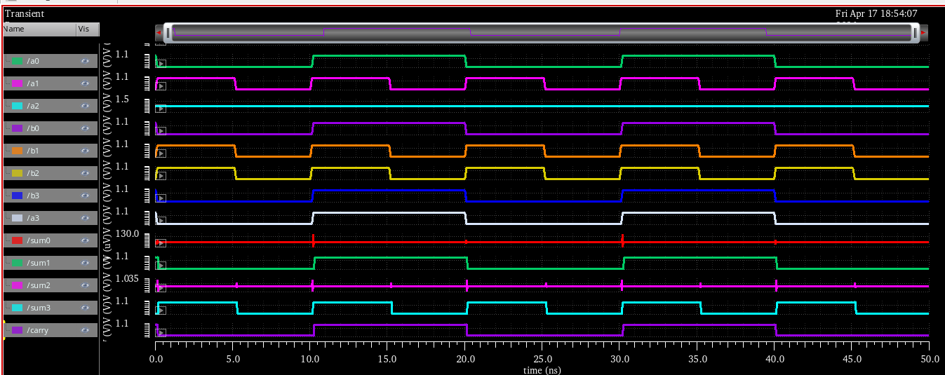
Waveform of 4 bit cla
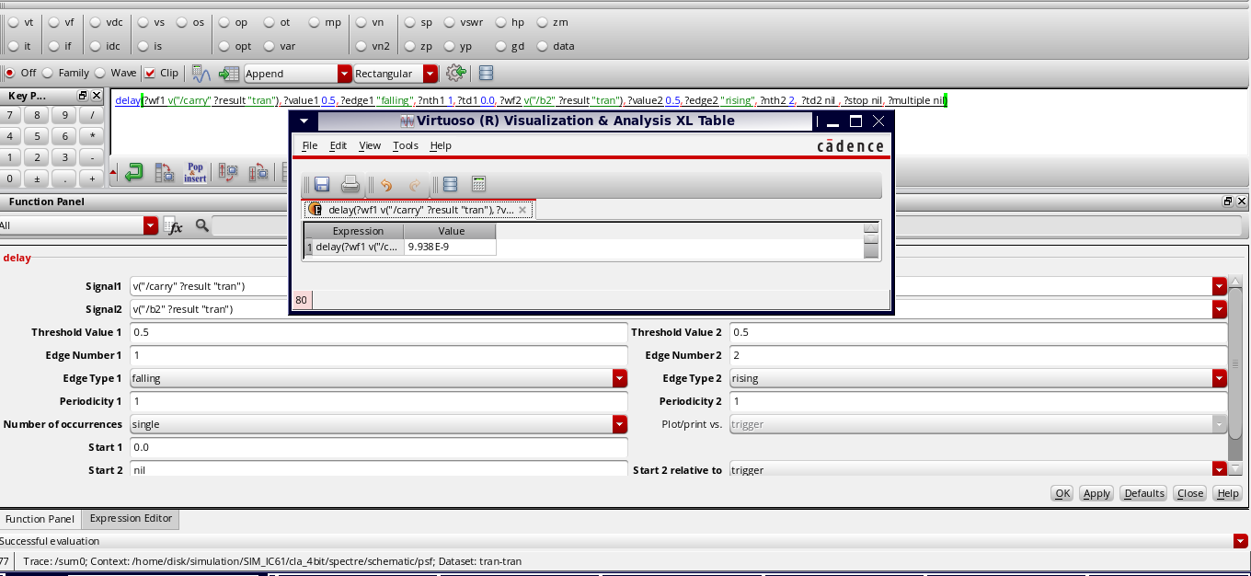
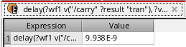
DELAY FOR 4BIT CLA
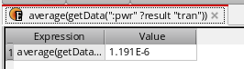
Power consumption of 4bit cla
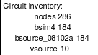
Transistors count of cla 4 bit

Comparison Table
 | Mos count | Power consumption (nW) | Delay (ns) | PDP (aj)
Appr_adder | 136 | 480 | 0.1 | 48
RCA | 112 | 867 | 25 | 21675
CLA | 184 | 1191 | 9 | 10719

CHAPTER-10
CONCLUSION
From the comparative analysis of the approximate adder, Ripple Carry Adder (RCA), and Carry Look Ahead Adder (CLA), it is evident that the proposed approximate adder significantly outperforms conventional designs in terms of speed and energy efficiency. The approximate adder achieves an exceptionally low delay of 0.1 ns, which is substantially better than RCA (25 ns) and CLA (9 ns), highlighting its suitability for high-speed applications. In terms of power consumption, the approximate adder consumes only 480 nW, which is considerably lower than both RCA and CLA, making it highly energy-efficient.
Although the MOS count of the approximate adder (136) is slightly higher than that of RCA (112), it is still lower than CLA (184), indicating a balanced hardware complexity. The most significant improvement is observed in the Power-Delay Product (PDP), where the approximate adder achieves a value of 48 aJ, which is drastically lower than RCA (21675 aJ) and CLA (10719 aJ). This confirms that the proposed design provides superior overall performance by minimizing both power consumption and delay.
Therefore, the approximate adder proves to be an efficient alternative to traditional adders, offering an optimal trade-off between accuracy, speed, and power. It is particularly well-suited for error-tolerant applications such as image processing, artificial intelligence, and multimedia systems, where minor inaccuracies can be tolerated in exchange for improved performance. The results validate that approximate computing is a promising approach for next-generation low-power and high-speed VLSI system design.

References
[1] V. V. Joshi and P. Mane, “Design and Analysis of Approximate Arithmetic Circuits for Error-Resilient Applications,” International Journal of Intelligent Systems and Applications in Engineering, vol. 12, no. 4, pp. 1–10, 2024.
[2] A. Mohammadi, et al., “Design of High-Speed and Low-Energy Approximate Full Adder Using CNFET Technology,” Microelectronics Journal, vol. 123, pp. 105–112, 2022.
[3] B. Gaur, H. Thapliyal, and T. S. Humble, “Noise-Resilient Approximate Quantum Adders,” arXiv preprint arXiv:2408.00927, 2024.
[4] M. Qiu, et al., “IMPLY-Based Approximate Adders for In-Memory Computing,” arXiv preprint arXiv:2412.15888, 2024.
[5] O. Kokane, et al., “Hybrid Overestimating Approximate Adder for Edge AI Applications,” arXiv preprint arXiv:2408.00806, 2024.
[6] Nivedita and A. Savadi, “Design of Approximate Adder Using Error Reduced Carry Prediction and Truncation,” International Journal of VLSI Design & Communication Systems, vol. 13, no. 2, pp. 15–25, 2022.

