EXPT.NO: 9  DATE: | FACIAL RECOGNIZATION USING ARTIFICIAL NEURAL NETWORK


AIM:
To implement Facial Recognition using Artificial Neural Network (ANN) by training a Multi-Layer Perceptron on the AT&T Laboratories Cambridge Face Database and classify facial images into their respective identities.
DATASET DESCRIPTION:
The AT&T Laboratories Cambridge Face Database (formerly known as the ORL Face Database) is a widely used dataset for face recognition research.
- Total Images: 400 grayscale face images
- Subjects: 40 different individuals
- Images per Person: 10 images each • Image Size: 92 × 112 pixels • Variations Included:
o Different facial expressions (smiling, neutral, etc.) o Open and closed eyes o Slight head tilts and rotations o Small lighting variations o With and without glasses
This dataset is commonly used to test and evaluate face recognition algorithms such as PCA (Eigenfaces), LDA, and Neural Networks.

ALGORITHM:
Step 1: Load the ORL face dataset containing 40 subjects with 10 images each.
Step 2: Read each image in grayscale format.
Step 3: Resize images to uniform dimension (92 × 112).
Step 4: Flatten each image into a 1-D feature vector.
Step 5: Normalize pixel values to the range [0,1].
Step 6: Encode class labels (s1, s2, … s40) into numerical form using Label Encoding.
Step 7: Apply Principal Component Analysis (PCA) to reduce dimensionality and improve computational efficiency.
Step 8: Split the dataset into training set (80%) and testing set (20%).
Step 9: Initialize the Artificial Neural Network (MLP Classifier) with hidden layers and ReLU activation.
Step 10: Train the ANN model using the training dataset.
Step 11: Predict the class labels for the testing dataset.
Step 12: Evaluate model performance using Accuracy, Confusion Matrix, and Classification Report.
Step 13: Display the predicted person name (e.g., s30) along with its encoded index.

PROGRAM:
# ==========================================
# Facial Recognition using ANN + Streamlit
# ORL Dataset# ==========================================
import os

import cv2 numpy as np
import streamlit as st
import matplotlib.pyplot as plt
from sklearn.model_selection
import train_test_split from sklearn.preprocessing
import LabelEncoder from sklearn.neural_network
import MLPClassifier
from sklearn.metrics
import accuracy_score, classification_report, confusion_matrix from sklearn.decomposition
import PCA
# ==========================================
# STREAMLIT PAGE CONFIG
# ==========================================
st.set_page_config(page_title="Facial Recognition ANN", layout="wide") st.title("Facial Recognition using Artificial Neural Network (ANN)") st.markdown(""" ### Project Description.
This project implements Facial Recognition using a Multi-Layer Perceptron (ANN). The ORL face dataset is used. Images are flattened, normalized, reduced using PCA, and classified using ANN.""")
# ==========================================
# LOAD DATASET FUNCTION
# ==========================================
@st.cache_resource def load_and_train_model():
dataset_path = "ORL"
faces = [] labels = [] image_paths = [] for person_folder in os.listdir(dataset_path):
person_path = os.path.join(dataset_path, person_folder) if not os.path.isdir(person_path):
continue
for image_name in os.listdir(person_path):
image_path = os.path.join(person_path, image_name) img = cv2.imread(image_path, cv2.IMREAD_GRAYSCALE) if img is None:continue
img = cv2.resize(img, (92, 112)) faces.append(img.flatten()) labels.append(person_folder) image_paths.append(image_path)
faces = np.array(faces) / 255.0 labels =
np.array(labels) le = LabelEncoder()
labels_encoded = le.fit_transform(labels)
pca = PCA(n_components=150) faces_pca = pca.fit_transform(faces)
X_train, X_test, y_train, y_test = train_test_split( faces_pca, labels_encoded, test_size=0.2, random_state=42,
stratify=labels_encoded)
mlp = MLPClassifier( hidden_layer_sizes=(256, 128),
activation='relu', solver='adam', max_iter=500,
random_state=42)
mlp.fit(X_train, y_train) y_pred = mlp.predict(X_test) accuracy = accuracy_score(y_test, y_pred) return {
"model": mlp, "pca": pca, "le": le, "accuracy": accuracy, "X_test": X_test, "y_test": y_test, "y_pred": y_pred, "image_paths": image_paths, "faces": faces }
# ==========================================
# TRAIN MODEL (CACHED)
# ==========================================
data = load_and_train_model() model = data["model"] pca = data["pca"] le = data["le"]
OUTPUT:
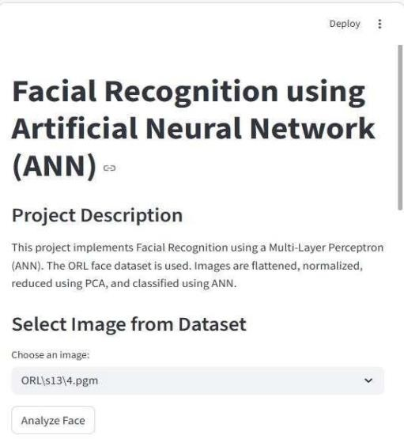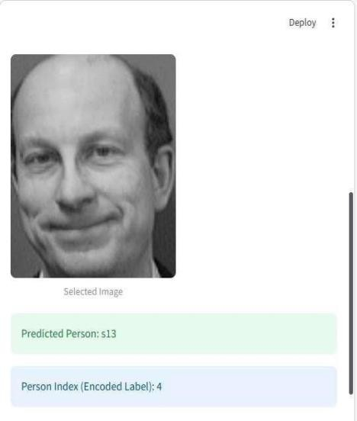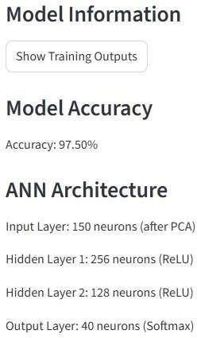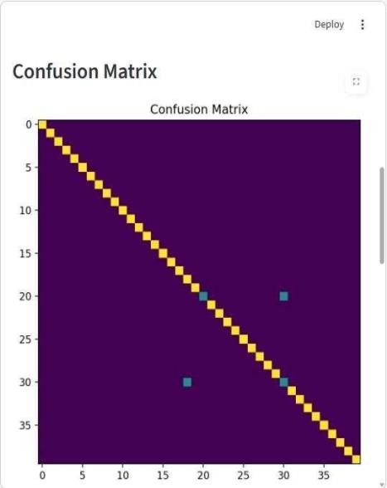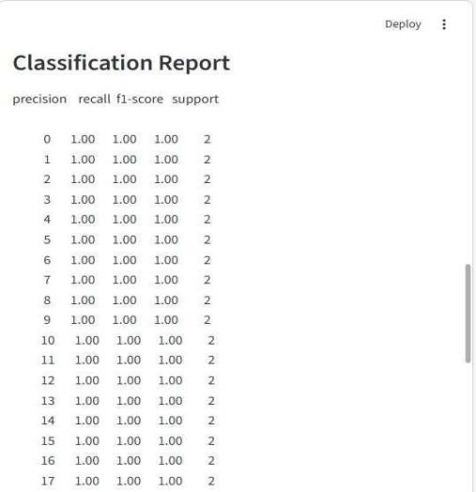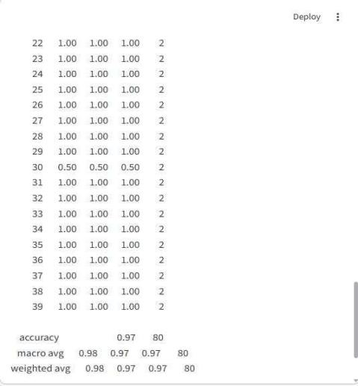

accuracy = data["accuracy"] image_paths = data["image_paths"]
faces = data["faces"]
# ==========================================
# USER INPUT SECTION
# ==========================================
st.subheader("Select Image from Dataset") selected_image_path = st.selectbox( "Choose an image:", image_paths )
if st.button("Analyze Face"):
img = cv2.imread(selected_image_path, cv2.IMREAD_GRAYSCALE)
img = cv2.resize(img, (92, 112))
img_flat = img.flatten().reshape(1, -1) / 255.0
img_pca = pca.transform(img_flat) prediction =
model.predict(img_pca)[0] person_name = le.inverse_transform([prediction])[0] person_index = prediction col1, col2 = st.columns(2) with col1: st.image(img, caption="Selected Image", width=250)
with col2:
st.success(f"Predicted Person: {person_name}") st.info(f"Person Index (Encoded Label): {person_index}")
st.subheader("Model Information") if st.button("Show Training Outputs"):
st.write("### Model Accuracy") st.write(f"Accuracy: {accuracy * 100:.2f}%") st.write("### ANN Architecture") st.write("Input Layer: 150 neurons (after PCA)") st.write("Hidden Layer 1: 256 neurons (ReLU)") st.write("Hidden Layer 2: 128 neurons (ReLU)") st.write("Output Layer: 40 neurons (Softmax)") st.write("### Confusion Matrix") cm =
confusion_matrix(data["y_test"], data["y_pred"])
fig, ax = plt.subplots(figsize=(8, 6)) ax.imshow(cm) ax.set_title("Confusion Matrix")
st.pyplot(fig)
st.write("### Classification Report")
st.text(classification_report(data["y_test"], data["y_pred"]))

PREPARATION | 20
IMPLEMENTATION | 30
VIVA | 15
RECORD | 10
TOTAL | 75

RESULT:
The ANN model was successfully trained and tested on
the ORL face dataset. The system correctly classified facial images with high accuracy (approximately 95–98%) and displayed the predicted person label (e.g., s30) along with its corresponding encoded index.
GITHUB LINK: https://github.com/deepan420/vidamuyarchi/upload/main

EXPT. NO: 10  DATE: | CHARACTER RECOGNITION USING MULTI-LAYER PERCEPTION

AIM:
To develop a handwritten character recognition system for A–Z alphabets using a Multi- Layer Perceptron (MLP) classifier trained on a labeled CSV dataset of 28×28 grayscale images.
DATASET DESCRIPTION:
Dataset: A–Z Handwritten Alphabets in CSV Format
Source: Kaggle
Dataset Link: A-Z Handwritten Alphabets in CSV Format
Overview: This dataset contains handwritten English alphabets (A–Z) represented as pixel values in CSV format.
PROPERTY | DESCRIPTION
Total Classes | 26 (A–Z)
Image Size | 28 × 28 pixels
Total Features | 784 pixel values
Format | CSV
Label Column | First column (0–25)
Feature Columns | Remaining 784 columns

ALGORITHM:
Step 1: Import required libraries such as Streamlit, Pandas, NumPy, and Scikit-learn.
Step 2: Load the CSV dataset into the program.
Step 3: Separate the label column (y) and pixel feature columns (X).
Step 4: Convert numeric class labels (0–25) into their corresponding alphabet characters (A–Z).
Step 5: Split the dataset into training and testing sets using train_test_split().
Step 6: Apply StandardScaler to normalize the feature values.
Step 7: Initialize the Multi-Layer Perceptron (MLP) classifier with 128 neurons in the hidden layer, ReLU activation function, and Adam optimizer.
Step 8: Train the MLP model using the training data.
Step 9: Evaluate the model performance using Accuracy, Precision, Recall, F1-score, and Confusion Matrix.
Step 10: Save the trained model using joblib for future use.
Step11: In Streamlit UI:
- Allow user to select an image from dataset
- Provide "Analyze" button

- Provide "Show Training Outputs" button
- Display training metrics and confusion matrix.

PROGRAM:
import streamlit as st
import pandas as pd
import numpy as np
from sklearn.model_selection import train_test_split
from sklearn.preprocessing import StandardScaler
from sklearn.neural_network import MLPClassifier
from sklearn.metrics import accuracy_score, precision_recall_fscore_support, confusion_matrix
import joblib
import matplotlib.pyplot as plt
import seaborn as sns
from PIL import Image
import os
st.set_page_config(page_title="Character Recognition using MLP", layout="wide")
st.title("Handwritten Character Recognition (A–Z)")
st.markdown("""
This project recognizes handwritten English alphabets (A–Z) using a Multi-Layer Perceptron (MLP) classifier trained on pixel data.
Upload a 28x28 grayscale character image for prediction.""")
st.markdown("---")
@st.cache_data
def load_data():
data = pd.read_csv("A_Z Handwritten Data.csv", nrows=50000).astype("float32")
return data
with st.spinner("Loading dataset..."):
data = load_data()
X = data.iloc[:, 1:].values
y = data.iloc[:, 0].values
letters = [chr(i) for i in range(65, 91)]
y_letters = np.array([letters[int(label)] for label in y])
model_exists = os.path.exists("model.pkl")
if not model_exists:
st.info("Training model for first time...")
X_train, X_test, y_train, y_test = train_test_split(
X, y_letters, test_size=0.2, random_state=42)
scaler = StandardScaler()
X_train = scaler.fit_transform(X_train)
X_test = scaler.transform(X_test)
mlp = MLPClassifier(
hidden_layer_sizes=(128,),
activation='relu',
solver='adam',

max_iter=100,
random_state=42
with st.spinner("Training MLP model..."):
mlp.fit(X_train, y_train)
y_train_pred = mlp.predict(X_train)
y_test_pred = mlp.predict(X_test)
train_accuracy = accuracy_score(y_train, y_train_pred)
test_accuracy = accuracy_score(y_test, y_test_pred)
train_precision, train_recall, train_f1, _ = precision_recall_fscore_support(
y_train, y_train_pred, average='weighted', zero_division=0)
test_precision, test_recall, test_f1, _ = precision_recall_fscore_support(
y_test, y_test_pred, average='weighted', zero_division=0)
test_cm = confusion_matrix(y_test, y_test_pred, labels=letters)
metrics = {
'train_accuracy': train_accuracy,
'train_precision': train_precision,
'train_recall': train_recall,
'train_f1': train_f1,
'test_accuracy': test_accuracy,
'test_precision': test_precision,
'test_recall': test_recall,
'test_f1': test_f1,
'confusion_matrix': test_cm
}
joblib.dump((mlp, scaler, metrics), "model.pkl")
st.success("Model trained and saved successfully!")
model, scaler, metrics = joblib.load("model.pkl")
st.subheader("Upload Character Image")
uploaded_file = st.file_uploader(
"Browse and upload a handwritten character image",
type=["png", "jpg", "jpeg"]
)
if uploaded_file is not None:
image = Image.open(uploaded_file).convert("L")
image = image.resize((28, 28))
image_array = np.array(image)
display_image = image_array.astype(np.uint8)
image_flat = image_array.reshape(1, -1)
image_scaled = scaler.transform(image_flat)
if st.button("Analyze Character"):
prediction = model.predict(image_scaled)
col1, col2 = st.columns(2)
with col1:
st.image(display_image, caption="Uploaded Image", width=200)
with col2:
st.success(f"### Predicted Character: {prediction[0]}")

OUTPUT:

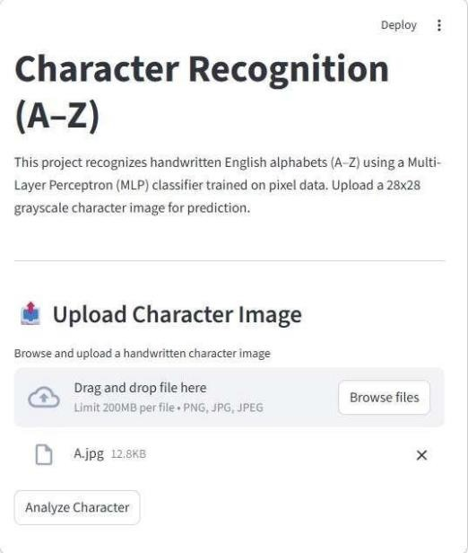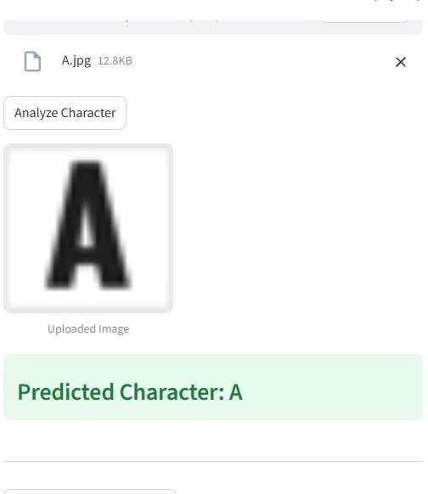

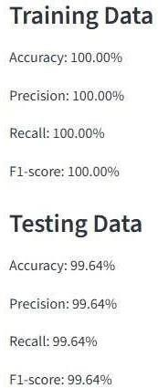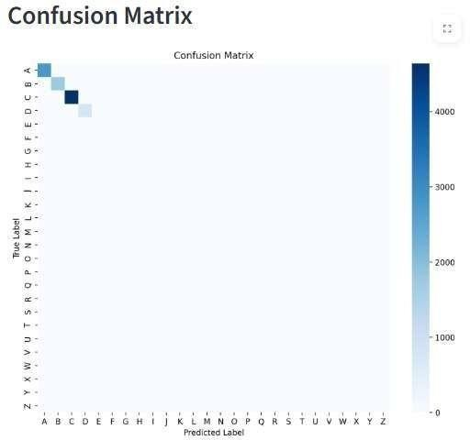

st.markdown("---")
if st.button("Show Training Outputs"):
st.subheader("Training Metrics")
col1, col2 = st.columns(2)
with col1:
st.markdown("### Training Data")
st.write(f"Accuracy: {metrics['train_accuracy']*100:.2f}%")
st.write(f"Precision: {metrics['train_precision']*100:.2f}%")
st.write(f"Recall: {metrics['train_recall']*100:.2f}%")
st.write(f"F1-score: {metrics['train_f1']*100:.2f}%")
with col2:
st.markdown("### Testing Data")
st.write(f"Accuracy: {metrics['test_accuracy']*100:.2f}%")
st.write(f"Precision: {metrics['test_precision']*100:.2f}%")
st.write(f"Recall: {metrics['test_recall']*100:.2f}%")
st.write(f"F1-score: {metrics['test_f1']*100:.2f}%")
st.subheader("Confusion Matrix")
fig, ax = plt.subplots(figsize=(10, 8))
sns.heatmap(
metrics['confusion_matrix'],
cmap='Blues',
xticklabels=letters,
yticklabels=letters,
ax=ax)
ax.set_xlabel("Predicted Label")
ax.set_ylabel("True Label")
ax.set_title("Confusion Matrix")
st.pyplot(fig)
plt.close()

PREPARATION | 20
IMPLEMENTATION | 30
VIVA | 15
RECORD | 10
TOTAL | 75

RESULT:
The Multi-Layer Perceptron successfully classifies handwritten A–Z characters with high accuracy. The model demonstrates strong performance in recognizing alphabet patterns from pixel data, achieving reliable classification results validated using accuracy, precision, recall, F1-score, and confusion matrix.
GitHub Link: https://github.com/deepan420/vidamuyarchi/upload/main

