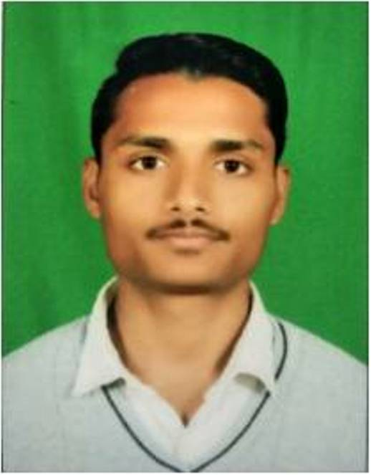

Amit Mathur

299,Sidh Mohalla

Sodal Road,Jalandhar-144001

Punjab (India).

Contact No: +91-8284083970

e-mail: amitmathur349@gmail.com

**CAREER OBJECTIVE**

I wish to have a challenging position where I can effectively contribute my skills and best

possible use of my potential in the field of Information Technology for the sublime growth of your deputed organization.

**ACADEMIC PROFILE**

|  |  |  |  |
| --- | --- | --- | --- |
| **Degree** | **Board/University** | **Year of Completion** | **Percentage/CGPA** |
| Bsc-IT | GNDU | 2020 | 65 |
| 12th(science) | PSEB | 2017 | 60 |
| 10th | PSEB | 2015 | 78.30 |

**TECHNICAL SKILLS**

**Programming:** Basic Knowledge of (C , C++ , Python , Java)

Great Knowledge of HTML , CSS , BOOTSTRAP , JAVASCRIPT , CORE PHP.

Database Known: MYSQL

**SPECIALIZATION:**

Specialization in HTML , CSS , BOOTSTRAP , CORE PHP AND MYSQL.

**ADDITIONAL SKILLS**

* Ability to handle complex tasks.
* 45 days of php course from Aegis Institute.
* One month training for web designing course from doaba college.

**WORK EXPERIENCE**

Currently Working on a Project for the College Event Management System.

**LANGUAGES KNOWN**

Hindi and English.

**HOBBIES**

* Eager to Learn new things.
* Like to code.
* Listening songs,watching movies.

**PERSONAL DETAILS**

**Father’s Name:** Mr. Raj Kumar

**Mother’s Name:** Smt. Kanti Devi

**Date of Birth:**  13 May, 1999

**Declaration**

I hereby declare that the above mentioned information is correct up to my knowledge and I bear the responsibility for the correctness of the above mentioned particulars.

**Date: [Amit Mathur]**

**Place:**