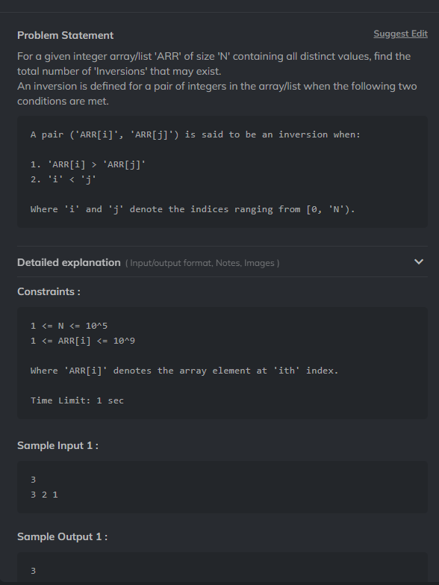
import java.util.* ;
import java.io.*;
public class Solution {
public static long getInversions(long arr[], int n) {
long count = divide(arr, 0, n-1);
return count;
}
private static long divide(long[] arr, int lo, int hi) {
long count = 0;
if(lo == hi) return count;
int mid = lo + (hi - lo) / 2;
count += divide(arr, lo, mid);
count += divide(arr, mid + 1, hi);
count += merge(arr, lo, mid, hi);
return count;
}
private static long merge(long[] arr, int lo, int mid, int hi) {
int count = 0;
ArrayList<Long> temp = new ArrayList<>();
int left = lo;
int right = mid + 1;

while(left <= mid && right <= hi) {
if(arr[left] <= arr[right]) {
temp.add(arr[left]);
left++;
} else {
temp.add(arr[right]);
right++;
count += (mid - left + 1);
}
}

while(left <= mid) {
temp.add(arr[left++]);
}

while(right <= hi) {
temp.add(arr[right++]);
}

for(int i = lo; i <= hi; i++) {
arr[i] = temp.get(i - lo);
}
return count;
}
}

