**UCS548**

**Data Science Fundamentals**

Dashboard in Tableau

**Deepankar Varma**

**102003431, 3CO17**

Topic :

**San Francisco Airport Analysis**

Submitted To :

**Dr. Geeta Kasana**



Link to Tableau Dashboard :- <https://public.tableau.com/app/profile/deepankar.varma/viz/SFOFlight_16693065605440/SFOFlightDataDashboard>

Data Cleaning

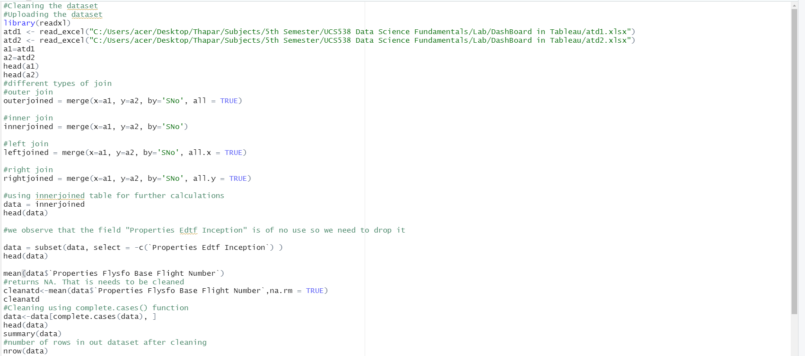



Environment Variables

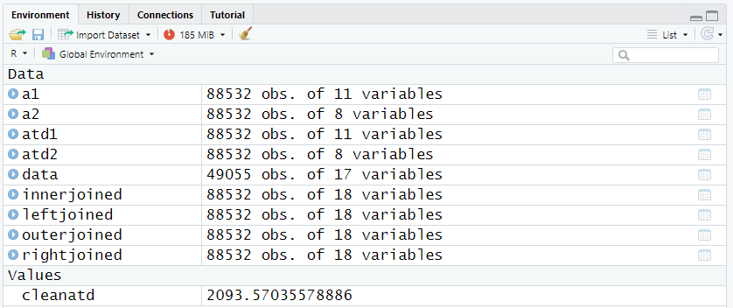

DashBoard in Tableau

