**ITE5315 Assignment 4**

**Submission Deadline:** Sunday, Nov 26 @ 11:59pm

**Assessment Weight:** 7% of your final course Grade

**Objective**: To explore more on developing db-driven Node/Express app

**Description:** Using the concepts of week8,9,10 we are going to develop a new Node/Express app program extracting data from databases. We are going to design a simple app and using MongoDB Atlas based on the given instructions on Q1 and Q2.

**Question 1)** You are asked to develop a sample Node/Express app which interact with MongoDB database in Atlas. Complete the following steps and take screenshot of the outcome of each step:

**Step1:** Create new Node/Express app (in new folder named “Asn4-mongo-yourname”) as follow:

* Add the following dependencies to your project

|  |  |
| --- | --- |
| o | "dependencies": { |
| o | "express-validator": "^6.14.2", |
| o | "express": "^4.18.1", |
| o | "mongoose": "^6.7.2" |
| o | } |

* Make sure to have the following project structure:

|  |  |
| --- | --- |
| Create a “config” folder which contains  “database.js” (will be used for database connection parameters for Mongodb.)    Create “models” folder which contains “employee.js” (will be used to create employee schema and model.)    Create “app.js” in the project root.    Make sure to have proper project settings and dependencies in “package.json” |  |

**Step2:** Using the attach file (codenippet-mongo.txt), copy/paste the related code to “config/database.js”, “model/employee.js”, and “app.js”.

* *Note: Create a new MongoDB database in your local machine and update the “url” in database.js accordingly*

**Step 3**: Run the application and test it using the following routes:

* A) Open Postman, choose POST method and use the url <http://localhost:8000/api/employees> o In the Body, choose “x-www-form-urlencoded” and add three pair of key values as follow o Click on send. What is the output?

o

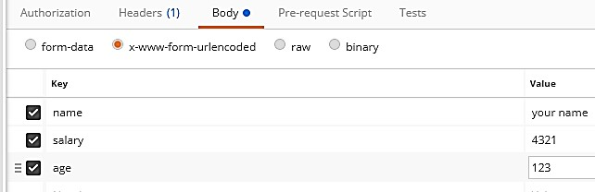

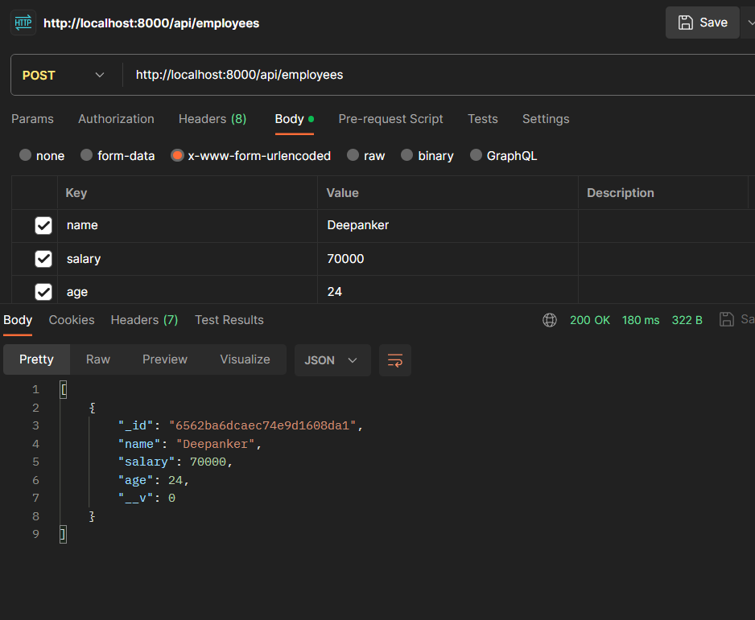

* + Check the console in VScode, what is the output?



* + Check the Compass, is the new record added to “Employee” collection in Database?

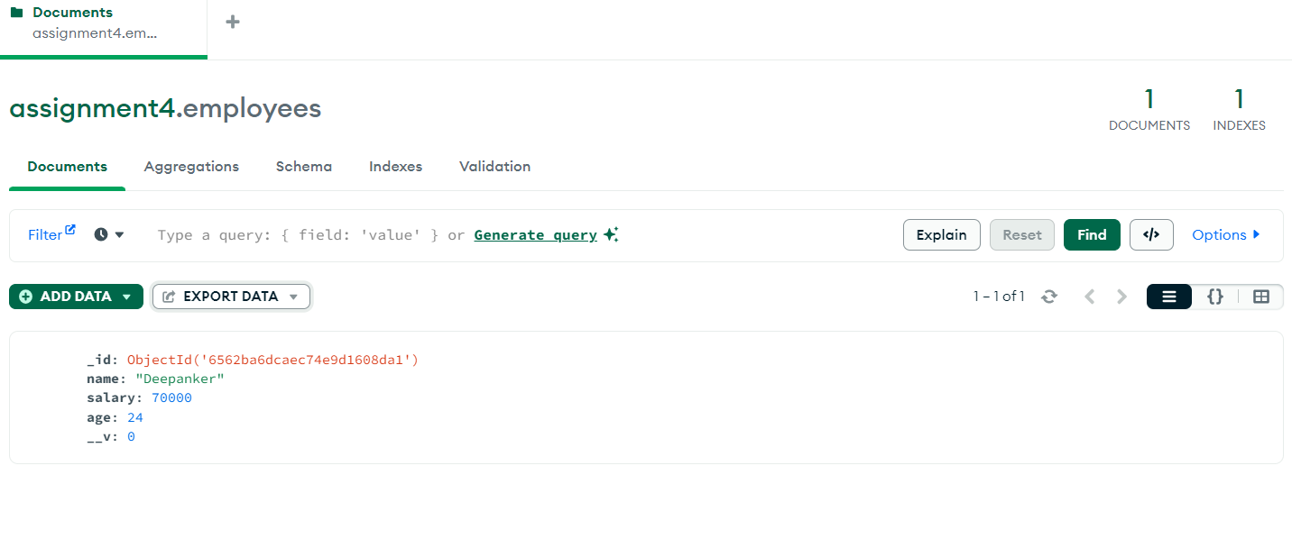

* B) Open browser and enter <http://localhost:8000/api/employees>. What is the output?

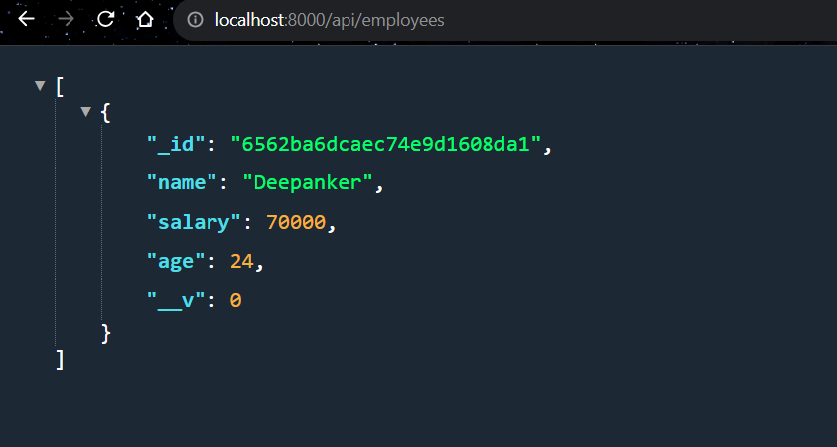

* C) Using any _id of any employee records in database, run the following query in the browser:
  + <http://localhost:8000/api/employees/618cf962f36b27c5379212b7>. What is the output?

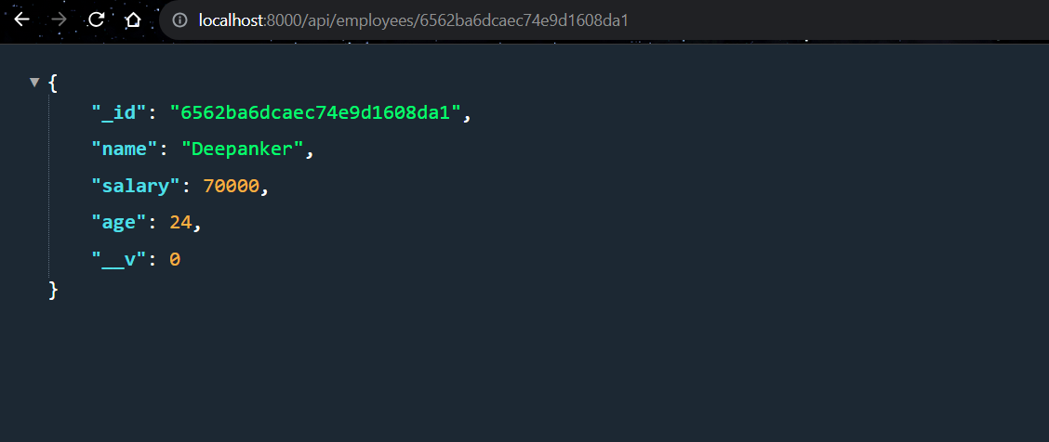

**Step 4**: Base on your observation, answer the following questions:

1. How does the Step3:A, B,C work? Explain the work flow, route, and the way the query executed.

Step A) For post request our post function is running for path (api/employees )

In this post function first we are printing the body of the request which contsians are key value pairs then we are creating the employee object of Employee schema which we have imported from another file and the create function also have a callback function which get and return all the employees after newly created employe record.

Step B) Its basically performing the second part of post function again by usig same concept we are printing all the current employess in our database

Step C)

let id = req.params.employee_id;

We are basically extracting employeeid from parameter provided in the route and using the findbyid function to get particular employee information.

1. What is the role of:
   1. module.exports = mongoose.model('Employee', EmpSchema);

It is basically exporting employee model created on the bases of empsxhema schema

* 1. Employee.findByIdAndUpdate

This is basically used for updating info of particular employee . This is used when we pass employee id as well as the data of employee in post request

1. Using the idea of Step3:C, try to update one of the record in the employee table .Find related route ☺ in the code and explain how it works.

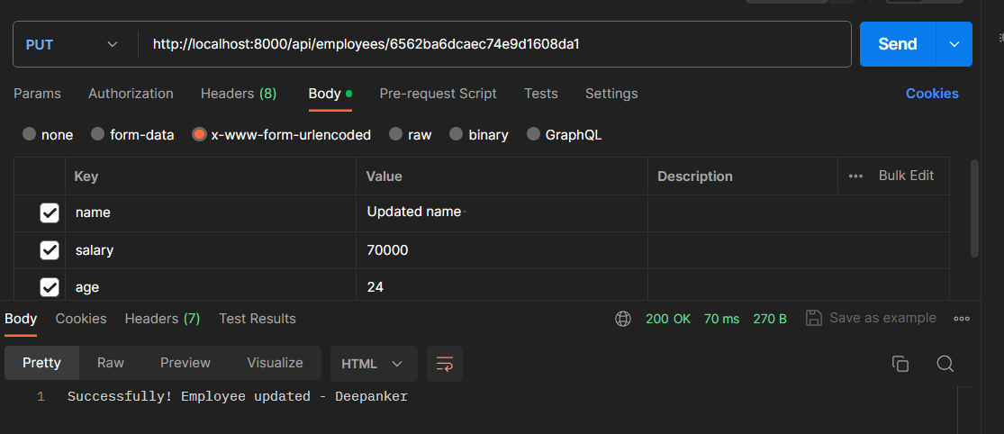

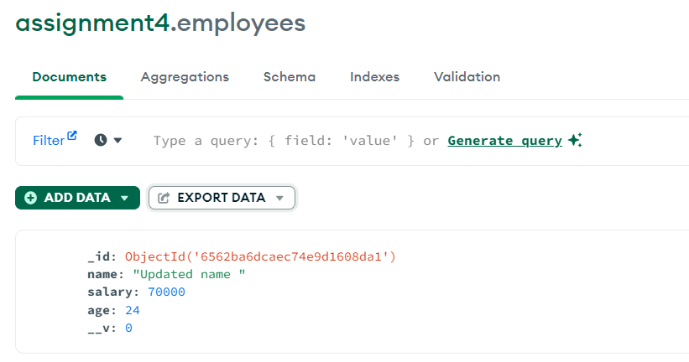

1. Using the idea of Step3:C, try to delete one of the record in the employee table. Find related route ☺ in the code and explain how it works.

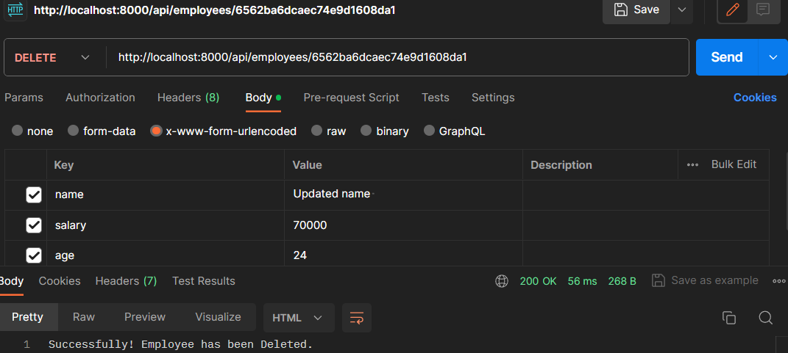

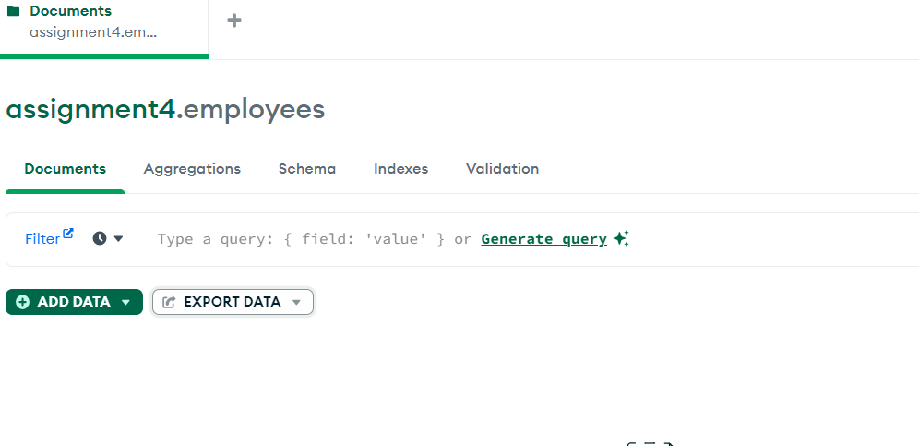

*Note:*

* 1. *It is important to explain how this app works in your video demonstration*

**Question 2)** You are asked to redesign Question 1 by using the given dataset of Assignment2.

* Step 1: Create a new MongoDB database in Atlas based on the given dataset of Assignment2.
* Step 2: Redesign the route/code in Question1 and set it up to work with invoice-data instead of employee data.
  + - You may need to change the “model” and routes.
    - Your app should have the following features and Demonstrate how app works using Postman/ThunderClient. (similar to Q1):
      * Show all invoice-info

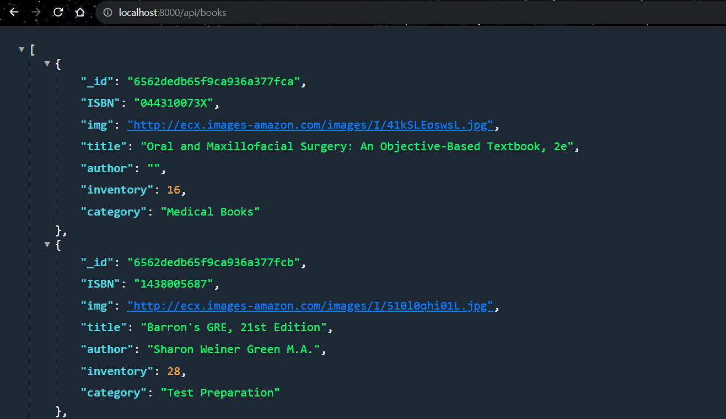

* + - * Show a specific invoice (based on the _id or invoiceID)

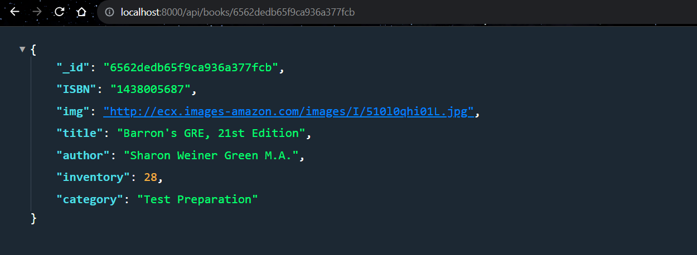

* + - * Insert a new invoice

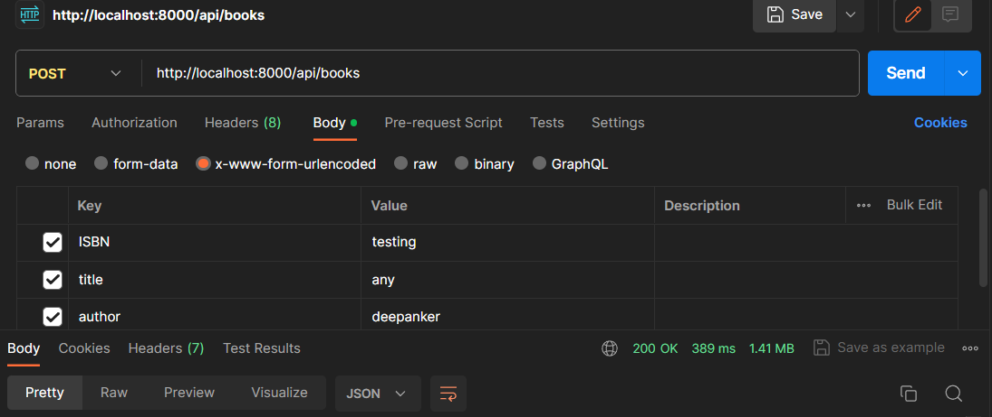



* + - * Delete an existing invoice (based on the _id or invoiceID)

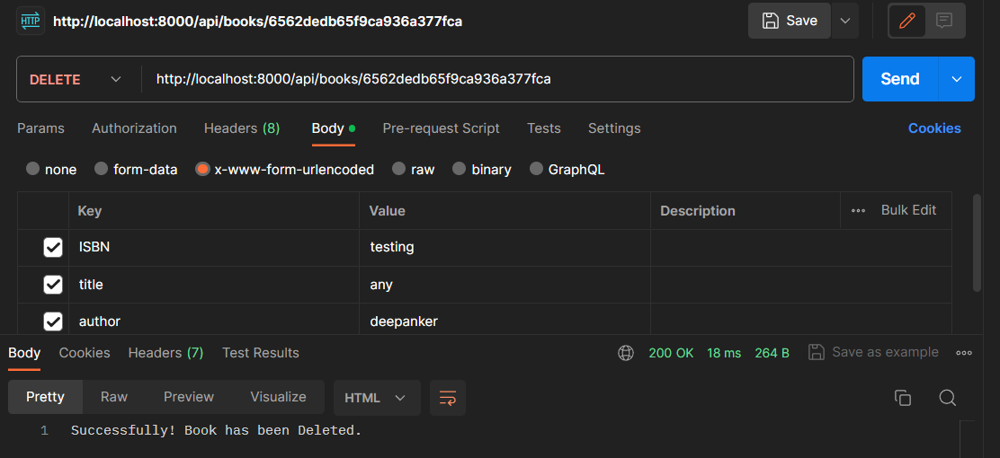

* + - * Update “Customer type” & “unit price” of an existing invoice (based on the _id or invoiceID)

As Customer tpe and unit price is not there is given data

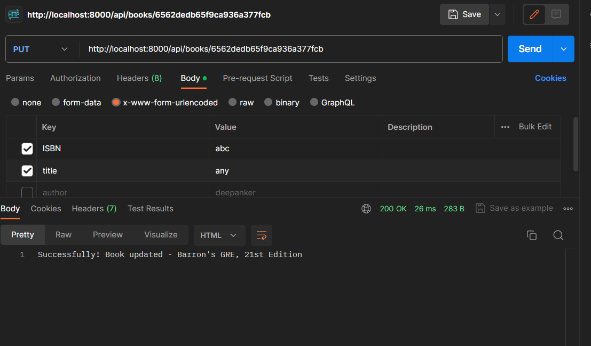

o Using Handlebar and Form complete the followings (*hint:use ideas from Assingment2*):

* + - * Show all invoice-info
      * Insert a new invoice
* Step 3:Using your creativity, Add a new functionality to this app.
* Step 4: Deploy the Question2 app (Cyclic)
* *Note:* o *It is important to explain how this app works in your video demonstration.*

**Question 3)** Open the attached sample JS file. This program use setTimeout() to simulate a running two tasks in asynchronous way. Complete the following steps

* Step 1: and run it using nodemon. Look at the output of the program.

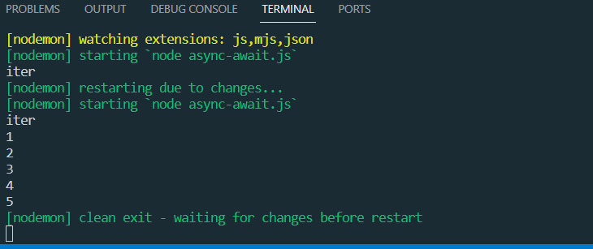

* Step 2: What if you remove wait from Task1, any error? Explain what have you learned.
* Step 3: What if you remove all await/async from the task1 and 2. How do you explain changes in the output compare to Step 1?
* Step 4: Bonus: Can you design the given functionality/program using Promise?

Assignment Submission:

* Add the following declaration at the top of .js files

/****************************************************************************** ***

* + ITE5315 – Assignment 4
  + I declare that this assignment is my own work in accordance with Humber Academic Policy. * No part of this assignment has been copied manually or electronically from any other source * (including web sites) or distributed to other students.

*

* + Name: ___________________ Student ID: _______________ Date: ____________________

*

*

******************************************************************************

**/

* Compress (.zip) the files in your Visual Studio working directory (this is the folder that you opened in Visual Studio to create your client side code).

Important Note:

* Submitted assignments must run locally, ie: start up errors causing the assignment/app to fail on startup will result in a **grade of zero (0)** for the assignment.
* **LATE SUBMISSIONS for assignments**. There is a deduction of 10% for Late assignment submissions, and after three days it will grade of zero (0).
* Assignments should be submitted along with a video-recording which contains a detailed walkthrough of solution. Without recording, the assignment can get the maximum of 1/3 of the total.