"Adaptive AI-Enabled Humanoid Robotic System for Therapeutic and Educational Interventions in Children with Autism Spectrum Disorder"

DEEPAN CHANDRASEKARAN
KL UNIVERSITY
2300032731@kluniversity.in

Abstract

This paper presents NeuroDott, a low-cost adaptive Agentic Ai system for therapeutic engagement and cognitive intelligence for autism and other neurodiverse disorders (ADHD, ASD). NeuroDott is an emotion aware AI companion that is engineered to deliver a safety first and offline capable therapeutic system and personalized learning method for two clinical population, Neurodiverse children and individuals with progressive neurological conditions such as frontotemporal dementia, Parkinson disease, brain injury. A companion clinical dashboard provides therapists and family members with session analytics like mood detection, engagement tracking, learning progress metrics, and reinforcement adaptation signals. [7][8]

- Introduction

Many children with autism, Down syndrome, ADHD, and cerebral palsy, do not have access to the help that is required. These children often require one-on-one time with a trained therapist. It is hard for them to get this help because therapists are expensive, and there aren't enough of them. Robots and computer programs that can engage with people are being used as a basic interaction tool and was not built specifically for children with autism. Most of these systems are not suitable for therapy because they are not safe and these systems produce unpredictable outputs as response while interacting. NeuroDott is designed to be safe and predictable. It uses artificial intelligence governed by a set of rules (Harness), ensuring it behaves as expected. This system is designed to help the children in a safe and secure way possible. It also has a system that controls how it interacts with children. It can track a child's feelings and how they interact. It does not send any information to the cloud; it is private. It can work with systems that assist children in learning and receiving therapy.AI systems that can engage in conversation have also been utilized in schools and hospitals. These systems can have conversations that feel natural, but they can also be unpredictable, which can be problematic when working with special children.
Some systems can analyze a child's feelings and adjust their actions and response in a conversation accordingly.
- LITERATURE REVIEW

The research on robotic assistance, also known as Assistive AI and Therapeutic Robotics, has shown that it can really help people who are neurodiverse. Scassellati and his team discovered this back in 2012. In 2013, Mubin and his team suggested that robots should understand people in a more natural way by observing their eye movements, gestures, and surroundings. Most of the robots currently helping people need to be connected to the internet to function. However, NeuroDott is different because it can operate without an internet connection. It is still very hard to analyze a child’s feeling and the emotional state with robotic assistance. In 2011, Bidwell and Fuchs developed a method to analyze the attention by tracking where someone is looking. Recently, they have started combining various signals, such as where the child is looking, the position of their head, their facial expressions, and their body posture to better understand their level of engagement and also limited emotional state. NeuroDott, use a method to measure engagement based on factors like, the position of the [1]
Face with respect to the robot or the screen that displays the
Content, the gaze towards the camera and the screen, the hand moments, the posture of the children. Then this information is analyzed to calculate the score of engagement during a session.
- METHODOLOGY

NeuroDott was crafted with several parts identically before they were all put together. So, the interaction with NeuroDott goes through several steps: it listens what you say, tries to understand how you feel now, decides what to do now and acts accordingly. When you interact with NeuroDott, it listens using microphone, then it uses a program to understand your speech. This program runs on the device, so it works as fast it can. Same time the system can accurately distinguish between human speech and background noise. NeuroDott is enough capable to analyze the feeling of person using their tone when they are interacting. It surfs for words that may relate or indicate your feelings. By concluding the speech pattern and tone of voice it ensures the system is not mislead by some unclear or context-dependent speech inputs. NeuroDott gives supportive encouragement to the users, and it is able to give the feel of mother's love and care, as it works calm and composed way the engagement with users creates a friendly environment, and also NeuroDott learns adaptability that suits for user and it keeps on observing your reaction and what you accomplish. NeuroDott won't stores unnecessary datas that goes useless, instead it inherits only the thing user likes and expect during the session, it keeps track of how user behave, how user feel and it establish the result accordingly. As NeuroDott deals with health and well being, The creators focused on safety as first priority, and trained the model with certain rules that prevents by saying fowl or improper words to the user, and also, they ensure NeuroDott does not try to analyze users feeling and it won't try to convey what user feels or think during the session.
- SYSTEM ARCHITECTURE

NeuroDott system is designed as a safety-oriented modular and microservice architecture, that divides perception, reasoning, inference, language generation and database operations into separate micro systems that serves independently without any biased pressure on hardware such as RAM, GPU and CPU. This independent behavior ensures that behavioral decisions and inference remain independent and deterministic while enabling the conversation with the child in a natural language. NeuroDott operates entirely local without any external Api calls to any LLM inference providers and integrates live speech interactions, emotion detection, engagement score tracking and child preference injection. [7][8]

- SYSTEM OVERVIEW

The NeuroDott consists of multiple layers of actions and programs, the five primary layers are:
- User Interface Layer
- Perception Layer
- State Management Layer
- Decision and Regulation Layer
- Narrative Generation Layer
Each layer performs tasks independently with a specific task function and communicate with each layer through an event-driven pipeline. From the highest layer the system receives interactions through the react web interface, this information is transmitted to the backend services. The architecture offers modular independence. So, Vision processing, speech recognition, and dialogue generation will not interfere in the heavy workload of the whole system in real time. [4]
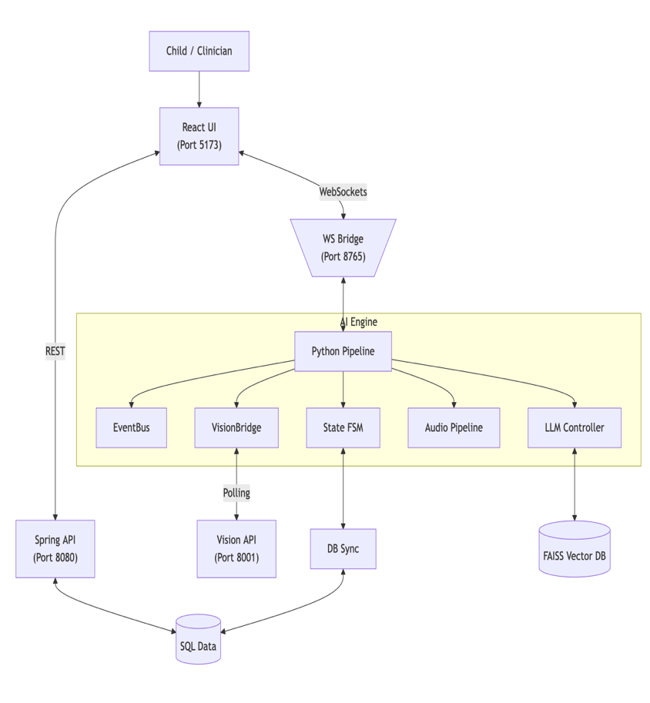
Figure 1: NeuroDott System Overview

- PERCEPTION LAYER

The perception layer ensures in capturing and analyzing the signals from the environment including the children. This includes speech, facial alignment, gesture detection, gaze detection and environmental context using a VLM. This subsystem captures user input in the form of speech through a microphone and processes it using a Speech to Text (STT)model. Voice Activity Detection (VAD) ensures that only meaningful speech is processed by filtering noise from the background. At the same time, the vision perception module analyzes real-time camera input to find and decide the engagement and attention scores of the child. [4]

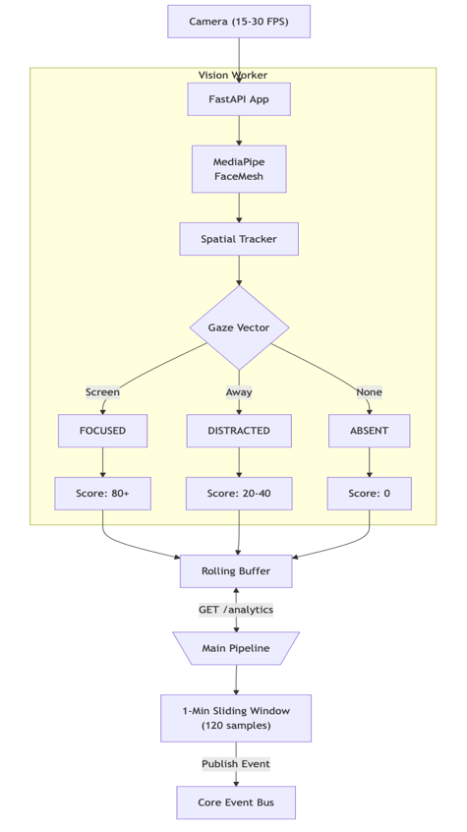
Figure 2:Vision Perception Pipeline
The perception subsystem operates at 15-30 fps and uses MediaPipe facial tracking to estimate head pose and gaze direction. Based on the gaze vector and the pose detector with eye contact detection, the system classifies into three engagement stages: [5]
- Focused
- Distracted
- Absent
These states are converted to numbers that represent the engagement scores within the range of 0 and 1. A sliding window mechanism collects engagement observations over a one-minute interval, that allows a stable engagement metric that can affects the system’s response behaviour.

- SESSION STATE MANAGEMENT
To maintain continuous interaction without loss of context, NeuroDott uses a structured session state manager that keep tracks the current interaction between the child and the system.
The session state stores key variables including:
- Current learning concept
- Difficulty level
- Interaction turn count
- Emotional trends [7][8]
- Engagement trends
- Reinforcement history

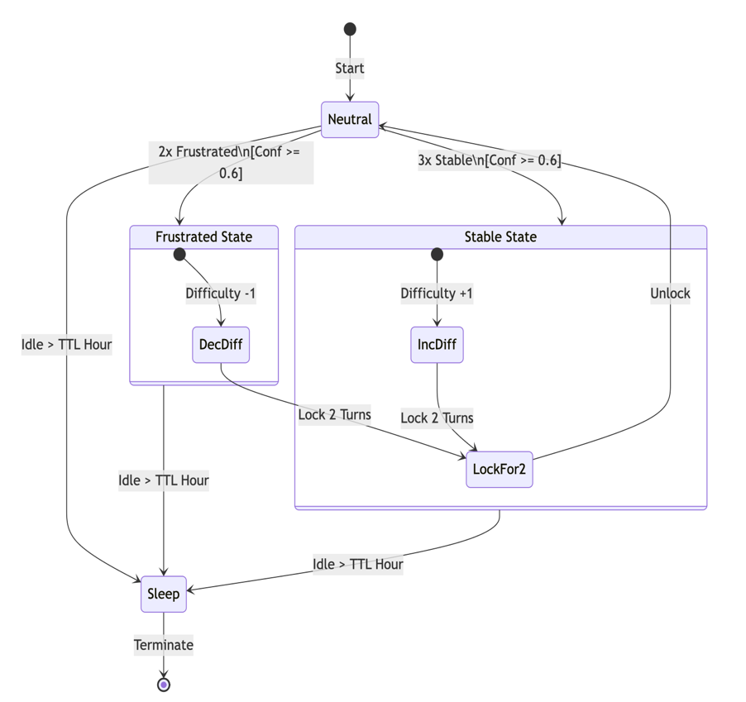
Figure 3:Session State Machine

This micro service regulates change between stable and frustrated interaction States. Difficulty changes occur only when emotional signal changes occur for multiple times. To prevent oscillation between states, a basic cooldown time is integrated after each difficulty adjustment. This approach ensures that this subsystem is more likely to be predictable. [7][8]

- PROMPT ARCHITECTURE AND LANGUAGE GENERATION

The language generation module will produce natural conversational responses while maintaining the deterministic rules in the system prompt. The system uses a structured prompt architecture that injects deterministic guidance into every generation request. Each response is constructed by the following components:
- System rules (define safety constrains and boundaries)
- Recovery strategy (defines tone adjusting and pacing from regulation engine)
- Reinforcement style (defines encouragement style)
- Learning context (defines the current concept, mastery level and session progress)
- Vision summary (recent engagement signals from perception layer)
- Conversational history (recent ‘N’ dialog context)
- Live User input (latest translated input from the child)
These segments are combined by a prompt caching system to reduce redundant token processing and improve speed and response latency.

- MEMORY ARCHITECTURE

To enable both long-term and short-term personalization without affecting the privacy and inference quality, NeuroDott uses a layered memory architecture. The memory system consists of six layers:
- Immediate turn buffer
- Rolling session buffer
- Session summary
- Session state memory
- Long-term memory
- Vector memory
Semantic memory is used optional for recalling story elements or contextual knowledge. Important feature is that the system will never store raw speech transcripts. Instead, the engagement scores, behavioural patterns and metrics are stored in structured
form to protect user privacy and biased response that leads to judging of the child’s personality.

Table 1: Tables and Contents
Table | Contents
users | User ID, instruction depth baseline, TTS speed preference
learning progress | Mastery level (0–5) per concept, attempt counts, success rate
emotional metrics | Frustration / Recovery / Stability event counts with weekly decay (0.95×)
child preferences | Likes and dislikes (max 20 entries, JSON array, 6-month soft expiry)
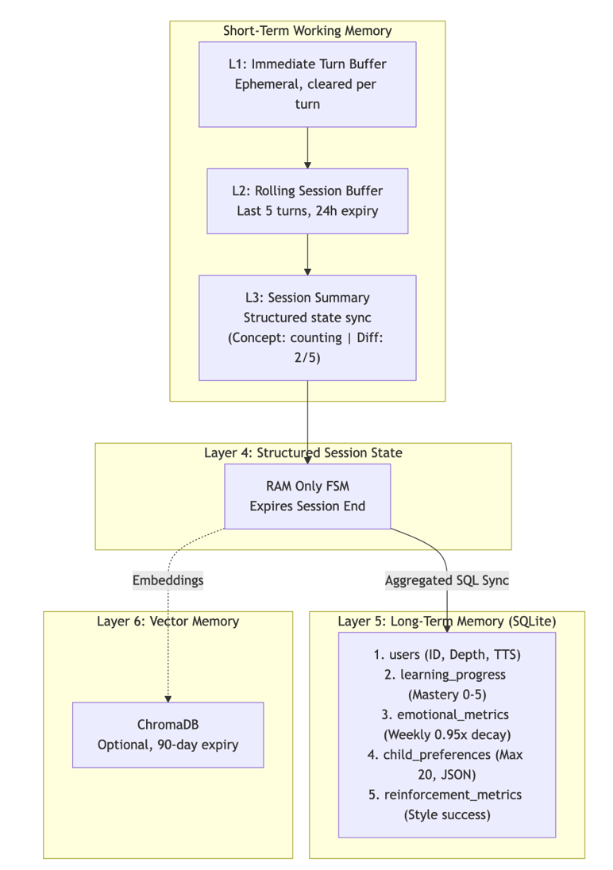
Figure 4: Memory Architecture
- EMOTIONAL DETECTION AND ENGAGEMENT SCORING

The most crucial and important aspects for adaptive interaction is to identify the exact emotional state of the child. The system uses a multimodal emotion detection pipeline that combines speech analysis and visual perception signals. Signals like Textual analysis, Audio patterns, pitch pattern of the input voice and visual Cues are combined through a fusion module that estimates emotional confidence. If the level of confidence crosses the defined adaptive threshold, the system delivers a mood classification. Else, the system falls to a neutral interaction strategy. This conservative design reduces the risk of incorrect emotional inference. Child engagement is continuously measured through a combination of gaze detection, posture estimation and gesture recognition. Engagement scores are calculated by specific weights times detected signals. [7][8]

Equation 1:Confidence of engagement
$$Engagemtent=\left((0.45*FacePresence\right)+\left(0.45*Gaze\right)+(0.10*Gesture))$$

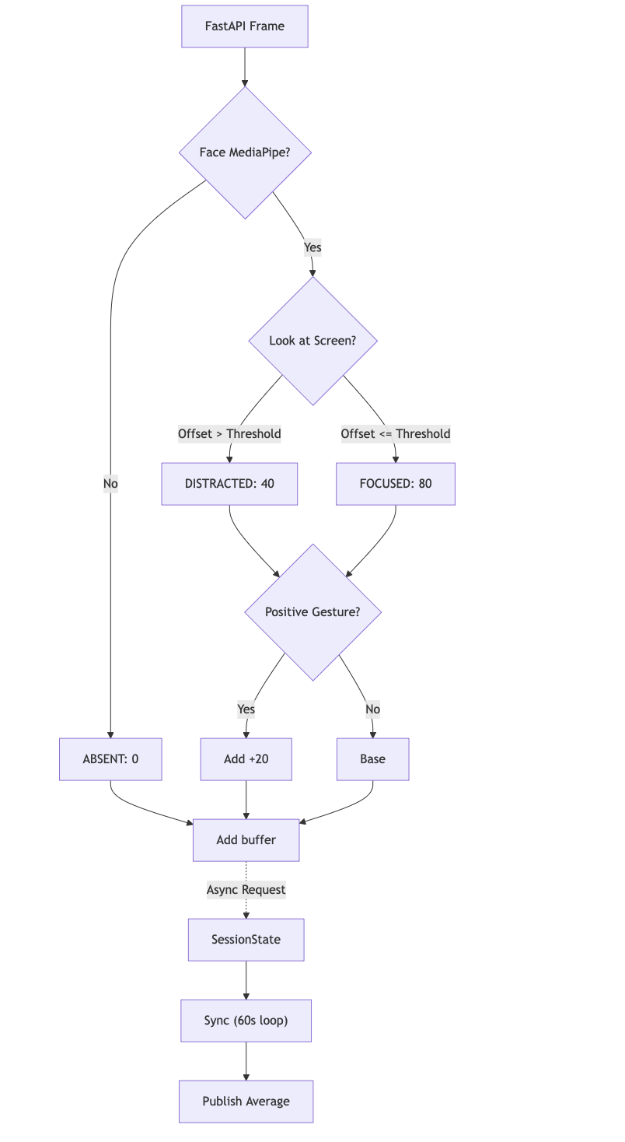
Figure 5: Engagement Scoring Algorithm

- EXPERIMENTAL RESULTS AND EVALUATION

Latency was measured over 20 simulated conversation turns on a system with local GPU and a camera capture thread. The table:1 summarizes the percentile latencies across pipeline stages. The vision microservice sustains 15 fps at 640x480 with the full pipeline active (Face Mesh, Hands, solvePnP, YOLO/3 frames, Insight Face/30 frames) on the GPU CUDA configuration. The /latest endpoint response time measured under 4 Ms across 1,000 consecutive requests, satisfying the design target of under 10 Ms. The vision microservice sustains 15 fps at 640x480 with the full pipeline active (Face Mesh, Hands, solvePnP, YOLO/3 frames, Insight Face/30 frames) on the GPU configuration. Table 2 shows subsystem timing contributions. /latest endpoint response time measured under 4 Ms across 1,000 consecutive requests, satisfying the design target of under 10 Ms.

Table 2: Subsystem latency
Subsystem | Mean (Ms) | Run Frequency
MediaPipe FaceMesh + solvePnP | 18 | Every frame
MediaPipe Hands + gesture rules | 11 | Every frame
YOLOv8n object detection | 28 | Every 3 frames (adaptive)
InsightFace embedding verify | 9 | Every 30 frames
EngagementTracker + AttentionFSM | <1 | Every frame

Mood classifier accuracy was assessed against a scripted utterance corpus of 220 items covering the four non-neutral moods (happy, frustrated, sad, anxious) plus 60 neutral fillers and 40 negated mood expressions. Table:3 reports per-class precision and recall under the full (text + audio) fusion and under text-only mode. Audio fusion consistently improves precision and recall across all non-neutral classes by three to six percentage points. Negated expressions (e.g., 'I do not hate this') are correctly classified as neutral in 93 percent of cases owing to the three-token negation window applied before keyword matching. The temporal smoothing window further reduces false mood transitions: in a 50-turn scripted session with five deliberate single-utterance mood spikes, zero spurious difficulty changes were triggered.

Table 3: Accuracy chart of different moods
Mood | Text Precision | Text Recall | Fusion Precision | Fusion Recall
Happy | 0.88 | 0.84 | 0.91 | 0.88
Frustrated | 0.82 | 0.79 | 0.86 | 0.83
Sad | 0.78 | 0.75 | 0.83 | 0.80
Anxious | 0.76 | 0.72 | 0.82 | 0.78
Neutral (incl. negated) | 0.91 | 0.93 | 0.92 | 0.94
Macro average | 0.83 | 0.81 | 0.87 | 0.85

The largest processing delay occurs during the large language model inference generation, while perception modules operate with less latency. Overall system latency remains within acceptable limits for conversational interaction.

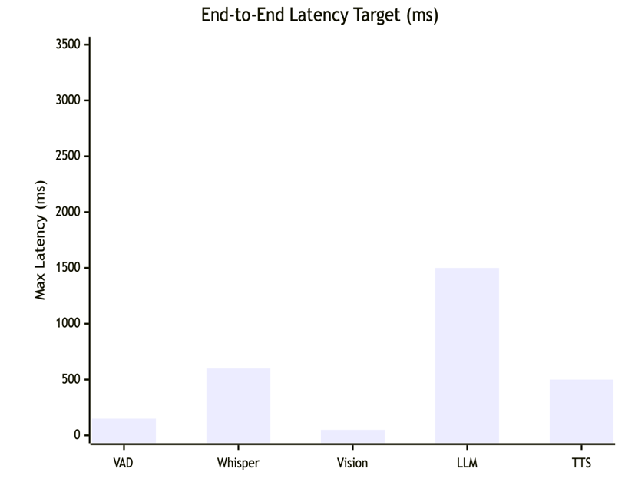
Figure 6:Latency of subsystems
- ADVANTAGES

The proposed NeuroDott system delivers several key advantages compared to the traditional conversational AI systems and conventional assistive systems that lack personalization of child’s preference for neurological and neurodiverse individuals. It is a privacy first architecture, it is fully offline capable architecture that includes operations like speech processing, emotion detection, language generation run locally. Unlike other modern conversational agentic AI systems that depends on unpredictive generative reasoning, NeuroDott separates decision-making from language generation. It does not make decisions; it generates natural language that depends on deterministic rule which is more predictable than other modern AI system. It can dynamically adapts difficulty and reinforcement strategies based on the child’s engagement and emotional state at the moment. [3]

- CONCLUSION

The recent growth in the field of AI and robotics have enabled better language and dialogue generation for regular conversational system, but existing systems lack in safety guardrails to deal with special children for safe interaction with sensitive individuals. To resolve the unpredictability of the existing systems, NeuroDott is introduced, a privacy first adaptive therapeutic system designed specifically for structured interaction with neurodiverse children and individuals with neurological problems. The system includes several microservices including live speech translation, multimodality emotional state detection, adaptive throttling, engagement tracking using computer vision, reinforcement adaptation with more accurate memory management. These components are connected and communicated through a pipeline which allows the system to adapt interaction strategics based on user engagement and emotional signals and engagement scores while maintaining the safety constraints strictly. Future work will focus on the expansion of the system through clinical evaluation with neurodiverse individuals to measure social impacts and changes in real time. By integrating embodied robotic platforms for physical interactions rather than a digital interaction and expanding the language support to multilingual environment .By combining structured intelligence with modern AI capabilities, NeuroDott represents a step towards scalable, safe and privacy first therapeutic environment.

- REFERENCES

[1] Scassellati, Brian, Henny Admoni, and Maja Mataric. “Robots for use in autism research.” Annual Review of Biomedical Engineering 14 (2012): 275–294. [1]
[2] Dautenhahn, Kerstin. “Socially intelligent robots: Dimensions of human–robot interaction.” Philosophical Transactions of the Royal Society B 362, no. 1480 (2007): 679–704. [2]
[3] Fitzpatrick, Kathleen K., Alison Darcy, and Molly Vierhile. “Delivering cognitive behavior therapy to young adults with symptoms of depression and anxiety using a fully automated conversational agent.” JMIR Mental Health 4, no. 2 (2017): e19. [3]
[4] Radford, Alec, Jong Wook Kim, Tao Xu, Greg Brockman, Christine McLeavey, and Ilya Sutskever. “Robust speech recognition via large-scale weak supervision.” In International Conference on Machine Learning, 2023 [4]
[5] Lugaresi, Camillo, Jiuqiang Tang, Hadon Nash, Chris McClanahan, Esha Uboweja, Michael Hays, Fan Zhang, Chuo-Ling Chang, Ming Yong, Juhyun Lee, and Matthias Grundmann. “MediaPipe: A framework for building perception pipelines.” In Proceedings of the IEEE/CVF Conference on Computer Vision and Pattern Recognition Workshops, 2019. [5]
[6] Jocher, Glenn, Ayush Chaurasia, and Jing Qiu. “Ultralytics YOLOv8.” Ultralytics Documentation, 2023. [6]
[7] Picard, Rosalind. Affective Computing. Cambridge, MA: MIT Press, 1997.
[8] Calvo, Rafael A., and Sidney D’Mello. “Affect detection: An interdisciplinary review of models, methods, and applications.” IEEE Transactions on Affective Computing 1, no. 1 (2010): 18–37.
[9] Baltrušaitis, Tadas, Chaitanya Ahuja, and Louis-Philippe Morency. “Multimodal machine learning: A survey and taxonomy.” IEEE Transactions on Pattern Analysis and Machine Intelligence 41, no. 2 (2019): 423–443. [9]
[10] Brooke, John. “SUS: A quick and dirty usability scale.” In Usability Evaluation in Industry, edited by P. Jordan et al., 189–194. London: Taylor & Francis, 1996. [10]
[11] Satyanarayanan, Mahadev. “The emergence of edge computing.” Computer 50, no. 1 (2017): 30–39. [11]
[12] Wei, Jason, Xuezhi Wang, Dale Schuurmans, Maarten Bosma, Brian Ichter, Fei Xia, Ed Chi, Quoc Le, and Denny Zhou. “Chain-of-thought prompting elicits reasoning in large language models.” In Advances in Neural Information Processing Systems (NeurIPS), 2022.

