Todo Application with Basic CRUD Operations

PROJECT REPORT

Submitted by

Deepansh Kainth–UID:23BAI70184

in partial fulfilment for the award of the degree of

Bachelor of Engineering
(Computer Science and Engineering)
IN


Specialization in Artificial Intelligence and Machine Learning


Chandigarh University
October,2025


BONAFIDE CERTIFICATE

Certified that this project report “To-Do List application” is the bonafide work of “Deepansh” who carried out the project work under my/our supervision.

SIGNATURE SIGNATURE

Submitted for the project viva-voce examination held on

INTERNAL EXAMINER EXTERNAL EXAMINER

Project Title
Full-Stack Task Management Application with Real-Time State Synchronization

Project Description
This project is a comprehensive full-stack web application designed to help users manage their daily tasks efficiently. The application follows a modern client-server architecture, implementing a Single Page Application (SPA) on the frontend that communicates with a RESTful API backend.
Key Aspects:
The system provides a seamless task management experience where users can create, read, update, and delete tasks (CRUD operations) through an intuitive user interface. The frontend, built with React 19 and Vite, offers a responsive design that adapts to different screen sizes and includes both light and dark theme modes for enhanced user comfort. The application maintains theme preferences across sessions using browser localStorage.
The backend API, developed with Express 5 and MongoDB, handles all data persistence and business logic. It implements proper RESTful conventions with appropriate HTTP methods (GET, POST, PUT, DELETE) and status codes. The MongoDB database, accessed through Mongoose ODM, stores todo items with automatic timestamps for tracking creation and modification times.
The application features real-time UI updates, showing loading states during asynchronous operations and providing clear error feedback to users. Tasks can be filtered by their completion status (All, Active, Completed), and users can perform bulk operations like clearing all completed tasks. The interface displays statistics including pending task count and total tasks, helping users track their productivity.
Technical Architecture:
The project follows a three-tier architecture:
- Presentation Layer: React-based SPA with component-based UI
- Application Layer: Express.js REST API with route handlers and middleware
- Data Layer: MongoDB database with Mongoose schema validation
The separation of concerns ensures maintainability, scalability, and the ability to deploy frontend and backend independently.

Hardware/Software Requirements
Development Environment Requirements:
Hardware Requirements:
- Processor: Minimum Intel Core i3 or equivalent (Recommended: Core i5 or above)
- RAM: Minimum 4GB (Recommended: 8GB or above for smooth development)
- Storage: At least 2GB free disk space for project files and dependencies
- Display: 1366x768 resolution minimum (1920x1080 recommended)
- Network: Stable internet connection for package installation and MongoDB Atlas (if used)
Software Requirements:
- Operating System: Windows 10/11, macOS 10.15+, or Linux (Ubuntu 20.04+)
- Node.js: Version 18.0.0 or higher (LTS version recommended)
- npm: Version 8.0.0 or higher (comes with Node.js)
- MongoDB: Version 5.0 or higher (local installation or MongoDB Atlas cloud service)
- Web Browser: Chrome 90+, Firefox 88+, Safari 14+, or Edge 90+ (for testing)
- Code Editor: VS Code (recommended), Sublime Text, or any modern IDE
- Git: Version 2.30+ for version control
Production/Deployment Requirements:
Client-Side Requirements:
- Modern web browser with JavaScript enabled
- ES6+ support required
- Minimum screen resolution: 320px width (mobile responsive)
- Internet connection for API communication
Server-Side Requirements:
- VPS/Cloud Platform: Minimum 512MB RAM, 1 vCPU
- Node.js Runtime: Version 18+ installed
- Process Manager: PM2 or similar for production
- Reverse Proxy: Nginx or Apache (optional but recommended)
- SSL Certificate: For HTTPS in production
- Domain Name: For production deployment (optional)
Supported Deployment Platforms:
- Vercel/Netlify (Frontend)
- Render, Railway, Heroku (Backend)
- MongoDB Atlas (Database)
- AWS EC2, DigitalOcean, Linode (Full-stack)

ER Diagram
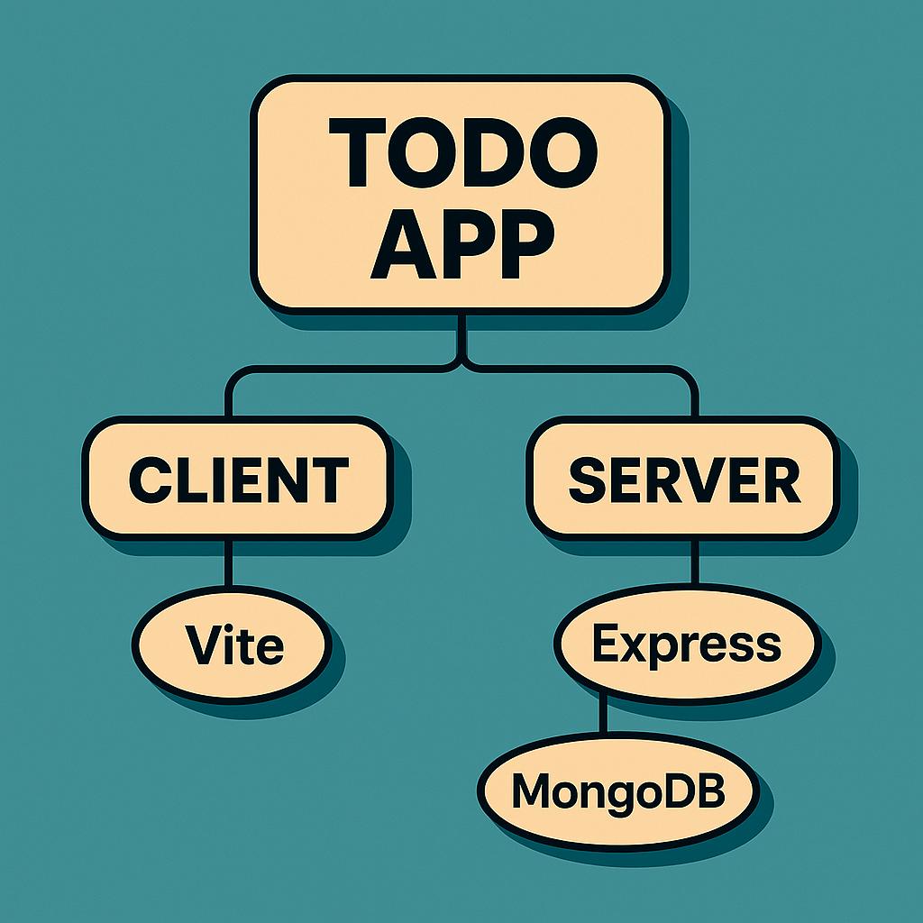
Database Schema
MongoDB Collection Structure:
Database Name: todos_app
Collection: todos
JavaScript
Todo Schema:
{
_id: ObjectId (Primary Key, Auto-generated),
title: {
type: String,
required: true,
trim: true,
maxLength: 500,
description: "The task description text"
},
completed: {
type: Boolean,
default: false,
index: true,
description: "Task completion status"
},
createdAt: {
type: Date,
default: Date.now,
description: "Timestamp of task creation"
},
updatedAt: {
type: Date,
default: Date.now,
description: "Timestamp of last modification"
}
}
Indexes:
- _id: Primary index (automatic)
- completed: Secondary index for filtering performance
- createdAt: Compound index for sorting (descending)
Schema Features:
- Automatic timestamp management through Mongoose
- Built-in validation for required fields
- String trimming to remove whitespace
- Default values for boolean and date fields
- Optimized for query performance with strategic indexing
Sample Document:
JSON
{
"_id": "6579f3b8e4b0c3d2a1b4c5d6",
"title": "Complete project documentation",
"completed": false,
"createdAt": "2024-01-15T10:30:00.000Z",
"updatedAt": "2024-01-15T14:45:30.000Z"
}

Front-End Screens

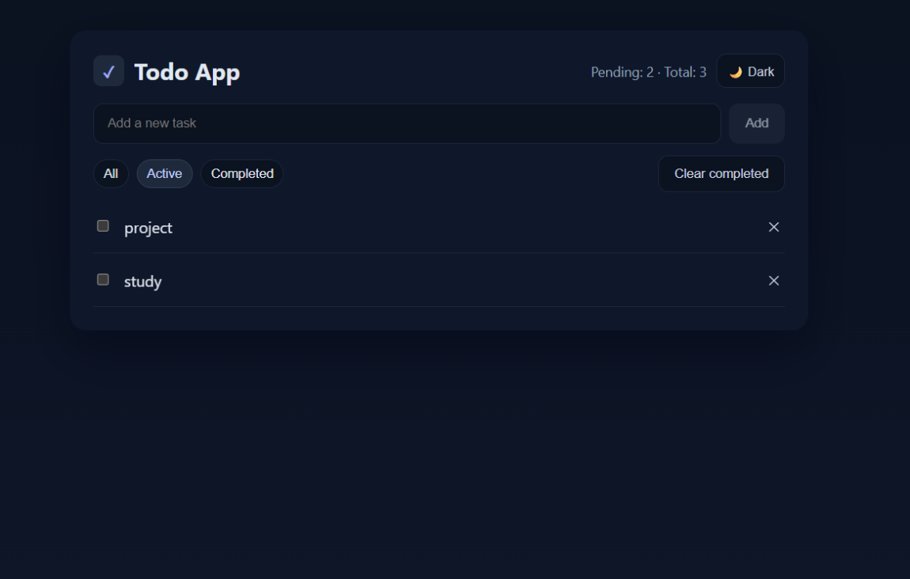
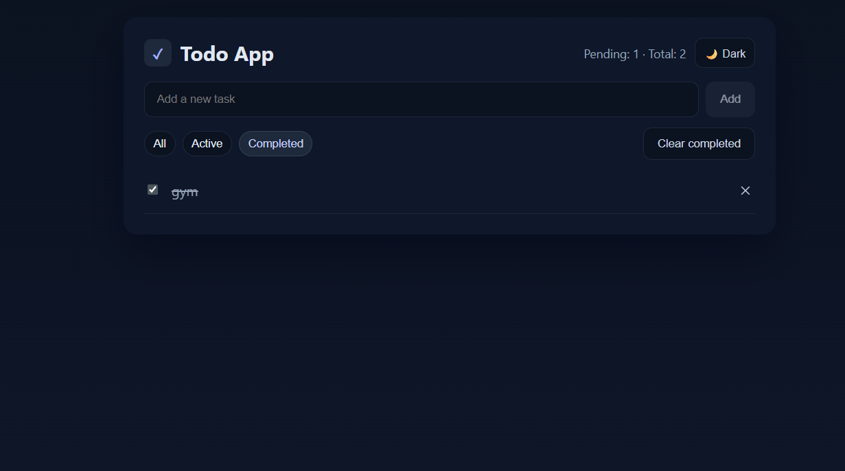
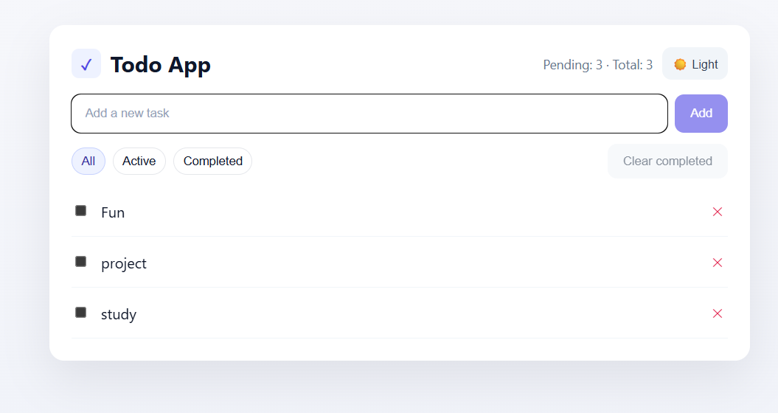

Output Screens and Reports
Limitation & Future Scope
Current Limitations:
- No User Authentication: The application currently operates in single-user mode without login functionality, making it unsuitable for multi-user environments.
- Local Storage Only for Preferences: Theme settings are stored in browser localStorage, which doesn't sync across devices.
- Limited Task Properties: Tasks only have title and completion status - no priority levels, due dates, or categories.
- No Data Backup/Export: Users cannot export their tasks or create backups, risking data loss.
- Basic Search: No text search functionality to find specific tasks quickly in large lists.
- No Offline Support: Requires constant internet connection; no service worker for offline functionality.
- Performance with Large Datasets: No pagination implemented, which could cause performance issues with hundreds of tasks.
- Single Database: No database replication or caching layer for improved performance.
- Limited Error Recovery: Basic error handling without retry mechanisms or detailed error logging.
- No Real-time Sync: Multiple browser tabs/devices don't sync automatically without refresh.
Future Scope & Enhancements:
Phase 1 - Core Improvements (1-2 months):
- Implement JWT-based user authentication and authorization
- Add pagination and virtual scrolling for large task lists
- Introduce Redis caching layer for improved performance
- Implement comprehensive error logging with Winston/Morgan
- Add input validation and sanitization middleware
- Include rate limiting and security headers (Helmet.js)
Phase 2 - Feature Enhancements (2-3 months):
- Task categories and tagging system
- Due dates with calendar integration
- Priority levels (High, Medium, Low) with visual indicators
- Advanced search and filter capabilities
- Drag-and-drop to reorder tasks
- Bulk selection and operations
- Task notes/descriptions with Markdown support
- File attachments for tasks
Phase 3 - Advanced Features (3-4 months):
- Real-time synchronization using WebSockets (Socket.io)
- Progressive Web App (PWA) with offline support
- Mobile applications (React Native)
- Task sharing and collaboration features
- Email/SMS notifications for due tasks
- Data export/import (CSV, JSON, PDF)
- Task templates and recurring tasks
- Analytics dashboard with productivity metrics
- Voice input for task creation
- AI-powered task suggestions and categorization
Phase 4 - Enterprise Features (4-6 months):
- Team workspaces with role-based access control
- Integration with third-party services (Google Calendar, Slack, Trello)
- Automated backups and disaster recovery
- Multi-language support (i18n)
- Customizable themes and branding
- API rate limiting per user
- Webhook support for external integrations
- Audit logs for compliance
- GraphQL API alternative
- Microservices architecture migration
Technical Debt Improvements:
- Comprehensive unit and integration testing (Jest, Cypress)
- CI/CD pipeline with GitHub Actions
- Docker containerization
- Kubernetes orchestration for scaling
- Performance monitoring (New Relic, DataDog)
- A/B testing framework
- Database sharding for horizontal scaling
- CDN integration for static assets

GitHub URL
https://github.com/deepansh2630/To-Do-List-App
Presentation Slides
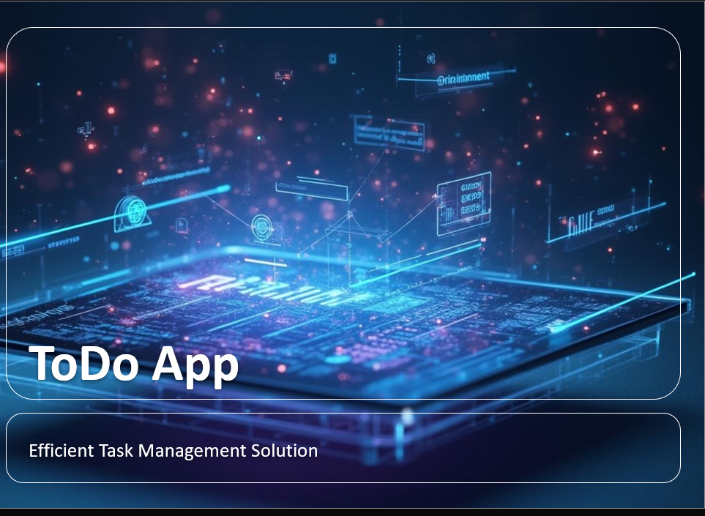
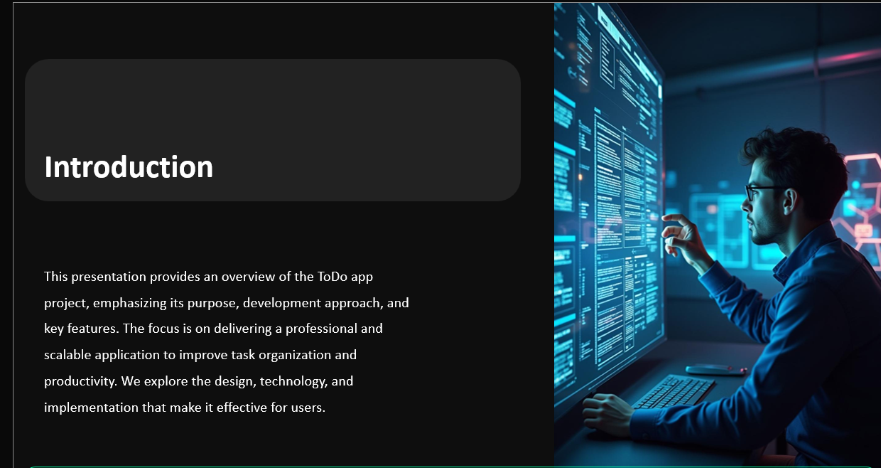
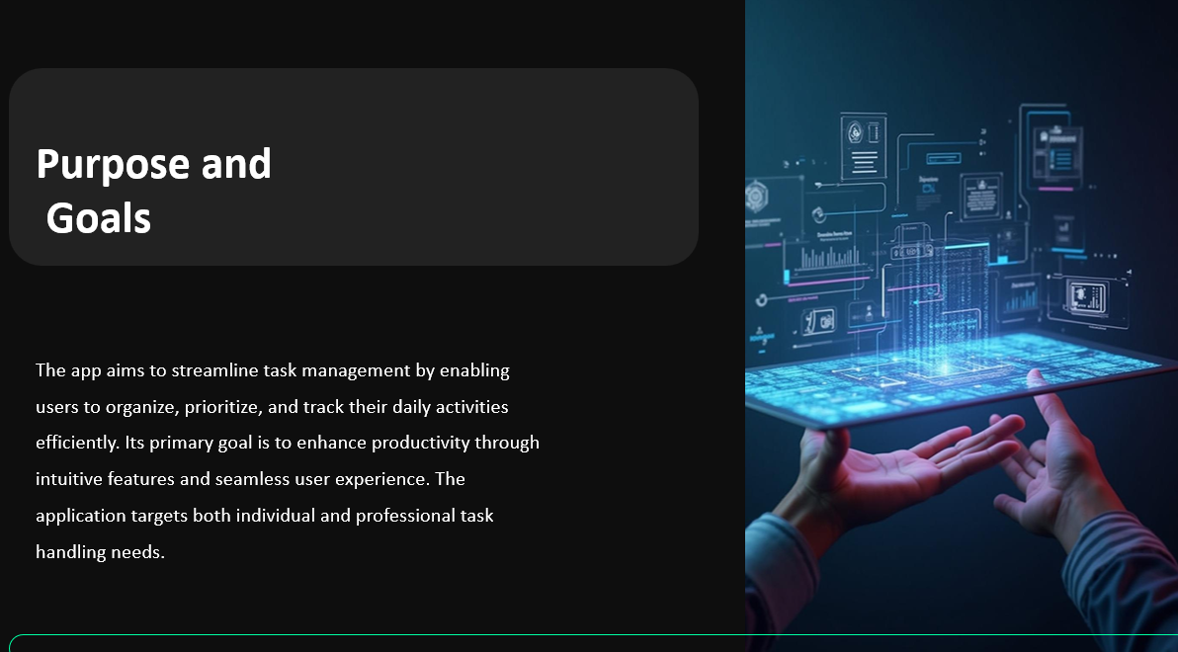
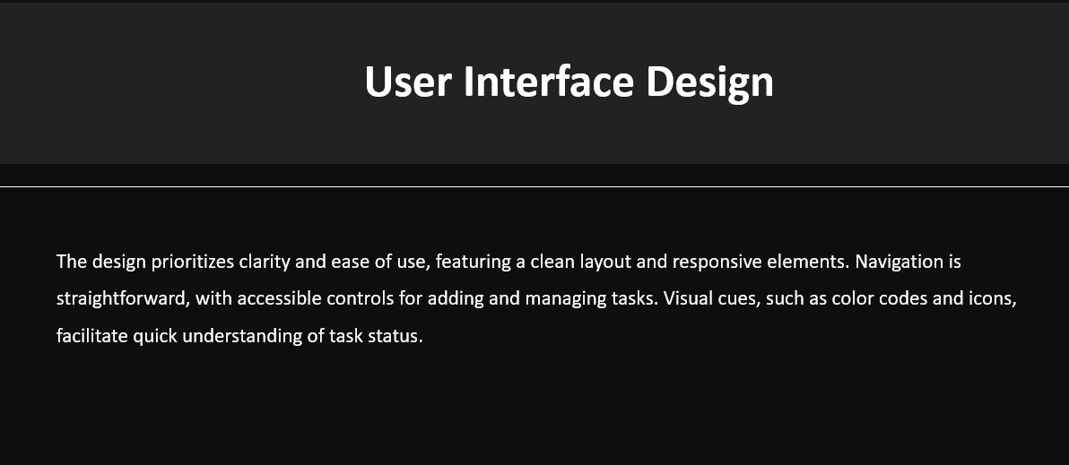
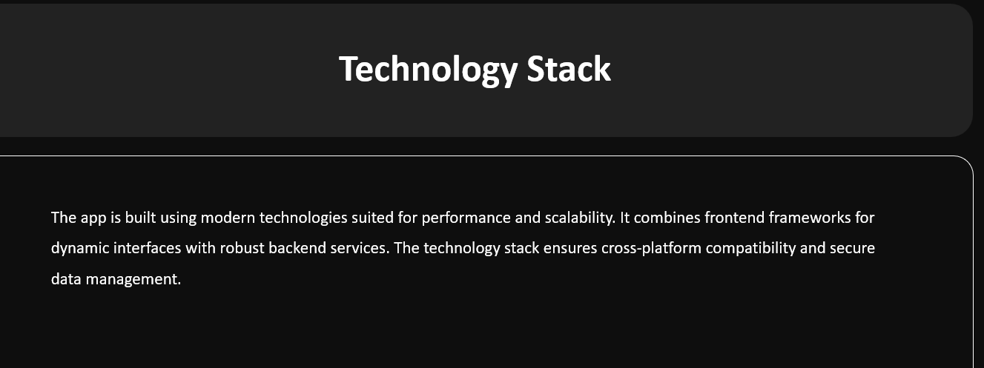
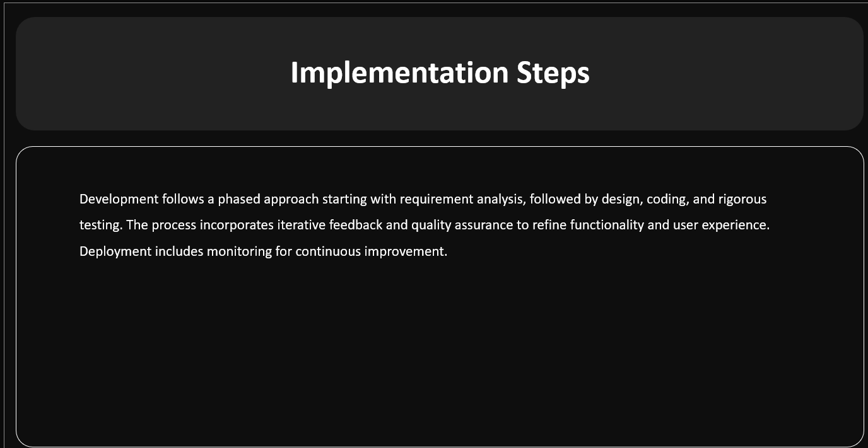
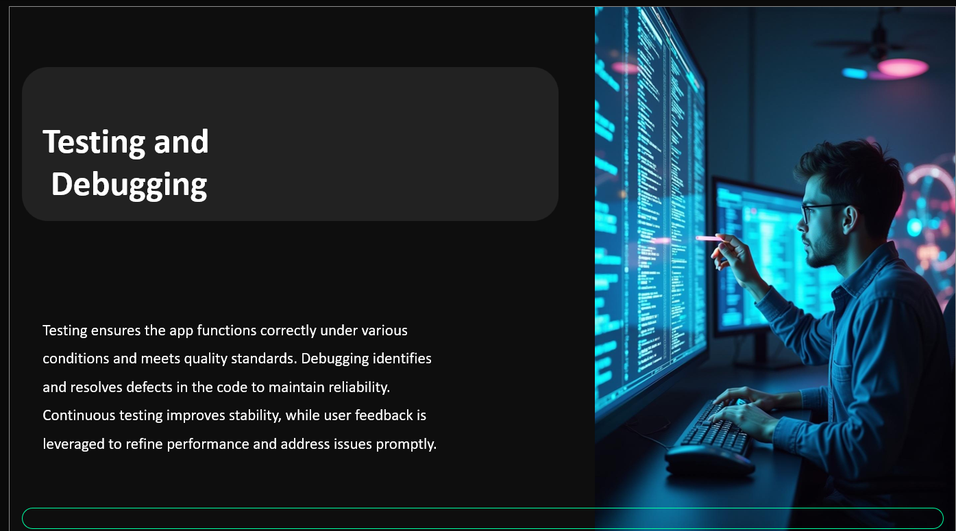
Project Code
Backend Code Files
server/index.js
JavaScript
require('dotenv').config();
const express = require('express');
const cors = require('cors');
const mongoose = require('mongoose');

const app = express();

// Middleware
app.use(cors());
app.use(express.json());

// Database connection
const mongoUri = process.env.MONGODB_URI || 'mongodb://127.0.0.1:27017/todos_app';
mongoose
.connect(mongoUri, {
dbName: process.env.MONGODB_DB || undefined,
})
.then(() => {
console.log('Connected to MongoDB');
})
.catch((err) => {
console.error('MongoDB connection error:', err.message);
});

// Routes
const todosRouter = require('./routes/todos');
app.use('/api/todos', todosRouter);

app.get('/api/health', (req, res) => {
res.json({ status: 'ok' });
});

const PORT = process.env.PORT || 5000;
app.listen(PORT, () => {
console.log(`Server listening on port ${PORT}`);
});
server/models/Todo.js
JavaScript
const mongoose = require('mongoose');

const TodoSchema = new mongoose.Schema(
{
title: {
type: String,
required: true,
trim: true,
},
completed: {
type: Boolean,
default: false,
index: true,
},
},
{ timestamps: true }
);

module.exports = mongoose.model('Todo', TodoSchema);
server/routes/todos.js
JavaScript
const express = require('express');
const Todo = require('../models/Todo');

const router = express.Router();

// Create a new todo
router.post('/', async (req, res) => {
try {
const { title } = req.body;
if (!title || !title.trim()) {
return res.status(400).json({ message: 'Title is required' });
}
const todo = await Todo.create({ title: title.trim() });
res.status(201).json(todo);
} catch (err) {
res.status(500).json({ message: 'Failed to create todo' });
}
});

// Get all todos
router.get('/', async (_req, res) => {
try {
const todos = await Todo.find().sort({ createdAt: -1 });
res.json(todos);
} catch (err) {
res.status(500).json({ message: 'Failed to fetch todos' });
}
});

// Update a todo (title or completed)
router.put('/:id', async (req, res) => {
try {
const { id } = req.params;
const { title, completed } = req.body;

const updates = {};
if (typeof title === 'string') updates.title = title.trim();
if (typeof completed === 'boolean') updates.completed = completed;

const updated = await Todo.findByIdAndUpdate(id, updates, { new: true });
if (!updated) return res.status(404).json({ message: 'Todo not found' });
res.json(updated);
} catch (err) {
res.status(500).json({ message: 'Failed to update todo' });
}
});

// Delete a todo
router.delete('/:id', async (req, res) => {
try {
const { id } = req.params;
const deleted = await Todo.findByIdAndDelete(id);
if (!deleted) return res.status(404).json({ message: 'Todo not found' });
res.json({ message: 'Deleted' });
} catch (err) {
res.status(500).json({ message: 'Failed to delete todo' });
}
});

module.exports = router;
server/package.json
JSON
{
"name": "server",
"version": "1.0.0",
"main": "index.js",
"scripts": {
"dev": "nodemon index.js",
"start": "node index.js",
"test": "echo \"Error: no test specified\" && exit 1"
},
"keywords": [],
"author": "",
"license": "ISC",
"description": "",
"dependencies": {
"cors": "^2.8.5",
"dotenv": "^17.2.3",
"express": "^5.1.0",
"mongoose": "^8.19.2"
},
"devDependencies": {
"nodemon": "^3.1.10"
}
}
Frontend Code Files
client/src/App.jsx
JavaScript
import React, { useEffect, useMemo, useState } from 'react';
import { createTodo, deleteTodo, fetchTodos, updateTodo } from './services/api.js';
import './style.css';

export default function App() {
const [todos, setTodos] = useState([]);
const [newTitle, setNewTitle] = useState('');
const [loading, setLoading] = useState(false);
const [error, setError] = useState(null);
const [filter, setFilter] = useState('all'); // all | active | completed
const [theme, setTheme] = useState('light'); // light | dark

const pendingCount = useMemo(() => todos.filter(t => !t.completed).length, [todos]);
const shownTodos = useMemo(() => {
if (filter === 'active') return todos.filter(t => !t.completed);
if (filter === 'completed') return todos.filter(t => t.completed);
return todos;
}, [todos, filter]);

useEffect(() => {
// initialize theme from localStorage or system preference
const saved = localStorage.getItem('theme');
if (saved === 'light' || saved === 'dark') {
setTheme(saved);
document.documentElement.dataset.theme = saved;
} else {
const prefersDark = window.matchMedia && window.matchMedia('(prefers-color-scheme: dark)').matches;
const initial = prefersDark ? 'dark' : 'light';
setTheme(initial);
document.documentElement.dataset.theme = initial;
}

(async () => {
setLoading(true);
setError(null);
try {
const data = await fetchTodos();
setTodos(data);
} catch (e) {
setError('Failed to load todos. Is the server running?');
} finally {
setLoading(false);
}
})();
}, []);

function toggleTheme() {
const next = theme === 'dark' ? 'light' : 'dark';
setTheme(next);
document.documentElement.dataset.theme = next;
localStorage.setItem('theme', next);
}

async function handleAdd(e) {
e.preventDefault();
if (!newTitle.trim()) return;
setLoading(true);
setError(null);
try {
const created = await createTodo({ title: newTitle.trim() });
setTodos(prev => [created, ...prev]);
setNewTitle('');
} catch (e) {
setError('Failed to add todo');
} finally {
setLoading(false);
}
}

async function toggleCompleted(todo) {
setLoading(true);
setError(null);
try {
const updated = await updateTodo(todo._id, { completed: !todo.completed });
setTodos(prev => prev.map(t => (t._id === updated._id ? updated : t)));
} catch (e) {
setError('Failed to update todo');
} finally {
setLoading(false);
}
}

async function removeTodo(id) {
setLoading(true);
setError(null);
try {
await deleteTodo(id);
setTodos(prev => prev.filter(t => t._id !== id));
} catch (e) {
setError('Failed to delete todo');
} finally {
setLoading(false);
}
}

async function clearCompleted() {
const completed = todos.filter(t => t.completed);
if (completed.length === 0) return;
setLoading(true);
setError(null);
try {
for (const t of completed) {
try {
await deleteTodo(t._id);
} catch {}
}
setTodos(prev => prev.filter(t => !t.completed));
} catch (e) {
setError('Failed to clear completed');
} finally {
setLoading(false);
}
}

return (
<div className="page">
<div className="card">
<header className="header">
<div className="brand">
<span className="logo" aria-hidden>✓</span>
<h1 className="title">Todo App</h1>
</div>
<div className="header-right">
<div className="stats">Pending: {pendingCount} · Total: {todos.length}</div>
<button type="button" className="button subtle theme-toggle" onClick={toggleTheme} aria-label="Toggle theme">
{theme === 'dark' ? '🌙 Dark' : '☀️ Light'}
</button>
</div>
</header>

<form onSubmit={handleAdd} className="form">
<input
className="input"
type="text"
placeholder="Add a new task"
value={newTitle}
onChange={(e) => setNewTitle(e.target.value)}
/>
<button className="button primary" type="submit" disabled={loading || !newTitle.trim()}>
Add
</button>
</form>

<div className="toolbar">
<div className="filters">
<button type="button" className={`chip ${filter === 'all' ? 'active' : ''}`} onClick={() => setFilter('all')}>All</button>
<button type="button" className={`chip ${filter === 'active' ? 'active' : ''}`} onClick={() => setFilter('active')}>Active</button>
<button type="button" className={`chip ${filter === 'completed' ? 'active' : ''}`} onClick={() => setFilter('completed')}>Completed</button>
</div>
<button type="button" className="button subtle" onClick={clearCompleted} disabled={loading || todos.every(t => !t.completed)}>
Clear completed
</button>
</div>

{error && <div className="alert error">{error}</div>}
{loading && <div className="alert">Loading…</div>}

{shownTodos.length === 0 ? (
<div className="empty">
<div className="empty-icon">🗒️</div>
<div className="empty-text">No tasks here. Add something to get started!</div>
</div>
) : (
<ul className="list">
{shownTodos.map((todo) => (
<li key={todo._id} className="item">
<label className={`label ${todo.completed ? 'completed' : ''}`}>
<input
type="checkbox"
checked={todo.completed}
onChange={() => toggleCompleted(todo)}
/>
<span className="text">{todo.title}</span>
</label>
<button className="icon-button danger" onClick={() => removeTodo(todo._id)} disabled={loading} aria-label="Delete">
✕
</button>
</li>
))}
</ul>
)}
</div>
</div>
);
}
client/src/services/api.js
JavaScript
import axios from 'axios';

const API_BASE = import.meta.env.VITE_API_URL || 'http://localhost:5000';

export async function fetchTodos() {
const res = await axios.get(`${API_BASE}/api/todos`);
return res.data;
}

export async function createTodo(payload) {
const res = await axios.post(`${API_BASE}/api/todos`, payload);
return res.data;
}

export async function updateTodo(id, payload) {
const res = await axios.put(`${API_BASE}/api/todos/${id}`, payload);
return res.data;
}

export async function deleteTodo(id) {
const res = await axios.delete(`${API_BASE}/api/todos/${id}`);
return res.data;
}
client/src/main.jsx
JavaScript
import React from 'react';
import { createRoot } from 'react-dom/client';
import './style.css';
import App from './App.jsx';

const container = document.getElementById('app');
if (container) {
const root = createRoot(container);
root.render(
<React.StrictMode>
<App />
</React.StrictMode>
);
}
client/package.json
JSON
{
"name": "client",
"private": true,
"version": "0.0.0",
"type": "module",
"scripts": {
"dev": "vite",
"build": "vite build",
"preview": "vite preview"
},
"devDependencies": {
"vite": "^7.1.7"
},
"dependencies": {
"axios": "^1.13.1",
"react": "^19.2.0",
"react-dom": "^19.2.0"
}
}
Configuration Files
server/.env.example
text
MONGODB_URI=mongodb://127.0.0.1:27017/todos_app
MONGODB_DB=todoapp
PORT=5000
client/.env.example
text
VITE_API_URL=http://localhost:5000

References
- React Documentation (2024). React: The library for web and native user interfaces. Meta Platforms, Inc. Available at: https://react.dev/reference/react [Accessed: January 2024].
- Express.js Documentation (2024). Express - Node.js web application framework. OpenJS Foundation. Available at: https://expressjs.com/en/5x/api.html [Accessed: January 2024].
- MongoDB Documentation (2024). MongoDB Manual v7.0. MongoDB, Inc. Available at: https://www.mongodb.com/docs/manual/ [Accessed: January 2024].
- Mongoose Documentation (2024). Mongoose v8.0.0: Elegant MongoDB object modeling for Node.js. Automattic. Available at: https://mongoosejs.com/docs/guide.html [Accessed: January 2024].
- Vite Documentation (2024). Vite: Next Generation Frontend Tooling. Evan You. Available at: https://vitejs.dev/guide/ [Accessed: January 2024].
- MDN Web Docs (2024). Web APIs and JavaScript Reference. Mozilla Foundation. Available at: https://developer.mozilla.org/en-US/docs/Web/JavaScript [Accessed: January 2024].
- Node.js Documentation (2024). Node.js v20.11.0 Documentation. OpenJS Foundation. Available at: https://nodejs.org/docs/latest-v20.x/api/ [Accessed: January 2024].
- Axios Documentation (2024). Getting Started with Axios. Available at: https://axios-http.com/docs/intro [Accessed: January 2024].
- RESTful API Design Best Practices (2023). REST API Tutorial. Available at: https://restfulapi.net/ [Accessed: January 2024].
- Web Content Accessibility Guidelines (WCAG) 2.2 (2023). W3C Recommendation. World Wide Web Consortium. Available at: https://www.w3.org/WAI/WCAG22/quickref/ [Accessed: January 2024].
- OWASP Top Ten (2023). OWASP Top 10:2021. Open Web Application Security Project. Available at: https://owasp.org/www-project-top-ten/ [Accessed: January 2024].
- React Hooks Documentation (2024). Built-in React Hooks. Meta Platforms, Inc. Available at: https://react.dev/reference/react/hooks [Accessed: January 2024].
- CSS-Tricks (2024). A Complete Guide to Dark Mode on the Web. DigitalOcean. Available at: https://css-tricks.com/dark-modes-with-css/ [Accessed: January 2024].
- npm Documentation (2024). npm Docs. GitHub, Inc. Available at: https://docs.npmjs.com/ [Accessed: January 2024].
- dotenv Documentation (2024). Dotenv: Loads environment variables from .env file. Available at: https://github.com/motdotla/dotenv#readme [Accessed: January 2024].

Bibliography
Books
- Flanagan, D. (2020). JavaScript: The Definitive Guide (7th ed.). O'Reilly Media. ISBN: 978-1491952023.
- Banks, A., & Porcello, E. (2020). Learning React: Modern Patterns for Developing React Apps (2nd ed.). O'Reilly Media. ISBN: 978-1492051725.
- Brown, E. (2019). Web Development with Node and Express: Leveraging the JavaScript Stack (2nd ed.). O'Reilly Media. ISBN: 978-1492053514.
- Hahn, E. (2018). Express in Action: Writing, Building, and Testing Node.js Applications. Manning Publications. ISBN: 978-1617292422.
- Simpson, K. (2015-2020). You Don't Know JS (Book Series, 2nd ed.). O'Reilly Media. ISBN: 978-1491904244.
- Dayley, B., Dayley, C., & Dayley, M. (2018). Node.js, MongoDB and Angular Web Development (2nd ed.). Addison-Wesley Professional. ISBN: 978-0134655536.
Academic Papers
- Fielding, R. T. (2000). Architectural Styles and the Design of Network-based Software Architectures (Doctoral dissertation). University of California, Irvine.
- Tilkov, S., & Vinoski, S. (2010). "Node.js: Using JavaScript to Build High-Performance Network Programs". IEEE Internet Computing, 14(6), pp. 80-83.
- Rodriguez, A. (2008). "RESTful Web Services: The Basics". IBM DeveloperWorks, November 2008.
- Garrett, J. J. (2005). "Ajax: A New Approach to Web Applications". Adaptive Path, February 18, 2005.

