PROJECT REPORT

ALGORITHM EXPLORER
&
COMPLEXITY ANALYZER
CSE1021 – PROBLEM SOLVING AND PROGRAMMING

VIT Bhopal University
B.Tech CSE – AI & ML
Academic Year 2026–2027
Submitted By
Deepansh Kumar
GitHub Repository:
https://github.com/deepanshh44/Algorithm-Explorer

Introduction

Algorithm Explorer & Complexity Analyzer is a Python-based educational project created for CSE1021 – Problem Solving and Programming. The project combines a set of fundamental algorithms into one application so that a user can enter data, execute an algorithm, and observe the result.
The project focuses on Linear Search, Selection Sort, Factorial, Fibonacci, and Tower of Hanoi. A separate complexity section presents the basic time and space complexity associated with each algorithm. The application is available through a command-line workflow and an additional Tkinter interface.
The central idea is simple: instead of studying each algorithm only as an isolated program, the project provides one place where the algorithms can be executed and compared at a basic conceptual level.

Purpose of the Project
- Connect classroom algorithm concepts with an executable Python implementation.
- Show how input, processing, output, branching, looping, and recursion appear in a complete program.
- Give the user direct feedback through results, comparisons, swaps, and recursive output.
- Keep the implementation modular so that each major algorithm can be understood separately.

Course Relevance
The project is directly related to problem definition, algorithm design, searching, sorting, recursion, flow control, and basic complexity analysis covered in the course.

Problem Statement

Fundamental algorithms are often taught as separate examples. A student may understand the definition of Linear Search or Selection Sort but still find it difficult to connect the algorithm, its implementation, its output, and its complexity in one practical program.
Another difficulty is that recursive problems such as Factorial, Fibonacci, and Tower of Hanoi behave differently from ordinary loop-based programs. Their results depend on repeated function calls, making them useful examples for understanding recursion and space usage.
Algorithm Explorer addresses this learning problem by providing a single interactive system where the user can choose an algorithm, provide an input, run the operation, and view the result. The project also provides a separate Complexity Analyzer so that algorithm execution and complexity information can be considered together.

Problems Addressed
- Separate algorithm examples with no common interface.
- Difficulty relating an input to the amount of work performed.
- Limited visibility into comparisons and swaps in search and sorting operations.
- Difficulty observing recursive execution through a simple program.
- Lack of a single small project that combines these CSE1021 concepts.

Proposed Solution
The proposed solution is a modular Python application with separate files for searching, sorting, recursion, complexity information, and validation. The main program controls the workflow, while the interface layer provides a more visual way to access the same functions.

Functional Requirements

The functional requirements describe what the completed system should allow a user to do.

FR-1: Search Lab
The system shall accept a list of integers and a target value, execute Linear Search, and display whether the target was found. When a target is found, the application also displays its position and the number of comparisons performed.

FR-2: Sorting Lab
The system shall accept a list of integers and execute Selection Sort. It shall display the original list, sorted list, number of comparisons, and number of swaps.

FR-3: Recursion Lab
The system shall provide Factorial, Fibonacci, and Tower of Hanoi. The user shall be able to enter a valid value and view the corresponding recursive result or sequence of Tower of Hanoi moves.

FR-4: Complexity Analyzer
The system shall allow the user to select a supported algorithm and display its best case, worst case, space complexity, and a short explanation.

FR-5: Input Validation
The application shall identify common invalid inputs such as non-numeric values, empty list input, invalid menu selections, negative values where they are not accepted, and invalid disk counts.

FR-6: Navigation
The user shall be able to return to the main menu after completing an operation and exit the application when required.
Non-Functional Requirements

The project also follows practical requirements related to usability, reliability, maintainability, and resource use.

NFR-1 (Usability)
The menu structure should be straightforward. Labels, prompts, and results should use simple wording so that a student can understand what to enter and what the output represents.

NFR-2 (Maintainability)
Search, sorting, recursion, complexity information, and validation are placed in separate modules. This reduces duplication and makes individual parts easier to modify.

NFR-3 (Reliability & Defensive Coding)
The program checks user input before passing it to the algorithms. Invalid numerical input is handled with clear messages rather than allowing the application to terminate unexpectedly.

NFR-4 (Resource Efficiency)
The core project uses Python's standard library and does not depend on databases, web services, external APIs, or data-science libraries.

NFR-5 (Readability)
Function names and module names describe their purpose. The program is divided into smaller functions instead of putting all logic into one large block.

NFR-6 (Portability)
The project is designed to run as a normal Python project from the repository folder. Its core algorithms do not require a special hardware environment.

System Architecture

The system follows a simple modular architecture. The application entry point controls the user workflow, while the algorithm modules perform the actual operations. This separation keeps the main interaction logic independent from the algorithm implementations.

1. Presentation Layer
main.py provides the command-line menu and interface.py provides the graphical interface. Both layers collect input and display output.

2. Algorithm Layer
search.py contains Linear Search, sorting.py contains Selection Sort, and recursion.py contains Factorial, Fibonacci, and Tower of Hanoi.

3. Support Layer
complexity.py stores the complexity information shown to the user. validation.py contains reusable input-validation functions for the command-line application.
The project architecture can be represented as: User → Main/Interface → Algorithm Modules → Results, with validation and complexity information supporting the workflow.

Design Diagrams

Use-Case Style View
The main user interactions are selecting an algorithm, entering the required data, executing the operation, viewing the result, checking complexity information, returning to the menu, and exiting the application.
User Action | System Response
Open application | Display main menu
Choose Search Lab | Collect list and target, then run Linear Search
Choose Sorting Lab | Collect list and run Selection Sort
Choose Recursion Lab | Run selected recursive algorithm
Choose Complexity Analyzer | Display complexity details
Choose Exit | Terminate the application

Process Workflow
Start → Main Menu → Select Module → Validate Input → Execute Algorithm → Display Result → Return to Menu or Exit.

Design Principle
The workflow keeps input handling, algorithm execution, and result display as separate steps. This makes the program easier to trace during demonstration and viva.

Algorithm Design

Linear Search
- Begin with the first element of the list.
- Compare the current element with the target.
- If the values match, return the position.
- Otherwise continue to the next element.
- If the list ends, return -1 to indicate that the target was not found.
The implementation also counts comparisons. For example, searching for 30 in [10, 20, 30, 40, 50] requires three comparisons.

Selection Sort
- Treat the first element of the unsorted portion as the current minimum.
- Compare it with the remaining elements.
- Remember the position of the smallest element.
- Swap the smallest element into the current position.
- Repeat for the remaining unsorted portion.
For [64, 25, 12, 22, 11], the final result is [11, 12, 22, 25, 64]. The implementation records comparisons and actual swaps.

Why These Algorithms?
Linear Search and Selection Sort are straightforward examples of searching and sorting. They also make the connection between input size, repeated operations, and complexity easy to demonstrate at the course level.

Recursive Algorithms

Factorial
Factorial is implemented with a base condition for 0 and 1. For larger values, the function calls itself using n-1 and multiplies the returned result by n.
For example, 5! = 5 × 4 × 3 × 2 × 1 = 120.

Fibonacci
The recursive Fibonacci function uses F(0) = 0 and F(1) = 1 as base conditions. For other values it calculates F(n-1) + F(n-2). This demonstrates how recursive calls can branch into additional calls.
For n = 7, the program produces 13.

Tower of Hanoi
Tower of Hanoi uses three rods and a recursive strategy. To move n disks, n-1 disks are moved to the auxiliary rod, the largest disk is moved to the destination, and the n-1 disks are moved from the auxiliary rod to the destination.
For three disks, the implementation produces seven moves. The output makes the recursive structure visible instead of presenting recursion only as a formula.

Recursive Base Conditions
Base conditions are important because they stop further recursive calls. Without an appropriate stopping condition, the function would continue calling itself and would not terminate correctly.

Complexity Analysis

Complexity analysis is included to show how the amount of work performed by an algorithm changes with input size. The project presents a concise complexity summary instead of attempting to perform advanced automatic mathematical analysis.
Algorithm | Best Case | Worst Case | Space Complexity
Linear Search | O(1) | O(n) | O(1)
Selection Sort | O(n²) | O(n²) | O(1)
Factorial (Recursive) | O(n) | O(n) | O(n)
Fibonacci (Recursive) | O(2^n) | O(2^n) | O(n)
Tower of Hanoi | O(2^n) | O(2^n) | O(n)

Linear Search Analysis
If the target is the first element, only one comparison is needed. If the target is at the end or is absent, the elements may all need to be checked. Therefore the best and worst cases differ.

Selection Sort Analysis
Selection Sort repeatedly scans the remaining unsorted section. The number of comparisons remains quadratic with input size, which gives O(n²) time complexity.

Recursive Analysis
Factorial creates a chain of recursive calls, while recursive Fibonacci and Tower of Hanoi produce a rapidly increasing number of calls or moves. Their behavior illustrates why recursion can have substantially different complexity from a simple loop.

Design Decisions & Rationale

Modular Python Files
The algorithm implementations are separated into search.py, sorting.py, recursion.py, and complexity.py. This was chosen because each module has one clear responsibility and can be tested independently.

Simple Data Handling
The project uses normal Python lists and integers for the algorithm inputs. This keeps the implementation close to the problem-solving concepts taught in the course.

Separate Validation
Validation functions are kept in validation.py so that input checking does not have to be repeated throughout the main program.

Command-Line First Design
The command-line version was completed as the core application because it directly demonstrates input, output, conditions, loops, and function calls. The graphical interface was then added as a presentation layer.

Tkinter as Interface Layer
Tkinter is used only to provide buttons, input fields, and result windows. The actual algorithm logic remains inside the existing modules. This avoids maintaining two different implementations of the same algorithm.

Git and GitHub
Git was used to track the project, and the completed repository was pushed to GitHub. This also keeps the source code, documentation, tests, and project files together.

Implementation Details

Module | Implementation
main.py | Menu-driven command-line workflow
interface.py | Tkinter graphical interface
search.py | Linear Search and comparison counting
sorting.py | Selection Sort with comparison and swap counting
recursion.py | Factorial, Fibonacci, Tower of Hanoi
complexity.py | Complexity information and explanations
validation.py | Input validation for CLI operations
tests/test_algorithms.py | Manual assertion-style test script

Linear Search Function
The function loops through the list using a for loop and checks each value against the target. A comparison counter is increased on each check. It returns the index and comparison count.

Selection Sort Function
The function works on a copy of the supplied list. Nested loops locate the minimum value in each remaining section. A swap counter records when an exchange is actually performed.

Recursion Functions
Factorial and Fibonacci use direct recursive calls. Tower of Hanoi recursively prints each disk movement. The implementation follows the standard recursive structure rather than replacing recursion with an iterative shortcut.

Complexity Module
The complexity module returns a small set of values and an explanation for the selected algorithm. The main program and graphical interface both use this same information.

Sample Terminal Outputs

The development process included repeated runs of the command-line application. The screenshots below are from the actual project development environment.

1 Application Test : Menu

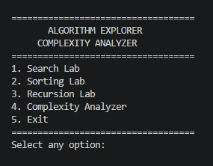

2 Application Test : Search lab

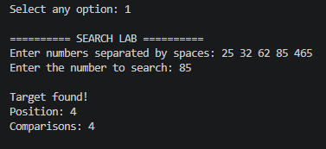

3 Application Test : SORTING LAB

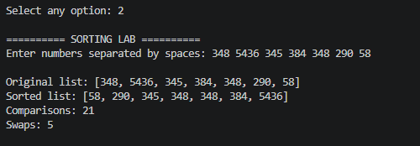

4 Application Test : RECURSION LAB

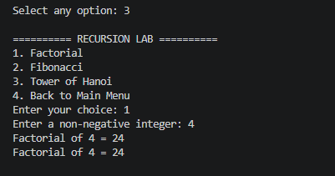

5 Application Test : COMPLEXITY ANALYZER

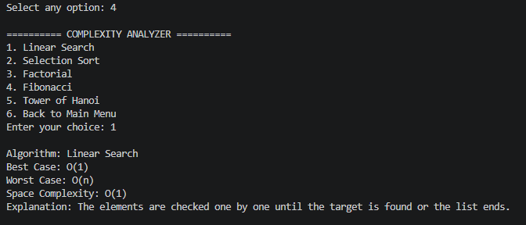

6 Application Test : END

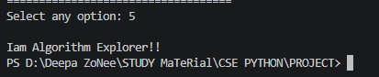

Project Files and Main Program

The screenshots document the actual development workflow and are included as evidence of the project structure and execution environment.
Testing Approach
Testing was performed using a simple Python test script containing normal cases and boundary cases for the main algorithms. Additional manual testing was used for menu navigation, complexity output, input validation, and the application exit flow.
Test Case | Input | Expected Result | Status
Search – target found | [10,20,30,40,50], 30 | Index 2 / position 3 | PASS
Search – target absent | [10,20,30,40,50], 100 | -1 / not found | PASS
Selection Sort | [64,25,12,22,11] | [11,12,22,25,64] | PASS
Sorted list | [1,2,3,4,5] | Same sorted list | PASS
Factorial | 5 | 120 | PASS
Factorial boundary | 0 | 1 | PASS
Fibonacci | 7 | 13 | PASS
Fibonacci boundary | 0 | 0 | PASS
Tower of Hanoi | 3 | 7 moves | PASS

Manual Validation Tests
- Non-numeric integer input displays an invalid-input message.
- Empty list input is rejected.
- Negative values are rejected where required.
- Invalid menu choices are handled without closing the application.
- Complexity Analyzer returns information for all supported algorithms.

Challenges Faced

1. Keeping the Project Within the Syllabus
One of the main constraints was avoiding unnecessary advanced programming concepts. The implementation therefore stayed focused on lists, loops, conditions, functions, recursion, searching, sorting, validation, and complexity.

2. Separating the Modules
At the beginning, it would have been possible to place everything in main.py. Separating the algorithms into modules required additional planning, but it made the final project easier to understand and test.

3. Input Validation
User input can contain spaces, invalid characters, empty values, or negative numbers. Validation functions were therefore added for the command-line workflow.

4. GitHub Authentication
During the GitHub upload, the local Git setup initially used credentials belonging to a different GitHub account. The push returned a permission error. After correcting the authentication, the repository was successfully pushed.
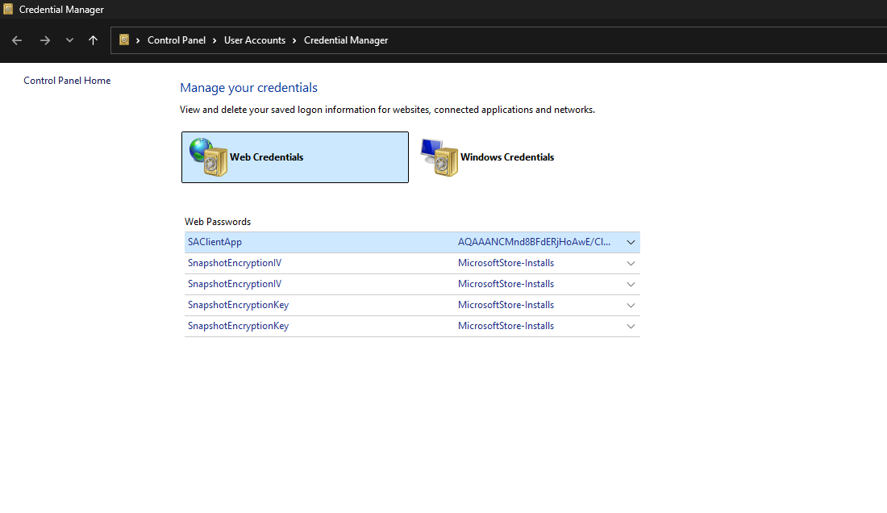
Figure 5. GitHub authentication during the project upload.

5. Final Push Verification
After authentication was corrected, the repository successfully received the master branch and was set to track origin/master.

Learnings & Key Takeaways

Programming Concepts
- Using if/elif/else to control program decisions.
- Using for and while loops for repeated operations.
- Using lists to store and process input data.
- Using functions to divide a larger problem into smaller parts.
- Using recursion with clear base conditions.
- Implementing searching and sorting algorithms directly in Python.

Problem-Solving Concepts
- Breaking a problem into smaller subproblems.
- Identifying inputs, processing steps, and outputs.
- Tracing an algorithm with a sample input.
- Considering time and space complexity.
- Testing boundary cases instead of checking only normal inputs.

Development Skills
- Organizing a Python project into multiple files.
- Writing a README and project statement.
- Using diagrams to explain architecture and workflow.
- Running tests and checking actual outputs.
- Using Git and GitHub for version control.
The most useful outcome of the project was understanding that a working program is more than an algorithm alone. Input handling, validation, organization, testing, documentation, and version control are all part of completing a project.

References

1. CSE1021 – Problem Solving and Programming course material, VIT Bhopal University.
2. VITyarthi – Build Your Own Project guidelines and submission requirements.
3. Python 3 documentation and standard library reference for Python language features and Tkinter.
4. Project source code, README, statement, diagrams, tests, and documentation maintained in the Algorithm-Explorer GitHub repository.

Project Repository
https://github.com/deepanshh44/Algorithm-Explorer

Project Deliverables
- Python source code
- Modular algorithm files
- Input validation module
- Test script
- Command-line application
- Graphical interface
- README.md and statement.md
- Architecture and workflow diagrams
- Project report

Final Note
This report is based on the actual Algorithm Explorer implementation and the development evidence collected during the project. The screenshots used in the report are from the project development process.

THANK YOU!
Algorithm Explorer & Complexity Analyzer
CSE1021 – Problem Solving and Programming
Deepansh Kumar

