##Chemistry##

#Single#

**Nikhil 1.** 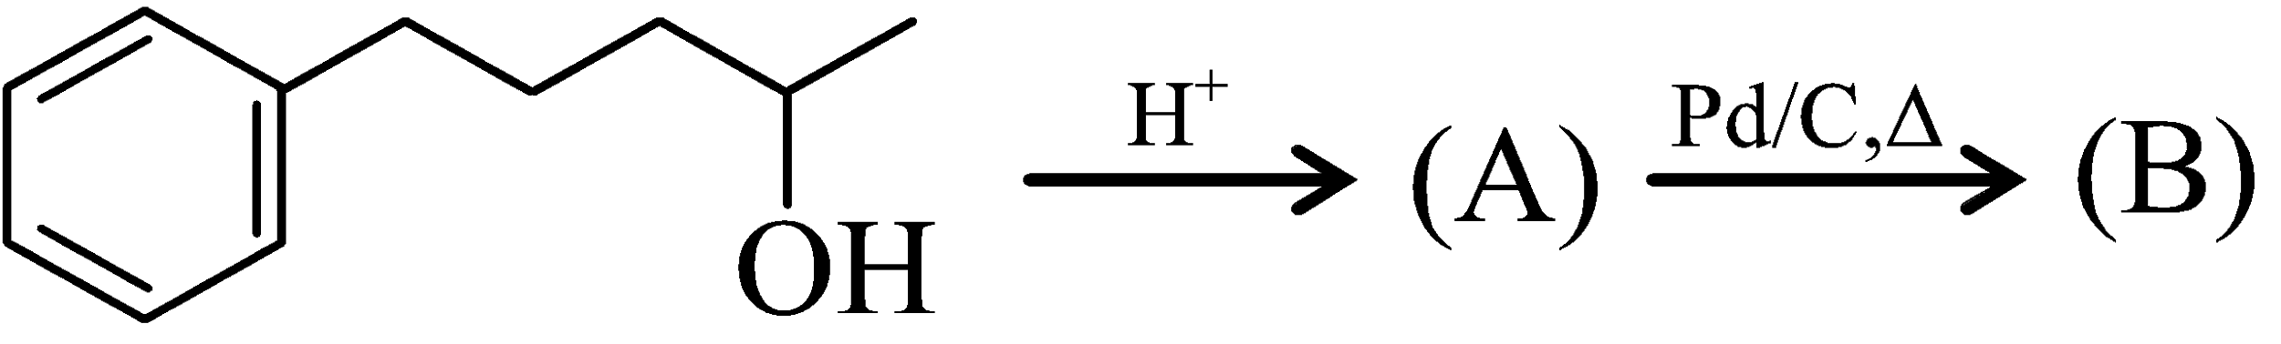

Compounds (A) and (B) in the above reaction are

vishwas 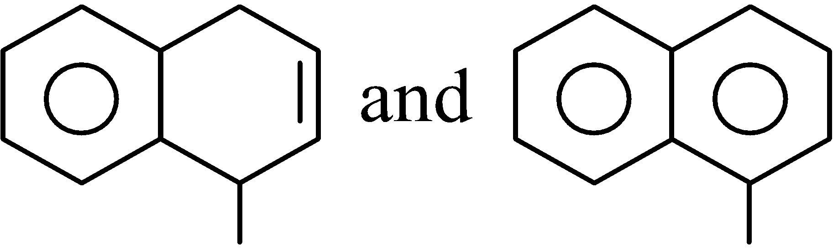 respectively vishwas 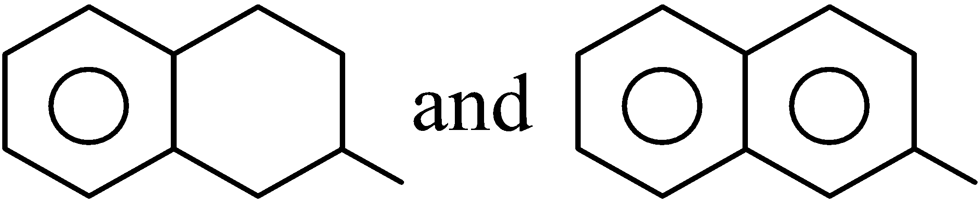 respectively

vishwas 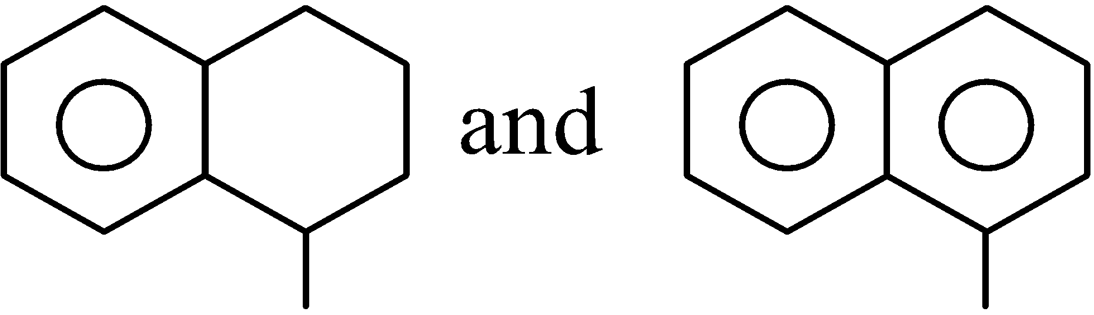 respectively vishwas 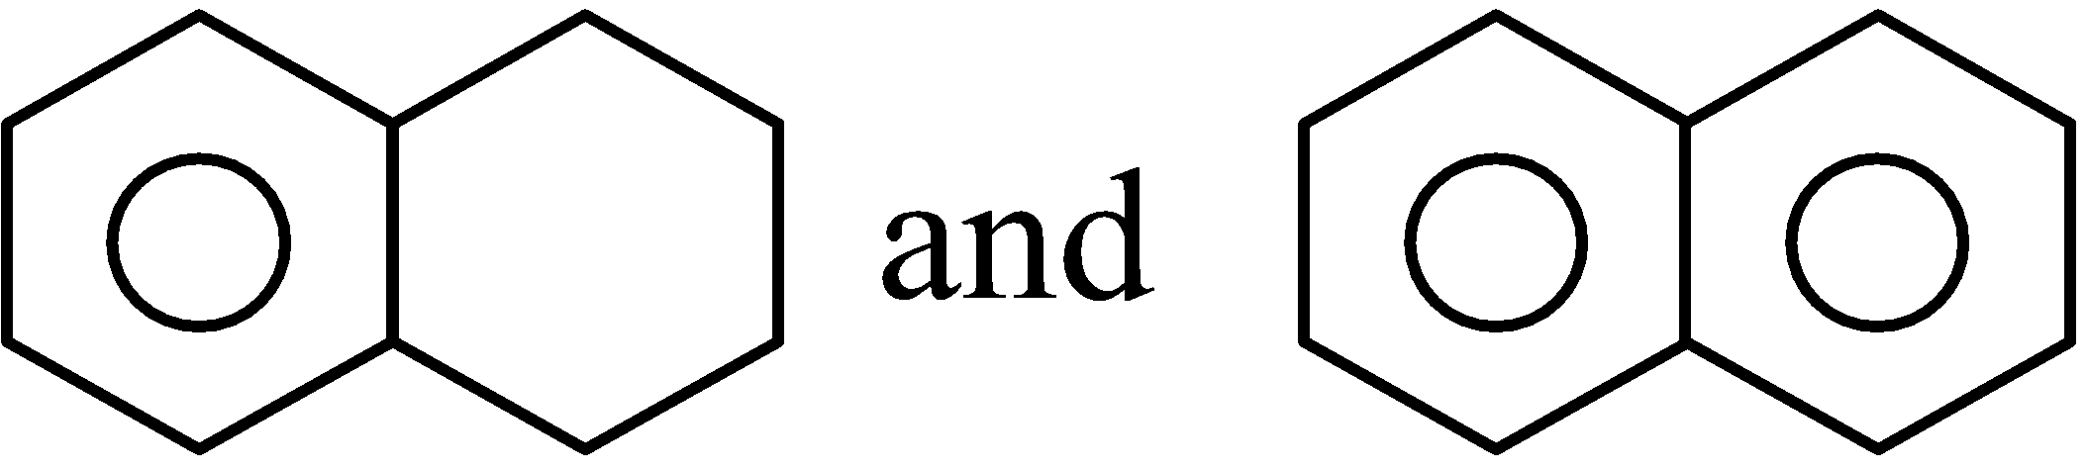 respectively

**Nikhil 2.** From the following three graphs between log *t*1/2 *vs.* log[*A*0], choose the correct answer: (where *A*0 is the initial concentration)

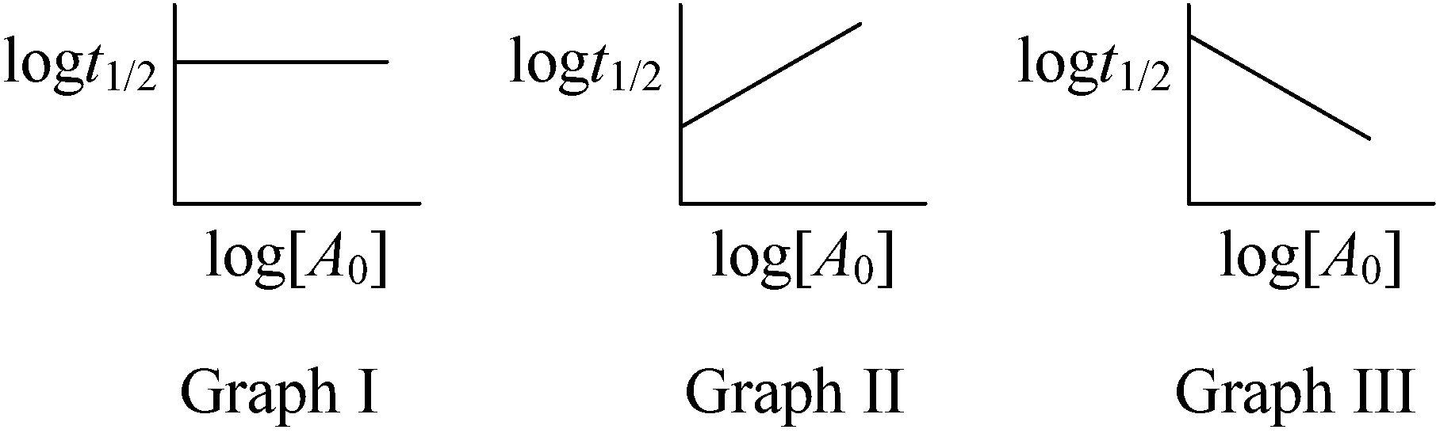

vishwas graph I, II, III shows reactions obeying zero, first and second order reactions.

vishwas graph I, II, III shows reactions obeying first, zero and second order reactions.

vishwas graph I, II, III are showing reactions obeying second, zero and first order kinetics

vishwas graph I and II shows zero order and graph III is showing second order kinetics.

**Nikhil 3.** The volume strength of H2O2 solution prepared by mixing of 250 ml of 3 N H2O2 and 750 ml of 1 N H2O2 solution would be

vishwas 11.2 volume vishwas 5.6 volume

vishwas 8.4 volume vishwas 2.8 volume

**Nikhil 4.** Which one of the following characteristics of lithium does not resemble with other alkali metals?

vishwas It can form nitride when heated in air.

vishwas It reacts with water to form hydroxide and hydrogen.

vishwas It is soluble in liquid ammonia.

vishwas It’s nitrate is thermally unstable.

**Nikhil 5.** Anaqueous solution of gas (X) shows the following reactions:

(i) It decolourises an acidified K2Cr2O7 solution.

(ii) On boiling it with H2O2, cooling and then adding an aqueous solution of BaCl2, a precipitate is obtained which is insoluble in dil. HCl.

Gas (X) would be

vishwasNO2 vishwas SO2 vishwasNH3 vishwas SO3

**Nikhil 6.** An oxyacid of phosphorous has the following properties. Complete neutralization of the acid with NaOH solution gives an aqueous solution of sodium ions and oxyacid anions in the ratio of 2 : 1. When a solution of the acid is warmed with AgNO3 solution, metallic silver is deposited. The structure of the oxyacid is

vishwas 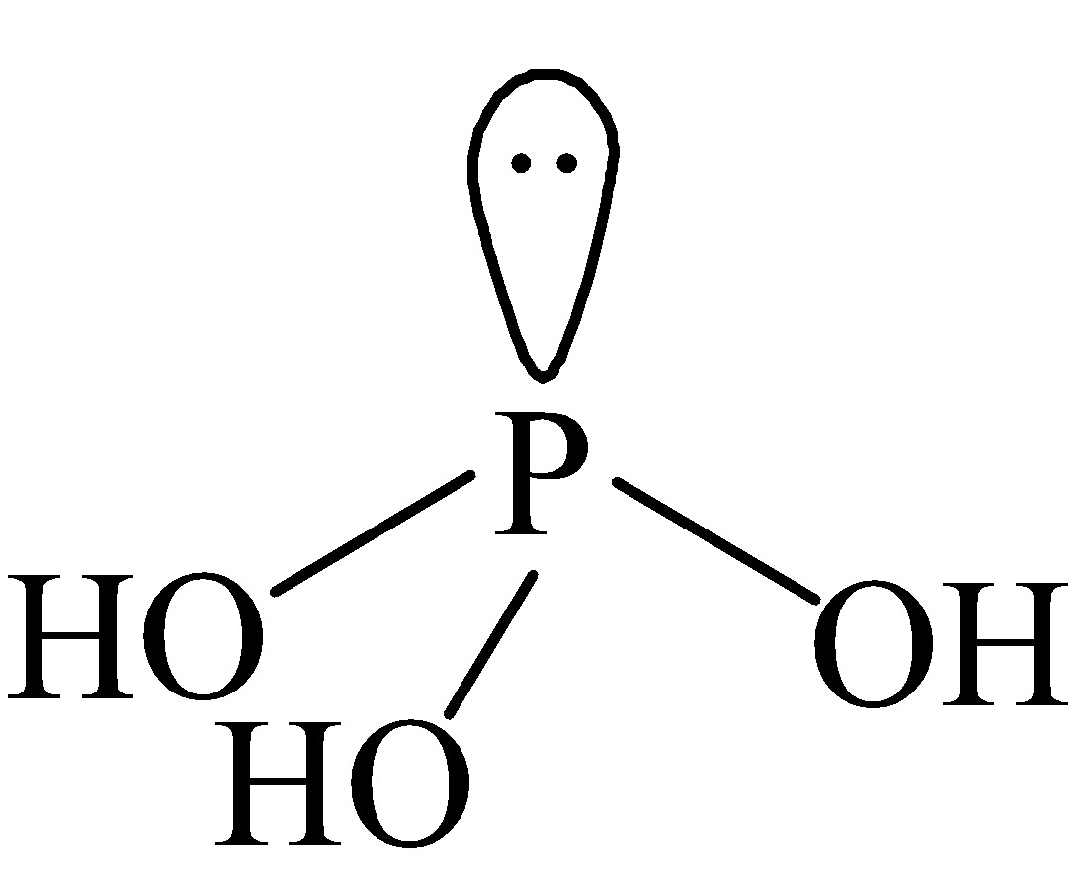 vishwas 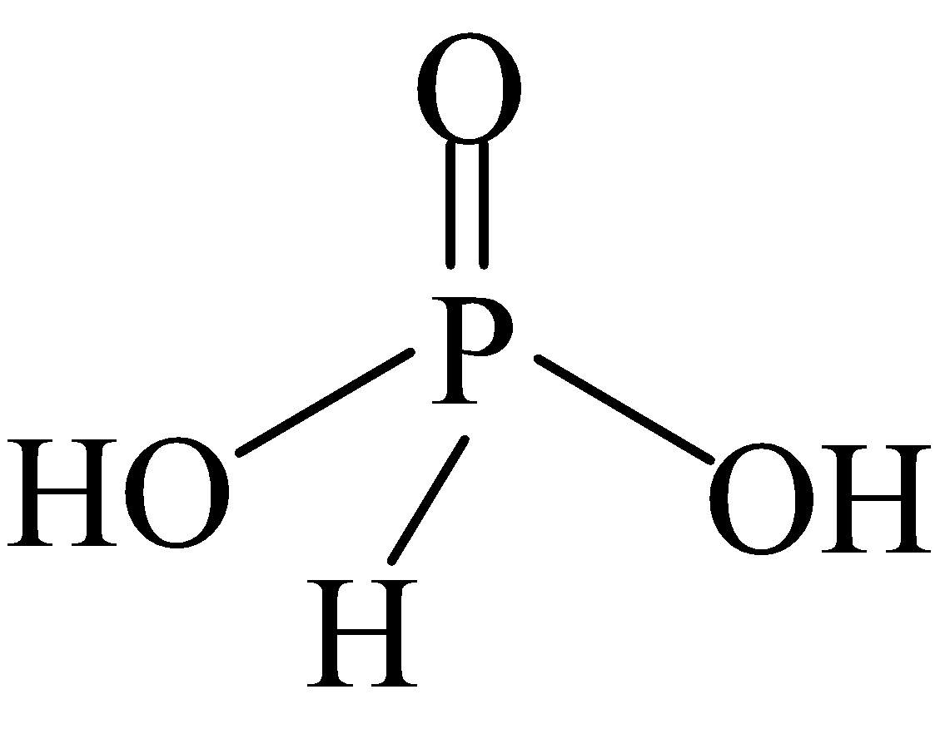 vishwas 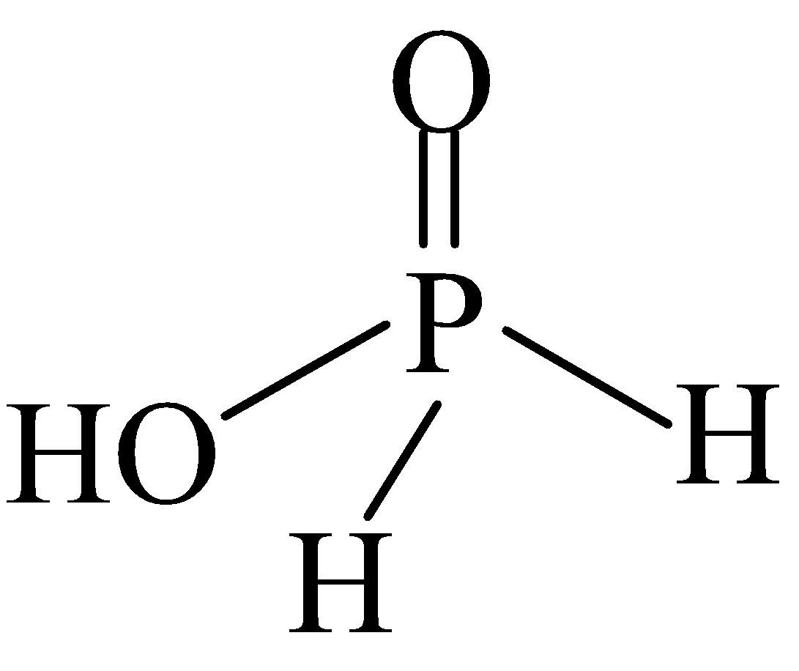 vishwas 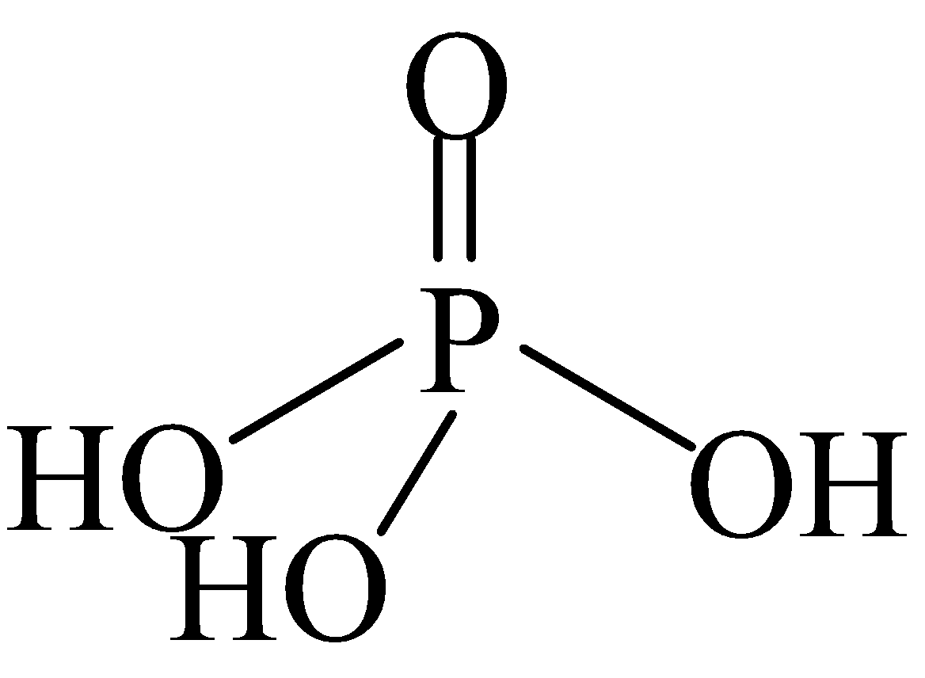

**Nikhil 7.** A coloured solution known to contain two metal ions, was treated with excess cold NaOH solution. When filtered a whitish solid, slowly changing to brown, was retained on the filter paper and a colourless solution collected as the filterate. Dropwise addition of HCl to the filterate produced a white precipitate which dissolved in excess acid. Treatment of the residue from the filter paper with a solution of strong oxidiser produced a reddish-violet solution.   
The given ions were

vishwas Zn2+ and Mn2+ ions vishwas Mn2+ and Mg2+ ions

vishwas Mn2+ and Fe2+ ions vishwas Ni2+ and Zn2+ ions

**Nikhil 8.** The major product (X) of the following reaction is

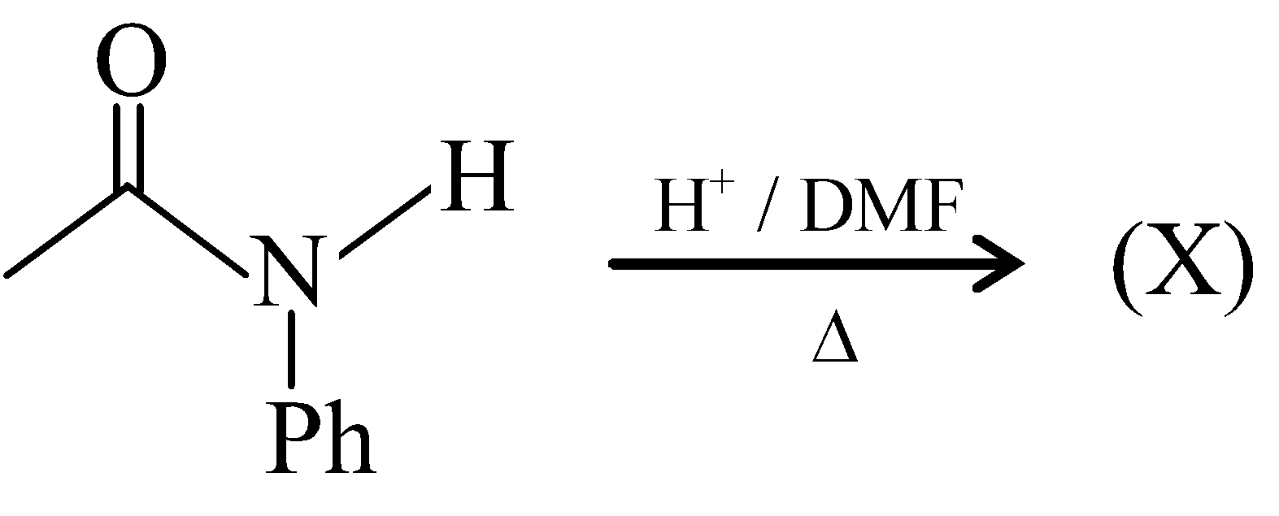

vishwas 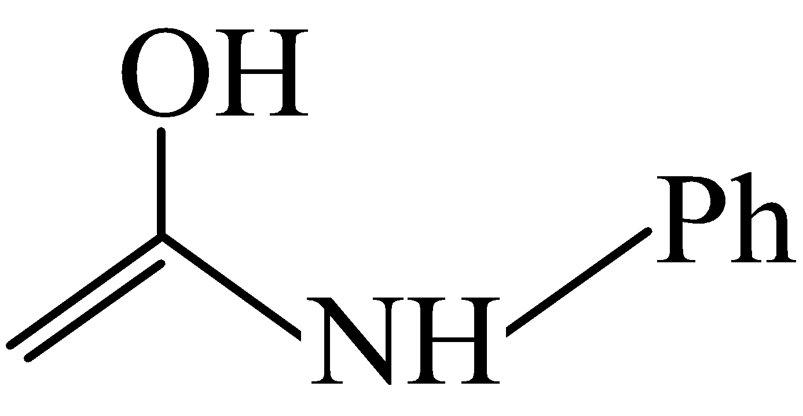 vishwas 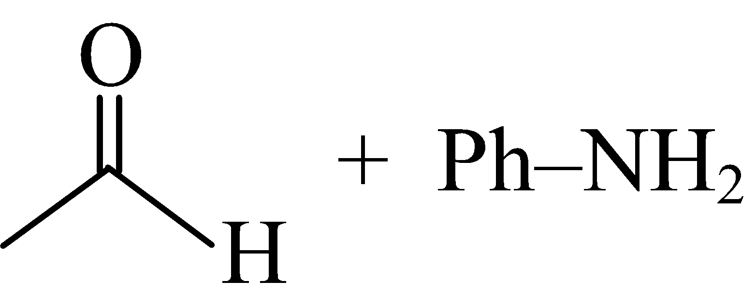 vishwas 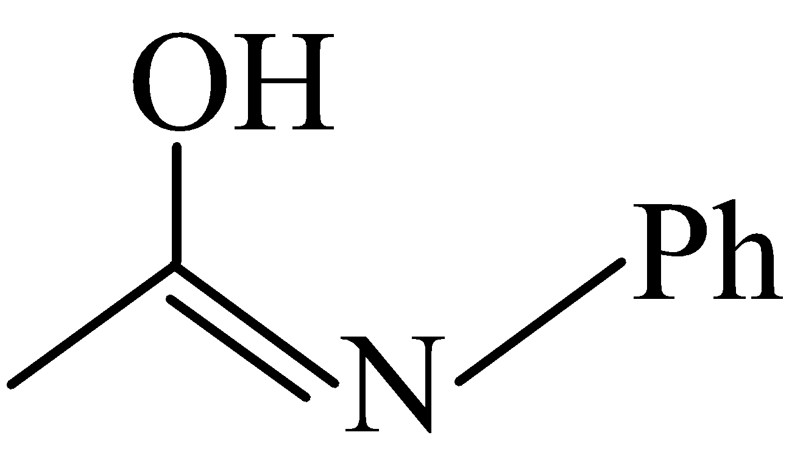 vishwas 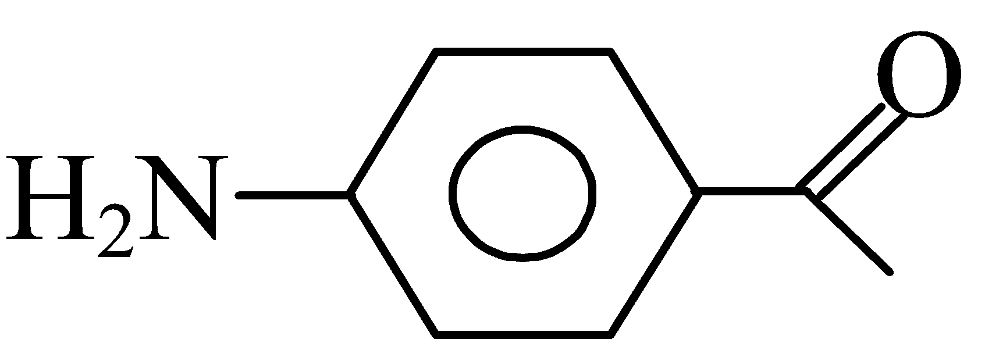

**Nikhil 9.** There are three monoprotic acids (HL, HM and HN) for which pKa values are 4.5, 7 and 2.3 respectively. Based on this data, predict which of the following acyl nucleophilic substitution will not occur?

vishwas 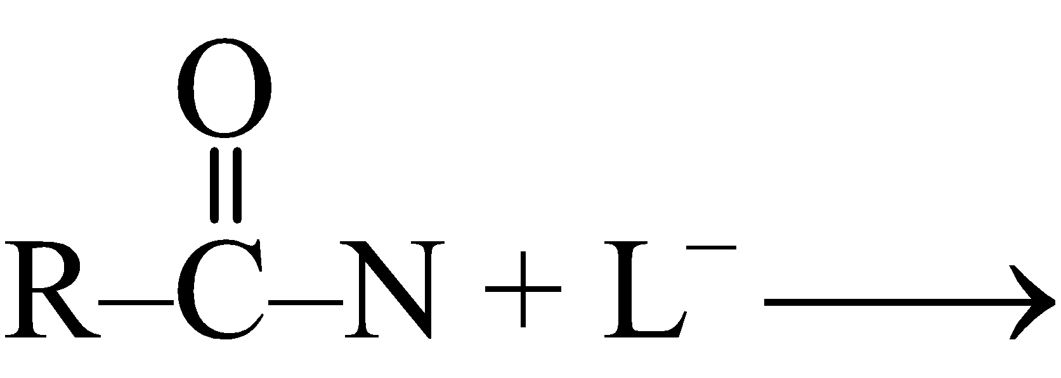 vishwas 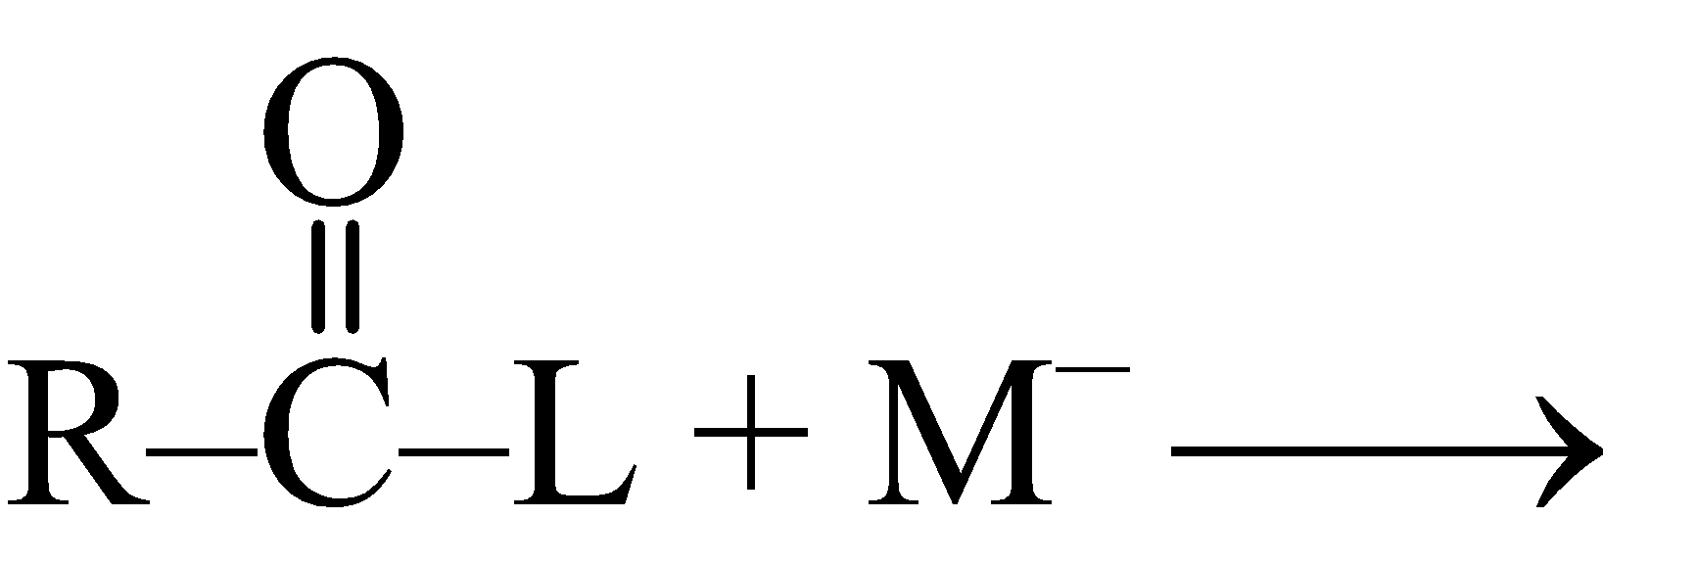 vishwas 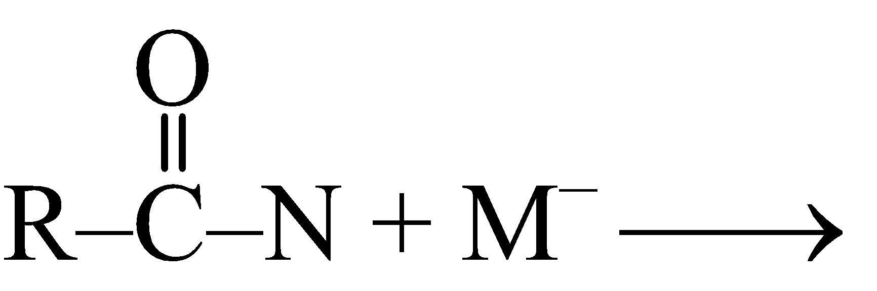 vishwas 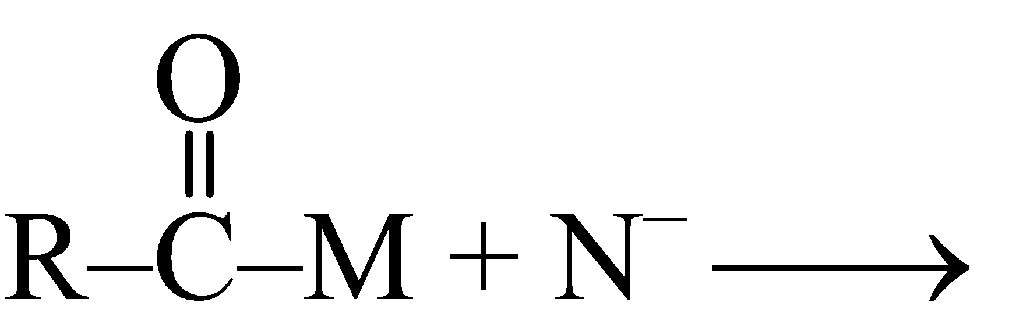

**Nikhil 10.** Consider the following first order competing reactions: 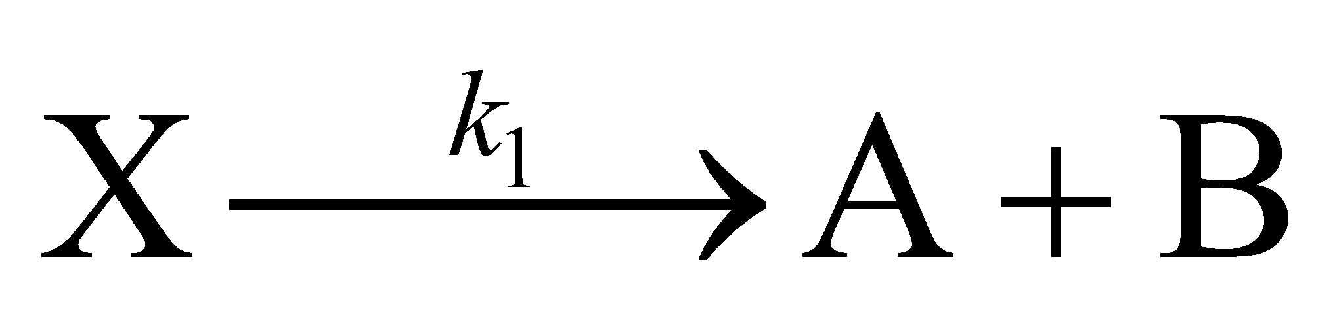and 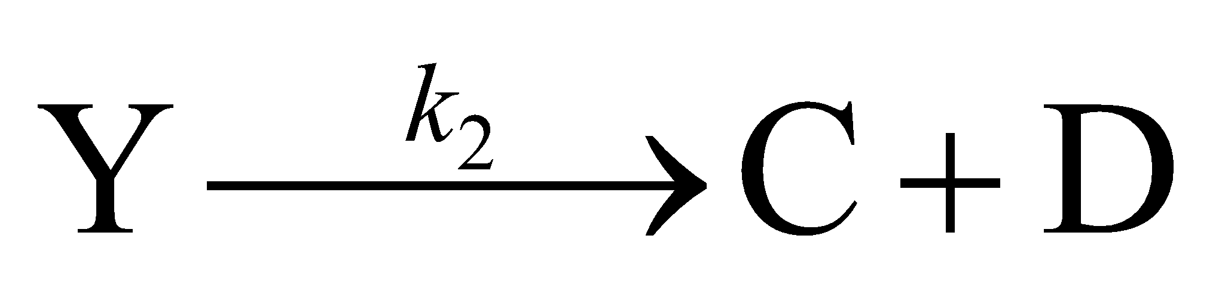

If 50% of the reaction of ‘X’ has been completed when 96% of the reaction of ‘Y’ was completed, then the ratio of their rate constants (*k*2/*k*1) is

vishwas 2.34 vishwas 0.215 vishwas 1.1 vishwas 4.64

#Multiple#

**Nikhil 11.** 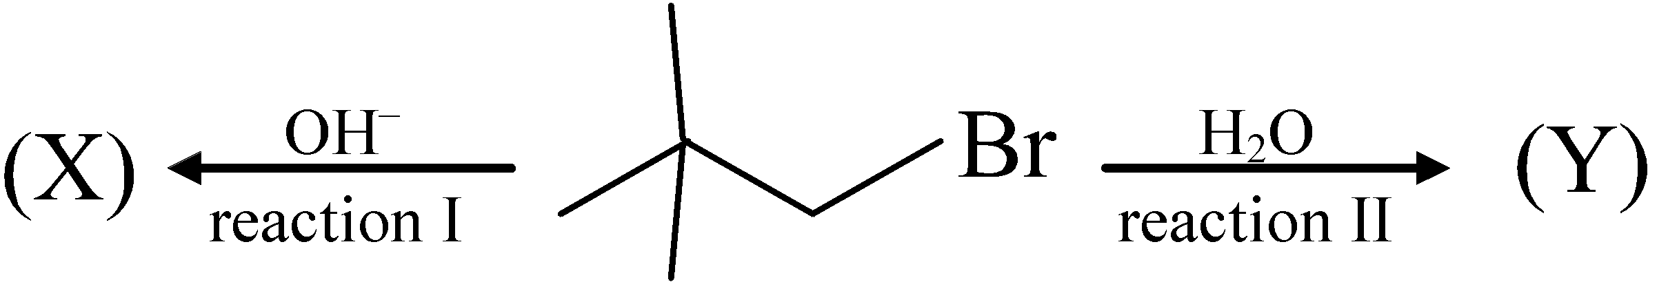

Choose the correct statement from the following:

vishwas Minor product of reaction I would be 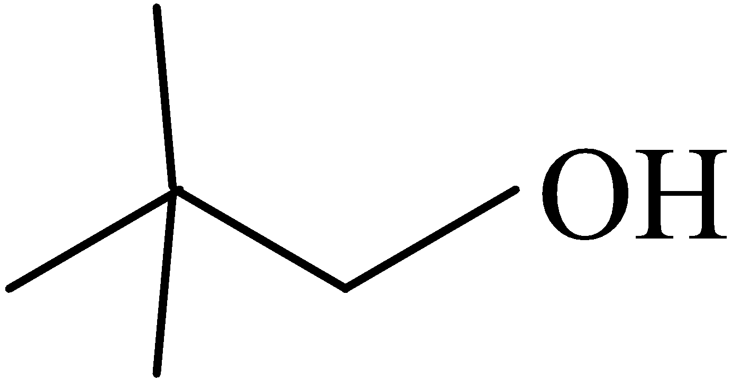 adopting SN2 mechanism.

vishwas Predominant product of reaction II would be 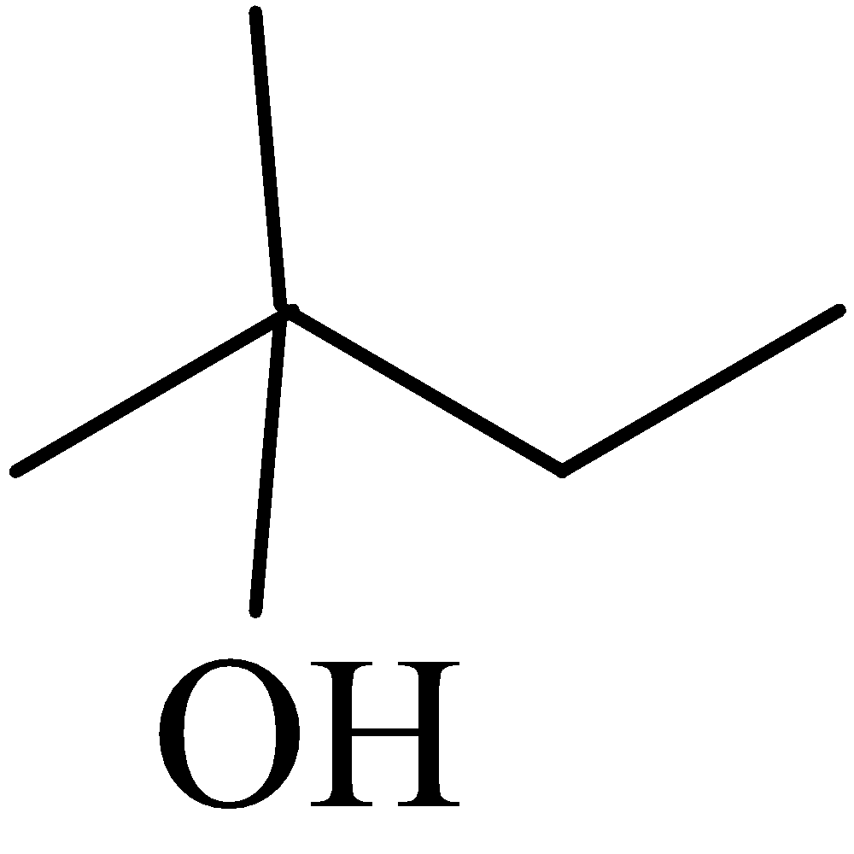 adopting SN1 mechanism.

vishwas Predominant product of reaction I would be 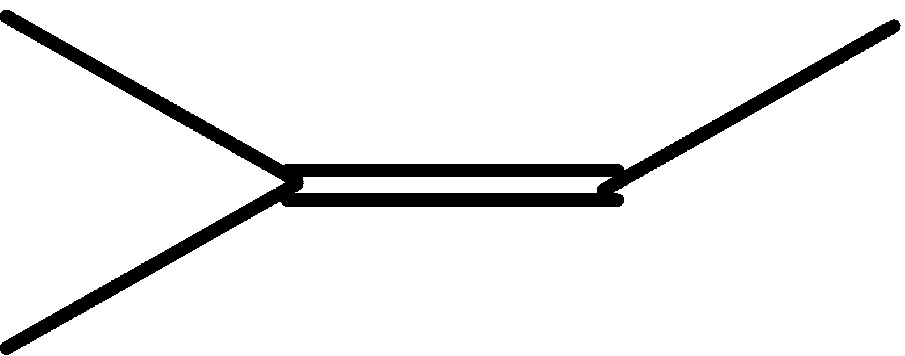 adopting E1 mechanism.

vishwas Predominant product of reaction II would be 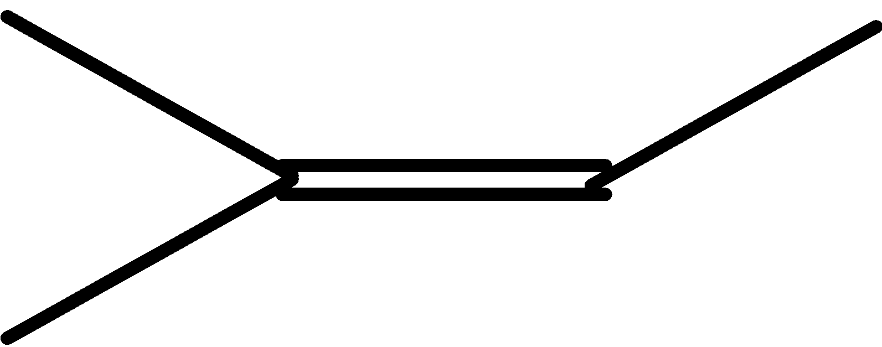 adopting E1 mechanism.

**Nikhil 12.** Out of the following, choose the incorrect statement.

vishwas Gases tend to behave ideally when pressure is high and temperature is low.

vishwas Gases can be liquefied only when critical pressure is applied above their critical temperature.

vishwas For all gases, value of compressibility factor (Z) becomes more than one when pressure of gas is very high.

vishwas For hydrogen and helium gases, value of Z is more than one even when pressure is low.

**Nikhil 13.** Which among the four disaccharides namely 1,4′-glycoside, 1,6′-glycoside, 1,1′-glycoside and 1,5′-glycoside is a reducing sugar? (Assume that all disaccharides have glucose units only)

vishwas 1,4′-glycoside vishwas 1,6′-glycoside

vishwas 1,1′-glycoside vishwas 1,5′-glycoside

**Nikhil 14.** ‘*n*’ moles of an ideal gas undergo isothermal and reversible expansion. Which of the following condition(s) is/are correct for the given process?

vishwas Δ*H* = 0 vishwas Δ*E* = 0 vishwas *w* = 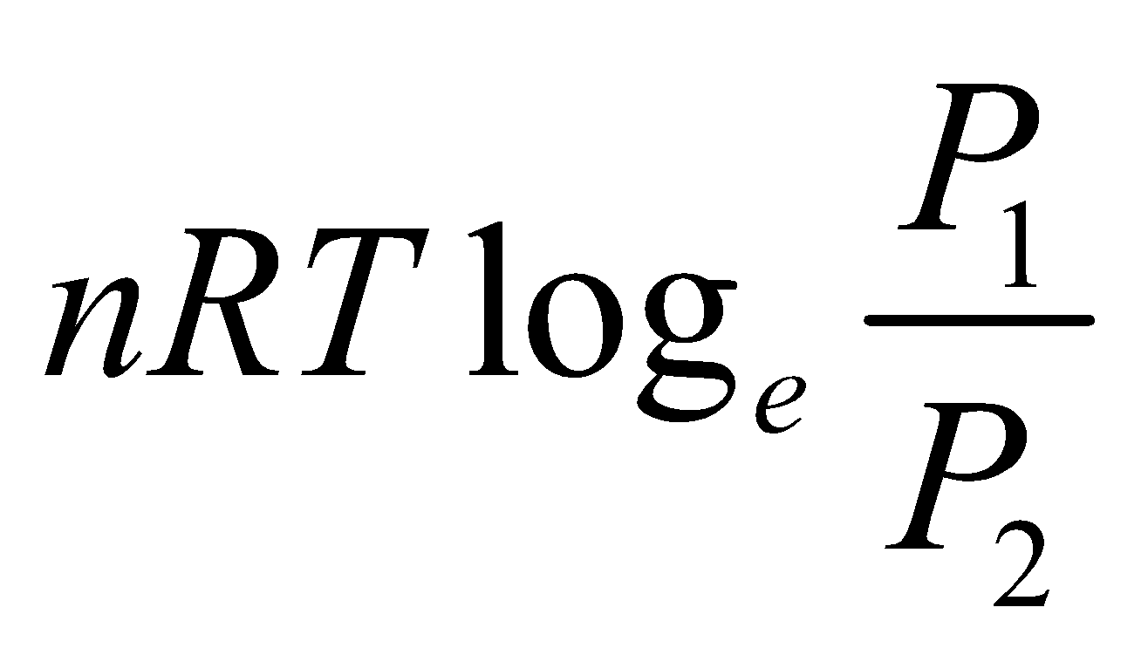 vishwas *w* = –*q*

**Nikhil 15.** An element obtained from calcite ore when burnt in nitrogen produces an ionic compound (X) that on treatment with water gives (Y) and (Z) (a pungent smelling gas). A solution of (Y) becomes milky on bubbling carbon dioxide through it. Using this data, we can say that

vishwas milkiness is due to bicarbonate ions vishwas (X) is Ca3N2

vishwas (Z) is NH3 vishwas (Y) is Ca(OH)2

#Integer#

**Nikhil 16.** Find out the ratio of optically active isomers to meso-isomers for the following reaction:

CH3–CH = CH–CH3 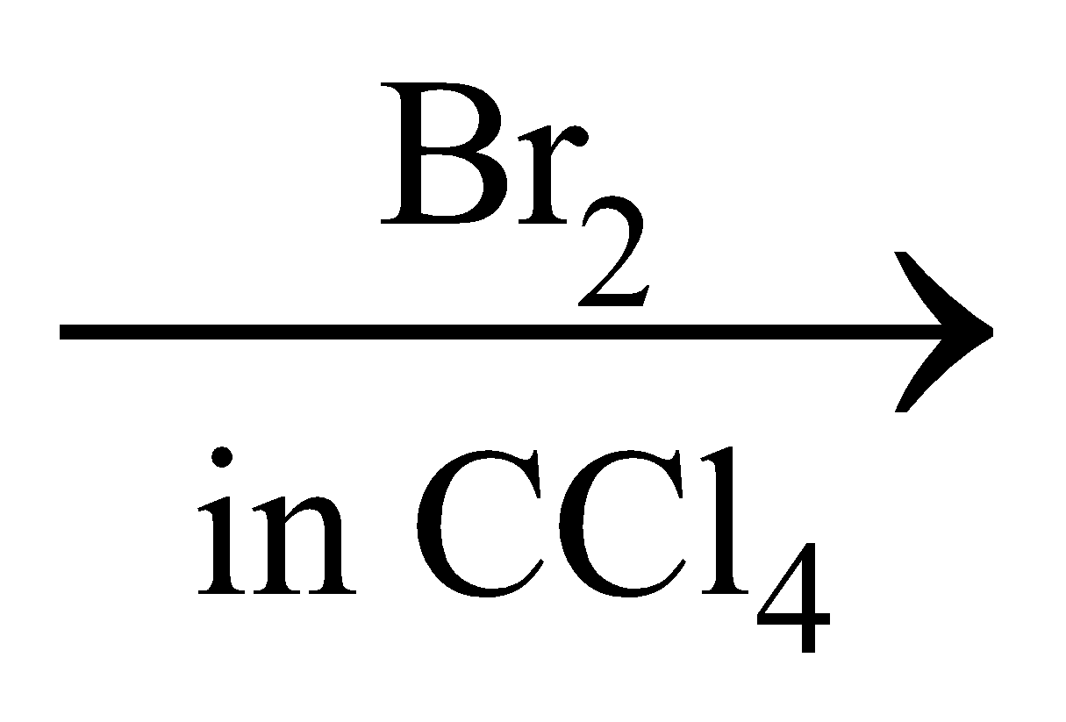 products

**Nikhil 17.** In the given reaction, [Fe(CO)5] + 2NO ⎯→ [Fe(CO)2(NO)2] + 3CO↑

the co-ordination number of Fe in the complex on product side is ________ .

**Nikhil 18.** 736 g of K4[Fe(CN)6] reacts with 40 L of 0.2 M H2SO4 to undergo non-redox reaction to liberate CO gas. The number of moles of CO released is ________ .

**Nikhil 19.** In order to obtain a solution of pH 9, the volume (in ml) of 5 M KCN solution required to be added to 10 ml of 2 M HCN solution is ________ . (*Ka* of HCN = 5 × 10–10 M and log 5 = 0.7 ; log 2 = 0.301)

**Nikhil 20.** The emission spectrum of a sample of single hydrogen atom contains 3 lines. The value of ‘*n*’ to which the hydrogen atom gets excited is ________ .

##Physics##

#Single#

**Nikhil 21.** A particle is at rest at *t* = 0 at the origin of coordinate system (*x*, *y*). The acceleration of the particle varies with *x* coordinate as 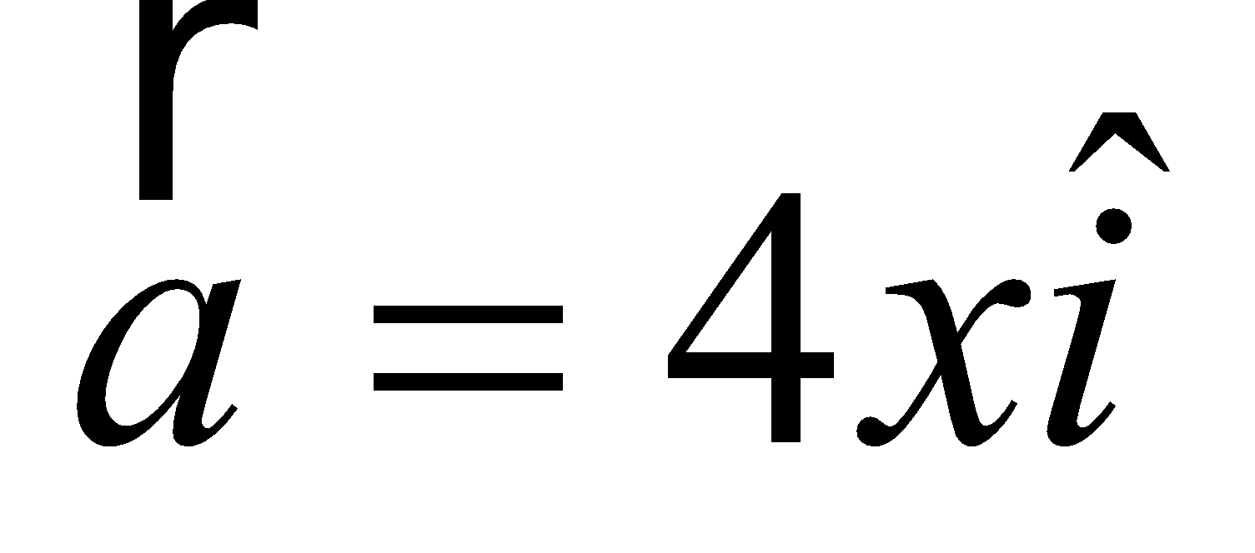. The velocity of the particle at *t* = 1s will be

vishwas 2 *e*2 m/s vishwas 2 *e* m/s

vishwas 2 m/s vishwas 0 m/s

**Nikhil 22.** Two bodies of masses 2 kg and 3 kg are connected by a metal wire of cross section 0.04 mm2 and are placed on a frictionless horizontal surface. Breaking stress of metal wire is 2.5 GPa. The maximum force *F* that can be applied to 3 kg block so that wire does not break is

vishwas 100 N vishwas 150 N

vishwas 200 N vishwas 250 N

**Nikhil 23.** A sphere of radius *R*, mass *M*0 is filled with a liquid of density ρ0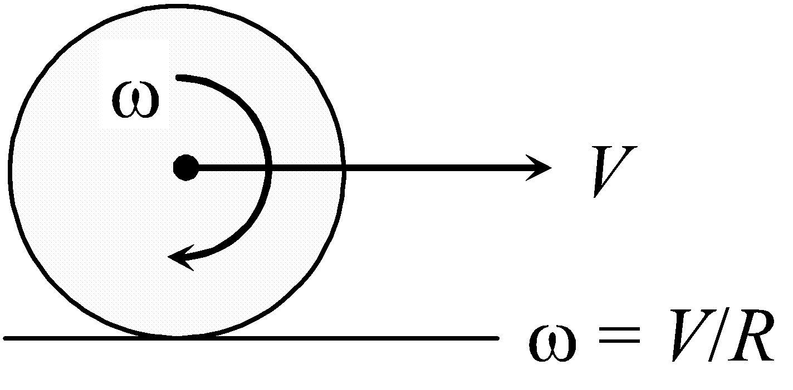.This sphere is under pure rolling on a horizontal surface as shown in figure. The kinetic energy of sphere is (liquid is non-viscous)

vishwas 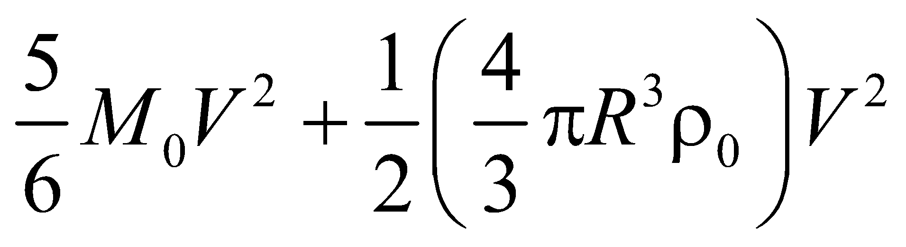 vishwas 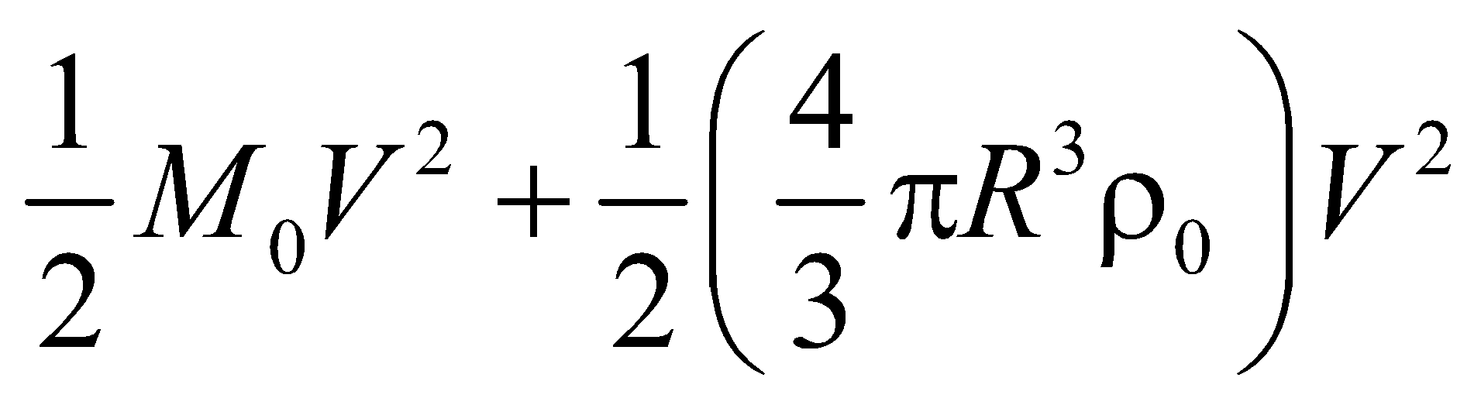

vishwas 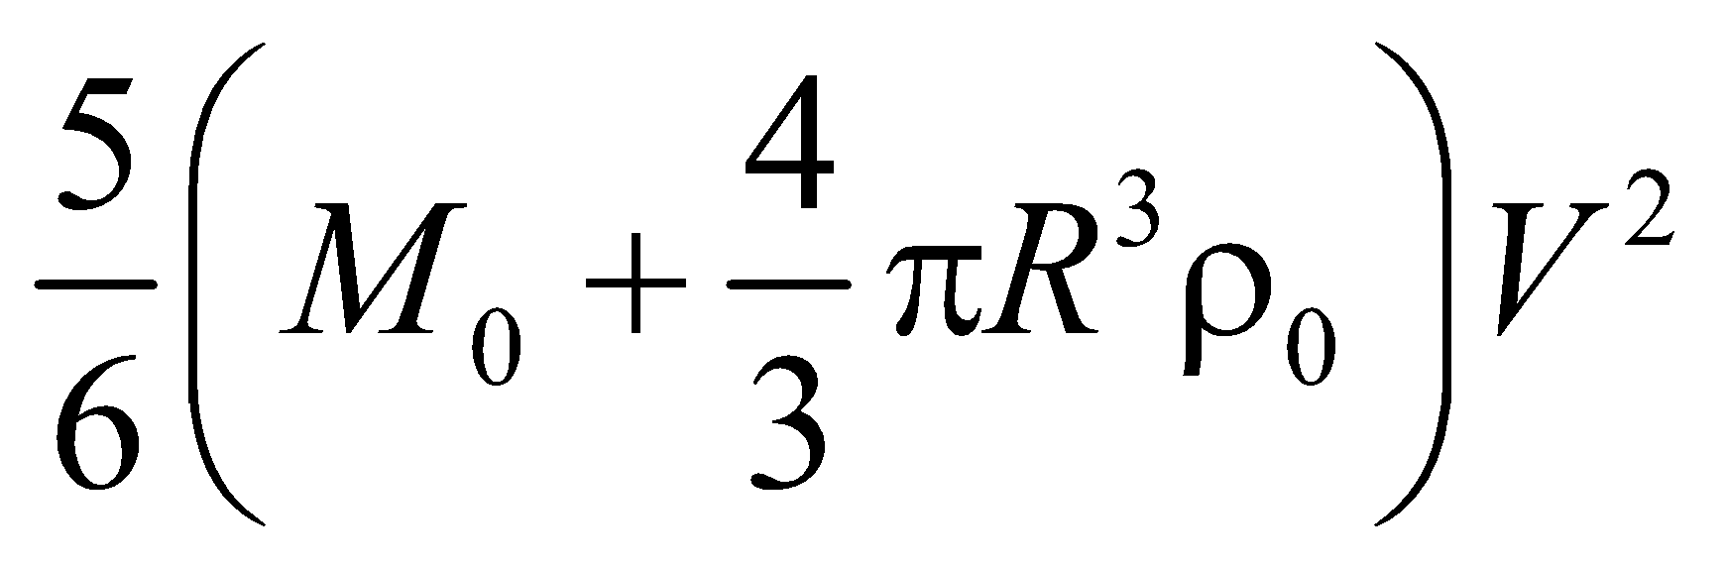 vishwas 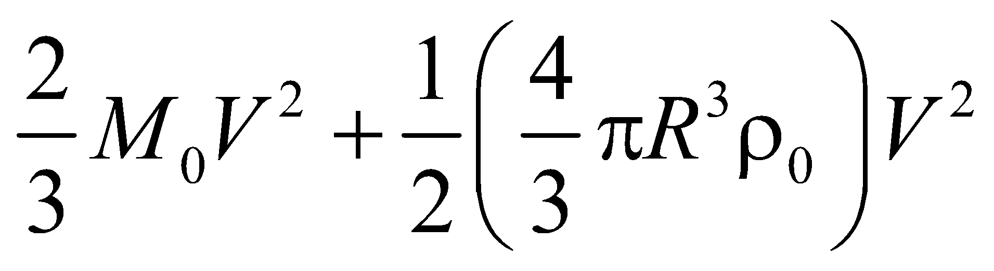

**Nikhil 24.** A source and an observer start to move simultaneously along two perpendicular straight lines from the same point as shown in the figure. The velocity of source is half the velocity of observer. The sound emitted by source has frequency *f*. The variation of received frequency 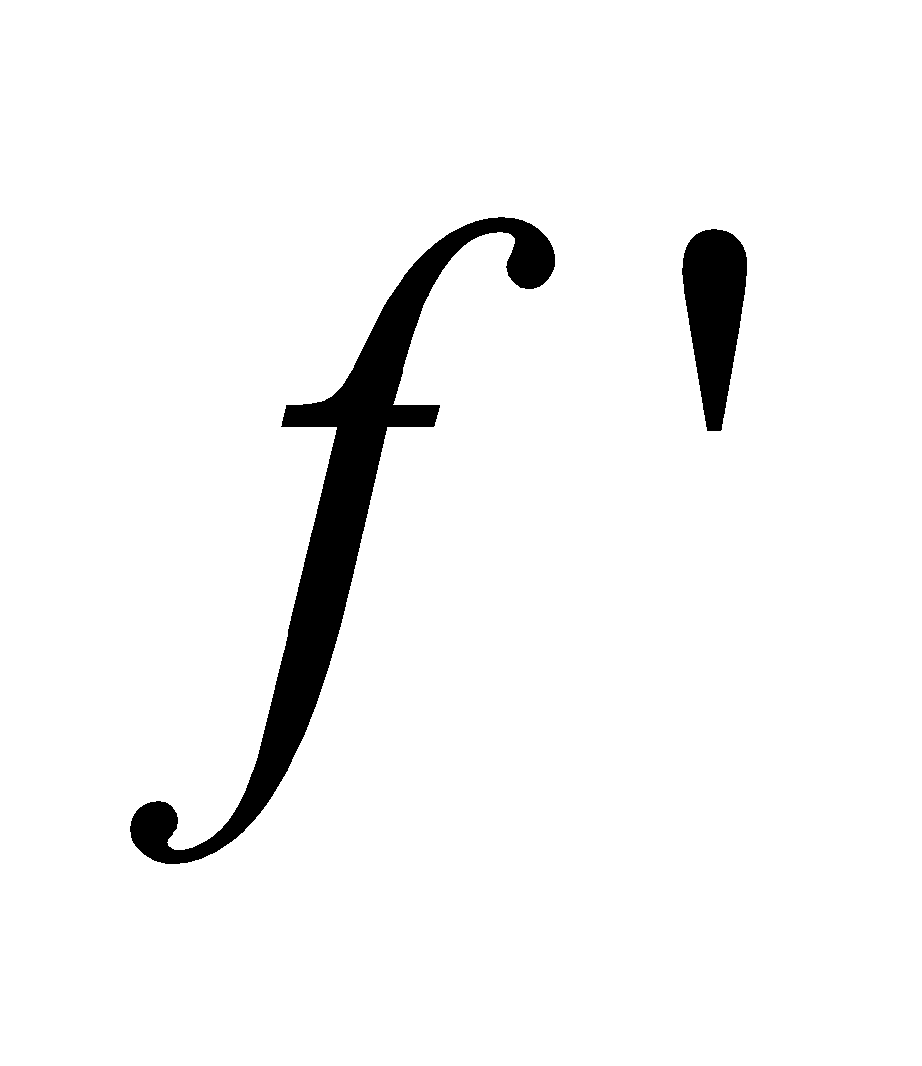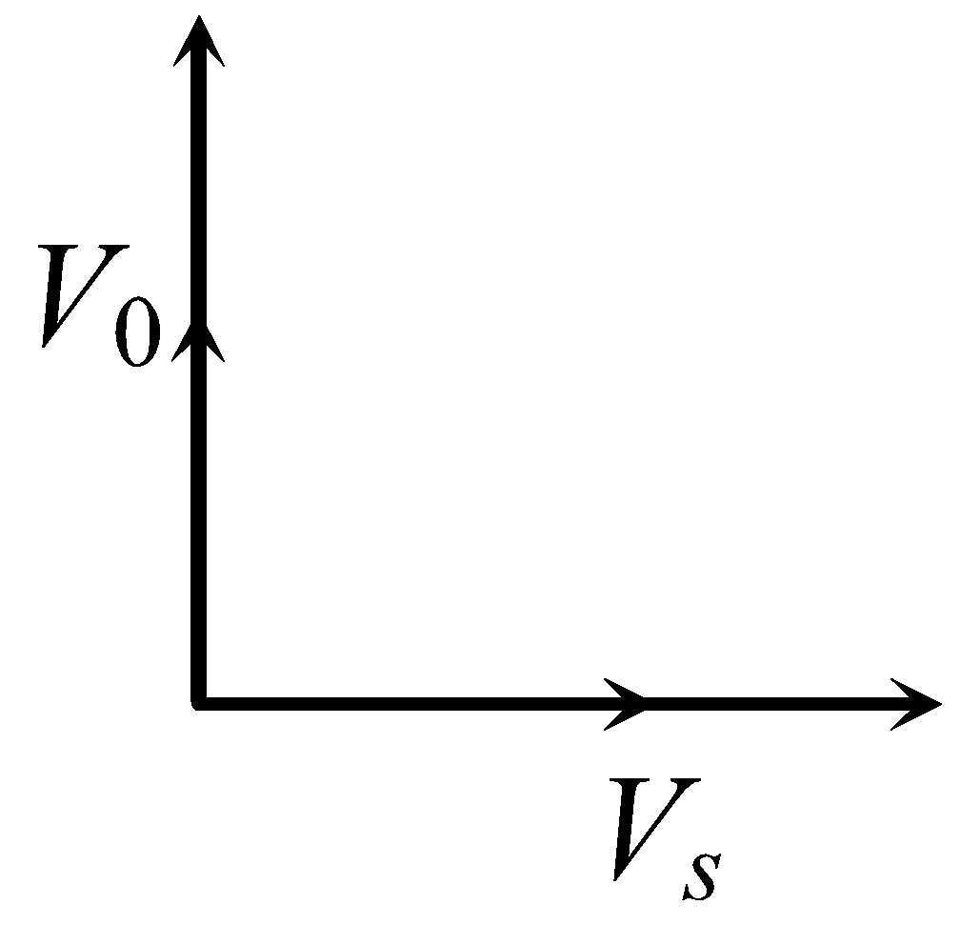 with time can be best represented by

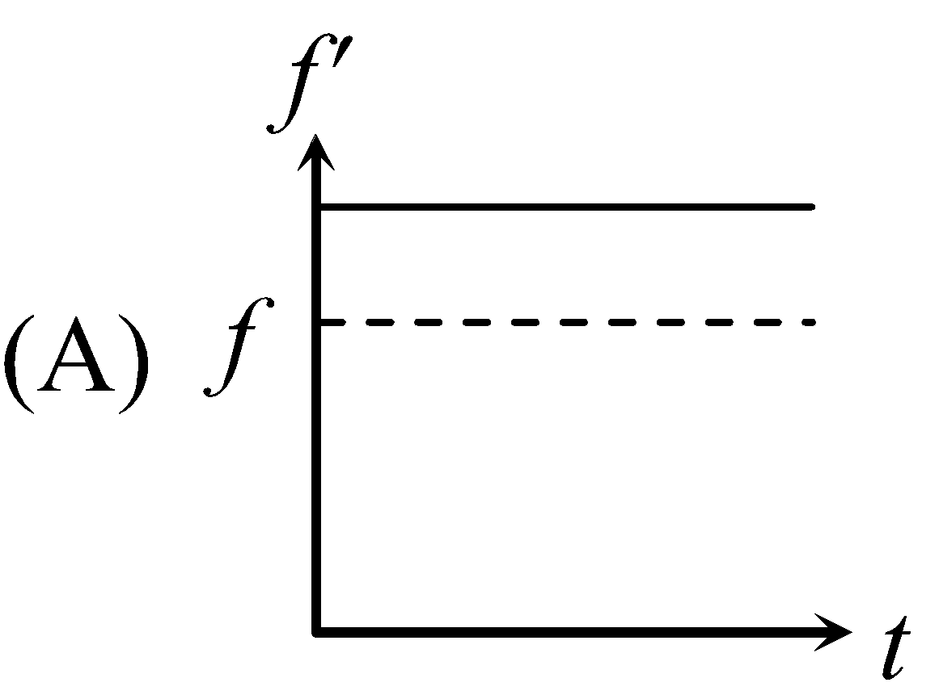 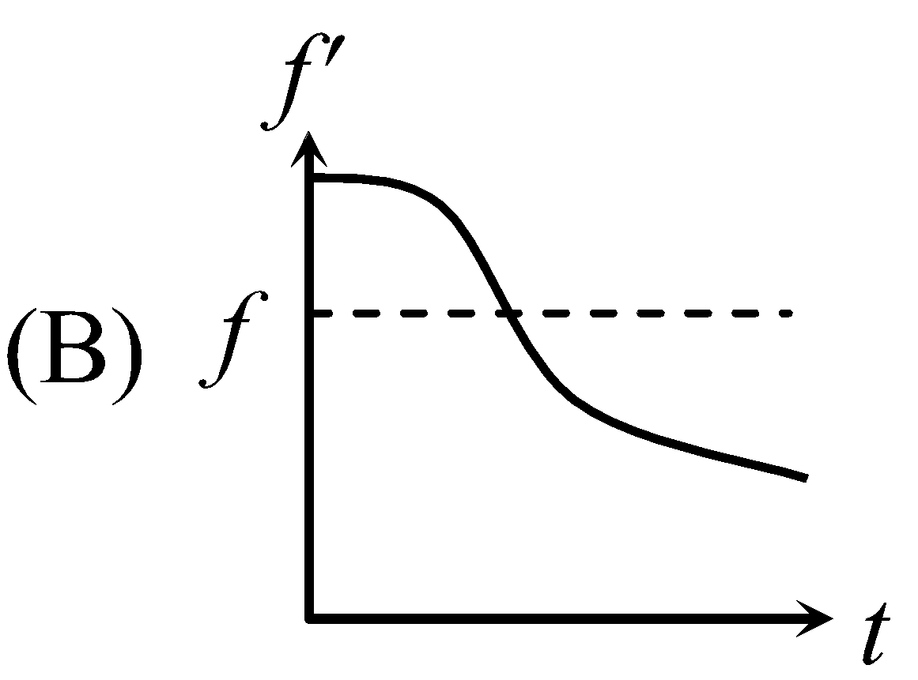 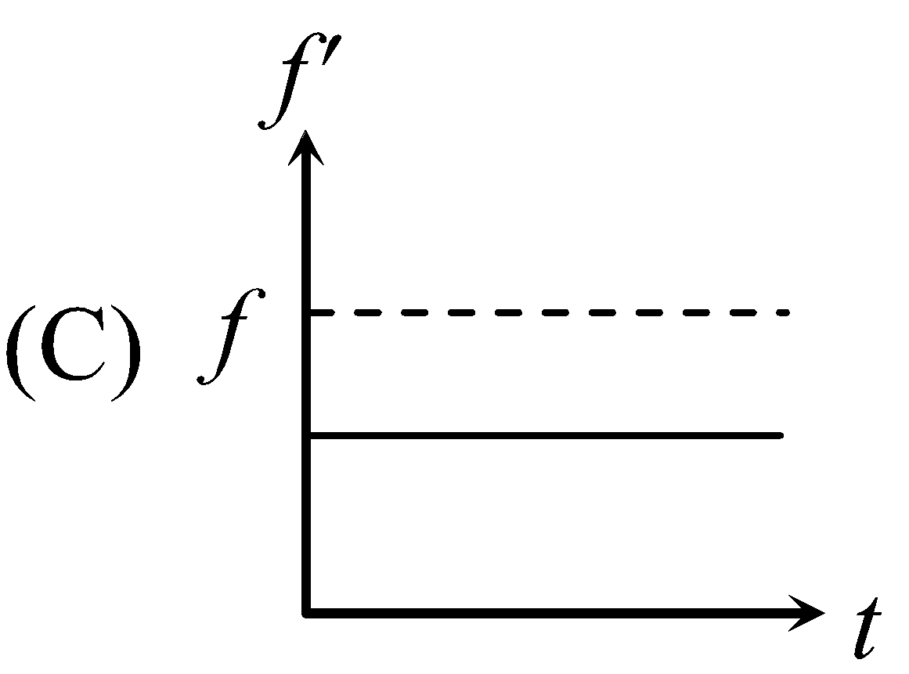 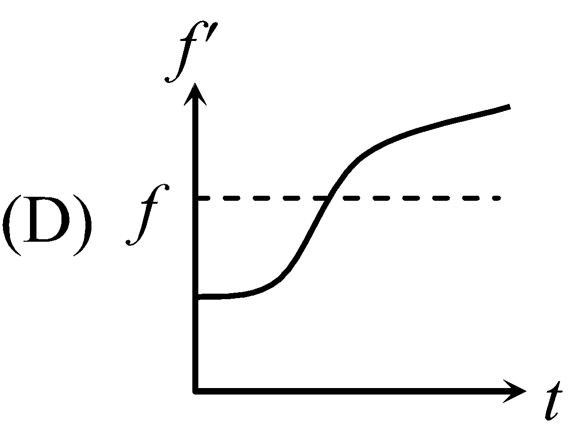

**Nikhil 25.** Two identical conducting plates of area *A* are charged by a battery and then battery is disconnected. The two plates have masses *m*1 and *m*2 and charges *q* and –*q* respectively. They are attached with an ideal spring of spring constant *k*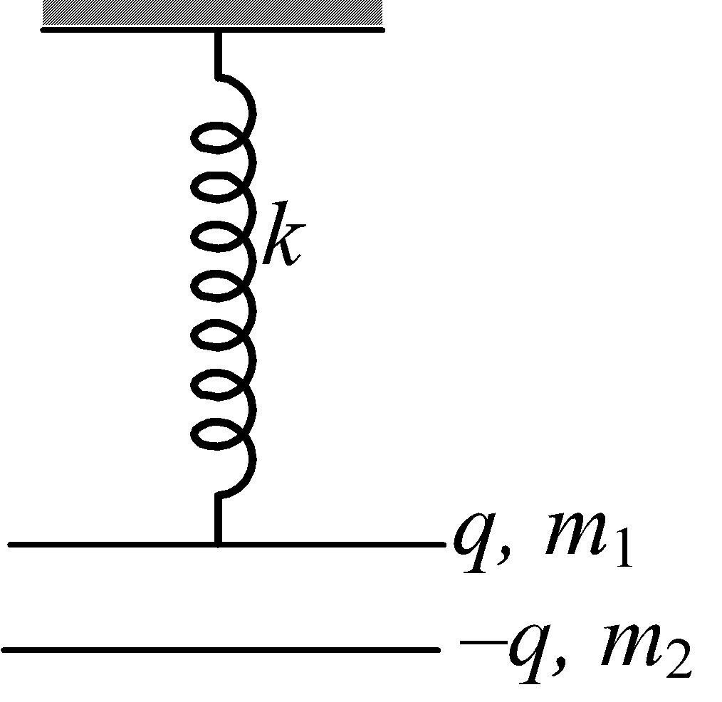 in vertical plane as shown. Both plates are in equilibrium and separation distance between them is small. The deformation in spring will be

vishwas 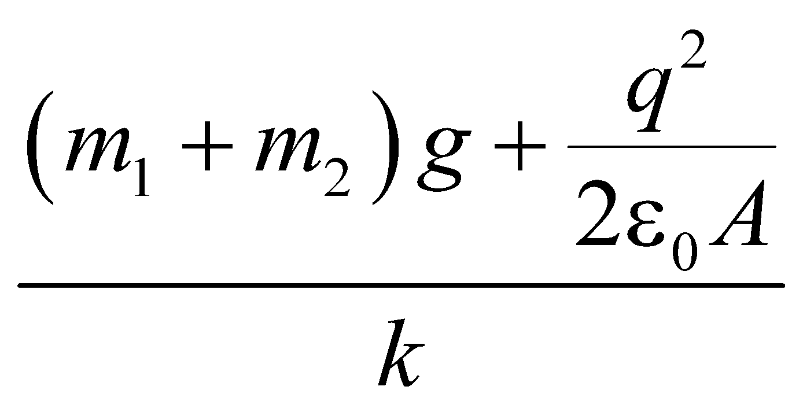 vishwas 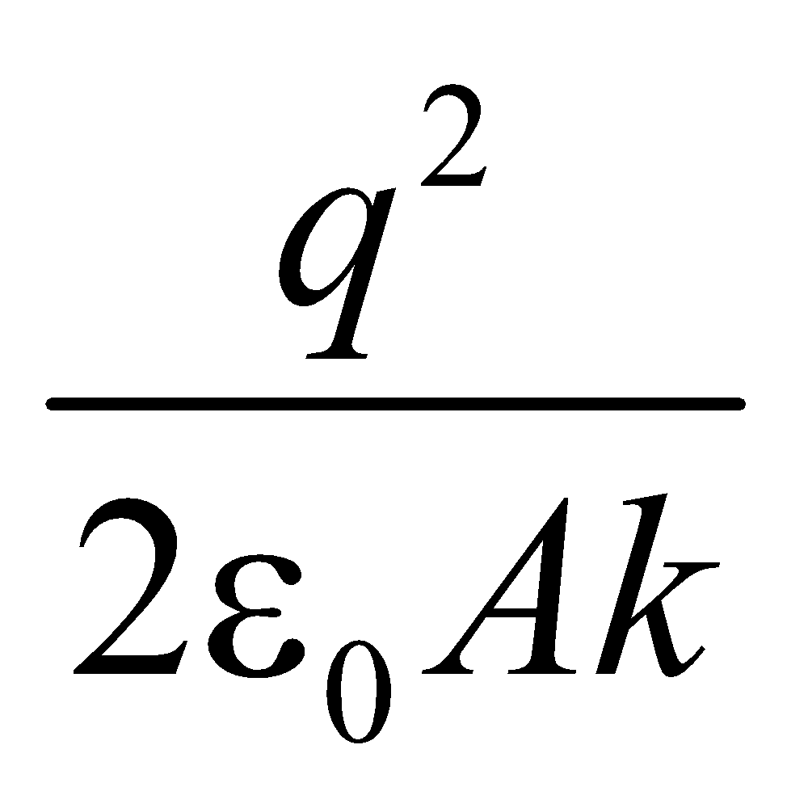

vishwas 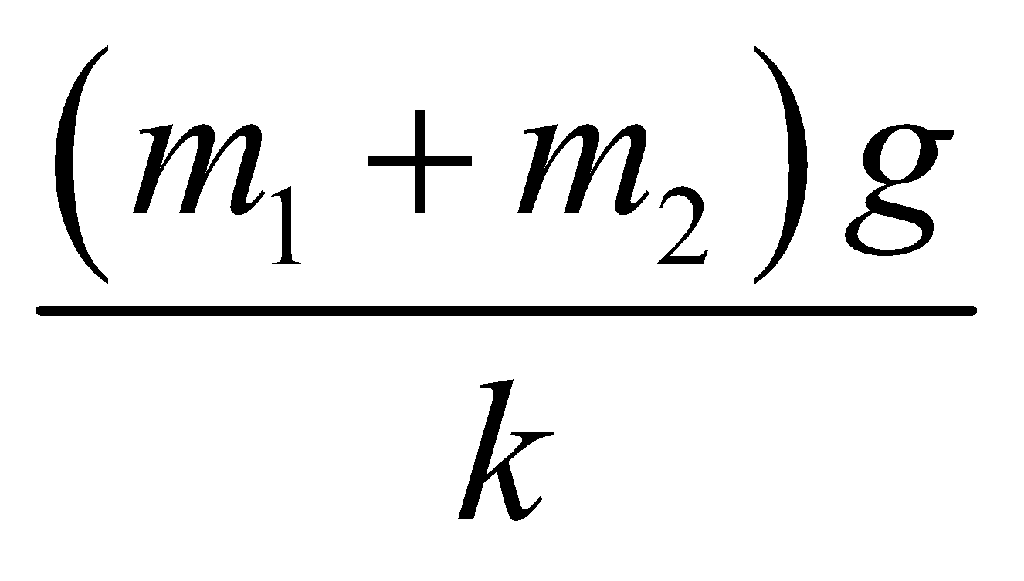 vishwas 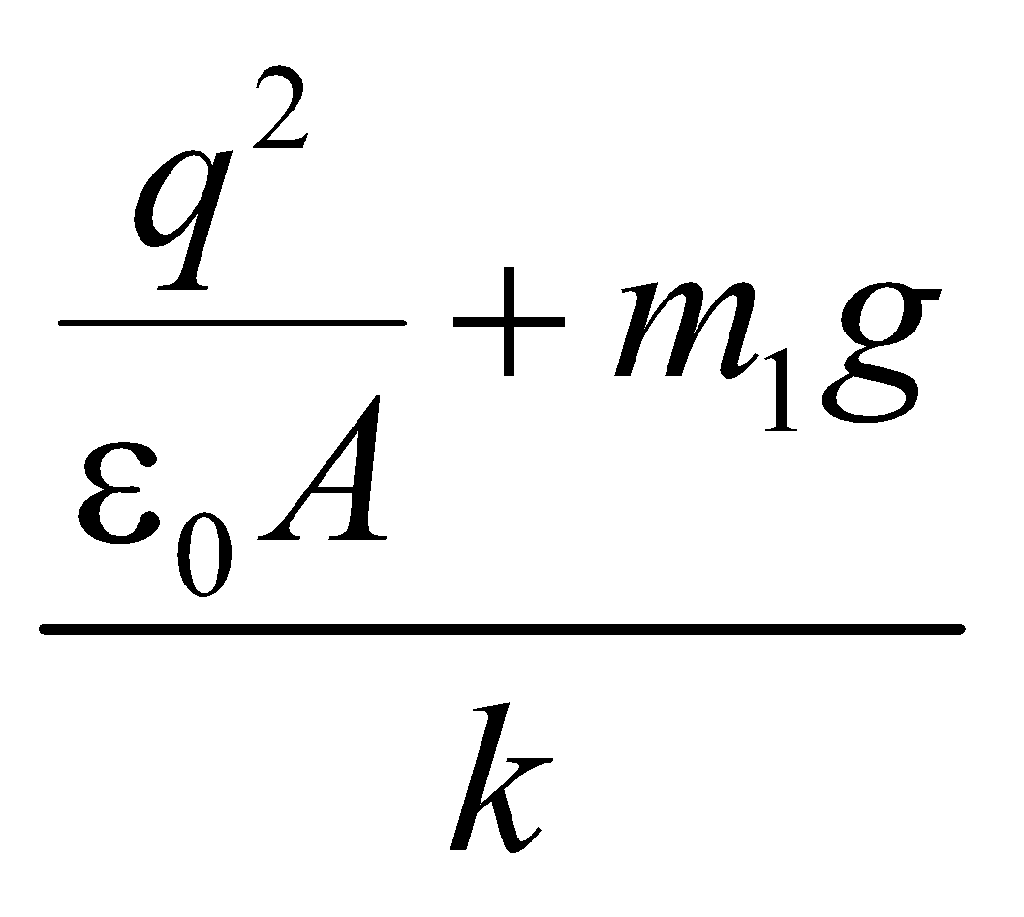

**Nikhil 26.** A parallel plate capacitor of capacitance *C* is charged with a battery of emf *V*. The battery is then disconnected and electromagnetic waves are incident on negative plate of the capacitor. As a result the negative plate starts emitting electrons towards the positive plate. The current which flows between the plates remains constant till time *t*1 and then starts decreasing. The potential difference between the plates at time *t*1 is (Assume plates of capacitor are close to each other)

vishwas *CV* vishwas *CV*/2 vishwas 2*CV* vishwas zero

**Nikhil 27.** The circuit in the figure is situated in a magnetic field of intensity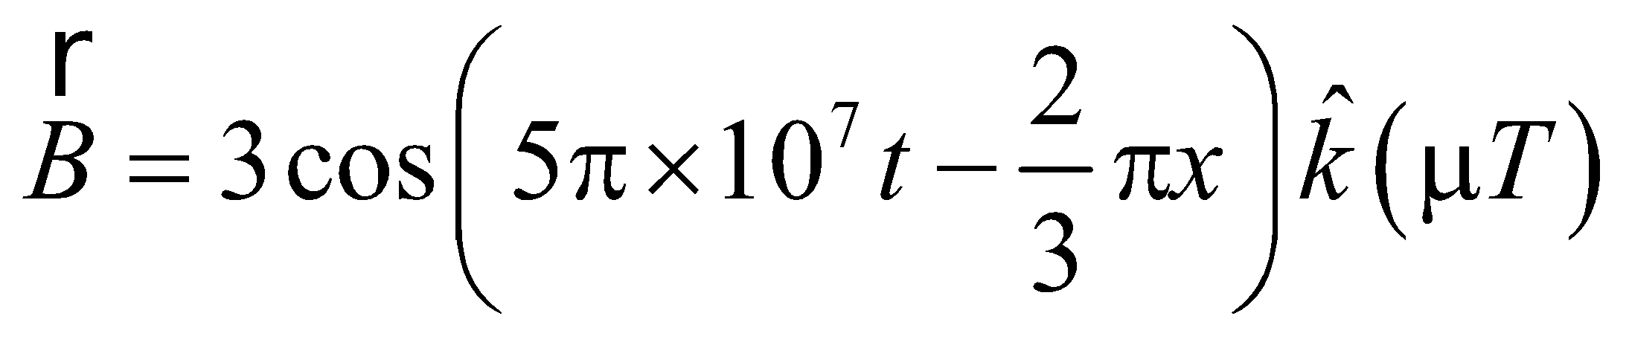. If 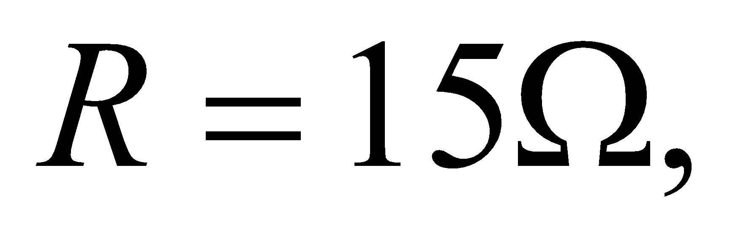 the current *I* in the circuit at 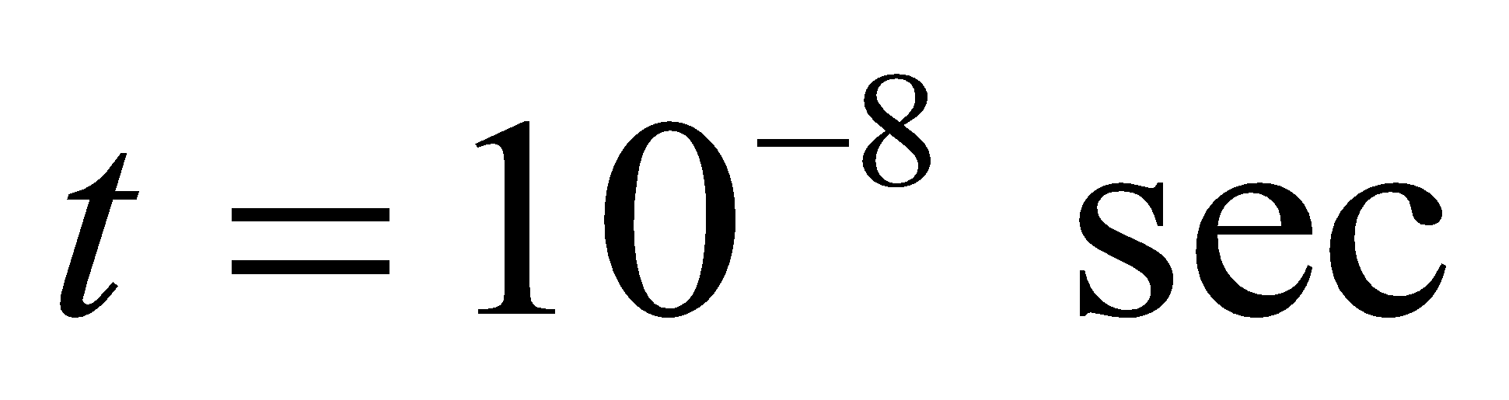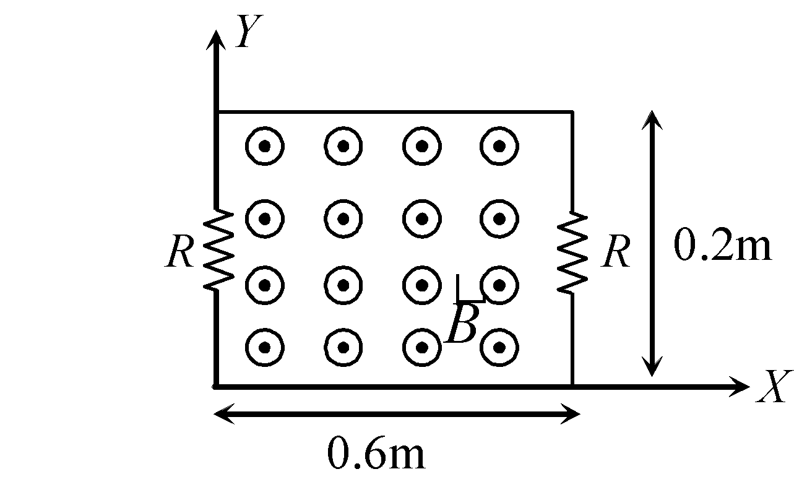 will be

vishwas 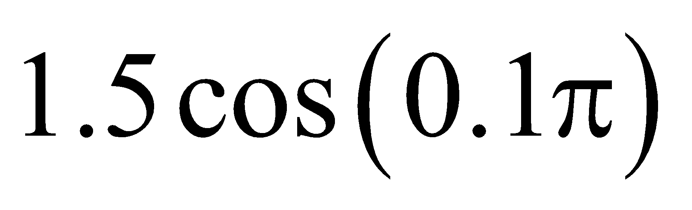A

vishwas 1.5 A

vishwas 0 A

vishwas 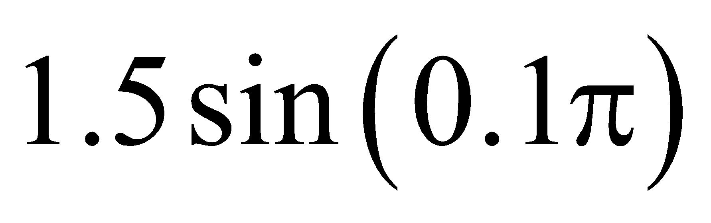A

**Nikhil 28.** A capacitor and a resistor are connected with an A.C. source as shown in figure. Reactance of capacitor is *XC* = 3Ω and resistance of resistor is 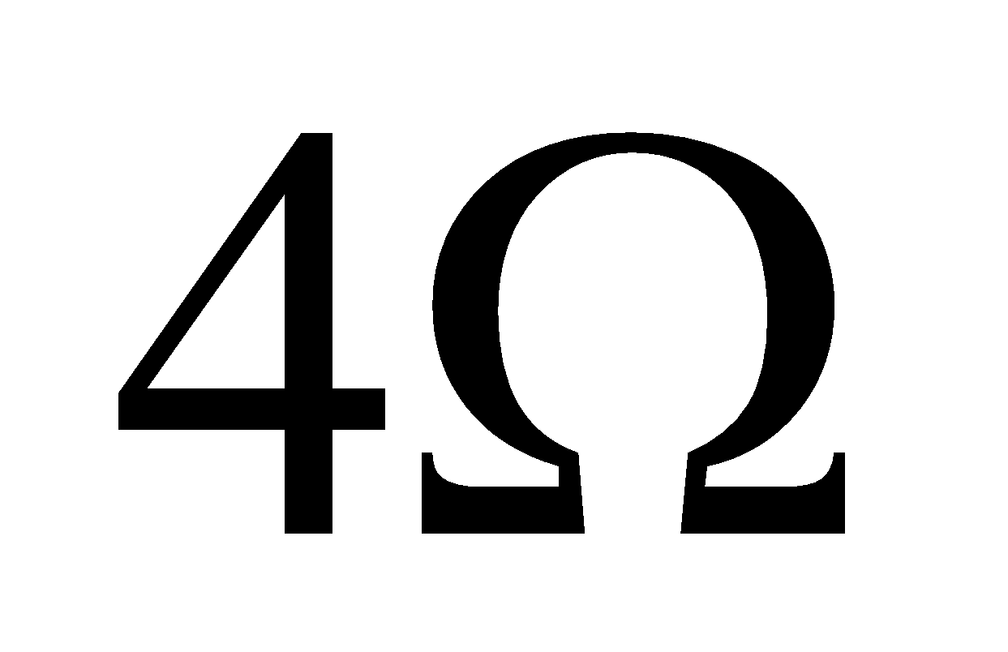. Phase difference between current *I* and *I*1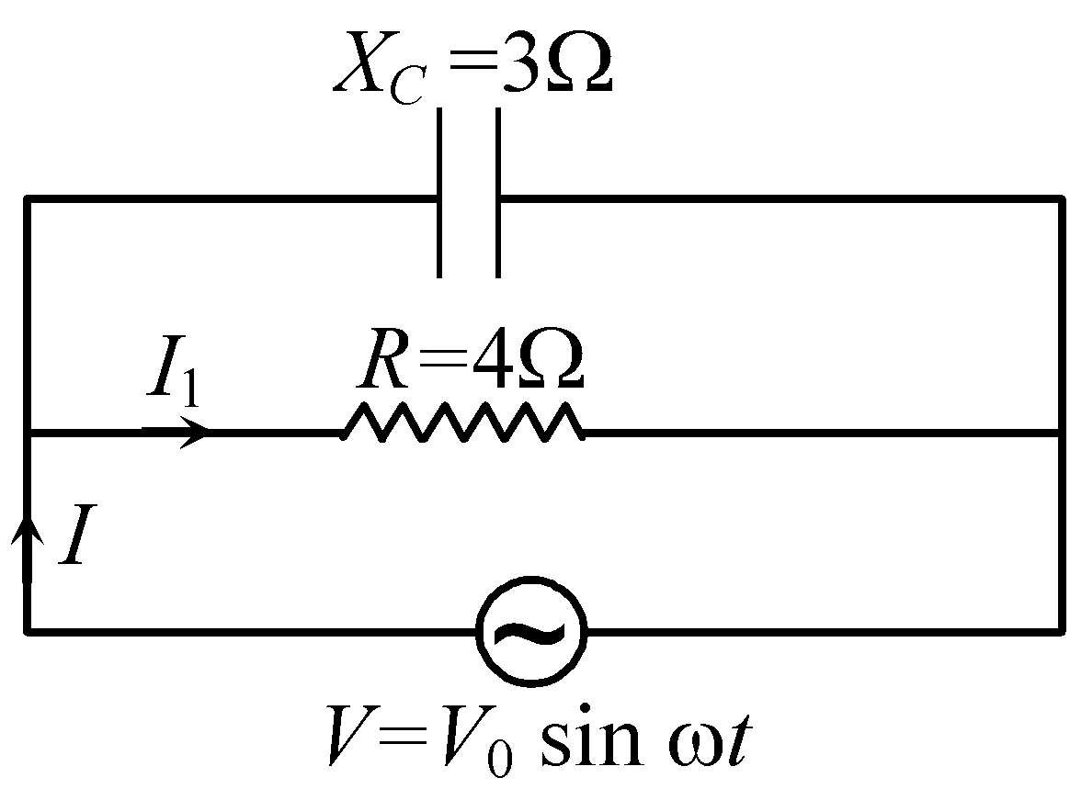 is

vishwas 90° vishwas zero

vishwas 53° vishwas 37º

**Nikhil 29.** The length of a plate is measured with the help of a vernier calliper having zero correction – 0.02 cm. The observation is shown in figure. Then length of the plate from these observations is

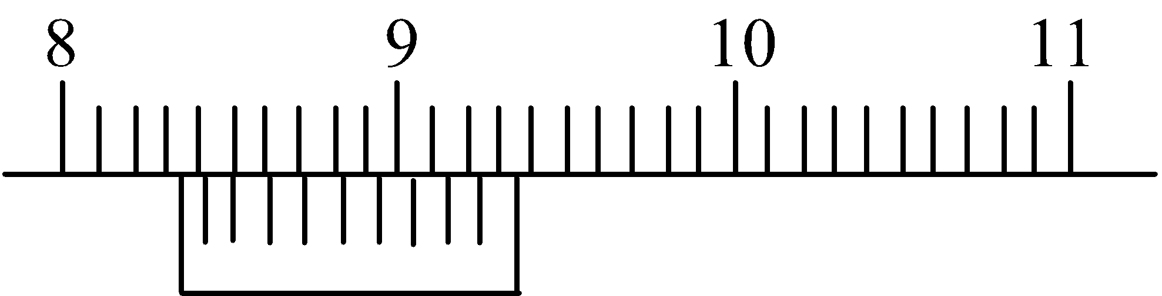

vishwas 8.30 cm vishwas 8.34 cm

vishwas 8.32 cm vishwas 8.36 cm

**Nikhil 30.** A plank of mass *M* is placed on a smooth horizontal surface. Two light identical springs each of stiffness *k* are rigidly connected to struts at the ends of the plank as shown in the figure. When the springs are in their unextended position the distance between their free ends is 3*l*. A block of mass *m* is placed on the plank and pressed against one of the springs so that it is compressed by *l*. To keep the block at rest it is connected to the strut by means of a light string. Initially the system is at rest. Now the string is burnt. Then the maximum displacement of the plank is

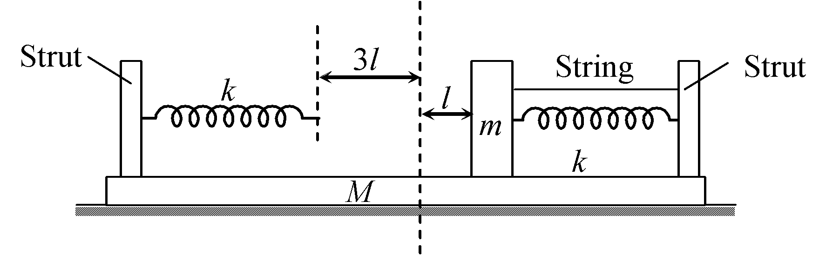

vishwas 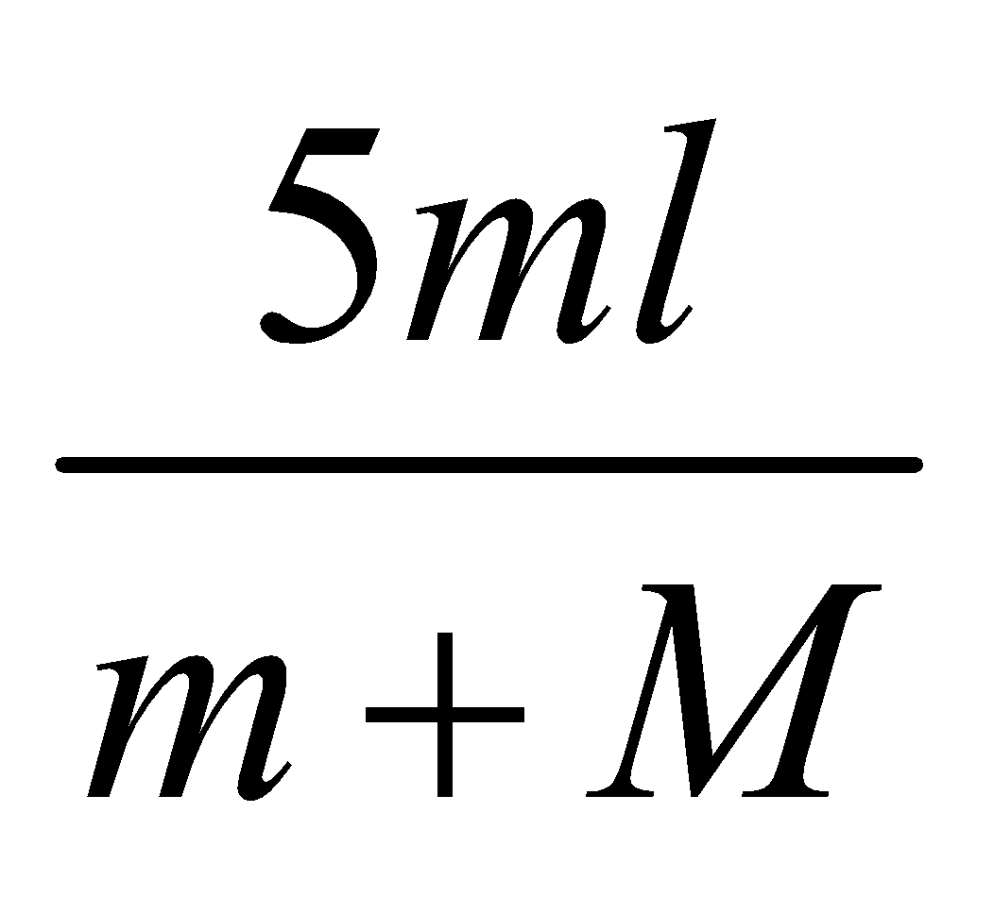 vishwas 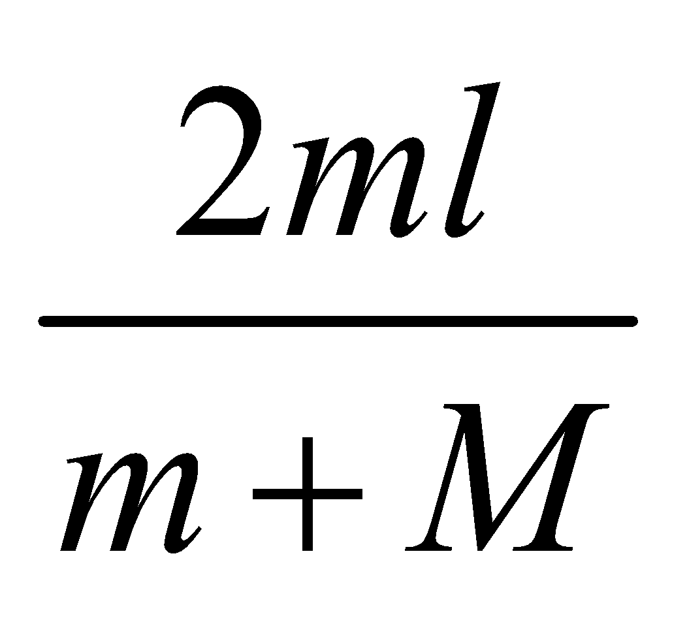 vishwas 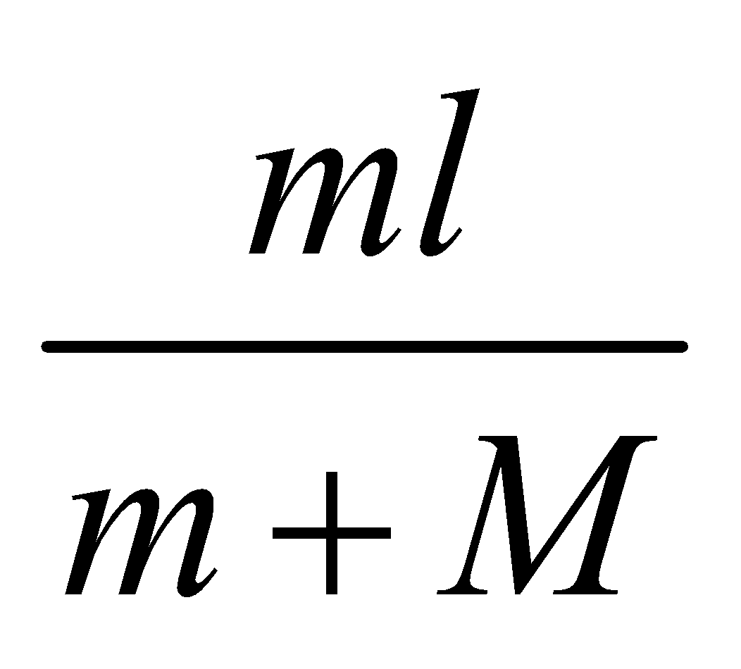 vishwas 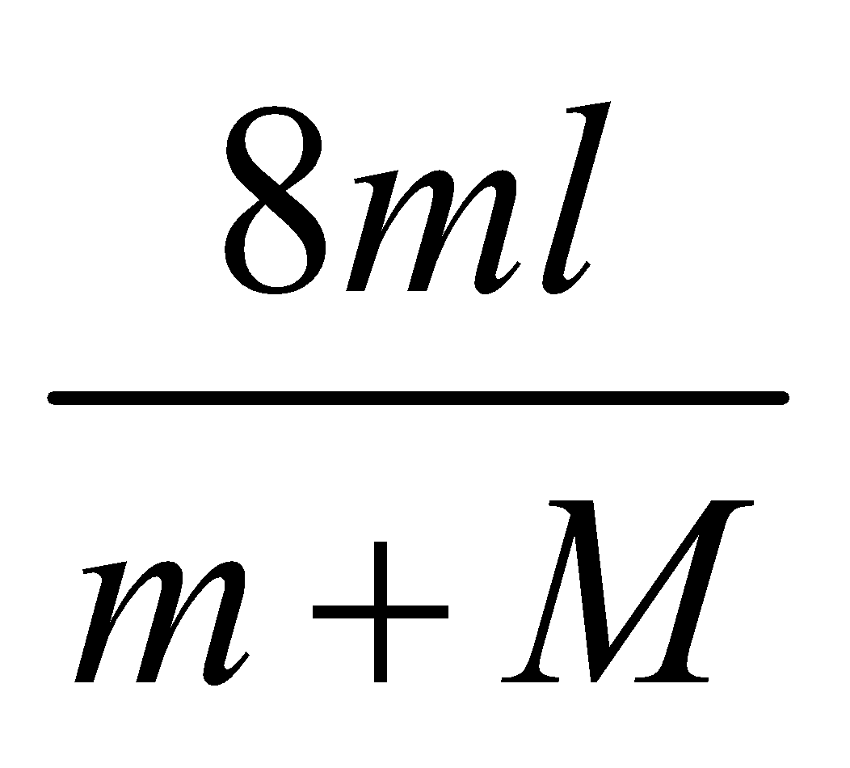

#Multiple#

**Nikhil 31.** Three identical blocks are attached with three springs as shown in figure. The spring between block *B* and *A* 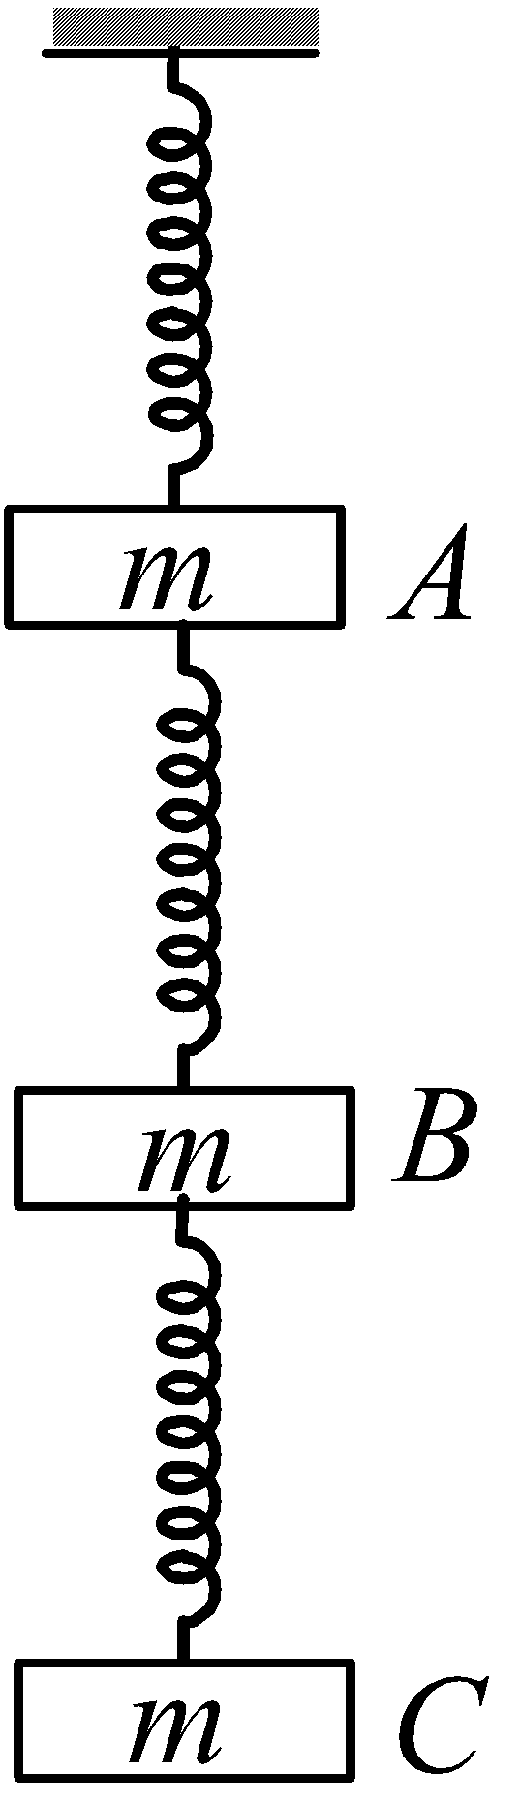is cut. Consider the instant just after cutting the spring.

Choose the correct alternative(s)

vishwas the acceleration of block *A* is 2g upward

vishwas the acceleration of block *B* is 2g downward

vishwas the acceleration block *C* is zero

vishwas the acceleration of block *C* is *g* downward

**Nikhil 32.** Equal volume *V* of a liquid is poured in three containers as shown in figure. The base area of each container is *A* and liquid has density ρ.

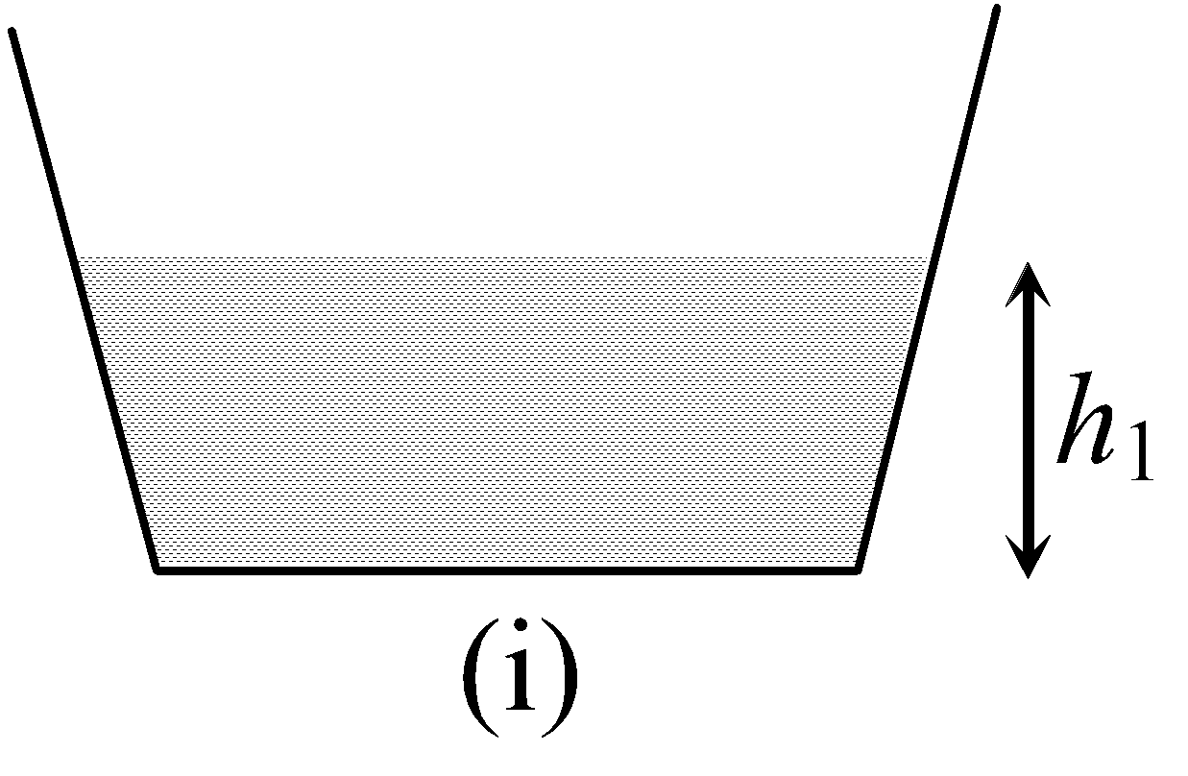 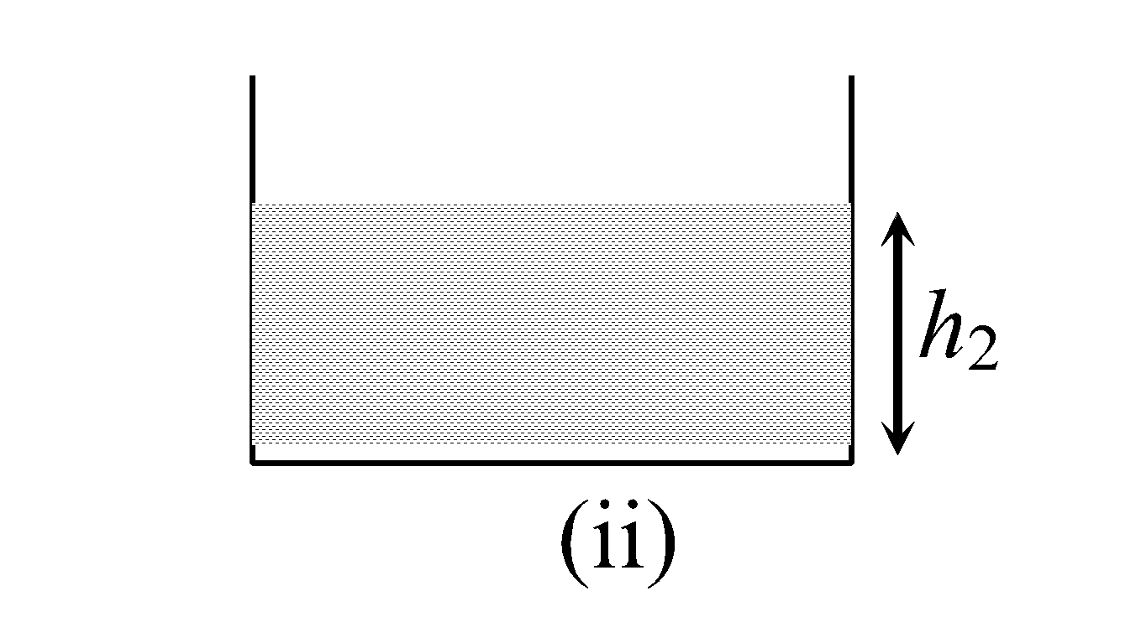 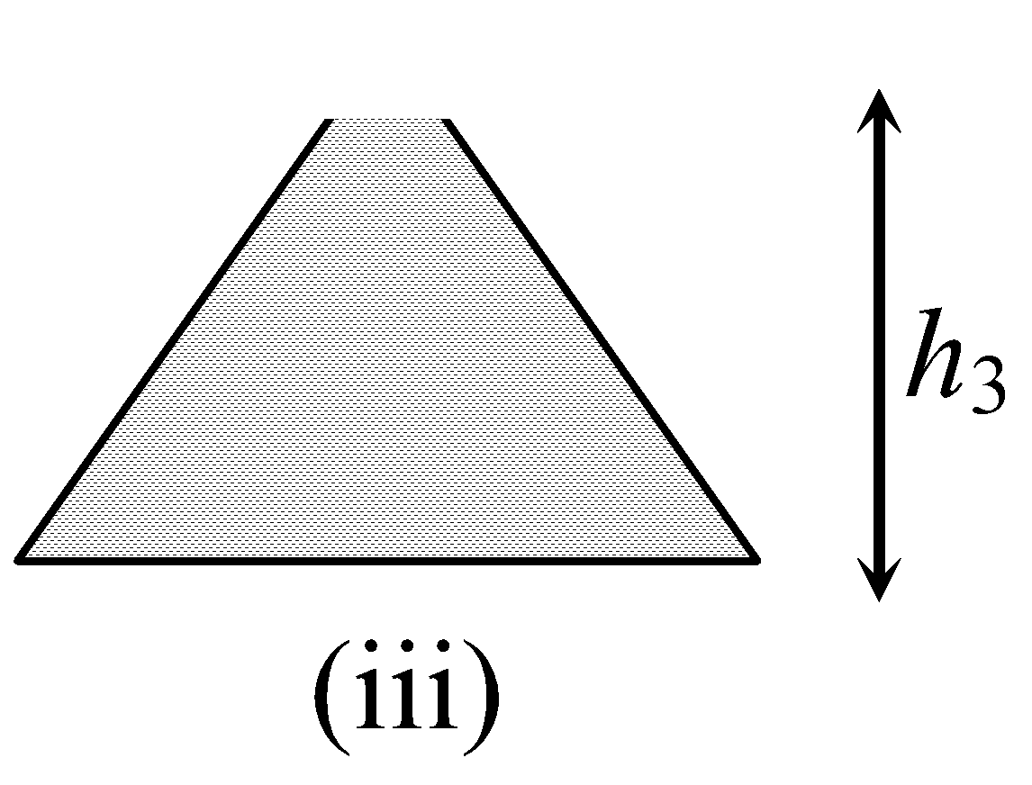

Let *F*1, *F*2, *F*3 represents the force exerted by the liquid on the base of container in (i), (ii) and (iii) figure respectively. Atmospheric pressure is *P*0. Then

vishwas 

vishwas 

vishwas The force exerted by the liquid on the side walls of the container in figure (i) is 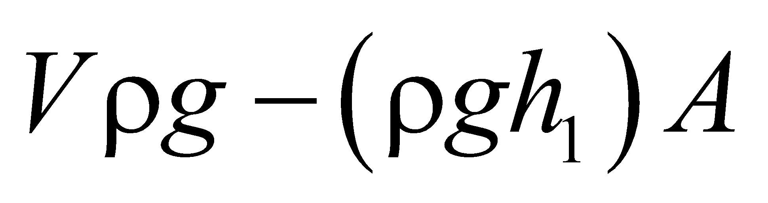

vishwas The force exerted by the liquid on the side walls of the container in figure (iii) is 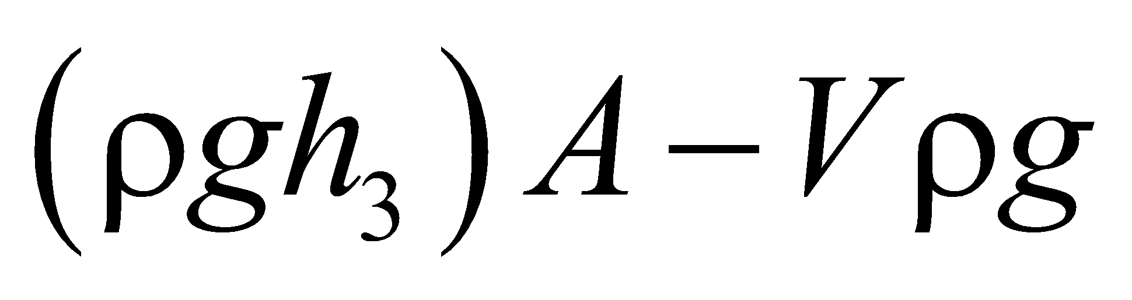

**Nikhil 33.** A uniform conducting rod of length *l* and mass *m* is hinged about one of its end and is resting on a conducting support such that initially rod is horizontal. A battery of emf *V* is connected across the rod as shown in the figure. A magnetic field *B* is present perpendicular to the plane of paper. The switch is closed at *t* 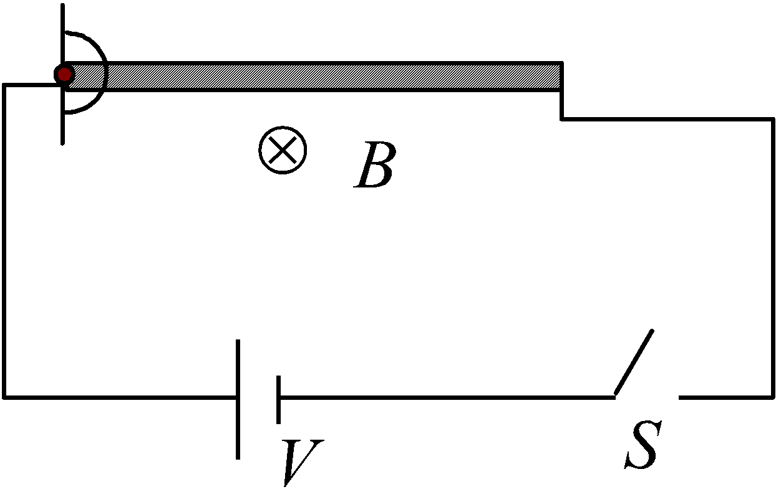= 0. The rod is just able to reach the vertical position. The whole circuit is resistance less. Then

vishwas the charge that will flow through the rod will be 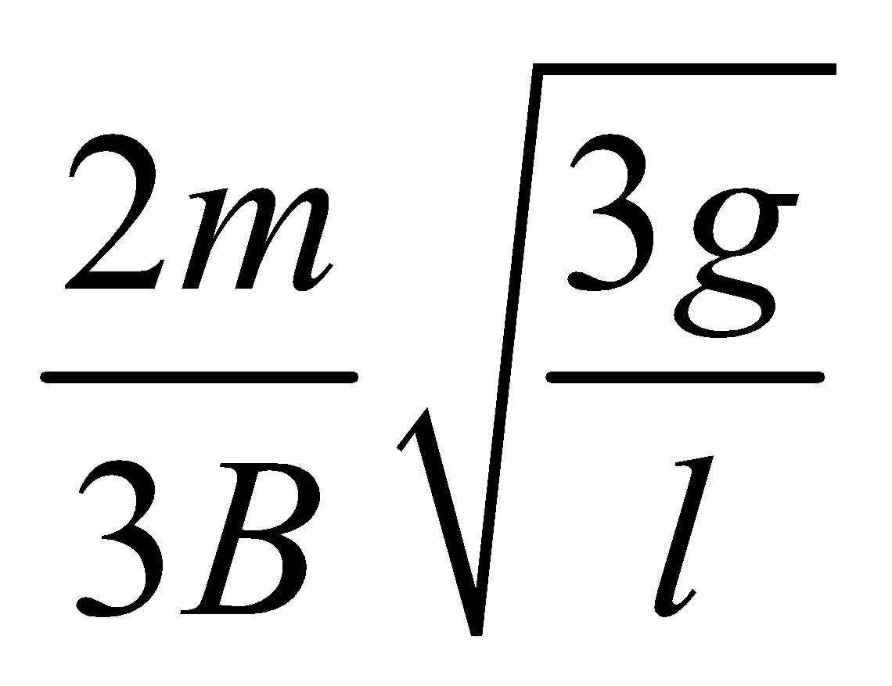

vishwas the angular velocity of the rod at the moment of leaving the contact is 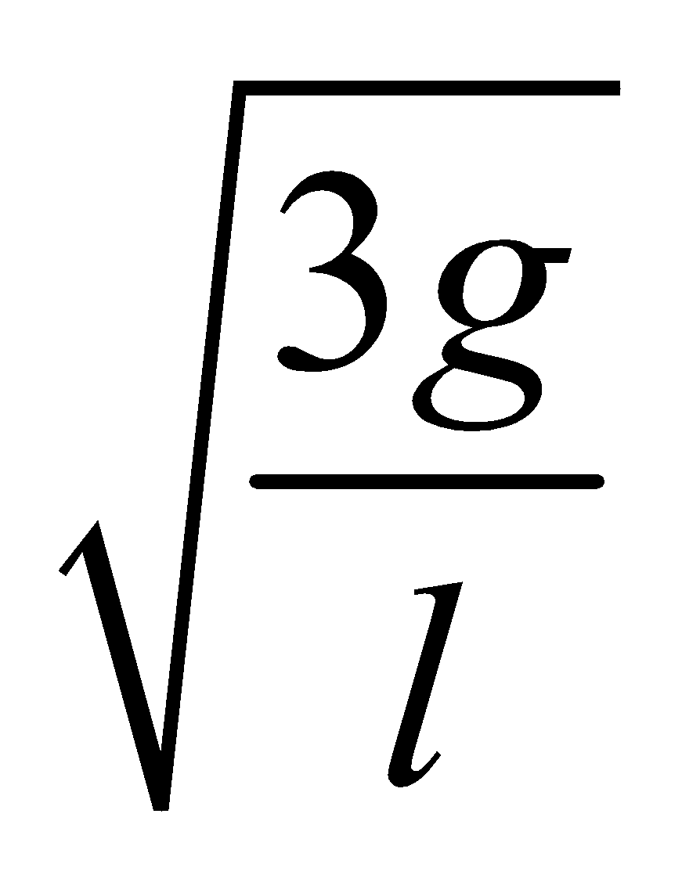

vishwas the rod will experience a net force in vertical upward direction just after closing the switch.

vishwas the rod will remains at rest just after closing the switch

## **Nikhil 34.** The potential energy of a particle of mass 4 kg is given as , where *x* is the position of the particle along positive *x*-axis from origin. The particle moves along *x*-axis Then

vishwas the potential energy of the particle is maximum at *x* = 0

vishwas the potential energy of the particle is minimum at *x* = 1/2

vishwas the time period of small oscillations of the particle about a point of minima is 2π s

vishwas the time period of small oscillations of the particle about a point of minima is π s

**Nikhil 35.** A particle is moving on *x*-axis according to the equation *x* = sin ω*t*. Consider the motion of the particle from 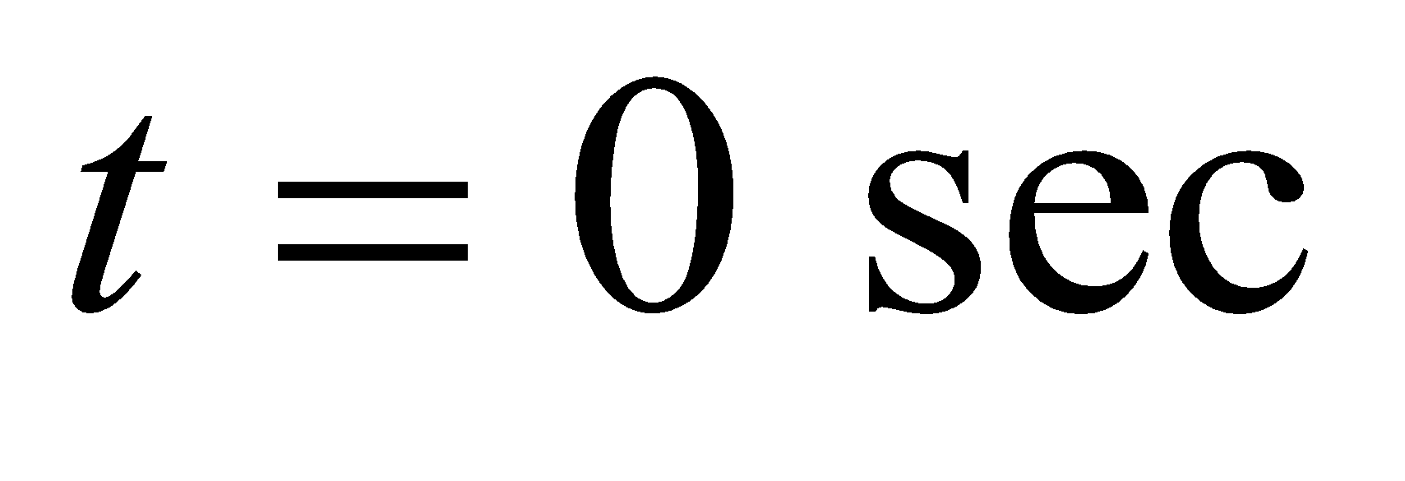. to 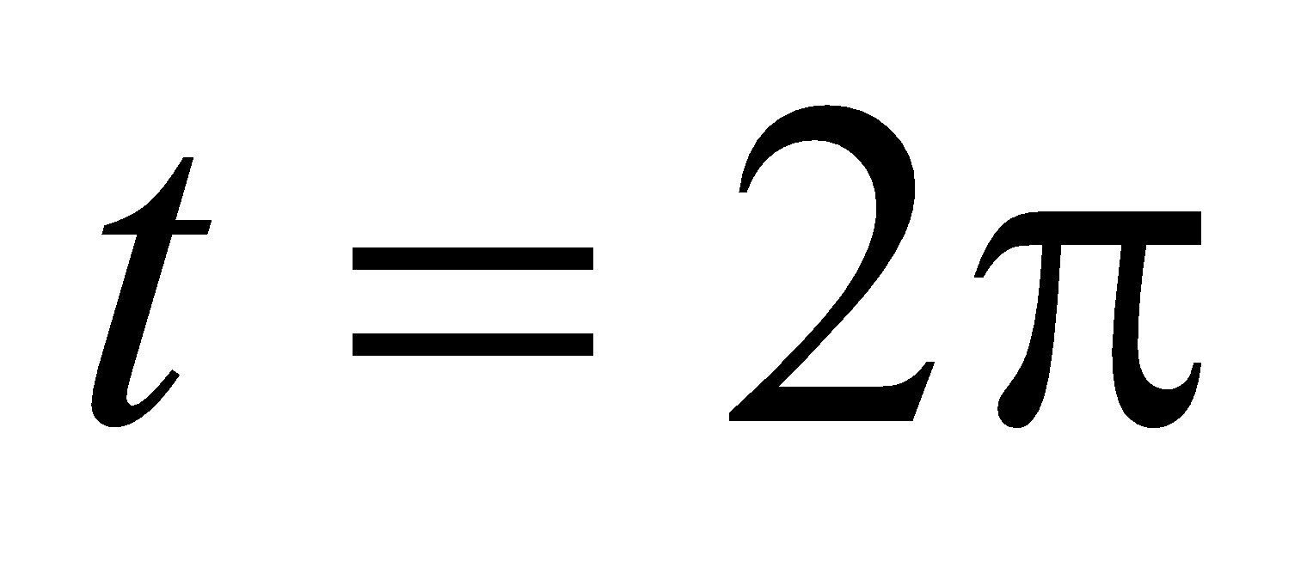sec. Choose the correct statement(s).

vishwas Particle is retarding from 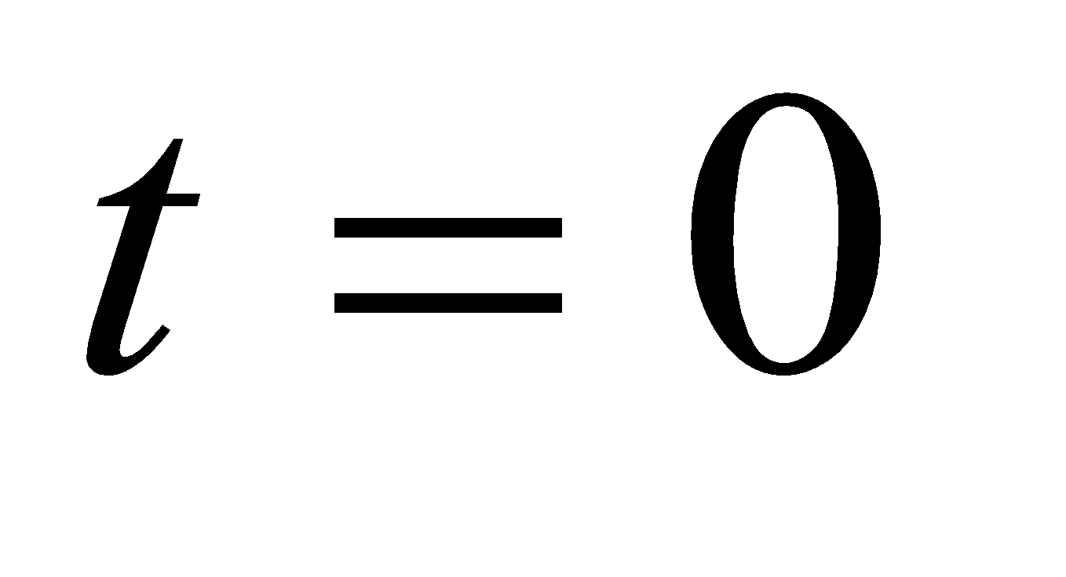sec. to 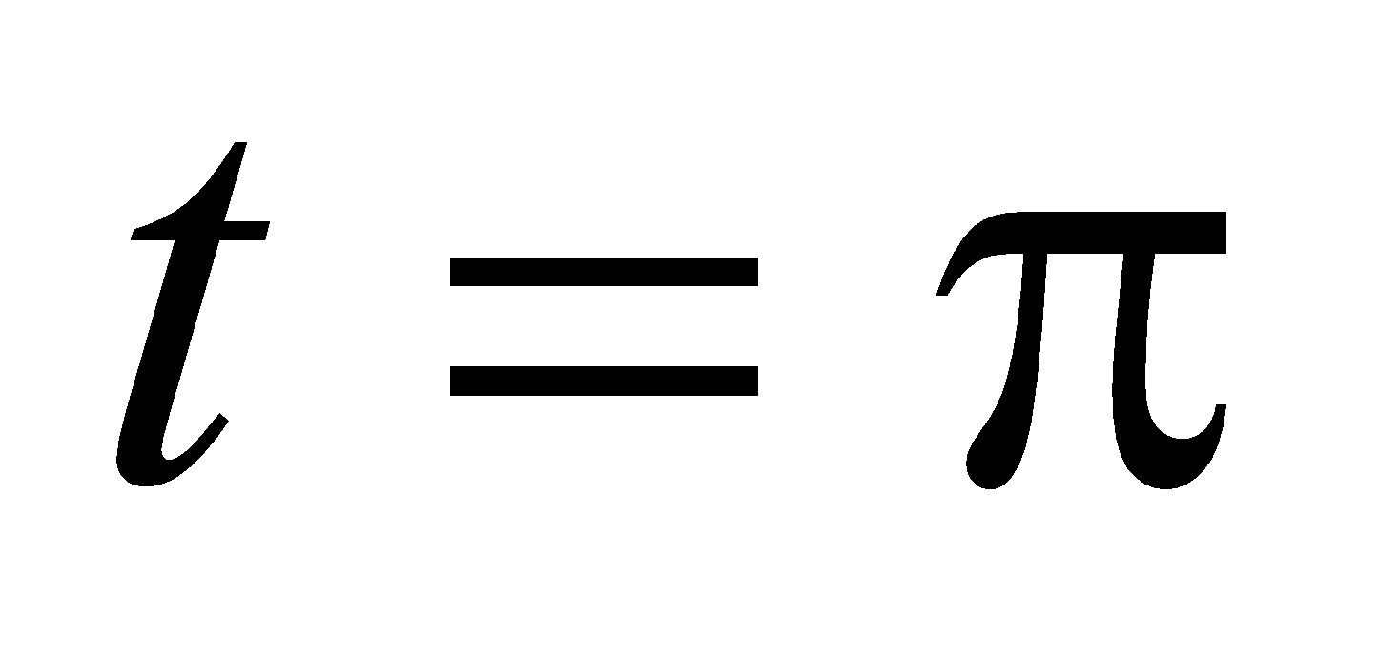 sec.

vishwas Particle is retarding from 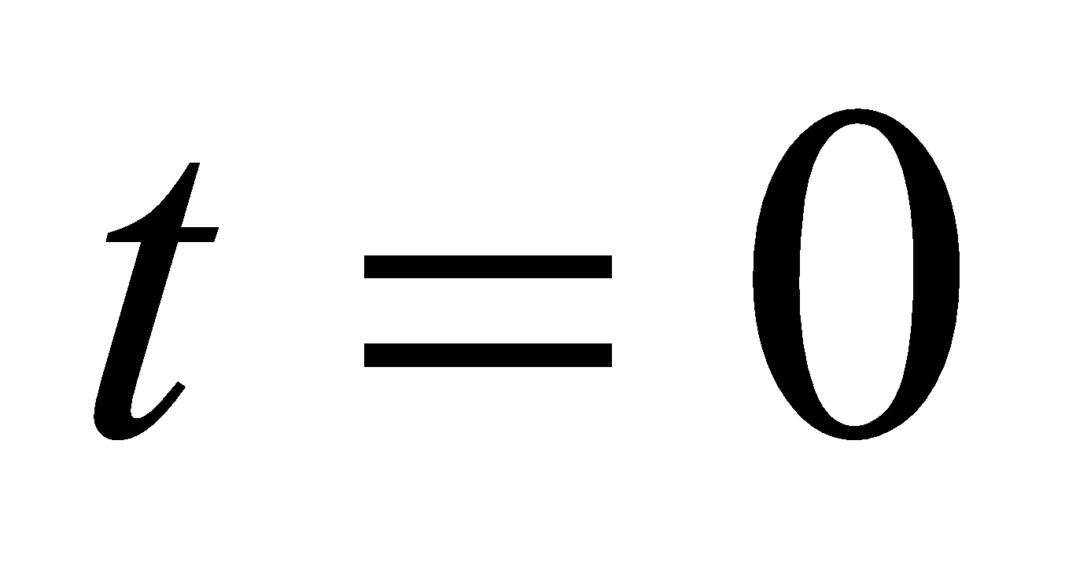 sec. to 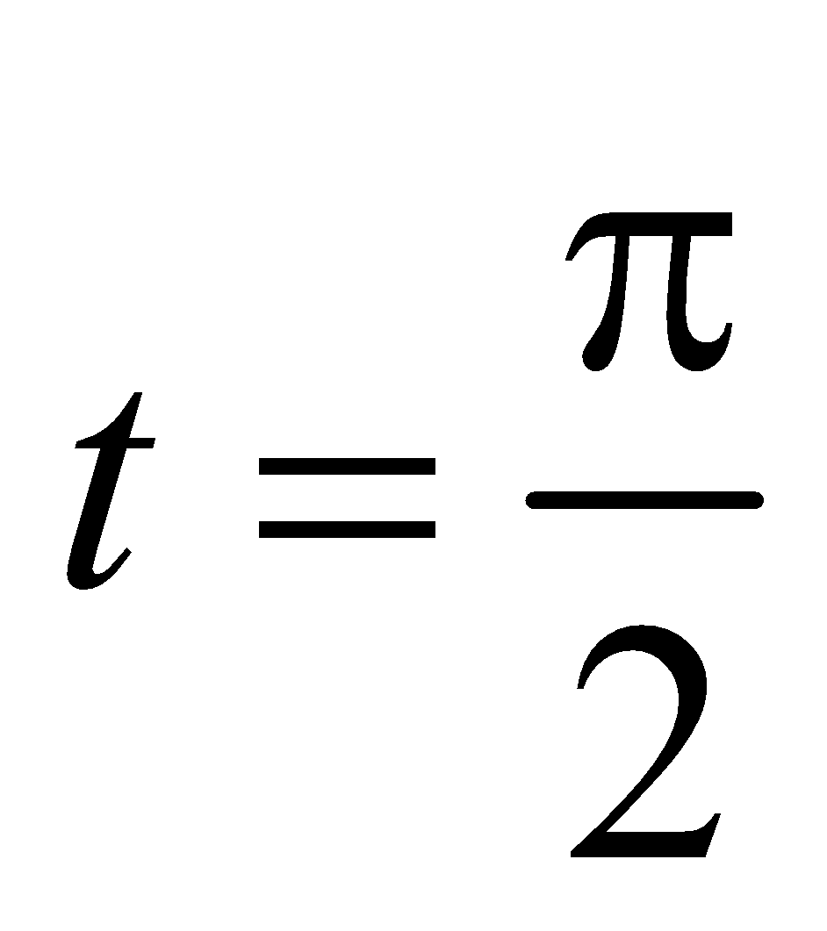 sec. and from  sec. to 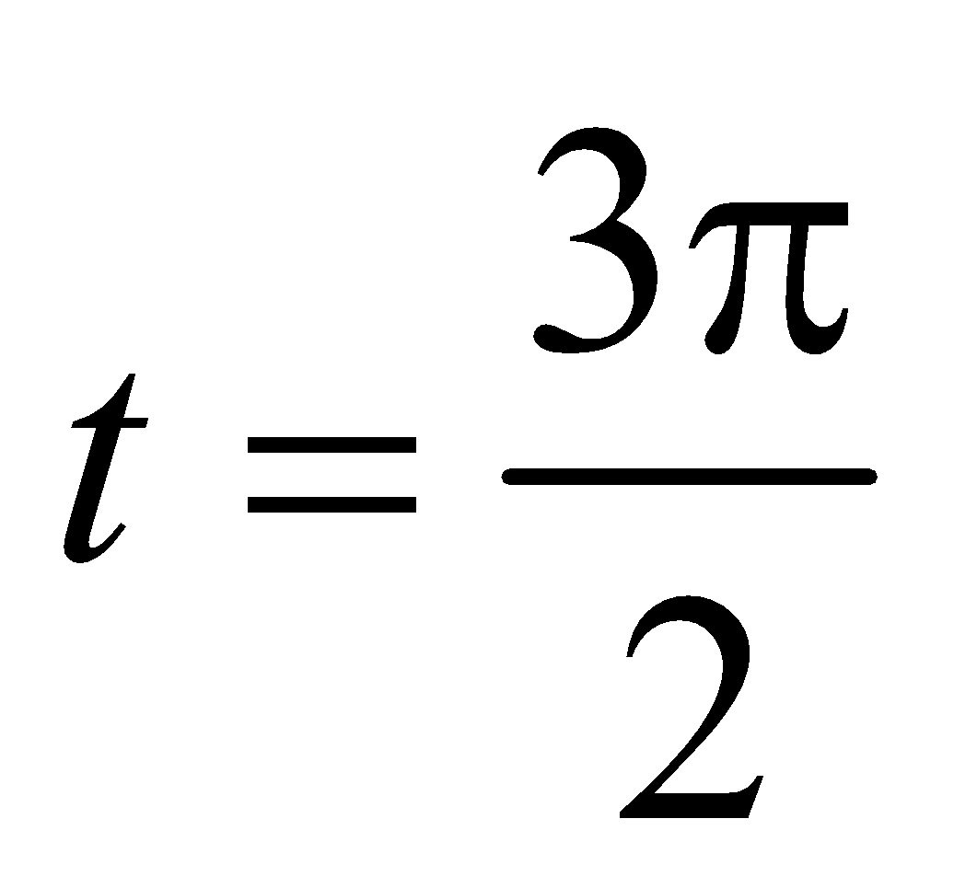 sec.

vishwas Particle is retarding from  sec. to  sec.

vishwas Particle is retarding from  sec. to  sec. and from  sec. to  sec.

#Integer#

**Nikhil 36.** Consider the given system. All strings, pulleys and spring are ideal, mass *M* is in equilibrium. Maximum amplitude of oscillation of block in vertical direction is 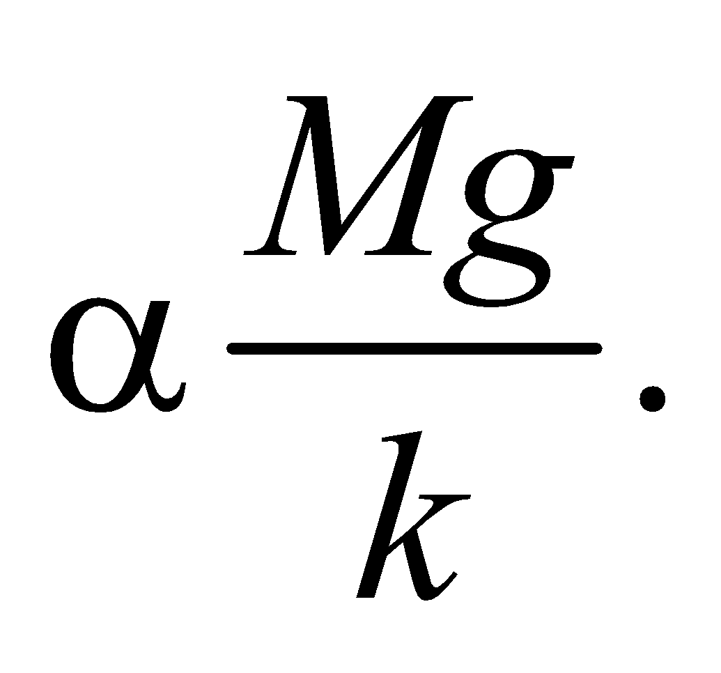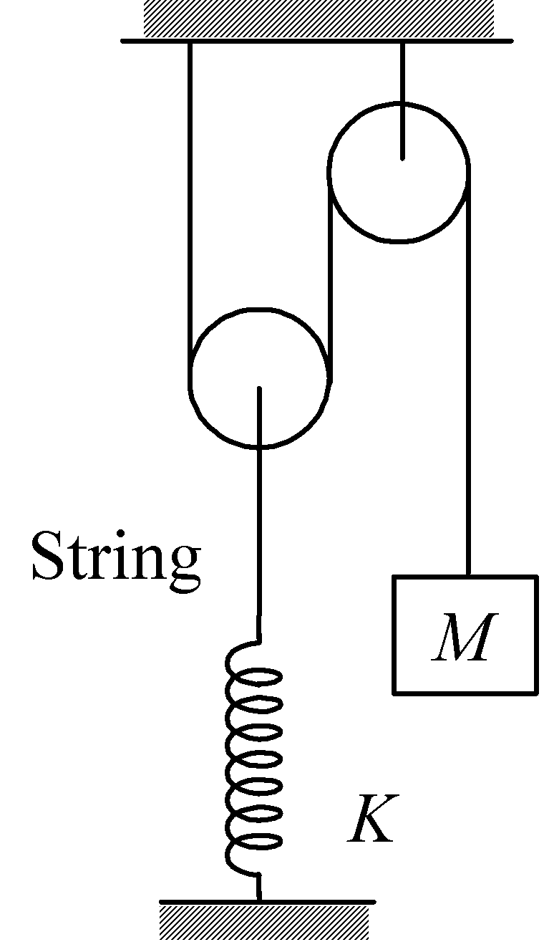 Find value of α.

**Nikhil 37.** A satellite is orbiting around a planet in a circular path of radius *R*. A meteorite of mass *m* collides with the satellite and sticks to the satellite. After collision, the satellite is seen to have gone into an orbit whose minimum distance from the planet is *R*/2. Mass of satellite is 9*m* and that of planet is *M* and assume that the meteorite is moving radially towards the satellite’s orbit with speed *v* before collision as shown in the figure. If 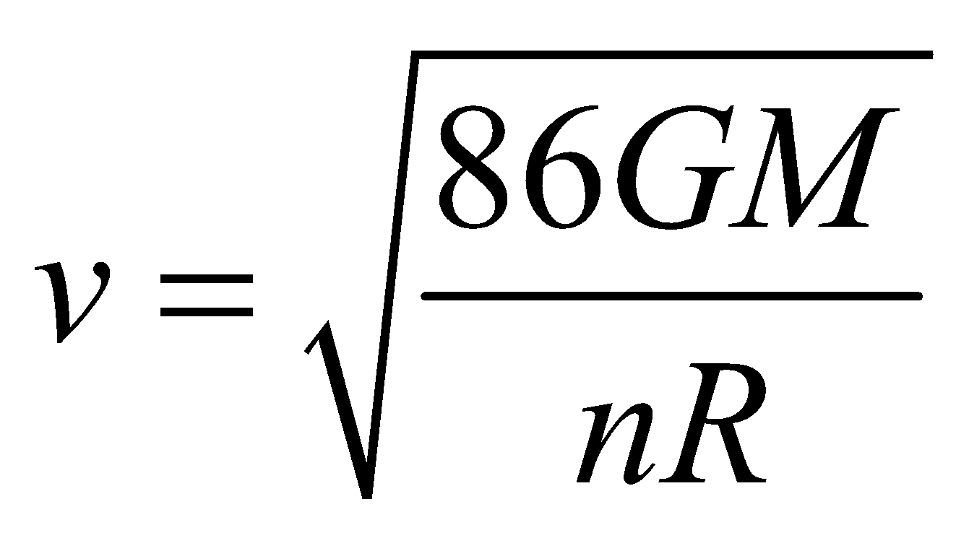, find the value of *n*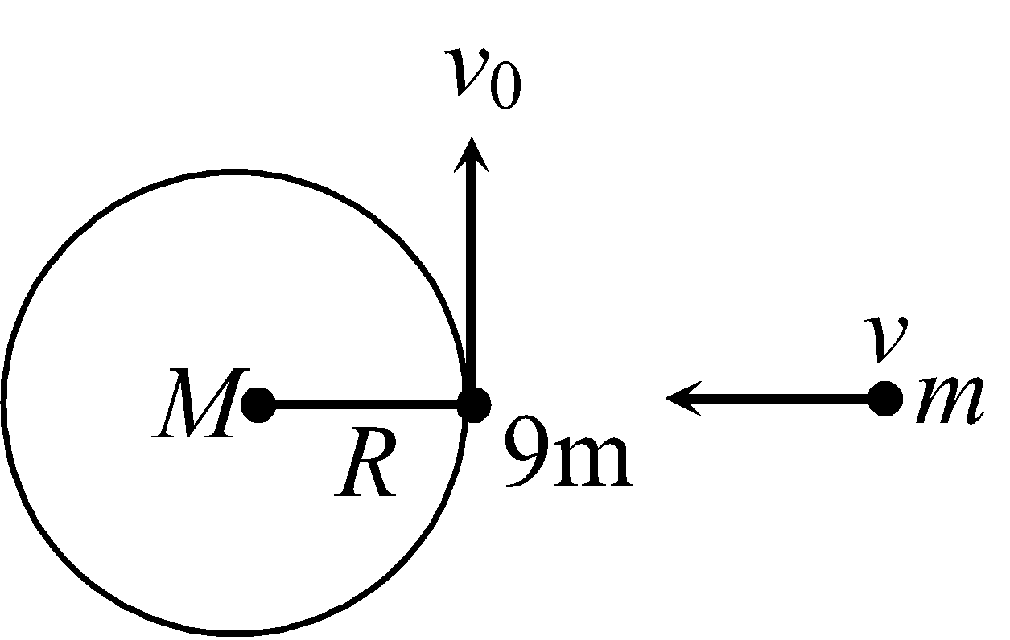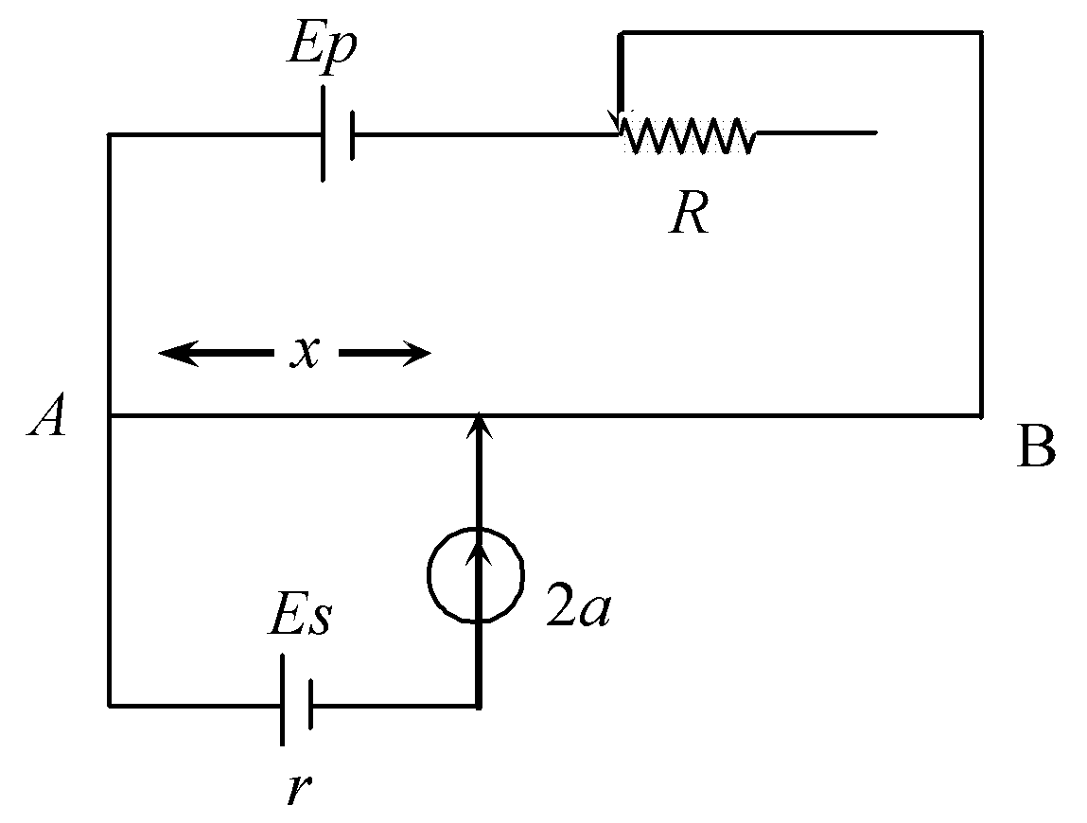.

**Nikhil 38.** Consider a potentiometer circuit. Primary cell is ideal. The length of potentiometer wire is 1m and the resistance per unit length of potentiometer wire varies with length as 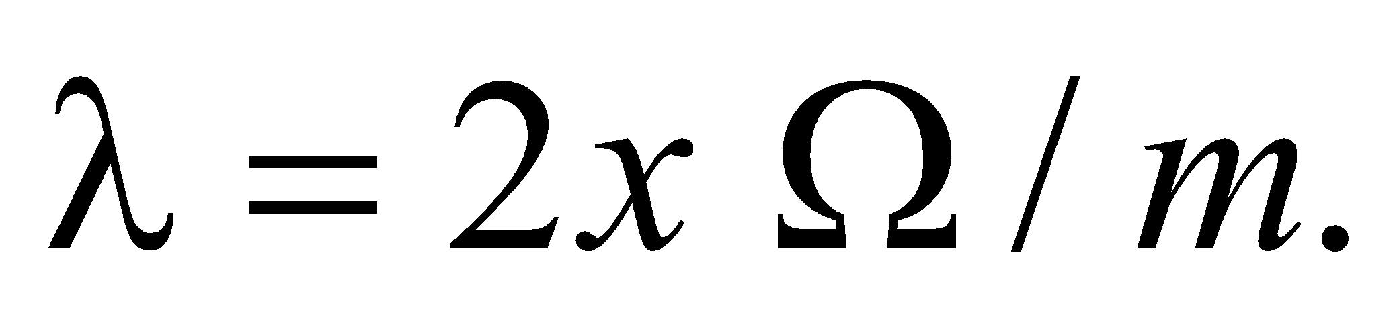 Where *x* is distance from end A. Resistance of Rheostat varies with time as 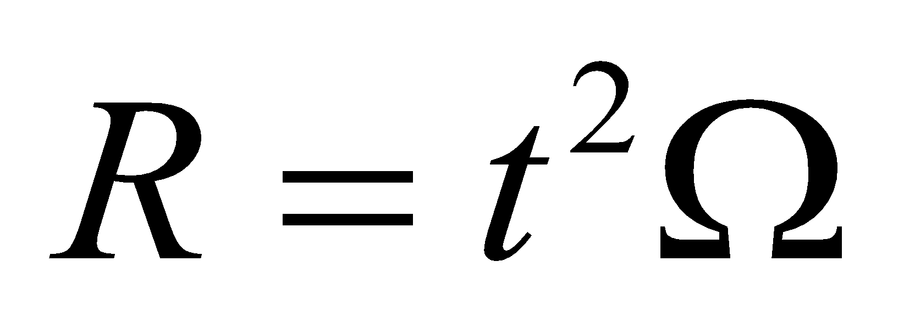. Null deflection point for secondary cell is obtained at *x* = 1/2m and at 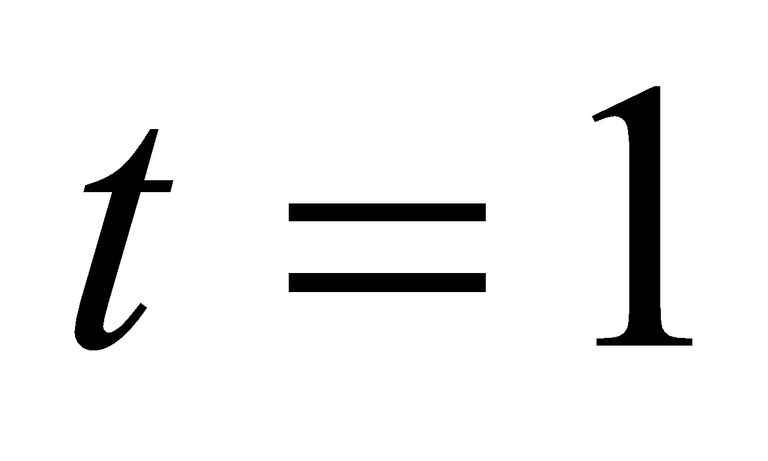 sec. If emf of secondary cell is 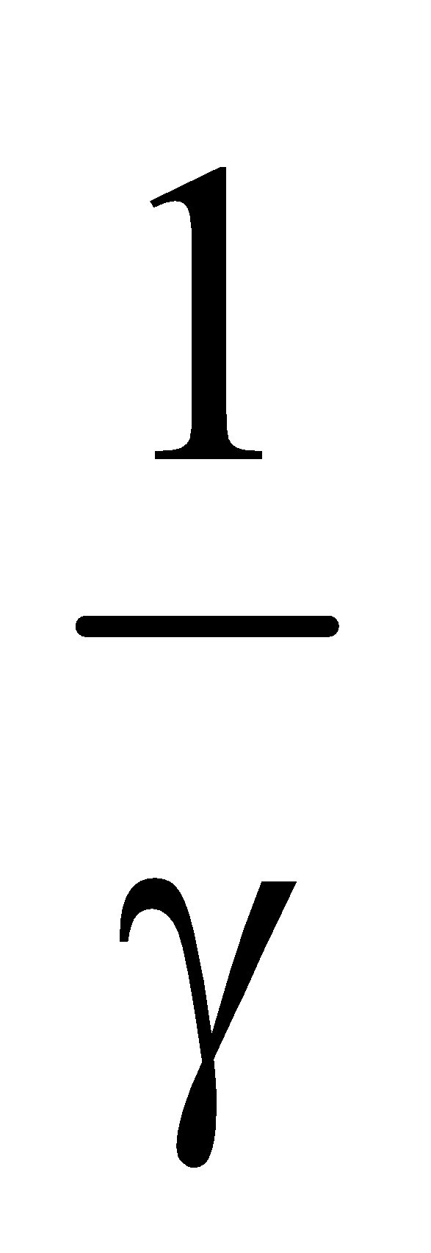 times of emf of primary cell. Find  *γ*.

**Nikhil 39.** An infinitely long straight wire carries a current 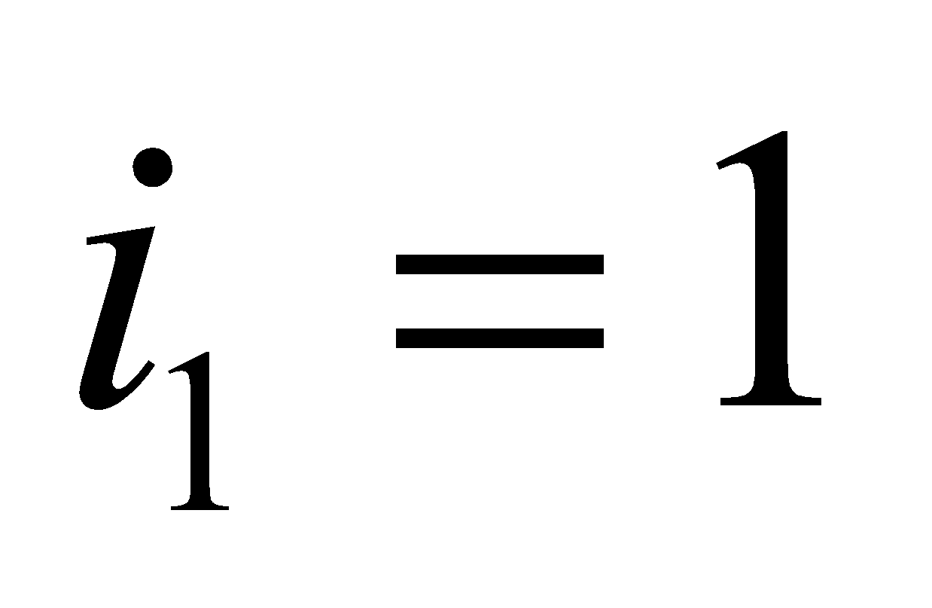 amp. A rectangular current loop placed in the same plane of shown dimensions carries a current 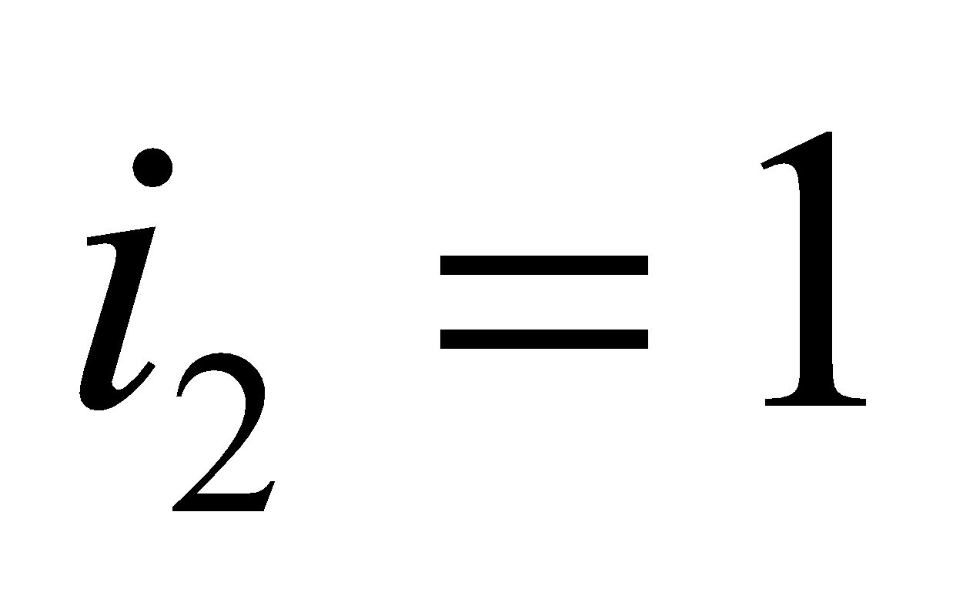 amp anticlockwise. Magnitude of net force on the loop is found to be 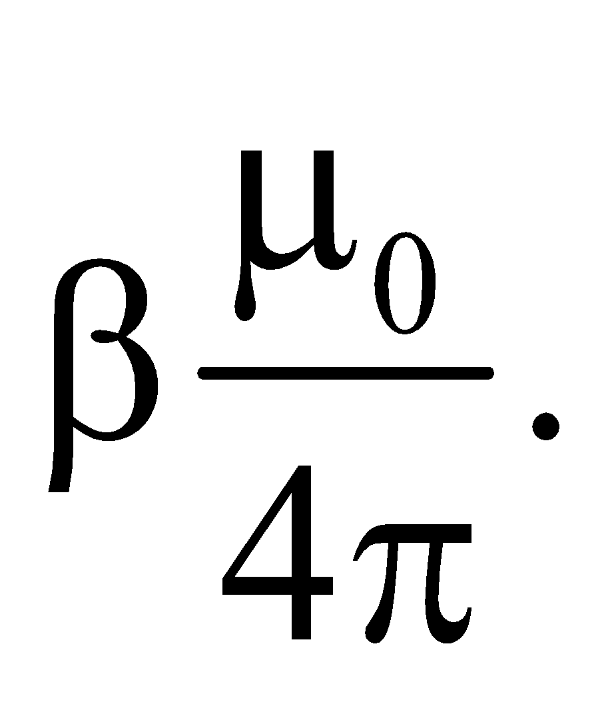 Find value of β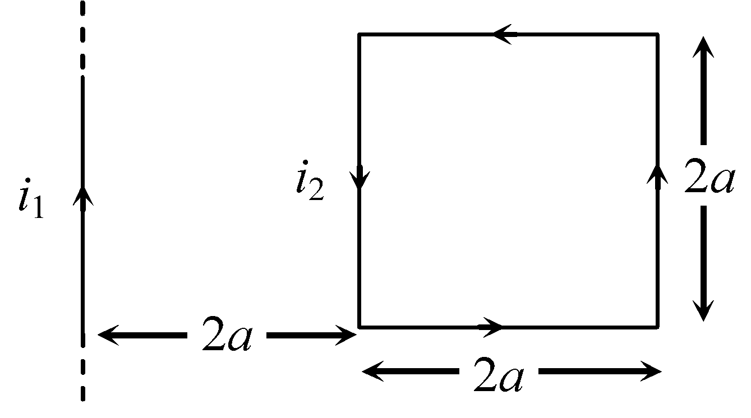.

**Nikhil 40.** A radioactive sample can decay either simultaneously or individually by two processes X and Y. The half life for process X is Hr and for process Y is 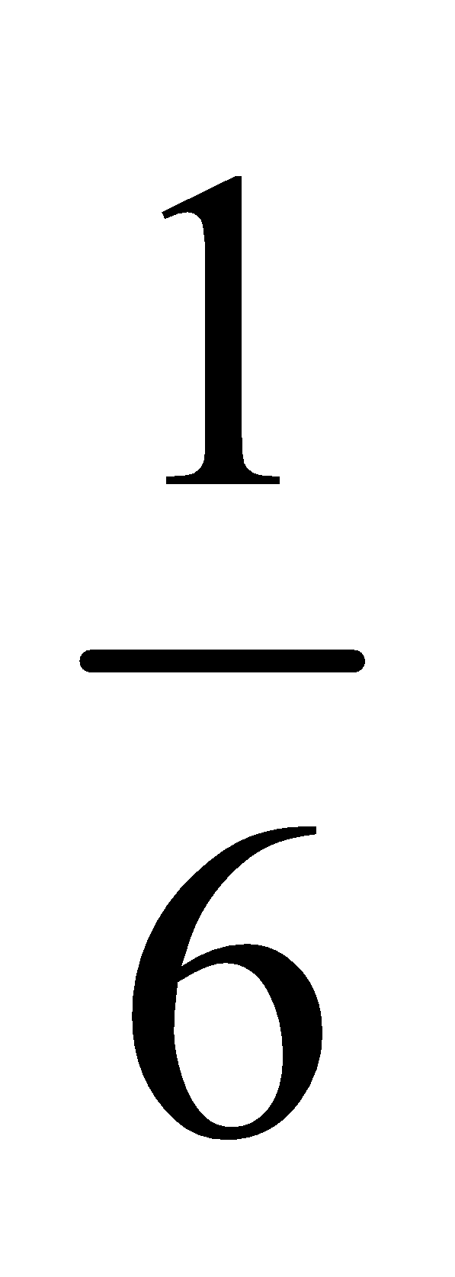Hr. The sample decays for first half hour by process X, for next one hour by process Y and for next half hour by process X and Y both. The initial number of nuclei of the sample is N0. After 2hr, the number of nuclei of the sample are 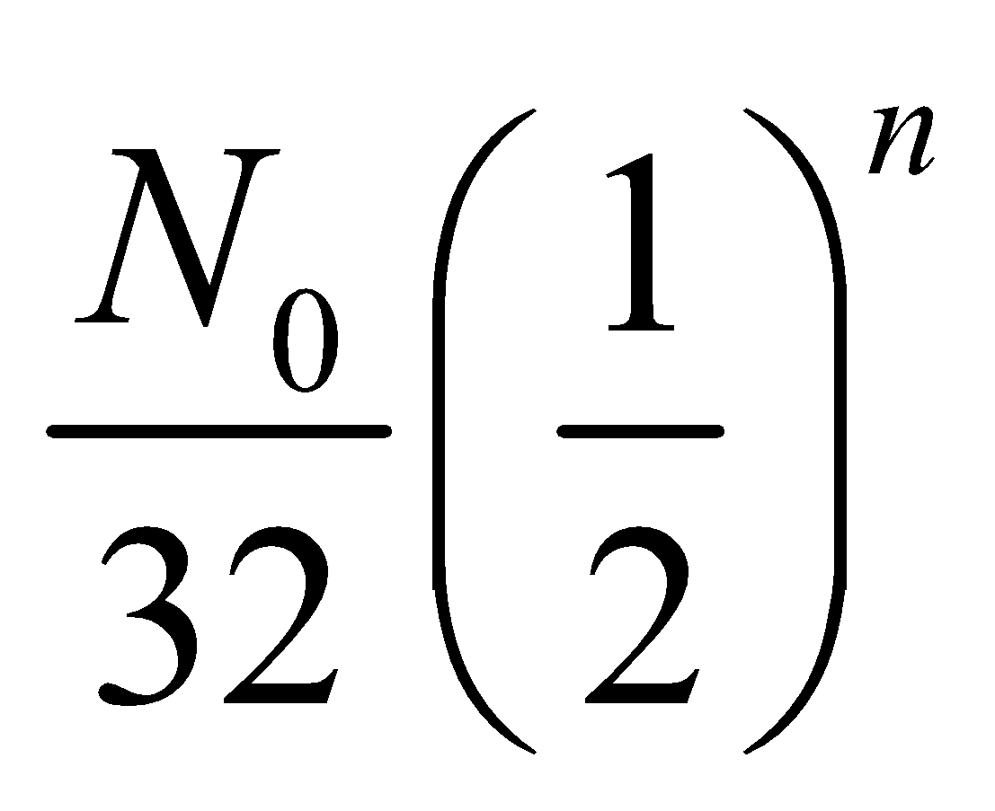. Find the value of *n*.

##Maths##

#Single#

**Nikhil 41.** The figure shows the plan of a town where all the street blocks are square. There is a park *ABCD* in the town with a diagonal road through it. Madhuri walks every day from her house at *H* to her school at *S*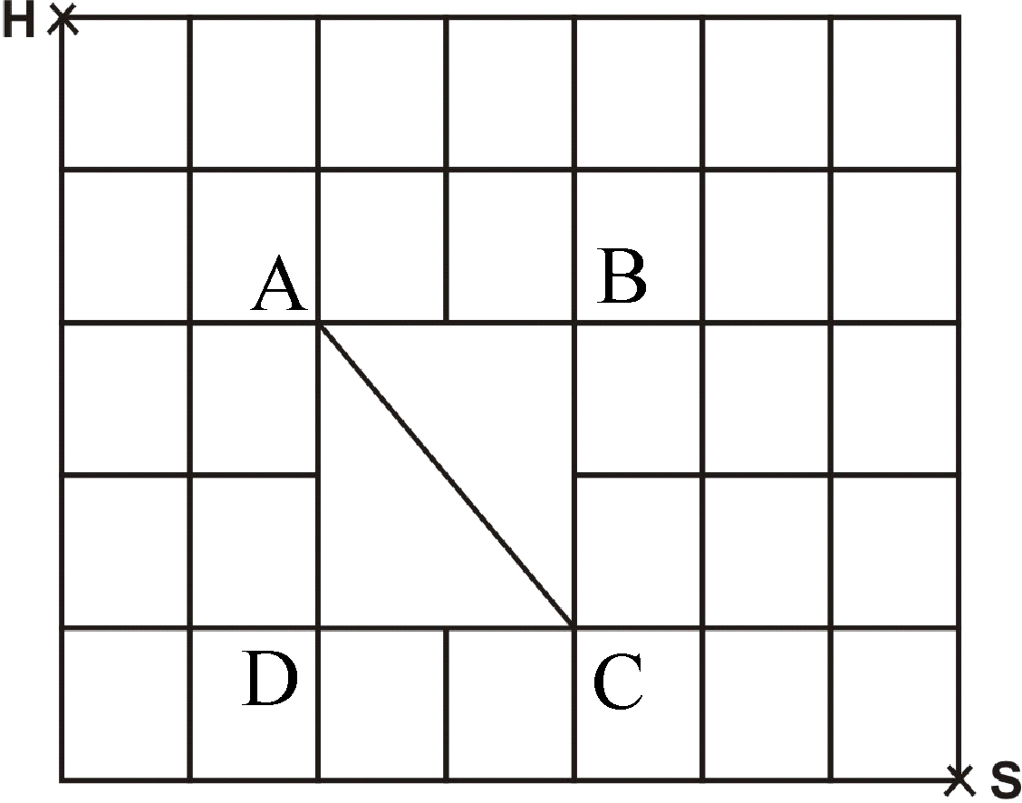, always taking one of the shortest routes. Number of different shortest routes that she can choose is

vishwas 6

vishwas 12

vishwas 18

vishwas 24

**Nikhil 42.** The sum of the series,   
terms, (where *a* > 0) will be

vishwas 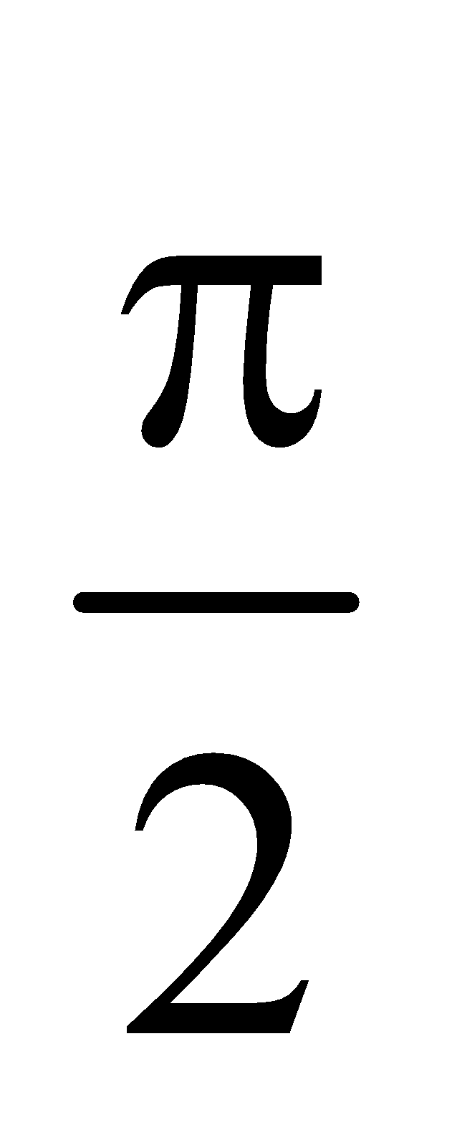 vishwas 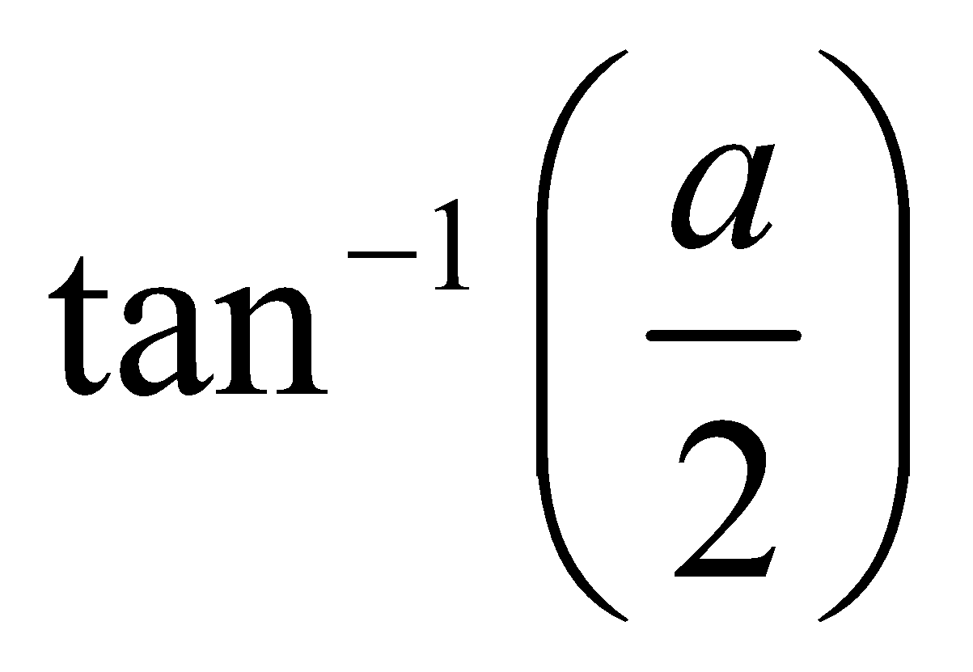 vishwas 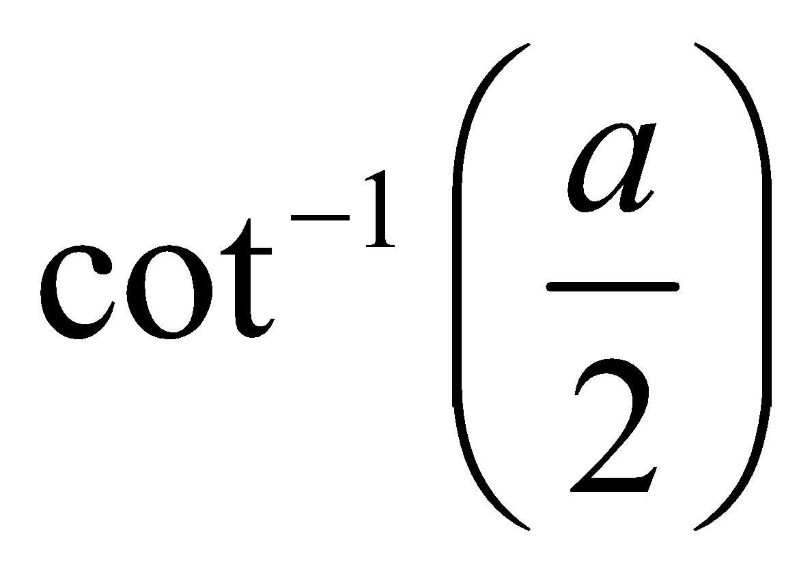 vishwas 0

**Nikhil 43.** Let 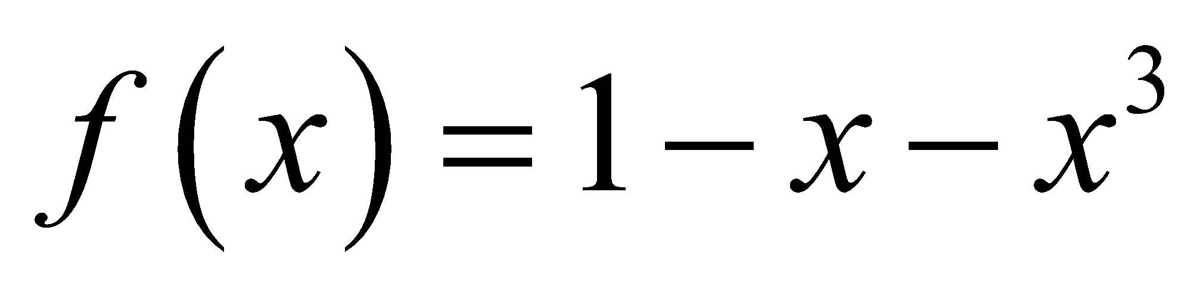, then all real values of *x* satisfying the inequality, 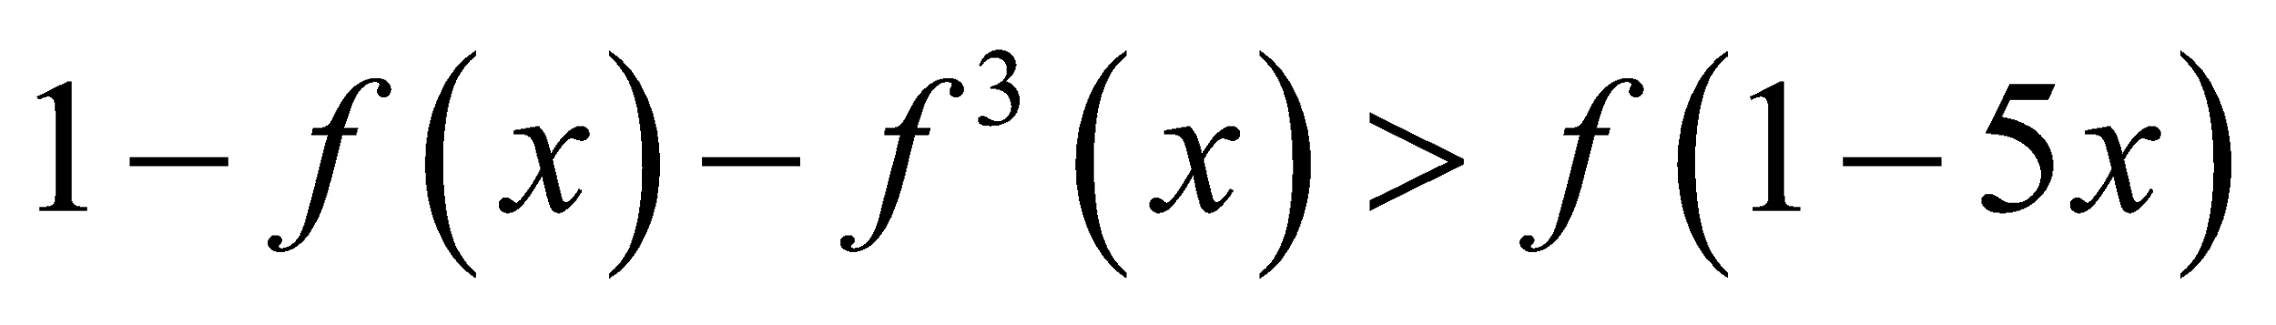 will be

vishwas (0, 2) vishwas (–2, 2) vishwas (–2, 1) (1, ∞) vishwas none of these

**Nikhil 44.** 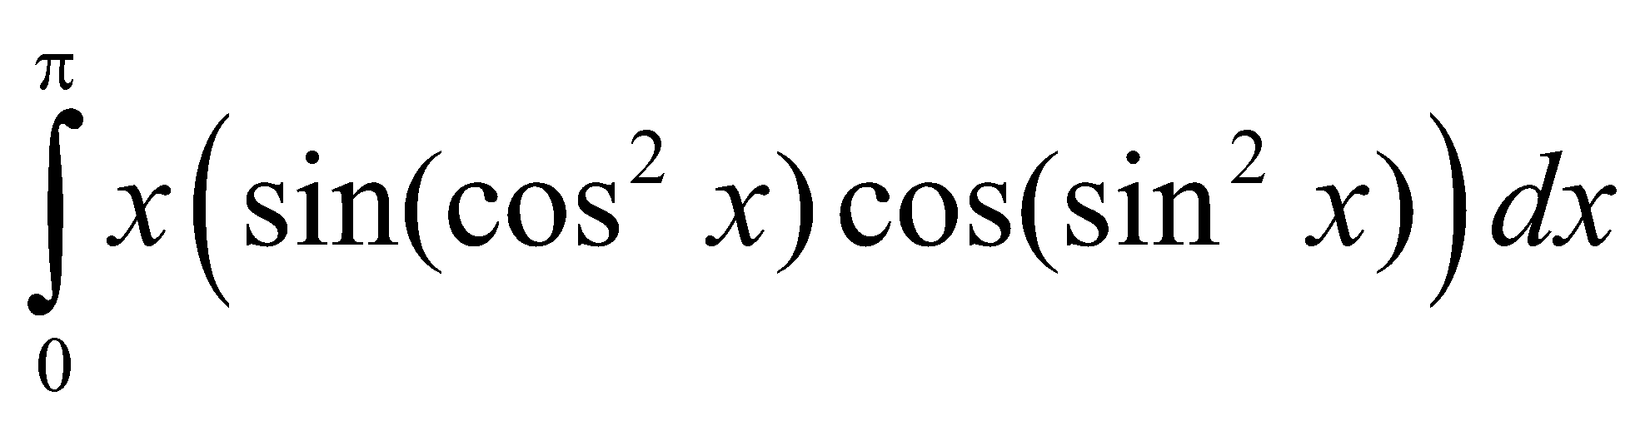 is equal to

vishwas 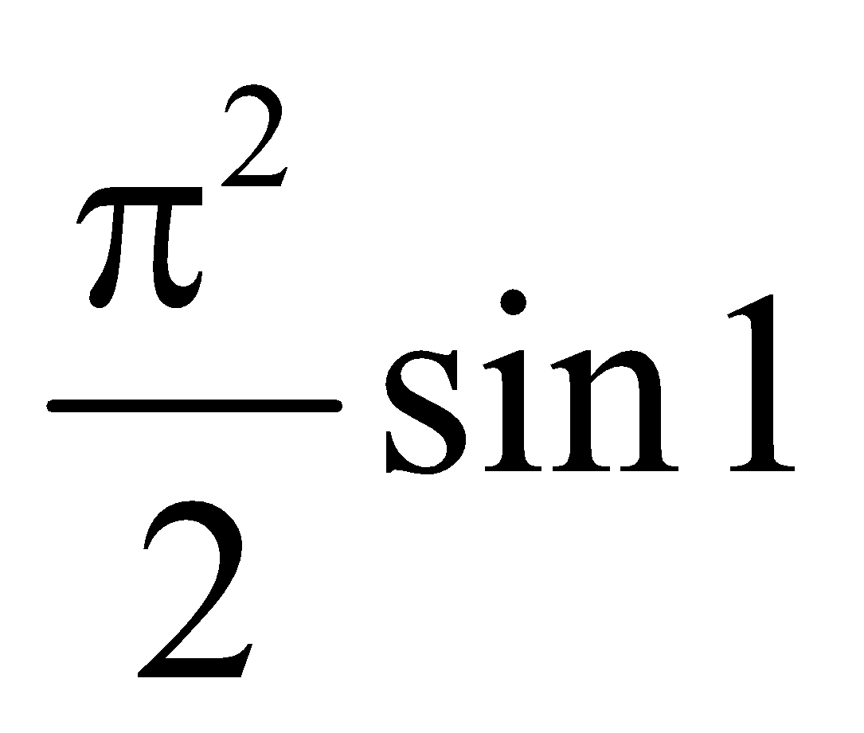 vishwas 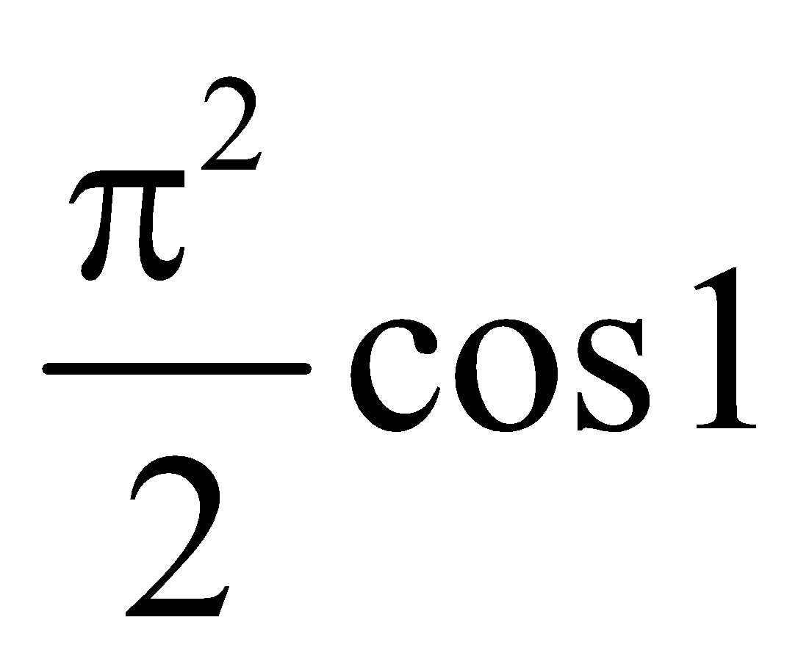 vishwas 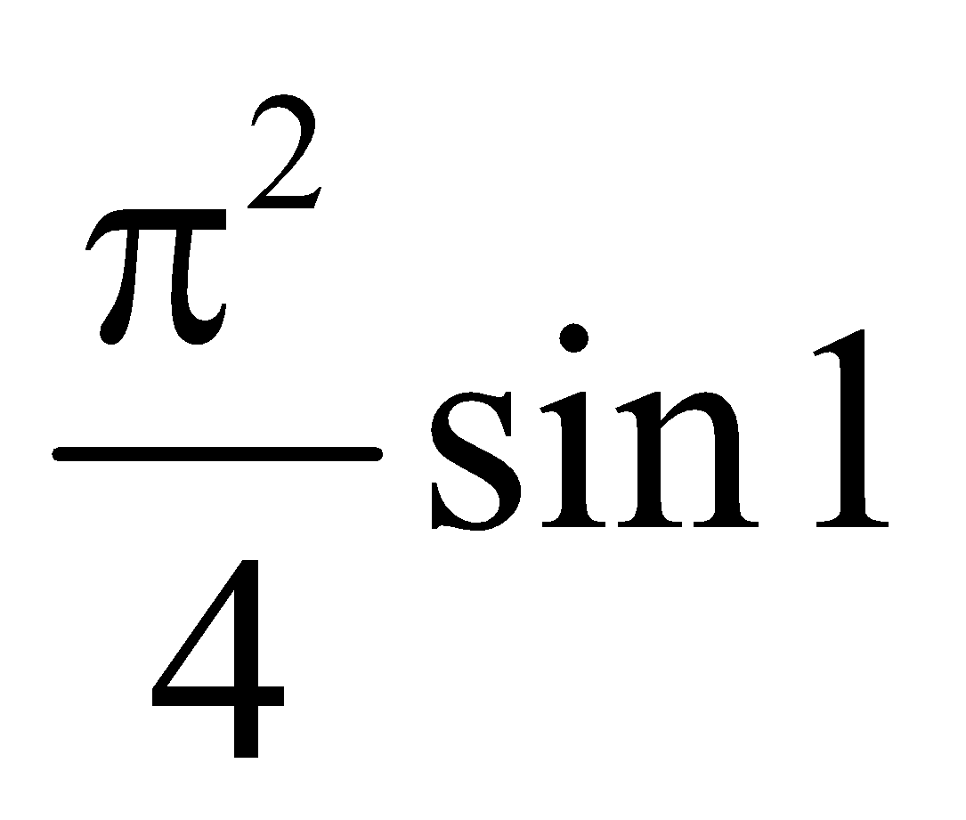 vishwas 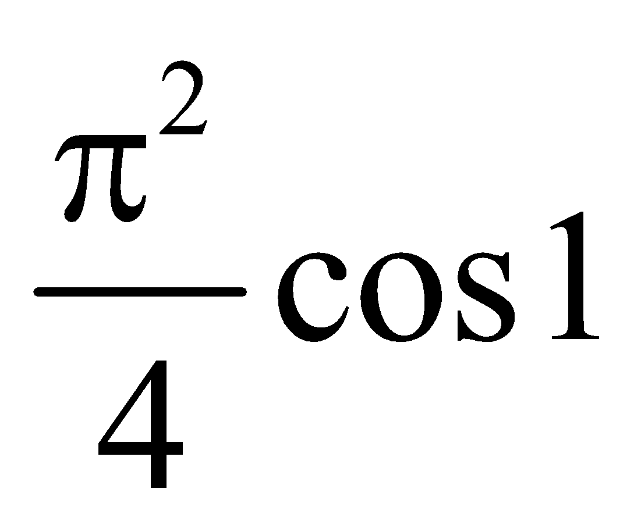

**Nikhil 45.** Number of ordered pair(s) (*z, ω*) of the complex numbers *z* and *ω* satisfying the system of equations 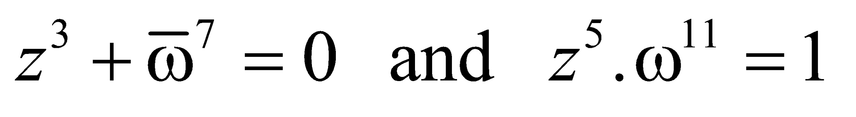is

vishwas 7 vishwas 5 vishwas 3 vishwas 2

**Nikhil 46.** If α, β are roots of the equation 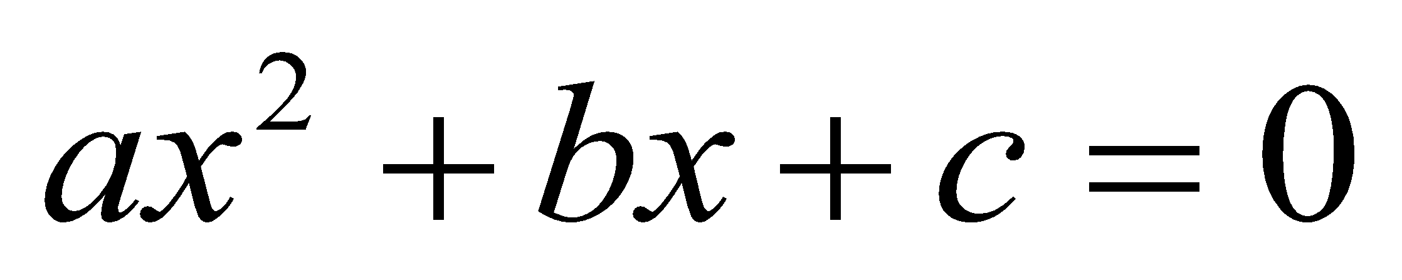, 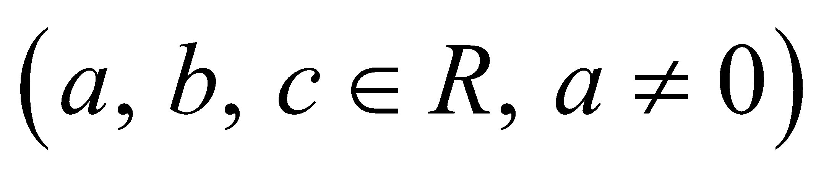, then the value of determinant 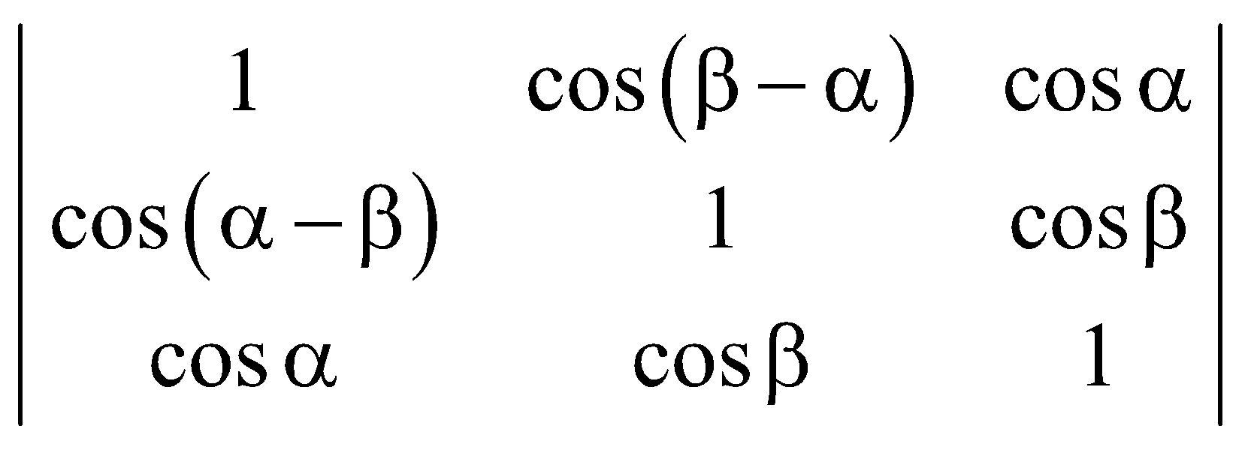 is

vishwas 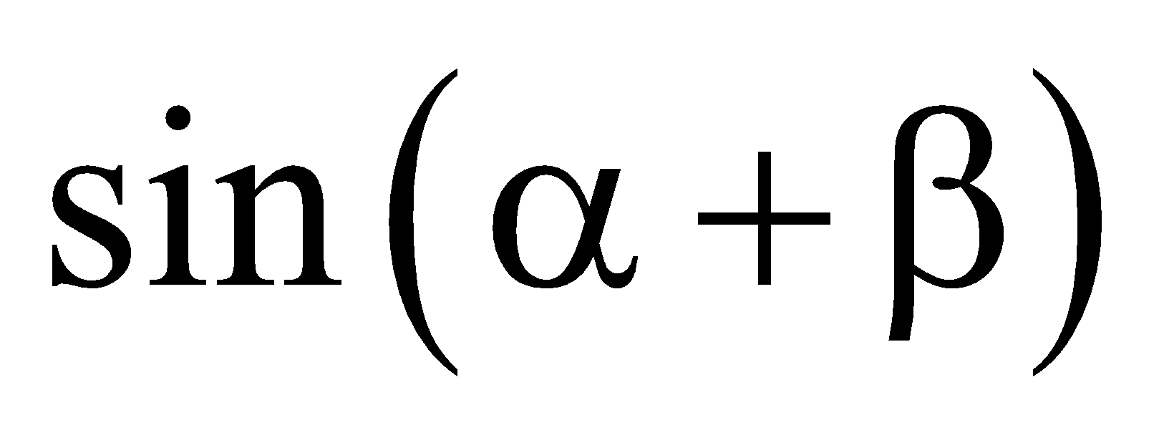 vishwas 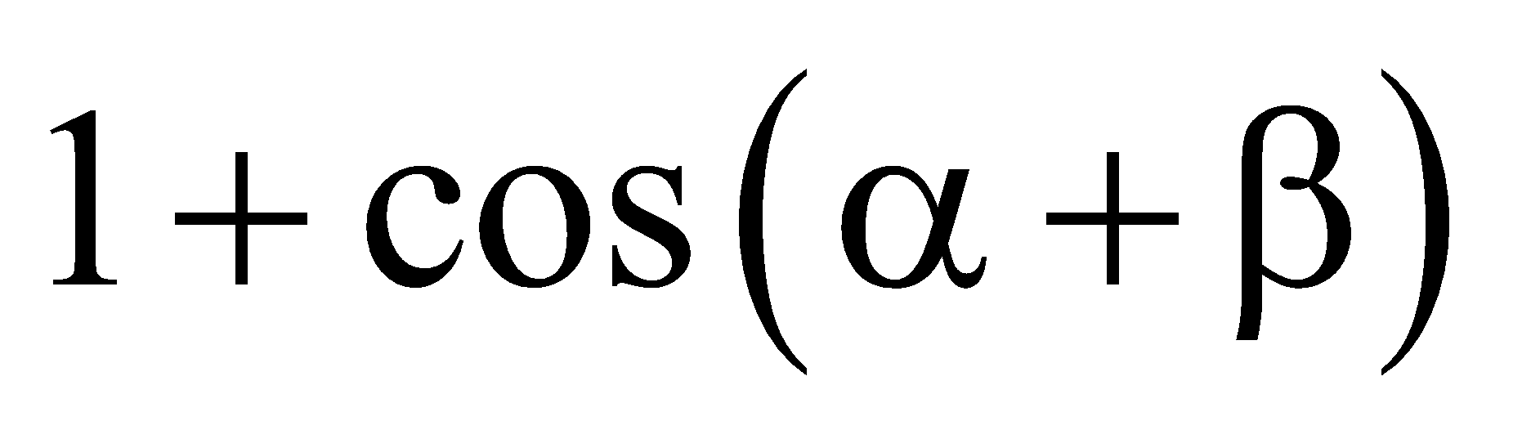 vishwas 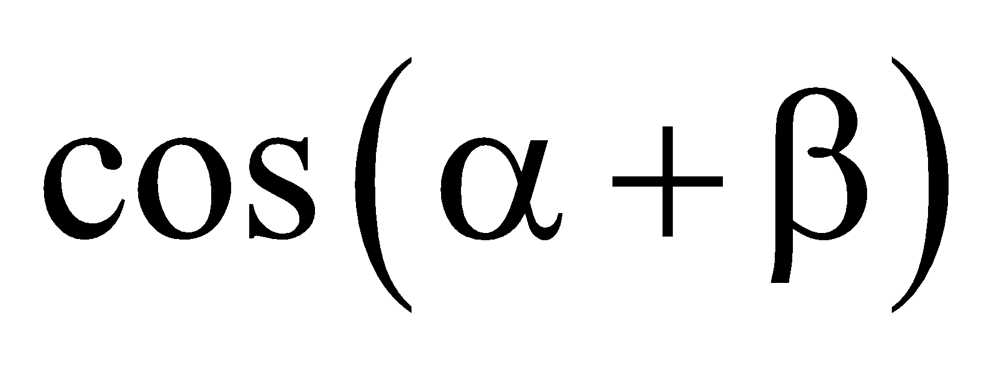 vishwas none of these

**Nikhil 47.** If 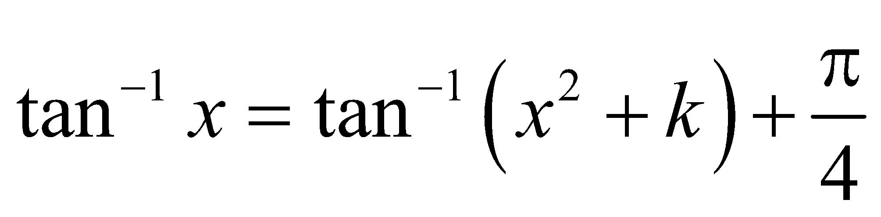 is satisfied for exactly one 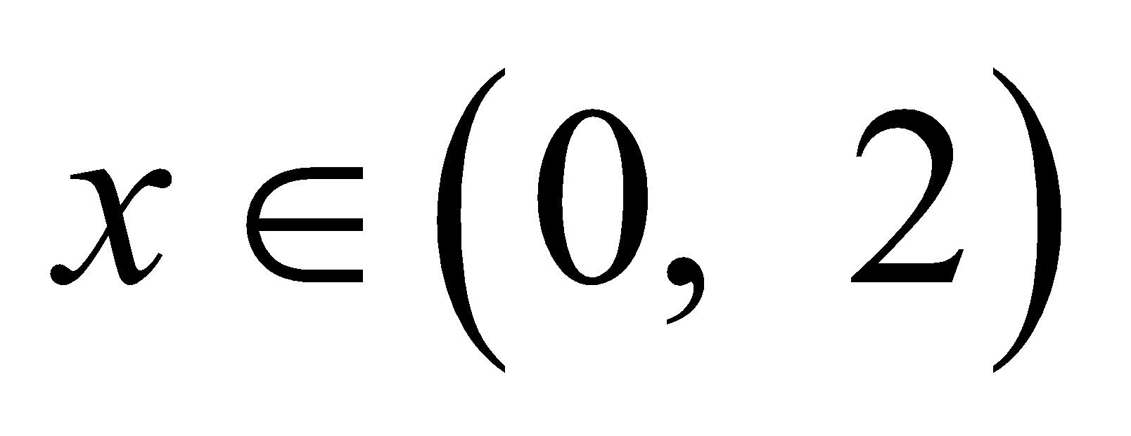, then number of integral values of *k* is

vishwas 2 vishwas 3 vishwas 4 vishwas 5

**Nikhil 48.** If the curves 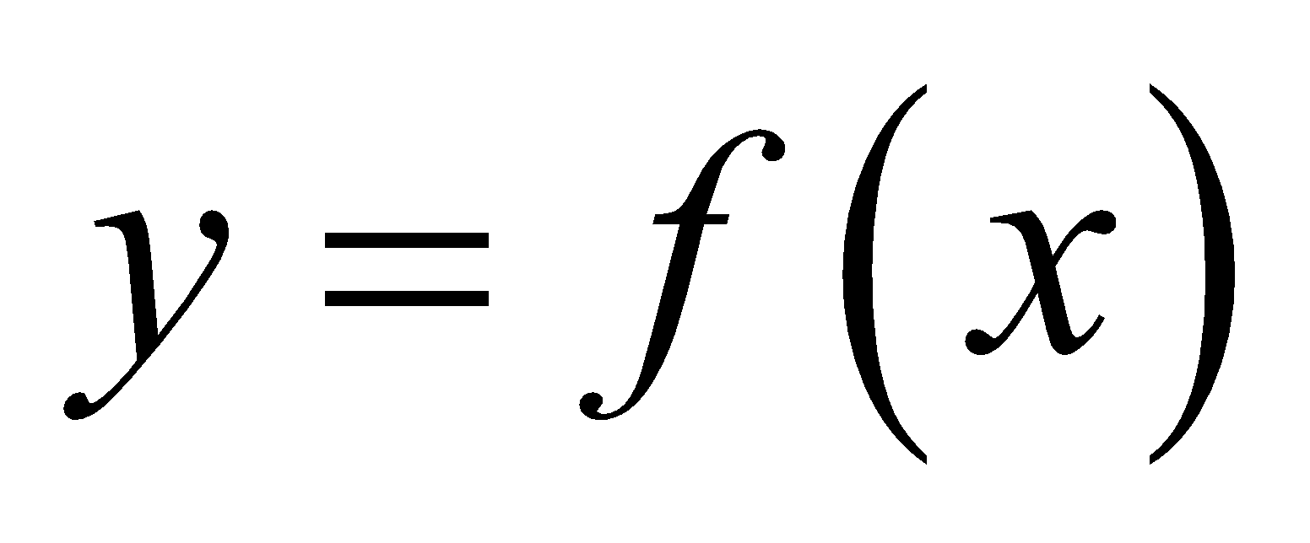 and 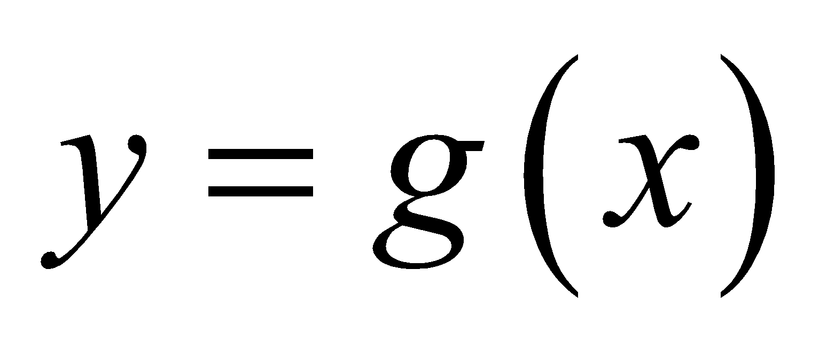 intersects each other orthogonally at some point *P*, then at *P*

vishwas *f* and *g* both may be increasing vishwas *f* and *g* both may be decreasing

vishwas *f* and *g* have opposite monotonicity vishwas none of these

**Nikhil 49.** Circle *C*1 and *C*2 touches externally and circles 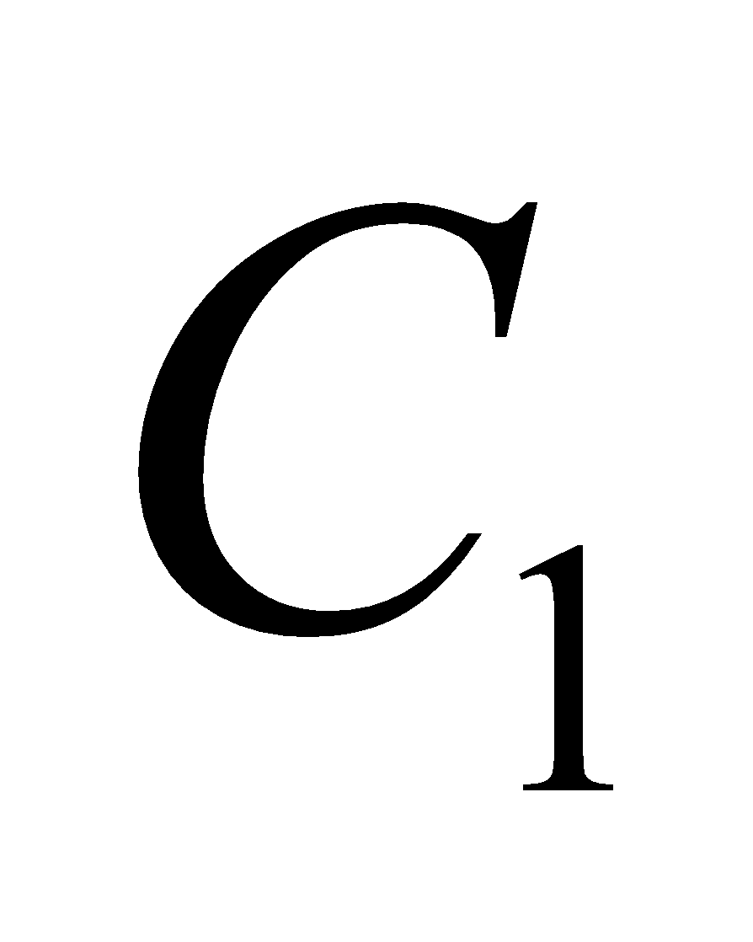 and 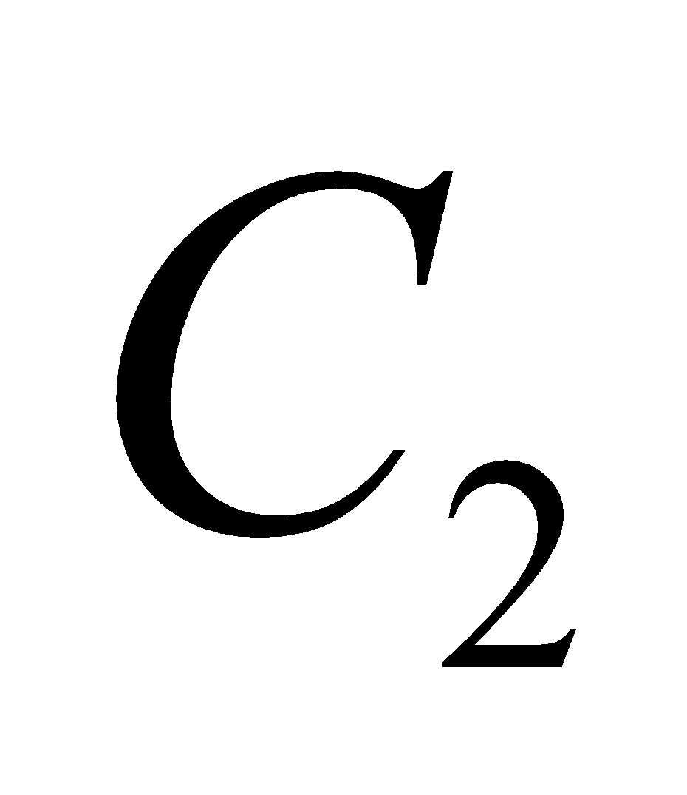 touches internally to the circle *C*3. The radii of *C*1 and *C*2 are 4 and 10 respectively and the centres of the three circles are collinear. A chord of *C*3 is also acommon transverse tangent of *C*1 and *C*2. Given that the length of the chord is 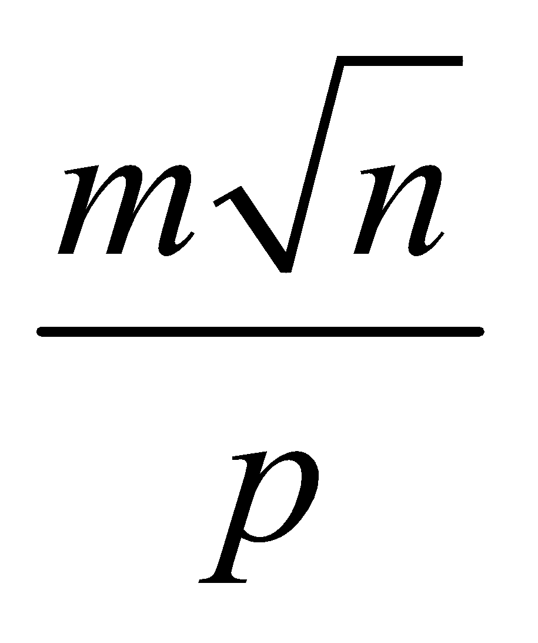, where *m, n* and *p* are positive integers, *m* and *p* are relatively prime and *n* is not divisible by the square of any prime, then the value of (*m + n + p*) is

vishwas 19 vishwas 18 vishwas 17 vishwas 20

**Nikhil 50.** The area bounded by 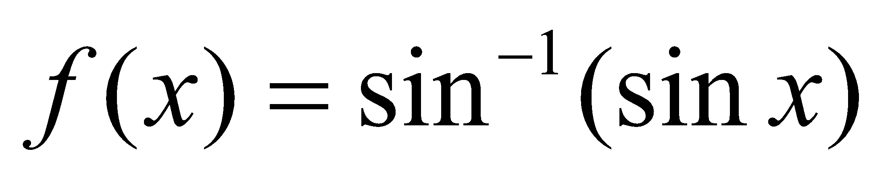 and 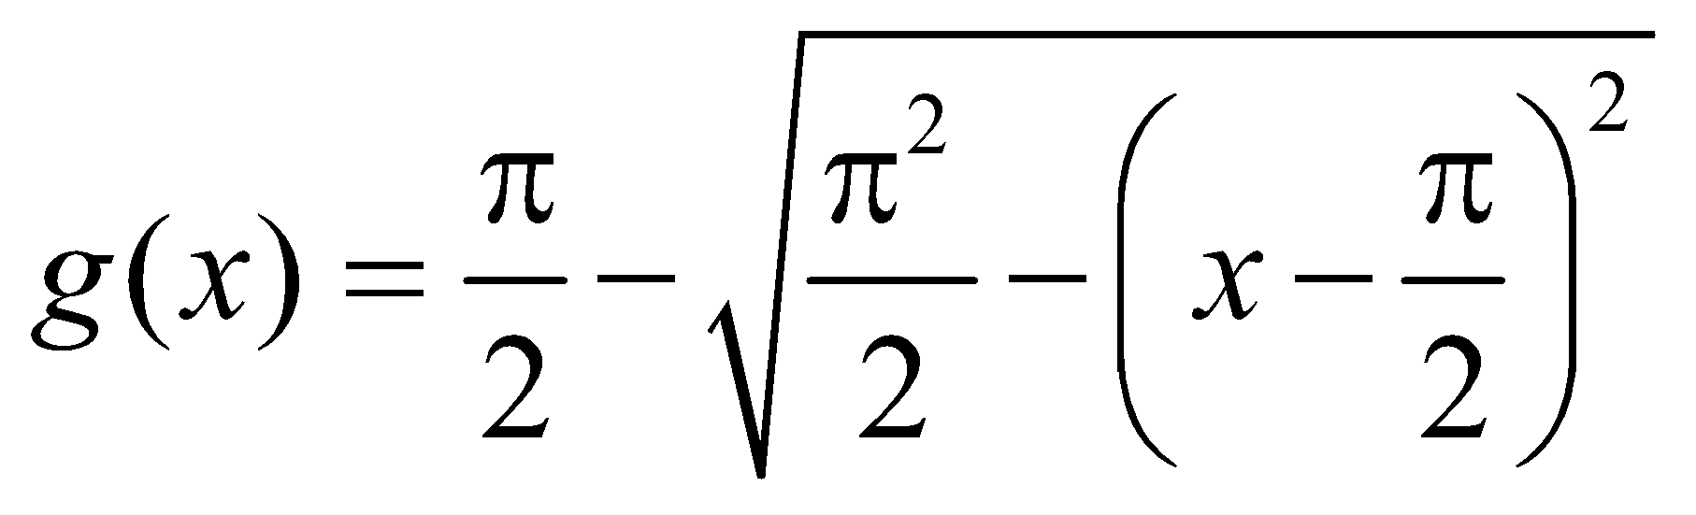 is

vishwas 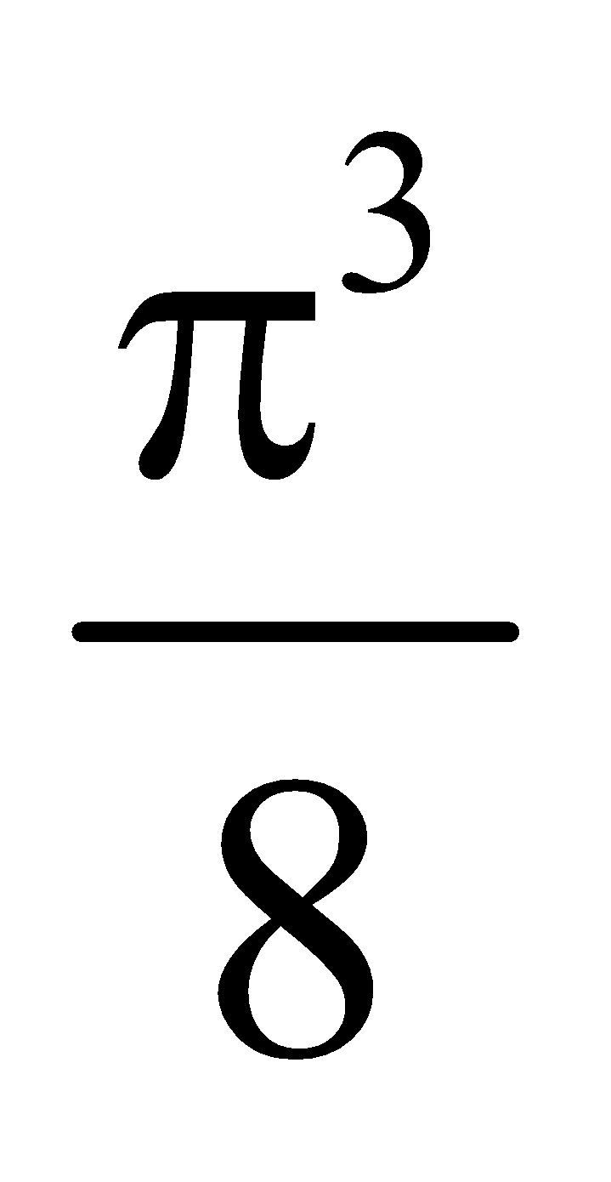(unit)2 vishwas 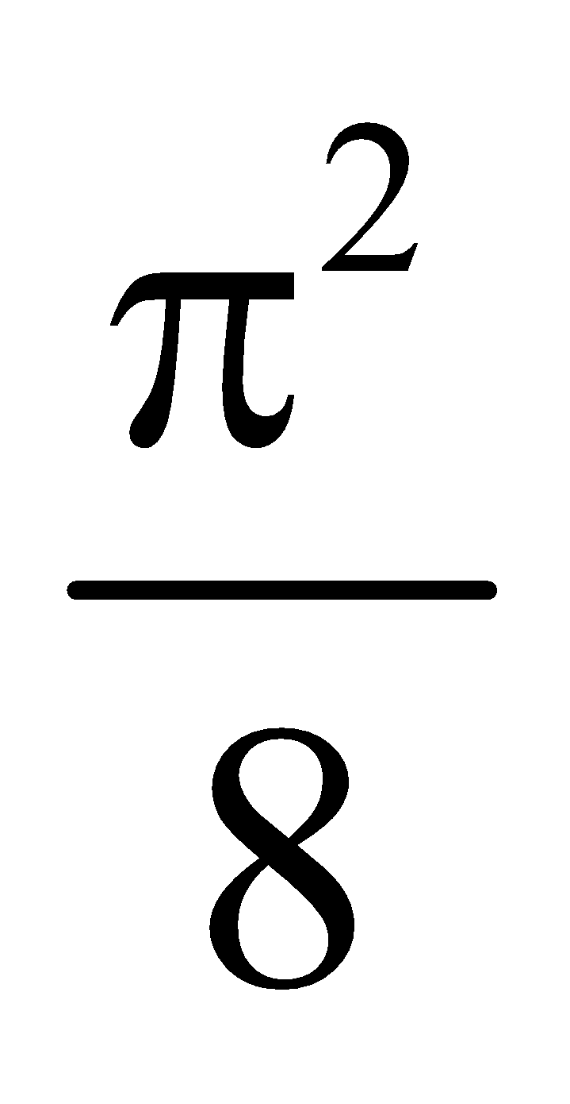(unit)2 vishwas 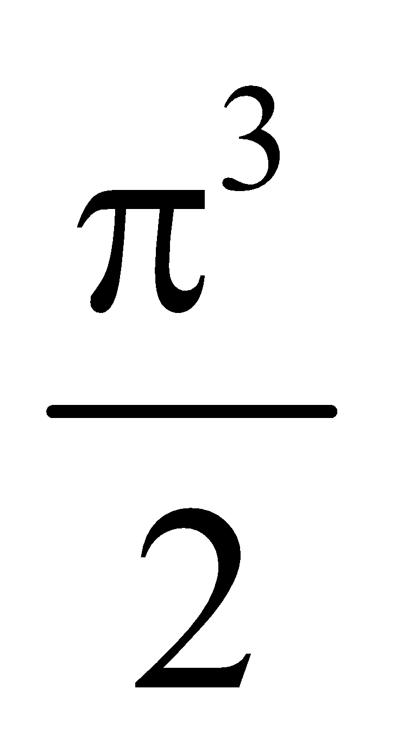(unit)2 vishwas 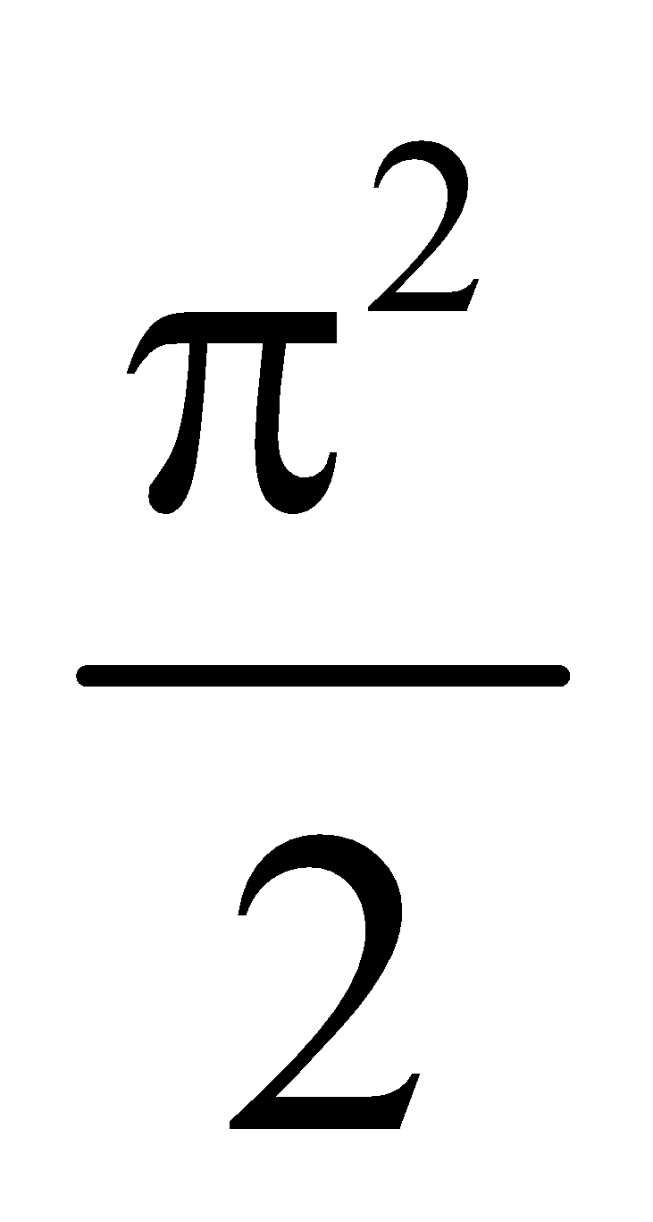(unit)2

#Multiple#

**Nikhil 51.** If in a triangle *ABC*, , then triangle may be

vishwas right angled vishwas isosceles vishwas equilateral vishwas right angled isosceles

**Nikhil 52.** The value(s) of α for which the curves 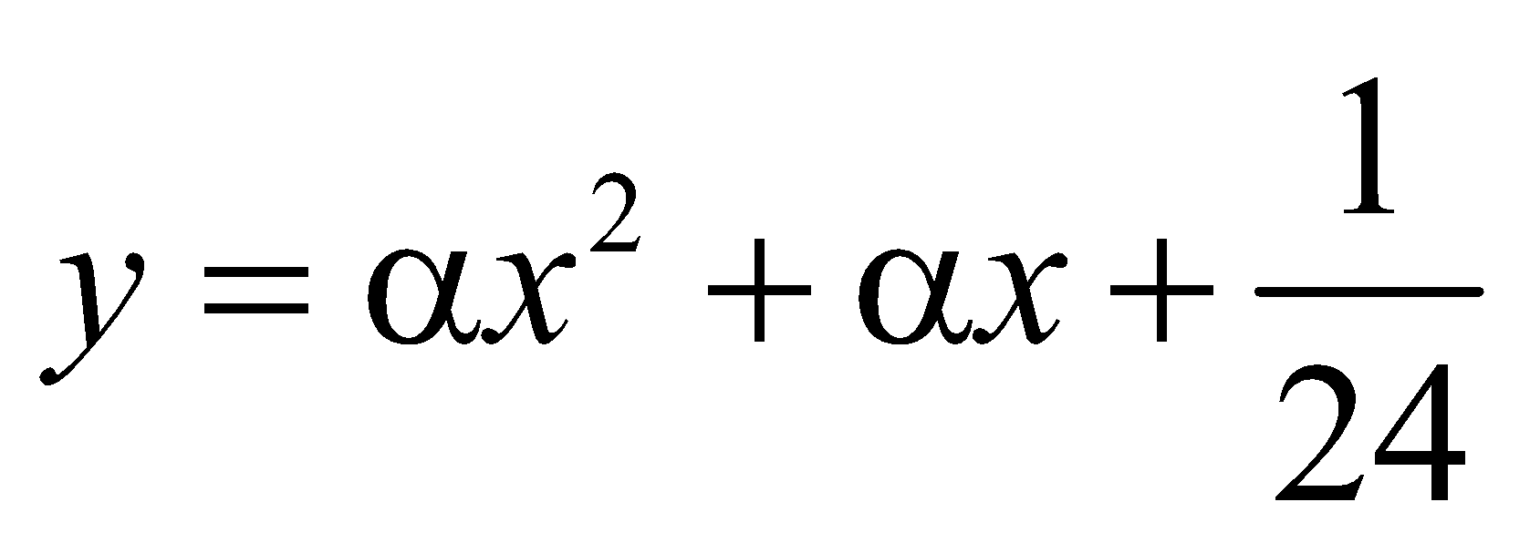 and 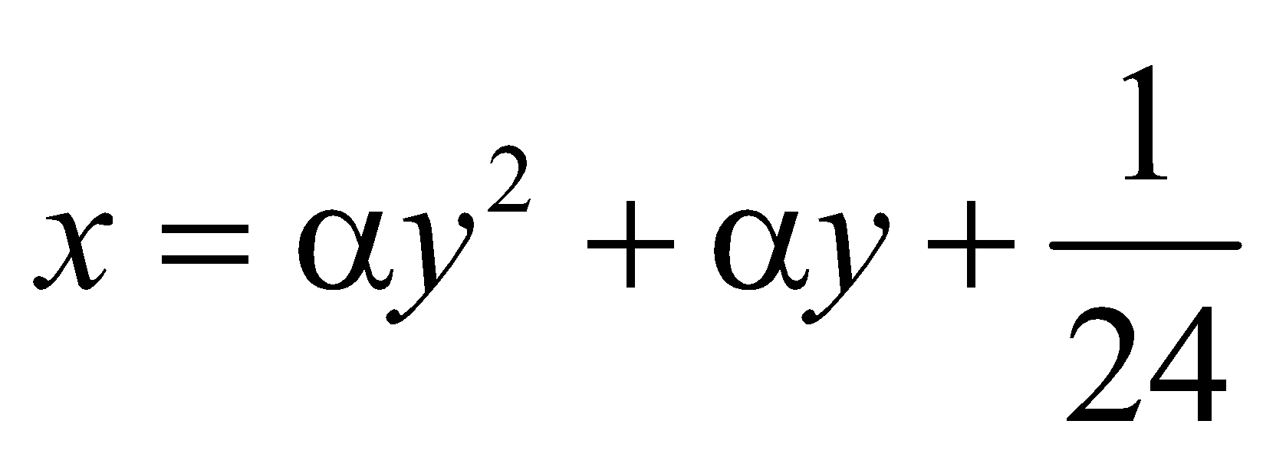 touches each other is/ are

vishwas 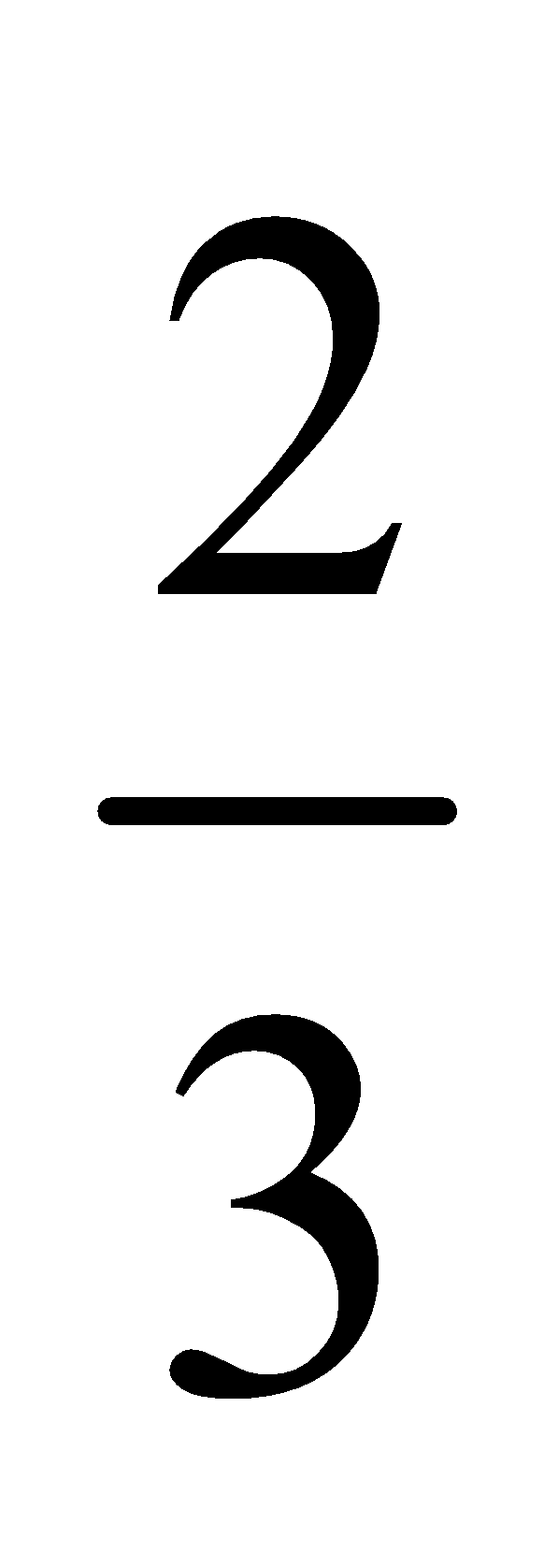 vishwas 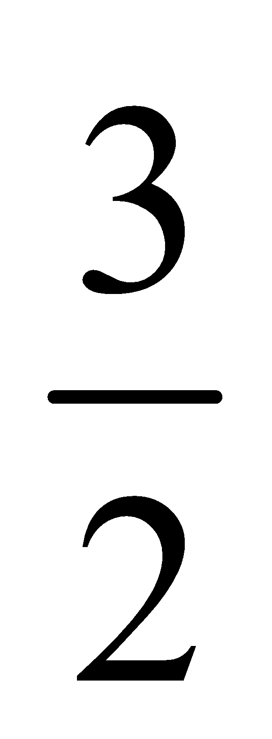 vishwas 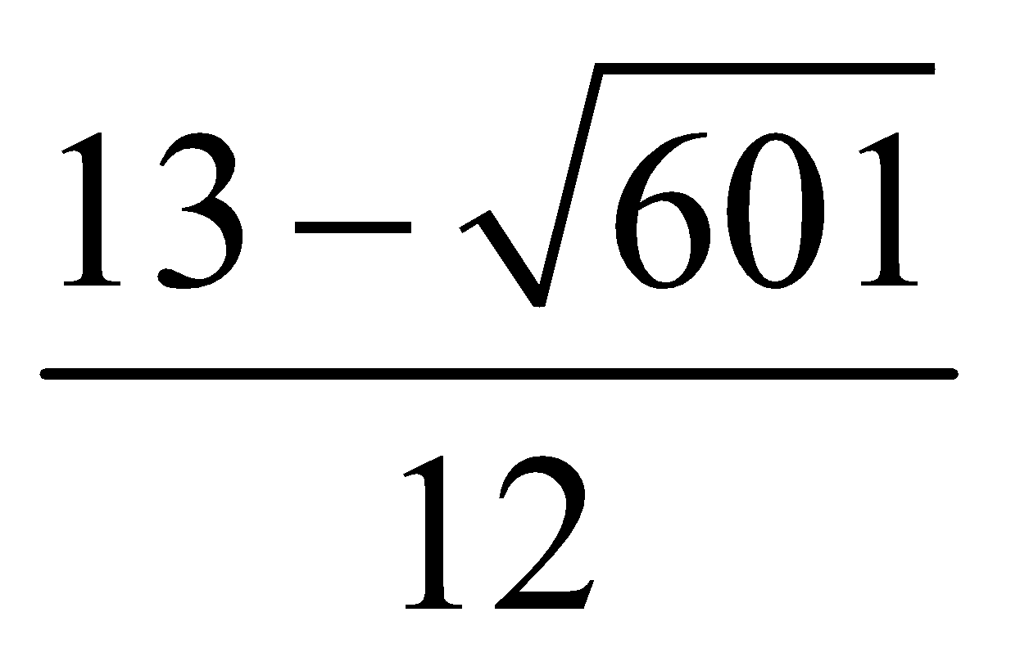 vishwas 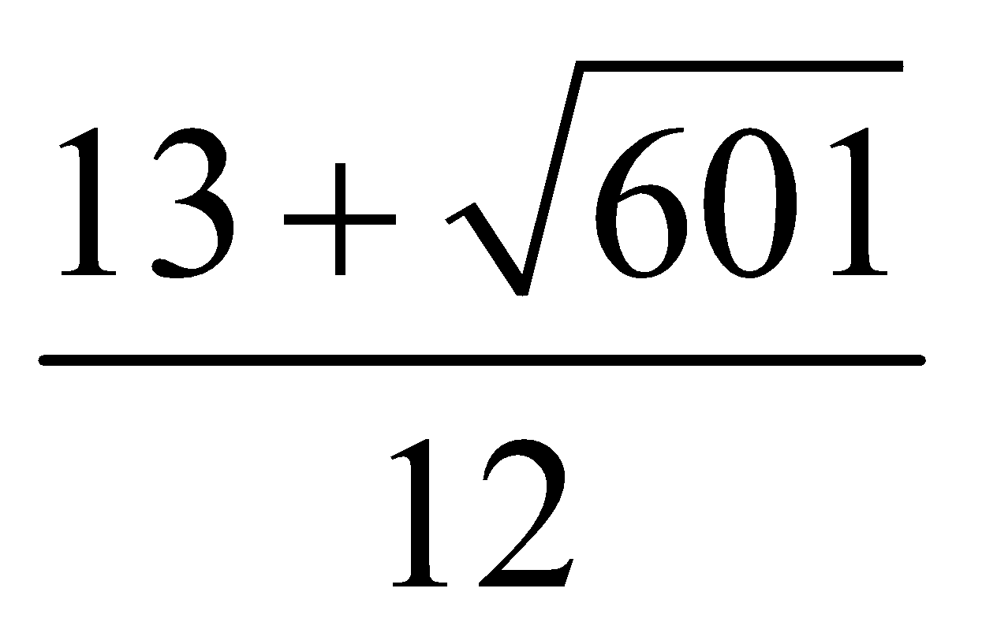

**Nikhil 53.** If 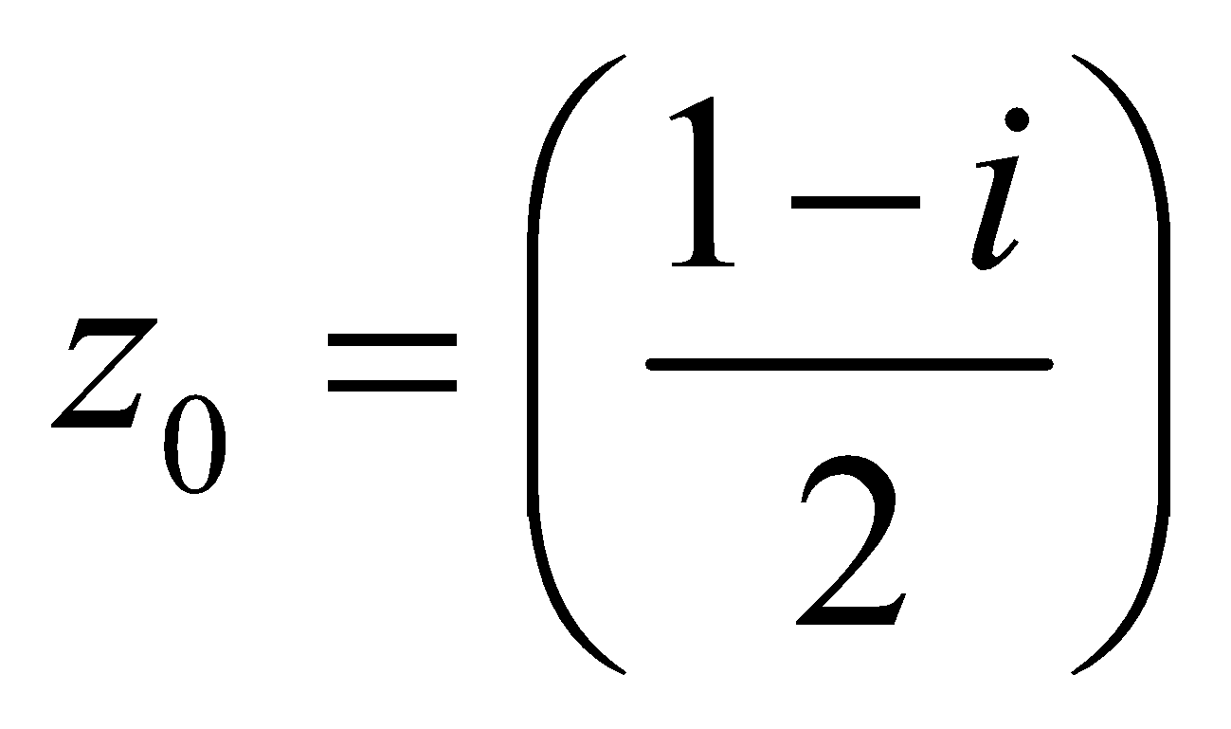, then the value of the product 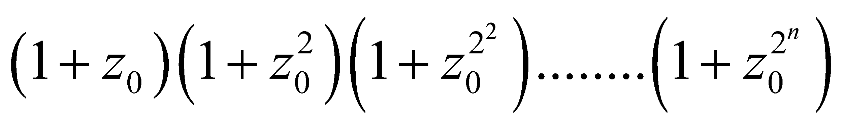 must be

vishwas 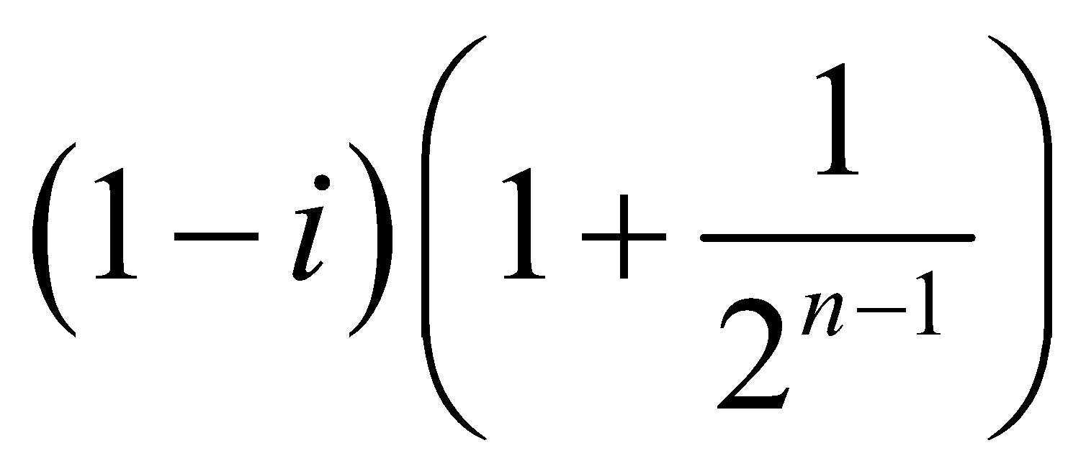, if 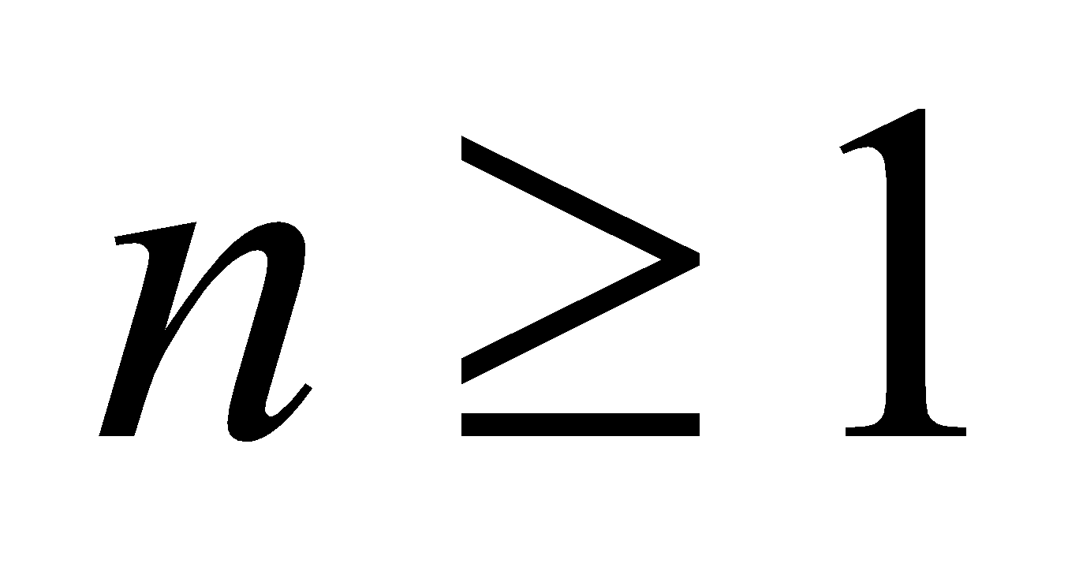 vishwas 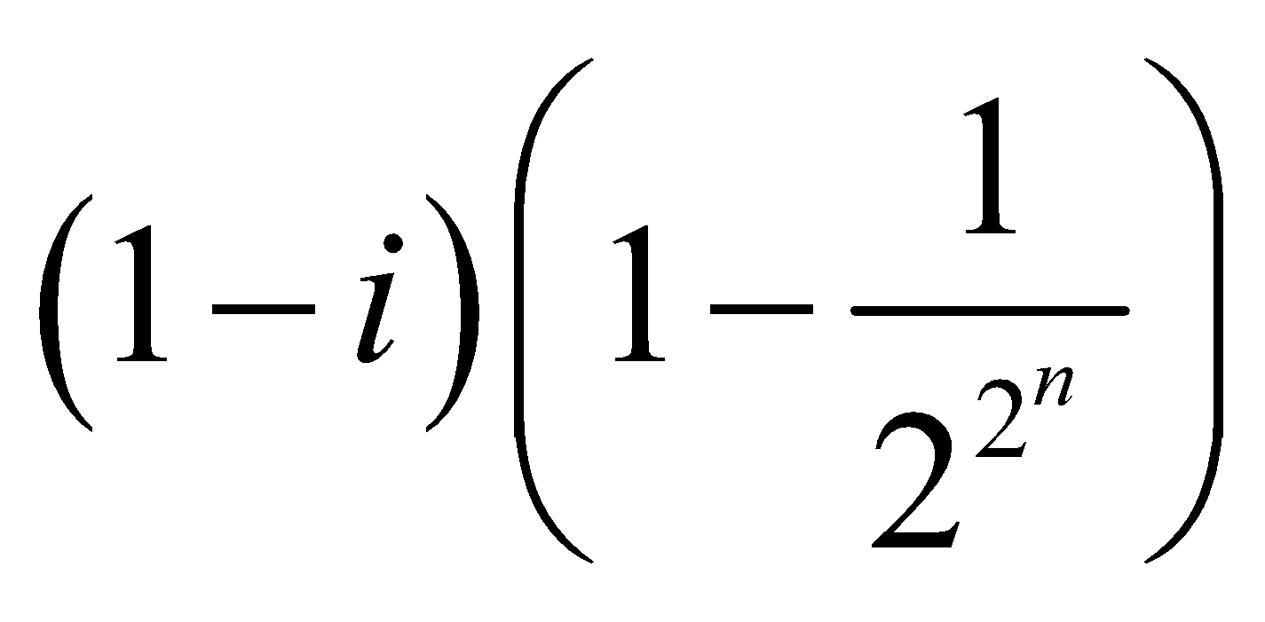, if 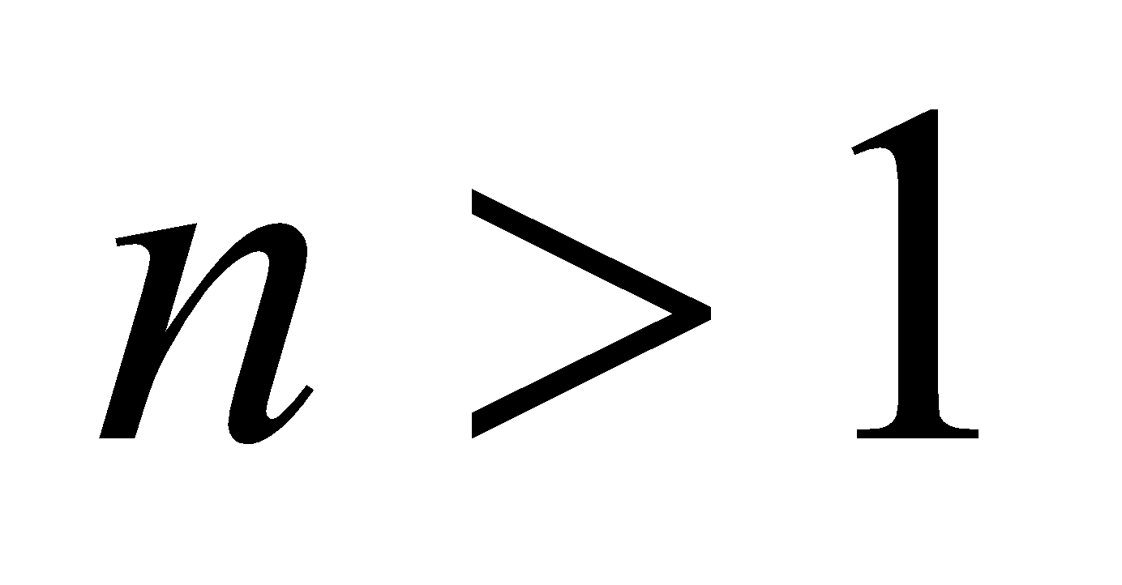

vishwas 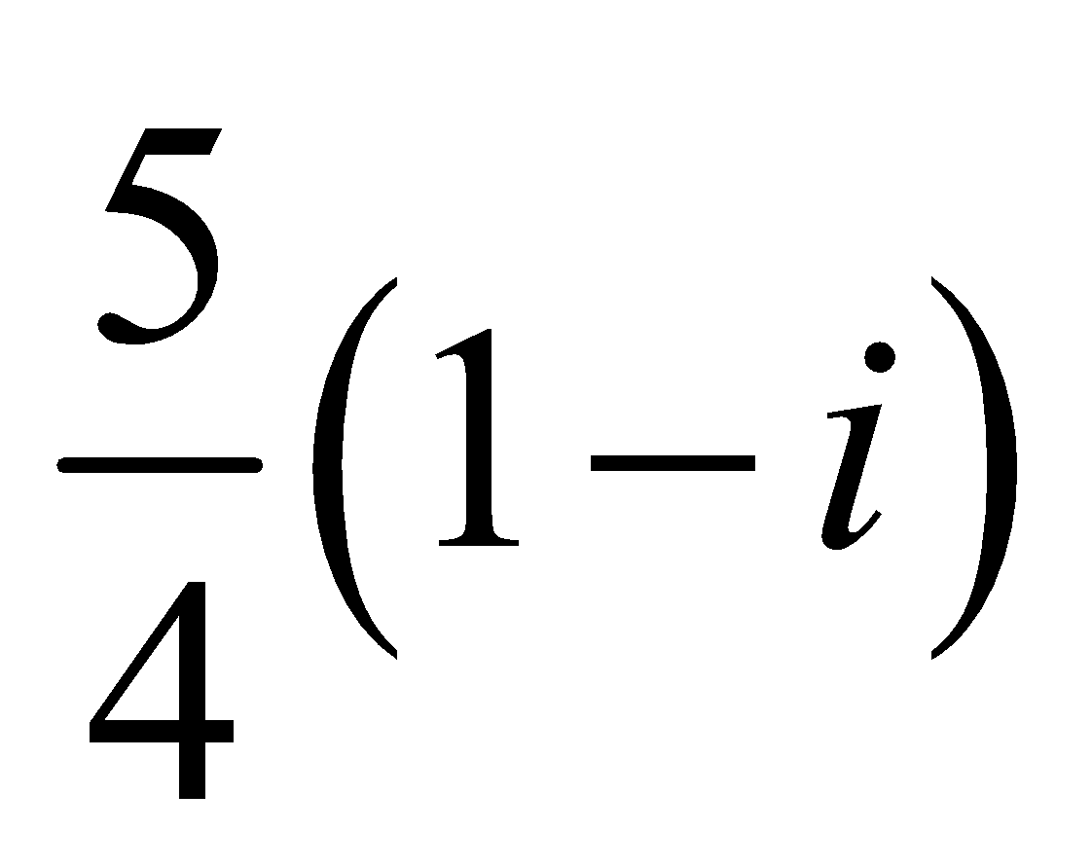, if 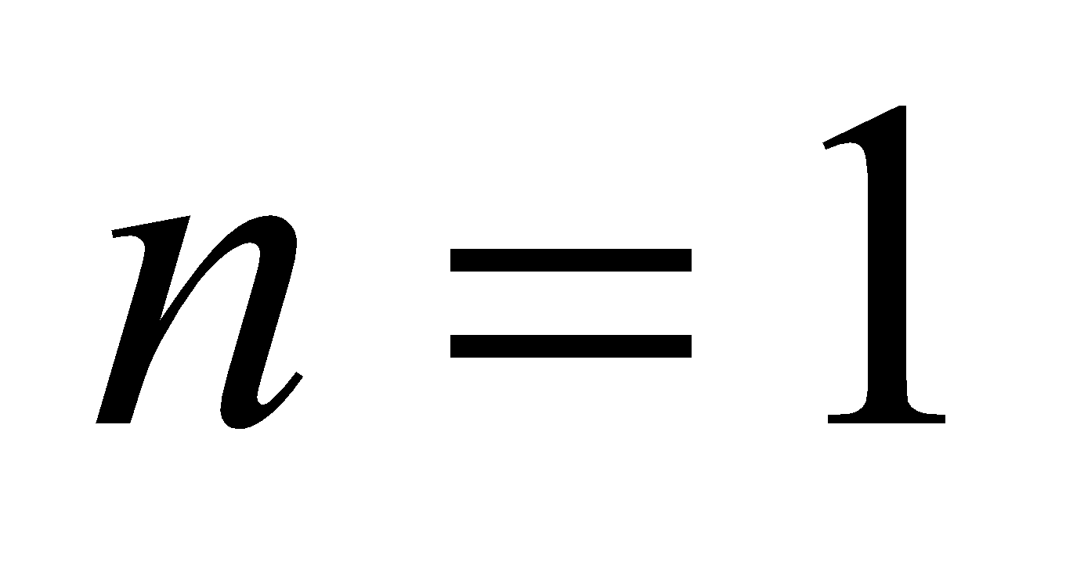 vishwas 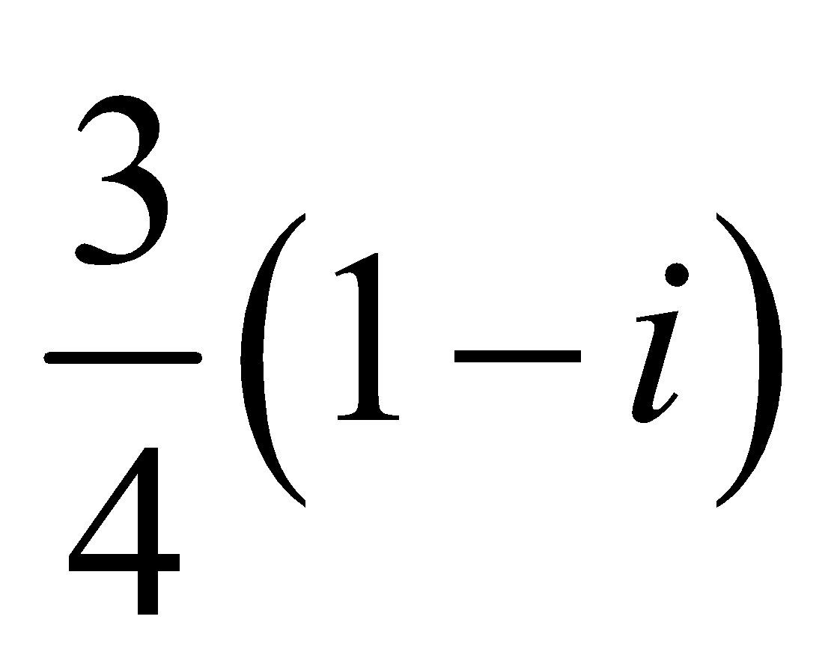, if 

**Nikhil 54.** Given 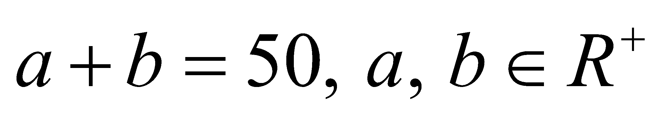. If *A, G* and *H* are respectively, the A.M., G.M. and the H.M. between the numbers *a* and *b* such that the G.M. exceeds H.M. by 4, then (where*A* >1, *G* > 1, *H* > 1)

vishwas *A + G* = 30 *H*

vishwas *G + H* = *A* + 11

vishwas 4 (*G + H*) = *A* − 1

vishwas *A + G* = 3(*H* − 1)

**Nikhil 55.** If 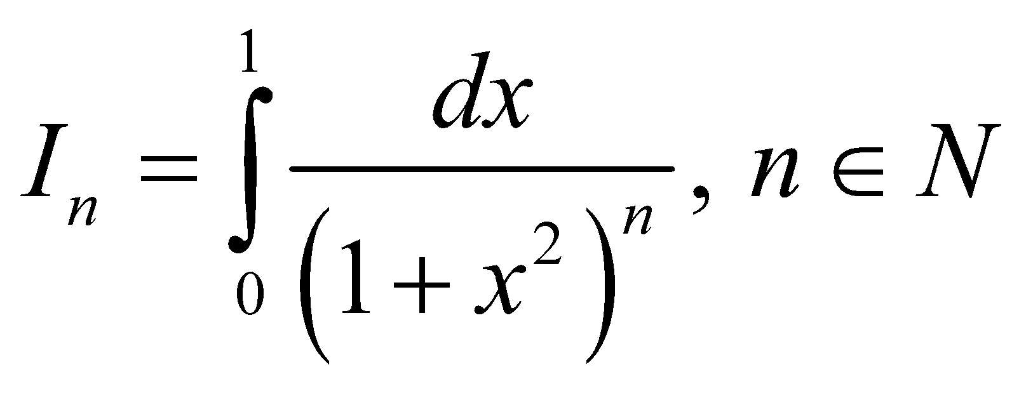, then which of the following statement holds good ?

vishwas 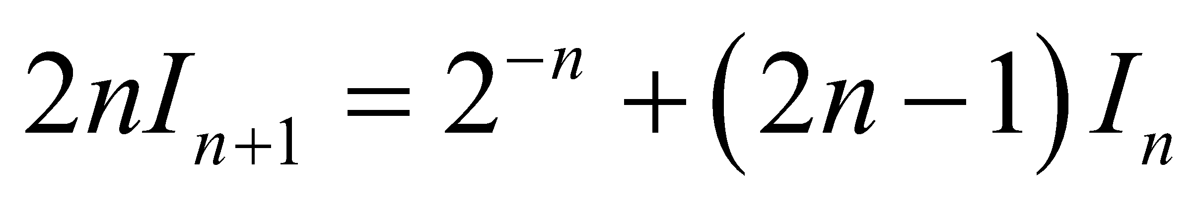 vishwas 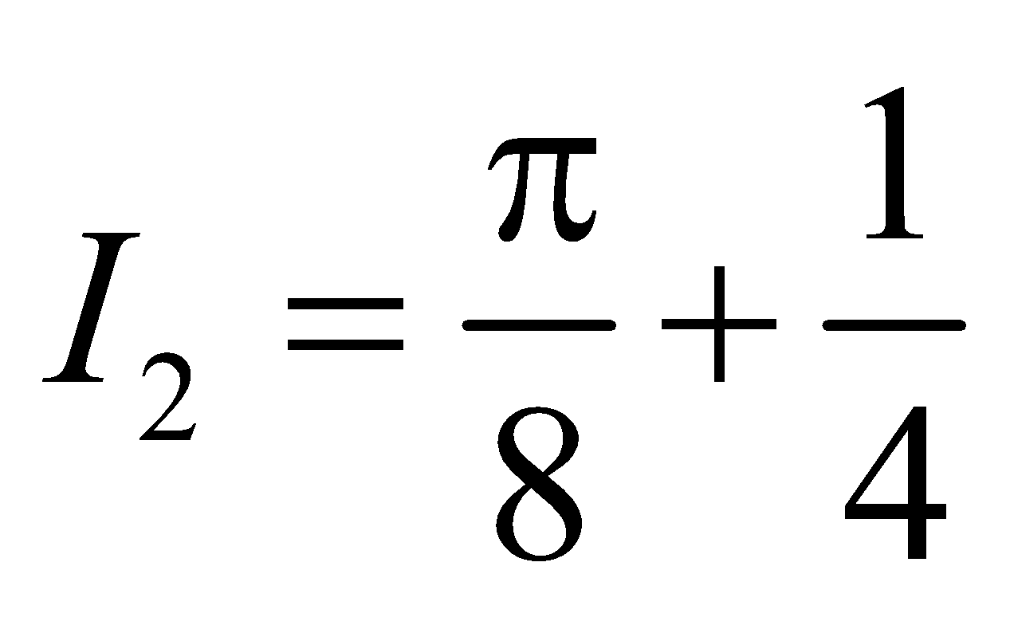

vishwas 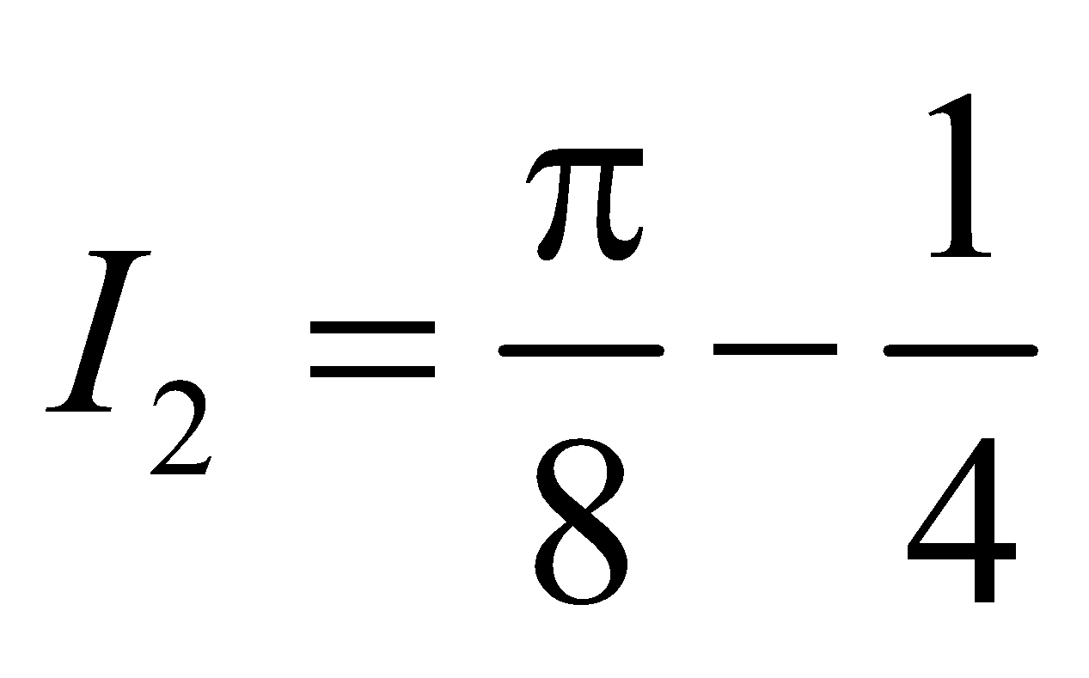 vishwas 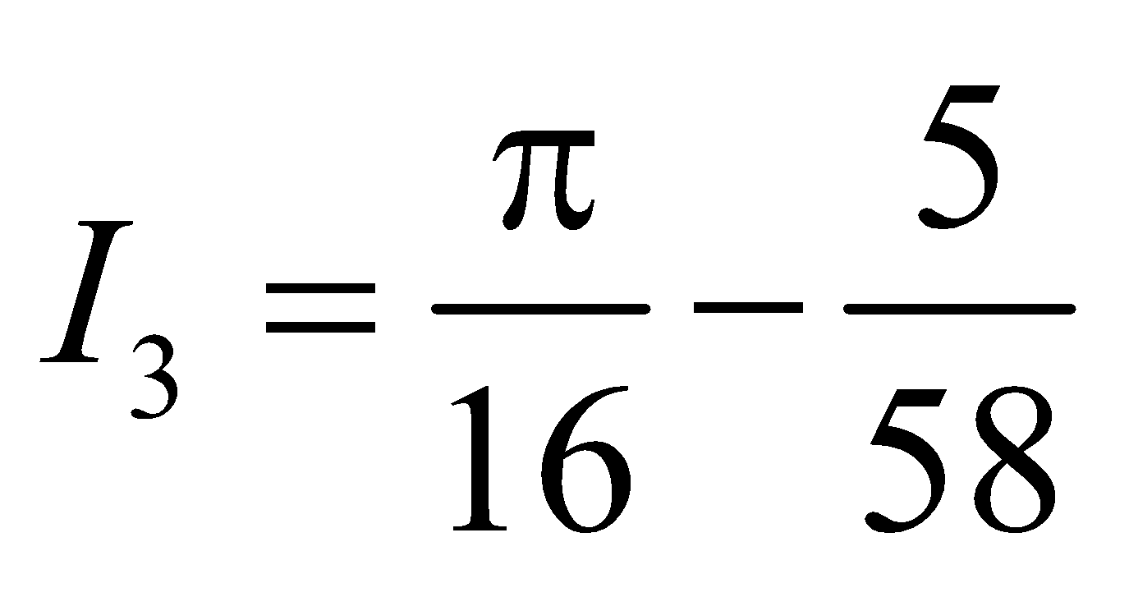

#Integer#

**Nikhil 56.** With usual notations the triangle *ABC* is inscribed in a circle of unit radius then find least value of 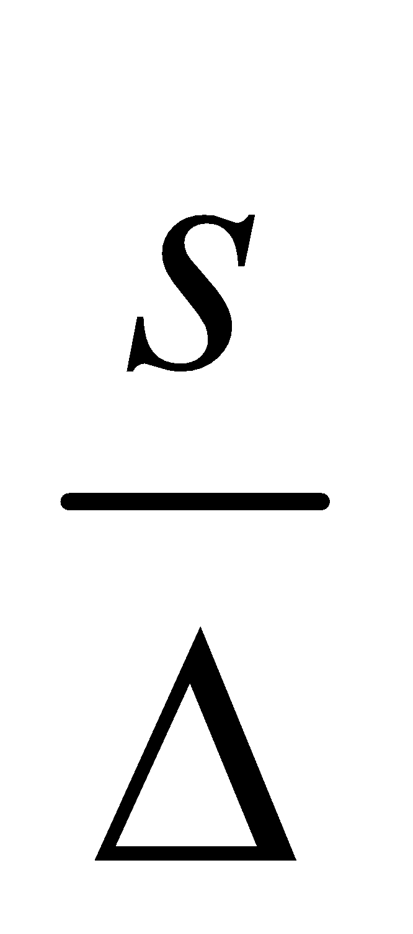.

**Nikhil 57.** Let 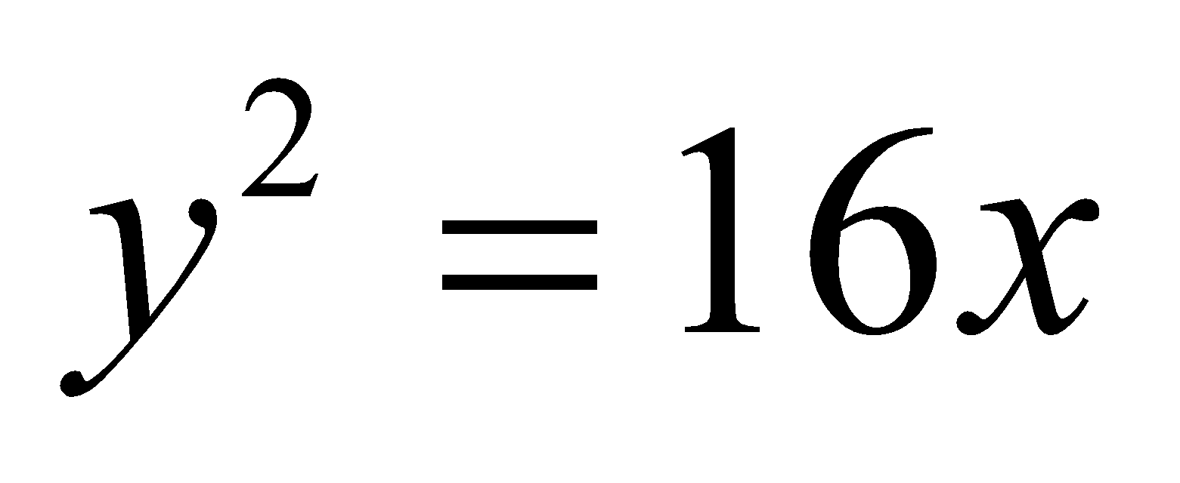 be a parabola on which *AB* is a focal chord with *S* as the focus. Suppose *M* and *N* be the feet of the perpendiculars from *A* and *B* on the axis of the parabola respectively such that 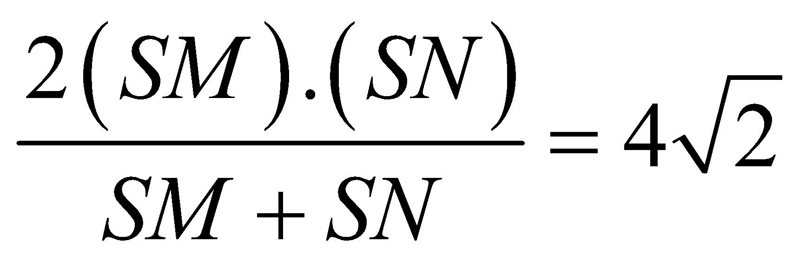. If the equation of the focal chord is 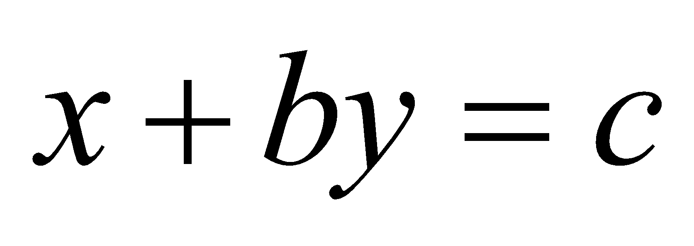, then find 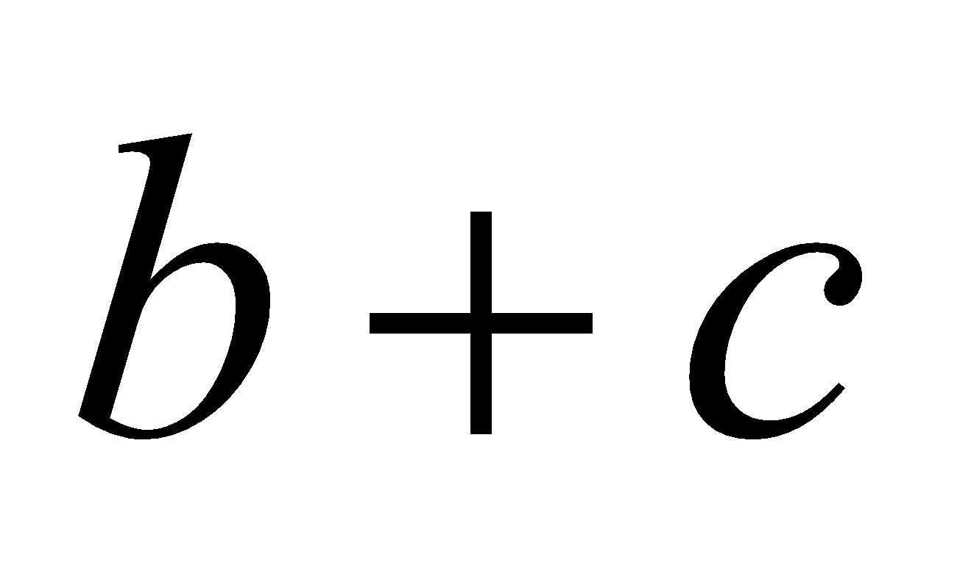.

**Nikhil 58.** If *a* and *b* are positive numbers and 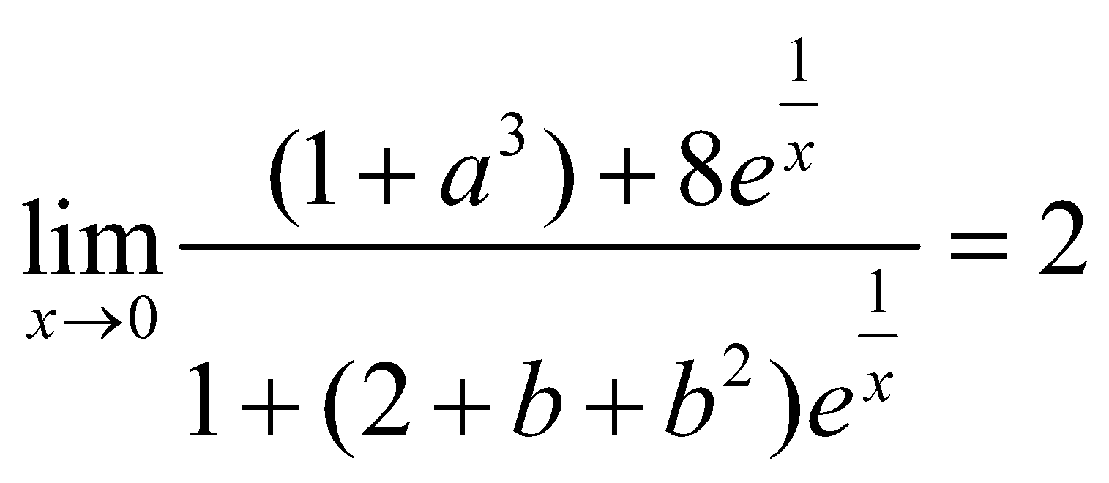, then find the value of 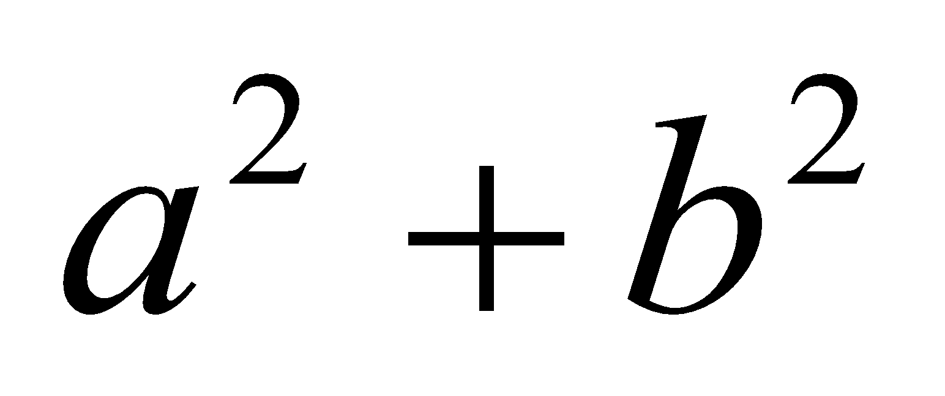.

**Nikhil 59.** Consider the collection of all curves of the form 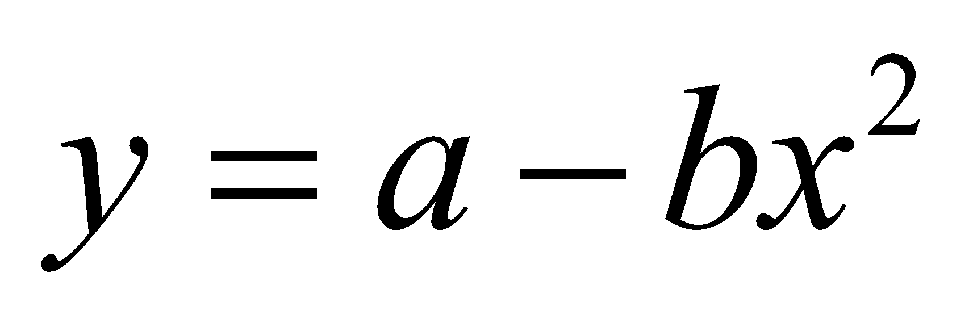 that passes through the point   
(2, 1) where *a* and *b* are positive real numbers. if the minimum area of the region bounded by  and the *x*-axis is 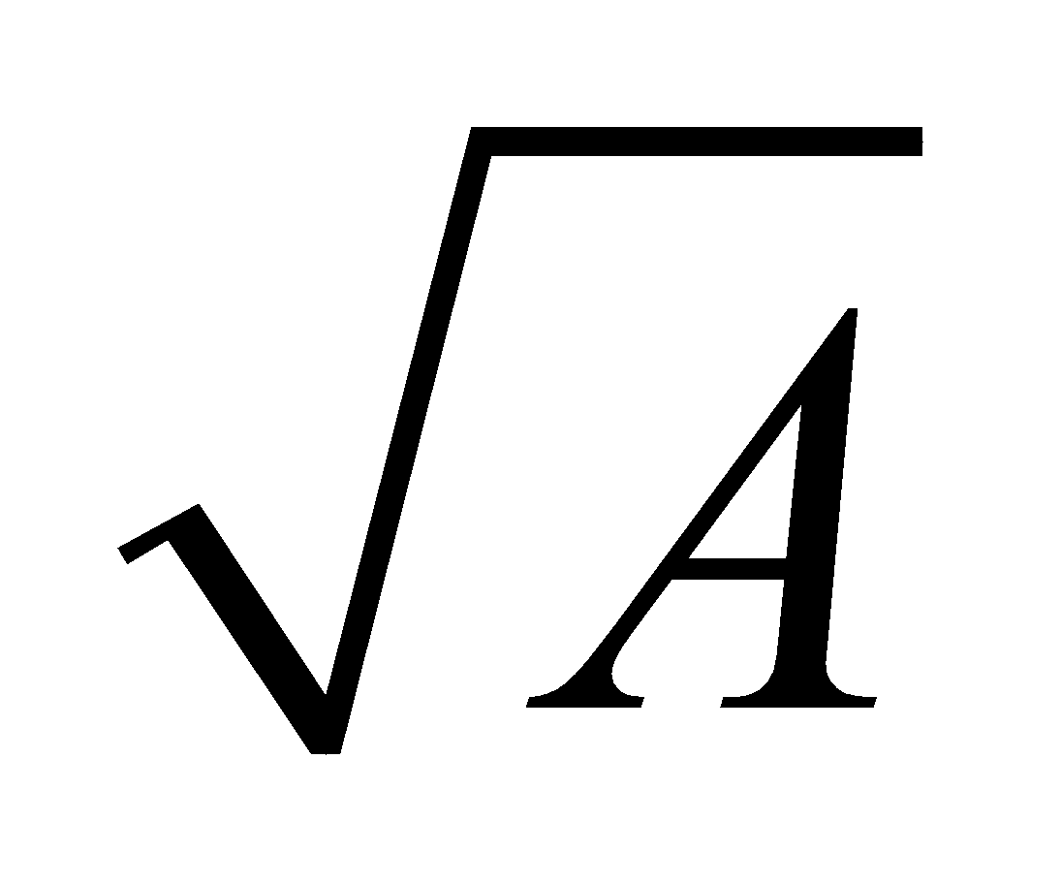, then find the value of 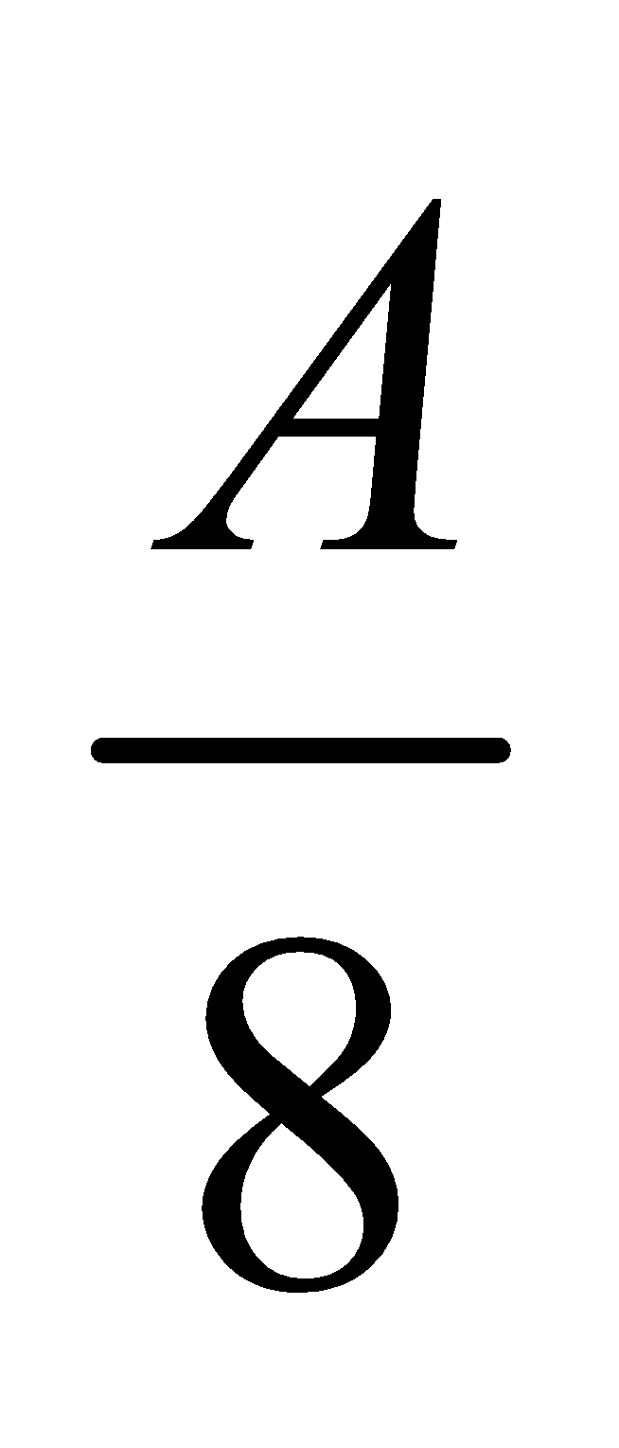.

**Nikhil 60.** Find the value of  (where 