BITS PILANI DUBAI CAMPUS

Sustainability projects across our Dubai Campus
Campus is steadily moving towards sustainability in electricity, water & uses of natural resources. Water conservation and systematic distribution of portable water supply is managed and monitored efficiently.
Awareness drive on Food wastage
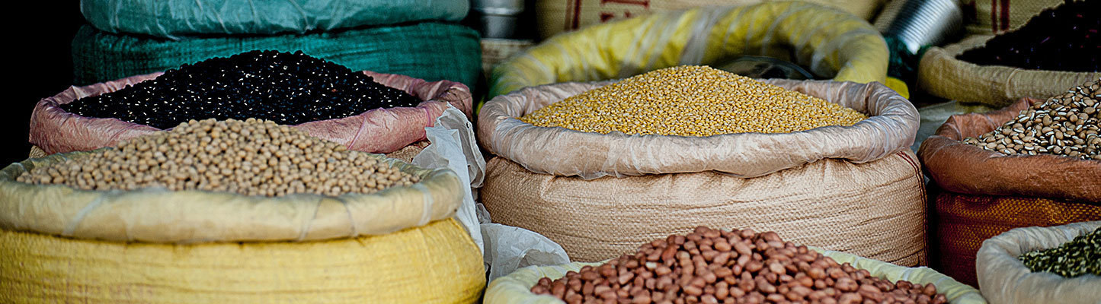
Food wastage is not only a humanitarian concern but also an environmental problem. Food is extremely energy intensive and any wastage will increase the carbon footprint in an alarming level. Wasted food in landfill produces methane which is more potent than carbon dioxide as a greenhouse gas. About 6%-8% of all human-caused greenhouse gas emissions could be reduced if we stop wasting food.
Creating Awareness is the first step towards any effort to bring about a change.

Operation Energy saving LED lights

LED lamps are more energy efficient, durable and emit less heat. By replacing the conventional bulbs with LED lighting systems BPDC managed to save a whopping 129121 W. The carbon intensity for electricity production in UAE is *0.42 kg CO2/KWh and hence we are saving 54.23 kg CO2 every hour.
Recycling
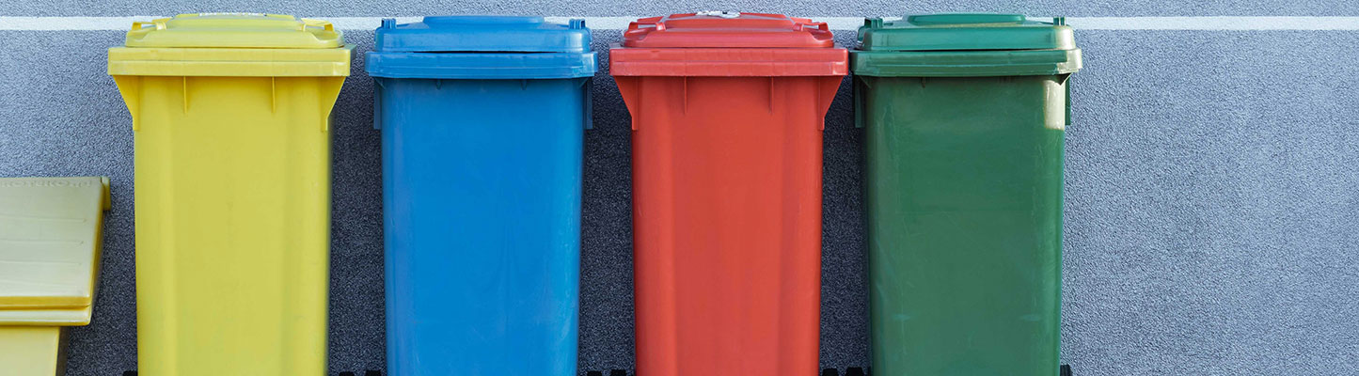
Recycling is a key aspect for reducing our environmental impact. Designated bins are located on the interior and exterior of buildings across campus to collect recyclable materials on a day to day basis. Recyclable materials are collected and deposited in the Municipal recycling centre.
Every academic year, paper and other recyclable materials are collected and taken for recycling to the Dubai Recycling Centre
Donation Drives for used Clothes

Recycling and reusing of cloths and other textiles create a huge impact in reducing Greenhouse gases and ecological footprint. Every Year ,the Social and Environment Club of BPDC collects cloths ,beddings and donate it to Emirates Red Crescent

The Book Room (Reuse of Textbooks)
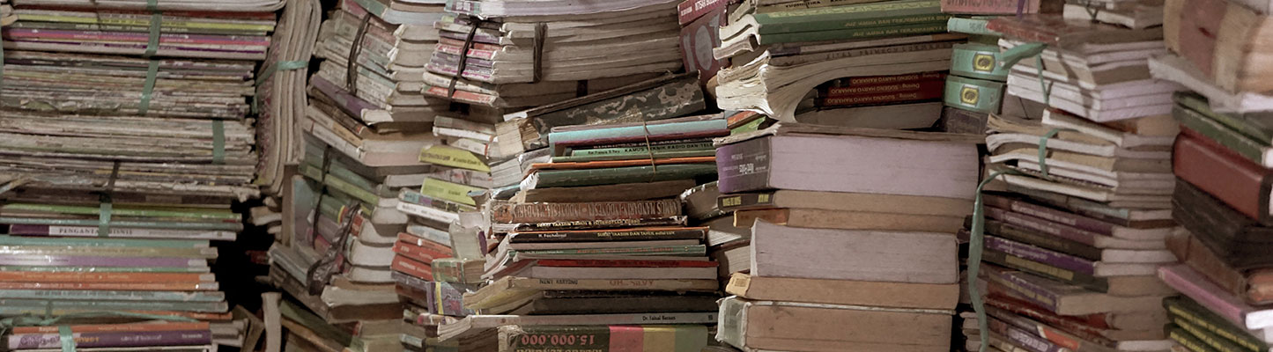
Production of printed books has an enormous Ecological/Carbon Footprint because of the excessive usage of water, fossil fuel and paper consumptions. Printed papers in landfill generates enormous amounts of greenhouse gases. To reduce the negative impacts, used textbooks are made available for students in the BPDC campus to borrow instead of buying new books.
Usable papers from the exam booklets were collected and made into scribbling pads which are distributed among students, Staff and faculty every year.

Earth Day Celebrations
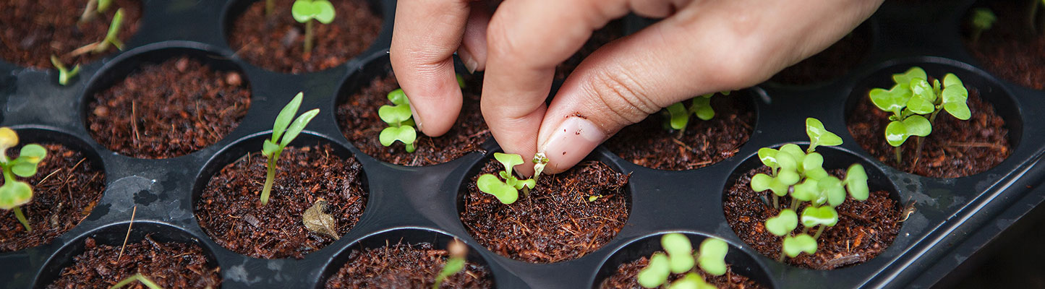
Every year on 22th April world community celebrates Earth day to Support Environmental Movements and to create awareness about the Environment. BPDC community too celebrated Earth day on 22.4.2021
Word Search on our social media platforms where students had to comment as many words they could find to win exciting prizes.
The club also took the initiative of planting a sapling on the campus premises to mark Earth Day.

Earth Hour Celebrations
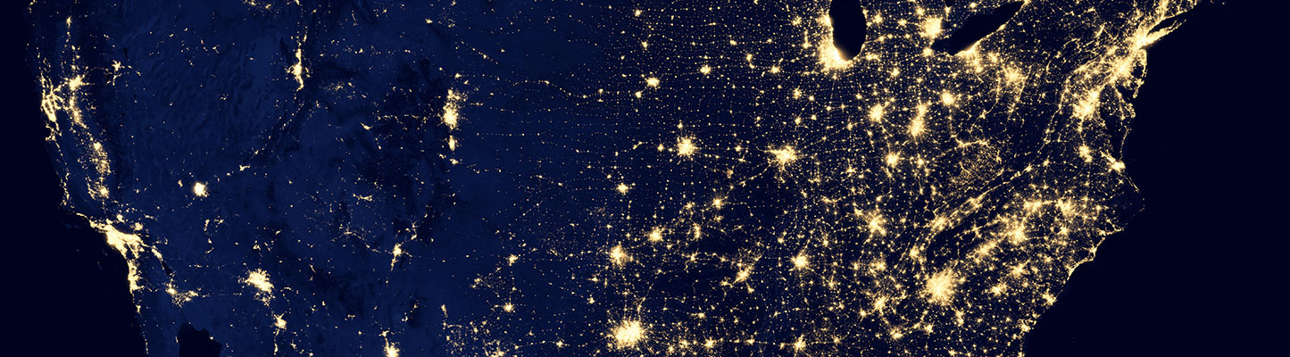
BITS Pilani Dubai Campus joined the people across the world to show support for our mother Earth and to raise awareness by turning off non-essential lights on 26.3. 2021.
Energy and Water Conservation Awareness Drive
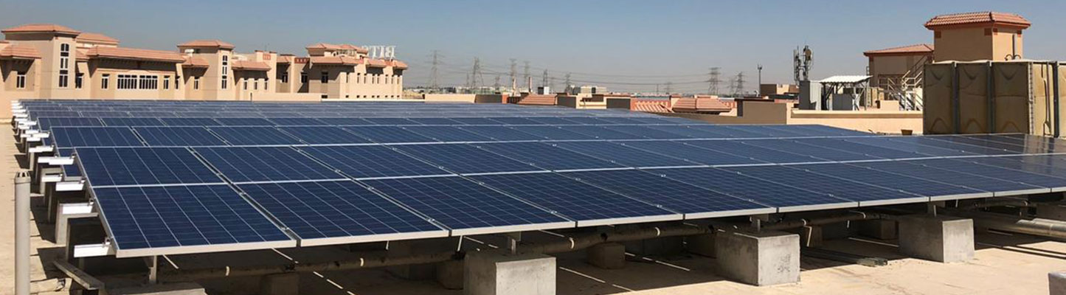
Awareness messages to conserve energy and water are put up across the campus to encourage the BITS fraternity to adopt more sustainable living.

Greener Alternative for Plastic Bags

Paper bags being biodegradable are far more sustainable than plastic bags. Students made paper bags using newspapers and donated to the Mini Mart(Grocery BITS Pilani Dubai Campus) and Canteen for usage. This initiative was active till February 2020.It was suspended due to the pandemic.

Tree Plantation Drive: Environmental sustainability was encouraged through a Tree Plantation Drive on campus. Students and staff contributed to creating a greener campus and spreading awareness about ecological responsibility.
