BITS PILANI KK BIRLA GOA CAMPUS

Water Conservation Initiatives Implemented on Campus
- Installation of Water-Saving Aerators
Water-saving aerators have been installed in washbasins across the academic buildings, resulting in approximately 20–30% reduction in water consumption.
- Push-Type (Self-Closing) Taps in Washbasins
Push-type (self-closing) taps have been installed in academic building washbasins to prevent unnecessary water wastage and ensure controlled usage.
- Use of Treated Water for Flushing
Treated water is being utilized for flushing purposes in hostels, new academic buildings, and faculty residential towers. This has significantly reduced the dependency on potable water and promoted sustainable water management.
- Reuse of Treated Water for Landscaping and Grounds
Treated water is also reused across the campus for activities such as watering gardens, maintaining landscaping areas, and irrigation of the SAC ground, thereby conserving fresh water resources.
- Push-Type Urinal Flush Taps
Push-type (self-closing) urinal flush taps have been installed in hostels and academic buildings to minimize water wastage.
- Hydropneumatic Water Supply System
A hydro pneumatic system is used for water supply in hostels, new academic buildings, and faculty residential towers. This system ensures regulated water pressure and reduces water wastage.
- Sensor-Based Level Control Systems
Sensor-based level control systems have been implemented to automatically cut off pump supply when overhead tanks reach optimal levels, preventing overflow. This system is also adopted for cooling tower make-up water, resulting in significant water conservation.

Waste Management

- Color-coded bins for dry waste, wet waste, sanitary waste, and e-waste are placed across the campus, including hostels, residential areas, and academic blocks. Daily door-to-door waste collection is carried out, and the collected waste is transported to the segregation yard.
- Dry waste is further segregated into recyclable and non-recyclable waste, which is baled using a 5HP baling machine and handed over to authorized recycle rs. Wet waste is treated in a 1 TPD organic waste composter & biogas plant. The compost generated after processing is used in the institute gardens.
- Biomedical and sanitary waste are collected and disposed of through an authorized agency. E-waste, hazardous waste are collected and disposed of through authorized agencies.
- Dried sludge from STP is used as manure for our campus greenery initiatives.

Energy Conservation
- The total installed solar power capacity has now reached 1.45 MWp, generating approximately 20 lakh units of electricity annually. This has resulted in a reduction of nearly 1,700 tons of CO₂ emissions per year and annual financial savings of approximately ₹60 lakhs.
- As part of the lighting retrofit program, 36 W fluorescent tubes and CFL lamps were replaced with 20 W LED lights (4,500 numbers, assembled in-house) and 10 W LED lights (1,000 numbers). Additionally, 2×2 72 W CFL fixtures were replaced with 2×2 36 W LED fixtures (620 numbers), resulting in annual energy cost savings of approximately ₹30 lakhs.
3. Limit switches were installed for hostel washroom exhaust fans, and occupancy
sensors were installed for lighting control in academic buildings, leading to annual energy
savings of approximately ₹20 lakhs.
4. Conventional induction ceiling fans were replaced with BLDC ceiling fans, with 1,750 fans
replaced to date, yielding annual savings of approximately ₹20 lakhs.
- An Energy Management System (EMS) was implemented to monitor real-time energy consumption, identify system losses, enable early fault detection in the electrical network, and assist in load re-balancing and optimization.
- A Building Management System (BMS) was implemented to automate the ON/OFF control of Air Handling Units (AHU) based on classroom schedules, resulting in annual savings of approximately ₹10 lakhs.
- Timers have been fixed for street lights to ensure automatic switching on and off as per the set schedule, thereby preventing unnecessary energy usage.
- Solar hot water systems have been installed in all hostels to provide hot water using renewable solar energy, thereby reducing dependence on conventional electricity sources and contributing to overall energy savings and sustainability objectives
Green Campus Initiatives
1. Green are is developed as a model sustainability initiative that enhances campus aesthetics, reduces environmental impact, and promotes ecological awareness.
2. Native and climate-resilient plantations, along with bird houses, create a thriving micro-ecosystem that supports biodiversity and natural ecological balance.
3. Organic composting and the use of recycled materials ensure sustainable waste management and resource conservation within the campus.
4. In collaboration with the Goa Forest Department during Van Mahotsav and the 20 Years Celebration of Excellence, a total of 150 trees were planted to strengthen campus green cover and sustainability efforts.

Campus Contribution towards Sustainable Environment
Campus is steadily moving towards sustainability in electricity and water usage. Water conservation and systematic distribution of portable water supply is managed and monitored efficiently. Water used by campus residents is treated scientifically and recycled back to use in the campus. Campus had aimed to reduce its dependence on conventional power. In this regard, power plants enabled by solar power and energy saving fixtures have been introduced and installed in the campus.
Usage of transport in the campus is very limited. 3500+ students residing in the campus are not permitted to use their private transport inside the campus and are encouraged to use public transport for their local movement outside the campus. Students use covered corridors to walk from their hostels to academic block within the campus.
Campus maintains lush green gardens with a rich collection of flora and fauna. Every year during the monsoon, tree plantation drives are conducted with the help of the students.
ENERGY CONSERVATION
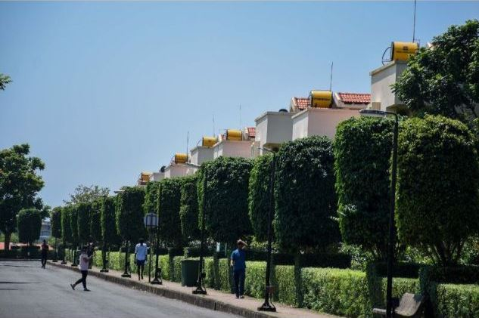
- Over 60 solar water heaters of 500 liters each are provided at all 20 hostels which accommodate 3500+ students.
- Around 40 standalone solar powered street lights are installed in the campus, which is estimated to save around 2,600 kW of electricity annually.
- Around 85% of the street lights (total 275) in the campus are connected to off-grid solar power plant of 19 kW per day. These street lights function on solar power for about six to eight hours every night, which is estimated to save around 41,000 kW of electricity annually. After exhausting the solar power, these street lights function on conventional power.
- Since 2016, hostels, residential quarters, academic and administrative blocks constructed as part of the infrastructure expansion are provided with LED fixtures to reduce consumption of energy.
- Similarly, in the earlier infrastructure, existing CFL, tube lights and other electrical fixtures are being replaced with energy saving LED fixtures in a phased manner.
- In the coming years, it is planned to install 50 to 100 kW on-grid solar power systems thus enhancing the use of renewable energy in the campus.
WATER CONSERVATION
- Five groundwater recharge points are created across the campus. In this, the surface runoff water during monsoon is directed to a designated area which then percolates in the ground resulting in groundwater recharge. Many such recharge points are being planned across the campus in the coming years.
- All overhead tanks and water coolers are fitted with floats, sensors and other mechanisms to shut the water supply and avoid overflow.
- Overhead tanks which are filled with pressurized supply of water through pumps are fitted with actuator valves for avoiding overflow.

Transportation
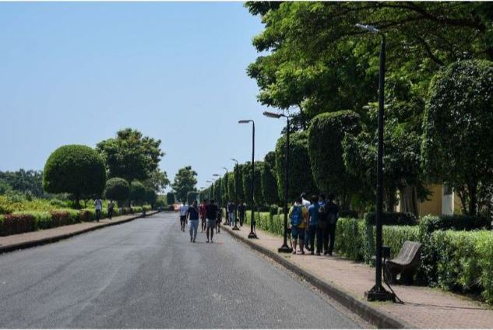
- Movement of transport is very limited in the campus. 3500+ students residing in the campus are not permitted to use their private transport inside the campus.

RECYCLING
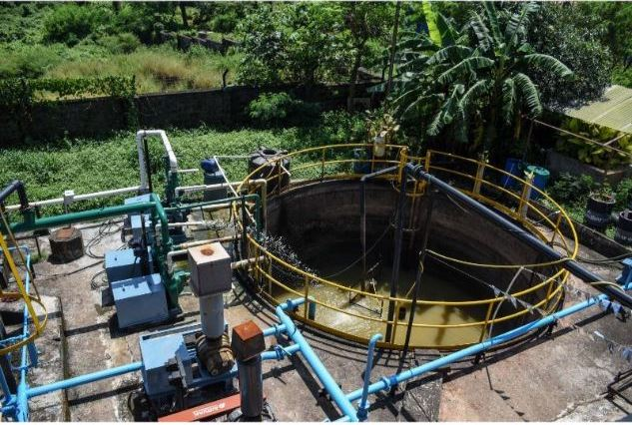

- The Sewage Treatment Plant (STP), with the capacity of 600 cumec is working round the clock to treat sewage generated by residents of the campus.
- In the recently completed hostels and residential quarters, the STP treated water is supplied to flush tanks of EWC through dedicated supply network.
- The treated water is also recycled by using it to maintain lush green garden.
- The sludge generated at STP is transferred to drying bed in the vicinity of STP which is used as manure after drying.
- Domestic waste generated in the campus at residences, hostels, messes, etc. is segregated at source into dry, wet and medical waste.
- Wet waste is treated in a bio-gas plant and composter machine, with the capacity to treat one ton of waste each on daily basis.
- Dry waste is further segregated as per norms and handed over to GSPCB approved vendor for recycling.
- All garden waste is composted and converted into manure which is used to maintain the garden.
Environment Protection and Awareness Club (EPAC) by students: Activities conducted in 2018-19

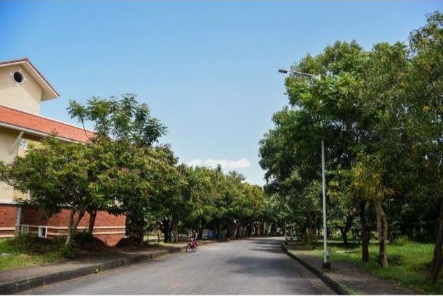

- Beach cleanup drive
- Campus cleanup drive - in association with Nirmaan
- Slithers (annual snake awareness program)
- Paw Pals - visit to animal shelter
- Through Nature's lens, Green Quiz and Best out of Waste held during Quark 2019

