BITS PILANI PILANI CAMPUS

BITS - Zero Discharge Campu:

BITS Pilani is steadily moving towards sustainability in electricity, water & uses of natural resources, taking us closer to our aim of becoming a zero discharge campus. We also aim to reduce dependence on conventional power. In this regard, solar power plants and energy saving fixtures have been introduced and installed in the campus.
Water conservation and systematic distribution of portable water supply is managed and monitored efficiently. Water used by campus residents is treated scientifically and recycled back to use in the campus, whereas the recycled water is being reused in flushing systems & in horticulture work.
Battery operated vehicles are being introduced on campus for transportation. 5000+ students residing in the campus are encouraged to use cycles for their local movement inside the campus & public transportation for outside the campus.
ENERGY CONSERVATION

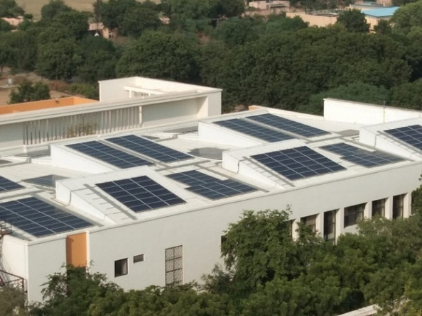
- In campus total 949.12 KWp of on grid rooftop solar power plants installed and commissioned to use renewable energy in the campus & it is planned to commission about 45 KWp rooftop solar power plants by end of December month in this year.
- Total 26 Nos. standalone solar powered street lights are installed in the campus, which is estimated to save around 9, 90 kW of electricity annually.
- Around 80 Nos. of the street lights out of 495 in the campus are connected to off-grid solar power plants of 18.5 kW per day. These street lights work on solar power for about eight to ten hours every night, which is estimated to save around 6,753 kW of electricity annually. After exhausting the solar power, these street lights function on conventional power.
- Since 2014, hostels, residential quarters, academic and administrative blocks constructed as part of the infrastructure expansion by Project Parivartan, replace all CFL, Metal Halide, Fluorescent tube lights with LED fixtures to reduce consumption of energy.
- Similarly existing CFL, tube lights and other electrical fixtures are being replaced with energy saving LED fixtures in a phased manner.
- On campus 28 nos. (Each carries 2 nos. of four wheelers) of car parking stands having standalone solar powered lights, able to park 56 nos. of four wheelers.
- On campus all the newly renovated hostel’s toilet lights & exhaust fans are controlled with motion sensors to save electricity.
- On campus all street lights (Total No.495) fixtures are LED type.
- In campus all street lights (Total 495 Nos.) on/off with LDR, as per sun light intensity availability. No need to change time as seasons change.
WATER CONSERVATION

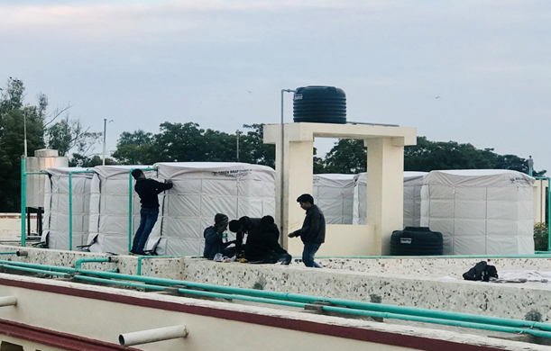
- Six groundwater recharge points are created across the campus. In this, the surface runoff water during monsoon is directed to a designated area which then percolates in the ground resulting in groundwater recharge. Many such recharge points are being planned across the campus in the coming years.
- All overhead tanks and water coolers are fitted with floats, sensors and other mechanisms to shut the water supply and avoid overflow.
- Overhead tanks which are filled with pressurised supply of water through pumps are fitted with actuator valves for avoiding overflow.
- Insulation on water storage tank at Ram & Budh Bhawan to guard against extreme temperature.
- VFD based hydro pneumatic system.
- Pumps & equipment selected on ‘’best ‘energy efficiency point.
- Use of low flow fixtures.
- Use of treated water with BOD less than 10 ppm and COD less than 50 ppm from STP for HVAC cooling tower make up ,flushing and irrigation.

IRRIGATION WATER NETWORK
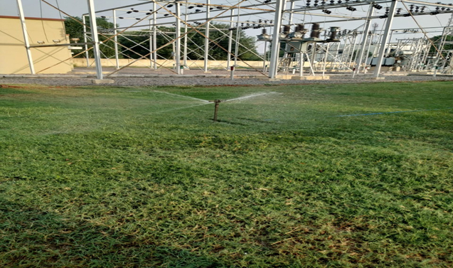
- Irrigation water for landscape use within the campus is a domestic quality and it sourced from in house STP and has acceptable parameters as per governing requirement, using it to maintain lush green gardens.

RECYCLING

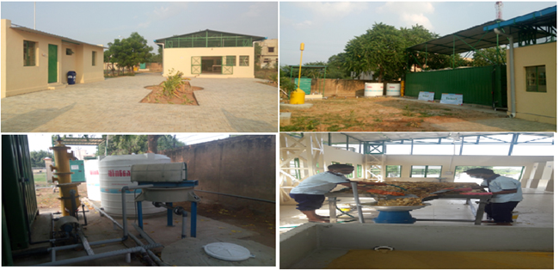
- Domestic waste generated in the campus at residences, hostels, messes, etc. is segregated at source into dry, wet waste.
- To maintain natural balance in the environment and make optimum utilisation of waste available, the biodegradable waste is being processed.
- The Solid waste management Facility is being developed in the campus with a 2 Ton per day capacity organic waste processing plant to treat wet/ organic waste generated by the residents of campus & kitchen facilities.
- The plant produces biogas which store & use to generate electric power using Biogas Generator.
- The by-product of the plant is organic manure that is used as a soil improviser.
- The two Sewage Treatment Plant (STP) with the capacity of 1 MLD & 1.5 MLD each is working round the clock to treat sewage generated by residents of the campus.
- Flushing water sourced from in-house sewage Treatment plant. The Treated Effluent for flushing is obtained after tertiary treatment at STP. Treated effluent is odourless and shall be acceptable chemical /bacteriological parameters as per Rajasthan pollution control boards laws. Recently in some hostels, STP treated water is supplied to flush tanks of EWC through a dedicated supply network.
- The sludge generated at STP is transferred to a drying bed in the vicinity of STP which is used as manure after drying.

