Sustainability

Tree Plantation Drive: Environmental sustainability was encouraged through a Tree Plantation Drive on campus. Students and staff contributed to creating a greener campus and spreading awareness about ecological responsibility.

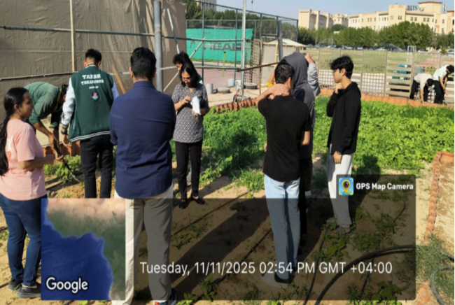

Social Responsibility

Humanitarian Relief Donation: In collaboration with the Emirates Red Crescent, BPDC conducted a relief donation drive to aid families affected by the earthquake in Afghanistan. The campus community collected essential relief materials, reflecting their solidarity and dedication to humanitarian support.

Community Volunteering: Demonstrating a commitment to community service, students actively participated in volunteering activities at the BAPS Mandir in Abu Dhabi, assisting with organizational tasks to support the Mandir's smooth functioning.

Social Awareness & Inclusivity: BPDC organized interactive, pledge-based initiatives like the Gender Awareness Trivia Challenge and the Voices & Vitality Awareness Stall. These events promoted important dialogues on gender equality, men's health, and the elimination of violence against women.

Campus Staff Support: Spoken English classes were organized for facility management (FM) staff members to support their skill development and improve their communication abilities.

Responsible Digital Citizenship: To educate students on online safety, digital responsibility, and the legal implications of cyber offenses, a Cybercrime Awareness Talk was conducted in collaboration with Dubai Police

