**OUTPUT**

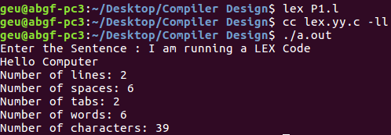

**OUTPUT**

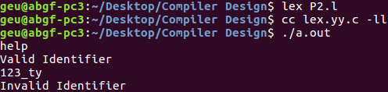

**OUTPUT**

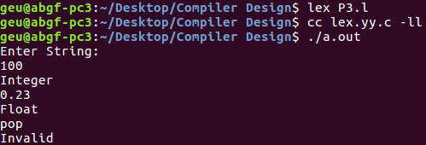

**OUTPUT**

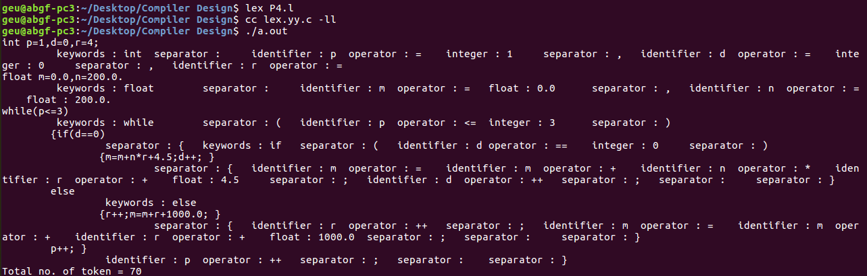

**OUTPUT**

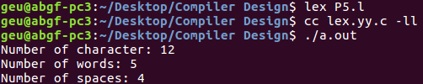

**OUTPUT**

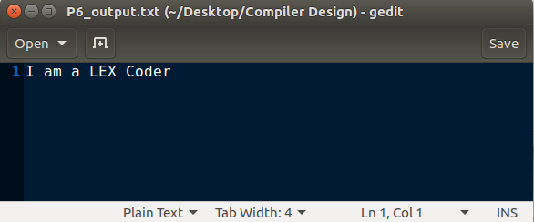

**OUTPUT**

**//out.c**

**OUTPUT**

**//output7.txt**

**OUTPUT**

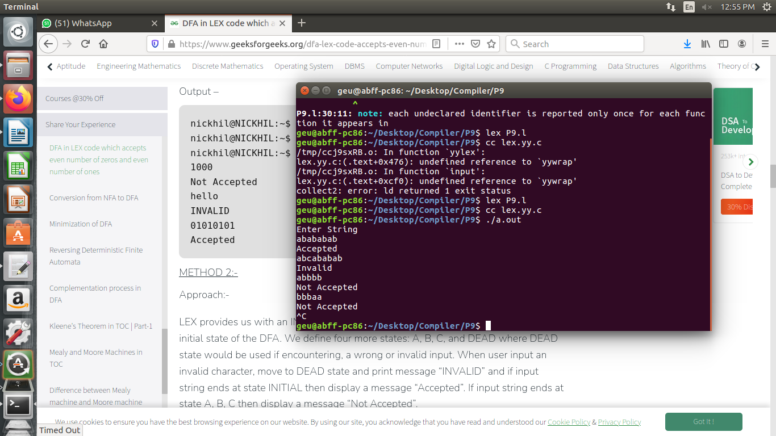

**OUTPUT**

**OUTPUT**

**OUTPUT**

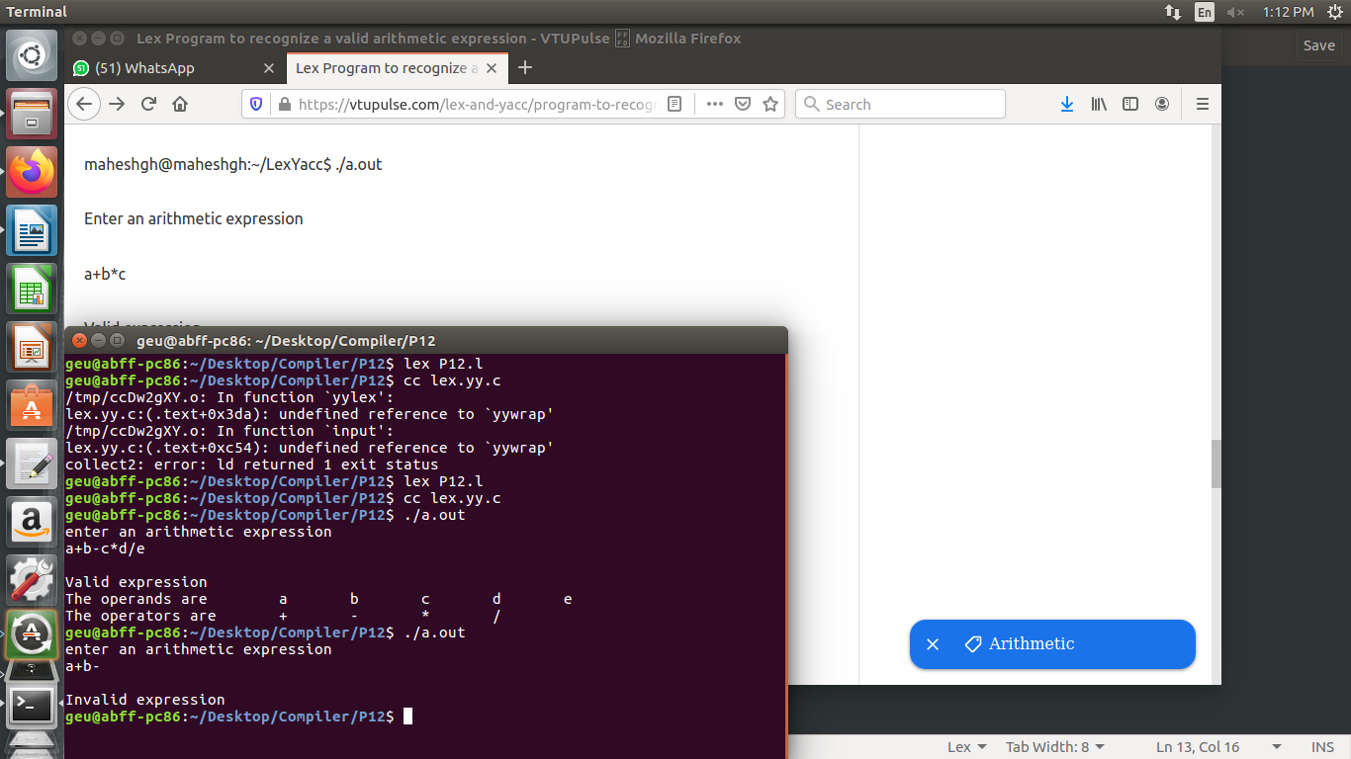

**OUTPUT**

**OUTPUT**

**OUTPUT**

