Gcloud auth login

#private VM has been created using

provider "google" {

  project = "manifest-zephyr-457115-v2"  # Your GCP Project ID

  region  = "us-central1"                # Choose your preferred region

  zone    = "us-central1-a"              # Choose your preferred zone

}

resource "google_deployment_manager_deployment" "vm_deployment" {

  name = "my-vm-deployment12"

  target {

    config {

      content = <<-EOT

        resources:

          - name: my-private-vm

            type: compute.v1.instance

            properties:

              zone: ${var.zone}

              machineType: zones/${var.zone}/machineTypes/${var.machine_type}

              disks:

                - boot: true

                  autoDelete: true

                  initializeParams:

                    sourceImage: "projects/debian-cloud/global/images/family/debian-12"

              networkInterfaces:

                - network: global/networks/default

                  # No external IP (public IP), remove the accessConfigs block

                  accessConfigs: []  # Empty array means no public IP

      EOT

    }

  }

}

output "deployment_name" {

  value = google_deployment_manager_deployment.vm_deployment.name

}

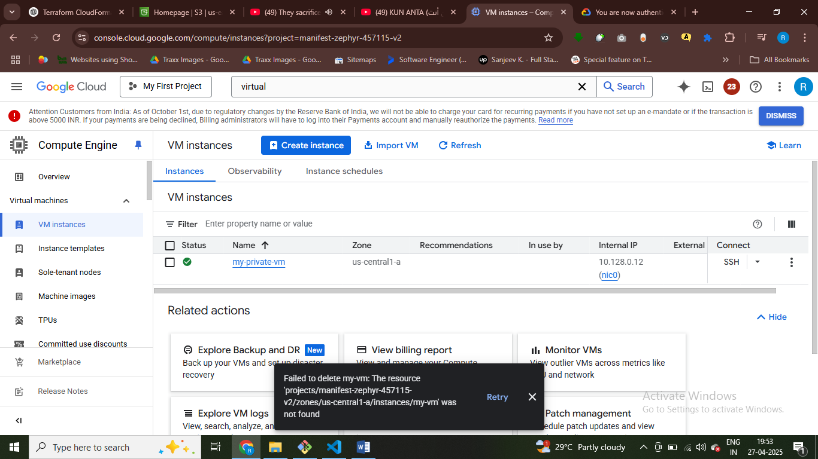

provider "google" {

  project = "manifest-zephyr-457115-v2"  # Your GCP Project ID

  region  = "us-central1"                # Choose your preferred region

  zone    = "us-central1-a"              # Choose your preferred zone

}

resource "google_deployment_manager_deployment" "vm_deployment" {

  name = "my-vm-deployment234"

  target {

    config {

      content = <<-EOT

        resources:

          - name: my-vm

            type: compute.v1.instance

            properties:

              zone: ${var.zone}

              machineType: zones/${var.zone}/machineTypes/${var.machine_type}

              disks:

                - boot: true

                  autoDelete: true

                  initializeParams:

                    sourceImage: "projects/debian-cloud/global/images/family/debian-12"  # Updated to Debian 12

              networkInterfaces:

                - network: global/networks/default

                  accessConfigs:

                    - name: External NAT

                      type: ONE_TO_ONE_NAT  # Public IP

              metadata:

                items:

                  - key: startup-script

                    value: |

                      #! /bin/bash

                      apt-get update

                      apt-get install -y nginx

                      systemctl enable nginx

                      systemctl start nginx

                      echo "Welcome to Nginx on GCP!" > /var/www/html/index.html

                      systemctl restart nginx

      EOT

    }

  }

}

# Allow HTTP traffic on port 80 from the internet

resource "google_compute_firewall" "allow_http" {

  name    = "allow-http"

  network = "default"

  allow {

    protocol = "tcp"

    ports    = ["80"]

  }

  source_ranges = ["0.0.0.0/0"]  # Allow all sources (public access)

}

output "deployment_name" {

  value = google_deployment_manager_deployment.vm_deployment.name

}

Install nginx on public vm and go to vpc and check firewall rules open port 80

provider "google" {

  project = "manifest-zephyr-457115-v2"  # Your GCP Project ID

  region  = "us-central1"                # Choose your preferred region

  zone    = "us-central1-a"              # Choose your preferred zone

}

resource "google_deployment_manager_deployment" "vm_deployment" {

  name = "my-vm-deployment23124"

  target {

    config {

      content = <<-EOT

        resources:

          - name: my-vm

            type: compute.v1.instance

            properties:

              zone: ${var.zone}

              machineType: zones/${var.zone}/machineTypes/${var.machine_type}

              disks:

                - boot: true

                  autoDelete: true

                  initializeParams:

                    sourceImage: "projects/debian-cloud/global/images/family/debian-12"  # Updated to Debian 12

              networkInterfaces:

                - network: global/networks/default

                  accessConfigs:

                    - name: External NAT

                      type: ONE_TO_ONE_NAT  # Public IP

              metadata:

                items:

                  - key: startup-script

                    value: |

                      #! /bin/bash

                      apt-get update

                      apt-get install -y nginx

                      systemctl enable nginx

                      systemctl start nginx

                      echo "Welcome to Nginx on GCP!" > /var/www/html/index.html

                      systemctl restart nginx

      EOT

    }

  }

}

# Allow HTTP traffic on port 80 from the internet

resource "google_compute_firewall" "allow_http" {

  name    = "allow-http"

  network = "default"

  allow {

    protocol = "tcp"

    ports    = ["80"]

  }

  source_ranges = ["0.0.0.0/0"]  # Allow all sources (public access)

}

output "deployment_name" {

  value = google_deployment_manager_deployment.vm_deployment.name

}

Install nginx on VM

Storage Bucket created

provider "google" {

  project = "manifest-zephyr-457115-v2"  # Your GCP Project ID

  region  = "us-central1"                # Your preferred region

  zone    = "us-central1-a"              # Your preferred zone

}

# Create a Cloud Storage bucket

resource "google_storage_bucket" "my_bucket" {

  name          = "my-static-website-bucket56431"  # Replace with your desired bucket name

  location      = "US"

  storage_class = "STANDARD"

  # Enable Uniform bucket-level access (this disables ACL-based permissions)

  uniform_bucket_level_access = true

}

# Upload the HTML file to the bucket using google_storage_bucket_object

resource "google_storage_bucket_object" "html_file" {

  name   = "index.html"

  bucket = google_storage_bucket.my_bucket.name  # Reference the bucket created above

  source = "index.html"  # Path to your local index.html file

  content_type = "text/html"

}

output "bucket_name" {

  value = google_storage_bucket.my_bucket.name

}

output "storage_url" {

  value = "http://storage.googleapis.com/${google_storage_bucket.my_bucket.name}/index.html"

}

