User Guide

Java Visual Debuggers – Jeliot and Online Java-Visualizer

Instructions :

1. User will select the java course on Moodle.

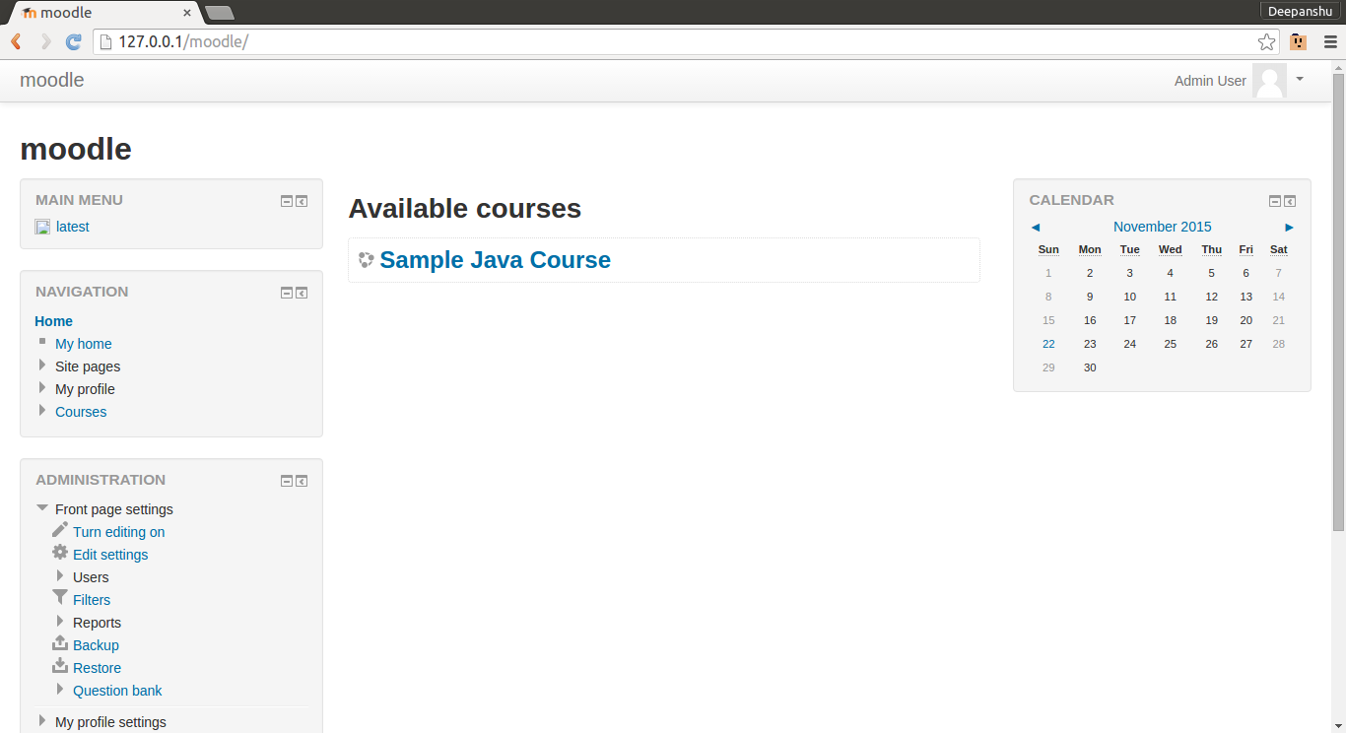

1. Here the user can see all the programs, which are uploaded by the course instructor.

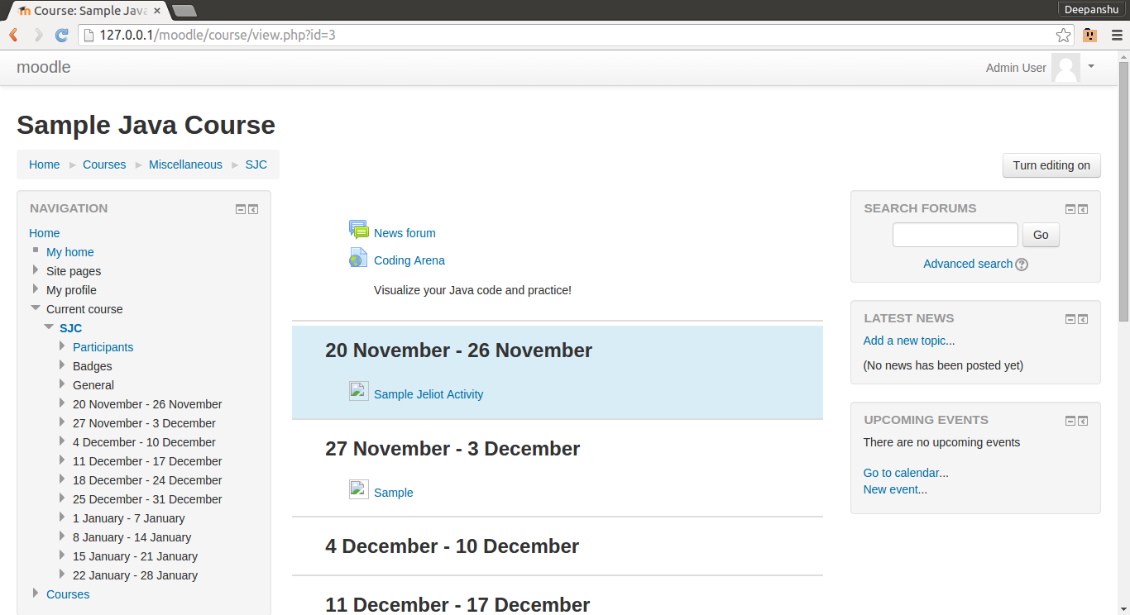

1. To understand and visualize a program, user will click on that program.
2. Here it shows the name of the program and description which user selected and It shows the whole code of the program in a box.

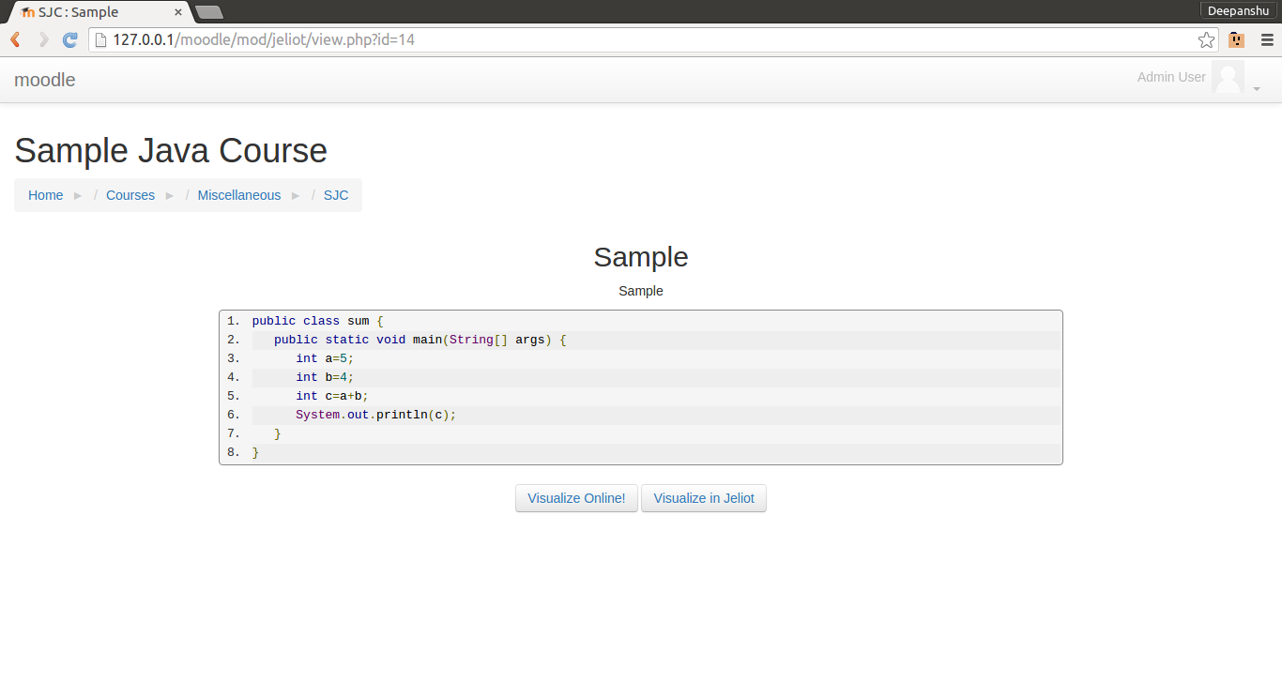

1. Now user has two options for visualizing the program.
2. Visualize Online
3. Visualize in Jeliot

a.) Visualize online : If user has selected this option, then -

1. It redirects user to the Online java visualizer.
2. First it takes user to the Coding Arena and shows a message “Please wait... Processing your code” and then loads the Java Visualizer.

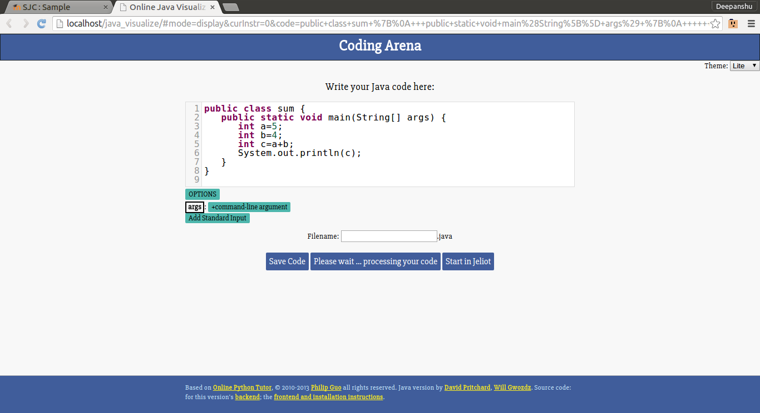

1. Here, to visualize the code, User can click on “forward” and “back”button to go forward and backward in the code. And can use “first“ and “last” button to go at the starting and at the end of the code.

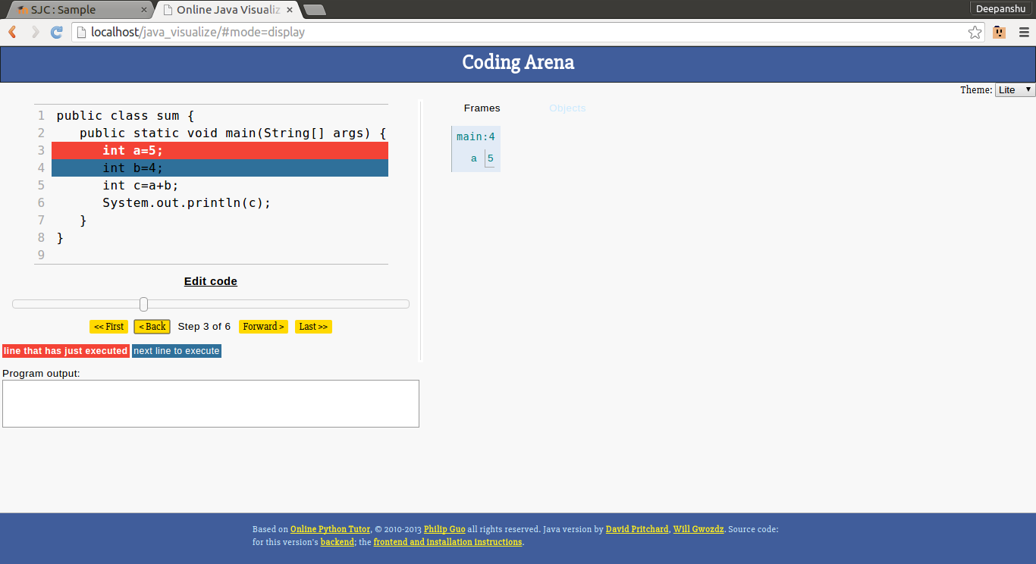

1. User can use the slider to go to a particular line of the code.
2. The line highlighted in blue is the line which will be executed next and the line highlighted in red is the line which is just executed.
3. In the bottom white box, it prints the output of the program.

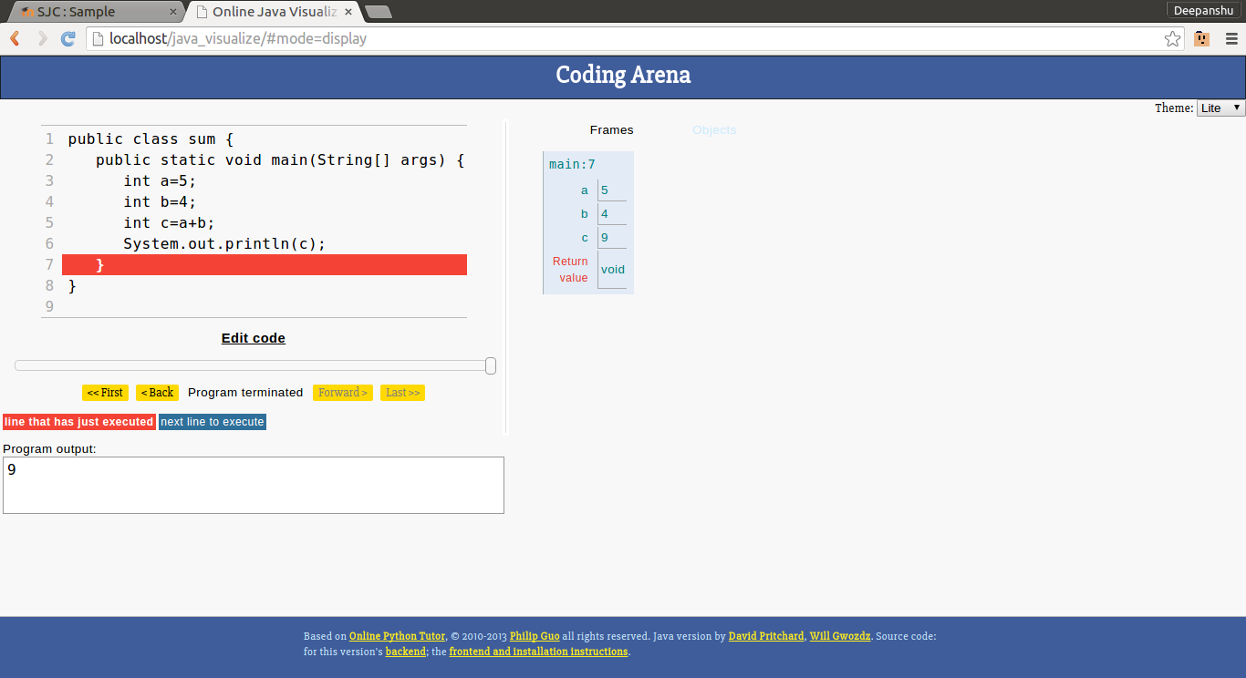

1. If a user wants to edit the code, he/she can click on the “edit code”, it redirects user to the Coding Arena.

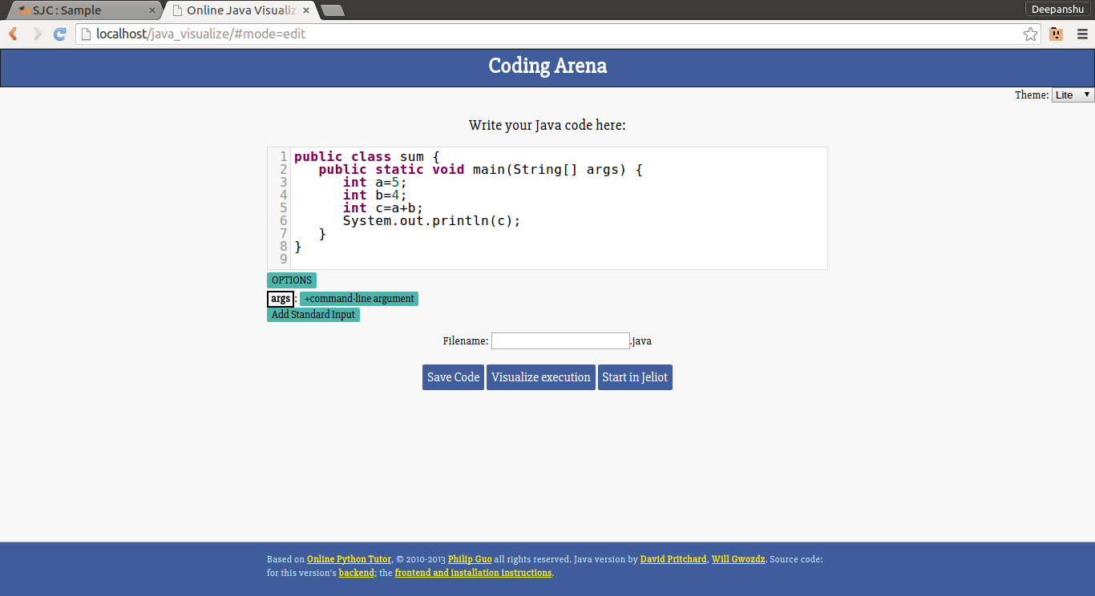

1. Here user can edit the code.
2. User can use the options and can give command line arguments and standard input as well.

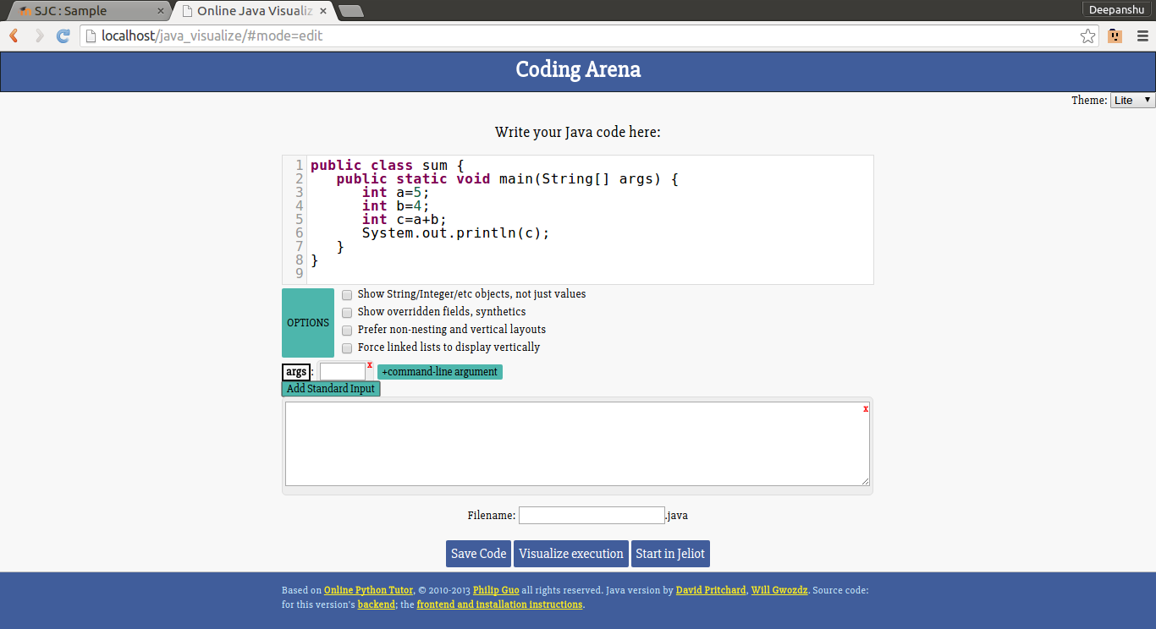

1. Now here again user have choices to visualize the code in Jeliot or Online Java Visualizer. And also If user wants to save the code, user can give some name to file as the input to the ‘Filename’ , then user will click on the “save code” button. It downloads a file with extension .java to the user’s machine with the name given by the user and the code written in the Coding Arena.

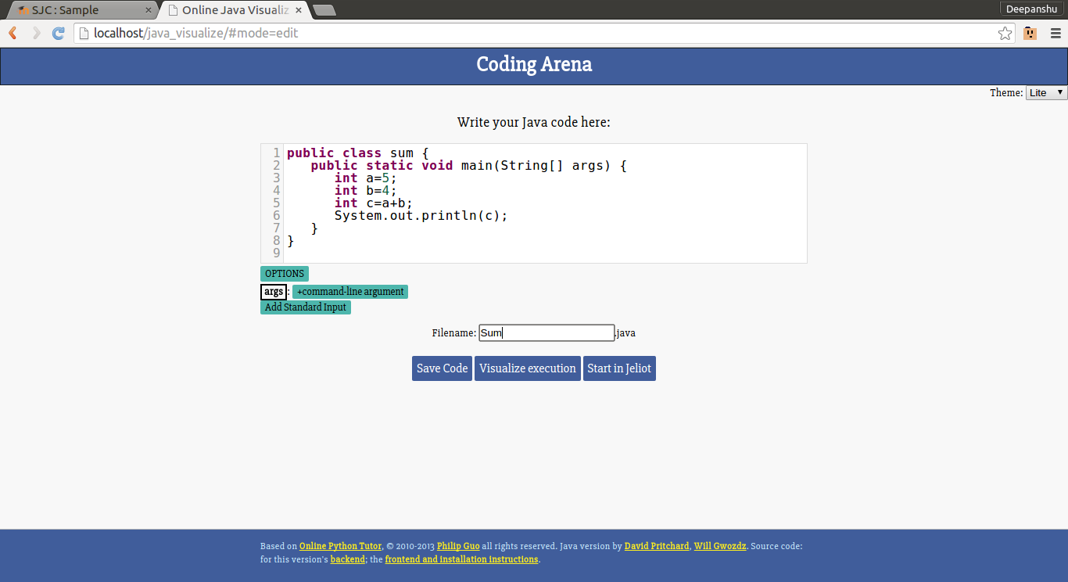

1. If user wants to Visualize in Jeliot, he/she can click on the “Start in jeliot” button.

b.) Visualize in Jeliot :

1. If user selects option “Visualize in Jeliot”, it downloads a JNLP file to the user’s machine. When user clicks on it -

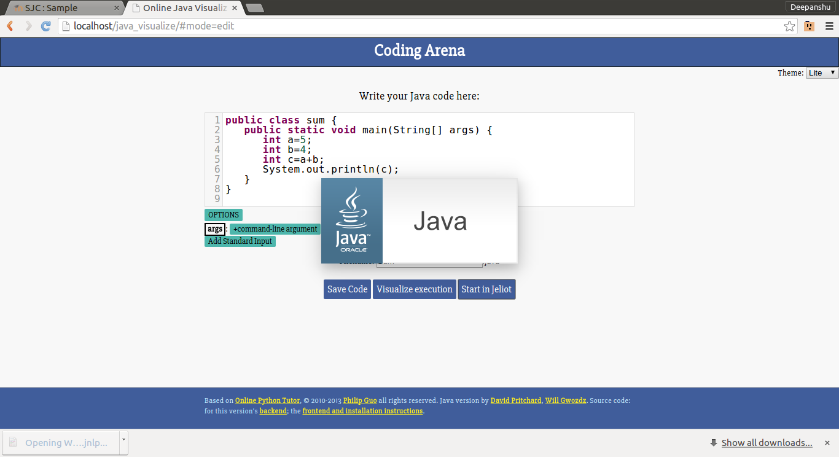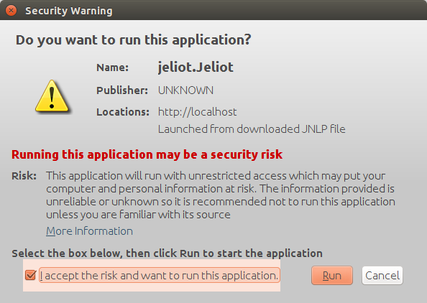

1. It loads the Jeliot Visual debugger with the code written in the Coding Arena.

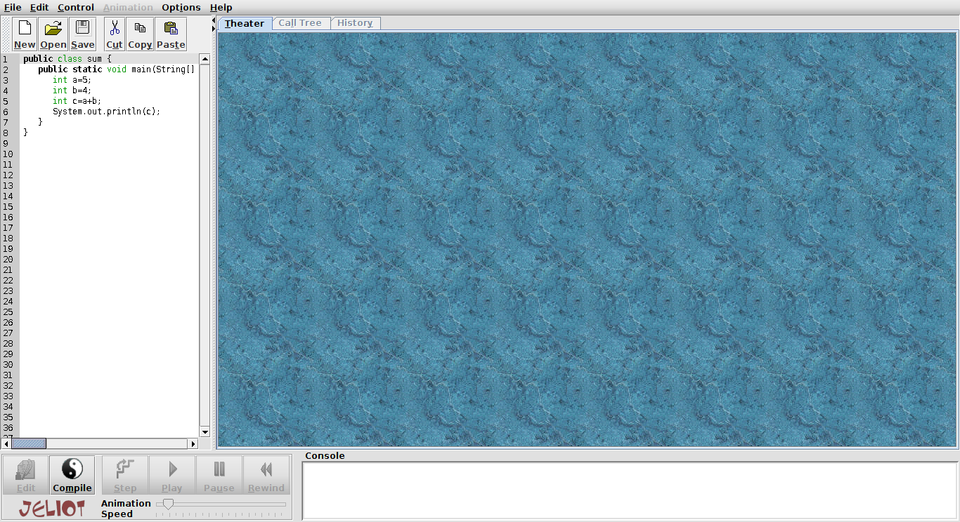

1. Here, in Jeliot user can click on “compile” to compile the program and then click on “play” to visualize the code.

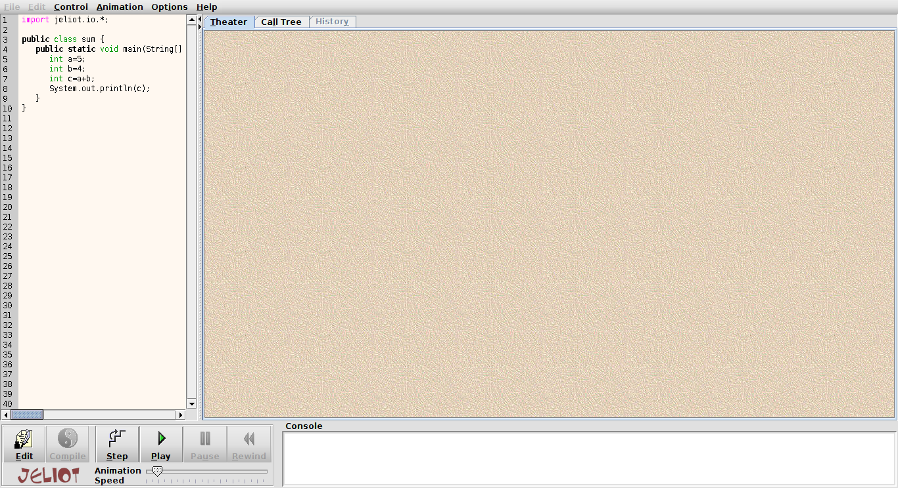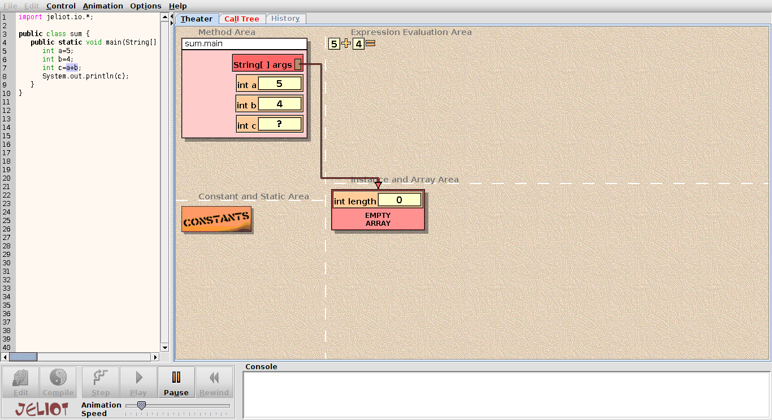

1. At the end of visualization of the program it prints the final output into the console.

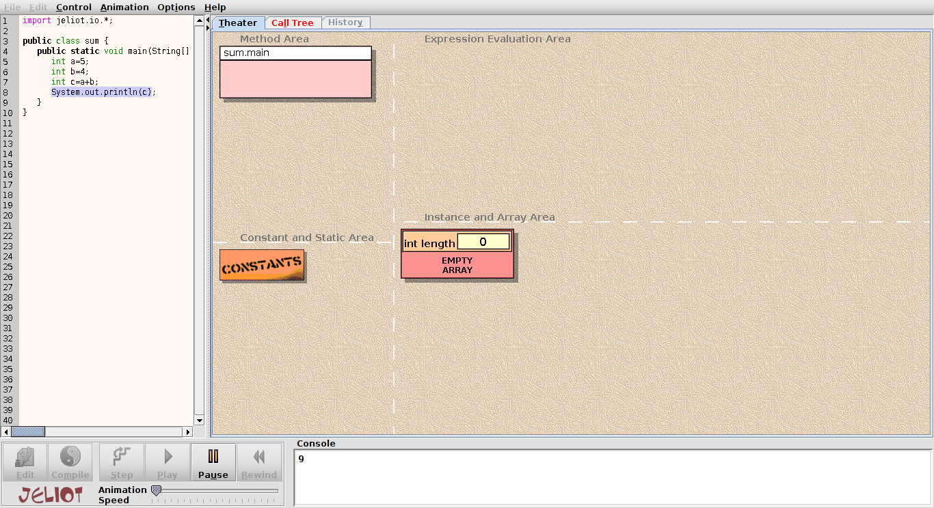

1. Further more user can edit the code in the jeliot itself by clicking on the “edit” button.