Software Requirements Specification (SRS) Document
Integrated Java Visual Debugger
Jeliot Team
Deepanshu Jain, Susobhan Ghosh, Vanjape Rajas Mangesh

Brief problem statement
The main task is to create a Java learning environment for the students taking the introductory Java course on the Moodle platform of EnhanceEdu. To accomplish the task, we have to integrate TWO Java Visual Debuggers – Java Visualizer (https://github.com/daveagp/java_visualize) and Jeliot (http://cs.joensuu.fi/jeliot) – which will help the students to understand Java better by visualizing the Java code, promoting the idea of Learning by Doing.

System requirements
- System requires Moodle platform to work on.
- System requires Jeliot debugger (in .jar format) for the plugin.
- System requires Java Web Start on the client machine for Jeliot (with added exceptions of the website URL to Java settings in Java Control Panel)

Users profile
- Person should be able to sign up on the Moodle Platform.
- Basic Computer Skills:
  - Can manipulate a mouse.
  - Can use a keyboard to type.
  - Can use a web browser.
  - Can make changes to machine’s Java settings by following instructions.
- Student:
  - Should be able to browse courses on Moodle Platform.
  - Should be capable of following step-by-step instructions.
  - Should be capable of trying to write programs in Java.
  - Should know how to upload files on a website.
- Course Instructor:
  - Should be fully proficient with writing programs in Java.
  - Should know how to upload files on Moodle platform using Instructor’s view.
  - Should know how to add an Activity on a course on Moodle platform.
- Admin:
  - Should be able to create courses on Moodle Platform.
  - Should be able to add plugins to Moodle.
  - Should be able to add activity and modules to a course on Moodle.

Feature requirements (described using use cases)

No. | Use Case Name | Description | Release
 | Create Jeliot Activity | Creating a Jeliot Activity in a course to upload Java codes to be visualized via Jeliot Debugger | R1
 | Upload Java file. | Uploading Java file to Moodle for a Java visualization based activity and add appropriate records to Moodle database | R1
 | Open Coding Arena | Link to open a Java Visualizing Arena where user can type code in code editor and visualize according to suitable tool | R2
 | Submit Java code | Submit code in the Visualizing Arena to visualize code, and add appropriate entry in Moodle database | R2
 | Opening Jeliot with Java code via JNLP | User should open the downloaded JNLP file via Java Web Start to load Jeliot along with the uploaded code | R1
 | Move visualization forward | Move forward the java code visualization on the online Java-Visualizer | R2
 | Move visualization backward | Move backward the java code visualization on the online Java-Visualizer | R2
 | Browse Jeliot Activities | User will browse through all the Jeliot Activities created by Instructor / Admin | R1
 | Check Login | Checks if the user is logged in to view the visualization activity for the course. | R1
 | Redirect to login/signup | Redirects the non-logged in user to the login/signup if he/she tries to access the visualization activity. | R1
 | Check Course | Check what kind of access the user is having in a particular course. | R1
 | Start Execution of Jeliot Activity | Shows the download button to download Jeliot Web Start JNLP file to the client machine | R1
 | Visualize Execution of Online Java-Visualizer | Opens the Online Java-Visualizer with the uploaded code created via activity or submit code in Visualizing Arena | R2
 | Save Code | Downloads a file with the code written in the Coding Arena | R2

Use case diagram :

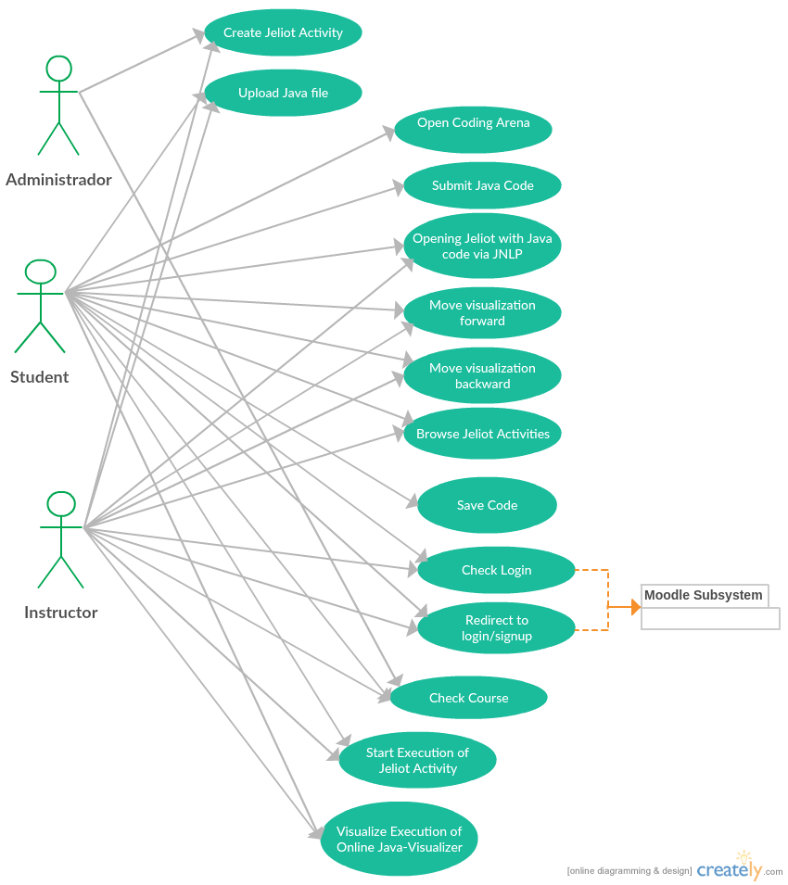

Use case description :

Use Case Number: | UC-01
Use Case Name: | Create Jeliot Activity
Overview: | Creating a Jeliot Activity in a course to upload Java codes to be visualized via Jeliot Debugger
Actors: | Instructor, Admin
Pre-condition: | Execution of “Check Course” results in Instructor or Admin to have an option of creating a Jeliot Activity.
Flow: | - System checks that the user is logged in by “Check Login”  - System checks that the user is browsing a course by “Check Course” he/she has access to edit.  - User clicks on “Turn Editing On” on Moodle  - User selects an appropriate week and selects Add an Activity or Resource  - Select Jeliot Activity and click Add  - Fill Name and Description and select Java file to upload  - User selects save and display  - System initiates “Upload Java file”  - System creates a Jeliot Activity associated with the course and updates the Database
Alternate Flows:
Alt 1:
  - User is not logged in. System initiates “Redirect to Login/Signup”
Post Condition: User has to login or sign up to get access to proceed with creation of Jeliot Activity
Alt 2:
- System checks that the user is browsing a course he/she has access to using “Check Course”. User is found not to have access
Post condition: Moodle system doesn’t show Turn editing on option. User cannot edit and add jeliot activity to the course until she/he gets edit access.
Alt 3:
7.1 User clicks save and close.
8. System initiates “Upload Java file”
9. System creates a Jeliot Activity associated with the course and updates the Database.
Post Condition: System redirects to the course contents page.
Post Condition: | System redirects to Show Jeliot Activity page and initiates “Start Execution of Jeliot Activity”

Use Case Number: | UC-02
Use Case Name: | Upload a Java File
Overview: | Uploading Java file to Moodle for a Java visualization based activity and add appropriate records to Moodle database
Actors: | Instructor, Student
Pre-condition: | Any actor can write a Java code in the Visualizing Arena and click on Run. Or Instructor / Admin is creating a Jeliot / Java-Visualizer Activity and clicks on “Save and Display” or “Save and Return”
Flow: | - User opens Online Visualizing Arena.  - User writes a Java-code in the online editor.  - User clicks on Run/Compile.  - System saves the file and adds record to Database if error free.  - System initiates download of JNLP file to launch Jeliot on the client machine.
Alternate Flows:
Alt 1:
- Instructor / Admin has created or edited a Jeliot or Java-Visualizer Activity and selected a file to upload.
- User selects “Save and Return”
Post Condition: System uploads the Java file and redirects user to course contents page with a new Jeliot or Java-Visualizer Activity added.
Alt 2:
- Instructor / Admin has created or edited a Jeliot or Java-Visualizer Activity and selected a file to upload.
- User selects “Save and Display”
Post Condition: System uploads the Java file and redirects user to the Visualizing page of the appropriate activity where the file has been uploaded.
Post Condition: | User opens the downloaded JNLP file and initiates “Opening Jeliot via JNLP file”

Use Case Number: | UC-03
Use Case Name: | Open Coding Arena
Overview: | Link to open a Java Visualizing Arena where user can type code in code editor and visualize according to suitable tool.
Actors: | Student
Pre-condition: | The user is logged in and browsing the Java course and wishes to write programs in Java.
Flow: | - User browses a Java course.  - System checks if user is registered using “Check Course”.  - User clicks on a link to Visualizing Arena.  - System loads a Visualzing Arena.
Alternate Flows:
Alt 1:
2.1 User is not registered for the course. System displays Unauthorized access.
Post Condition: System will redirect to course listing after displaying error message.
Post Condition: | User can type and edit code in the web-based editor and visualize their Java codes according to the appropriate Debuggers.

Use Case Number: | UC-04
Use Case Name: | Submit Java code
Overview: | Submit code in the Visualizing Arena to visualize code, and add appropriate entry in Moodle database.
Actors: | Student
Pre-condition: | The user is in the visualizing arena.
Flow: | - User is in visualizing arena.  - User edits his Java code.  - User hits submit.  - System adds entry to database for the edited code after analyzing it using appropriate debugger.
Alternate Flows:
Alt 1:
  - The Java code is incorrect in syntax.
  - System doesn’t add entry to the database until the user edits the code to be syntactically correct and hits submit. Then move to step 5 of main flow.

Post Condition: | System redirects user to appropriate debugger and starts visualizing the user’s code.

Use Case Number: | UC-05
Use Case Name: | Opening Jeliot with Java code via JNLP
Overview: | User will open the downloaded JNLP file via Java Web Start to load Jeliot along with the uploaded code
Actors: | Student, Instructor
Pre-condition: | Student submits Java code on Visualizing arena and downloads JNLP file for Jeliot.
Flow: | Main (success) Flow:  - Student edits code online on Visualizing arena and submits.  - Student downloads JNLP file to his/her machine.  - User runs the JNLP file using Java WebStart.  - System sends Jeliot Debugger to the client machine and his/her code.
Alternate Flows:
Alt 1:
- Instructor uploads Java code while creating or editing Java-Visualizer or Jeliot Activity.
- Instructor clicks on Save and Display, and Start Jeliot to download JNLP file
Continues with Step 3 of Main Flow
Alt 2:
3.1 User’s Machine is not connected to the Internet
3.2 System throws error saying no internet connectivity. Goes to Step 4 of Main Flow only when relaunched with Internet access.
Post Condition: | Jeliot Debugger loads along with user inputted code on the website. User can visualize his/her code in the Jeliot Debugger on his machine instead of visualizing on the webpage.

Use Case Number: | UC-06
Use Case Name: | Move Visualization Forward
Overview: | Move forward the java code visualization on the online Java-Visualizer
Actors: | Student, Instructor
Pre-condition: | User has uploaded a syntactically correct Java code via Visualizer Arena (for Student) or adding/editing Java-Visualizer Activity (for Instructor)
Flow: | Main (success) Flow:  - User edits code online on Visualizing arena and submits.  - System redirects and initiates “Visualize execution of Online Java-Visualizer”  - User can click on forward button. System moves the visualization in the forward direction (i.e. towards the end)
Alternate Flows:
Alt 1:
3.1 User clicks the forward button. System cannot go any forward with the execution as it has finished. System grays out forward button and doesn’t go forward any further.
Post Condition: | User visualizes the next step in the execution of the submitted code.

Use Case Number: | UC-07
Use Case Name: | Move Visualization Backward
Overview: | Move backward the java code visualization on the online Java-Visualizer
Actors: | Student, Instructor
Pre-condition: | User has uploaded a syntactically correct Java code via Visualizer Arena (for Student) or adding/editing Java-Visualizer Activity (for Instructor) and has moved forward the visualization of execution of Java code.
Flow: | Main (success) Flow:  - User edits code online on Visualizing arena and submits.  - System redirects and initiates “Visualize execution of Online Java-Visualizer”  - User has already clicked on forward button and moved execution forward.  - User clicks on Back button to go back one step of execution.
Alternate Flows:
Alt 1:
3.1 User clicks the back button. System cannot go any backward with the execution as it has not yet begun. System grays out back button and doesn’t go backward any further.
Post Condition: | User visualizes the previous step in the execution of the submitted code.

Use Case Number: | UC-08
Use Case Name: | Browse Jeliot Activities
Overview: | User will browse through all the Jeliot Activities created by Instructor / Admin.
Actors: | Instructor, Student
Pre-condition: | User should be logged in. User should have access to browse the course contents.
Flow: | - System lists all the Jeliot activities created by the Instructor / Admin  - User browses an activity from all the listed Jeliot Activities created by Instructor / Admin.  - System initiates “Start Execution of Jeliot Activity”
Alternate Flows:
Alt 1.
If there does not exist any Jeliot activity, main flow will not be executed unless Instructor or Admin adds a new Jeliot Activity
Post Condition: | The selected activity launches Jeliot Activity Execution which will show Start Jeliot option to download JNLP file into the Client Machine.

Use Case Number: | UC-09
Use Case Name: | Check login
Overview: | Checks if the user is logged in to view the visualization activity for the course.
Actors: | Instructor, Student
Pre-condition: | User is on the site and tries to access the visualization activity.
Flow: | - User tries to access the Java Visualizer Activity directly using URL.  - System determines if the user is logged in or not and returns the result.
Alternate Flow:
Alt 1:
- User tries to access the course contents.
Merges with Step 2 of Main flow.
Post Condition: | 1. If the user is not logged in, System initiates “Redirect to Login / Sign up”  2. If the user is logged in, System proceeds as it is.

Use Case Number: | UC-10
Use Case Name: | Redirect to login / Sign up
Overview: | Redirects the non-logged in user to the login/signup if he/she tries to access forbidden content.
Actors: | Instructor, Student
Pre-condition: | User clicks on a Visualization activity or login / Sign up option.
Flow: | - User clicks on visualization activity.  - System initiates Check Login and gets negative result.  - It redirects user to the login / Sign up page.
Alternate Flows:
Alt 1.
  - If result is positive, it redirects him/her to the asked for content.
Post Condition: System proceeds as normal without redirection.
Alt 2.
- User clicks on Login / Sign up from any page on the website.
Merges with Step 3 on main flow.
Post Condition: | The user is redirected to login / Sign up page if he/she is not logged in and asks for input to login / sign up.

Use Case Number: | UC-11
Use Case Name: | Check Course
Overview: | Checks if the user is logged in to view the visualization activity for the course.
Actors: | Instructor, Student, Admin
Pre-condition: | User is logged in and clicks on a course to browse course contents.
Flow: | - User clicks on a course to see course contents.  - System validates user from database entry if the user has registered for the course or not, and if the user has rights to edit course or not.  - System returns validation result and gives browsing access to the user
Alternate Flows:
Alt 1:
  - System gives editing access to Instructor and Admin as well as browsing access.
Alt 2:
3. System throws Unauthorized access if user is not registered for the course and has no other usage access.
Post Condition: User is redirected to the course listings page with the appropriate error message of unauthorized access and asking the user to register for the course when it is available.
Post Condition: | Appropriate access to the course contents are given to the user.

Use Case Number: | UC-12
Use Case Name: | Start Execution of Jeliot Activity
Overview: | On execution of Jeliot Activity it shows the download button to download Jeliot Web Start JNLP file to the client machine
Actors: | Instructor, Student
Pre-condition: | Instructor should have uploaded a java code. Or Student browses Jeliot Activities of the course.
Flow: | - The Instructor has clicked on “Save and Display” button.  - System updates the database and uploads the Java code and loads the plugin to generate JNLP file.  - Instructor clicks on JNLP file and it gets downloaded to client machine.
Alternate Flows:
Alt 1:
- Student while browsing Jeliot Activities for a course selects an activity.
- System loads the JNLP for download into the client machine and sets up Start Jeliot option on the webpage.
- Student clicks on start Jeliot to download the generated JNLP file.
Post Condition: Same as Main Flow
Post Condition: | User can open the downloaded JNLP file using Java WebStart which starts “Opening Jeliot with Java code via JNLP”

Use Case Number: | UC-13
Use Case Name: | Visualize Execution of Online Java Visualizer
Overview: | Online Web based Java Visualizer will work on the webpage of course itself.
Actors: | Instructor, Student
Pre-condition: | Student has successfully submitted Java code in Visualizing Arena without errors. Or Instructor has uploaded a Java file via a Java-Visualizer Activity.
Flow: | 1. Student submits his/her java code on the Visualizing Arena.  2. System initiates “Upload Java File”.  3. The Online Java Visualizer starts running on the webpage using the user's submitted java code.
Alternate Flows:
Alt 1.
1.1 If the submitted code has error (Syntax Error etc.) it throws an Error box describing there is an error and highlights the line in yellow which is causing the error.
1.2 Student has to correct the code and submit again until it is compiled successfully. Once done, step 3 of main flow gets executed.
Alt 2.
2.1 After uploading the java code, if Instructor clicks on “Save and Display Button” it takes him/her to the Java Visualizer.
Alt 3
1. If student clicks on a Java Visualizer Activity, the Online Java Visualizer starts running on the webpage using the java code which the Activity has.
Post Condition: | The Java-Visualizer Debugger starts visualizing the uploaded code on the website and user can either Move forward the execution or move back the execution which the system executes by “Move visualization forward” or “Move visualization backward”

Use Case Number: | UC-14
Use Case Name: | Save Code
Overview: | Downloads a file named by the user with the code written in the Coding Arena
Actors: | Student
Pre-condition: | User should have internet connection
Flow: | - Use clicks on the save code button.  - It downloads a java file with name given by the user.
Alternate Flow:
Alt 1:
If user did not give name, then it will have default file name ‘code’. (code.java)
Post Condition: | 1. It downloads a file with extension .java with the code written in the Coding Arena.

