Product Design
Team | 46  Susobhan Ghosh  Deepanshu Jain  Vanjape Rajas Mangesh

Design Model

Home | Class state  - logged into moodle as instructor  Class behavior(method)  - create_activity()  - coding_arena()
Activity | Class state  - Enter Name : string  - Enter Description : string  - Upload java code : string  Class behavior(method)  - show_code()  - home()
Jeliot Activity | Class state  - Show entered code  Class behavior(method)  - visualize_in_jeliot()  - java_visualize()
Java Visualizer | Class state  - Showing visualization of entered code  Class behavior(method)  - forward()  - backward()
Coding Arena | Class state  - Area to enter code  Class behavior(method)  - save_code  - visualize_in_jeliot()  - java_visualize()
Jeliot | Class state  - Showing entered code  Class behavior(method)  - download_jnlp()
.

Class and Sequence Diagram

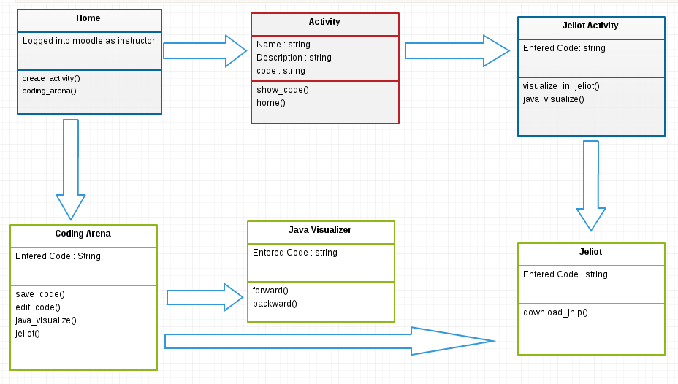

Design Rationale

The plugin is needed to view java code animations in two different visualizations and a coding arena to edit the code. Hence, different classes has been made for each visualizer and a different class for coding arena.

