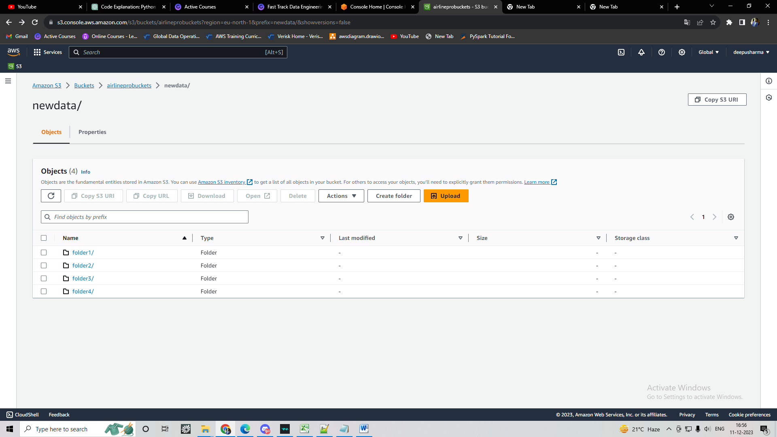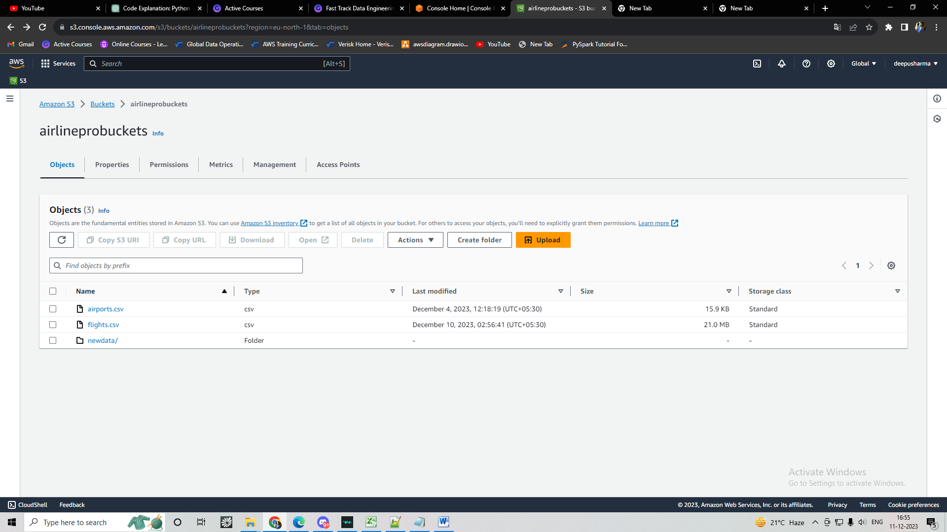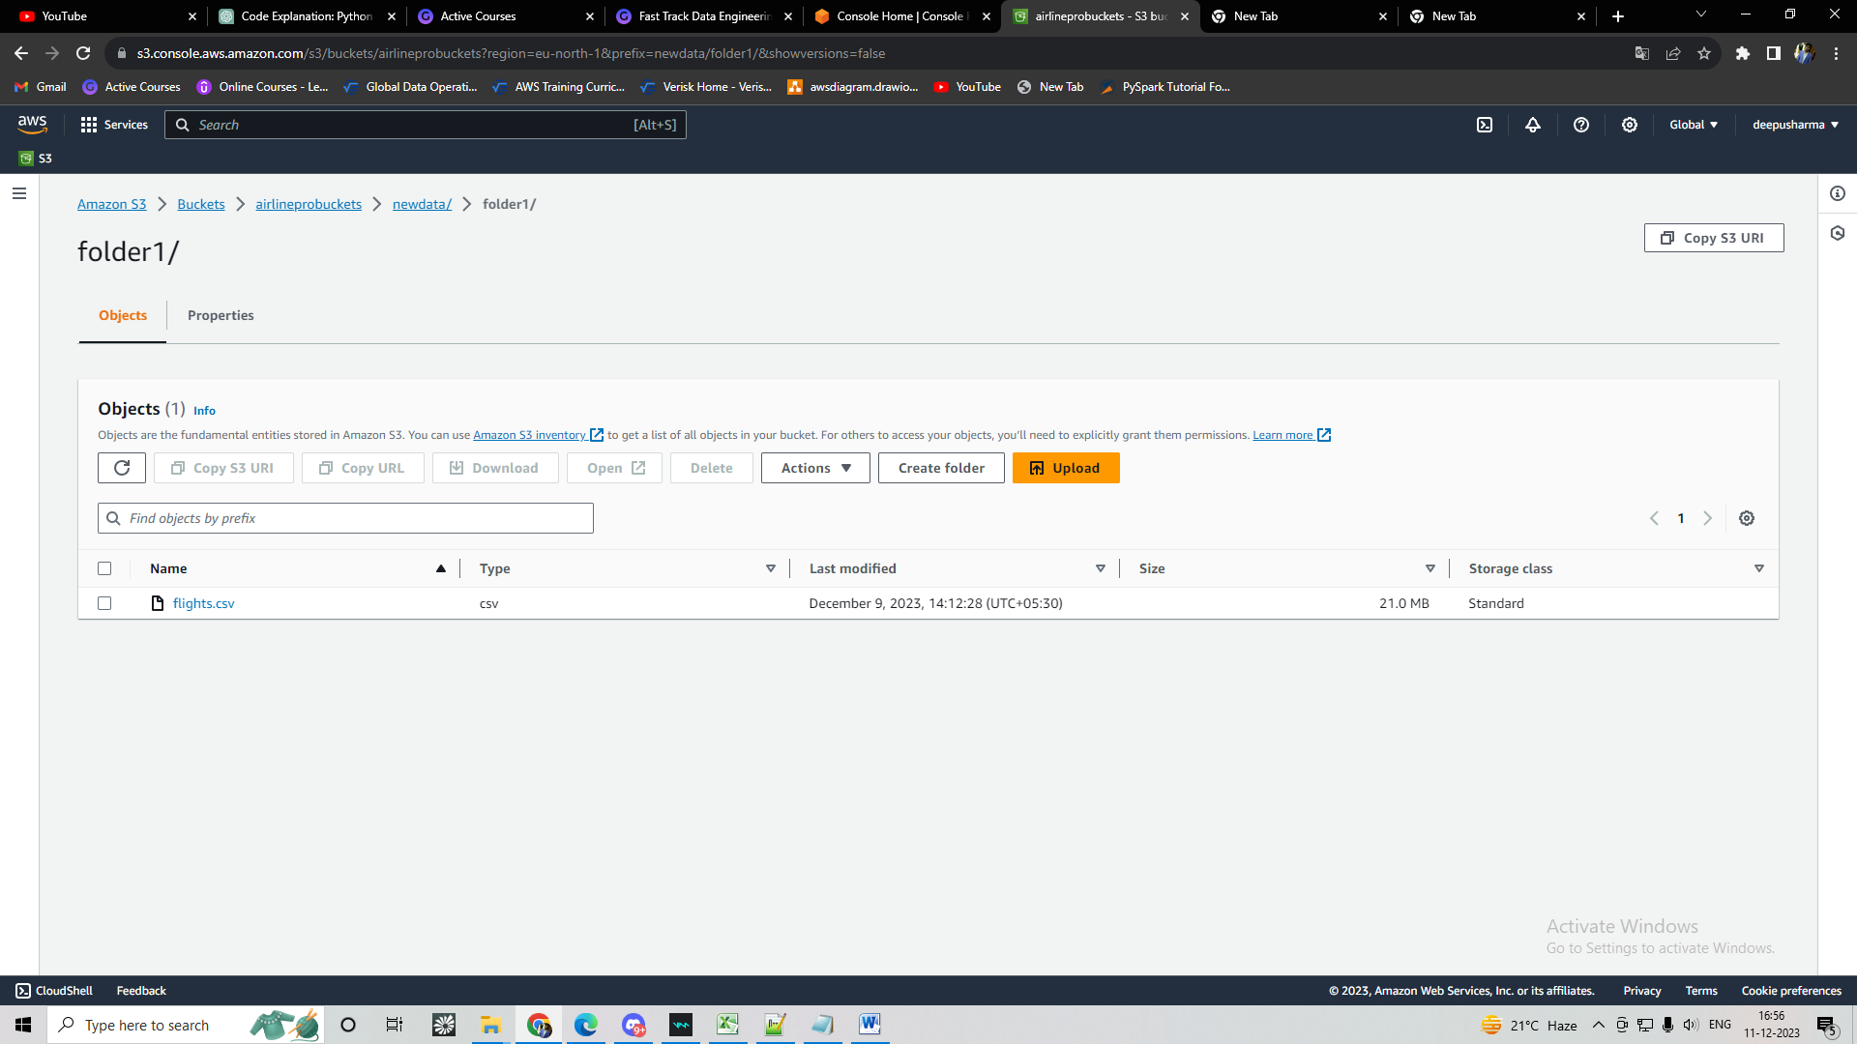

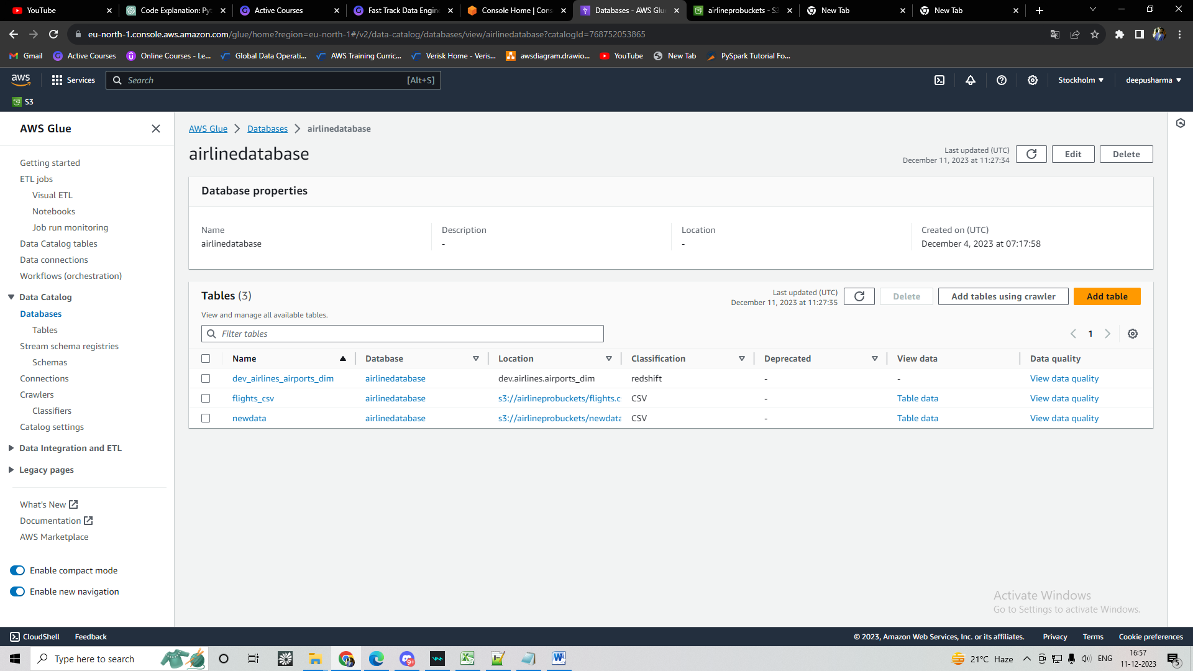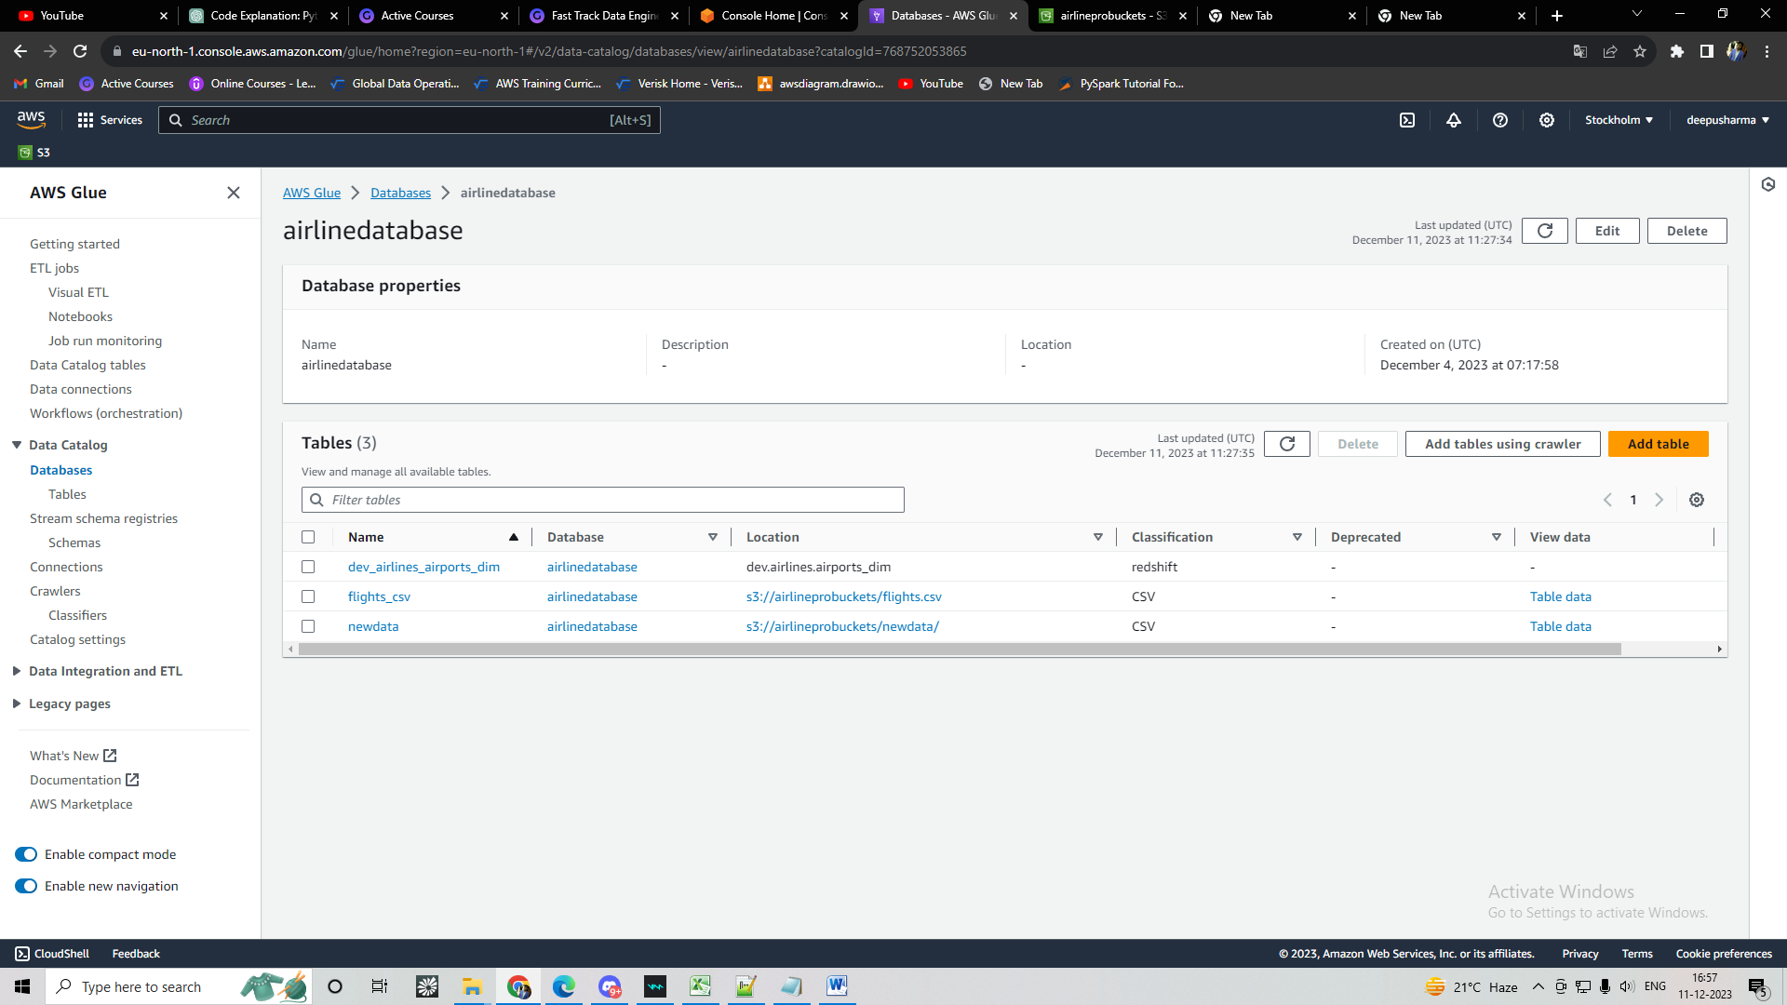

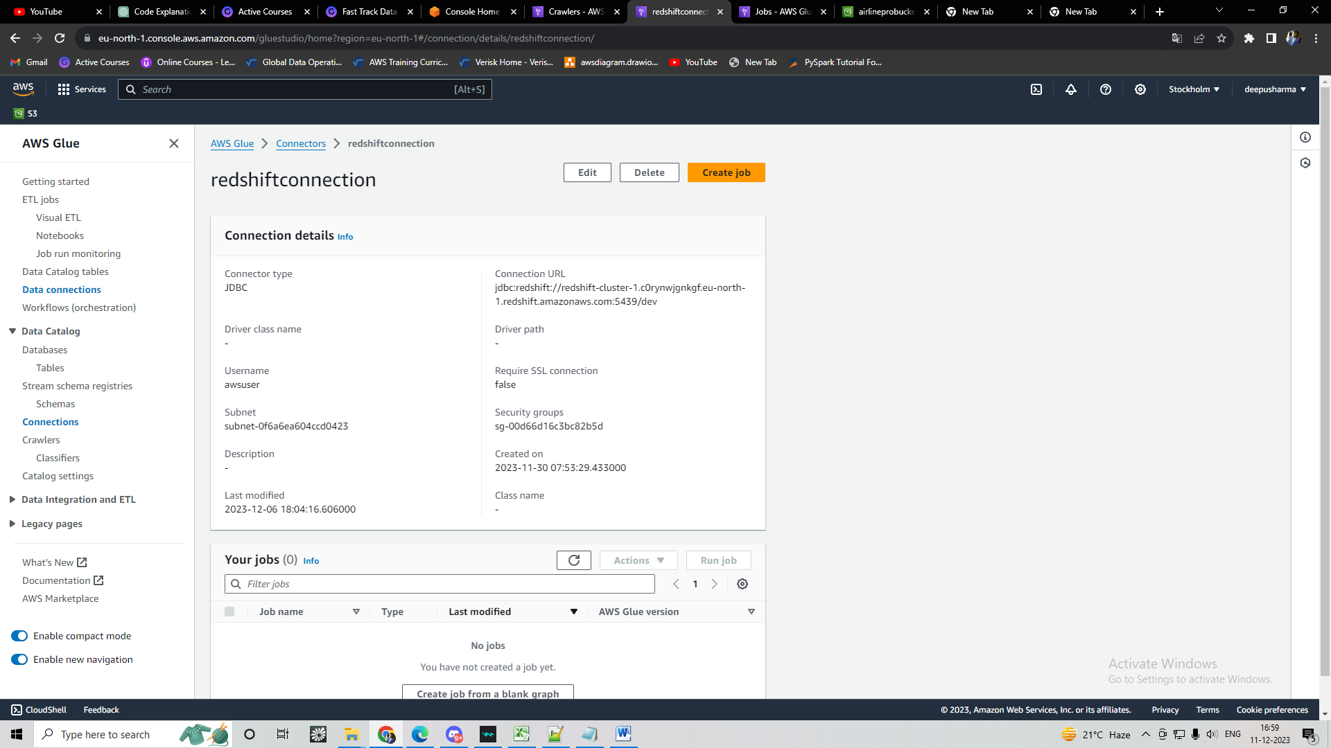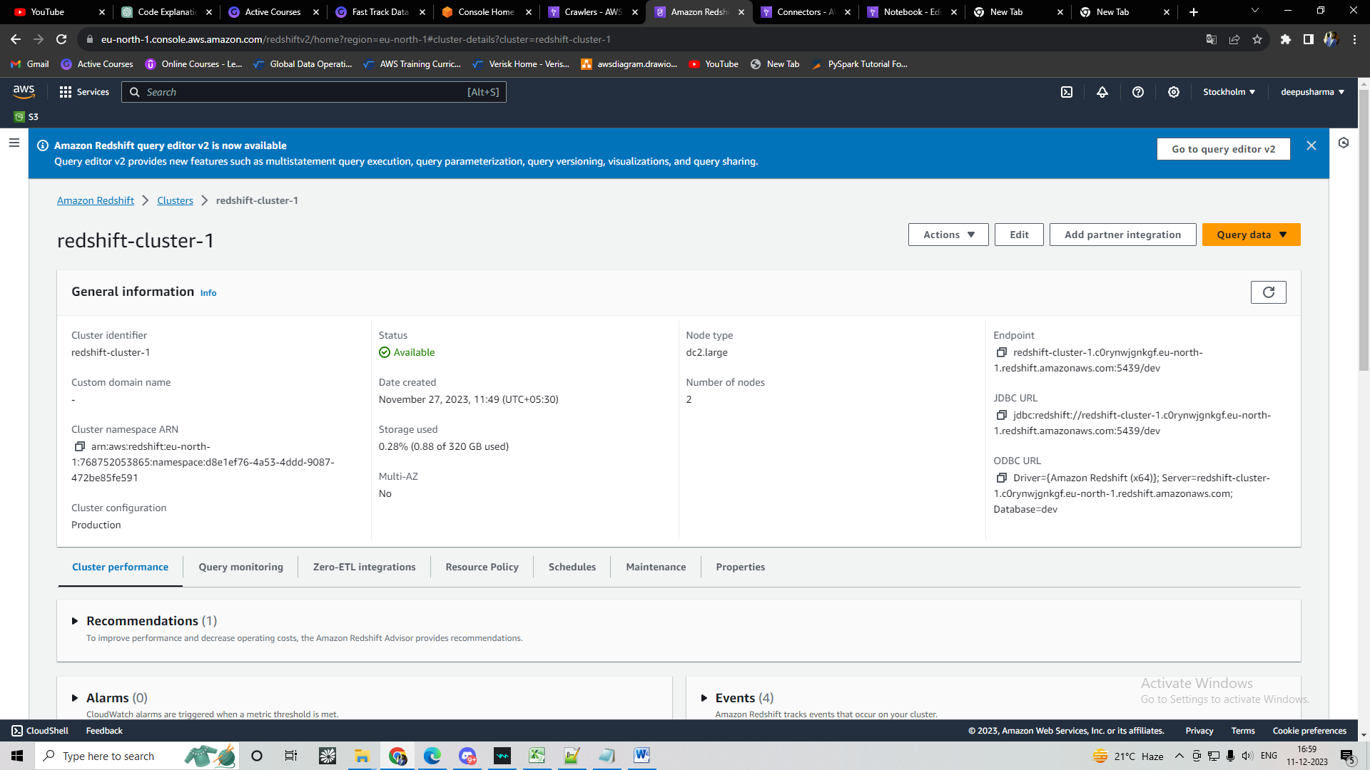

-- create schema airlines;

-- CREATE TABLE airlines.airports_dim (

--     airport_id BIGINT,

--     city VARCHAR(100),

--     state VARCHAR(100),

--     name VARCHAR(200)

-- );

-- COPY airlines.airports_dim

-- FROM 's3://airlineprobuckets/airports.csv'

-- IAM_ROLE 'arn:aws:iam::768752053865:role/redshiftaccessrole'

-- DELIMITER ','

-- IGNOREHEADER 1

-- REGION 'eu-north-1';

-- --------------

-- drop table airlines.finaltable;

-- CREATE TABLE airlines.finaltable(

--     carrier VARCHAR(10),

--     dep_airport_name VARCHAR(200),

--     arr_airport_name VARCHAR(200),

--     dep_city VARCHAR(100),

--     arr_city VARCHAR(100),

--     dep_state VARCHAR(100),

--     arr_state VARCHAR(100),

--     depdelay BIGINT,

--     arrdelay BIGINT

-- );

-- delete from airlines.finaltable;

select count(*) from  airlines.finaltable;

