**GIT**

**Create new GIT local repository and initializing it**

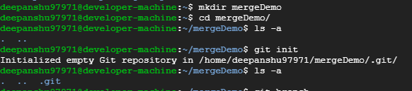

**Creating a new file and committing it**

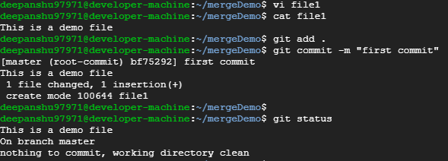

**Creating two branches “branch1” and “branch2”**

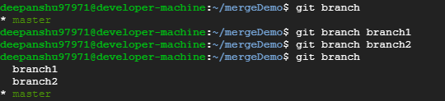

**Switching to feature2 branch and updated the file**

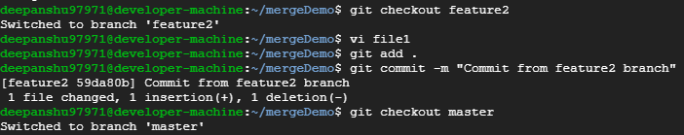

**Merging feature2 branch with master node**

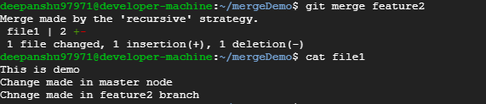

**Switching to feature1 branch and updated the file**

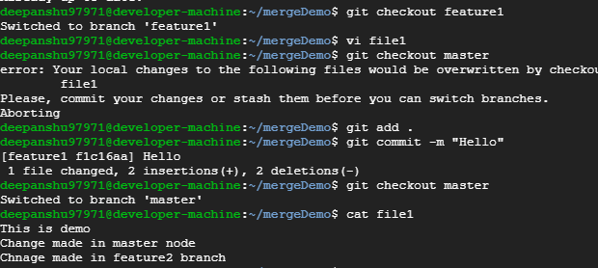

**Merging feature1 branch to master but getting merge conflict**

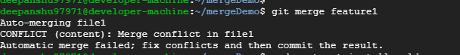

**File after merge conflict**

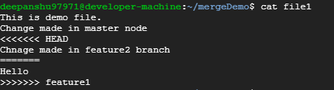

**File after fixing merge conflict**

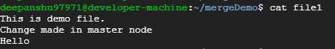

**Committing the file**

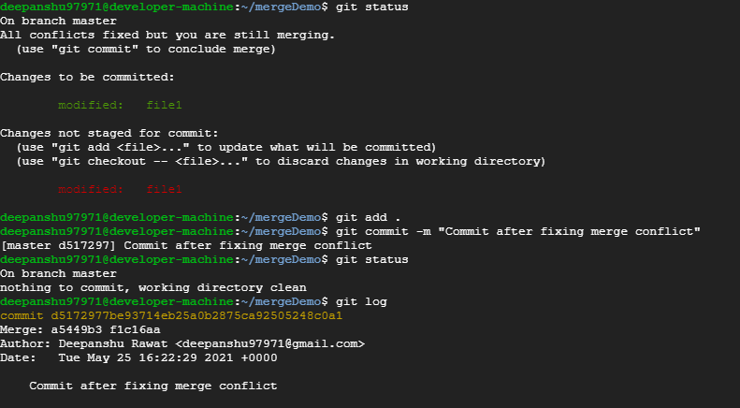

**JENKINS**

**Created configure code/checkout project**

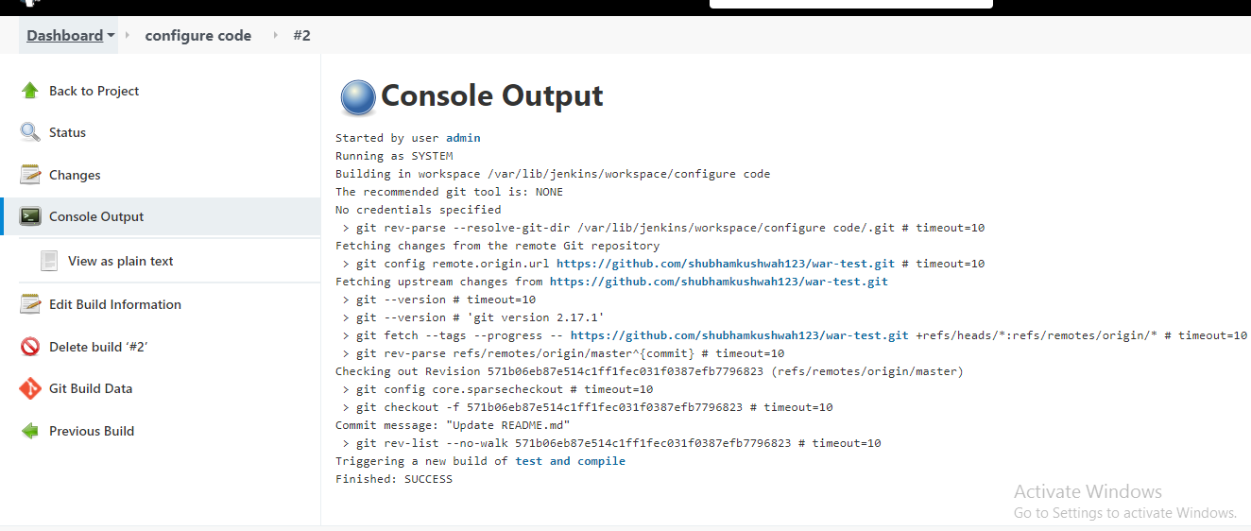

**Created test and compile/package project**

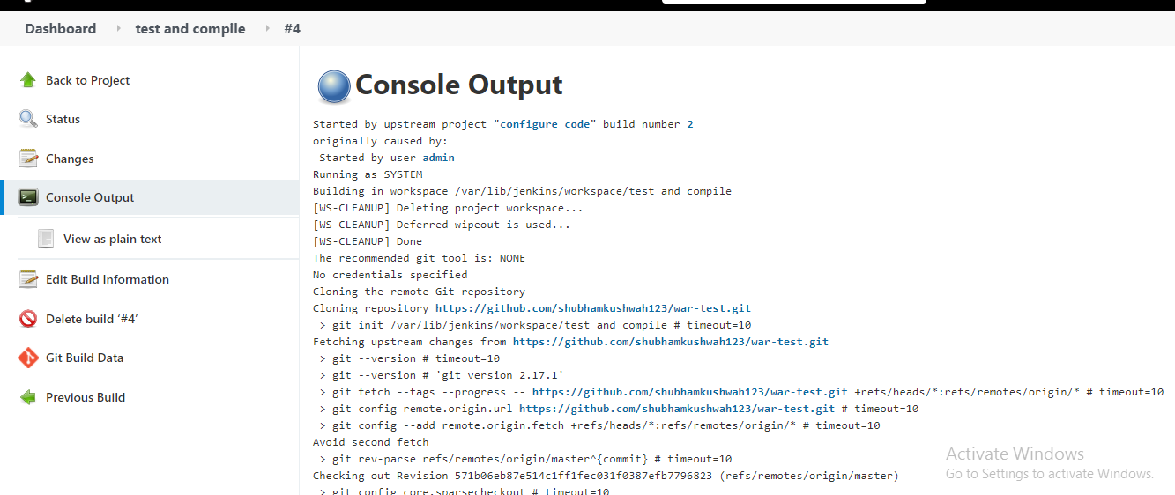

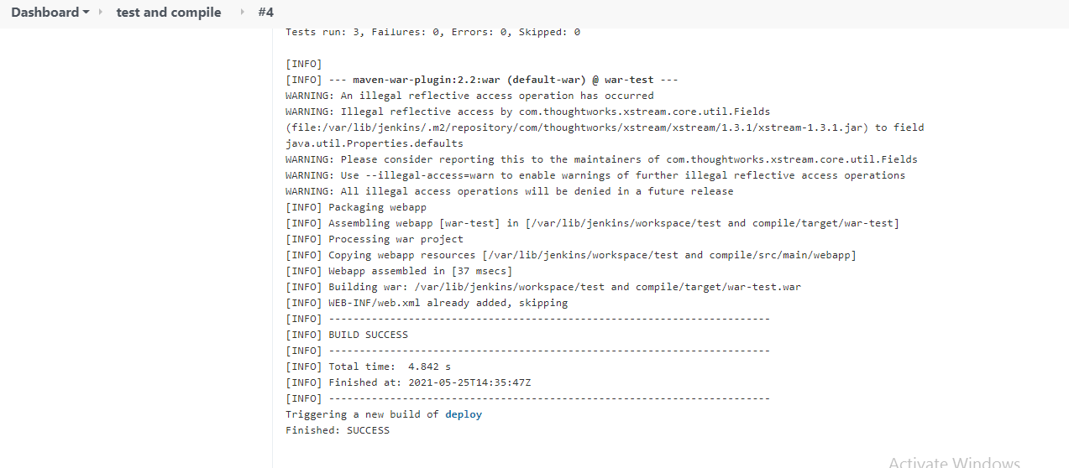

**Created deploy web application project**

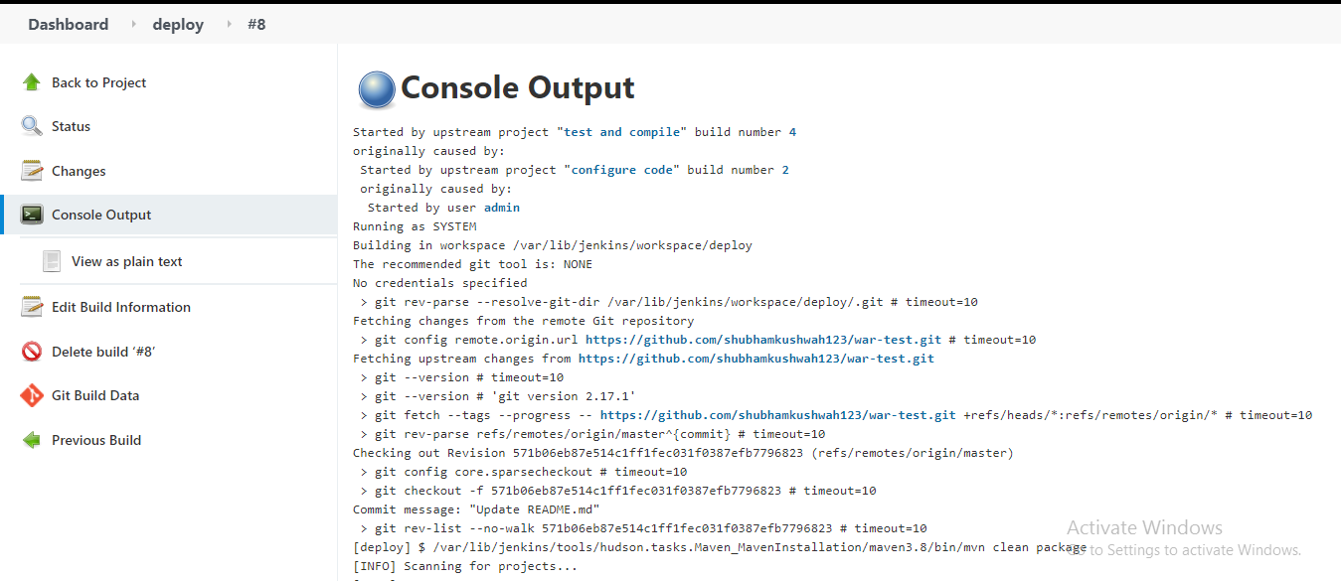

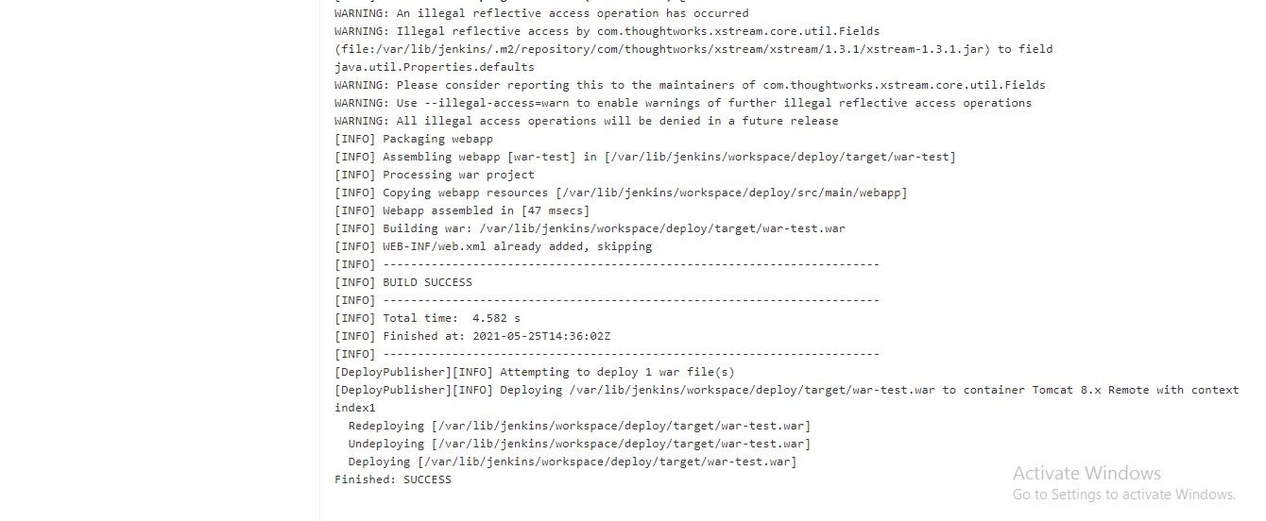

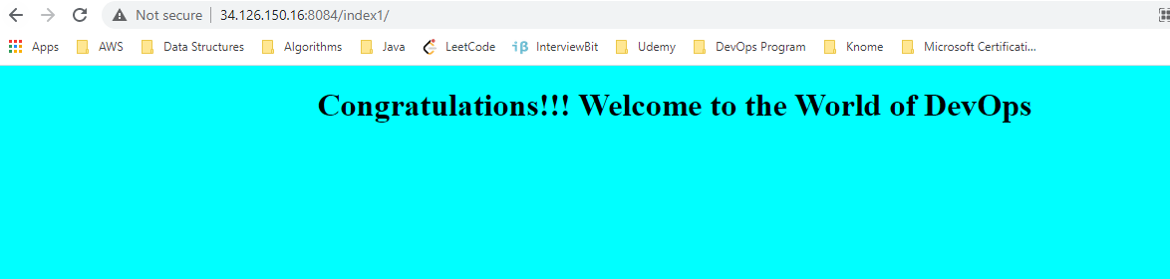

**Established build pipeline view**

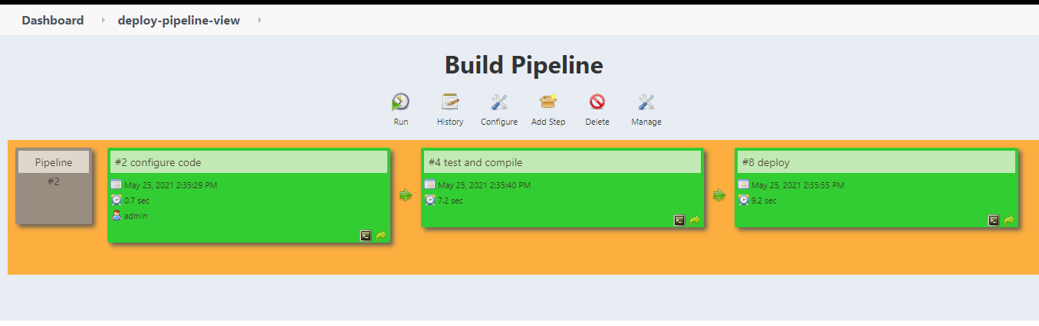

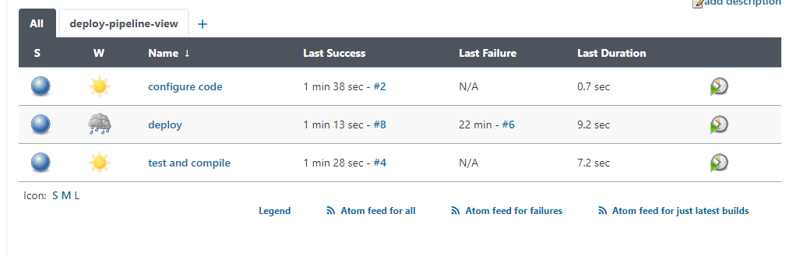

**Configured Maven as tool in Jenkins**

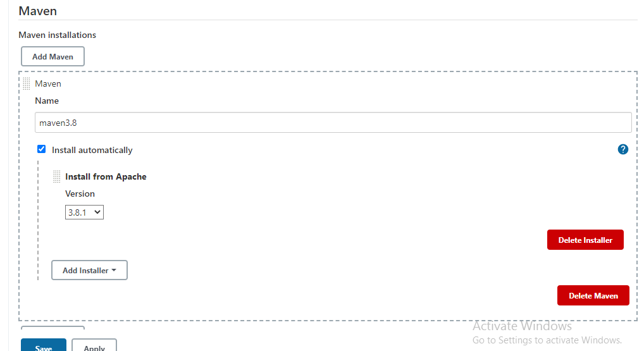

**Creating pipeline job and writing the script for achieving above task**

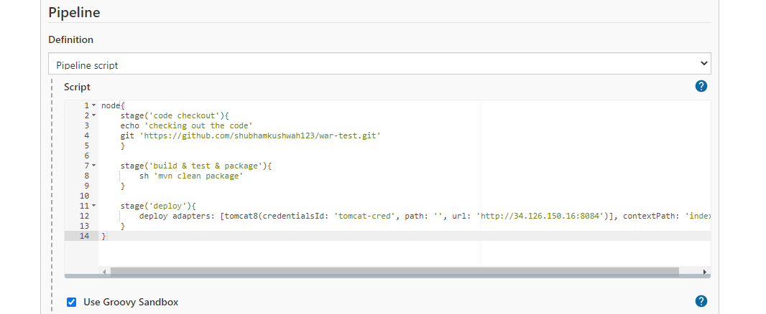

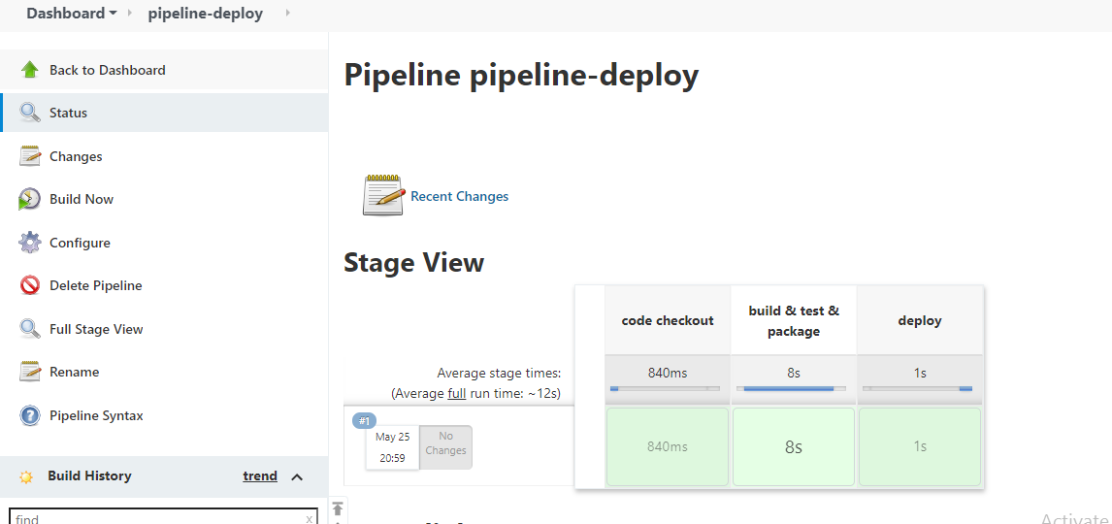

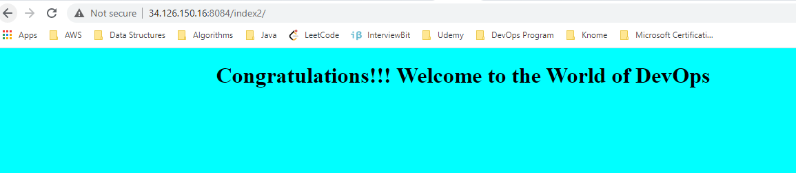

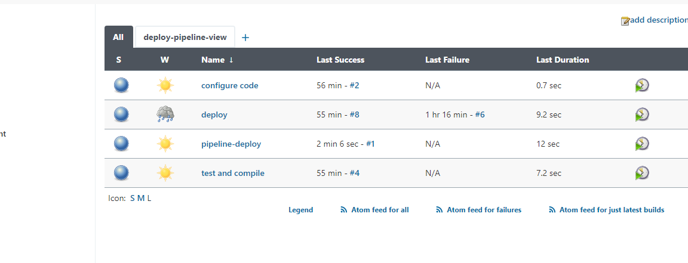

**Testing GitHub Webhook for every commit**

**Configuration on GitHub:**

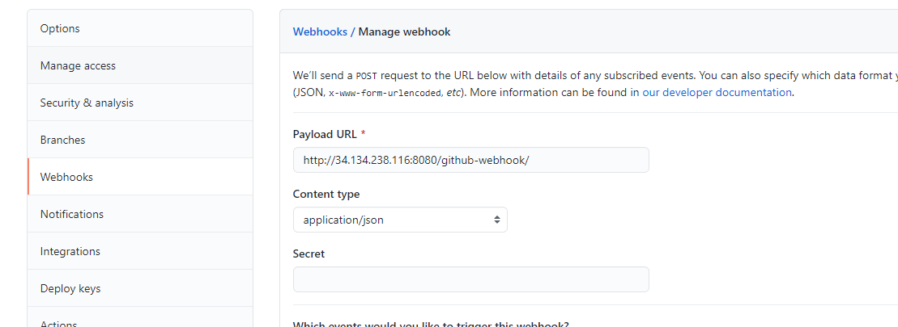

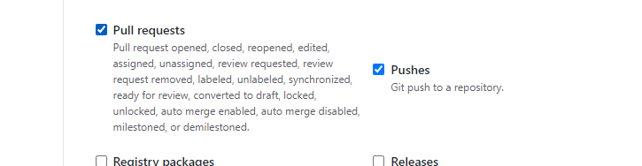

**Configuration on Jenkins**

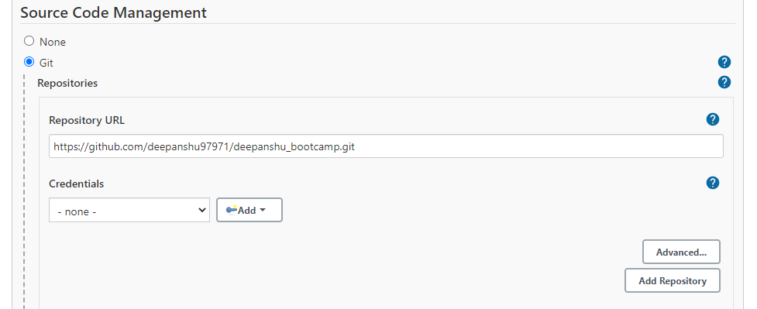

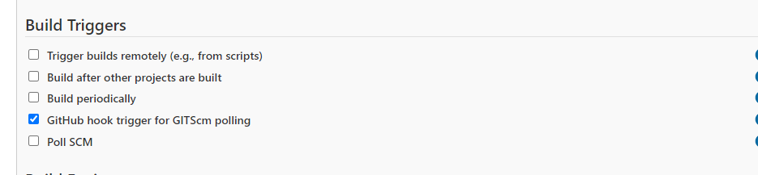

**Output in GitHub**

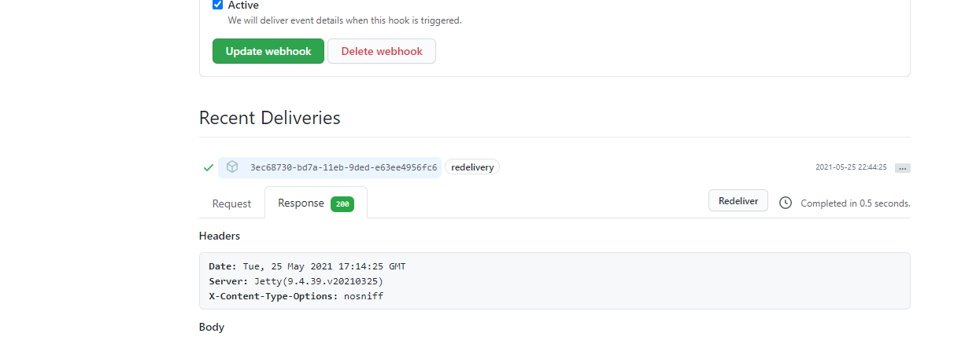

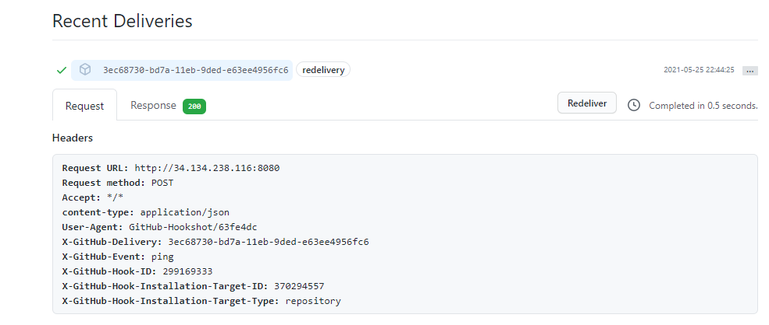

**Output in Jenkins**

