**docker file**

**Searching for nginx image in repository**

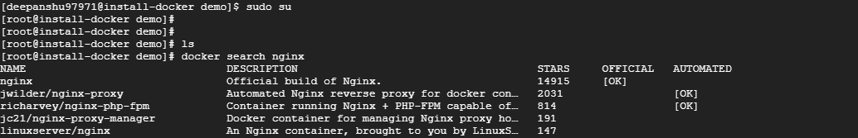

**Created a docker file to create a docker image using nginx as the base image and copy the static page inside container and deploy it**

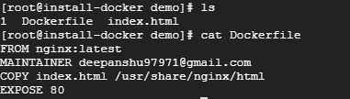

**Building docker file and created an image “deepanshu97971/my-image:1.0”**

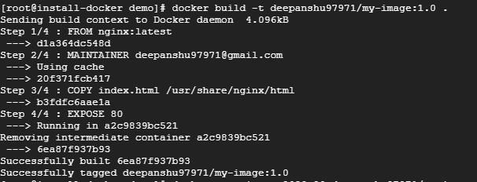

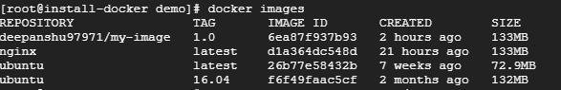

**Logging into Docker Hub**

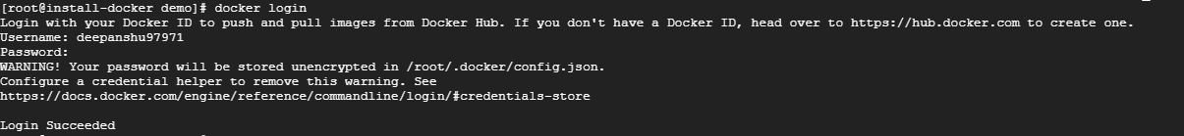

**Pushing the image to Docker Hub**

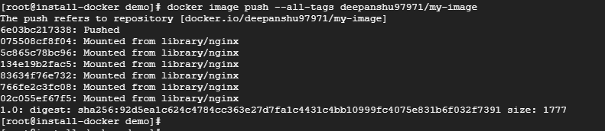

**Imaged pushed to docker hub and it is visible from docker hub console**



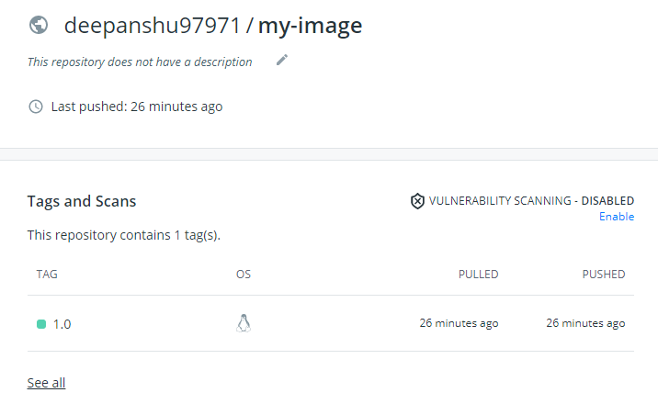

**Removing the image from local repository for testing “docker pull”**

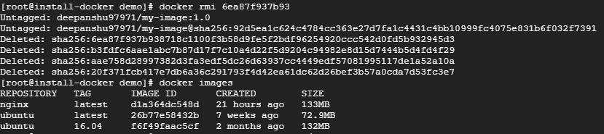

**Pulling image from docker hub**

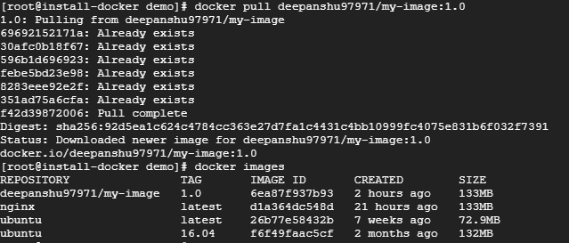

**Running an container in detach mode and application is deployed**



**Application can be accessed from browser on port 8080**

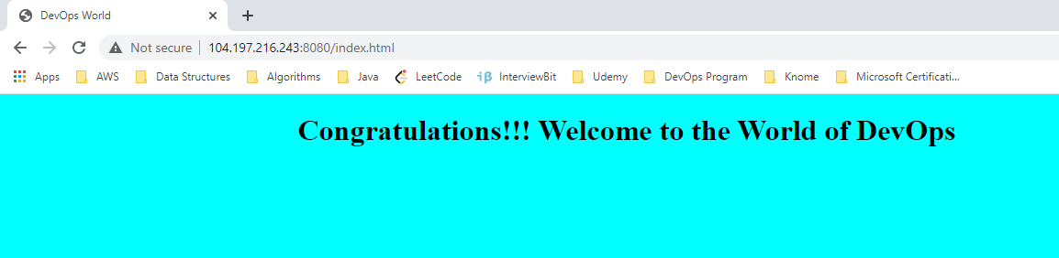

**Docker-Compose**

**Writing docker-compose file to run the above application container along with MYSQL database container**

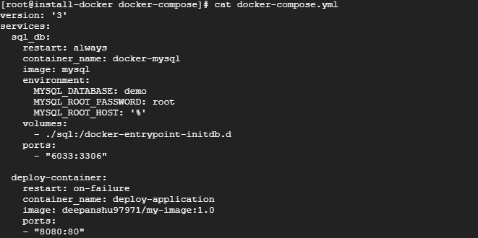

**Running docker-compose file**

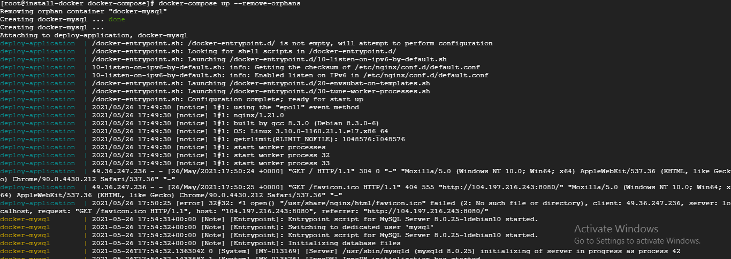

**Both containers are up successfully**



**Application is deployed successfully**

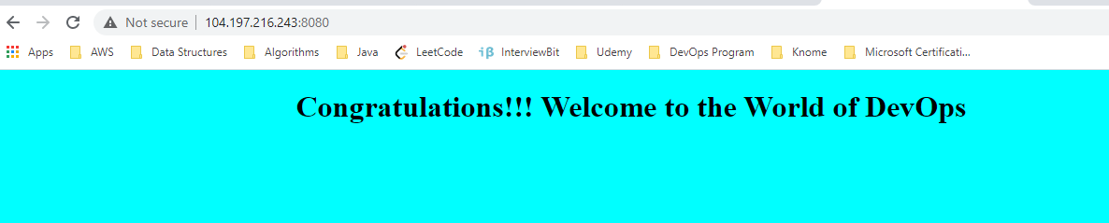

**Connecting to the MYSQL database container**

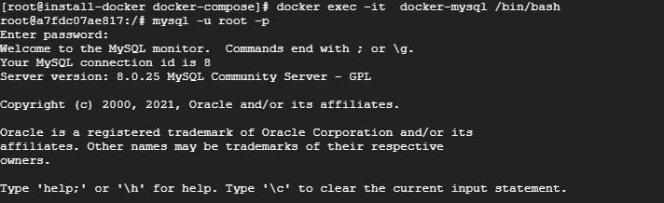

**Created a table called “test” with attributes id, name and age, and inserting values inside table**

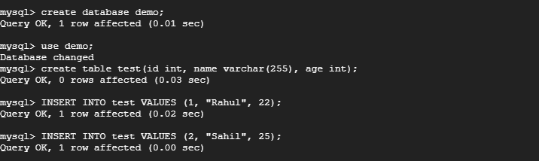

**Showing data of the table**

