**ANSIBLE**

**Created two nodes: master-node and slave-node in GCP**



**Configuring master node to enable password less authentication**

**Generating key pair using “ssh-keygen”**

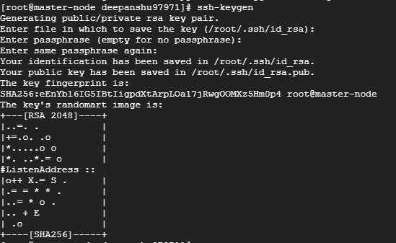

**Copy public key to slave node:**

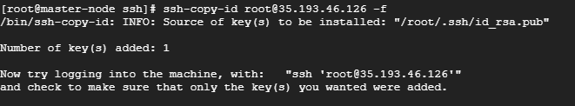

**After copy of public key to slave node, we can ssh without password**

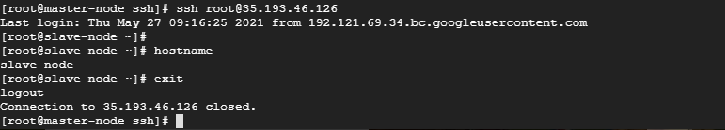

**Installing Ansible on master node**

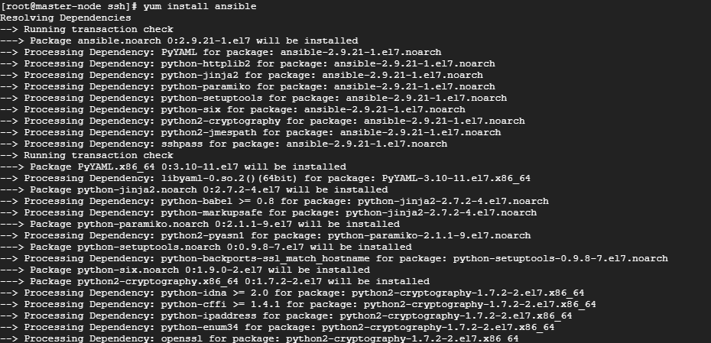

**Ansible is installed successfully**

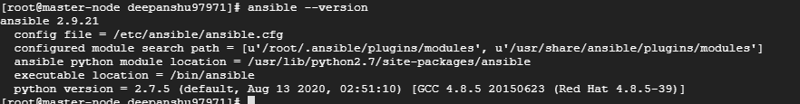

**Writing playbook for installing Java, Maven, Nginx, Docker on slave node**

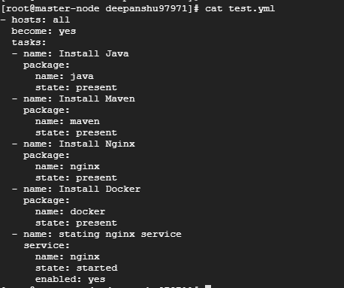

**Output of above playbook execution**

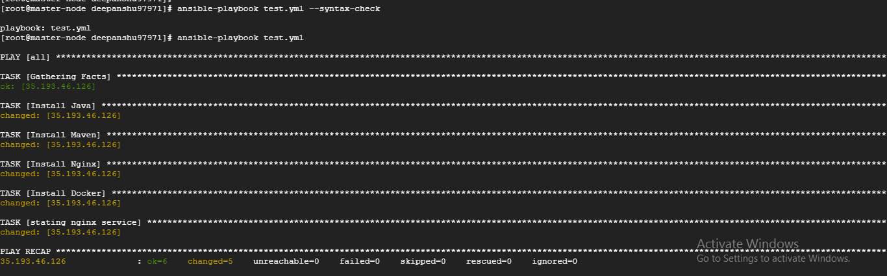

**Below we are checking if all software’s are installed successfully on slave node**

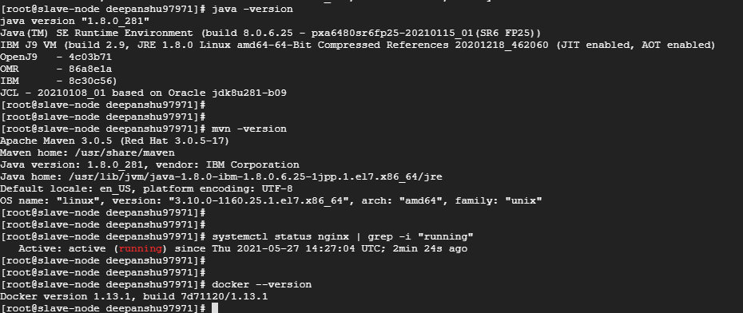

**Writing docker file to create an docker image for deploying application**

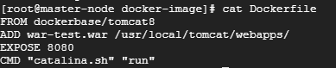

**Image build is successful using above Dockerfile**

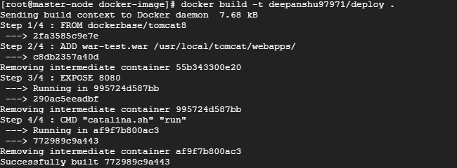

**We get an image called “deepanshu97971/deploy”**



**Below we are writing playbook for deploying our application on slave node and we are also trying to start docker service in case if it is not running on slave node**

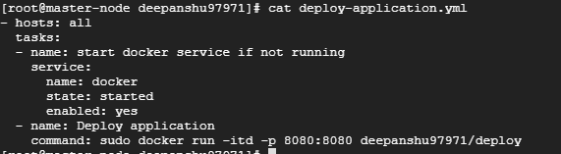

**Execution of above playbook is successful**

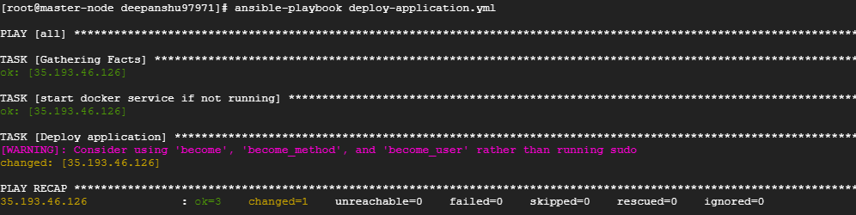

**Application is deployed successfully on slave node and we are getting expected output from browser**



