**Assignment 1**

**Creating a directory “developerA”**



**Converting directory to git repository**

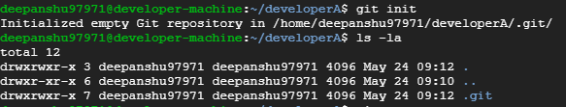

**Creating 3 files**



**Adding files to staging area and commiting them**

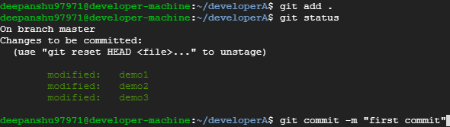

**Add the remote repository to local repositroy**



**Pushing changes from local repository to remote repository**

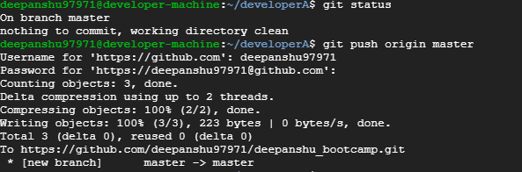

**Create another folder “developerB” and clone the remote repository**

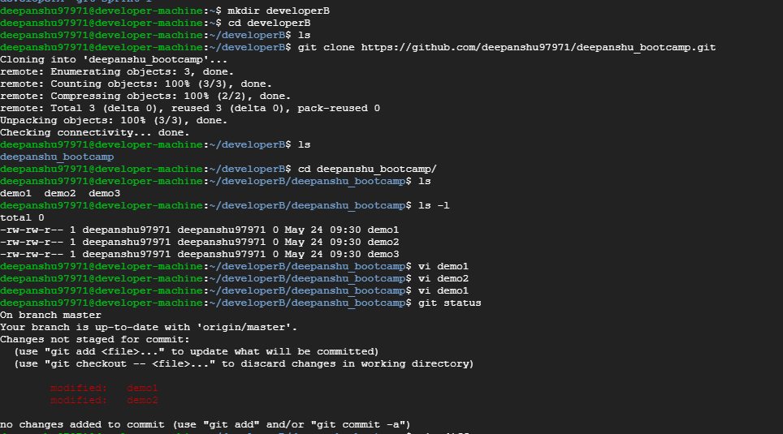

**Make and commit changes via developer B**

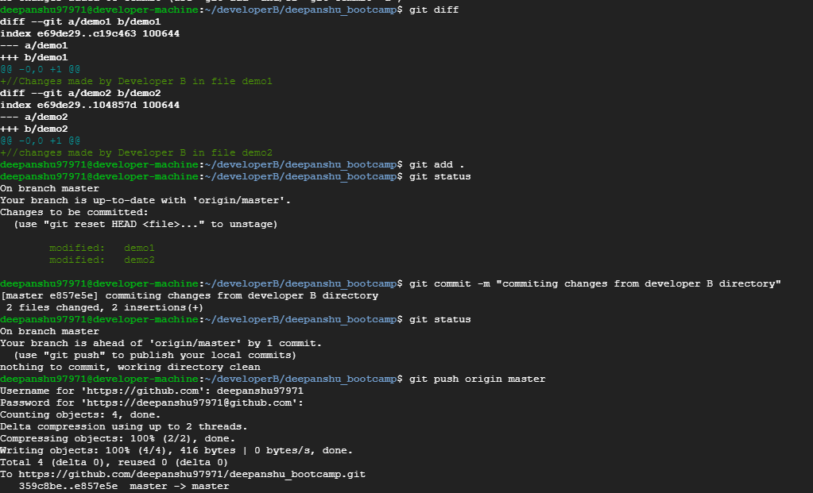

**Synchronize chagnes in developer A repository**

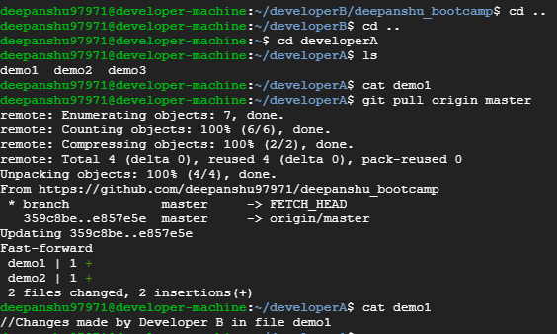

**Create a new branch “feature1”**

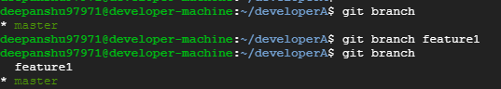

**Make changes in files from new branch and merge it with master branch**

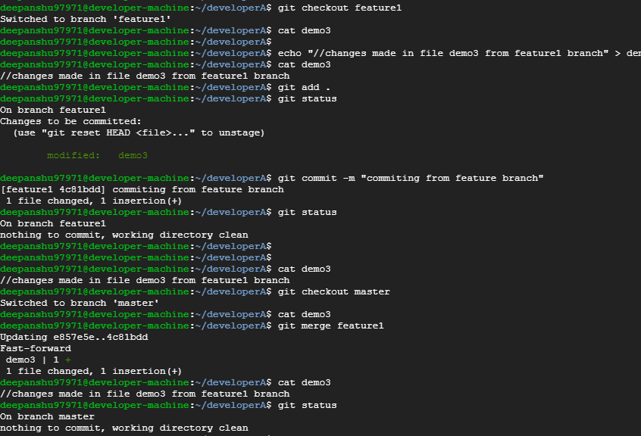

**Delete the new branch “feature1”**

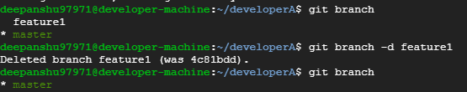

**History Command output :**

