**Deepanshu Miglani**

**500106264**

**R2142220476**

**Predictive analysis**

**Lab-02**

1-

# 1. Create a tuple of colors

colors = ("red", "green", "blue", "yellow", "green")

print("Tuple of colors:", colors)

# 2. Access elements using indexing

first_color = colors[0]

third_color = colors[2]

print("\nFirst color:", first_color)

print("Third color:", third_color)

# 3. Try to modify an element in the tuple (demonstrating immutability)

try:

colors[1] = "purple" # This will raise a TypeError because tuples are immutable

except TypeError as e:

print("\nError:", e)

# 4. Find the number of occurrences of a specific element (e.g., 'green')

count_green = colors.count("green")

print("\nNumber of occurrences of 'green':", count_green)

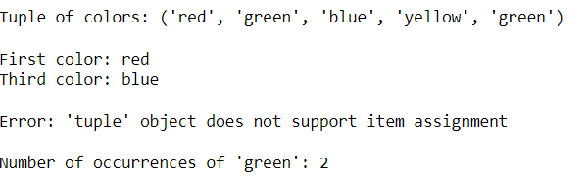

2-

# Create a dictionary to store information about a person

person = {"name": "Alice", "age": 30, "city": "New York"}

# Access values using keys

print("Name:", person["name"])

print("Age:", person["age"])

print("City:", person["city"])

# Add a new key-value pair

person["country"] = "USA"

print("Country:", person["country"])

# Modify an existing value

person["age"] = 31

print("Updated Age:", person["age"])

# Check if a key exists in the dictionary

if "occupation" in person:

print("Occupation:", person["occupation"])

else:

print("Occupation key does not exist.")

# Get a list of all keys and values

keys = person.keys()

values = person.values()

print("Keys:", keys)

print("Values:", values)

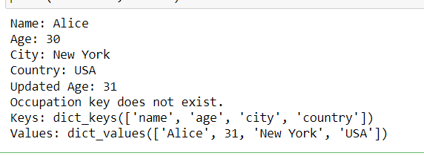

3-

# Create a list and a tuple

my_list = [1, 2, 3]

my_tuple = (4, 5, 6)

# Try to modify an element in the list

my_list[0] = 10

print("Modified list:", my_list)

# Try to modify an element in the tuple (this will raise an error)

try:

my_tuple[0] = 10

except TypeError as e:

print("Error:", e)



4-

# Get input from the user

num = int(input("Enter a number: "))

# Print the multiplication table

print(f"Multiplication table of {num}:")

for i in range(1, 11):

product = num * i

print(f"{num} x {i} = {product}")

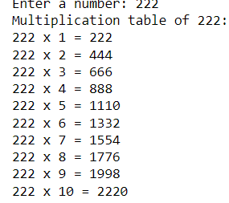

5-

def factorial(n):

"""Calculates the factorial of a given number.

Args:

n: The number for which to calculate the factorial.

Returns:

The factorial of the given number.

"""

if n == 0 or n == 1:

return 1

else:

result = 1

for i in range(2, n+1):

result *= i

return result

# Get the number from the user

num = int(input("Enter a number: "))

# Calculate and print the factorial

factorial_result = factorial(num)

print(f"The factorial of {num} is {factorial_result}")

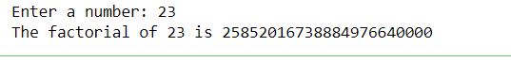

6-

def is_prime(num):

"""Checks if a given number is prime.

Args:

num: The number to check.

Returns:

True if the number is prime, False otherwise.

"""

if num <= 1:

return False

elif num <= 3:

return True

elif num % 2 == 0 or num % 3 == 0:

return False

i = 5

while i * i <= num:

if num % i == 0 or num % (i + 2) == 0:

return False

i += 6

return True

# Get the number from the user

num = int(input("Enter a number: "))

# Check if the number is prime

if is_prime(num):

print(f"{num} is a prime number.")

else:

print(f"{num} is not a prime number.")



7-

def sum_of_even_numbers(start, end):

"""Calculates the sum of even numbers within a given range.

Args:

start: The starting number.

end: The ending number.

Returns:

The sum of even numbers within the given range.

"""

sum = 0

for num in range(start, end + 1):

if num % 2 == 0:

sum += num

return sum

# Find the sum of even numbers between 1 and 100

result = sum_of_even_numbers(1, 100)

print("The sum of even numbers between 1 and 100 is:", result)



8-

def calculator():

"""A simple calculator that performs basic arithmetic operations."""

while True:

print("Choose an operation:")

print("1. Addition")

print("2. Subtraction")

print("3. Multiplication")

print("4. Division")

print("5. Exit")

choice = input("Enter your choice (1-5): ")

if choice == '5':

print("Exiting the calculator.")

break

num1 = float(input("Enter the first number: "))

num2 = float(input("Enter the second number: "))

if choice == '1':

result = num1 + num2

print("Result:", result)

elif choice == '2':

result = num1 - num2

print("Result:", result)

elif choice == '3':

result = num1 * num2

print("Result:", result)

elif choice == '4':

if num2 == 0:

print("Error: Division by zero is not allowed.")

else:

result = num1 / num2

print("Result:", result)

else:

print("Invalid choice. Please enter a number between 1 and 5.")

# Start the calculator

calculator()

