**Name : Deepanshu Miglani**

**SAP ID : 500106264**

**BATCH – B4 (AIML NH)**

**Experiment 5**

<https://www.kaggle.com/code/shivanirana63/guide-to-complete-statistical-analysis/input>

Descriptive Statistics of data:

* 1. Measure of Central Tendency: Mean, Geometric mean, Harmonic mean, Mode, Median

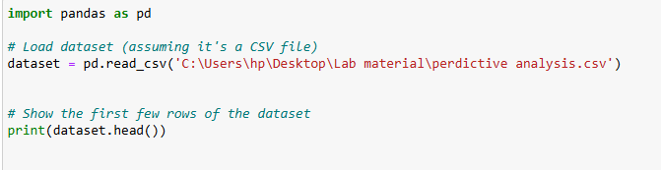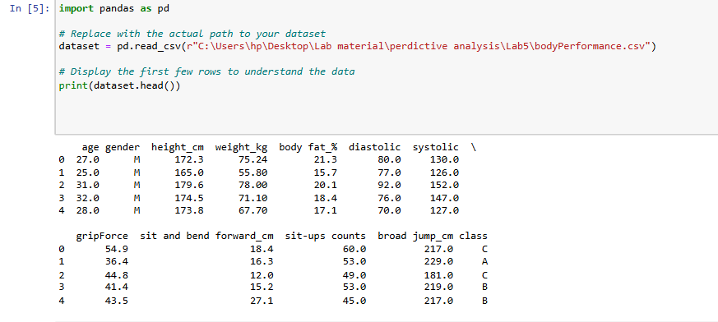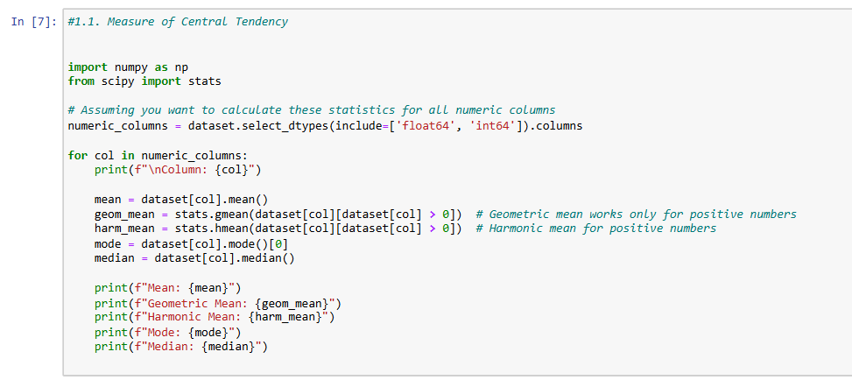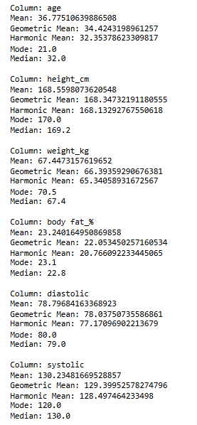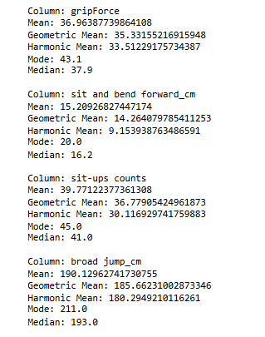

1.2 Measure of Dispersion: Variance, Standard deviation, Shape of Data (Symmetric, Skewness), Inter Quartile Range (IQR) / percentiles, Range, Mean Absolute Deviation(MAD)

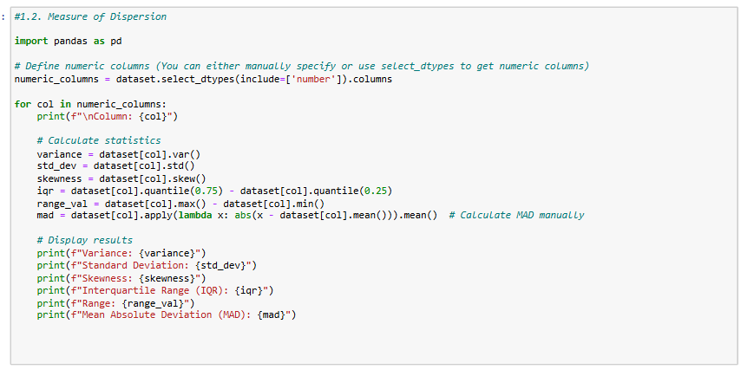

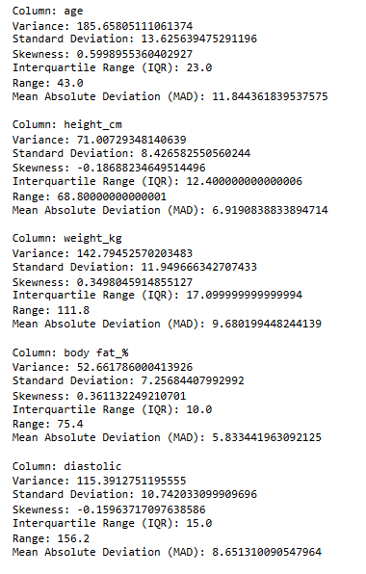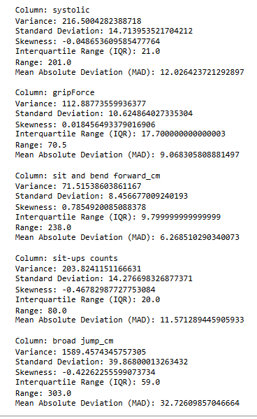

* 1. Correlation between features.

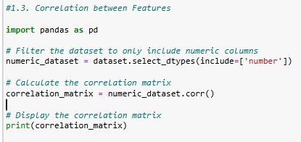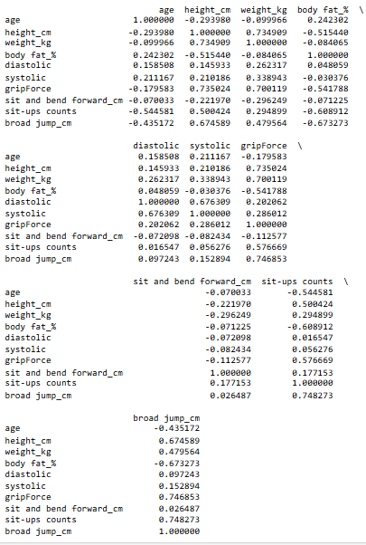

1.4  Visualizing Data Distribution: Boxplot, Histograms, Density plots, Scatterplot, Bar chart

