Operating System Project

BANKER’S ALGORITHM
find whether the system is in safe state or not

Student Name: Deepanshu Pathak
Student ID: 11612065
Section: K1647_A19
Email Address: deepanshupathak50@gmail.com
GitHub Link:
QUESTION: There are 5 processes and 3 resource types, resource A with 10 instances, B with 5 instances and C with 7 instances. Consider following and write a c code to find whether the system is in safe state or not?
Available Processes Allocation Max
A B C A B C A B C
3 3 2 P0 0 1 0 7 5 3
P1 2 0 0 3 2 2
P2 3 0 2 9 0 2
P3 2 1 1 2 2 2
P4 0 0 2 4 3 3
Code:
#include<stdio.h>
#include<conio.h>
int main()
{
char a[7]="user123";
char c[7];
char u[4]="user";
printf("\n\t -----------------------------------------------");
printf("\n\t \t \t BANKER'S ALGORITHM\n");
printf("\t -----------------------------------------------\n\n");
printf("PASSWORD : user123\n");
printf("\nplease enter the System password :");
char ch;
int i1;
for(i1=0;i1<7;i1++)
{
ch=getch();
c[i1]=ch;
printf("*");
}
c[i1-1]='\0';
int flag=1;
for(i1=0;c[i1]!='\0';i1++)
{
if(c[i1]!=a[i1])
{
flag=0;
break;
}
}
if(flag==1)
{
printf("\n\nsuccessfully login\n");
printf("\n||-------------------------------------------- ||\n");
printf("|| YOU ARE IN SYSTEM CHECKING STATE ||");
printf("\n||-------------------------------------------- ||\n\n\n");
}

else
{
printf("\n\nsorry ! you have entered incorrect password\n");
return(0);
}

int i,j,k,l,m,n;
printf("PLEASE ENTER THE NO OF PROCESS TO INCLUDE IN THE SYSTEM : ");
scanf("%d",&m);
printf("\n\nPROCESSES ARE :\n\n");
printf("--------------------------------\n");
for(i=0;i<m;i++)
{

printf("||\tP%d with instance A,B,C\t ||\n",i+1);
printf("||-------------------------------||\n");
}
int max[m][3],allo[5][3],need[5][3];
int avail[5][3],seq[5][3],unsafe[4][5];
int s[]={1,2,3,4,5};
int s1[5],s2[5];
for(i=0;i<5;i++)
{
s2[i]=0;
}

for(i=0;i<m;i++)
{
for(j=0;j<3;j++)
unsafe[i][j]=0;
}
printf("\n||--------------||\n||\tSTEP 1:\t||\n||--------------||\n\n");
printf("\n ENTER THE MAXIMUM RESOURSES FOR ALL PROCESSES WITH INSTANCES A,B,C RESPECTIVELY\n");

for(i=0;i<m;i++)
{
int a=65;
for(j=0;j<3;j++)
{
printf("\nenter maximum RESOURSES for the P%d process With %c :",i+1,a);
scanf("%d",&max[i][j]);
a++;
}
printf("\n----------------------------------------------------------------------\n");
}
printf("\nprocess\t maximum\n\n");
for(i=0;i<m;i++)
{
printf(" p%d\t",i+1);
for(j=0;j<3;j++)
{

printf("%d ",max[i][j]);
}
printf("\n");
}
printf("\n||---------------------------------------------------------------------------------------------||\n");
printf("\n||---------------------------------------------------------------------------------------------||\n");
printf("\n\n\n\n\n||--------------||\n||\tSTEP 2:\t||\n||--------------||\n\n");
printf("\nENTER THE ALLOCATION RESOURSES FOR ALL PROCESSES WITH INSTANCES A,B,C RESPECTIVELY\n");
for(i=0;i<m;i++)
{
int a1=65;
for(j=0;j<3;j++)
{
printf("\nenter the allocation for p%d process with instance %c :",i+1,a1);
scanf("%d",&allo[i][j]);
a1++;
}
printf("\n------------------------------------------------------------------\n");
}
printf("\nprocess\t\t maximum\t\tallocation");
printf("\n");

for(i=0;i<m;i++)
{
printf("\np%d\t ",i+1);
for(j=0;j<3;j++)
{
printf(" %d ",max[i][j]);
}
printf("\t\t");
for(k=0;k<3;k++)
{
printf(" %d ",allo[i][k]);
}

printf("\n");
}

printf("\n||---------------------------------------------------------------------------------------------||\n");
printf("\n||---------------------------------------------------------------------------------------------||\n");
printf("\n\n\n\n\n||--------------||\n||\tSTEP 3:\t||\n||--------------||\n\n");
printf("NEED MATRIX WILL BE :\n");
printf("\nprocess \tmaximum \tallocation \tNEED\n");
for(i=0;i<m;i++)
{
printf("\np%d\t ",i+1);
for(j=0;j<3;j++)
{
need[i][j]=max[i][j]-allo[i][j];
printf(" %d ",max[i][j]);
}
printf("\t");
for(j=0;j<3;j++)
{
printf("%d ",allo[i][j]);
}
printf("\t");
for(k=0;k<3;k++)
{
printf("%d ",need[i][k]);
}
printf("\n");
}
printf("\n\nfrom the given process table AVAILABLE RESOURSES is :\n");
avail[0][0]=3;
avail[0][1]=3;
avail[0][2]=2;
int a22=65;
for(i=0;i<1;i++)
{
for(j=0;j<3;j++)
{
printf("\nfor Instance %c : %d\n",a22,avail[i][j]);
a22++;
}
}
printf("\n\n");
l=0;
int a5=0,a6=0;
for(i=0;i<m;i++)
{

j=0;

if(need[i][j]<=avail[l][0])
{

avail[l+1][j]=avail[l][j]+allo[i][j];
avail[l+1][j+1]=avail[l][j+1]+allo[i][j+1];
avail[l+1][j+2]=avail[l][j+2]+allo[i][j+2];
seq[l][j]=allo[i][j];
seq[l][j+1]=allo[i][j+1];
seq[l][j+2]=allo[i][j+2];
s1[l]=s[i];
l++;
}
else
{
s2[a6]=s[i];
unsafe[a5][j]=need[i][j];
unsafe[a5][j+1]=need[i][j+1];
unsafe[a5][j+2]=need[i][j+2];
a5++;
a6++;
}
}

for(i=0;i<a5;i++)
{
j=0;
if(unsafe[i][j]<=avail[l][j])
{
avail[l+1][j]=avail[l][j]+allo[i][j];
avail[l+1][j+1]=avail[l][j+1]+allo[i][j+1];
avail[l+1][j+2]=avail[l][j+2]+allo[i][j+2];
seq[l][j]=allo[i][j];
seq[l][j+1]=allo[i][j+1];
seq[l][j+2]=allo[i][j+2];
s1[l]=s2[i];
l++;

}

}
if(l==m)
{
printf("\n||--------------------------------------------||\n");
printf(" SYSTEM IN SAFE STATE \n");
printf("||--------------------------------------------||\n");
printf("\nSAFE SEQUENCE WILL BE...\t");
for(i=0;i<l;i++)
{
printf("P%d\t",s1[i]);
}
printf("\n\n");
printf("\nprocess \tallocation\n\n");
for(i=0;i<l;i++)
{
printf("P%d",s1[i]);
for(j=0;j<3;j++)
{
printf("\t \t%d ",seq[i][j]);
}

printf("\n");
}
}
else
printf("\nSYSTEM IS IN DEADLOCK STATE...");
return(0);
}
- Explain the problem in terms of operating system concept?
Banker's algorithm is a deadlock avoidance algorithm. It is named so because this algorithm is used in banking systems to determine whether a loan can be granted or not.
Consider there are n account holders in a bank and the sum of the money in all of their accounts is S. Everytime a loan has to be granted by the bank, it subtracts the loan amount from the total money the bank has. Then it checks if that difference is greater than S. It is done because, only then, the bank would have enough money even if all the n account holders draw all their money at once.
Banker's algorithm works in a similar way in computers.
Whenever a new process is created, it must specify the maximum instances of each resource type that it needs, exactly.
Let us assume that there are n processes and m resource types. Some data structures that are used to implement the banker's algorithm are:

1. Available
It is an array of length m. It represents the number of available resources of each type. If Available[j] = k, then there are k instances available, of resource type R(j).

2. Max
It is an n x m matrix which represents the maximum number of instances of each resource that a process can request. If Max[i][j] = k, then the process P(i) can request atmost k instances of resource type R(j).

3. Allocation
It is an n x m matrix which represents the number of resources of each type currently allocated to each process. If Allocation[i][j] = k, then process P(i) is currently allocated k instances of resource type R(j).

4. Need
It is an n x m matrix which indicates the remaining resource needs of each process. If Need[i][j] = k, then process P(i) may need k more instances of resource type R(j) to complete its task.
Need[i][j] = Max[i][j] - Allocation [i][j]

Resource Request Algorithm
This describes the behavior of the system when a process makes a resource request in the form of a request matrix. The steps are:
- If number of requested instances of each resource is less than the need (which was declared previously by the process), go to step 2.
- If number of requested instances of each resource type is less than the available resources of each type, go to step 3. If not, the process has to wait because sufficient resources are not available yet.
- Now, assume that the resources have been allocated. Accordingly do,
Available = Available - Requesti
Allocation(i) = Allocation(i) + Request(i)
Need(i) = Need(i) - Request(i)

This step is done because the system needs to assume that resources have been allocated. So there will be less resources available after allocation. The number of allocated instances will increase. The need of the resources by the process will reduce. That's what is represented by the above three operations.
After completing the above three steps, check if the system is in safe state by applying the safety algorithm. If it is in safe state, proceed to allocate the requested resources. Else, the process has to wait longer.

Safety Algorithm
- Let Work and Finish be vectors of length m and n, respectively. Initially,
- Work = Available
- Finish[i] =false for i = 0, 1, ... , n - 1.
This means, initially, no process has finished and the number of available resources is represented by the Available array.
- Find an index i such that both
- Finish[i] ==false
- Needi <= Work
If there is no such i present, then proceed to step 4.
It means, we need to find an unfinished process whose need can be satisfied by the available resources. If no such process exists, just go to step 4.
- Perform the following:
- Work = Work + Allocation;
- Finish[i] = true;
Go to step 2.
When an unfinished process is found, then the resources are allocated and the process is marked finished. And then, the loop is repeated to check the same for all other processes.
- If Finish[i] == true for all i, then the system is in a safe state.
That means if all processes are finished, then the system is in safe state.

4.purpose of use

Banker algorithm is used to avoid deadlock by checking whether a resource allocation may cause the system to be deadlock or not, while the lock is used to solve the critical section problem, i.e., to avoid more than one process can enter the critical section at the same time.

6. Explain the boundary conditions of the implemented code.

1NO OF PROCESS CAN NOT BE NEGATIVE.
2. ALLOCATED TIME CAN NOT BE NEGATIVE.
3. MINIMUM ONE INSTANCE SHOULD BE THERE.
OUTPUT:

-----------------------------------------------
BANKER'S ALGORITHM
-----------------------------------------------

PASSWORD : user123

please enter the System password :*******

successfully login

||-------------------------------------------- ||
|| YOU ARE IN SYSTEM CHECKING STATE ||
||-------------------------------------------- ||

PLEASE ENTER THE NO OF PROCESS TO INCLUDE IN THE SYSTEM :
5

PROCESSES ARE :

--------------------------------
|| P1 with instance A,B,C ||
||-------------------------------||
|| P2 with instance A,B,C ||
||-------------------------------||
|| P3 with instance A,B,C ||
||-------------------------------||
|| P4 with instance A,B,C ||
||-------------------------------||
|| P5 with instance A,B,C ||
||-------------------------------||

||--------------||
|| STEP 1: ||
||--------------||

ENTER THE MAXIMUM RESOURSES FOR ALL PROCESSES WITH INSTANCES A,B,C RESPECTIVELY

enter maximum RESOURSES for the P1 process With A :7

enter maximum RESOURSES for the P1 process With B :5

enter maximum RESOURSES for the P1 process With C :3

----------------------------------------------------------------------

enter maximum RESOURSES for the P2 process With A :3

enter maximum RESOURSES for the P2 process With B :2

enter maximum RESOURSES for the P2 process With C :2

----------------------------------------------------------------------

enter maximum RESOURSES for the P3 process With A :9

enter maximum RESOURSES for the P3 process With B :0

enter maximum RESOURSES for the P3 process With C :2

----------------------------------------------------------------------

enter maximum RESOURSES for the P4 process With A :2

enter maximum RESOURSES for the P4 process With B :2

enter maximum RESOURSES for the P4 process With C :2

----------------------------------------------------------------------

enter maximum RESOURSES for the P5 process With A :4

enter maximum RESOURSES for the P5 process With B :3

enter maximum RESOURSES for the P5 process With C :3

----------------------------------------------------------------------

process maximum

p1 7 5 3
p2 3 2 2
p3 9 0 2
p4 2 2 2
p5 4 3 3

||---------------------------------------------------------------------------------------------||

||---------------------------------------------------------------------------------------------||

||--------------||
|| STEP 2: ||
||--------------||

ENTER THE ALLOCATION RESOURSES FOR ALL PROCESSES WITH INSTANCES A,B,C RESPECTIVELY

enter the allocation for p1 process with instance A :0

enter the allocation for p1 process with instance B :1

enter the allocation for p1 process with instance C :0

------------------------------------------------------------------

enter the allocation for p2 process with instance A :2

enter the allocation for p2 process with instance B :0

enter the allocation for p2 process with instance C :0

------------------------------------------------------------------

enter the allocation for p3 process with instance A :3

enter the allocation for p3 process with instance B :0

enter the allocation for p3 process with instance C :2

------------------------------------------------------------------

enter the allocation for p4 process with instance A :2

enter the allocation for p4 process with instance B :1

enter the allocation for p4 process with instance C :1

------------------------------------------------------------------

enter the allocation for p5 process with instance A :0

enter the allocation for p5 process with instance B :0

enter the allocation for p5 process with instance C :2

------------------------------------------------------------------

process maximum allocation

p1 7 5 3 0 1 0

p2 3 2 2 2 0 0

p3 9 0 2 3 0 2

p4 2 2 2 2 1 1

p5 4 3 3 0 0 2

||---------------------------------------------------------------------------------------------||

||---------------------------------------------------------------------------------------------||

||--------------||
|| STEP 3: ||
||--------------||

NEED MATRIX WILL BE :

process maximum allocation NEED

p1 7 5 3 0 1 0 7 4 3

p2 3 2 2 2 0 0 1 2 2

p3 9 0 2 3 0 2 6 0 0

p4 2 2 2 2 1 1 0 1 1

p5 4 3 3 0 0 2 4 3 1

from the given process table AVAILABLE RESOURSES is :

for Instance A : 3

for Instance B : 3

for Instance C : 2

||--------------------------------------------||
SYSTEM IN SAFE STATE
||--------------------------------------------||

SAFE SEQUENCE WILL BE... P2 P4 P5 P1 P3

process allocation

P2 2 0 0
P4 2 1 1
P5 0 0 2
P1 0 1 0
P3 2 0 0

--------------------------------
Process exited after 29.59 seconds with return value 0
Press any key to continue . . .

7. Explain all the test cases applied on the solution of assigned problem.

Test case 1: FOR A SAFE STATE
All the process in a safe state which is also called safe sequence.

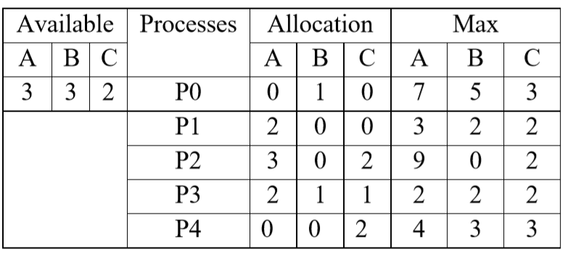

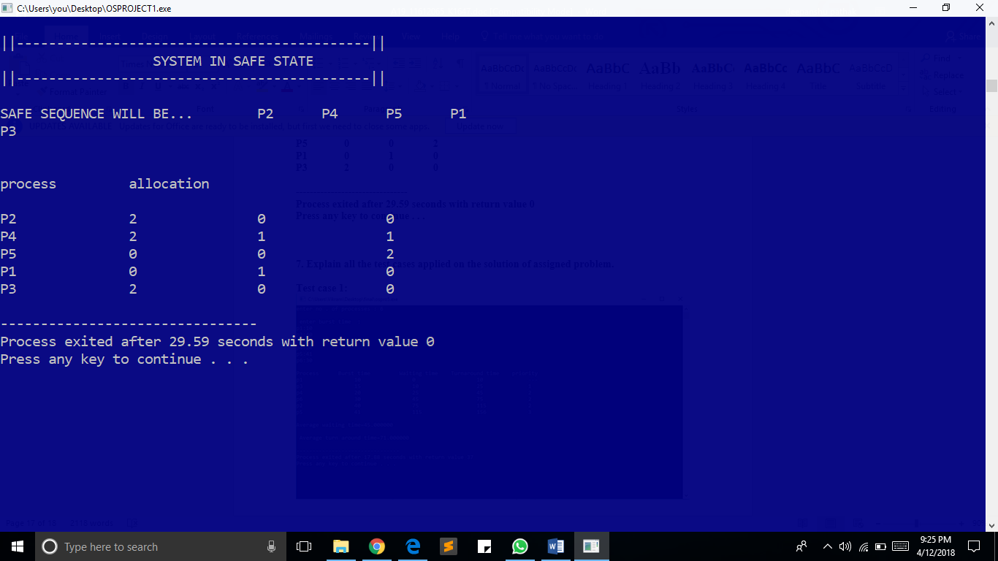

Test case2 : UNSAFE STATE
In this case the all the process can not not be in safe state.
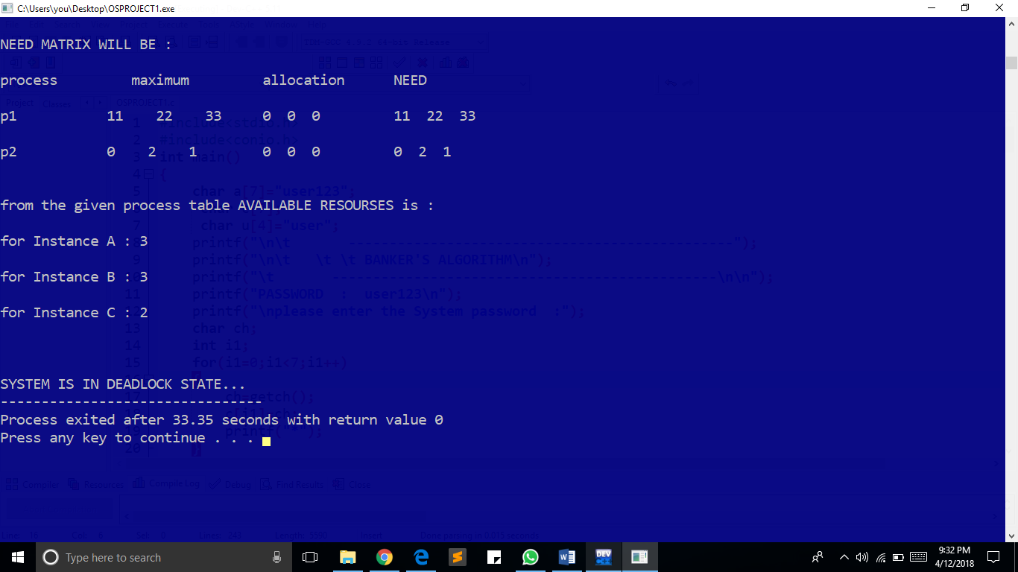

8. Have you made minimum 5 revisions of solution on GitHub?
=> Yes, I have made 5 revisions in GitHub.

