REPORT ON NAND-BASED LOGIC GATES
NAND2Tetris Simulator

Name: Deepanshu
Roll No.: 2501010044
Course/Section: B.Tech CSE(Core)
Date: 17/08/2026

1. AIM
To implement NOT, AND, and OR gates using only NAND gates and verify their Boolean expressions and truth tables using the NAND2Tetris Hardware Simulator.

2. OBJECTIVE
The objective is to understand how a universal NAND gate can be used to construct the basic NOT, AND, and OR logic gates.

3. THEORY
A NAND gate is a universal logic gate. It produces the complement of the AND operation. Because NAND is functionally complete, any Boolean function can be constructed using NAND gates alone.
NAND operation: Y = ¬(A · B)

4. SCHEMATIC DIAGRAM
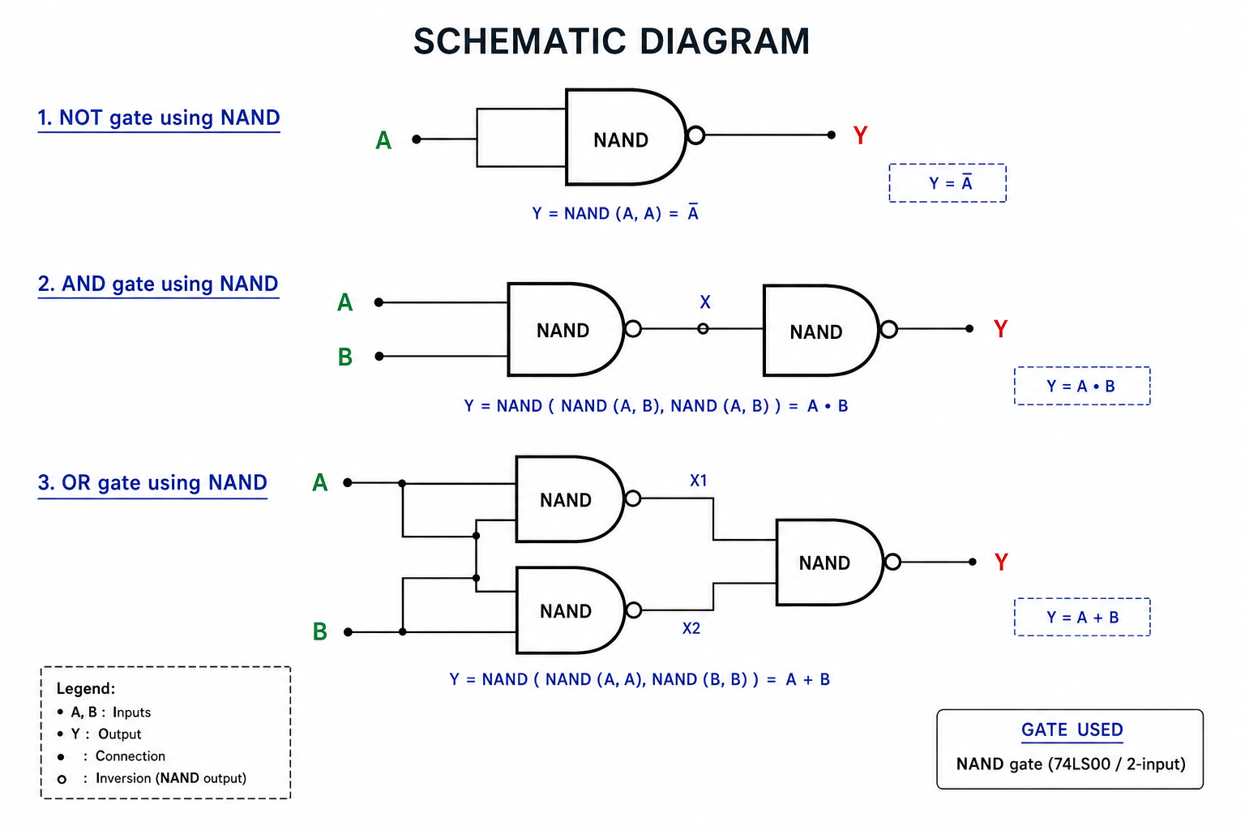

5. BOOLEAN EXPRESSIONS
NOT using NAND: Y = NAND(A, A) = ¬A
AND using NAND: X = NAND(A, B), Y = NAND(X, X) = A · B
OR using NAND: X1 = NAND(A, A), X2 = NAND(B, B), Y = NAND(X1, X2) = A + B

6. TRUTH TABLES
NOT Gate
A | Y = ¬A
0 | 1
1 | 0
AND Gate
A | B | Y = A·B
0 | 0 | 0
0 | 1 | 0
1 | 0 | 0
1 | 1 | 1
OR Gate
A | B | Y = A+B
0 | 0 | 0
0 | 1 | 1
1 | 0 | 1
1 | 1 | 1

7. HDL CODE

NOT Gate
CHIP Not {
IN in;
OUT out;
PARTS:
Nand(a=in, b=in, out=out);
}

AND Gate
CHIP And {
IN a, b;
OUT out;
PARTS:
Nand(a=a, b=b, out=nandOut);
Nand(a=nandOut, b=nandOut, out=out);
}

OR Gate
CHIP Or {
IN a, b;
OUT out;
PARTS:
Nand(a=a, b=a, out=notA);
Nand(a=b, b=b, out=notB);
Nand(a=notA, b=notB, out=out);
}

8. PROCEDURE
- Open the NAND2Tetris Hardware Simulator.
- Create the required HDL file for the gate being tested.
- Implement the logic using only NAND components.
- Load the corresponding .tst test file in the Hardware Simulator.
- Run the test and compare the output with the expected truth table.
- Verify all possible input combinations.

9. RESULT
The NOT, AND, and OR gates were successfully implemented using only NAND gates. The simulated outputs match the expected truth tables.

10. CONCLUSION
This experiment demonstrates that NAND is a universal gate. Basic logic gates such as NOT, AND, and OR can be constructed using combinations of NAND gates, which is an important concept in digital logic and computer architecture.

