Token Contract

//SPDX-License-Identifier: MIT

pragma solidity ^0.4.24;

// Token Contract

contract Token {

function totalSupply() public constant returns (uint256 supply) {}

function balanceOf(address _owner) constant returns (uint256 balance) {}

function transfer(address _to, uint256 _value) returns (bool success) {}

function transferFrom (address _from, address _to, uint256 _value) returns (bool success) {}

function approve(address _spender, uint256 _value) returns (bool success) {}

function allowance (address _owner, address _spender) constant returns (uint256 remaining) {}

// indexed keyword for searching logged events

event Transfer (address indexed _from, address indexed _to, uint256 _value);

event Approval (address indexed _owner, address indexed _spender, uint256 _value);

}

contract CT7Token is Token {

// defining Data Types

string public name;

uint8 public decimals;

string public symbol;

uint256 public unitsOneEthCanBuy;

uint256 public totalEthInWei;

address public fundsWallet;

mapping (address => uint256) balances;

mapping (address => mapping (address => uint256)) allowed; // amount of unit allowed by address1 to be used by address 2

uint256 public totalSupply;

// Constructor

// 1 ETH = 10^18 Weis

// 1 CT7 = 10^18

// Balances can be equal or less than totalSupply

constructor() public {

balances[msg.sender] = 1000000000000000000;

totalSupply = 1000000000000000000;

name = "CT7Token";

decimals = 18;

symbol = "CT7";

unitsOneEthCanBuy = 10;

fundsWallet = msg.sender;

}

// Main Function with Safe Math

function transfer(address _to, uint256 _value) returns (bool success) {

if (balances[msg.sender] >= _value && balances[_to] + _value > balances [_to]) {

balances[msg.sender] -= _value;

balances[_to] += _value;

emit Transfer(msg.sender, _to, _value);

return true;

}

else {

return false;

}

}

function transferFrom(address _from, address _to, uint256 _value) public returns (bool success){

if (balances[_from] >= _value && allowed[_from][msg.sender]>= _value && balances[_to]+ _value > balances [_to]) {

balances[_to] += _value;

balances[_from] -= _value;

allowed[_from][msg.sender] -= _value;

emit Transfer (_from, _to, _value);

return true;

}

else {

return false;

}

}

// constant is similar to view in the older version of Solidity

function balanceOf (address _owner) constant returns (uint256 balance) {

return balances[_owner];

}

function approve (address _spender, uint256 _value) returns (bool success) {

allowed[msg.sender][_spender] = _value;

emit Approval(msg.sender, _spender, _value);

return true;

}

//fallback function

function() payable{

totalEthInWei = totalEthInWei + msg.value;

uint256 amount = msg.value * unitsOneEthCanBuy;

require(balances[fundsWallet] >= amount);

balances[fundsWallet] = balances[fundsWallet] - amount;

balances[msg.sender] = balances[msg.sender] + amount;

emit Transfer (fundsWallet, msg.sender, amount);

fundsWallet.transfer(msg.value);

}

}

Transaction:

Contract: 0x83fF719287C49cFC50BD02a01c3EDa4bb7da41f0

User 1: 0x83fF719287C49cFC50BD02a01c3EDa4bb7da41f0

User 2: 0x83675E0cC7f1f55cEFeEb0E794eFD45EfFc3cf31

User 3: 0x314aF8A911e39CA773F0ff9A94a2B4FcfE83f62C

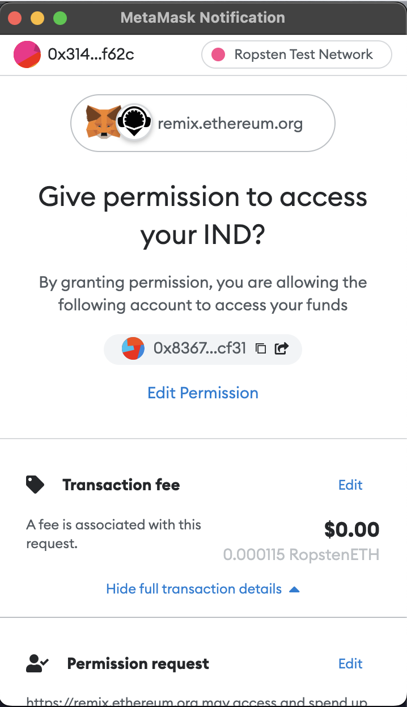

Additional Testing with STAR Tokens:



