**GIT ASSIGNMENT**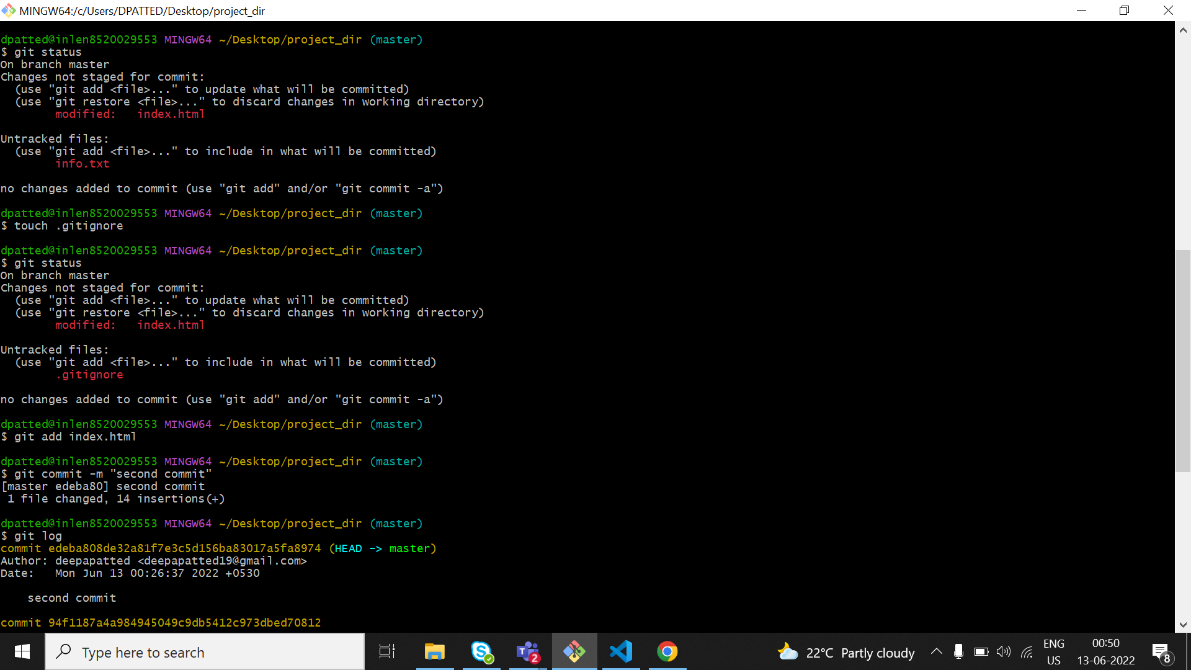

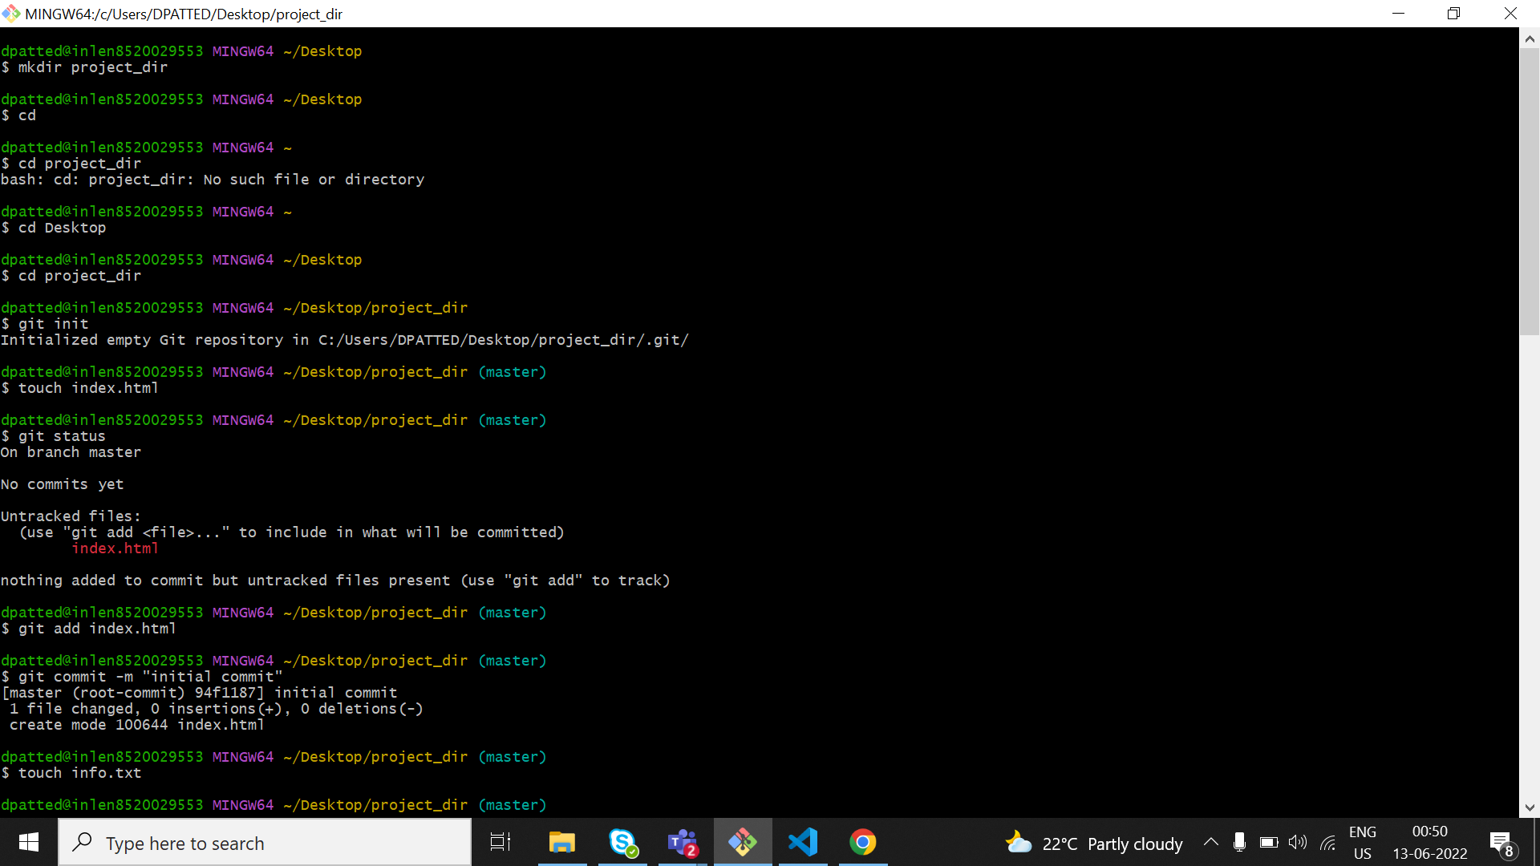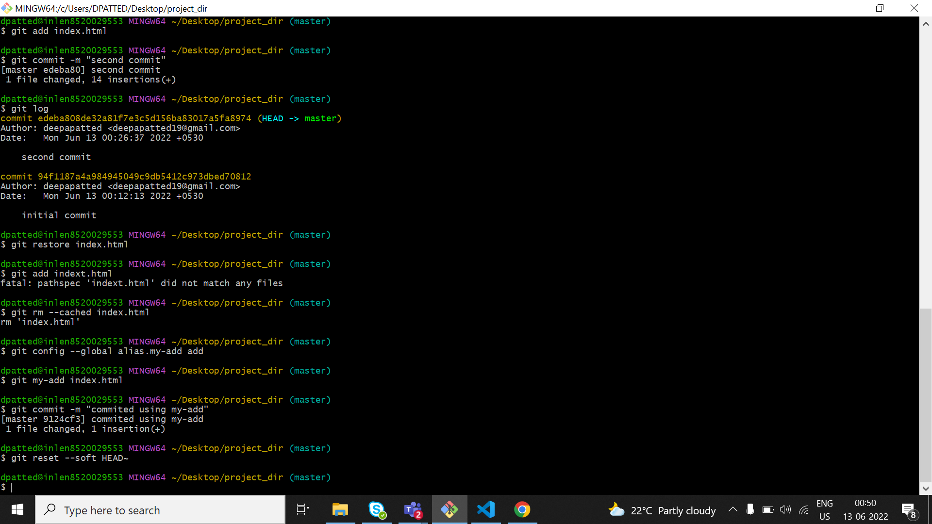

**SECTION-1**

**SECTION-2**

**SECTION-3**

**Git branching (Collaboration**

**Git Remoting(push the code to repo using eclipse Git plug in and Collaborated)**

**…**