Project Description
This is an introduction to DataCamp projects. DataCamp projects allow you to apply the skills you have learned in DataCamp courses. In each project, you will carry out an end-to-end analysis on real-world tasks using real-world tools and workflows.
In doing so, you will learn how to work with Jupyter notebooks: an open-source web application that is great for interactive data analysis.

Guided Project
In this gentle introduction to DataCamp projects, we will walk you through the project interface!

Project Tasks
- 1. This is a Jupyter notebook!
- 2. Put any code in code cells
- 3. Jupyter notebooks ♡ data
- 4. Jupyter notebooks ♡ plots
- 5. Jupyter notebooks ♡ a lot more
- 6. Goodbye for now!

Project: Introduction to DataCamp Projects

1. This is a Jupyter notebook!
A Jupyter notebook is a document that contains text cells (what you're reading right now) and code cells. What is special with a notebook is that it's interactive: You can change or add code cells, and then run a cell by first selecting it and then clicking the run cell button above ( ▶| Run ) or hitting ctrl + enter.

The result will be displayed directly in the notebook. You could use a notebook as a simple calculator. For example, it's estimated that on average 256 children were born every minute in 2016. The code cell below calculates how many children were born on average on a day.

Task 1: Instructions for Python

This is a DataCamp project!
Projects allow you to practice and apply the skills you've learned in the DataCamp courses. In each project you carry out an end-to-end analysis, on a real-world task, using real-world tools and workflows. The exception is this project, which is just an introduction to the DataCamp project interface.
On the side, you have a Jupyter notebook, a free, open-source web application that is great for interactive data analysis. A DataCamp project consists of a number of tasks, and here, you have the task instructions. Your first task is easy:

- Run the code cell below "1. This is a Jupyter Notebook!" by clicking the run cell button ( ▶| Run ) or hitting Ctrl + Enter. This will calculate how many children were born per day on average in 2016.
- Then, click the Next Task button below.

# I'm a code cell, click me, then run me!
256 * 60 * 24 # Children × minutes × hours

368640

Task 1: Instructions for R

This is a DataCamp project!
Welcome to your first DataCamp project!
Projects allow you to practice and apply the skills you've learned in the DataCamp courses. In each project you carry out an end-to-end analysis, on a real-world task, using real-world tools and workflows. The exception is this project, which is just an introduction to the DataCamp project interface.
# I'm a code cell, click me, then run me!
256 * 60 * 24 # Children × minutes × hours

368640

Task 1: Instructions for SQL

This is a DataCamp project!
Projects allow you to practice and apply the skills you've learned in the DataCamp courses. In each project you carry out an end-to-end analysis, on a real-world task, using real-world tools and workflows. The exception is this project, which is just an introduction to the DataCamp project interface.
# I'm a code cell, click me, then run me!
256 * 60 * 24 # Children × minutes × hours

368640

2. Put any code in code cells
But a code cell can contain much more than a simple one-liner! This is a notebook running python and you can put any python code in a code cell (but notebooks can run other languages too, like R). Below is a code cell where we define a whole new function (greet). To show the output of greet we run it last in the code cell as the last value is always printed out.

Task 2: Instructions for Python
The Jupyter notebook in a DataCamp project will contain an analysis, data exploration, or other narrative combining code, data, and text. But, and here is the catch, some of the code is missing, and it's up to you to get it right! Sometimes you will only need to fix small things with the code, but in some projects, you will get to write a whole analysis yourself.However, in this project you won't have to do much — the notebook on the side is almost complete — there are just some minor issues that you need to deal with:
- Replace the arguments to greet('James', 'Bond') with your own name.
- Run the code cell. (As this is part of every task we will drop this instruction from now on.)
def greet(first_name, last_name):
greeting = 'My name is ' + last_name + ', ' + first_name + ' ' + last_name + '!'
return greeting

# Replace with your first and last name.
# That is, unless your name is already James Bond.
greet('Deepa', 'Ponnusamy')

'My name is Ponnusamy, Deepa Ponnusamy!'

Task 2: Instructions for R
The Jupyter notebook in a DataCamp project will contain an analysis, data exploration, or other narrative combining code, data, and text. But, and here is the catch, some of the code is missing, and it's up to you to get it right! Sometimes you will only need to fix small things with the code, but in some projects, you will get to write a whole analysis yourself.
However, in this project you won't have to do much — the notebook on the side is almost complete — there are just some minor issues that you need to deal with:
- Replace the arguments to greet("James", "Bond") with your own name.
- Run the code cell. (As this is part of every task we will drop this instruction from now on.)
greet <- function(first_name, last_name) {
paste("My name is ", last_name, ", ",
first_name, " ", last_name, "!", sep = "")
}

# Replace with your first and last name.
# That is, unless your name is already James Bond.
greet("Deepa", "Ponnusamy")

My name is Ponnusamy, Deepa Ponnusamy!'

Task 2: Instructions for SQL
The Jupyter Notebook in a DataCamp project will contain an analysis, data exploration, or other narrative combining code, data, and text. But, and here is the catch, some of the code is missing, and it's up to you to get it right! Sometimes you will only need to fix small things with the code, but in some projects, you will get to write a whole analysis yourself.
However, in this project you won't have to do much — the notebook on the side is almost complete — there are just some minor issues that you need to deal with:

- Replace the arguments to greet('Jane', 'Bond') with your name.
- Run the code cell. (As this is part of every task we will
def greet(first_name, last_name):
greeting = 'My name is ' + last_name + ', ' + first_name + ' ' + last_name + '!'
return greeting

# Replace with your first and last name.
# That is, unless your name is already Jane Bond.
greet('SelviSriShelly', 'Eswaran')
[2]:
'My name is Eswaran, SelviSriShelly Eswaran!'

3. Jupyter notebooks ♡ data
We've seen that notebooks can display basic objects such as numbers and strings. But notebooks also support the objects used in data science, which makes them great for interactive data analysis!
For example, below we create a pandas DataFrame by reading in a csv-file with the average global temperature for the years 1850 to 2016. If we look at the head of this DataFrame the notebook will render it as a nice-looking table.

Task 3: Instructions for Python
- Read in the dataset datasets/global_temperature.csv and take a look at the first couple of rows
The list of instructions for this task are now listed at the top — that's where you'll usually find them in DataCamp projects. Below the list of instructions (that is, right here) you will find more information that will help you solve the task. For example:
This task requires you to write a single line of python code. It should replace the comment that says # ... YOUR CODE FOR TASK 3 ... .
If you still feel at a loss as to what to do you can always click the hint below.
# Importing the pandas module
import pandas as pd

# Reading in the global temperature data
global_temp = pd.read_csv('datasets/global_temperature.csv')

# Take a look at the first datapoints
# ... YOUR CODE FOR TASK 3 ...
global_temp

 | Year | degrees_celsius
0 | 1850 | 7.74
1 | 1851 | 8.09
2 | 1852 | 7.97
3 | 1853 | 7.93
4 | 1854 | 8.19
5 | 1855 | 8.12
6 | 1856 | 7.90
7 | 1857 | 7.71
8 | 1858 | 8.13
9 | 1859 | 8.20
10 | 1860 | 7.78
11 | 1861 | 7.81
12 | 1862 | 7.49
13 | 1863 | 8.15
14 | 1864 | 7.94
15 | 1865 | 8.13
16 | 1866 | 8.19
17 | 1867 | 8.28
18 | 1868 | 8.09
19 | 1869 | 8.32
20 | 1870 | 8.08
21 | 1871 | 8.05
22 | 1872 | 8.12
23 | 1873 | 8.24
24 | 1874 | 8.38
25 | 1875 | 7.87
26 | 1876 | 7.99
27 | 1877 | 8.49
28 | 1878 | 8.78
29 | 1879 | 8.14
... | ... | ...
137 | 1987 | 9.01
138 | 1988 | 9.21
139 | 1989 | 8.93
140 | 1990 | 9.25
141 | 1991 | 9.19
142 | 1992 | 8.84
143 | 1993 | 8.87
144 | 1994 | 9.04
145 | 1995 | 9.36
146 | 1996 | 9.04
147 | 1997 | 9.21
148 | 1998 | 9.53
149 | 1999 | 9.29
150 | 2000 | 9.20
151 | 2001 | 9.41
152 | 2002 | 9.56
153 | 2003 | 9.52
154 | 2004 | 9.32
155 | 2005 | 9.70
156 | 2006 | 9.52
157 | 2007 | 9.73
158 | 2008 | 9.42
159 | 2009 | 9.49
160 | 2010 | 9.70
161 | 2011 | 9.51
162 | 2012 | 9.50
163 | 2013 | 9.60
164 | 2014 | 9.56
165 | 2015 | 9.82
166 | 2016 | 10.02
167 rows × 2 columns

# Importing the pandas module
import pandas as pd
# Reading in the global temperature data
global_temp = pd.read_csv('datasets/global_temperature.csv')
# Take a look at the first datapoints
# ... YOUR CODE FOR TASK 3 ...
global_temp.head(6)
 | year | degrees_celsius
0 | 1850 | 7.74
1 | 1851 | 8.09
2 | 1852 | 7.97
3 | 1853 | 7.93
4 | 1854 | 8.19
5 | 1855 | 8.12

Task 3: Instructions for R
- Read in the dataset datasets/global_temperature.csv and take a look at the first couple of rows
# Reading in the global temperature data,data
global_temp <- read.csv("datasets/global_temperature.csv")

# Take a look at the first datapoints
# .... YOUR CODE FOR TASK 3 ....
head(global_temp[1:2,])

 | year | degrees_celsius
 | <int> | <dbl>
1 | 1850 | 7.74
2 | 1851 | 8.09

3. Jupyter Notebooks ♡ SQL (part i)
We've seen that notebooks can display basic objects such as numbers and strings. But notebooks also support and display the outputs of SQL commands! Using an open source Jupyter extension called ipython-sql, we can connect to a database and issue SQL commands within our notebook. For example, we can connect to a PostgreSQL database that has a table that contains country data, then inspect the first three rows of the table by putting %%sql ahead of the SQL commands (more on the meaning of %% later).

Task 3: Instructions for SQL
- Run the code cell to connect to the countries database, then query and display the first three rows of it.
- Then, click the Next Task button below.
%%sql postgresql:///countries
SELECT * FROM countries LIMIT 3;

3 rows affected.
[3]:
code | name | continent | region | surface_area | indep_year | local_name | gov_form | capital | cap_long | cap_lat
AFG | Afghanistan | Asia | Southern and Central Asia | 652090.0 | 1919 | Afganistan/Afqanestan | Islamic Emirate | Kabul | 69.1761 | 34.5228
NLD | Netherlands | Europe | Western Europe | 41526.0 | 1581 | Nederland | Constitutional Monarchy | Amsterdam | 4.89095 | 52.3738
ALB | Albania | Europe | Southern Europe | 28748.0 | 1912 | Shqiperia | Republic | Tirane | 19.8172 | 41.3317

4. Jupyter notebooks ♡ plots
Tables are nice but — as the saying goes — "a plot can show a thousand data points". Notebooks handle plots as well, but it requires a bit of magic. Here magic does not refer to any arcane rituals but to so-called "magic commands" that affect how the Jupyter notebook works. Magic commands start with either % or %% and the command we need to nicely display plots inline is %matplotlib inline. With this magic in place, all plots created in code cells will automatically be displayed inline.
Let's take a look at the global temperature for the last 150 years.

Task 4: Instructions for Python
- Add any suitable labels to the x-axis and y-axis of the plot.
A triple dot ... in a code cell means that something is missing and has to be filled in.
If you encounter any issues with this project, please Report an Issue by clicking the link in the top right corner.
# Setting up inline plotting using jupyter notebook "magic"
%matplotlib inline

import matplotlib.pyplot as plt

# Plotting global temperature in degrees celsius by year
plt.plot(global_temp['year'], global_temp['degrees_celsius'])

# Adding some nice labels
plt.xlabel('degrees_celsius')
plt.ylabel('year')
<matplotlib.text.Text at 0x7f3b48463d68>
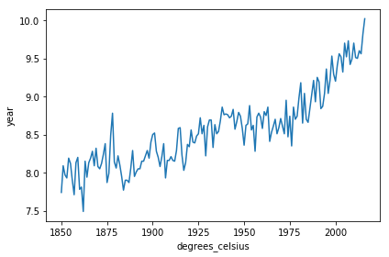

Task 4: Instructions for R

- Add any suitable labels to the x-axis and y-axis of the plot.
The dots .... in a code cell here means that something is missing and has to be filled in.
If you encounter any issues with this project, please Report an Issue by clicking the link in the top right corner.
# Plotting global temperature in degrees celsius by year.
plot(global_temp$year, global_temp$degrees_celsius,
type = "l", col = "forestgreen",
xlab = "year", ylab = "degrees_celsius")
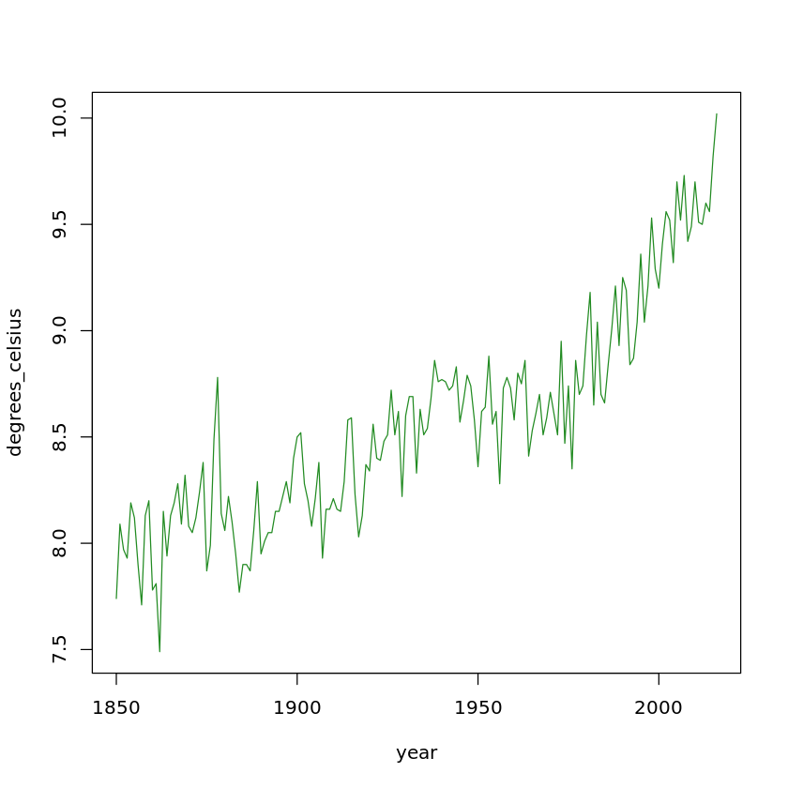

4. Jupyter Notebooks ♡ SQL (part ii)
And after the first connection to the database, the connection code (postgresql:///countries) can be omitted. Let's do a different query this time and select the row in the countries table for Belgium. Note the single % this time. Again, more on that later.

Task 4: Instructions for SQL
- Select all of the columns from the countries table where the name of the country is 'Belgium'. Remember to use single quotes (') for string constants like country names!
# Query the database
%sql SELECT * FROM countries WHERE name = 'Belgium';
* postgresql:///countries
1 rows affected.
[6]:
code | name | continent | region | surface_area | indep_year | local_name | gov_form | capital | cap_long | cap_lat
BEL | Belgium | Europe | Western Europe | 30518.0 | 1830 | Belgie/Belgique | Constitutional Monarchy, Federation | Brussels | 4.36761 | 50.8371

5. Jupyter notebooks ♡ a lot more
Tables and plots are the most common outputs when doing data analysis, but Jupyter notebooks can render many more types of outputs such as sound, animation, video, etc. Yes, almost anything that can be shown in a modern web browser. This also makes it possible to include interactive widgets directly in the notebook!
For example, this (slightly complicated) code will create an interactive map showing the locations of the three largest smartphone companies in 2016. You can move and zoom the map, and you can click the markers for more info!

Task 5: Instructions for Python
- Replace the ... in each label with the market share percentage for each smartphone company in companies.
Here is the information you need to solve this task — the 2016 market share of the top three smartphone companies:
- Samsung: 20.5%
- Apple: 14.4%
- Huawei: 8.9%
But wait! Before you complete this task try to check your project by clicking the Check Project button. This will go through all the tasks and check which are complete. For a correct task, the task circle will turn green and when something needs to be fixed the task circle will turn orange. You can then get more information about what needs to be done at the bottom of the orange tasks. You can check a project at any time to see how far you've gotten.
# Making a map using the folium module
import folium
phone_map = folium.Map()
# Top three smart phone companies by market share in 2016
companies = [
{'loc': [37.4970, 127.0266], 'label': 'Samsung: 20.5%'},
{'loc': [37.3318, -122.0311], 'label': 'Apple: 14.4%'},
{'loc': [22.5431, 114.0579], 'label': 'Huawei: 8.9%'}]
# Adding markers to the map
for company in companies:
marker = folium.Marker(location=company['loc'], popup=company['label'])
marker.add_to(phone_map)
# The last object in the cell always gets shown in the notebook
phone_map

Task 5: Instructions for R
- Plot the temperature_forecast using the autoplot function.
library(forecast)
library(ggplot2)
# Converting global_temp into a time series (ts) object.
global_temp_ts <- ts(global_temp$degrees_celsius,
start = global_temp$year[1])
# Forecasting global temperature 50 years into the future
# using an exponential smoothing state space model (ets).
temperature_forecast <- forecast( ets(global_temp_ts), h = 50)
# Plotting the forecast
# .... YOUR CODE FOR TASK 5 ....
autoplot(temperature_forecast)
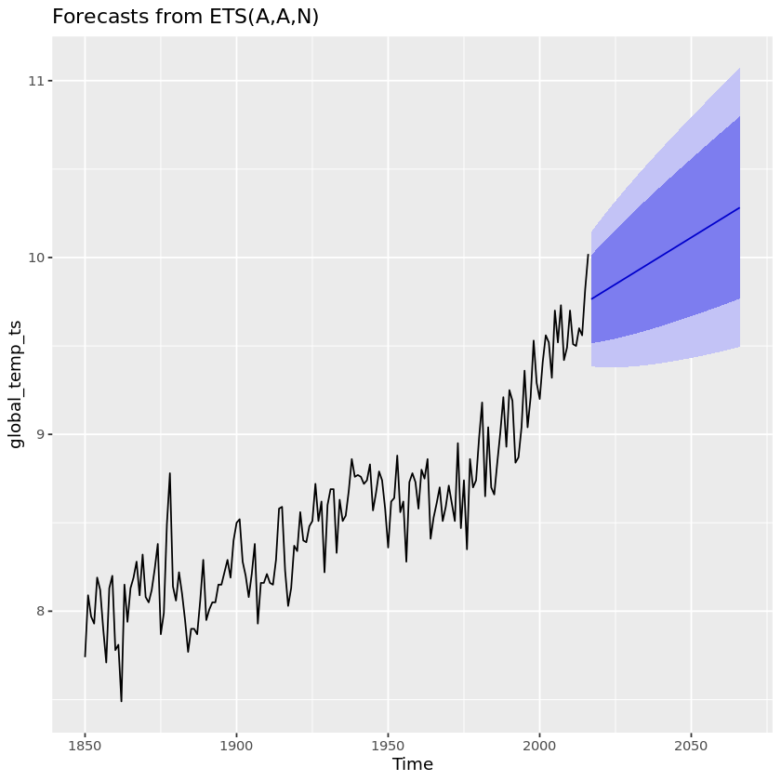

5. Jupyter Notebooks ♡ SQL (part iii)
We can even convert our SQL results to a pandas DataFrame! Let's convert the entire countries table.

Task 5: Instructions for SQL
- Use DataFrame() method the result object (which is called a ResultSet) to convert the results to a pandas DataFrame.

Helpful links are often provided in projects below the horizontal line that follows the task's bullet points.
Helpful links:
- ResultSet to DataFrame example from the creator of ipython-sql
# SQL Query
result = %sql SELECT * FROM countries;

# To pandas DataFrame
df = result.DataFrame()
df.info()
* postgresql:///countries
206 rows affected.
<class 'pandas.core.frame.DataFrame'>
RangeIndex: 206 entries, 0 to 205
Data columns (total 11 columns):
code 206 non-null object
name 206 non-null object
continent 206 non-null object
region 206 non-null object
surface_area 206 non-null float64
indep_year 188 non-null float64
local_name 206 non-null object
gov_form 206 non-null object
capital 201 non-null object
cap_long 204 non-null float64
cap_lat 204 non-null float64
dtypes: float64(4), object(7)
memory usage: 17.8+ KB

6. Goodbye for now!
This was just a short introduction to Jupyter notebooks, an open source technology that is increasingly used for data science and analysis. I hope you enjoyed it! :)
# Are you ready to get started with DataCamp projects?
I_am_ready =True

# Ps.
# Feel free to try out any other stuff in this notebook.
# It's all yours!

Task 6: Instructions for R
And this was just a short introduction to DataCamp projects. I hope you enjoyed it too! You are now ready to get started on your first real DataCamp project.
- Are you ready to get started with DataCamp projects, TRUE or FALSE?
- Check your project by clicking the Check Project button!
# Are you ready to get started with DataCamp projects?
I_am_ready <- TRUE

# Ps.
# Feel free to try out any other stuff in this notebook.
# It's all yours!

6. Jupyter Notebooks ♡ SQLAlchemy
If SQLAlchemy is your thing, you can do that in this notebook, too! Jupyter Notebooks love everything, apparently…
What's SQLAlchemy, you ask? SQLAlchemy is the Python SQL toolkit and Object Relational Mapper that gives application developers the full power and flexibility of SQL. Next, we'll run the last query we just ran except after connecting to and querying the database using SQLAlchemy.

Task 6: Instructions for SQL
- Run the code cell to query and display the columns of the countries table.
- Then, click the Next Task button below.
# Connect to database
from sqlalchemy import create_engine
engine = create_engine("postgresql:///countries");

# Query database
result = engine.execute("SELECT * FROM countries;")

# Display column names
result.keys()

['code',
'name',
'continent',
'region',
'surface_area',
'indep_year',
'local_name',
'gov_form',
'capital',
'cap_long',
'cap_lat']

7. Jupyter Notebooks ♡ plots
Tables are nice but — as the saying goes — "a plot can show a thousand data points." Notebooks handle plots as well, but it requires some more magic. Here magic does not refer to any arcane rituals but to so-called "magic commands" that affect how the Jupyter Notebook works. Magic commands start with either % or %% (just like we saw with %sql and %%sql) and the command we need to nicely display plots inline is %matplotlib inline. With this magic in place, all plots created in code cells will automatically be displayed inline.
Using the previously created pandas DataFrame that we named df, let's plot the number of countries in each continent as a bar chart using the plot() method of pandas DataFrames.
Now, for the difference between %%sql and %sql: ordinary assignment works for single-line %sql queries while %%sql is for multi-line queries. See the Assignment ipython-sql documentation section for more info.

Task 7: Instructions for SQL
- Run the code cell to plot the number of countries in each continent as a bar chart.
- Then, click the Next Task button below.
# Setting up inline plotting using Jupyter Notebook "magic"
%matplotlib inline

# Plotting number of countries in each continent
df.continent.value_counts().plot(kind='bar')

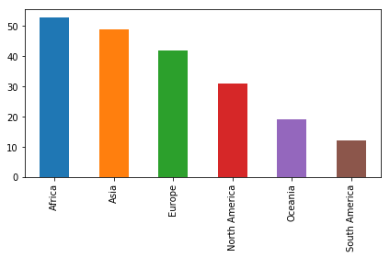

8. Goodbye for now!
Tables and plots are the most common outputs when doing data analysis, but Jupyter Notebooks can render many more types of outputs such as sound, animation, video, etc. Yes, almost anything that can be shown in a modern web browser. This also makes it possible to include interactive widgets directly in the notebook! Everything in this collection of Jupyter Widgets can be displayed in this notebook.
But that's enough for now! This was just a short introduction to Jupyter Notebooks, an open source technology that is increasingly used for data science and analysis. We hope you enjoyed it! :)

Task 8: Instructions for SQL
And this was just a short introduction to DataCamp projects. We hope you enjoyed it too! You are now ready to get started on your first real DataCamp project.
- Are you ready to get started with DataCamp projects, True or False?
- Check your project by clicking the Check Project button!

# Are you ready to get started with DataCamp projects?
I_am_ready = True

# P.S. Feel free to try out any other stuff in this notebook.
# It's all yours!

