**Acceptance Tests**

1. Verify field length for firstname and last name - enter more than 30 characters in both first and last name fields – user should be restricted to certain field length and appropriate validation message should display
2. Verify firstname and last name can accept only characters and does not accept numeric and special character except ‘ – appropriate validation message should display. At the moment user can enter special characters in firstname, surname and price fields
3. Verify Price field length – user is able to enter 10000000000000 – user should be restricted to certain amount or price field should be dropdown
4. Verify that mandatory field validation messages are implemented.
5. Verify that Checkin and Checkout dates are not in past – a validation message should display if user attempts this
6. Verify that Checkout date is greater than Check in date – a validation message should display if user attempts this
7. Verify that checkin date is >= todays date
8. Verify that and checkout date is always > todays date
9. Verify that checkout date > check in date and is in the future
10. Verify that deposite has to be paid upfront or not.
11. Verify that when all valid data is entered user can complete the booking
12. Verify that user can delete the booking
13. Check for SQL injection

**Test Evidence:**

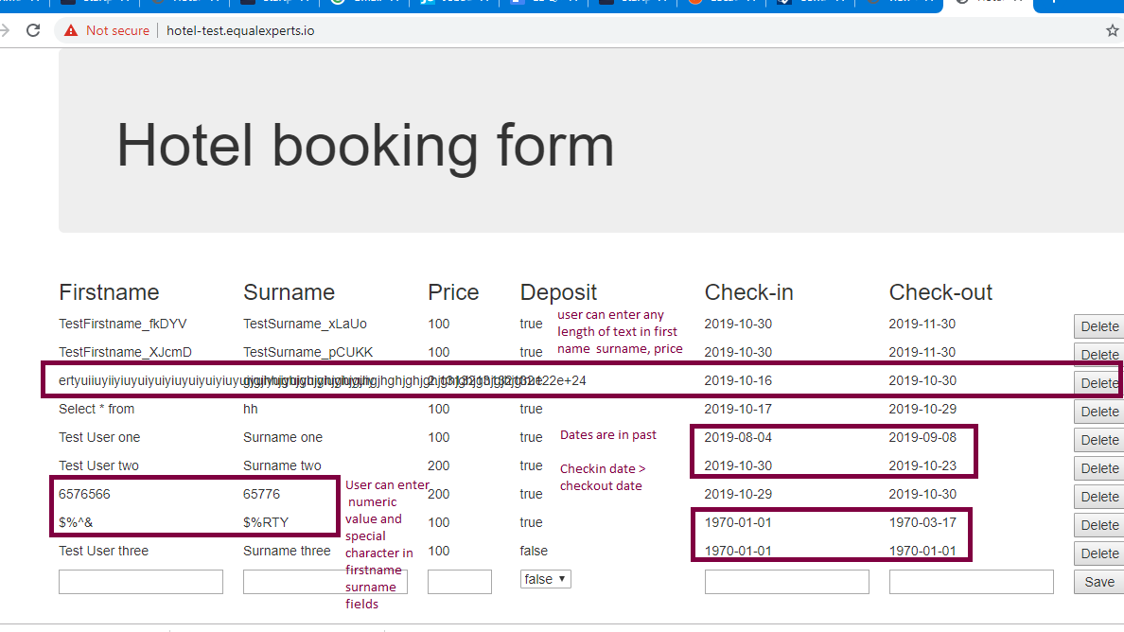

**Cross Browser Testing**

-Ensure that hotel booking system works on IE,Firefox, Chrome, Safari

**Mobile Testing**

-Ensure that hotel booking system works on Apple products and Android phones

**Security Testing**

**-**Check SQL injection

-Cross site scripting

-DDS attacks

**Performance Testing**

-check the site for load, stress and volume

**Accessibility Testing**

**-**Ensure that site is compatible with GDS standards

**Test Automation Approach**

Two main end to end journeys have been automated to get maximum benefit on regression testing. Many lower level tests haven’t been automated as there is no clarification on requirements.

For example,

field lengths and field validation.

Check in , Check out date validation

The test automation also does not address what happens if two people with same name does a booking for same check in and check out dates.

Scenario: Two different John Smiths books for checkin date = 10/10/2019 and check out date = 10/11/2019

If one of the customer cancels the booking – there is no way of knowing which record should be deleted from a UI point of view unless the newly generated Div Id is stored. Hence I have used unique firstnames for the test automation purpose