Easytaxi System Design

Design Specifications

Author | Ren Mian | 编写 时间 | 2011-3-26
Version | V1.0

Document Revision Summary

Date | Revision | Descriptions | Author
2011-3-26 | 1 | Create the initial document. | Ren Mian

System Summary
This System design is for easytaxi project’s Server side.

- Functional Requirements
1. Register as Taxi and be assigned a userid and password (or using phone number to login);
2. Register as Passenger and be assigned a userid and password (or using phone number to login);
3. Maintain a profile for Taxi and Passenger;
4. Passenger can initiate a request for hiring a taxi, record the request, and broadcast to the taxis in the scope.
5. Query the request info for taxi;
6. Get the taxies’ confirmations, and caculate the best one to provide passenger’s query;
7. Passenger and taxi can get each other’s informations.
8. Record the taxi’s ride;
9. Query history: Request for passenger, Confirm for Taxi, Ride for Taxi;
10. Credit Rating for both taxi and passenger

- Nonfunctional Requirements
- 5,000 simultaneous users with subsecond response time;
- Client access security check;
- Data processing speed;
- 99% availability 24*7.

System Design Strategy
- Infrastructure
Based on J2EE Framework and mysql db, and all using open source: Spring, google Map API.
- Design Strategy
Expansion: Flexible interface.
Reuse: User legality verification, data query and insert.
Compromise: Reduce complexity, client app need to finish the algorithm about the broadcasting for request of the passenger.

System Structure

DataBase
User Managerment
Location Service
Credit Rating

History Query
Interface
User
legality
check

Location
information
Record

Request
Initiate/
Broadcast/
Response
User
Information
Query

Credit
Rating

- External Relations Diagram
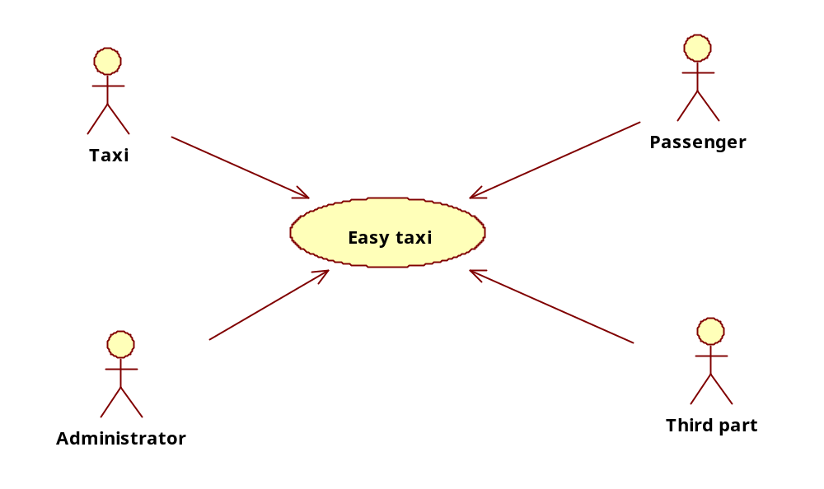

System Environment
- Developments environment
JDK1.5+
IDE: eclipse3.5
DB: Mysql
SVN: http://code.google.com/p/easytaxi
- Runtime environment
JDK1.5+
Server: Apache2.2+Tomcat6.0
DB: Mysql
Server OS: Linux, Windows, Unix.

Key Technology
- C/S data interactive mode：Http Protocol，JSON data stream；
- The performance requirements to process the real-time data：consider the use of cache or memory database to resolve it.
- the high consume about the large location data：using the GML to save the historical location data.

Potential Issues
- Client network delay or abnormal exit, the redundant data processing(客户端网络中断或异常退出，服务器对冗余数据的处理);
- Data communication security(客户端和服务器端的通信安全性);
- Communication packet size, the client GPRS consumption(通信包大小，对客户端流量消耗);

