**CHAPTER 1**

**INTRODUCTION**

**PROJECT TITLE:** Grocery Web App

**TEAM MEMBERS:**

1. R DEEPA(310121104020)
2. K DIVYA(310121104027)
3. M KEERTHIKA(310121104051)
4. A KUSHBOO(310121104050)
5. R MAHALAKSHMI (310121104057)

**PROJECT OVERVIEW**

**PURPOSE:**

The purpose of the Grocery Web App is to provide a convenient, efficient, and user-friendly platform for individuals to manage their grocery shopping. It aims to simplify the process of creating shopping lists, discovering new products, and ordering groceries from local stores or delivery services, all from a single interface.

The app’s goal is to save users time and effort by enabling them to quickly browse products, compare prices, and track spending, making it easier to plan meals and stick to budgets. Additionally, the app can recommend personalized items based on preferences, dietary restrictions, and purchase history, enhancing the overall shopping experience.

By integrating features like automatic list generation, order tracking, and multiple payment options, the app seeks to streamline the grocery shopping journey, offering a seamless, stress-free alternative to traditional in-store shopping

**GOALS:**

• **Enhance Shopping Convenience**  
The app aims to provide users with a simple, intuitive interface that allows them to quickly browse and purchase groceries without leaving their homes, saving time and effort.

• **Personalized Recommendations**  
By analyzing user preferences and shopping history, the app strives to offer tailored product suggestions, helping customers discover new items and make informed choices based on dietary needs, preferences, and past behavior.

• **Budget Management**  
The app seeks to help users stick to their budgets by providing price comparisons, tracking spending, and allowing users to create shopping lists that align with their financial goals.

• **Streamline Shopping Lists and Meal Planning**  
The app aims to automate the process of creating shopping lists by suggesting items based on past purchases, meal planning, or inventory tracking, making the grocery process more organized and efficient.

• **Support Local and Online Shopping Options**  
The goal is to bridge the gap between in-store and online shopping by offering users the option to choose between local grocery stores or delivery services, ensuring a wide range of options based on user preference.

• **Improve User Experience**  
With an intuitive and responsive design, the app's goal is to provide a seamless shopping experience across all devices, from desktop to mobile, ensuring users can shop at their convenience, anytime and anywhere.

• **Reduce Environmental Impact**  
The app seeks to promote sustainability by offering features like eco-friendly product suggestions, local sourcing, and tools to help users reduce food waste, like tracking expiration dates or recommending bulk purchasing options.

• **Increase User Engagement**  
By integrating features like loyalty programs, discounts, and social sharing, the app aims to foster a strong connection with users, encouraging repeat use and creating a sense of community around grocery shopping.

**FEATURES AND FUNCTIONALITIES**

• **User Accounts and Profiles**  
Users can create personal accounts to save preferences, shopping lists, and order history. Profiles allow customization of dietary restrictions, product preferences, and delivery information, enhancing the personalized experience.

• **Smart Shopping List**  
Users can easily create, manage, and edit shopping lists. The app can automatically suggest items based on past purchases, pantry inventory, or meal plans, helping to streamline the shopping process.

• **Product Search and Filters**  
A robust search engine lets users quickly find specific products by name, category, or brand. Filters such as price range, dietary requirements (e.g., gluten-free, vegan), and product ratings help narrow down options.

• **Price Comparison**  
The app allows users to compare prices of groceries across multiple local stores or online retailers, ensuring that they get the best deals available.

• **Product Recommendations**  
Using algorithms based on user behavior and preferences, the app suggests new products, recipes, and ingredients that align with their tastes and dietary restrictions.

• **Meal Planning Integration**  
The app includes a meal planner where users can choose or create recipes for the week. It will automatically generate shopping lists based on the selected meals, ensuring all ingredients are accounted for.

• **Inventory Tracking**  
Users can track what’s in their pantry or fridge, and the app can notify them when products are running low or nearing expiration, helping to reduce food waste and unnecessary purchases.

• **Order Management**  
The app offers easy order management, allowing users to view past orders, track current shipments, and reorder items with just a few clicks. Users can also save favorite items for quick future purchases.

• **Local Store Integration**  
The app integrates with local grocery stores, showing real-time availability of products, special promotions, and delivery options. This ensures that users can shop from their preferred stores or choose delivery services.

• **Multiple Payment Options**  
Users can securely pay for their orders using various payment methods, including credit/debit cards, digital wallets, or even cash on delivery, depending on the store’s policies.

• **Subscription and Auto-Refills**  
For frequently purchased items like toiletries or staples, the app allows users to set up subscriptions for automatic refills, ensuring they never run out of essential products.

• **Real-Time Delivery Tracking**  
Once an order is placed, users can track their delivery in real time, from dispatch to arrival, and receive notifications about their order status.

• **Promotions and Discounts**  
Users can access exclusive offers, discounts, and loyalty rewards based on their shopping behavior, helping them save money over time.

• **Eco-Friendly Product Options**  
The app highlights eco-conscious products, such as sustainable, organic, or zero-waste items, and allows users to filter for green alternatives.

• **Community and Social Features**  
Users can share shopping lists, recipes, or meal ideas with friends and family, creating a sense of community around grocery shopping. Social media integration allows easy sharing of their grocery experiences.

• **Push Notifications and Alerts**  
Users receive notifications about order status, sales, new product arrivals, and reminders for grocery replenishment or upcoming subscription renewals.

• **Voice Search and Virtual Assistant**  
Integration with voice-enabled devices (e.g., Alexa, Google Assistant) allows users to add items to their shopping list or reorder with simple voice commands.

• **Recipe Database**  
The app offers a wide database of recipes that users can search based on ingredients they have at home, helping them decide what to cook and automatically generate a shopping list for needed items.

• **Barcode Scanning**  
Users can scan product barcodes to quickly add items to their shopping list or check prices, nutritional information, or product reviews.

• **Customer Support and Live Chat**  
The app features a customer support system with live chat, FAQs, and troubleshooting guides to assist users with any issues they may encounter.

**ARCHITECTURE:**

The architecture of the Grocery Web App is designed to ensure scalability, reliability, and high performance while providing a seamless user experience. The application typically follows a **multi-layered (or multi-tier) architecture**, which separates concerns into distinct layers or modules. Here's an overview of how this architecture is structured:

**1. Frontend Layer (Client-Side)**

* **Technologies**: HTML, CSS, JavaScript, React, Angular, Vue.js, or Svelte
* **Purpose**: This is the user-facing part of the app. It is responsible for rendering the interface, interacting with the user, and sending requests to the backend.
  + **Components**:
    - **User Interface (UI)**: Displays the product catalog, shopping lists, search functionality, and order details.
    - **User Authentication**: Login, registration, and profile management interfaces.
    - **Real-Time Updates**: For showing live order status, delivery tracking, and inventory updates.
    - **Responsive Design**: Ensures that the app functions seamlessly across devices (desktop, tablet, mobile).
    - **State Management**: Libraries like Redux (React), Vuex (Vue), or NgRx (Angular) manage the application's state (e.g., cart contents, user authentication).

**2. Backend Layer (Server-Side)**

* **Technologies**: Node.js, Python (Django, Flask), Ruby on Rails, Java (Spring Boot), or .NET
* **Purpose**: The backend handles business logic, database interactions, and data processing. It processes requests from the frontend, performs necessary computations, and interacts with external services or databases.
  + **Components**:
    - **API Endpoints (RESTful or GraphQL)**: Handles requests from the frontend such as product search, adding items to the shopping list, user authentication, and processing orders.
    - **Business Logic Layer**: Manages the core functionality of the app, such as price comparison, meal planning logic, product recommendations, etc.
    - **Authentication & Authorization**: Manages secure user authentication (using JWT tokens, OAuth2, etc.) and role-based access control.
    - **Order Processing**: Handles order creation, payment processing, and integrates with external services for shipping and delivery tracking.

**3. Database Layer (Data Storage)**

* **Technologies**: Relational Databases (e.g., PostgreSQL, MySQL) or NoSQL Databases (e.g., MongoDB, Firebase)
* **Purpose**: Stores structured and unstructured data, including user profiles, product information, transaction history, shopping lists, and inventory levels.
  + **Components**:
    - **User Data**: Stores user profiles, preferences, and order history.
    - **Product Catalog**: Contains details about products, including name, price, description, category, and inventory.
    - **Shopping Lists & Orders**: Stores active and past shopping lists, order statuses, and payment history.
    - **Recommendations Engine Data**: Stores data used by the recommendation algorithm (e.g., user behavior, preferences, dietary restrictions).

**4. Third-Party Integrations and Microservices**

* **Payment Gateway**: Integrates with payment providers like Stripe, PayPal, or Apple Pay for secure payment processing.
* **External Grocery Store APIs**: Integrates with external stores or suppliers for real-time product availability, pricing, and delivery options.
* **Shipping and Delivery APIs**: Integrates with logistics providers like FedEx, UPS, or local delivery services for real-time tracking and delivery management.
* **Recommendation Engine**: Uses machine learning models or algorithm-based services to provide product recommendations, meal suggestions, and personalized offers.
* **Email/SMS/Push Notifications**: Sends order updates, promotions, and reminders through third-party services like Twilio, SendGrid, or Firebase Cloud Messaging.

**5. Caching Layer**

* **Technologies**: Redis, Memcached
* **Purpose**: Improves the performance of the app by storing frequently accessed data, like product details, search results, or user session information, in-memory to reduce database load and speed up response times.
* **Use Case**: Caching product catalogs, user shopping cart, and recommendation results to reduce repeated database queries.

**6. Search Engine and Indexing**

* **Technologies**: Elasticsearch, Apache Solr, Algolia
* **Purpose**: Provides fast and scalable search functionality for products, categories, and other data points. These systems enable full-text search, filtering, and sorting.
* **Use Case**: Fast product search, including autocomplete suggestions, filters based on price, ratings, categories, and more.

**7. Cloud Infrastructure & Hosting**

* **Technologies**: AWS, Google Cloud, Microsoft Azure
* **Purpose**: Hosts the application and its components, ensuring high availability, scalability, and fault tolerance. Cloud services allow for elastic scaling to handle traffic spikes, especially during promotions or peak shopping periods.
* **Components**:
  + **Compute**: EC2, Google Compute Engine, or Azure VMs to run the app’s backend.
  + **Storage**: S3 (Amazon), Google Cloud Storage for storing product images, user data backups, etc.
  + **CDN (Content Delivery Network)**: Distributes static assets (e.g., images, JavaScript files) globally for faster access.

**8. Security Layer**

* **Technologies**: SSL/TLS, OAuth, JWT, Two-Factor Authentication (2FA)
* **Purpose**: Ensures that data transfers are secure, user data is protected, and the application is resistant to common security vulnerabilities.
* **Components**:
  + **Encryption**: Protects sensitive data such as payment information and user credentials.
  + **Firewalls**: Protects the app’s servers from unauthorized access.
  + **User Privacy**: Ensures compliance with data protection regulations such as GDPR and CCPA.

**9. Monitoring and Analytics**

* **Technologies**: Prometheus, Grafana, Google Analytics, Sentry, New Relic
* **Purpose**: Tracks the app’s performance, usage patterns, error logging, and user activity to ensure smooth operation and to optimize performance.
* **Components**:
  + **Application Monitoring**: Tracks server health, load times, and response times to detect issues early.
  + **User Behavior Analytics**: Monitors how users interact with the app to identify friction points and areas for improvement.

.

**SET-UP INSTRUCTIONS:**

To develop a full-stack Grocery Web App using React js, Node.js,Express js and MongoDB, there are several prerequisites you should consider. Here are the key prerequisites for developing such an application:

**Node.js and npm:** Install Node.js, which includes npm (Node Package Manager), on your development machine. Node.js is required to run JavaScript on the server side.

**• Download:** <https://nodejs.org/en/download/>

**• Installation instructions:** <https://nodejs.org/en/download/package-manager/>

**MongoDB:** Set up a MongoDB database to store hotel and booking information. Install MongoDB locally or use a cloud-based MongoDB service.

• **Download:**<https://www.mongodb.com/try/download/community>

**• Installation instructions:** <https://docs.mongodb.com/manual/installation/>

**Express.js:** Express.js is a web application framework for Node.js. Install Express.js to handle server-side routing, middleware, and API development.

• **Installation:** Open your command prompt or terminal and run the following

**command:** npm install express

**React js:** React is a JavaScript library for building client-side applications.

 And Creating Single Page Web-Appliaction

**Getting Started**

Create React App is an officially supported way to create single-page React applications. It offers a modern build setup with no configuration.

**Quik  Start**

npm create vite@latest

cd my-app

npm install

npm run dev

If you've previously installed create-react-app globally via npm install -g create-react-app, we recommend you uninstall the package using npm uninstall -g create-react-app or yarn global remove create-react-app to ensure that npx always uses the latest version.

**Create a new React project:**

• Choose or create a directory where you want to set up your React project.

• Open your terminal or command prompt.

• Navigate to the selected directory using the cd command.

Create a new React project by running the following

**command:** npx create-react-app your-app-name.

Wait for the project to be created:

• This command will generate the basic project structure and install the necessary dependencies

**Navigate into the project directory:**

• After the project creation is complete, navigate into the project directory by running the following

**command:** cd your-app-name

**Start the development server:**

• To launch the development server and see your React app in the browser, run the following command:  npm run dev

• The npm start  will compile your app and start the development server.

• Open your web browser and navigate to [https://localhost:5173](https://localhost:5173/) to see your React app.

You have successfully set up React on your machine and created a new React project. You can now start building your app by modifying the generated project files in the src directory.

Please note that these instructions provide a basic setup for React. You can explore more advanced configurations and features by referring to the official  React documentation: <https://react.dev/>

HTML, CSS, and JavaScript: Basic knowledge of HTML for creating the structure of your app, CSS for styling, and JavaScript for client-side interactivity is essential.

**Database Connectivity:** Use a MongoDB driver or an Object-Document Mapping (ODM) library like Mongoose to connect your Node.js server with the MongoDB database and perform CRUD (Create, Read, Update, Delete) operations.

**Front-end Library:** Utilize React  to build the user-facing part of the application, including products listings, booking forms, and user interfaces for the admin dashboard.

**Version Control:** Use Git for version control, enabling collaboration and tracking changes throughout the development process. Platforms like GitHub or Bitbucket can host your repository.

• **Git:** Download and installation instructions can be found at:<https://git-scm.com/downloads>

**Development Environment:** Choose a code editor or Integrated Development Environment (IDE) that suits your preferences, such as Visual Studio Code, Sublime Text, or WebStorm.

• **Visual Studio Code:** Download from <https://code.visualstudio.com/download>

## ****Folder Structure****

### ****Client Folder Structure (React)****

plaintext

Copy code

client/

├── public/

│ └── index.html

├── src/

│ ├── assets/

│ ├── components/

│ ├── context/

│ ├── pages/

│ ├── services/

│ ├── App.js

│ └── index.js

└── package.json

### ****Server Folder Structure (Node.js/Express)****

plaintext

Copy code

server/

├── controllers/

├── models/

├── routes/

├── middleware/

├── config/

├── .env

├── server.js

└── package.json

## ****6. Running the Application****

1. **Frontend**:
   * Navigate to the client folder and run:
   * npm start
   * Open your browser and go to http://localhost:3000 to view the application.
2. **Backend**:
   * Navigate to the server folder and run:
   * npm start
   * The backend will run on <http://localhost:5000>.

## ****Authentication****

To add **authentication** to your grocery web app, we’ll need to implement **user registration** and **login** functionality. We will use **JWT (JSON Web Tokens)** for token-based authentication. Here's how you can add authentication using **Node.js**, **Express**, **JWT**, and **bcryptjs** for password hashing.

We'll break this into a few steps:

1. **Set up user model for MongoDB**.
2. **Implement registration and login routes**.
3. **Protect API routes** using JWT.
4. **Integrate frontend with the backend**.

## ****User Interface****

Creating a user-friendly **User Interface (UI)** for your grocery web app involves designing pages for registration, login, viewing grocery items, and adding new groceries. Here's a breakdown of how to structure the UI components for a better user experience.

We will use **React** to build the UI, with simple CSS for styling, but you can integrate more advanced styling libraries like **Material UI** or **Bootstrap** for a more polished design.

**1. App Structure Overview**

Your app will have the following components:

* **Registration Page**
* **Login Page**
* **Grocery List Page**
* **Add Grocery Form Page**
* **Header or Navbar**

Each page can be displayed conditionally based on the user's authentication status (whether they have logged in or registered).

## ****Testing****

**1. Backend Testing**

Backend testing ensures your API routes and logic work as expected. We’ll use **Jest** and **Supertest** to test HTTP requests. First, install the necessary dependencies with:

npm install --save-dev jest supertest

Then, create test files (e.g., auth.test.js) to test routes like user registration and login. For example, you can check that a successful registration returns a 201 status, and duplicate email registrations return a 400 error.

Run your tests with:

npx jest

This command will execute all .test.js files and output the results in the terminal.

**2. Frontend Testing**

Frontend testing verifies your React components function correctly. We’ll use **Jest** and **React Testing Library** for this. Install dependencies:

npm install --save-dev @testing-library/react @testing-library/jest-dom @testing-library/user-event jest

Create test files for each component (e.g., Login.test.js) to simulate user interactions like typing in input fields and clicking buttons. Use mocks for external calls (like API requests). After writing tests, run them with:

npm test

This will trigger Jest to run all frontend tests and display the results.

**3. End-to-End (E2E) Testing with Cypress**

End-to-end testing ensures the entire application flow works correctly. **Cypress** simulates real user interactions with your app. Install Cypress with:

npm install --save-dev cypress

Write tests in the cypress/integration folder, like verifying that a user can log in successfully and is redirected to the grocery list page. Run tests with:

npx cypress open

This opens the Cypress test runner for interactive testing.

**4. Summary of Testing Strategy**

For robust testing:

1. **Backend**: Use Jest and Supertest to test API routes and logic.
2. **Frontend**: Use Jest and React Testing Library to test individual components and simulate user interactions.
3. **End-to-End (E2E)**: Use Cypress to test the full app flow, simulating real-world user behavior.

By using **unit**, **component**, and **E2E tests**, you ensure both the backend and frontend work as expected, offering a reliable user experience.

**Screenshots** 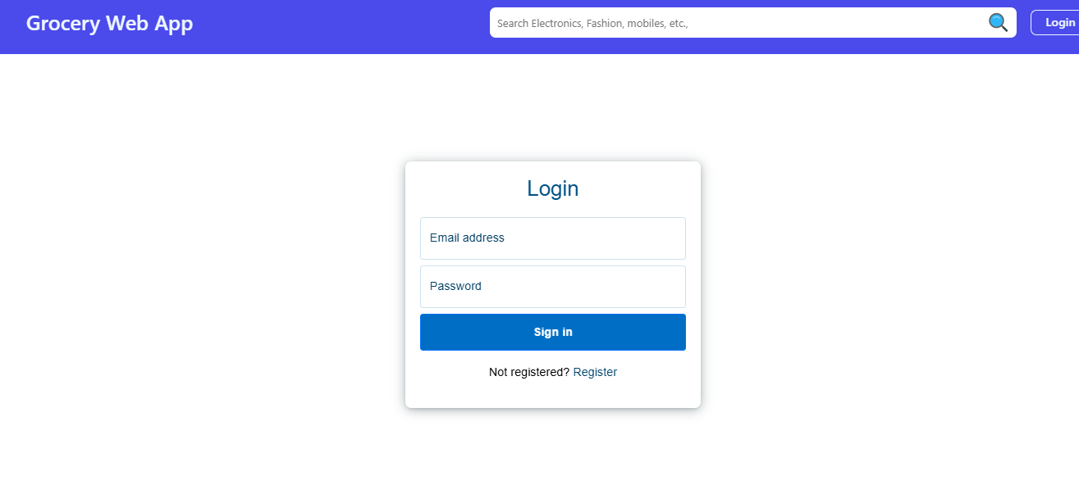

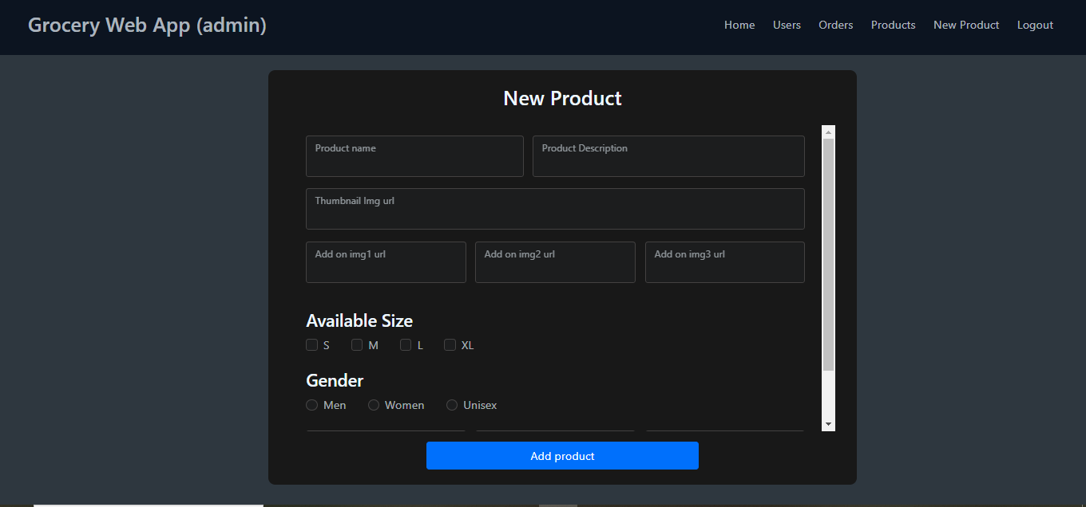

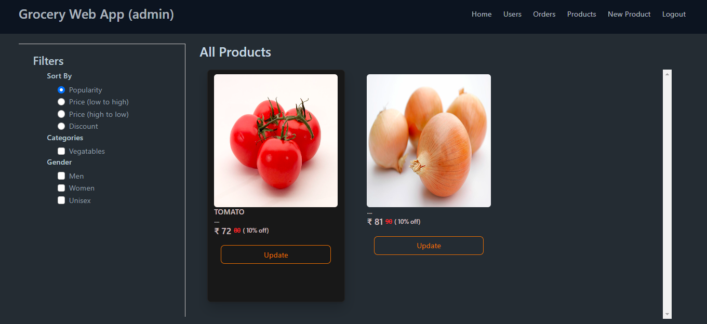

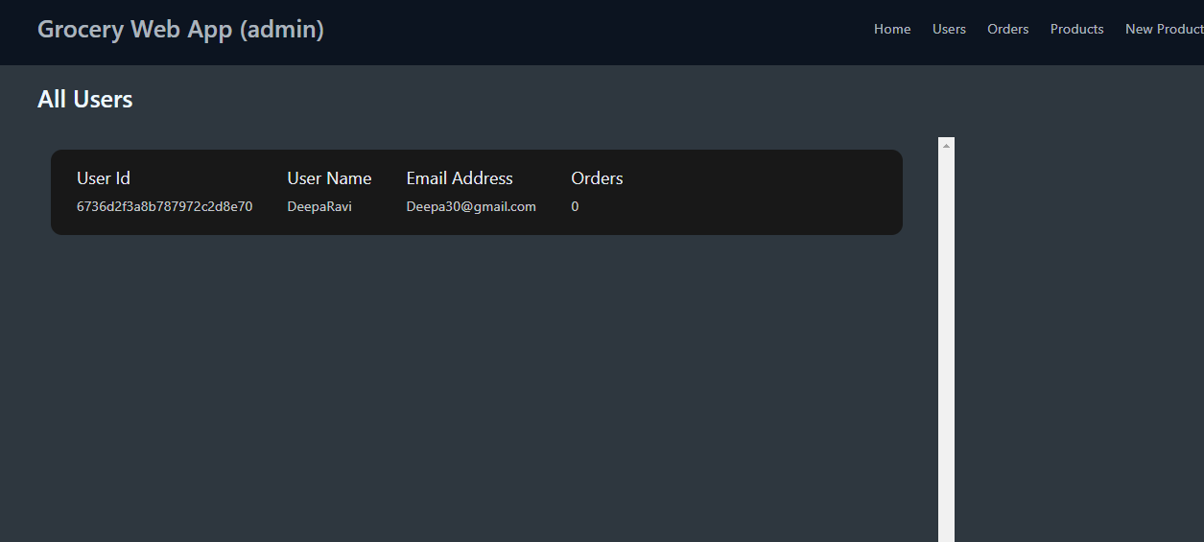

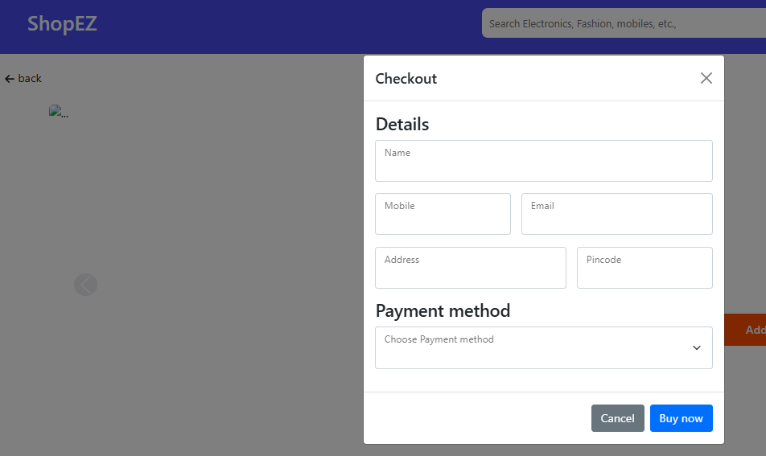

## ****Known Issues****

### ****Authentication Token Expiry****

**Issue**: Tokens may expire.  
**Solution**: Implement token refresh or store tokens in **httpOnly cookies**.

### ****CORS Issues****

**Issue**: Cross-origin requests may be blocked.  
**Solution**: Use **CORS middleware** in the backend.

### ****State Management****

**Issue**: Managing global state is tricky.  
**Solution**: Use **React Context** or **Redux**.

### ****Handling Large Data****

**Issue**: Large data can slow down the app.  
**Solution**: Use **pagination**, **infinite scrolling**, or **virtualization**.

### ****Slow API Responses****

**Issue**: Slow API calls affect UX.  
**Solution**: Optimize queries, use **caching**, and **lazy load** data.

### ****Form Validation****

**Issue**: Input errors are not handled properly.  
**Solution**: Use **client-side** and **server-side validation**.

### ****Mobile Responsiveness****

**Issue**: App may not display well on mobile.  
**Solution**: Use **CSS media queries** and **mobile-first design**.

### ****Security Issues****

**Issue**: Tokens may not be securely stored.  
**Solution**: Use **httpOnly cookies**, **HTTPS**, and **RBAC**.

### ****Version Mismatches****

**Issue**: Frontend and backend may get out of sync.  
**Solution**: Keep **API documentation** and **version control**.

### ****Testing Difficulties****

**Issue**: Testing complex flows is challenging.  
**Solution**: Use **mocking**, **Cypress**, and test edge cases.

### ****Browser Compatibility****

**Issue**: Inconsistent behavior across browsers.  
**Solution**: Test on multiple browsers and use **Autoprefixer**.

## ****Future Enhancements****

Future enhancements for the grocery web app could include adding **voice search integration** to enable hands-free shopping, improving accessibility and convenience. **AI-powered suggestions** could recommend groceries based on user preferences and purchase history, offering a personalized shopping experience. Integrating **real-time inventory updates** would provide accurate stock information, reducing the risk of out-of-stock issues. Supporting **advanced payment options** like Apple Pay, Google Pay, and even cryptocurrency would increase flexibility and appeal to a broader user base. **Barcode scanning** could be added to speed up the shopping process, making it easier to add items to the cart. Offering **subscription and delivery scheduling** features would provide users with the convenience of recurring orders and flexible delivery times. Adding **social sharing features** would allow users to share shopping lists or meal plans, boosting engagement. Incorporating **sustainability features** like highlighting eco-friendly or locally sourced products would attract environmentally conscious consumers. Implementing **Augmented Reality (AR)** would allow users to visualize products in their homes, especially for large items, creating a unique shopping experience. Enabling **user-generated content**, such as reviews and ratings, would help build community trust and assist in product decision-making. **Integrated recipe suggestions** based on cart contents or previous purchases could drive additional sales and enhance the overall shopping experience. Finally, adding **multi-language and multi-currency support** would make the app accessible to a global audience, expanding its reach. These features will help improve user experience, increase engagement, and keep the app competitive in an evolving market.