Analysis Report

Question 1

1. Display each digit. [5 points]

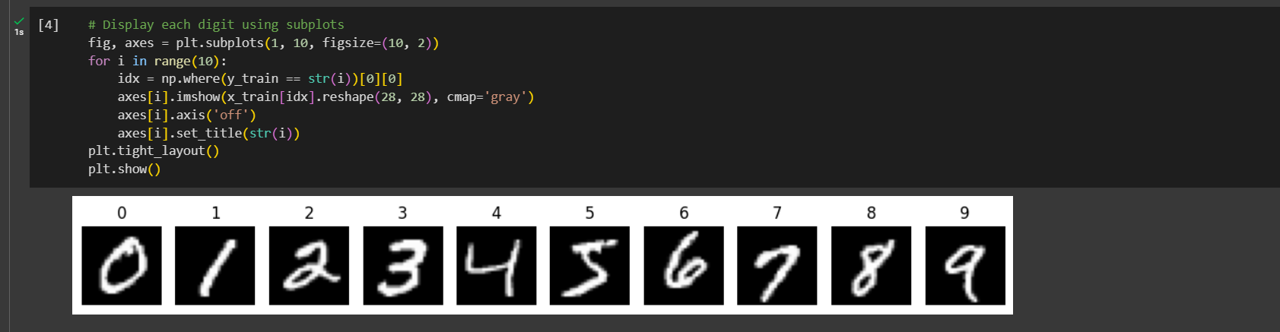

1. Explained Varience ratio

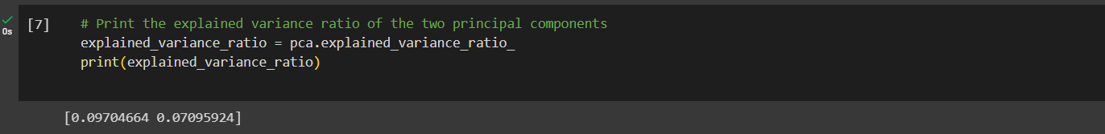

1. Plot the projections of the 1�ℎ and 2�� principal component onto a 2D hyperplane. [5 points]

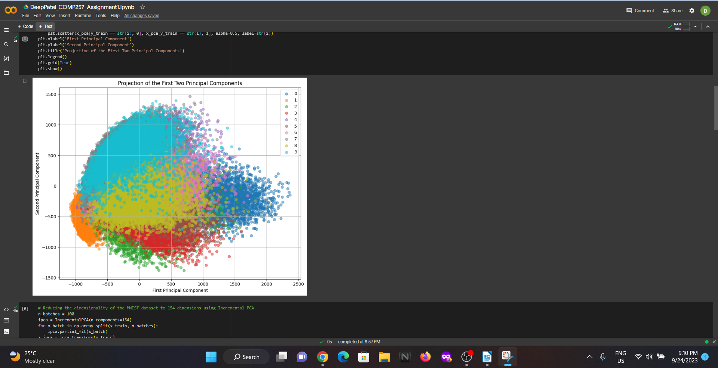

1. Display the original and compressed digits from (5). [5 points]

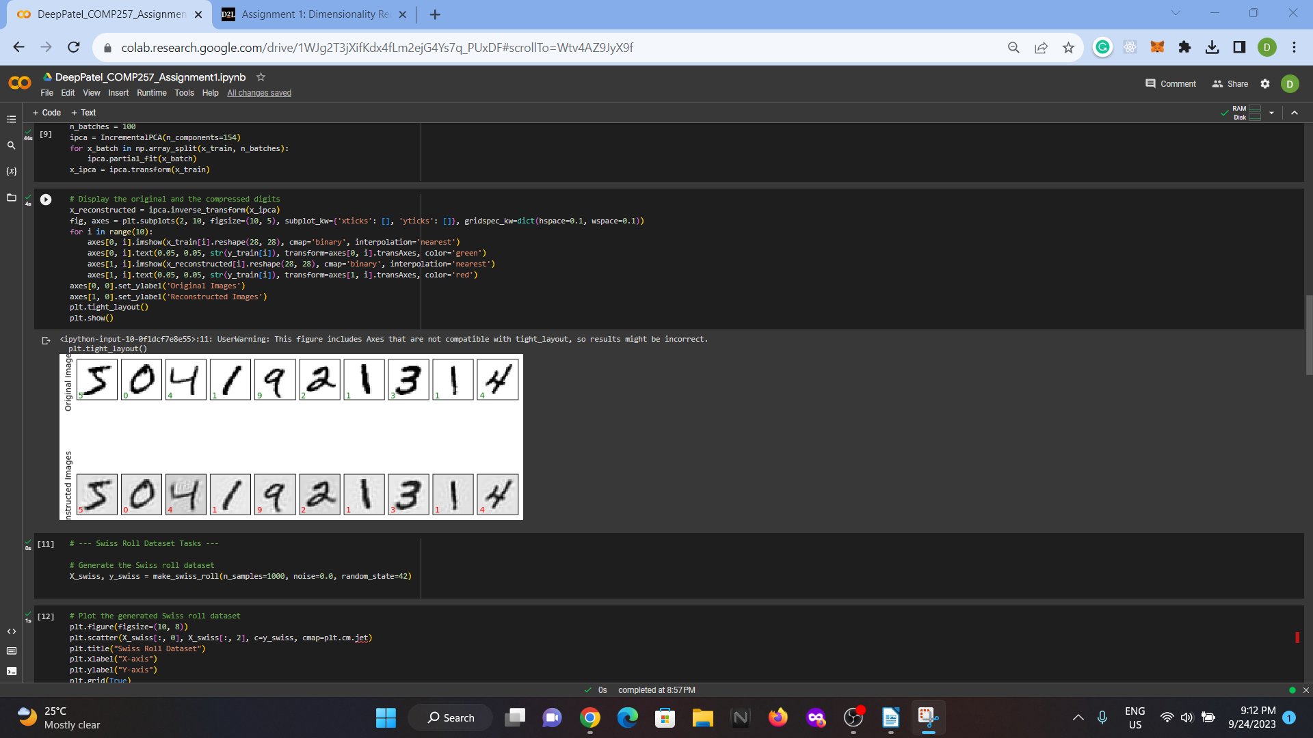

**Question 2**

1. Plot the resulting generated Swiss roll dataset. [2 points]

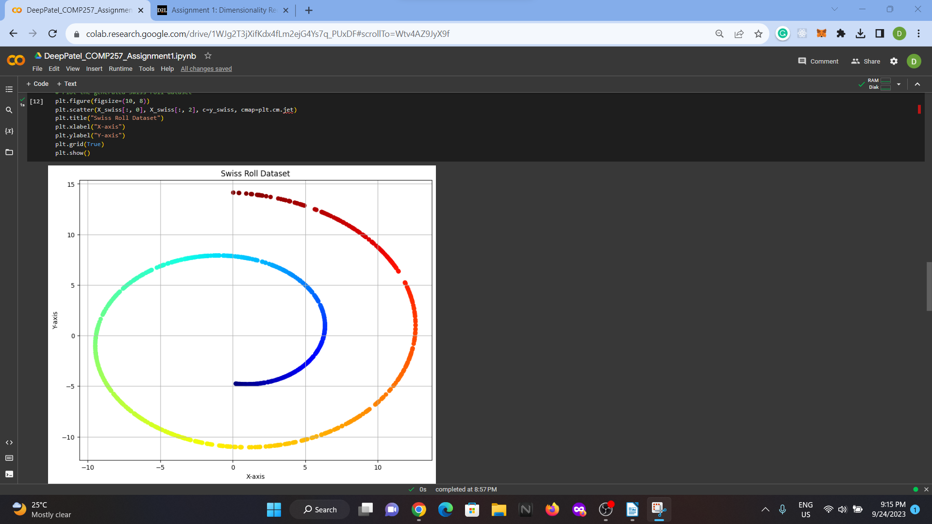

1. Plot the kPCA results of applying the linear kernel (2 points), a RBF kernel (2 points), and a sigmoid kernel (2 points) from (3). Explain and compare the results [6 points]

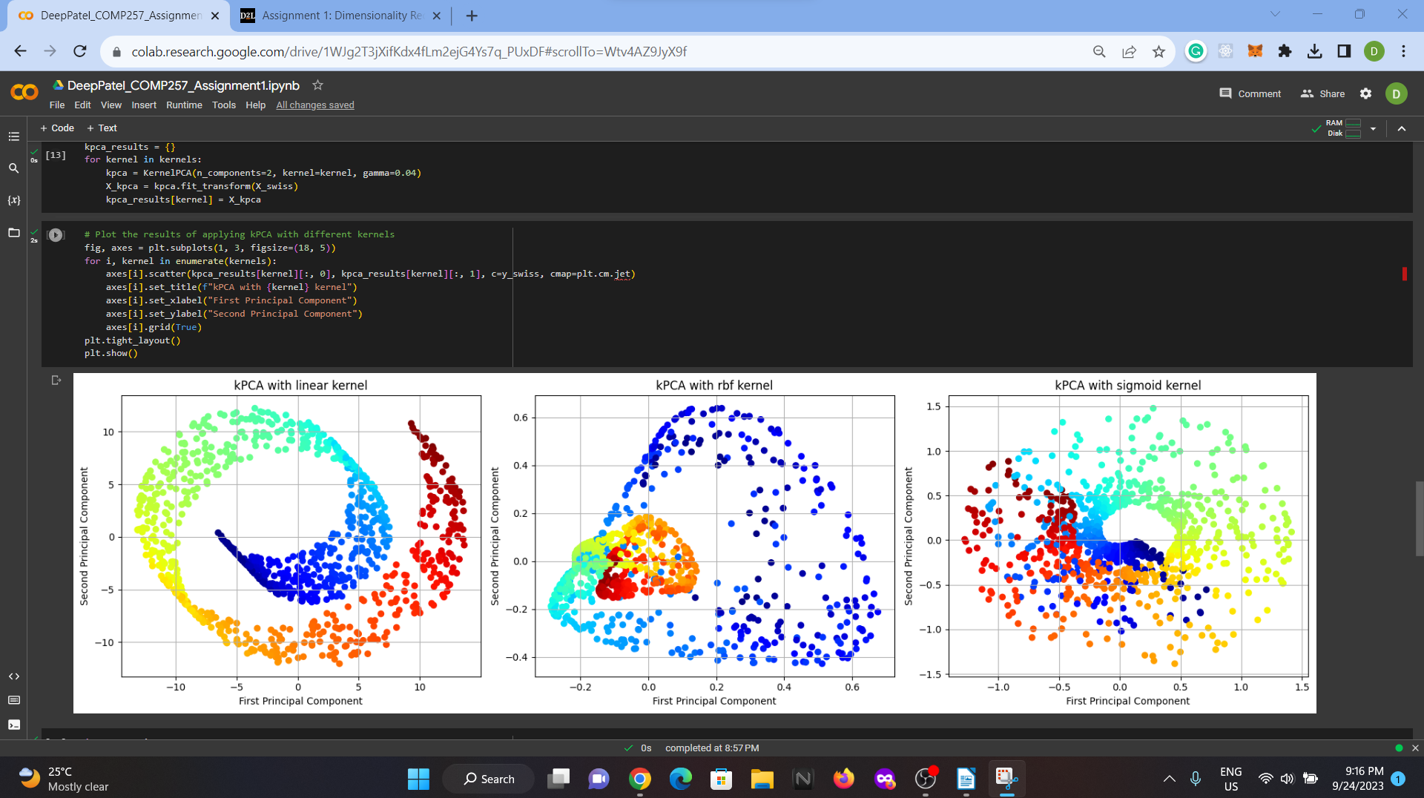

1. Using kPCA and a kernel of your choice, apply Logistic Regression for classification. Use GridSearchCV to find the best kernel and gamma value for kPCA in order to get the best classification accuracy at the end of the pipeline. Print out best parameters found by GridSearchCV. [14 points]

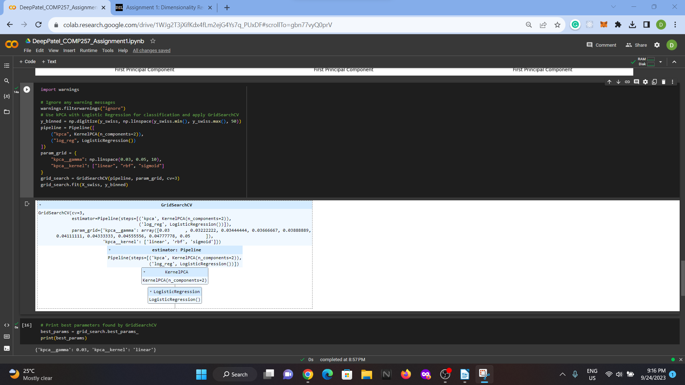

1. Plot the results from using GridSearchCV in (5). [2 points]

