PROJECT REPORT
End-to-End E-Commerce
Intelligence System
─────────────────────────────────────────
Data Integration • Feature Engineering • Business Intelligence
Revenue Analytics • Customer Behavior • Operational Efficiency

1. Project Overview
This project delivers an End-to-End E-Commerce Intelligence System designed to extract actionable business insights from a multi-table e-commerce dataset. The system integrates data engineering, feature construction, and visual analytics to surface revenue trends, customer patterns, and operational inefficiencies.

1.1 Business Problem Statement
E-commerce platforms generate vast transactional data across orders, customers, products, sellers, payments, and reviews. Without systematic analysis, this data remains underutilized. This project addresses the need to understand what is driving revenue, which customers and sellers matter most, where operational gaps exist, and how satisfaction can be improved.

1.2 Objectives
- Analyze revenue and order trends across time and product categories
- Identify top-performing product categories and revenue concentration
- Understand customer purchasing behavior — new vs. repeat, high vs. low value
- Detect operational inefficiencies, particularly in delivery performance
- Provide data-driven, actionable business recommendations

ER Diagram

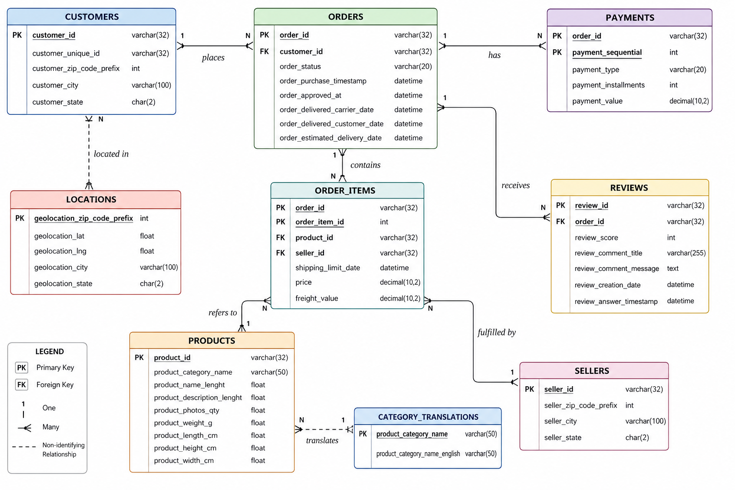

2. Methodology

2.1 Data Integration
Approach: Data from multiple relational tables was merged to create a unified master dataset (master_df). Left joins were used to retain all order records, preserving the full order history even where supplementary data may be missing.

Join Flow
Step | Left Table | Right Table | Join Key
1 | Orders | Customers | customer_id
2 | + Customers | Order Items | order_id
3 | + Order Items | Products | product_id
4 | + Products | Payments | order_id
5 | + Payments | Reviews | order_id
6 | + Reviews | Sellers | seller_id
7 | + Sellers | Category Translation | product_category_name

Outcome: A consolidated master dataset containing order details, customer information, product and category data, payment details, seller information, and review scores — ready for analysis.

2.2 Data Cleaning & Preparation
- Converted all timestamp columns to datetime format for time-series analysis
- Handled missing values introduced by left joins using appropriate imputation
- Removed negative delivery times by clipping values to zero
- Ensured consistency and integrity across key join columns

2.3 Feature Engineering
Order-Level Features
Feature | Formula / Method | Purpose
Total Order Value | SUM(price + freight_value) per order_id | Measure revenue per transaction
Delivery Time (days) | delivery_date − purchase_date | Measure fulfillment speed
Items per Order | COUNT(distinct item_id) per order_id | Understand basket size

Customer-Level Features
Feature | Formula / Method | Purpose
Purchase Frequency | COUNT(orders) per customer_id | Identify repeat vs. one-time buyers
Customer Lifetime Value (CLV) | SUM(total_order_value) per customer_id | Rank customer value
Average Order Value (AOV) | CLV / Purchase Frequency | Segment spend behavior

All engineered features were merged back into the master dataset to form the final analytical base table.

3. Key Findings

3.1 Customer Analysis
New Customers  ~93%  of total base | Retention Rate  ~7%  repeat buyers | High-Value Share  25%  24,020 users | HV Revenue Share  61%  ₹10.1M

New vs Repeat Customers
The business is highly acquisition-driven, with ~93% new customers and ~94% of revenue coming from first-time buyers, indicating a low retention rate of only ~7%. Repeat customers contribute relatively less value, highlighting clear gaps in post-purchase engagement.

Insight: Strengthening customer experience and loyalty strategies is the single highest-leverage action for improving long-term revenue.

High-Value vs Low-Value Customers
Segment | % of Customers | Users | Revenue | % of Revenue
High-Value | 25% | 24,020 | ₹10.1M | 61%
Low-Value | 75% | 72,060 | ₹6.5M | 39%

A small segment of customers drives the majority of revenue. Retaining and nurturing the high-value segment through personalized offers and loyalty programs can significantly boost overall profitability.

Geographic Distribution
Revenue is highly concentrated geographically. SP alone contributes the highest share (~₹6.2M), followed by RJ and MG. Together, the top 3 states account for a significant portion of total platform revenue — representing both a dependency risk and an expansion opportunity.

3.2 Revenue & Order Analysis
Metric | Finding
Revenue trend | Sharp peak in late 2017; strong performance into mid-2018; gradual decline thereafter
Order volume trend | Consistent upward growth through 2017; peak in late 2017; gradual post-2018 decline
Peak sales period | October 2017 — highest revenue month in the dataset
Post-mid-2018 drop | Sharp near-zero values; likely dataset cutoff or incomplete data artifact

3.3 Product Analysis
Top-Selling Categories
Rank | Category | Orders | Revenue Position
1 | Bed, Bath & Table | 2,650 | Highest volume and revenue
2 | Furniture & Decor | 1,693 | Strong revenue contributor
3 | Computers & Accessories | 1,489 | High-value ticket items
4 | Health & Beauty | 1,376 | Consistent top performer
5 | Sports & Leisure | 1,299 | Growing category
6 | Housewares | 1,133 | Stable mid-tier
7 | Watches & Gifts | 1,005 | Seasonal spike driver

A few top categories dominate revenue — a concentrated sales structure. The demand histogram shows a right-skewed distribution: most products have low demand while a few drive very high sales volume. Health & Beauty and Watches & Gifts emerged as consistent revenue leaders across 2017–2018.

3.4 Seller Analysis
Top Seller Revenue Share  ~1.5%  per seller | Long-Tail Sellers  3,000+  in lowest bucket | Revenue Concentration Risk  Low  well distributed | Seller Distribution  Power Law  classic long tail

Top sellers each contribute around 1.5% of total revenue — indicating no single seller dominates the platform. Contribution tapers smoothly from ~1.5% to ~0.5%, suggesting a healthy distribution. However, the vast majority of sellers (3,000+) fall in the lowest revenue bucket, confirming a classic long-tail structure with significant room for mid-tier seller uplift.

3.5 Review & Satisfaction Analysis
Review Score | 1-Star | 2-Star | 3-Star | 4-Star | 5-Star
Proportion | 13.1% | 3.5% | 8.4% | 18.9% | 56.2%

56% of reviews are 5-star — a strong positive signal. However, 1-star reviews are notably high at 13%, while 2-star is the lowest at 3.5%. This polarized distribution indicates customers either have an excellent or very poor experience, with little middle ground.

Avg Delivery — Good Reviews  10.95  days | Avg Delivery — Bad Reviews  18.25  days | Delivery Gap  +7.3  days difference | 1-Star Rate  13%  needs urgent action

Key Finding: Slower delivery is a meaningful and measurable driver of negative reviews. Reducing delivery time by ~7 days for underperforming orders directly addresses the 1-star review rate.

4. Business Recommendations

4.1 Customer Retention & Loyalty
Problem: Retention is only ~7% — the platform is almost entirely dependent on new customer acquisition.

Recommended Actions
- Post-purchase email sequences: Trigger automated follow-up at Day 3, 7, and 30 post-purchase to re-engage and drive repeat orders
- Loyalty points program: Introduce redeemable points on every order to incentivize return visits
- Win-back campaigns: Offer 10–15% 'welcome back' discount to customers inactive for 60+ days
- Referral program: Incentivize existing buyers to refer new customers with mutual rewards, reducing CAC

4.2 High-Value Customer Strategy
Opportunity: 25% of customers generate 61% of revenue — protecting this segment is the highest-priority retention task.

Tier | Strategy | Key Tactics
High-Value (25%) | Retain & maximize LTV | VIP tier, early access sales, free express shipping, dedicated support line
Mid-Value | Upgrade to high-value | Targeted upsells, bundle discounts, loyalty milestone rewards
Low-Value (75%) | Increase AOV | Cross-sell widgets, 'frequently bought together', volume discount nudges

4.3 Delivery Improvement
Problem: Average delivery time for bad reviews is ~18.25 days vs ~10.95 days for good reviews — a 7.3-day gap driving 1-star ratings.

Initiative | Description | Target Outcome
SLA targets | Set 7–10 days standard, 3–5 days express delivery benchmarks | Reduce avg. bad-review delivery time by 40%
Regional fulfillment | Partner with fulfillment centers near SP, RJ, MG | Cut last-mile delivery time by 2–3 days
Proactive alerts | Notify customers of delays before they notice; offer compensation | Reduce 1-star rate from logistics issues
Seller delivery KPI | Tie seller search visibility to delivery performance score | Improve platform-wide consistency
Recovery offers | Partial refund or store credit for confirmed late deliveries | Convert 1-star recovery, improve NPS

4.4 Geographic Expansion
Risk: SP alone contributes ~₹6.2M — over-concentration in one state creates revenue fragility.

- Expand performance marketing budget to underpenetrated mid-tier states (PR, SC, RS)
- Localized promotions in regional languages to improve resonance outside SP
- Open regional warehouses to reduce delivery time for customers outside the SP/RJ/MG cluster
- Partner with local delivery services for hyperlocal last-mile coverage in growth states

4.5 Seasonal & Revenue Planning
- Pre-build inventory 6 weeks ahead of festive season (August–September for October peak)
- Launch VIP early-access campaigns the week before peak sales windows open
- Investigate post-mid-2018 revenue decline: determine if data cutoff or real churn signal
- Deploy dynamic pricing models during high-demand periods to protect margins

4.6 Seller Ecosystem
Seller Tier | Characteristics | Strategy
Top 30 Sellers | ~1.5% revenue each, consistent performers | Preferential fee structures, account managers, retention bonuses
Mid-Tier Sellers | 0.5–1.0% revenue; growth potential | Ad credits, logistics support, uplift coaching
Long-Tail (3,000+) | Lowest revenue bucket; volume majority | Education program, quality scorecard, automated onboarding

4.7 Product Strategy
- Expand SKU depth in the top 3 categories (Bed Bath, Health Beauty, Computers)
- Bundle cross-category products to increase AOV (e.g., Health + Sports Leisure)
- Use algorithmic recommendations to surface long-tail products to relevant buyers
- Discontinue or de-list products with zero demand for 90+ consecutive days

5. Strategic Priority Roadmap
The following initiatives are prioritized by revenue impact and implementation feasibility:

Priority | Initiative | Timeline | Expected Impact
P1 — Critical | Reduce delivery time below 12 days for all orders | 0–3 months | Reduce 1-star reviews by 20–30%
P1 — Critical | Launch post-purchase retention email sequence | 0–3 months | Increase retention from 7% to 12–15%
P1 — Critical | Create VIP loyalty program for high-value customers | 0–3 months | Protect 61% revenue concentration
P2 — High | Geographic expansion campaigns to non-SP states | 3–6 months | Reduce regional revenue concentration risk
P2 — High | Seller performance scorecard and tiered quality system | 3–6 months | Improve platform-wide delivery consistency
P3 — Medium | Long-tail product optimization & cross-category bundling | 6–12 months | Increase AOV by 10–15%
P3 — Medium | Seller education and mid-tier uplift program | 6–12 months | Grow mid-tier seller revenue by 20%
P4 — Long-Term | AR try-before-buy for Furniture & Decor category | 12+ months | Reduce returns, increase conversion & AOV

6. Conclusion
This project successfully built an end-to-end intelligence pipeline over a multi-table e-commerce dataset, transforming raw transactional data into actionable business insights across five analytical dimensions: customers, revenue, products, sellers, and satisfaction.

The analysis reveals that the platform has strong acquisition capabilities and a healthy top-seller ecosystem, but faces critical challenges in customer retention (~7%), delivery consistency (7-day gap driving 1-star reviews), and geographic concentration (~₹6.2M in SP alone). These are not minor inefficiencies — they represent structural constraints on long-term growth.

The highest-return near-term investments are: reducing the delivery time gap for dissatisfied customers, launching a targeted retention and loyalty program for the 7% repeat customer base, and protecting the high-value 25% segment that drives 61% of revenue. These three P1 actions, if executed within 90 days, can materially improve NPS, reduce churn risk, and stabilize the revenue base.

Final Recommendation: Implement all P1 initiatives within Q1. Treat customer retention and delivery SLAs as engineering problems with measurable KPIs, not marketing afterthoughts. The data is clear — fix delivery, build loyalty, protect your best customers.

