1. **Minimum Number of experiments for building a robust hybrid model using simulated data.**

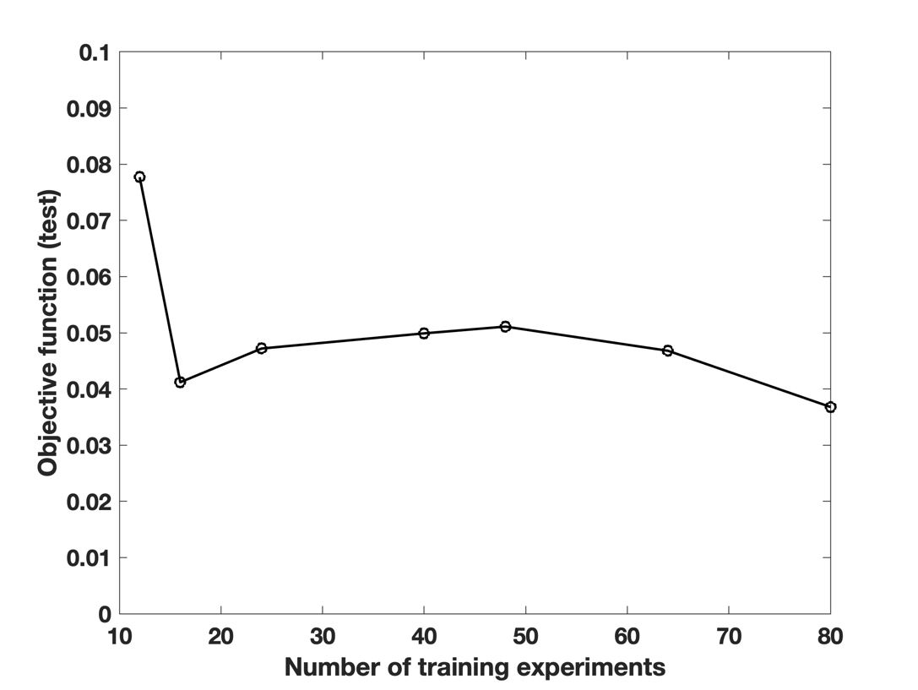

**Figure 1**: **Evolution of the sum of scaled root mean square error in prediction (scaled to the mean of respective variable) with respect to the number of training experiments.** **For comparability, same test set is used for all comparisons.**

1. **Detailed explanation of Figure 4 in the main text**.

Considering first the base models, it can be observed in Figure 4A for an exemplary run in the test set, that the PLS-propagated model (purple line) used in a completely predictive manner predicts the true Xv trajectory (in black) very poorly. The PLS model overfits during training and is biased by the noisy measurements resulting in poor prediction performance on the tuning and test set. Subsequently, during tuning, the EKF trusts only the measurement neglecting the model. This observation is validated by Figure 4A which demonstrates a comparison of the Xv profile estimated by the PLS-EKF module (Opt-Corr (PLS)) against the classical PLS2 model (PLS-direct). It is evident that the grey (PLS-EKF) and the crimson lines (PLS-direct) closely follow one another indicating that the correction of the state estimation using the EKF is equivalent to using a prediction of a classical PLS2 model that directly uses the measured values. This is due to the fact that PLS-propagated model does not provide much support to the EKF and measurements are mostly driving the EKF estimation. On the other hand, due to the mechanistic backbone, the hybrid model is robust to noise in the measurements and outperform a purely data-driven tool for a complete prediction, where only the initial conditions are used as model input. This can be observed in Figure 4B, where hybrid models (red dashed) predicts the trajectories of the variables closer to the actual values (represented in black). The state estimations are further improved by combining hybrid models with the EKF as highlighted by the green line in Figure 4B and C. The comparison of the Hybrid-EKF estimation with the PLS-direct model and the PLS-EKF estimation is illustrated with the profile of Xv for an exemplary run in Figure 4B and C, respectively. It can be observed that both the PLS direct and Opt-Corr (PLS) show large fluctuations and offset with respect to the true trajectory whereas the Opt-Corr (Hyb) fluctuates much less across the true value. In addition, Figure 4D then compares the RMSEP of the estimations made by the three modules, namely, the PLS-direct, PLS-EKF and Hybrid-EKF averaged over all times and runs for the four key state variables. It demonstrates that the Hybrid-EKF outperforms the reference tools by at least 35%, 32%, 34% and 25% for Xv, Titer, GLC and LAC, correspondingly.

1. **Additional Simulation studies**

Using the same *in-silico* model (c.f. Section 2.1.2) data was generated at two other noise levels: 2 % and 30 %. We present the protocol validation with 15% gaussian noise measurements in the main text. Here we report results of protocol validation on two other gaussian noise namely 2% and 30%.

As observed in the Table, for measurements generated with 2% gaussian noise, the measurement error is too small. Thus, the EKF highly trusts the measurements over the model and as a result Hybrid-EKF only improves minutely. However, this is an extremely idealistic scenario and such a framework may not be required if the measurements are so accurate. However, typically the measurement errors from a spectroscopic soft sensor is relatively high. Correspondingly, a scenario with 15% relative error was chosen to be discussed in the main manuscript. Here, we present a scenario with measurement error of 30%. RMSEP of Hybrid-EKF is much lower than Hybrid model and the measurement itself. We also present the time resolved RMSEP at discrete measurement time point (every 2.4 h) for the four key variables: Xv, Titer, GLC, and LAC at 30% gaussian noise.

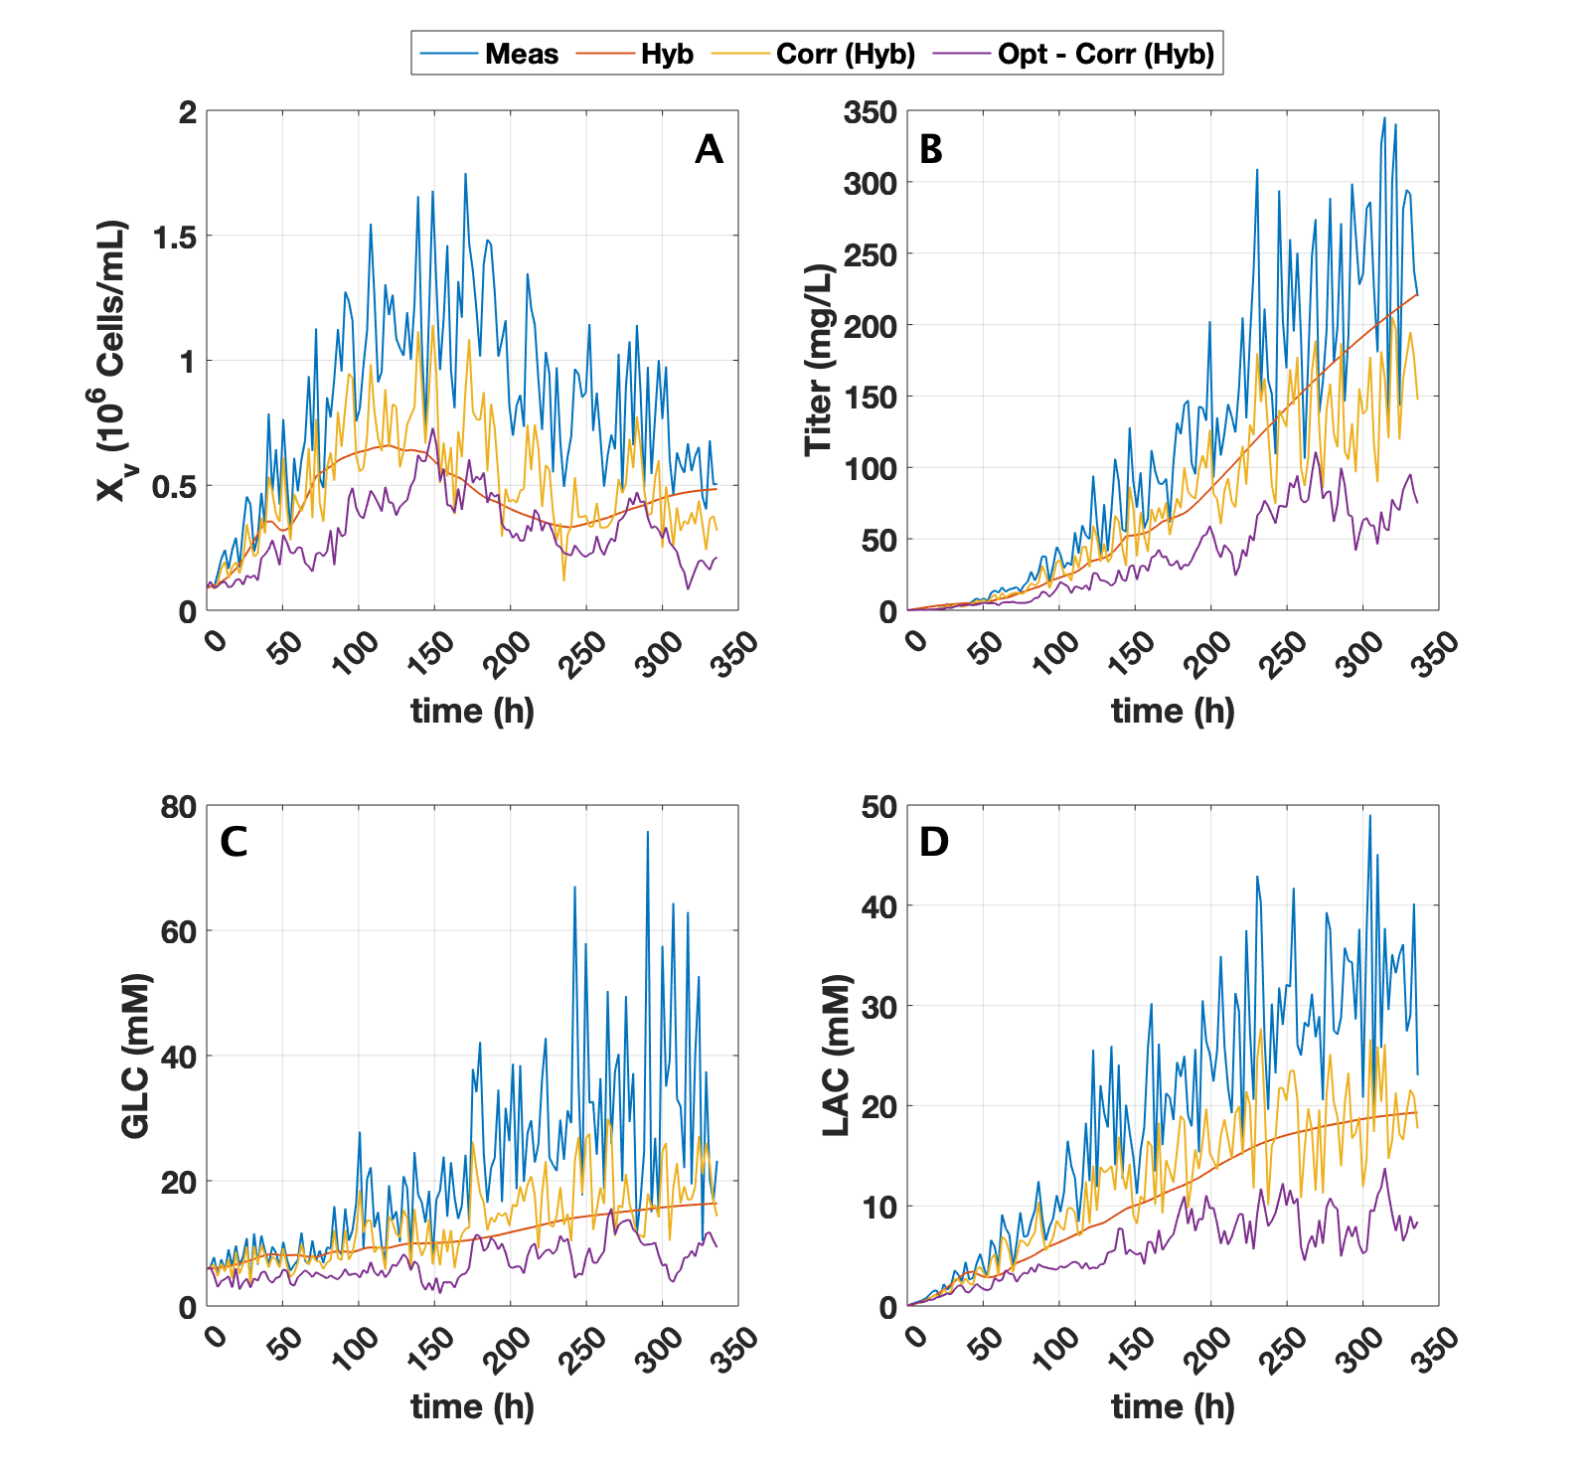

**Figure 2: Time resolved absolute RMSEP calculated at discrete measurement point for the four key state variables namely, (a) Xv, (b) Titer, (c) GLC and (d) LAC compared for the measurement (blue), model (red), Hybrid-EKF module when ${ k}_{Q}$ is** **not optimized (yellow) and Hybrid-EKF module when ${ k}_{Q}$ is** **optimized (purple). RMSEP is computed with respect to true state values (simulated dataset at 30% Noise).**

**Table 1: RMSEP of Measurement, Hybrid model, Non-optimized Hybrid-EKF and**

**Optimized Hybrid-EKF**

|  |  |  |  |  |  |  |  |
| --- | --- | --- | --- | --- | --- | --- | --- |
|  | | RMSE | | | | | |
|  | | Non-Opt | | Opt | |
| Noise Level | Variable | Meas. | Hyb | Pred (Hyb) | Corr (Hyb) | Opt-Pred  (Hyb) | Opt-Corr  (Hyb) |
| 2% | Xv  [106 Cells/mL] | 0.05 | 0.42 | 0.06 | 0.05 | 0.06 | 0.05 |
| GLC [mM] | 1.85 | 8.88 | 1.82 | 1.81 | 1.51 | 1.48 |
| GLN [mM] | 0.19 | 0.91 | 0.19 | 0.18 | 0.15 | 0.14 |
| NH4 [mM] | 0.28 | 1.38 | 0.27 | 0.27 | 0.23 | 0.22 |
| LAC [mM] | 1.31 | 11.71 | 1.34 | 1.30 | 1.22 | 1.16 |
| Titer [mg/L] | 7.94 | 73.10 | 8.11 | 7.88 | 7.37 | 7.08 |
| 15% | Xv  [106 Cells/mL] | 0.40 | 0.42 | 0.31 | 0.31 | 0.18 | 0.17 |
| GLC [mM] | 14.06 | 8.86 | 9.82 | 9.82 | 5.47 | 5.44 |
| GLN [mM] | 1.47 | 0.94 | 0.84 | 0.84 | 0.50 | 0.49 |
| NH4 [mM] | 2.08 | 1.49 | 1.38 | 1.41 | 0.75 | 0.75 |
| LAC [mM] | 9.64 | 11.80 | 7.56 | 7.64 | 4.25 | 4.23 |
| Titer [mg/L] | 59.03 | 77.93 | 46.30 | 46.86 | 24.45 | 24.52 |
| 30% | Xv  [106 Cells/mL] | 0.83 | 0.44 | 0.51 | 0.51 | 0.33 | 0.32 |
| GLC [mM] | 21.48 | 11.23 | 13.13 | 13.17 | 6.90 | 6.85 |
| GLN [mM] | 3.10 | 1.15 | 1.47 | 1.49 | 0.69 | 0.68 |
| NH4 [mM] | 3.74 | 1.96 | 1.70 | 1.72 | 0.99 | 0.98 |
| LAC [mM] | 19.25 | 10.88 | 12.28 | 12.38 | 5.95 | 5.87 |
| Titer [mg/L] | 113.34 | 81.85 | 72.20 | 73.22 | 37.15 | 37.18 |