Industrial gripper | Academic design | N - mm - MPa
1
Industrial 2-Finger Gripper
Parametric CAD Design and Static Structural Analysis
Mini Project Submission
Student: Tanvi Khalokar
Date: 17 October 2026
Software: CadQuery 2.7.0 (Open CASCADE) for CAD; Python / NumPy / SciPy for a reproducible 3D
linear static finite element solution. Free and open-source workflow.
Scope: a 5-10 kg friction gripper design, digital concept, dimensioned parametric profiles, STEP
parts and assembly, force calculations, and actual numerical stress/deformation results. This is an
academic design with an idealized finger simulation, not a certified manufactured assembly.
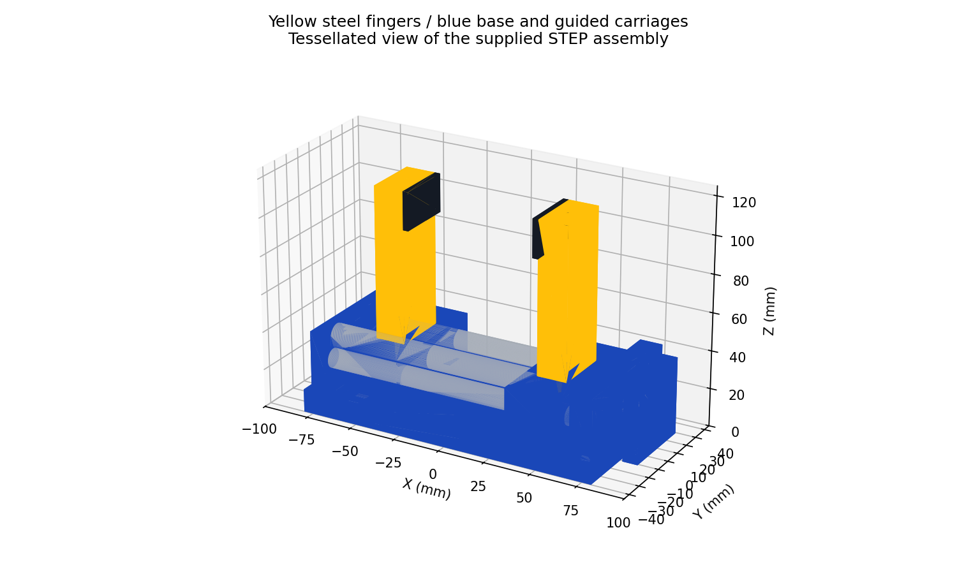

Industrial gripper | Academic design | N - mm - MPa
2
1. Concept and working principle (Q1)
A single opposed-thread screw drives two nut carriages. One half has a left-hand thread and the
other a right-hand thread, both with 3 mm lead. Screw rotation produces equal and opposite jaw
translation. Two parallel diameter 10 guide rods support each carriage and prevent its rotation,
keeping the jaw faces parallel. Rubber-like friction pads contact the payload.
Coordinates: X is jaw travel, Y is finger width, Z is vertical. The base is grounded. Carriage travel is
limited to +/-15 mm about jaw centres X = +/-45 mm. With 16 mm fingers and 3 mm pads,
nominal clear opening is 68 mm; full opening range is 38-98 mm. For screw rotation theta in
radians, travel per jaw is s = 3 theta/(2 pi) mm. Gap change is 2s. Mechanical travel stops must
enforce the stated limits.
A motor or hand-drive coupling connects to the diameter 12 screw extension. The 40 x 40 x 8 mm
blue end plate is an actuation interface envelope; motor-specific bolt holes, bearings, thrust
retention, nuts, bushings and travel stops require detailed selection. Threads are represented by
nominal cylinders in STEP, not helical thread geometry.
Materials: fingers and base: structural steel, E = 200 GPa, Poisson ratio 0.30, assumed minimum
yield strength 250 MPa, density 7850 kg/m3. Rods/screw: steel. Pads: assumed friction coefficient
0.30, to be verified on actual payload surfaces. Yellow fingers and blue base/carriages satisfy the
colour requirement.
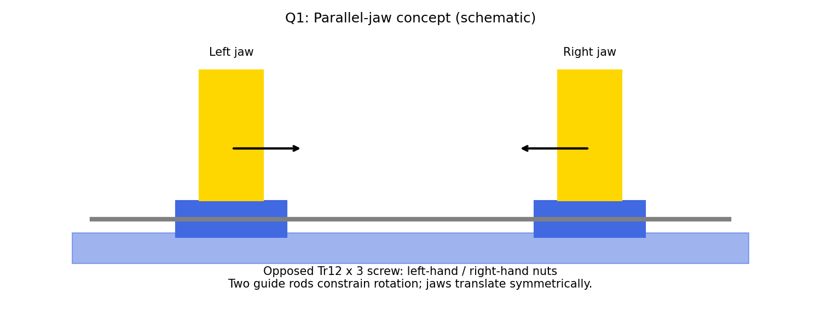

Industrial gripper | Academic design | N - mm - MPa
3
2. Sketches and parametric definition (Q2)
Component
Dimensions / local profile (mm)
Base
160 x 80 rectangle; thickness 12; 4 holes diameter 7
Finger (each)
16 x 30 rectangle; length 80; 2 root bores diameter 5 x 10
Carriage (each)
30 x 68 x 22; centre Z=25; rod bores Y=+/-25
Supports (each)
12 x 72 x 30; centres X=+/-72, Z=27
Guide rods / screw
2 rods diameter 10 x 144; screw diameter 12 x 172
Pads (each)
3 x 30 x 20; contact at finger-local Z=60..80
Constraint specification: all rectangles have horizontal/vertical edges, coincident corners, and
centres coincident with their defined local origin. Length and width dimensions fix scale; origin
coincidence fixes translation; horizontal edges fix rotation. Circles have fixed diameter and
dimensioned centres. Repeated bores have symmetry about Y=0. The root-bore centres in each
finger are X=0, Y=+/-9; their blind depth is 10 mm. These independent constraints leave zero
geometric freedom.
The supplied source generates these profiles deterministically from parameters. It is a scripted
parametric model, not a SolidWorks/FreeCAD sketch document with a constraint-status
screenshot. STEP is the permitted neutral deliverable and does not retain editable sketch
constraints. The SVG drawing and source preserve dimensions and dependencies.
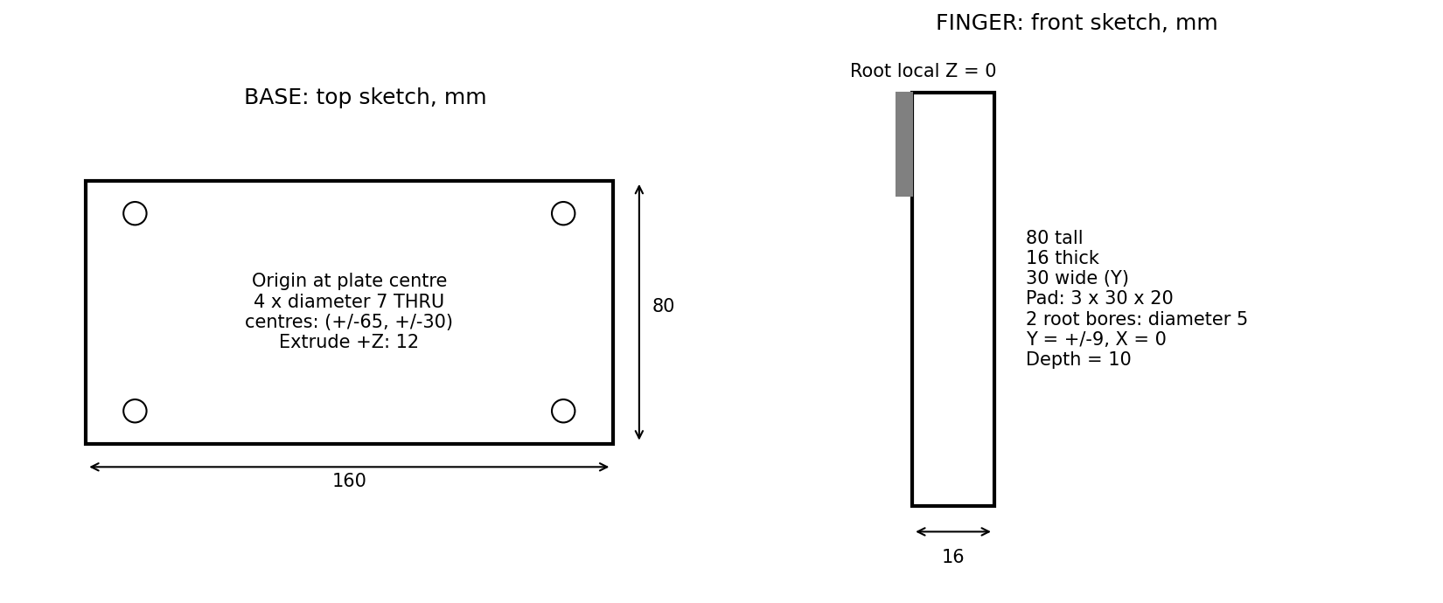

Industrial gripper | Academic design | N - mm - MPa
4
3. 3D parts and assembly (Q3-Q4)
Model operations: closed rectangular profiles are extruded into the base, fingers, carriages, pads
and supports; circles are extruded into guide rods, screw and simplified bolts; bores are
subtracted as cuts. Edge fillets/chamfers are deliberately omitted from load-bearing finger
geometry to match the prismatic FE domain. Small edge breaks may be added for manufacturing
after local stress review; the assignment feature examples do not require every feature on every
part.
Assembly: fix the base; align guide-rod axes with X at Y=+/-25, Z=25. Each carriage has one
translational degree of freedom along X; all its other motions are restrained by rod/bushing pairs.
Couple carriage translations as Xright = -Xleft. Fix each finger to its carriage, with root Z=36;
pads are fixed to inward-facing finger surfaces. Screw axial motion is restrained by thrust
bearings; only screw rotation is free. One actuation degree of freedom remains. STEP stores the
symmetric placement, while these kinematic constraints are specified here and in
motion_checks.csv rather than encoded as solver mates.
At nominal assembly the mounting face of each finger meets carriage top Z=36. Guide bores and
shaft bores are concentric. Guide rods pass through the carriages as intended. Mounting and
guide contacts are not treated as unintended interference. Assembly and individual STEP files
contain 17 positive-volume solids.

Industrial gripper | Academic design | N - mm - MPa
5
4. Gripping-force and drive calculations (Q4)
Assume a vertically suspended, rigid payload; two equal friction contacts; no acceleration, impact
or offset centre of mass. Let m be payload mass, mu = 0.30 the pad/object friction coefficient, n =
1.5 the minimum slip safety factor, and N the normal force exerted by EACH jaw. The total
available vertical friction is 2 mu N.
2 mu N >= n m g; therefore Nrequired = n m g/(2 mu), using g = 9.81 m/s2.
Payload
Weight (N)
Required per jaw (N)
Selected per jaw (N)
5 kg
49.05
122.63
300
10 kg
98.10
245.25
300
With N=300 N per jaw, total friction capacity = 180 N and slip safety factor at 10 kg = 180/98.1 =
1.835. The corresponding payload limit at safety factor 1.5 is 180/(1.5 x 9.81) = 12.23 kg. Total
clamping normal force is 600 N; this must not be confused with force per jaw. At 10 kg, tangential
force per finger is 49.05 N downward.
Sensitivity: minimum friction coefficient for 10 kg at safety factor 1.5 with 300 N/jaw is 0.2453. At
mu=0.20 the design would require 367.9 N/jaw and the selected setting would fail the specified
slip margin. Validate friction with the actual clean/oily surface. Assumed static loading does not
include robot acceleration; add the acceleration and eccentric moment before deployment.
Pad pressure = 300/(30 x 20) = 0.50 MPa. Check pad compression, adhesive/fastener strength
and allowable payload contact pressure. With screw lead p=3 mm and assumed screw efficiency
eta=0.30, torque for two translating nuts is T=2 N p/(2 pi eta)=0.955 N m. Specify at least 1.5 N
m continuous screw torque as a preliminary allowance; final motor selection needs speed, inertia,
duty cycle and bearing losses. A brake or verified self-locking mechanism is needed for power-loss
retention.

Industrial gripper | Academic design | N - mm - MPa
6
5. Static structural simulation method (Q5)
An actual custom 3D linear-elastic finite element solve was run for one finger. The other finger is
its mirror with identical stress magnitude under symmetric loads. Domain: 16 x 30 x 80 mm
prismatic steel finger. Root plane Z=0 has Ux=Uy=Uz=0. A uniformly distributed traction on X=0,
Y=0..30, Z=60..80 applies 300 N outward and 49.05 N downward. Consistent nodal surface loads
integrate to those exact resultants. No artificial point force is used.
Model assumption: rigid finger/carriage attachment. The two blind mounting holes, bolt preload,
contact, thread roots, pad compliance, base flexibility and guide-bushing flexibility are omitted.
The clamped plane represents their global restraint. This model evaluates global finger
strength/stiffness; it cannot establish local bolt-hole, bearing, pad or base safety. Actual fillets and
joints require a later detailed contact model or physical test.
Solver: four-node constant-strain tetrahedra, isotropic Hooke law, engineering shear strains,
direct sparse solution of K u = F. Each grid cell is divided into six tetrahedra. Stress is evaluated
per element; reported maximum is the unaveraged elemental von Mises value. Surface stress
plots use nodal averaging for readability. Equivalent elastic strain is defined as von Mises stress /
E. Units: N, mm, MPa.
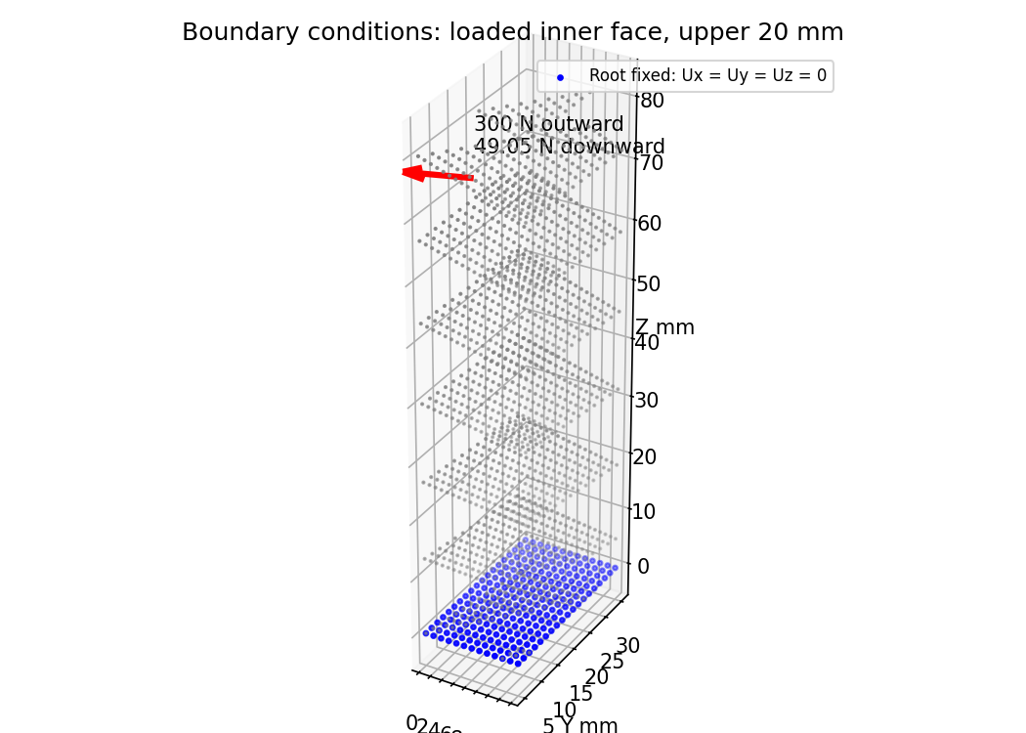

Industrial gripper | Academic design | N - mm - MPa
7
6. Mesh study and numerical checks
Mesh divisions
Nodes / elements
Max U (mm)
Max stress (MPa)
[4, 6, 20]
735 / 2880
0.017003
12.471
[8, 12, 40]
4797 / 23040
0.019992
16.141
[12, 18, 60]
15067 / 77760
0.020711
18.600
Linear tetrahedra can be overly stiff in bending; refinement is essential. These are
mesh-sensitivity results, not a claim of fully converged peak stress. Clamp-edge stress can remain
mesh sensitive. A second-order mesh and explicit joint geometry are recommended if local
maxima control a final design.
Finest-mesh results: maximum displacement 0.020711 mm; maximum von Mises stress 18.600
MPa; maximum equivalent elastic strain 9.300e-05; yield margin 250/sigma_vm = 13.44. This
exceeds 1.5 for the idealized finger domain.
Equilibrium check: summed support reaction = [300.000000, 0.000000, 49.050000] N. This
balances applied [-300, 0, -49.05] N. Maximum free-degree residual = 5.86e-11 N.
Independent beam check: contact resultant is 70 mm above root. Bending moment = 300 x 70 =
21,000 N mm. I = 30 x 16^3/12 = 10,240 mm4. Nominal root stress = M(8)/I + 49.05/(16 x 30) =
16.51 MPa. Normal-load beam tip deflection = F a^2(3L-a)/(6EI) = 0.02034 mm, with a=70
mm, L=80 mm. Distributed patch and 3D clamp effects account for differences from this simple
line-load beam estimate.
The safety factor against slipping (1.835) governs the payload more tightly than global finger
yielding. Large structural margin does not eliminate joint or friction uncertainty.

Industrial gripper | Academic design | N - mm - MPa
8
7. Stress and strain results
The maximum unaveraged elemental von Mises stress is 18.600 MPa. The plot legend uses
averaged nodal values, which can be lower than the raw element maximum. Highest global
bending stresses lie near the constrained root. The maximum equivalent elastic strain is
9.300e-05 (dimensionless). All six stress and strain components are retained in fea_fields.npz.
Acceptance for the modeled domain: sigma_vm <= 250/1.5 = 166.67 MPa. This criterion passes.
Yielding is not predicted under the stated material and static load assumptions. No fatigue life,
plasticity, shock, contact slip or joint stress conclusion is inferred from this check.
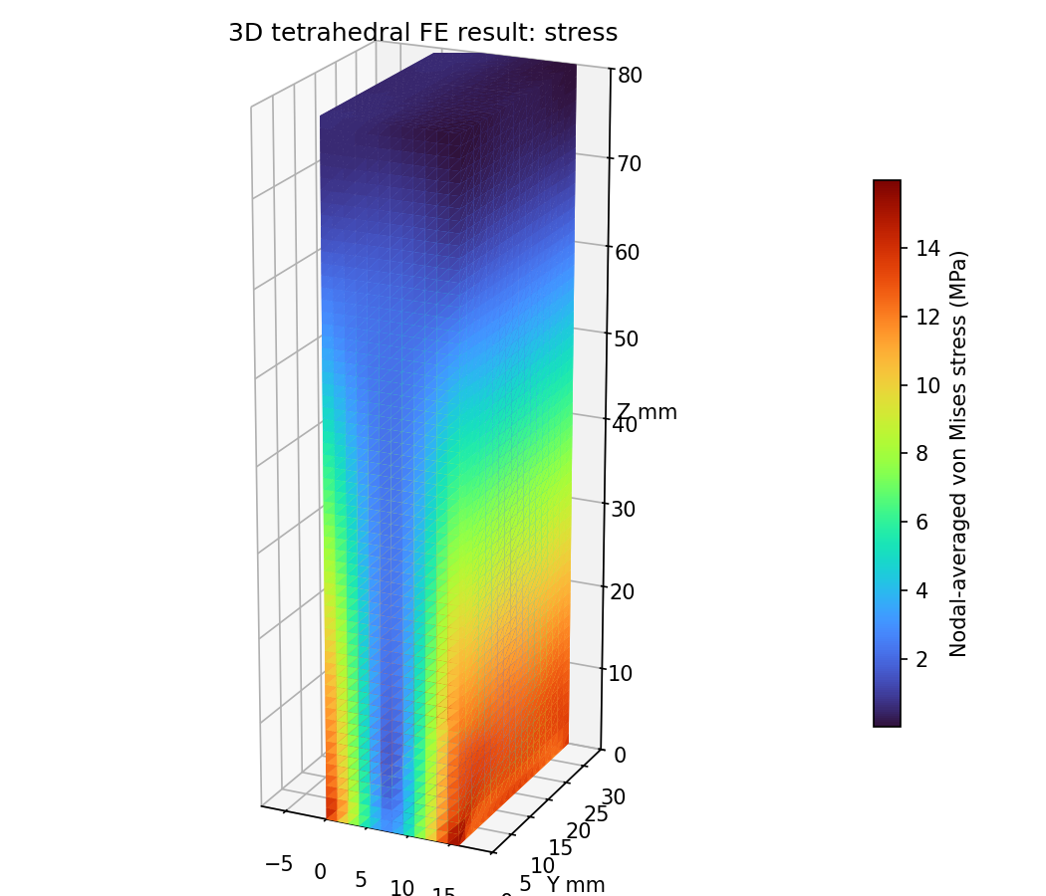

Industrial gripper | Academic design | N - mm - MPa
9
8. Deformation and motion validation
Maximum total displacement = 0.020711 mm. The displayed deformed shape is magnified 200
times and must not be read as actual geometry. Outward bending of the two fingers increases
their separation by approximately twice the normal deflection, about 0.0414 mm. There is no
assignment-specified displacement limit; this small calculated compliance is a reported result, not
a substitute for a positioning requirement.
Jaw centre |X| (mm)
Left / right X (mm)
Pad-face opening (mm)
30
-30 / +30
38
45
-45 / +45
68
60
-60 / +60
98
In all three states the pad faces remain parallel and their midpoint stays at X=0. These analytic
kinematic checks validate the prescribed symmetric positions. No dynamic CAD mate solver or
physical actuator test was performed.
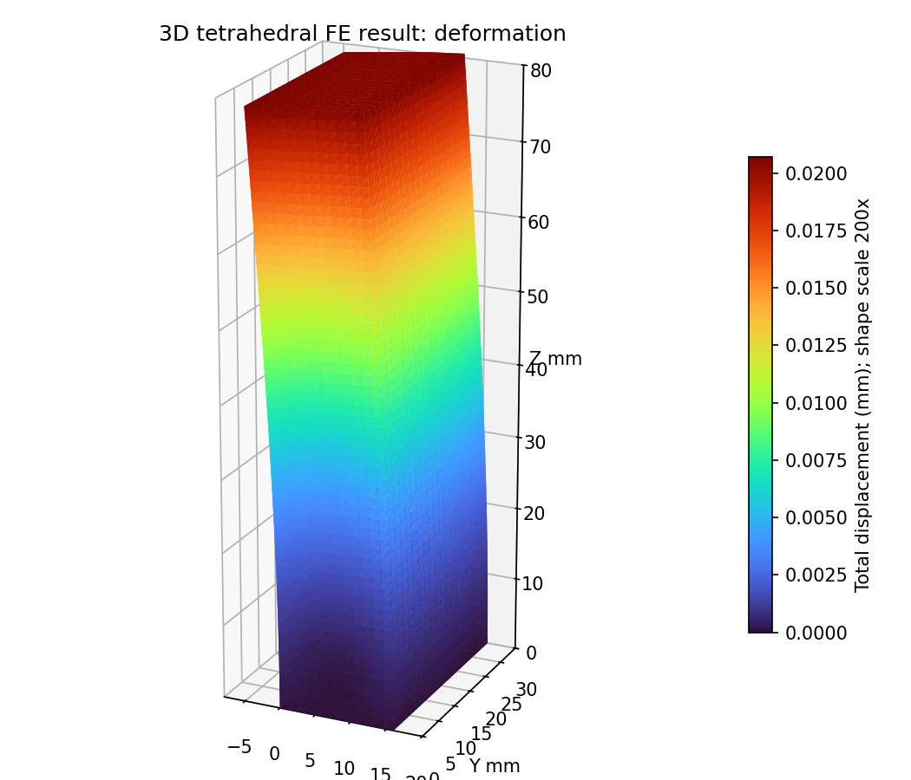

Industrial gripper | Academic design | N - mm - MPa
10
9. Conclusions and submission checklist
The opposed-screw concept provides parallel symmetric jaw motion. The supplied yellow-and-blue
parametric CAD assembly and STEP parts define a practical academic concept. At mu=0.30, 300
N per jaw holds a 10 kg static payload with slip factor 1.835, exceeding the required 1.5. The
performed 3D linear-static FE analysis predicts 18.600 MPa maximum finger stress and 0.020711
mm maximum displacement on the finest mesh; the idealized finger passes the specified yield
safety criterion.
Limits before manufacture: select actual screw/nuts, bearings, bushings, motor and pad
attachment; verify joint stresses, base bending, guide bending, wear, travel stops, object damage
and power-loss holding. The base is provided as CAD geometry but has not received a separate FE
solve. No claim is made that the complete physical assembly has passed experimental or
contact-aware validation. A detailed bolted-joint model would be needed for a complete
production-level structural validation.
Requirement
Evidence supplied
Q1: concept
Mechanism explanation and digital concept diagram
Q2: constrained profiles
Dimensioned drawing and deterministic parameter source
Q3: 3D CAD
17 STEP part files; coloured STEP assembly
Q4: assembly and forces
Placement, kinematic constraints, motion table, load sizing
Q5: static analysis
Executable 3D FE code, fields, equilibrium, plots, mesh study
Report / CAD / results
report.pdf / cad_files / simulation_results
Reproduction: use Python 3 with cadquery==2.7.0, numpy, scipy, matplotlib and reportlab. Run
cad_files/build_cad.py; then simulation_results/solve_fea.py (all three meshes); see README.txt.
No commercial CAD/FEA software is required. This report and results are generated from actual
code outputs; they are not SolidWorks or ANSYS screenshots.
References: supplied Industrial 2-Finger Gripper assignment (requirements); isotropic linear
elasticity and Euler-Bernoulli beam equations; CadQuery documentation
https://cadquery.readthedocs.io/; SciPy sparse linear solver documentation
https://docs.scipy.org/doc/scipy/reference/sparse.linalg.html. Material properties and friction are
stated design assumptions, not certified supplier values.
Before submission: fill in roll number, college and branch/semester placeholders; the ZIP is
named for Tanvi Khalokar. Review the stated modeling limitations with the instructor if a native GUI
sketch/assembly constraint demonstration or full-assembly contact simulation is mandatory.

