**12 July, 2024**

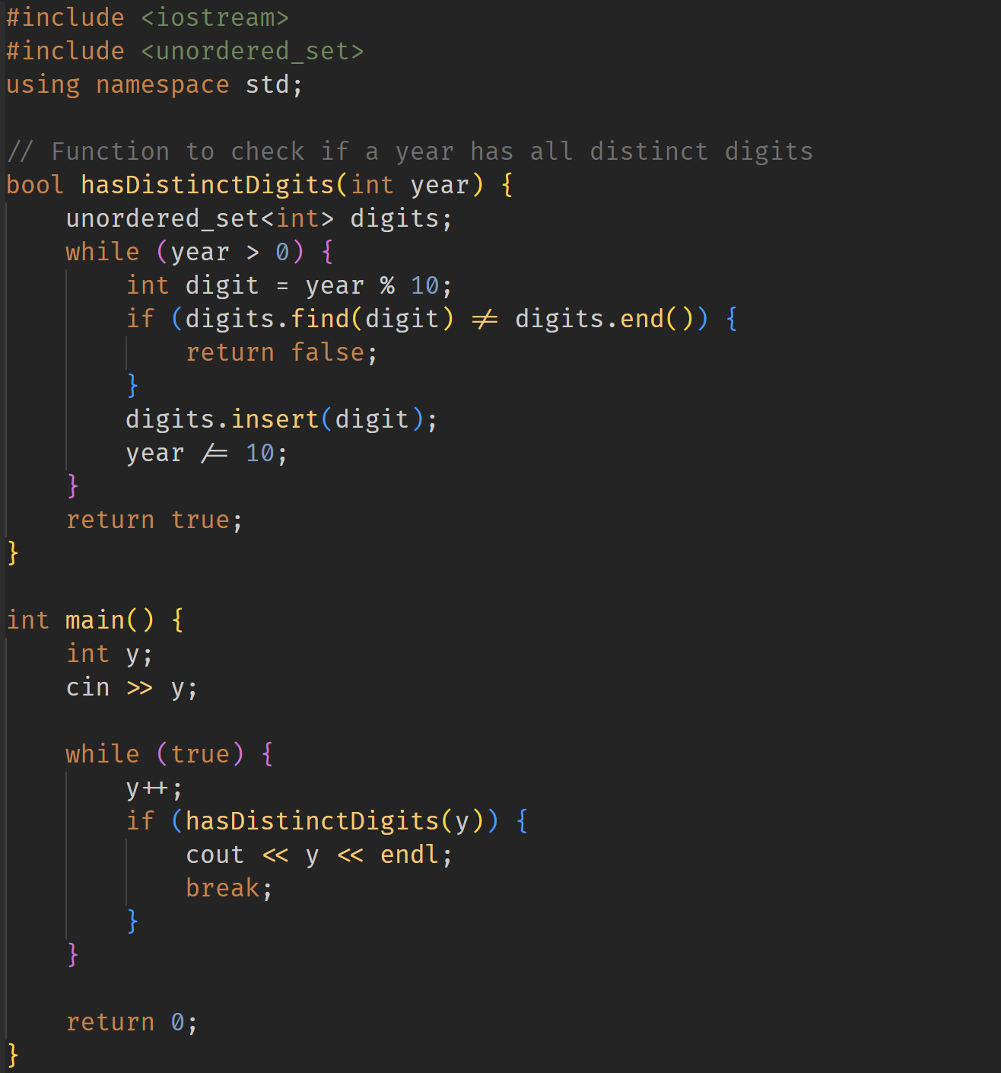

Learned about **set** implementation and its properties.