**Steps to setup Pycharm for remote debugging**

**1. Download and install Pycharm:**

https://www.jetbrains.com/community/education/#students

**2. Create new project: File/New Project**

Project name: CS224N

Location: up one level from the location where you cloned the github repository: https://github.com/deepbrain/CS224N

Leave other options default

**3. Go to File/Settings/Project CS224N/Python Interpreter:**

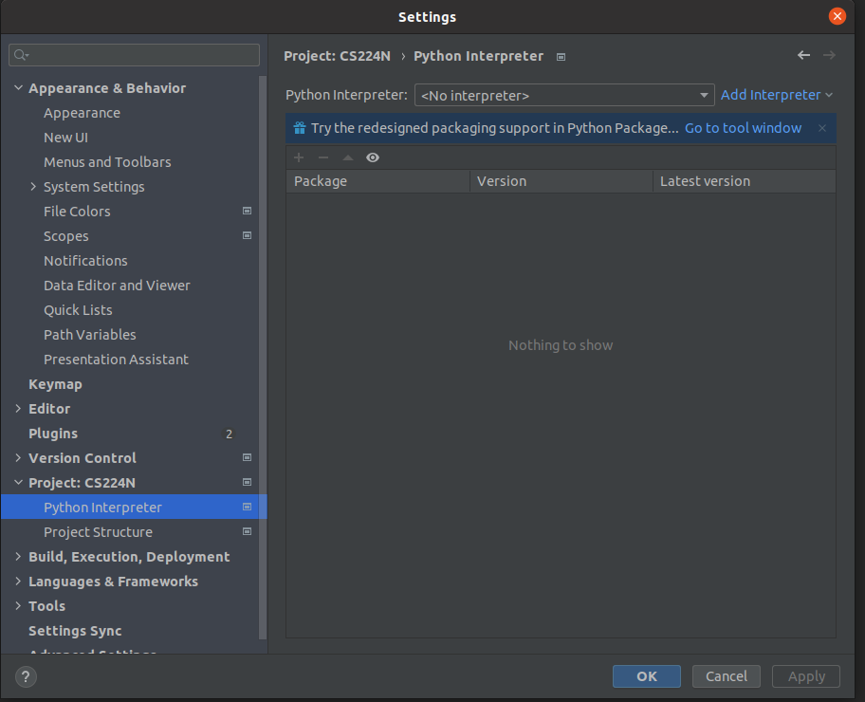

Click add interpreter, select “On SSH”, ssh connection:

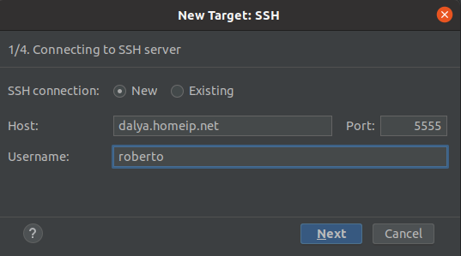

Click Next and enter your password (provided separately)

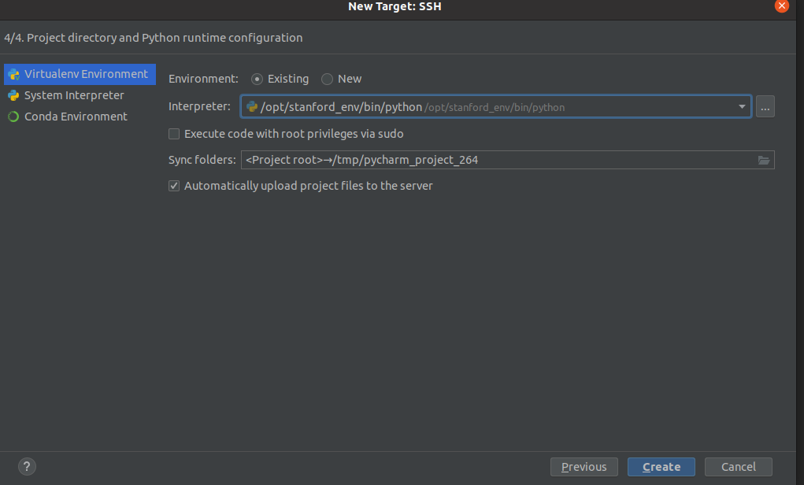

On the next screen, select “Existing” and enter interpreter location: /opt/stanford_env/bin/python

open the phi_model_test.py

Create a run configuration:

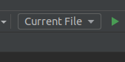

Click “add new:”

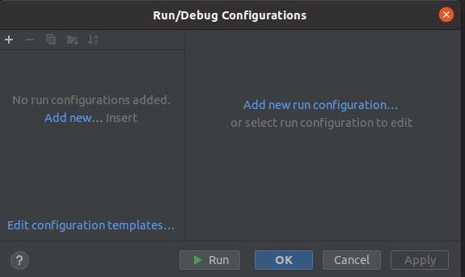

Select “Python” from the list, enter configuration name: “phi_test”, choose the ssh interpreter we created from the list. In the “script” field select: phi_model_test.py:

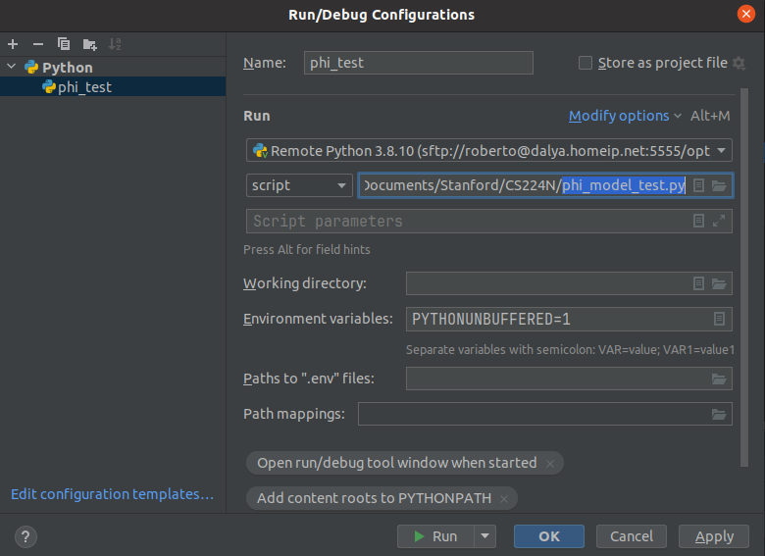

Click OK.