Machine Learning Based Buyer Segmentation and
Investment Profiling for Real Estate Market Intelligence
Research Paper
Prepared for: Unified Mentor / Parcl Co. Limited
Domain: Financial Analytics & Real Estate Market Intelligence

1. Executive Summary
This research applies K-Means and Hierarchical clustering to segment 2,000 real estate clients based on demographic and behavioral attributes, and evaluates whether these segments correspond to distinct investment behavior using a linked dataset of 10,000 property listings.
The analysis produced four segments, but the underlying statistical evidence shows these segments are weak: silhouette scores across all tested cluster counts (k=2 to 8) ranged from 0.14 to 0.19, below the 0.25 threshold generally associated with meaningful cluster separation. Segments are driven almost entirely by two features - client age and satisfaction score - while categorical attributes including country, referral channel, loan status, and gender contributed negligibly.
Critically, these segments do not correspond to meaningfully different investment behavior. Correlations between the segmenting variables (age, satisfaction) and investment outcomes (purchase frequency, total spend, property size) were all below 0.1. This is reported as an honest, statistically-supported finding rather than adjusted to match the business's original hypothesis of distinct "Global Investor" or "Luxury Investor" personas, which the data does not support.
Recommendations focus on what the data can support: using satisfaction score as an operational signal, and identifying which additional data (e.g. income, verified net worth, purchase intent surveys) would be required to build a segmentation model that supports genuine investment targeting.

2. Introduction and Problem Statement
Real estate companies serve buyers with highly diverse motivations and financial profiles: individual home buyers, institutional investors, international buyers, high-net-worth investors, and first-time buyers. Without segmentation, marketing and recommendation strategies default to a one-size-fits-all approach, resulting in inefficient marketing spend, generic property recommendations, and missed investment opportunities.
Parcl Co. Limited requested a data-driven segmentation of its buyer base along with an investment profiling layer connecting buyer segments to actual purchase behavior, to support more targeted marketing and investment strategy.

3. Dataset Description
Two datasets were provided:
- clients.csv - 2,000 records covering client demographics, acquisition purpose, financing, referral source, and satisfaction score.
- properties.csv - 10,000 property listing records, of which 7,305 are marked "Sold" (linked to a client) and 2,695 are marked "Available" (unsold, no linked client).

3.1 Client Fields
Field | Description
client_id | Unique client identifier
client_type | Individual or Company
gender | Client gender (M/F)
country / region | Geographic location
acquisition_purpose | Home or Investment
loan_applied | Financing indicator (Yes/No)
referral_channel | Website, Agency, or Client referral
satisfaction_score | Customer satisfaction rating, 1-5
date_of_birth | Used to derive client age

3.2 Property Fields
Field | Description
listing_id | Unique property identifier
unit_category | Apartment or Office
floor_area_sqft | Unit size
sale_price | Sale price (Sold listings only)
transaction_date | Month of sale
listing_status | Sold or Available
client_ref | Links to client_id for Sold listings

4. Methodology

4.1 Data Cleaning
- date_of_birth contained two date formats: dash-separated (interpreted as DD-MM-YYYY) and slash-separated (forced to MM-DD-YYYY, since every slash-formatted value had a second component greater than 12, ruling out a DD-MM reading).
- Age was derived using a fixed reference date of December 31, 2025, consistent with the dataset's transaction period, rather than the current calendar date.
- sale_price was stored as a formatted currency string and converted to numeric type.
- transaction_date was initially misparsed as DD-MM-YYYY, which collapsed all records into two invalid monthly buckets. Verification against the full range of values corrected this to MM-DD-YYYY, producing a valid 24-month series from January 2024 to December 2025.
- No duplicate client records and no missing values were found in either dataset.

4.2 Feature Engineering and Encoding
- Binary (0/1) encoding was applied to four true two-category fields: client_type, gender, loan_applied, and acquisition_purpose.
- One-hot encoding was applied to country and referral_channel, which have three or more unranked categories.
- region (57 unique values) was excluded from the clustering feature set due to high cardinality and sparsity risk, but retained in the dataset for dashboard filtering and geographic display.
- age and satisfaction_score were standardized (z-score) prior to clustering; encoded categorical fields were left as 0/1 and did not require scaling.

4.3 Clustering Approach
Two algorithms were tested for the segmentation task:
- K-Means on the encoded, scaled feature set.
- K-Prototypes with Gower distance, applied directly to the native mixed categorical/numeric data (no one-hot encoding required), to test whether K-Means' reliance on one-hot encoding was suppressing structure.
Optimal cluster count was evaluated using the elbow method (inertia) and silhouette score across k = 2 to 8.

5. Exploratory Data Analysis

5.1 Univariate Distributions
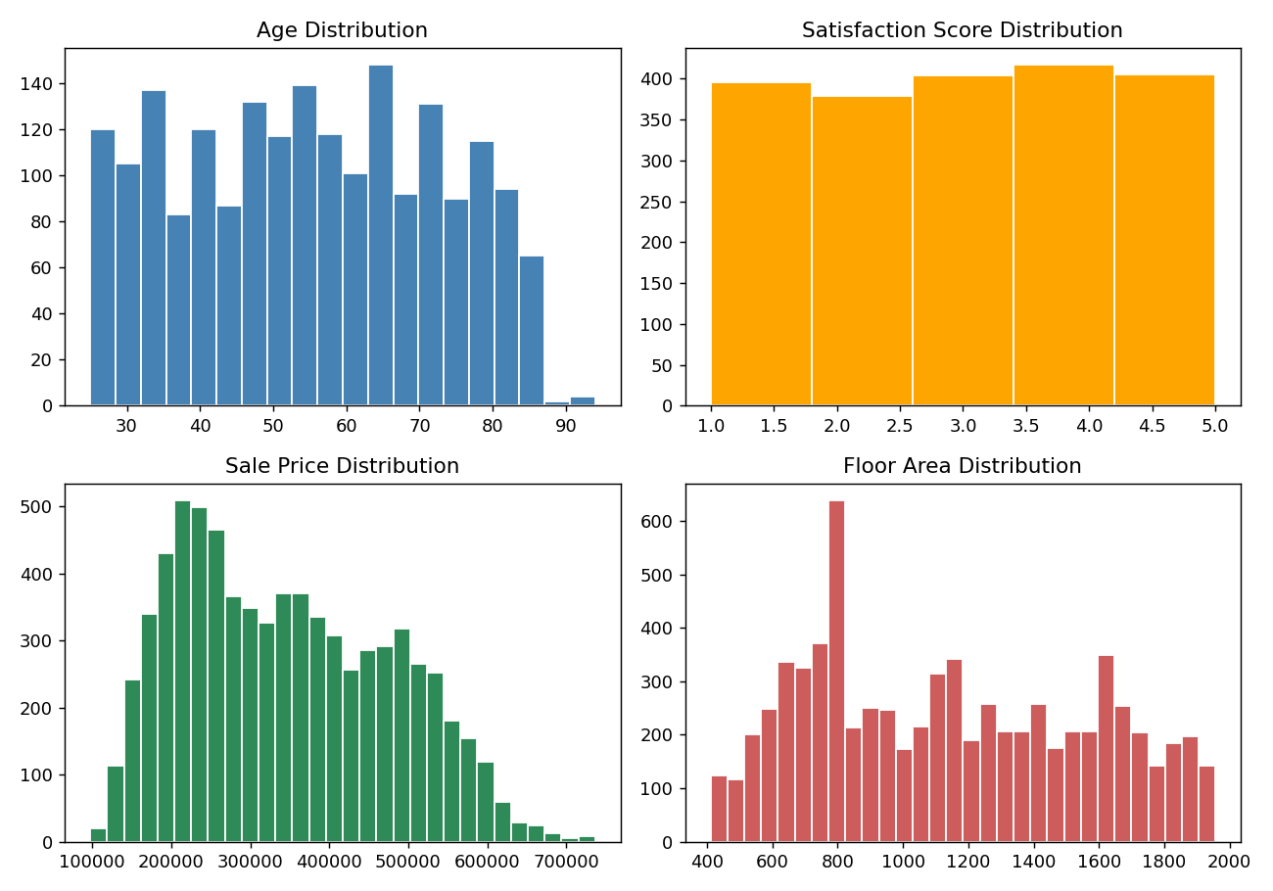
Figure 1: Distribution of age, satisfaction score, sale price, and floor area.
Age is broadly spread across the adult range with no strong skew. Satisfaction score is close to uniformly distributed across all five values (roughly 380-410 responses per rating) - a pattern inconsistent with typical real-world satisfaction survey data, which usually skews toward the higher end. This suggests satisfaction_score may be synthetically/randomly generated in this dataset rather than reflecting an organic customer sentiment pattern, a point directly relevant to interpreting later clustering results. Sale price and floor area are both right-of-center but show no extreme outliers (confirmed via IQR analysis: 0 outliers detected in sale price across 7,305 sold listings).

5.2 Categorical Distributions
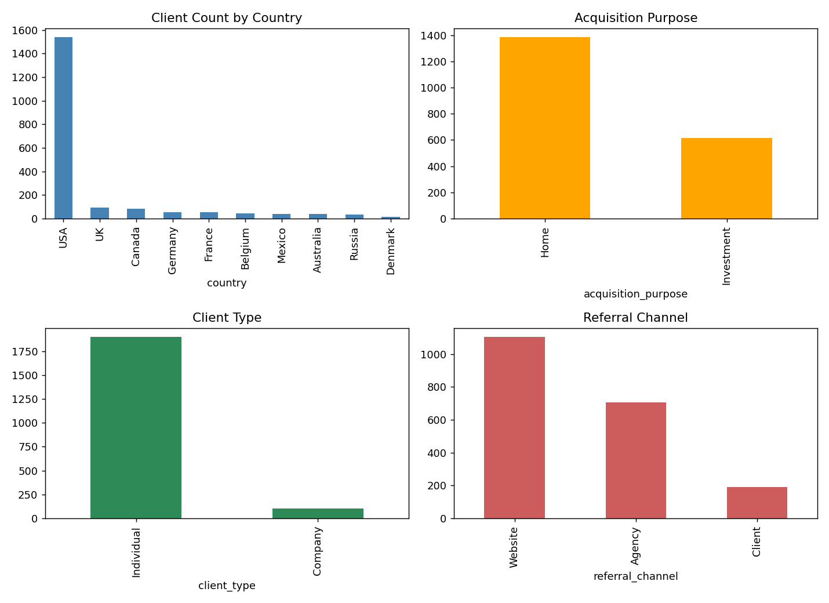
Figure 2: Distribution of country, acquisition purpose, client type, and referral channel.
All four categorical fields are heavily skewed toward a single dominant category: USA accounts for 76.9% of all clients, Individual clients account for approximately 94% of the client base, Home purchases represent roughly 70% of acquisitions, and Website referrals account for over half of all client acquisitions. This lack of balance limits how much these fields can contribute to distinguishing clusters, foreshadowing the clustering results in Section 6.

5.3 Transaction Trend
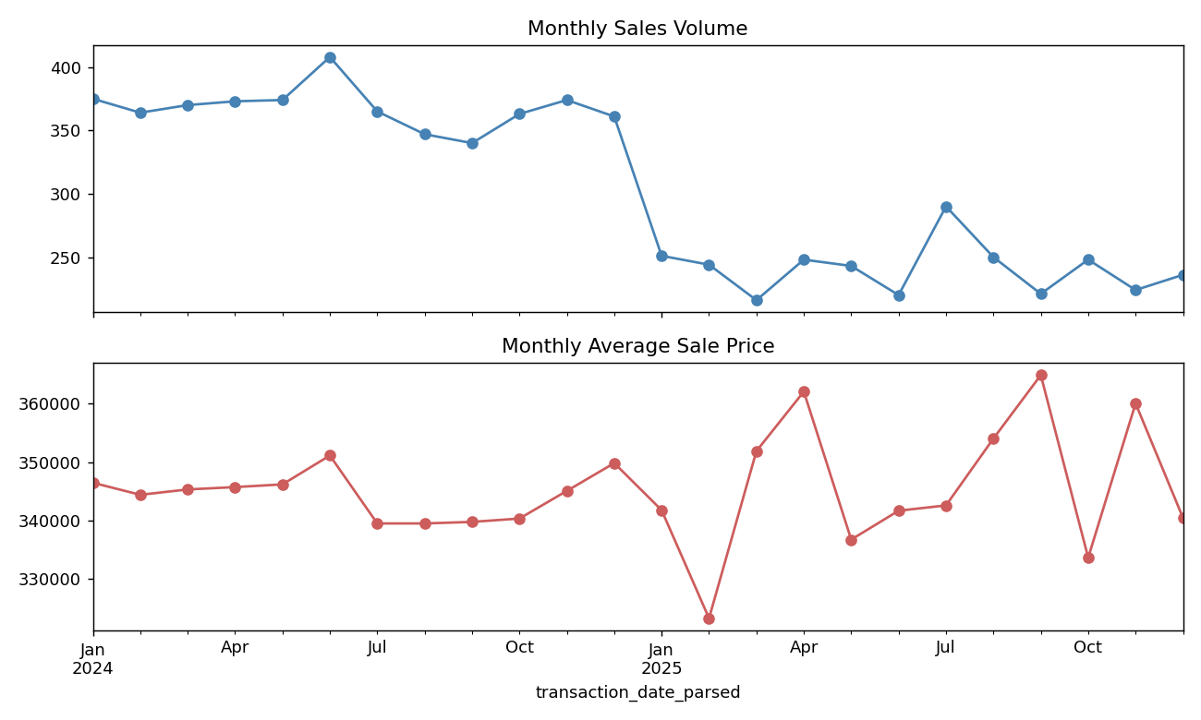
Figure 3: Monthly sales volume and average sale price, January 2024 - December 2025.
Monthly sales volume declines by roughly 40% partway through the observed period, from a range of approximately 340-410 sales/month in the first half of 2024 to approximately 220-290 sales/month for the remainder of the dataset. This is a genuine structural shift, not noise, and is worth further investigation by the business (e.g., whether it reflects seasonality, inventory constraints, or market conditions outside this dataset's scope). Average sale price, by contrast, fluctuates within a narrow band (approximately $330,000-$365,000) with no discernible trend - it should not be characterized as rising or falling.

6. Segmentation Results

6.1 Cluster Count Selection
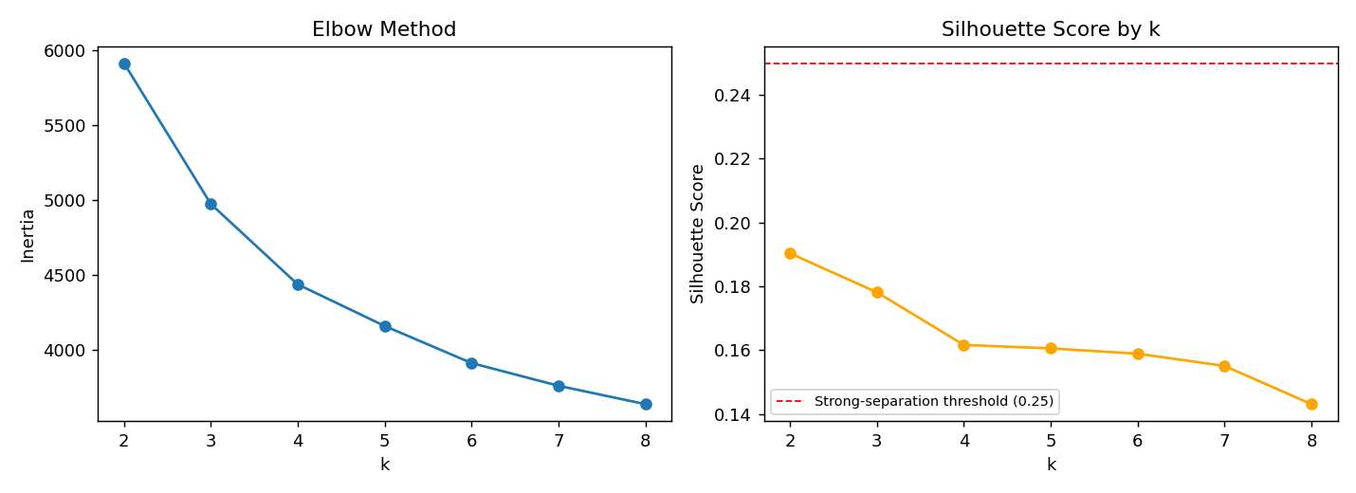
Figure 4: Elbow method (left) and silhouette score (right) across k = 2 to 8. Dashed line marks the 0.25 threshold typically associated with meaningful cluster separation.
Silhouette scores ranged from 0.14 (k=8) to 0.19 (k=2), with no value reaching the 0.25 threshold associated with meaningfully separated clusters. The elbow plot shows a smooth, gradual decline with no distinct "elbow" bend, a pattern consistent with data lacking well-separated natural groupings. k=4 was selected on the basis of interpretability and alignment with the business's original 4-segment framing, not because it was statistically superior to other values of k - this distinction is made explicit here rather than implied.
As a robustness check, K-Prototypes with Gower distance (which handles mixed categorical/numeric data natively, without one-hot encoding) was also tested. Silhouette scores under this approach ranged from 0.05 to 0.13 - weaker than K-Means, not stronger - indicating the weak separation is a property of the client data itself rather than an artifact of the one-hot encoding approach used in K-Means.

6.2 Cross-Validation with Hierarchical Clustering
Agglomerative Hierarchical clustering (k=4) was compared against the K-Means result using the Adjusted Rand Index (ARI), which measures agreement between two clusterings (1.0 = identical, 0 = random). The two methods produced an ARI of 0.357 - moderate agreement, meaning the two algorithms found related but not identical structure, consistent with a dataset that has some real but weak grouping signal.

6.3 Segment Profiles
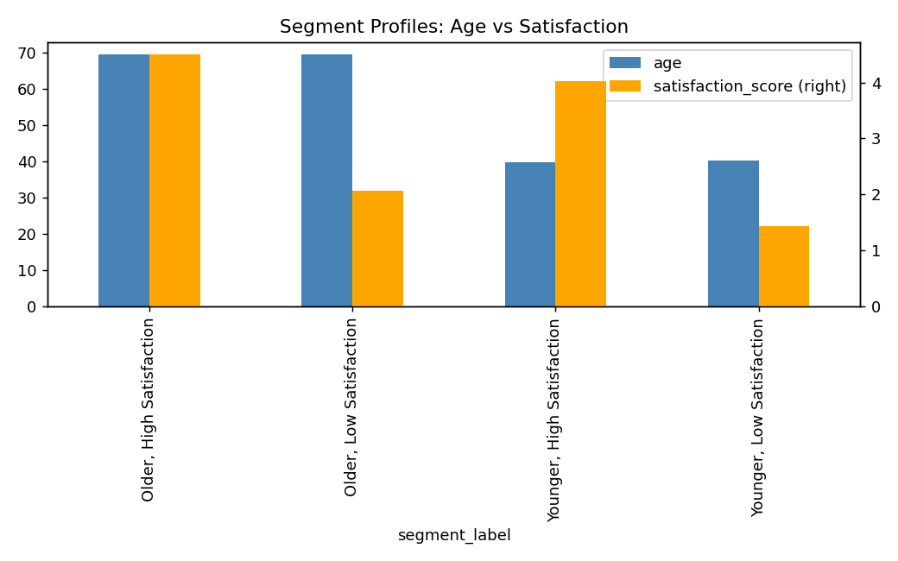
Figure 5: Average age and satisfaction score by segment.
Segment | n | Avg Age | Avg Satisfaction
Older, High Satisfaction | 423 | 69.5 | 4.50
Older, Low Satisfaction | 604 | 69.5 | 2.07
Younger, High Satisfaction | 582 | 39.7 | 4.02
Younger, Low Satisfaction | 391 | 40.2 | 1.44

Statistical testing (ANOVA for continuous features, Chi-square for categorical features) confirms that age and satisfaction score are overwhelmingly the dominant drivers of segment assignment (F = 1777 and F = 2067 respectively, both p < 0.000001). client_type and acquisition_purpose registered as statistically significant (chi2 = 30.1 and 8.9, both p < 0.05) but with effect sizes roughly two orders of magnitude smaller than age and satisfaction - a statistically real but practically negligible contribution. Gender, loan_applied, country, and referral_channel showed no statistically significant relationship with segment assignment (all p > 0.05).
In practical terms, the four segments reduce to a 2x2 grid of younger/older crossed with higher/lower satisfaction. They should not be described using business personas such as "Global Investors" or "Luxury Investors" as originally envisioned in the project brief, since the categorical attributes underpinning those labels (investment purpose, financing, geography) do not meaningfully differ across segments.

7. Investment Profiling (Overlay Analysis)
All 2,000 clients had at least one recorded property purchase (Sold listings only; Available/unsold listings were excluded from this analysis as they have no associated buyer). Purchase records were aggregated to one row per client (number of purchases, total spend, average floor area, dominant property type) and joined to the client-level segments.
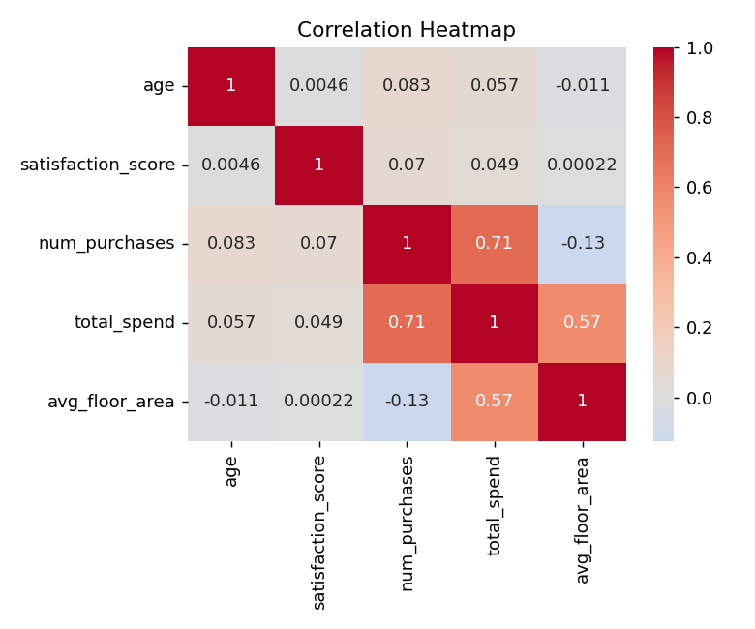
Figure 6: Correlation matrix across age, satisfaction score, and investment behavior metrics.
Correlations between the segmenting variables and investment behavior are negligible: age correlates with number of purchases at 0.083 and total spend at 0.057; satisfaction score correlates with number of purchases at 0.070 and total spend at 0.049. ANOVA testing found num_purchases and total_spend statistically significant across segments (F = 5.74, p = 0.0007; F = 3.24, p = 0.021), but with effect sizes an order of magnitude smaller than the effects driving the original segmentation - average purchase counts and total spend are effectively flat across all four segments (3.59-3.80 purchases; $1.23M-$1.30M average spend). avg_floor_area and dominant_property_type showed no statistically significant relationship with segment (p = 0.696 and p = 0.195 respectively).
This is the central finding of the investment profiling phase: demographic and satisfaction-based client segments, as derived from this dataset, do not translate into distinguishable investment behavior. A business seeking to target marketing spend by projected investment value would need a different set of signals than those available in the current client dataset - most plausibly, direct financial data such as income, net worth, or liquid assets, none of which are present in the current schema.

8. Limitations
- Silhouette scores across all tested cluster counts remained below the 0.25 threshold associated with meaningful structure; the reported segments reflect the strongest signal available in this dataset, not a strong or confidently separable clustering result.
- satisfaction_score's near-uniform distribution is inconsistent with typical organic survey data and may indicate this field was randomly generated for the synthetic dataset, which would explain both its statistical dominance in clustering (as one of only two continuous features) and its lack of predictive relationship with investment behavior.
- The dataset's 100% buyer-conversion rate (every client has at least one purchase) is not representative of a real-world client base and is most likely an artifact of synthetic data generation rather than an operational reality Parcl should expect to replicate.
- Country and region fields are heavily concentrated in the USA (76.9% of clients), limiting the ability of this dataset to support claims about genuine international buyer behavior.
- This is a single, static snapshot dataset; no time-based validation (e.g., out-of-sample testing on a later cohort) was possible.

9. Recommendations
- Do not adopt the four segments as fixed marketing personas (e.g. "Luxury Investor") in customer-facing systems; the underlying data does not support behaviorally distinct groups beyond age and reported satisfaction.
- Investigate the mid-2024 sales volume decline (Section 5.3) as a priority - this is the strongest, most reliable pattern identified in the entire dataset and has direct business relevance.
- If genuine investment-behavior segmentation is a business priority, prioritize collecting additional client-level financial data (income band, verified net worth, portfolio size, or prior real estate holdings) - the current fields are insufficient to support this goal, as demonstrated by the near-zero correlations in Section 7.
- Treat satisfaction_score as an operational monitoring metric (e.g., flagging the "Low Satisfaction" segments for retention outreach) rather than as an investment-targeting signal, since it shows no relationship with purchasing behavior.
- If a future dataset iteration is expected to support this project's original investment-profiling goals, verify that satisfaction_score and other fields are generated with realistic, non-uniform distributions so that clustering results reflect genuine population patterns rather than encoding artifacts.

10. Conclusion
This analysis delivers a statistically validated buyer segmentation and an honest assessment of its business applicability. Four client segments were identified, driven almost entirely by age and satisfaction score, with weak overall cluster separation (silhouette 0.14-0.19) confirmed across two independent algorithms (K-Means and K-Prototypes) and cross-validated against Hierarchical clustering (ARI = 0.357). These segments do not correspond to meaningfully different investment behavior, a finding supported by correlation and statistical testing rather than assumed. The most actionable and reliable finding to come out of this project is not the segmentation itself, but the identified ~40% decline in monthly sales volume beginning mid-2024, which merits direct business follow-up.

